Project Case | 
COSC6103001
Mobile Technology Solution
Computer Science | O272-COSC6103-VB02-00
Valid on Odd Semester Year 2026/2027 | Revision 00

- Kelompok tidak diperkenankan untuk:
Members of the group are prohibited from:
    - Melihat sebagian atau seluruh jawaban kelompok lain,
Seeing a part or the whole answer from other groups,
    - Menyadur sebagian atau seluruh jawaban dari buku, catatan, video, dan jenis referensi lainnya,
Retell a part or the whole answer from books, notes, videos, and other references,
    - Menyadur sebagian atau seluruh jawaban dari internet,
Retell a part or the whole answer from the internet,
    - Mengumpulkan jawaban yang tidak sesuai dengan tema soal,
Submitting an answer with a different theme from the given case,
    - Melakukan tindakan yang menyebabkan jawaban dicontek oleh orang lain atau kelompok lain, baik disengaja maupun tidak disengaja,
Doing action that could result the answer being copied by someone or other groups, intentionally or unintentionally,
    - Melakukan tindakan kecurangan lainnya.
Committing other dishonest actions.

- Jika kelompok terbukti melakukan tindakan seperti yang dicantumkan pada butir ke-1, maka nilai mahasiswa dan/atau kelompok yang melakukan kecurangan, baik menyontek atau dicontek, akan dinolkan sesuai dengan peraturan yang berlaku.
If it has been proven that a group has committed dishonest actions outlined in point 1 above, the whole groups related to the incident, regardless of which one copies or has their answer copied, will be issued a score of zero according to the regulation.

- Jawaban yang dapat diterima dan dinilai adalah jawaban yang dikumpulkan sebelum batas waktu yang telah ditentukan.
The answer must be submitted before the designated deadline to be accepted and graded,

- Jawaban akan dinilai berdasarkan teknik atau metode yang diajarkan pada kelas praktikum dengan menggunakan software yang sudah ditentukan.
The scoring will be based on the materials taught during the practicum classes using the designated software. Using different software than requested may result in your answer not being graded.

- Jika Anda tidak membaca peraturan ini, maka Anda dianggap sudah membaca dan menyetujuinya.
By taking this exam, you agree to these regulations, regardless of whether you have read it or not.

- Persentase penilaian untuk matakuliah ini adalah sebagai berikut:
The score will be distributed as follows:
Tugas Mandiri  Assignment | Proyek  Project | UAP  Final Exam
- | 100% | -

- Perangkat lunak yang digunakan pada matakuliah ini adalah sebagai berikut:
This course uses the following software:
Software
Software
Android SDK API 37
Android Studio Quail 1 2026.1.1

- Ekstensi file yang harus dikumpulkan untuk matakuliah ini adalah sebagai berikut:
Your answers must be in the following file extensions:
Tugas Mandiri  Assignment | Proyek  Project | UAP  Final Exam
- | Android Folder Project Kotlin (CLASS, XML, Asset Files) | -

- File yang harus dikumpulkan adalah keseluruhan jawaban beserta dengan aset yang digunakan (gambar, audio, video, dll) dan dokumentasi proyek yang berisikan link referensi aset dan penjelasan mengenai aplikasi yang dibuat (terlampir bersama dengan soal).
Include other files that can support your project, such as: all files in your project, other files (image, audio, video, etc.) used in your project, *.doc file (documentation of your project) that contains all pages in your project, reference links of additional files (image, audio, video, etc.) used in your project, the description about how to use your application, etc.

Soal
Case

ConcertX
ConcertX is a mobile application that helps concert-goers discover, browse, and purchase tickets for live music concerts held across multiple cities and venues in Indonesia. Currently, ConcertX is trying to make concert-going more accessible by creating a mobile application based on the Android operating system that may be downloaded by customers, thus increasing ConcertX's reach among music fans. The application provides user authentication features, viewing all available concerts, purchasing tickets, searching for specific concerts, and checking each concert's venue location via Google Map.
For the database engine, you are required to use SQLite. Below is the Entity-Relationship Diagram (ERD) used in this application.
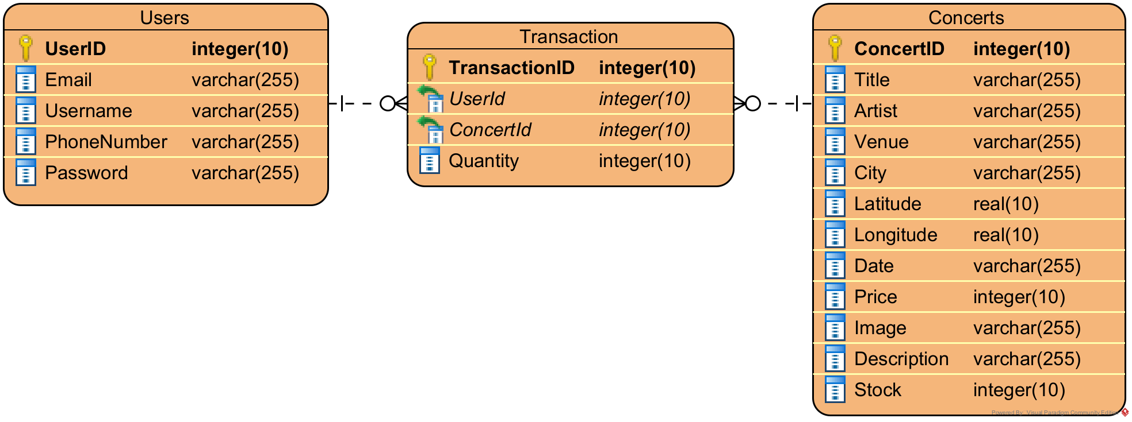
Figure 1. ERD of the Application’s Database
As stated above, this application will then need several pages to fulfill its purpose. The breakdown of those pages is described below:
- Login Page
This page contains a login form that will authenticate users to the application. The authentication process requires the user to input the registered username and password. The page has several components and validations, which are:
  - Use EditText for the username and password input field. Adjust the component's type to suit the proper purpose.
  - Use the Button for the user to log in.
This Button will validate and authenticate the user. The login processes are:

- Validate that username must be filled.
- Validate that password must be filled.
- Validate that username and password are registered in the application's database.
- If the validation fails, the application will show an error message according to the failure using Toast.
- If the validations are fulfilled, generate the OTP Code by random six numbers and send it using SMS Manager API to authenticate the user's registered phone number.
- Redirect the logged-in user to the OTP Page.
- Use TextView that contains "Don't have an account? Register". This component will direct users to the Register Page whenever clicked by the user.

- Register Page
This page contains a registration form that will be used to register a new user, which will then be stored in the application's database. The registration process requires a username, password, email, and phone number. The requirements for this form are:
  - Use EditText for the username, password, email, and phone number input field. The component's type must be adjusted to suit the proper purpose.
  - Use the Button for the user to register.
This Button will validate and register the user. The registration processes are:
- Validate that all fields must be filled.
- Validate that username must be unique and not registered by other users.
- Validate that password's length is at least five characters.
- Validate that the email is in a valid email format (contains '@' and a domain).
- Validate that the phone number contains only digits, between 10-13 characters in length, since it is used for OTP delivery.
- UserID will be an integer that always increments.
- If any validation fails, the application will show an error message according to the failure using Toast.
- Otherwise, register the given information and store it in the application's database. The user will then be directed to the Login Page.
- Use TextView for Login. This component contains "Already have an account? Login" which will redirect the user to the Login Page when clicked.

- OTP Page
This page contains an OTP form that will be used to re-authenticate the user by OTP Code sent through SMS. The requirements for this form are:
  - Use EditText for the OTP Code input field.
  - Use Button for the user to submit the code.
  - Validate that the OTP EditText must be filled.
  - Validate that the code typed by the user must be the same as the OTP Code sent via SMS, and must not be expired (codes expire 3 minutes after being sent).
  - If the OTP Code is not valid or has expired, show an error message using Toast.
  - Otherwise, start the user's session and redirect the user to the Home Page.
  - Use TextView for "Resend Code". This component will regenerate a new OTP Code, resend it via SMS, and enter a 30-second cooldown before it can be tapped again. Resending is limited to a maximum of three attempts per login.

- Home Page
This home page contains three sections: the home section, transaction section, and profile section. This application uses Bottom Navigation (a Menu component defined via a menu resource) to switch between these three sections. The details for the sections will be explained below:
  - Home Section
- Show a list of all available concert data from the application's database. The data must be retrieved from a JSON API using the Volley library, then stored in the application's database. Use the Volley library to fetch information from the JSON data. The JSON data is available at https://gist.githubusercontent.com/axelkrnwn/31139c9cfee4aca4acee3a36907a8c7e/raw/f4be1d6783d4331363e92b1bc450bf77259ea07c/concertx.json.
- Use Recycler View to show the data. Show each concert's poster, title, venue, city, and date in every concert item.
- When a specific concert is clicked, redirect the user to the corresponding Concert Detail Page.
- Provide a search icon (ImageView) that redirects the user to the Search Page when tapped.

  - Transaction Section
- Get the transaction list for the specific logged-in user from the application's database.
- Use Recycler View to show the data. Show concert's poster, concert's title, venue, date, and transaction quantity in every transaction item.
- Provide Update and Delete Button in every transaction item, along with an EditText for entering the updated quantity.
- If the user clicks the Update button, validate the quantity with the details below:
- Validate quantity must be filled.
- Validate quantity must be a number and more than 0.
- If any validation fails, the application will show an error message according to the failure (inline field error).
- Otherwise, update the quantity of the selected transaction data in the application's database.
- If the user clicks the Delete button, show a confirmation dialog before deleting the transaction to avoid human error.
- If the user has confirmed, delete the selected transaction in the application's database.
- If the user has no transactions, show an empty-state message instead of a blank list.
  - Profile Section
- Show username, email, and phone number of the logged-in user (read-only).
- Provide a Logout Button to log the user out of the application.
- Show a confirmation dialog before the user logs out, to avoid human error.
- Redirect the user to the Login Page after successfully logging out, clearing the user's session.

- Concert Detail Page
This page will show detailed concert information for a specific concert from the application's database. Show the concert's poster, title, venue, city, date, price, and description. This page also provides a form for users to buy tickets, along with a map showing the concert's venue location. The requirements for this page are:
  - Use EditText to enter the quantity of tickets the user wants to buy. The component's type must be adjusted to suit the proper purpose.
  - Use Button for the user to buy the ticket. This button starts disabled and only becomes enabled once a valid quantity is entered.
  - Use Google Play Services for Android Maps SDK to display the venue's location with a marker, based on the latitude and longitude stored for that specific concert in the database. The marker is named after the venue.
  - The Buy Button will validate and insert the transaction data into the application's database. The transaction process details are explained below:
- Validate quantity must be filled.
- Validate quantity must be a number and more than 0.
- Validate quantity must not exceed the concert's available ticket stock.
- If any validation fails, the application will show an error message according to the failure using Toast.
- Otherwise, insert the transaction of the selected concert and quantity into the application's database, decrement the concert's available stock, and show a success message using Toast.
- Put the marker on the specified location (latitude & longitude) and name the marker. The details will be specified below:
Google Maps Details
Marker Name | City | Latitude | Longitude
Indonesia Arena | Jakarta | -6.2153 | 106.8036
Jogja Expo Center | Jogjakarta | -7.7956 | 110.3865
Grand City Convex | Surabaya | -7.2575 | 112.7521

- Search Page
This page allows the user to search for a specific concert by title, artist, or city, without needing to fetch the data from the API again. The requirements for this page are:
  - Use EditText for the user to type in a search keyword.
  - Use Recycler View to show the filtered results, reusing the same item layout as the Home Section's concert list.
  - As the user types, filter the locally cached concert data in the application's database by title, artist, or city (case-insensitive, partial match).
  - If no concerts match the keyword, show an empty-state message ("No concerts found").
  - When a specific concert result is clicked, redirect the user to the corresponding Concert Detail Page.

