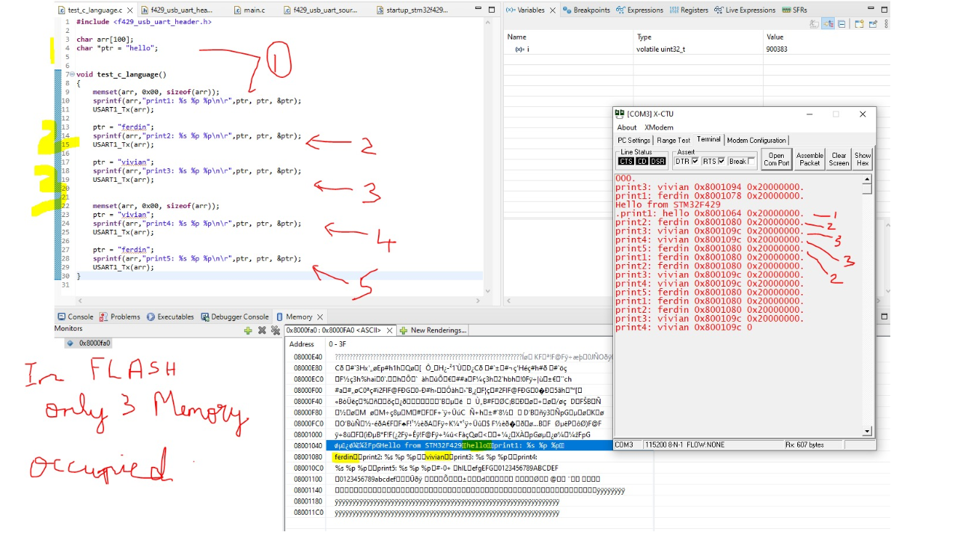
#include "header.h" vs #include <header.h>
1. #include "header.h"
- Meaning: "Look in MY folder first"
- Search order:
- Current project folder
- Then compiler/system folders
2. #include <header.h>
- Meaning: "Look in SYSTEM folders only"
- Search order:
- Compiler/Library folders only
- Use for: Standard library + MCU vendor files
CODE SUMMARY
char arr[100]; // Array in RAM
char *ptr = "hello"; // Pointer to String Literal in FLASH

void test_c_language()
{
memset(arr, 0x80, sizeof(arr)); // Fill RAM array with 0x80
ptr = "ferdin"; // Reassign pointer to new literal
ptr = "vivian"; // Reassign pointer again
}

KEY CONCEPTS - BULLET POINTS
String Literal Storage
- "hello", "ferdin", "vivian" are stored in FLASH memory at compile time
- Only 3 unique literals = Only 3 memory locations in FLASH. Hence your note: "In FLASH only 3 Memory occupied
"Pointer char *ptr
- ptr itself is in RAM. It just holds an address
- When you do ptr = "ferdin", you are NOT copying string. You are changing the address ptr points to
- Address changes: 0x8001064 -> 0x8001078 -> 0x800109C as seen in UART output
Array char arr[100]
- arr is 100 bytes allocated in RAM
- &arr is address of array in RAM: 0x20000000
- sizeof(arr) = 100 always
Why ptr address changes but &ptr stays same?
- %p ptr = Address of data in FLASH that ptr points to. This changes
- %p &ptr = Address of pointer variable itself in RAM. This stays constant: 0x20000000
memset on arr
- Only affects RAM array. Does NOT affect string literals in FLASH
- FLASH is read-only at runtime

UART OUTPUT ANALYSIS
- print1: ptr points to "hello" -> 0x8001064
- print2: ptr points to "ferdin" -> 0x8001078
- print3: ptr points to "vivian" -> 0x800109C
- print4: ptr points to "vivian" again -> same address reused
- print5: ptr points to "ferdin" again -> same address reused
- Conclusion: Compiler stores each unique literal only once in FLASH
LEARNINGS
- Pointers to string literals point to FLASH, not RAM
- Reassigning pointer is cheap. No memory copy happens
- To modify string, use array in RAM, not pointer to literal
- This saves RAM in embedded systems
IMPORTANT WARNING
- ptr = "hello"; ptr[0] = 'H'; -> CRASH. Because FLASH is read-only
- Use char arr[] = "hello"; if you need to modify

### **What image proves**
1. **Flash optimization**: Compiler put only 3 strings in flash even though you assigned 5 times
2. **Pointer vs Array**: `ptr` changes address, `arr` address is fixed at 0x20000000
3. **RAM vs FLASH**: `&ptr` and `arr` are in RAM `0x2000xxxx`. String data is in FLASH `0x8000xxxx`

Source Code:
#include <stdint.h>
#include <stdlib.h>
#include <stdio.h>
#include <string.h>

char arr[100];
char *ptr = "hello";

void test_c_language()
{
memset(arr, 0x00, sizeof(arr));
sprintf(arr,"print1: %s %p %p\n\r",ptr, ptr, &ptr);
USART1_Tx(arr);

ptr = "ferdin";
sprintf(arr,"print2: %s %p %p\n\r",ptr, ptr, &ptr);
USART1_Tx(arr);

ptr = "vivian";
sprintf(arr,"print3: %s %p %p\n\r",ptr, ptr, &ptr);
USART1_Tx(arr);

memset(arr, 0x00, sizeof(arr));
ptr = "vivian";
sprintf(arr,"print4: %s %p %p\n\r",ptr, ptr, &arr);
USART1_Tx(arr);

ptr = "ferdi";
sprintf(arr,"print5: %s %p %p\n\r",ptr, ptr, &ptr);
USART1_Tx(arr);
}

