**Bouncing Ball (pong)**

**Group : 03**

**CSE DEPARTMENT**

**EAST WEST UNIVERSITY**

**Date : 06.08.2018**

**CSE107 – Object Oriented Programming**

**Project Evaluation Rubrics**

|  |  |  |
| --- | --- | --- |
|  | **Max.** | **Awarded** |
| **A. Report** |  |  |
| i. Introduction / Problem statement |  |  |
| iv. System Design |  |  |
| v. Program output (Screen shots) |  |  |
| vi. Source code |  |  |
| vii. Disk/CD neatly attached (Y/N) |  |  |
| **B. Source Code** |  |  |
| i. Style |  |  |
| Indentation |  |  |
| Self-documentation |  |  | |
| ii. Modularity (small size functions) |  |  | |
| iii. Error reporting capabilities |  |  | |
| iv. Code efficiency, strategy, and originality |  |  | |
|  |  |  | |
| **C. Program Execution** |  |  | |
| i. Compile without errors |  |  | |
| ii. User friendly |  |  | |
| iii. Error free during runtime |  |  | |
| iv. Program output |  |  | |
|  |  |  | |
| **D. Presentation and Demonstration [Psychomotor Domain]** |  |  | |
| i. Presentation and communication skills (Soft skill) |  |  | |
|  |  |  | |
| **E. Bonus** |  |  | |
| i. Extra significant features |  |  | |
| **TOTAL** | **10** |  | |
|  |  |  | |

**CSE107 – Object Oriented Programming**

**Project Declaration**

**(Student 1)**

|  |  |
| --- | --- |
| **Student ID** | **2018-1-60-098** |
| **Name** | **Md. Ferdous** |
| **Session** | **02** |
| **Project No.** |  |
| **Date submitted** | **06.08.2018** |
| **Deadline of the project** | **06.08.2018** |
| **My contribution in doing this project (in percentage) in the group** | **50%** |
| **Description of my contribution in this project in the group** |  |
| **Number of hours I spent in doing this project** |  |

**(Student 2)**

|  |  |
| --- | --- |
| **Student ID** | **2018-1-60-194** |
| **Name** | **Pushpita Das Shakhi** |
| **Session** | **2** |
| **Project No.** |  |
| **Date submitted** | **06.08.2018** |
| **Deadline of the project** | **06.08.2018** |
| **My contribution in doing this project (in percentage) in the group** | **50%** |
| **Description of my contribution in this project in the group** |  |
| **Number of hours I spent in doing this project** |  |

**We hereby certify that this project represents the work done by all our group members with our contribution clearly stated above without copying from any other resources. We declare that no part of our work has been copied from or by other groups, and that no collusion has taken place with any other persons or groups.**

**We certify that any disks submitted with this project have been virus checked and have no viruses on them.**

**(1) Signature: …………………………… Date: ........................................**

**(2) Signature: …………………………… Date: ........................................**

* **Introduction :**

**This project is a gaming project. In this game there will two players and a ball. The ball will be always moving inside a ground. The two players will try to not ignore the ball. If a player miss the, the another player will get one point. After finishing the game final score will be showing on screen.**

* **System Design :**

System Design

Want to strat game?

No

Yes

Game over!

Ball

Player2 bar

Player1 bar

‘d’

‘k’

‘l’

‘s’

Show scores

‘q’

Score1:+1

Score2:+1

Ball miss

Ball miss

Bar down

Bar down

Bar up

Bar up

Game over!

‘q’

* **Program Output :**

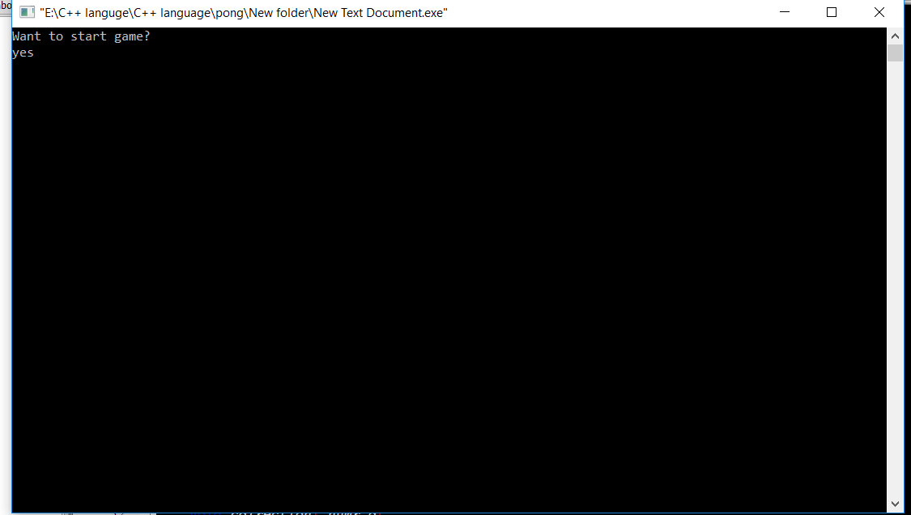

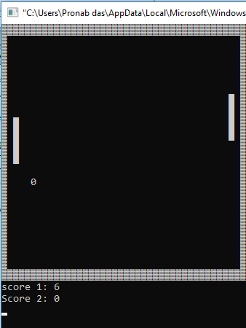

* **Limitation :**

1. **This is a 2D game.**
2. **Here, we did not work with graphics.**
3. **This game can not over automatically.**

* **Future Scope :**

1. **We can develop this game to make it 3D and a high quality graphics game.**
2. **We can develop this game to play this game by more than two persons.**