

**CSE 301/CSE302: Database Systems [Summer 2020]**

**Project Report**

**Formula-1 Racing**

1. Final version of the E-R Model of the Project

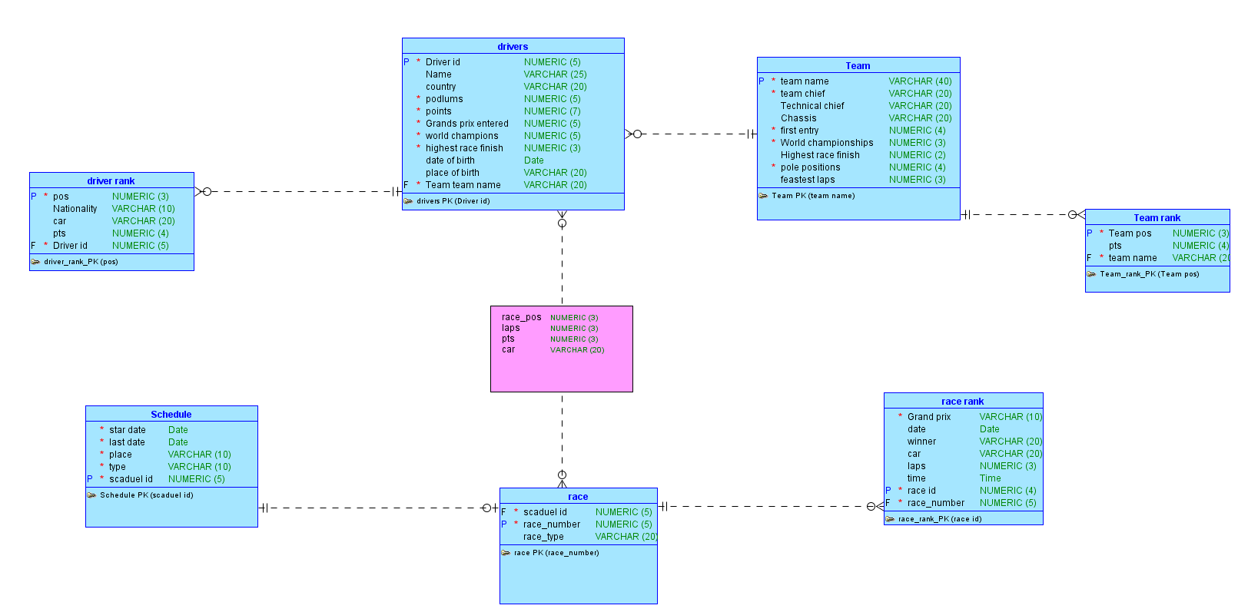

2. Final Version of the Relational Data Model of the Project

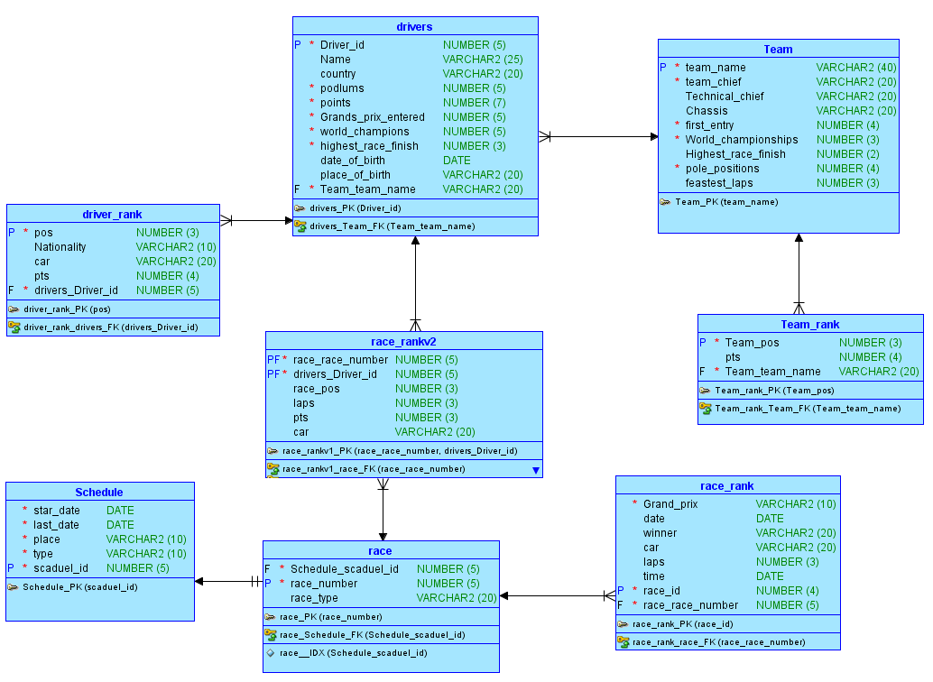

3. Implementation Checklist

|  |  |
| --- | --- |
| **Description** | **Remarks** |

|  |  |
| --- | --- |
| Authentication Type | Custom |
|  |  |
| Username and Password to Login |  |
| admin | Admin123 |
| User1 | User123 |
| User2 | User123 |
|  |  |
| Uploaded and Displayed Images in | yes |
| Reports |  |
| Implemented Page-wise Authorization | yes |
|  |  |
| Number of Reports with Forms | 8 |
| Number of Master-detail Forms | 2 |
| Number of Reports based on Queries, | 2 |
| Aggregate Queries |  |
| Number of Parameterized Reports | 2 |
| Number of Graphs/Charts | 3 |
|  |  |
| Write the most unique feature/functionality | The Queries Report And The Parameterized Reports |
| in your application or the page of your | The Query an Parameterized Report are shown as I |
| application which you are proud of. | hoped. |
| Explain briefly. |  |

4. Reports with Forms

|  |  |  |
| --- | --- | --- |
| Report Page Number and | Form Page Number and | Table |
| Name | Name |  |

|  |  |  |
| --- | --- | --- |
| 2 - Team | 3 – Team form | team |
| 4 - Drivers | 5 – Drivers form | Drivers |
| 6 – Race Schedule 1 | 7 – Race Schedule form | Schedule |
| 8 - Race | 9 – Race form | race |
| 10 – Drivers In Race | 11 – Drivers In Race form | Race_rankv2 |
|  |  |  |
| 18-Standing Race Results by Race | 19-Standing Race Results by Race Form | Race_rank |
| 20-Standing Race Results by Team | Standing Race Results by Team Form | Team_rank |
| 24-Standing Race Results by Drivers | 25-Standing Race Results by Drivers Form | Driver_rank |

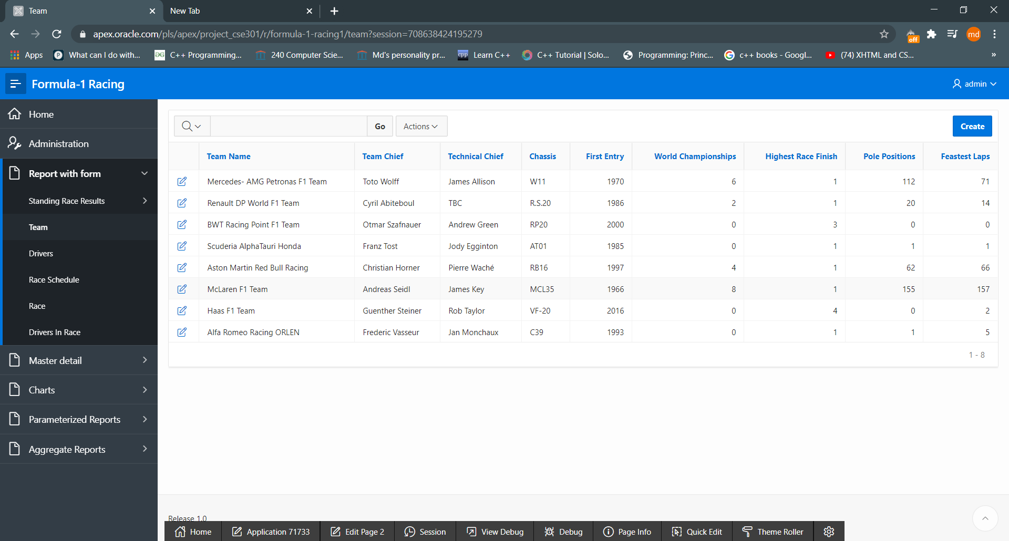

Fig: 4.1

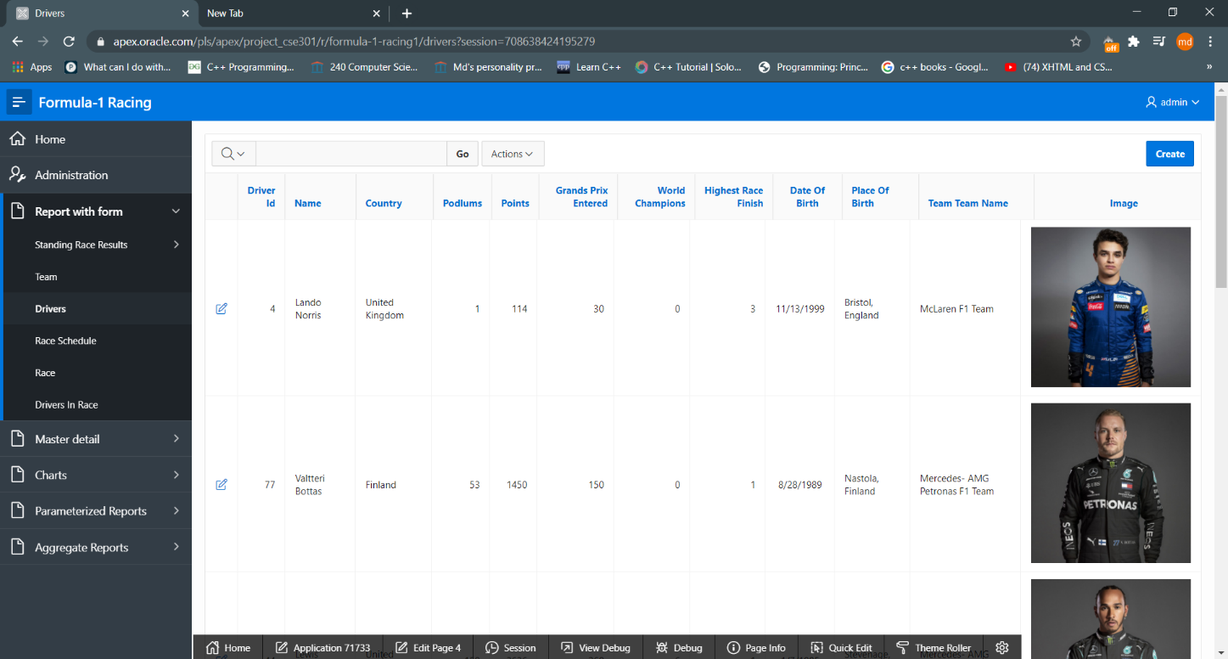

Fig: 4.2

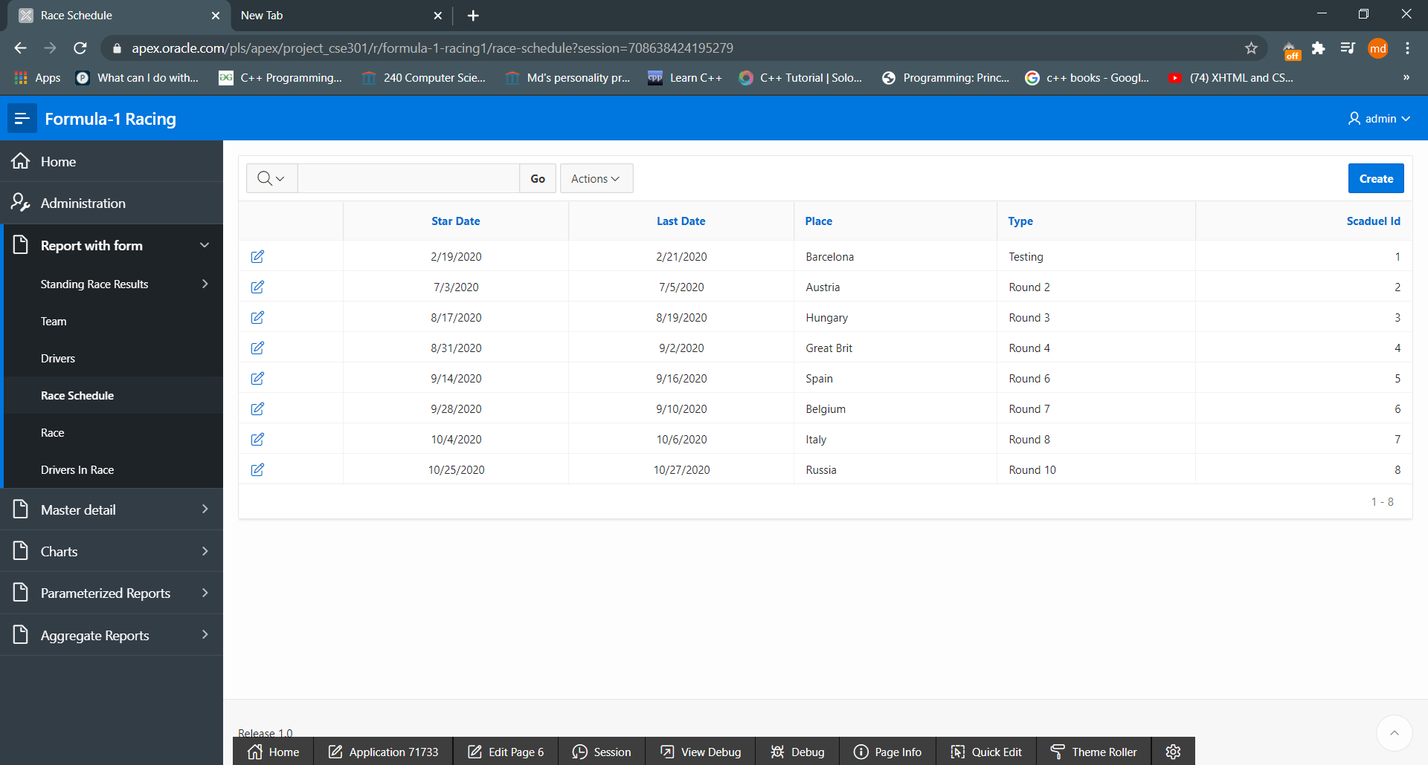

Fig: 4.3

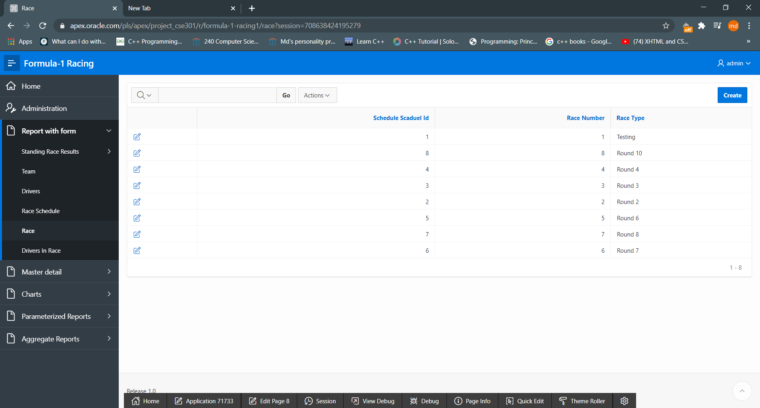

Fig: 4.4

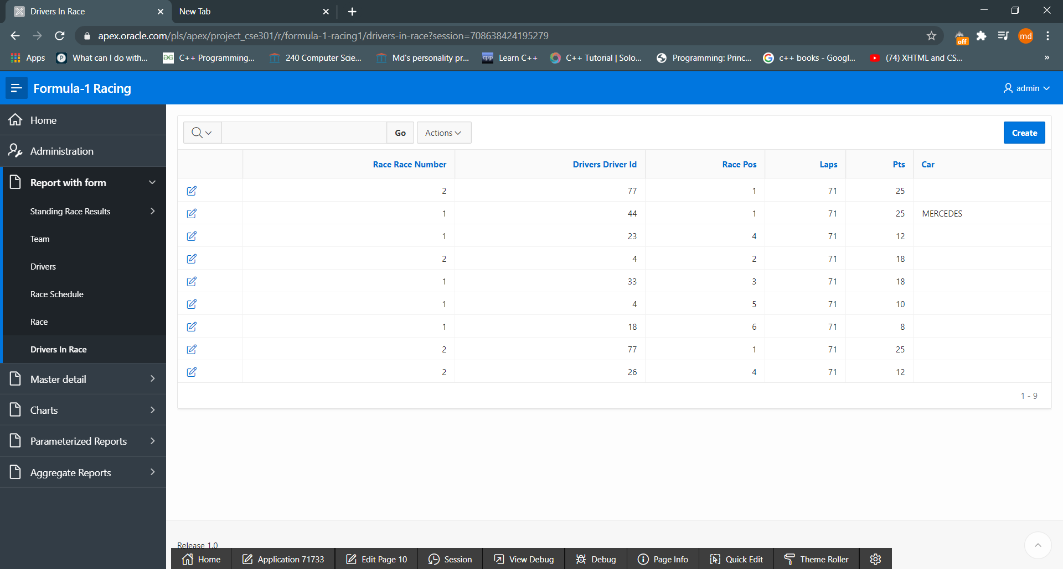

Fig: 4.5

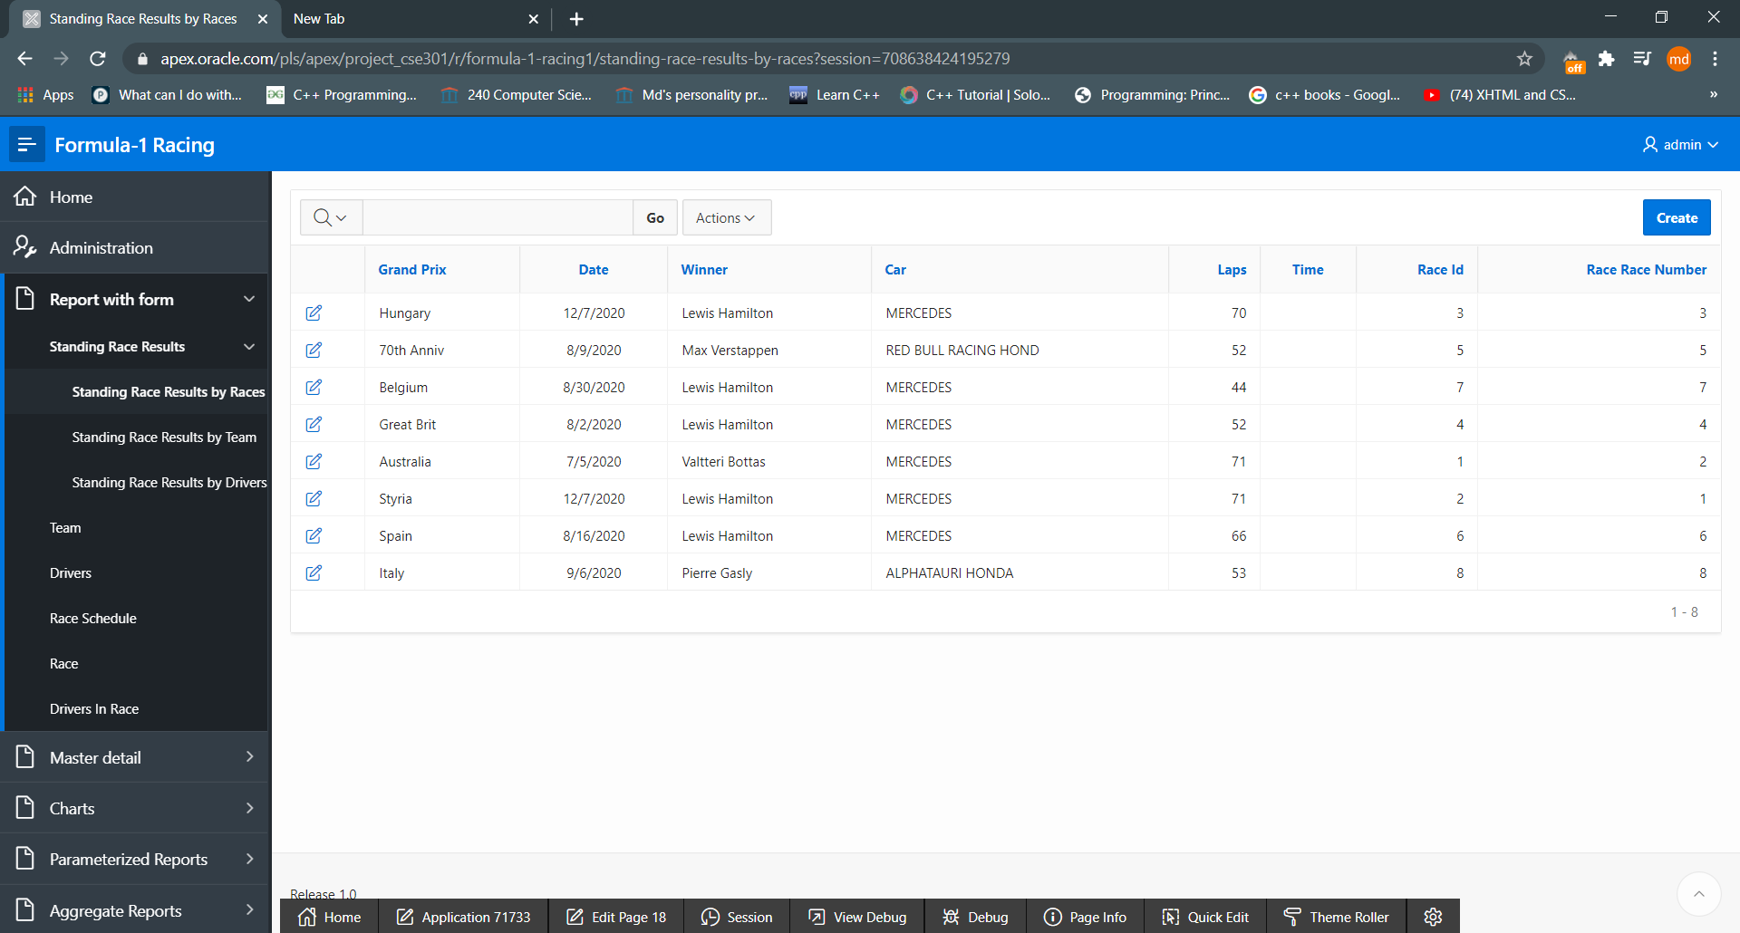

Fig: 4.6

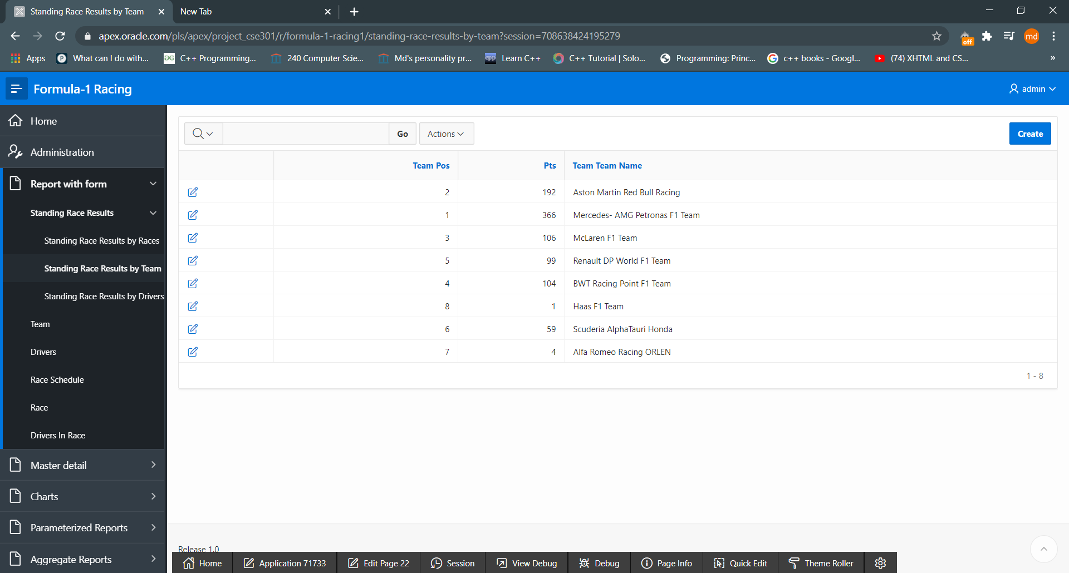

Fig: 4.7

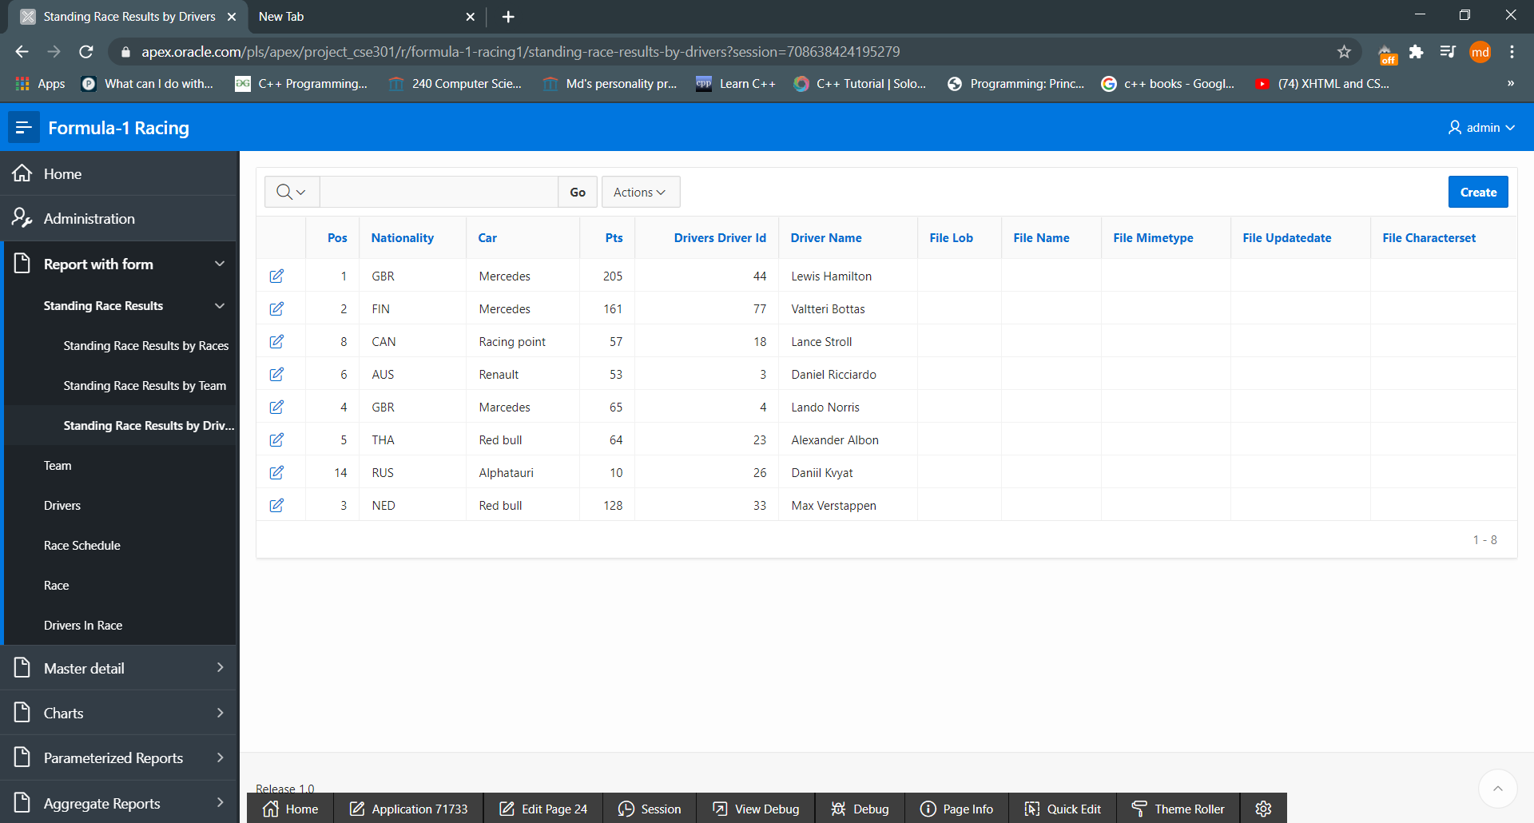

Fig: 4.8

5. Master-Detail Form

|  |  |  |
| --- | --- | --- |
| Page Number and Name | Master Table (Parent) | Detail Table (Child) |
| 26-Team wise Driver | team | drivers |
| 27-Drivers in races | drivers | Race_rankv2 |
|  |  |  |

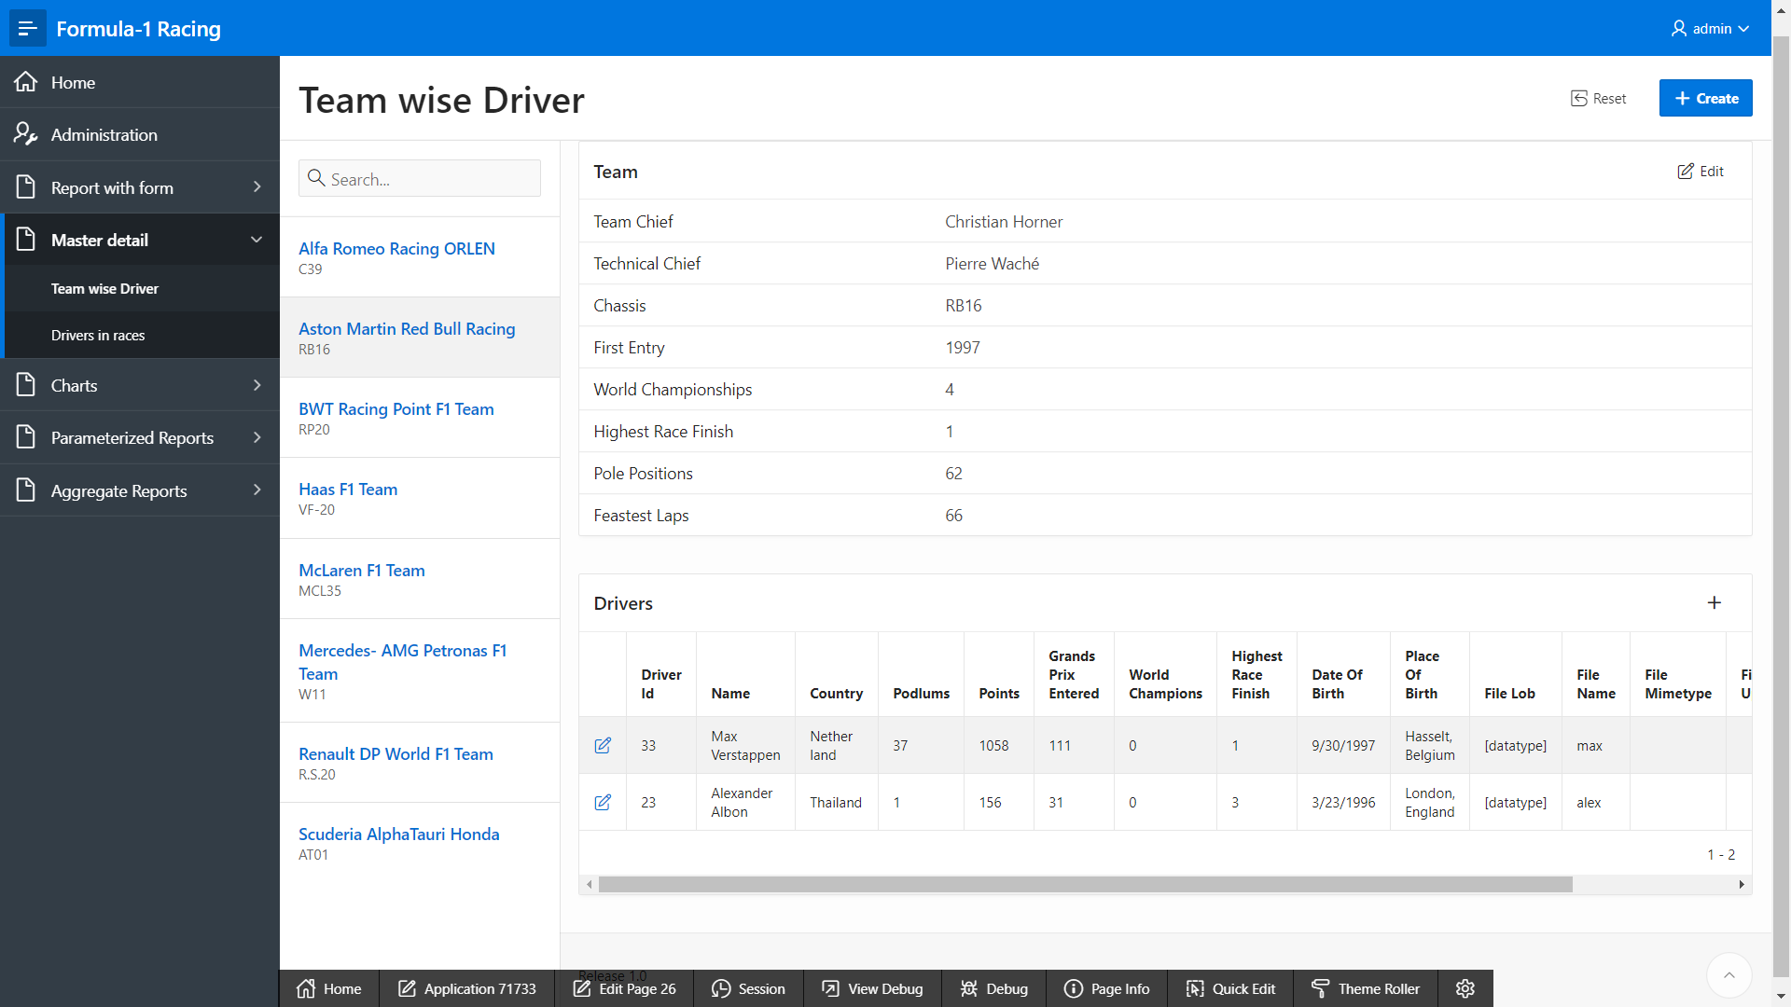

Fig: 5.1

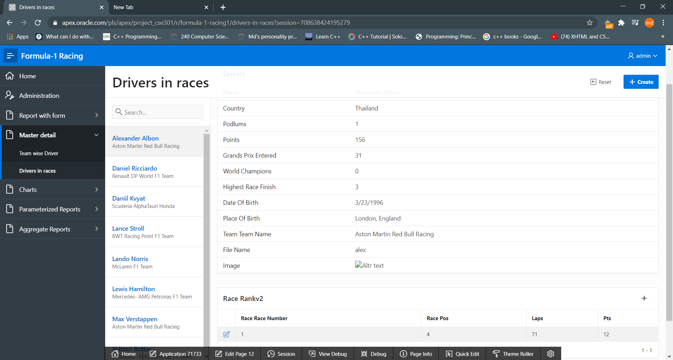

Fig: 5.2

6. Reports based on Multi-Table and Aggregate Queries

|  |  |  |
| --- | --- | --- |
| Page Number and Name | Query Type | Report description |
| 30-Drivers in race with name | Multi-Table | Shows the needed values of drivers and race |
| 30-Number of driver per race | Aggregate-Query | Number of drivers in races |
|  |  |  |

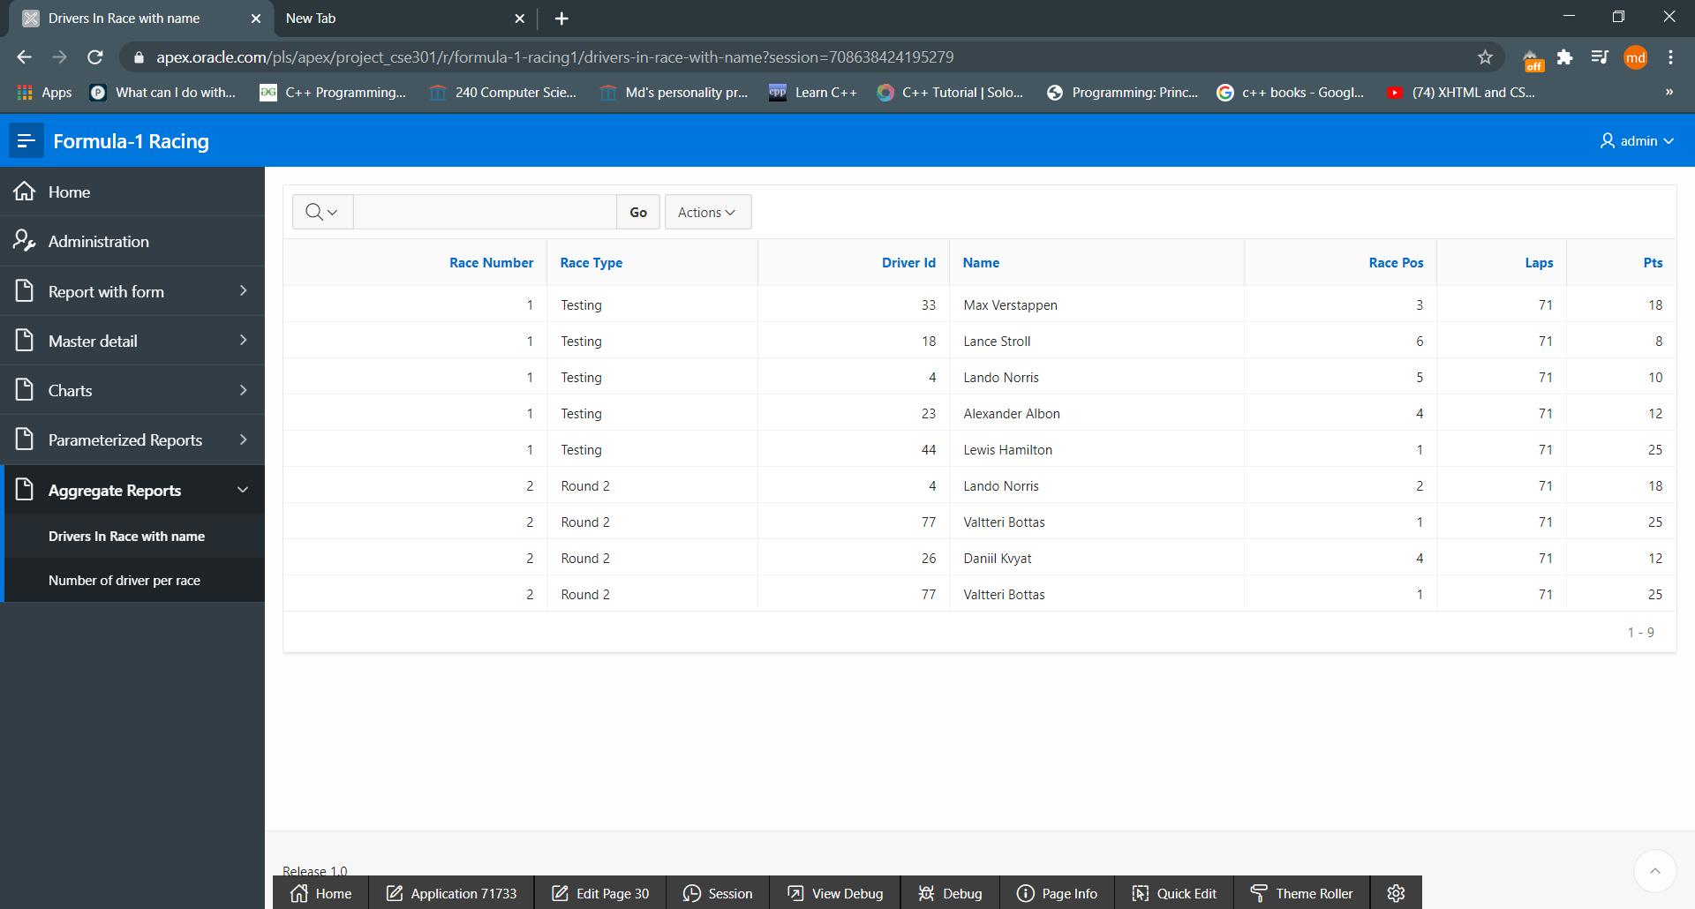

Fig: 6.1

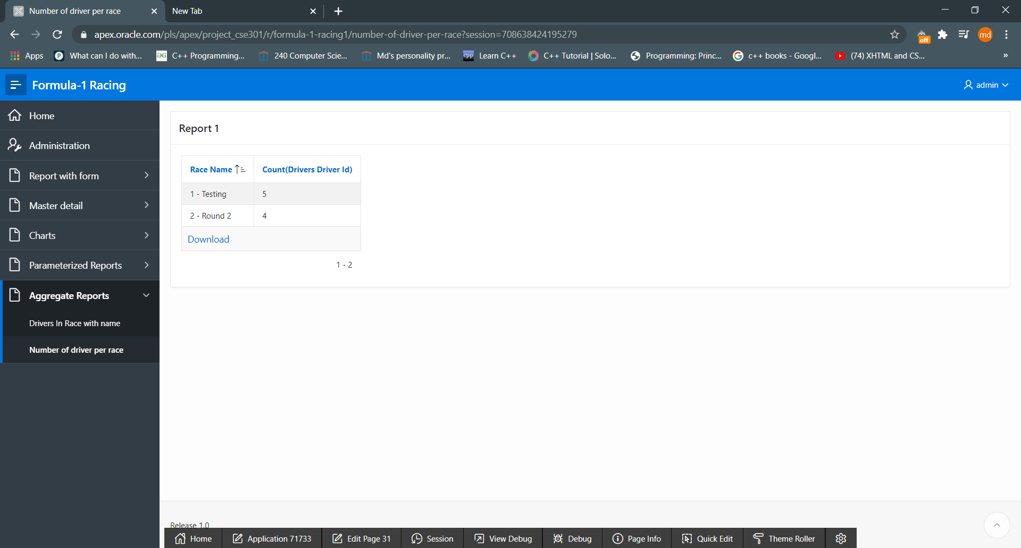

Fig:6.2

7. Parameterized Reports

|  |  |  |
| --- | --- | --- |
| Page Number and Name | Given Input | Report description |
| 17-Team to Driver | Team name | Driver details |
| 32-per race detail | Race information | Drivers details and winners of this race |
|  |  |  |

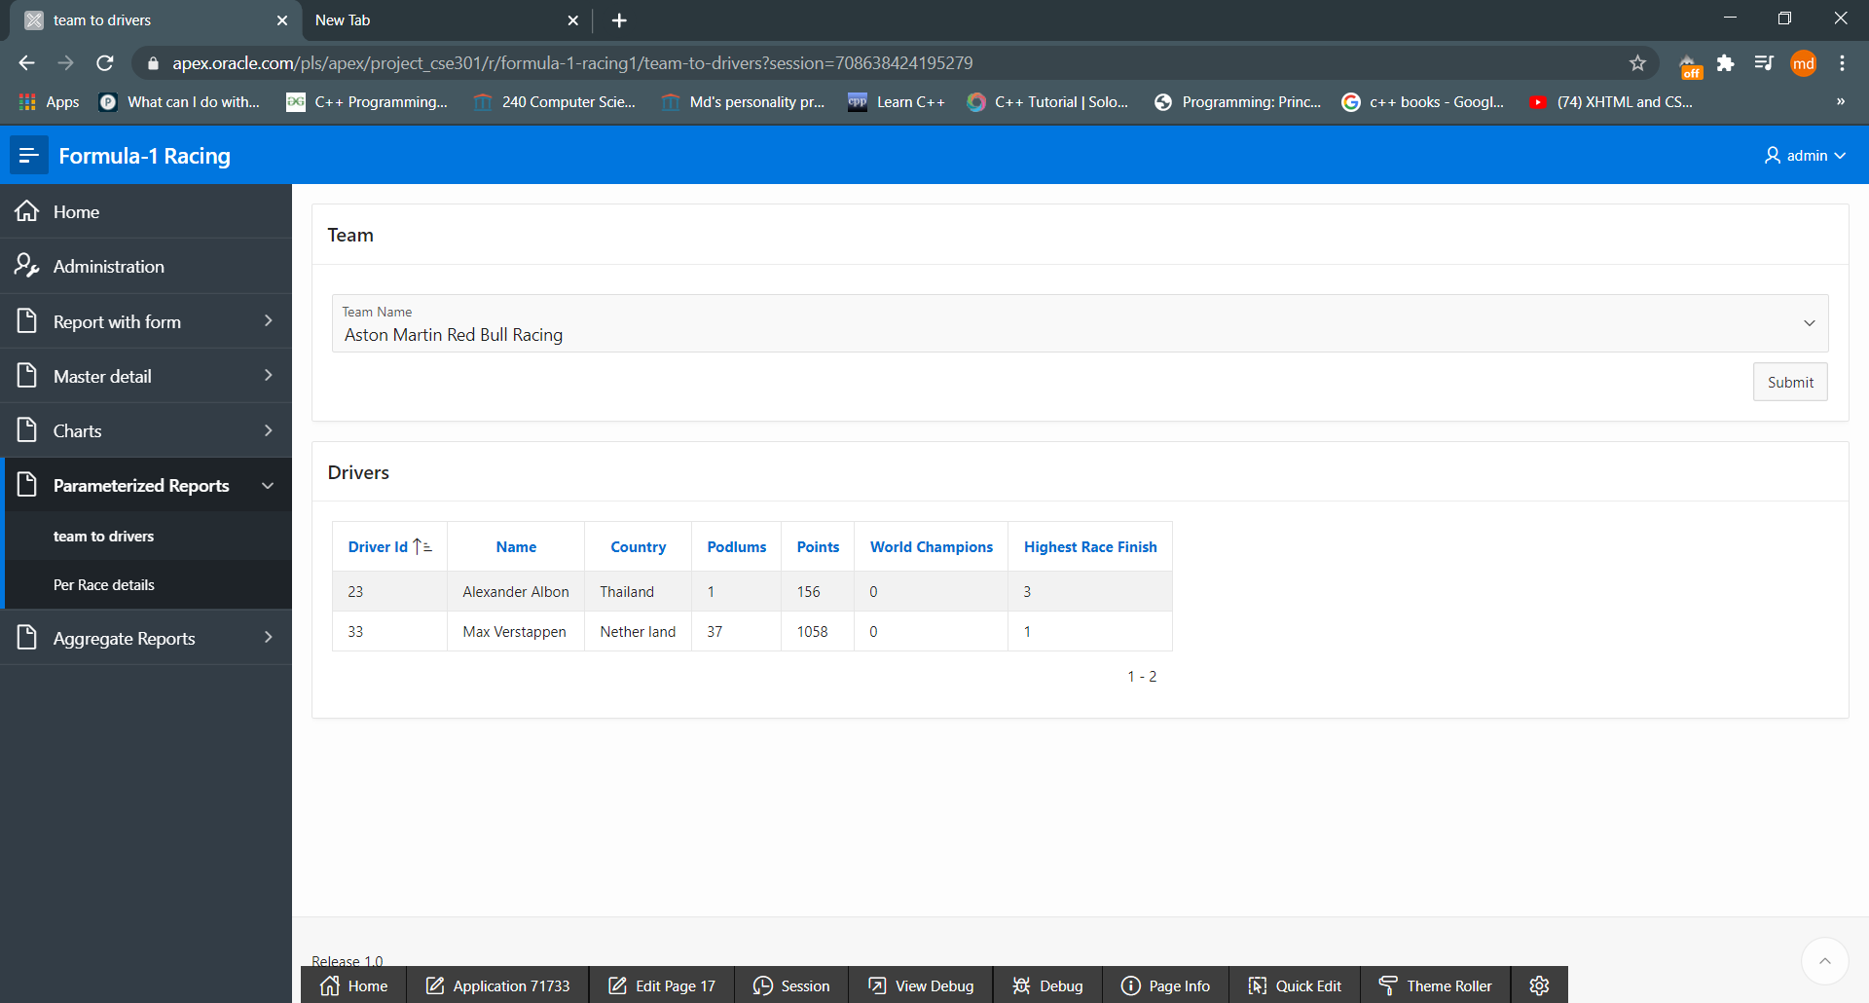

Fig:7.1

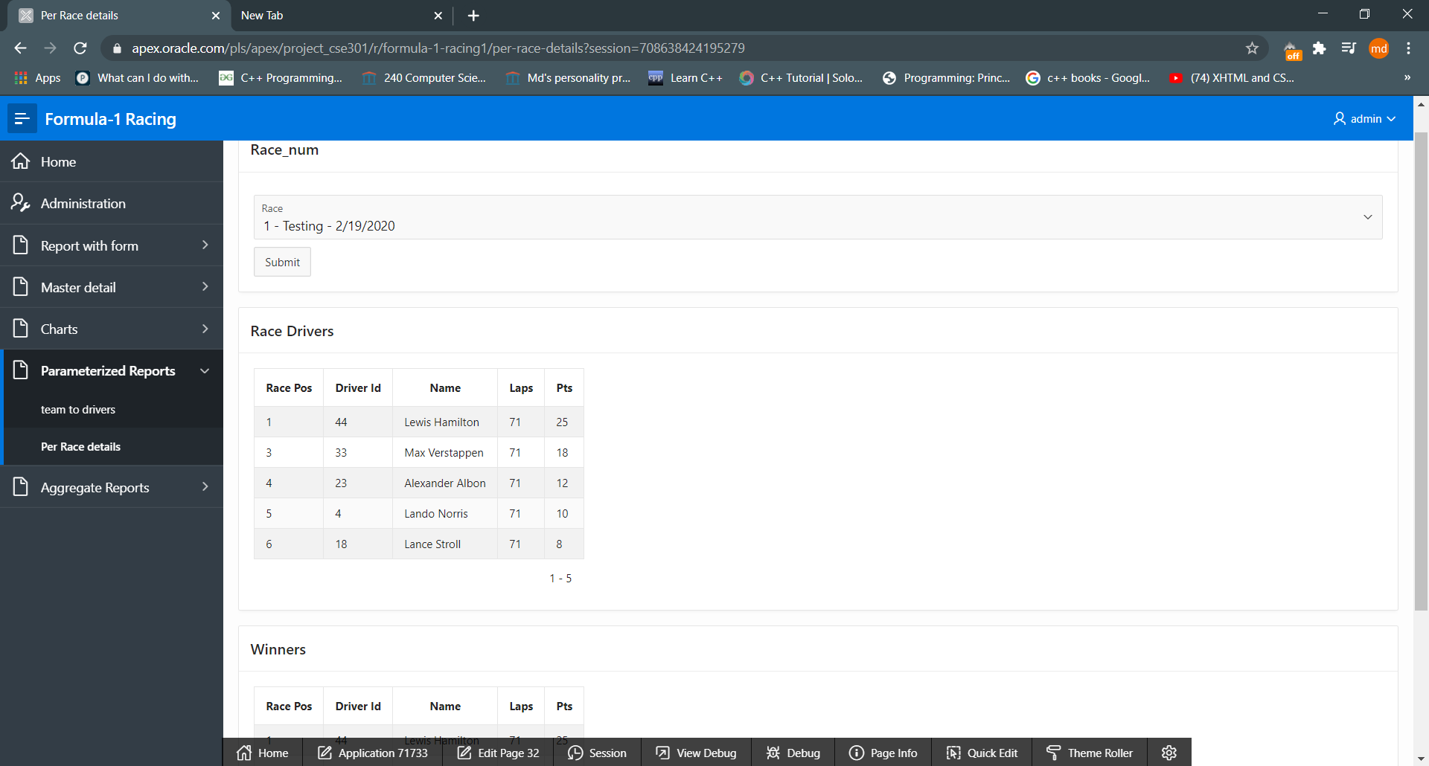

Fig:7.2

8. Charts

|  |  |
| --- | --- |
| Page Number and Name | Chart description |
| 29-Drivers Championship Chart | The chart shows how many time drivers won world championship |
| 19-Drivers PTS Chart | Drivers total points in descending order |
| 15-Team PTS Chart | Teams totoal points in descending order |
|  |  |

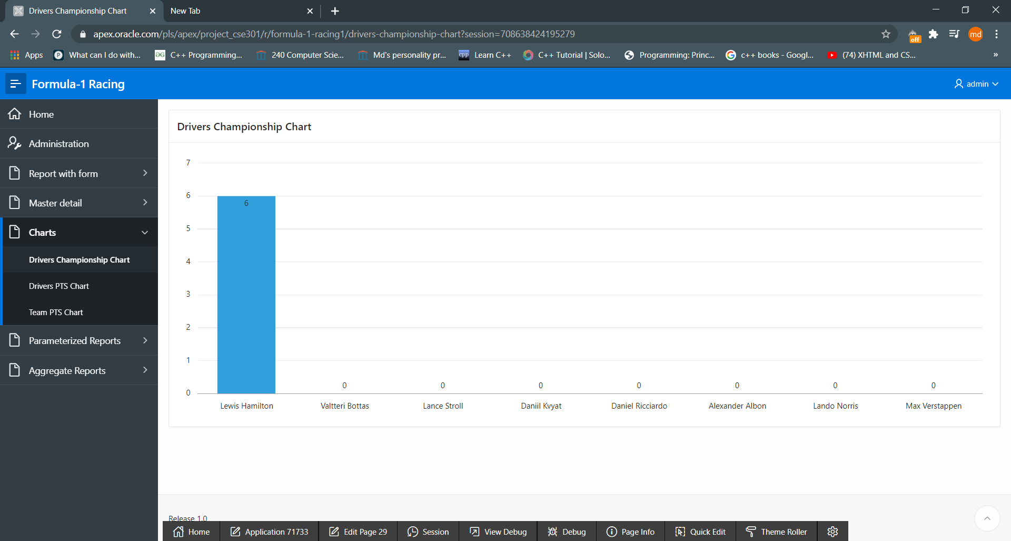

Fig: 8.1

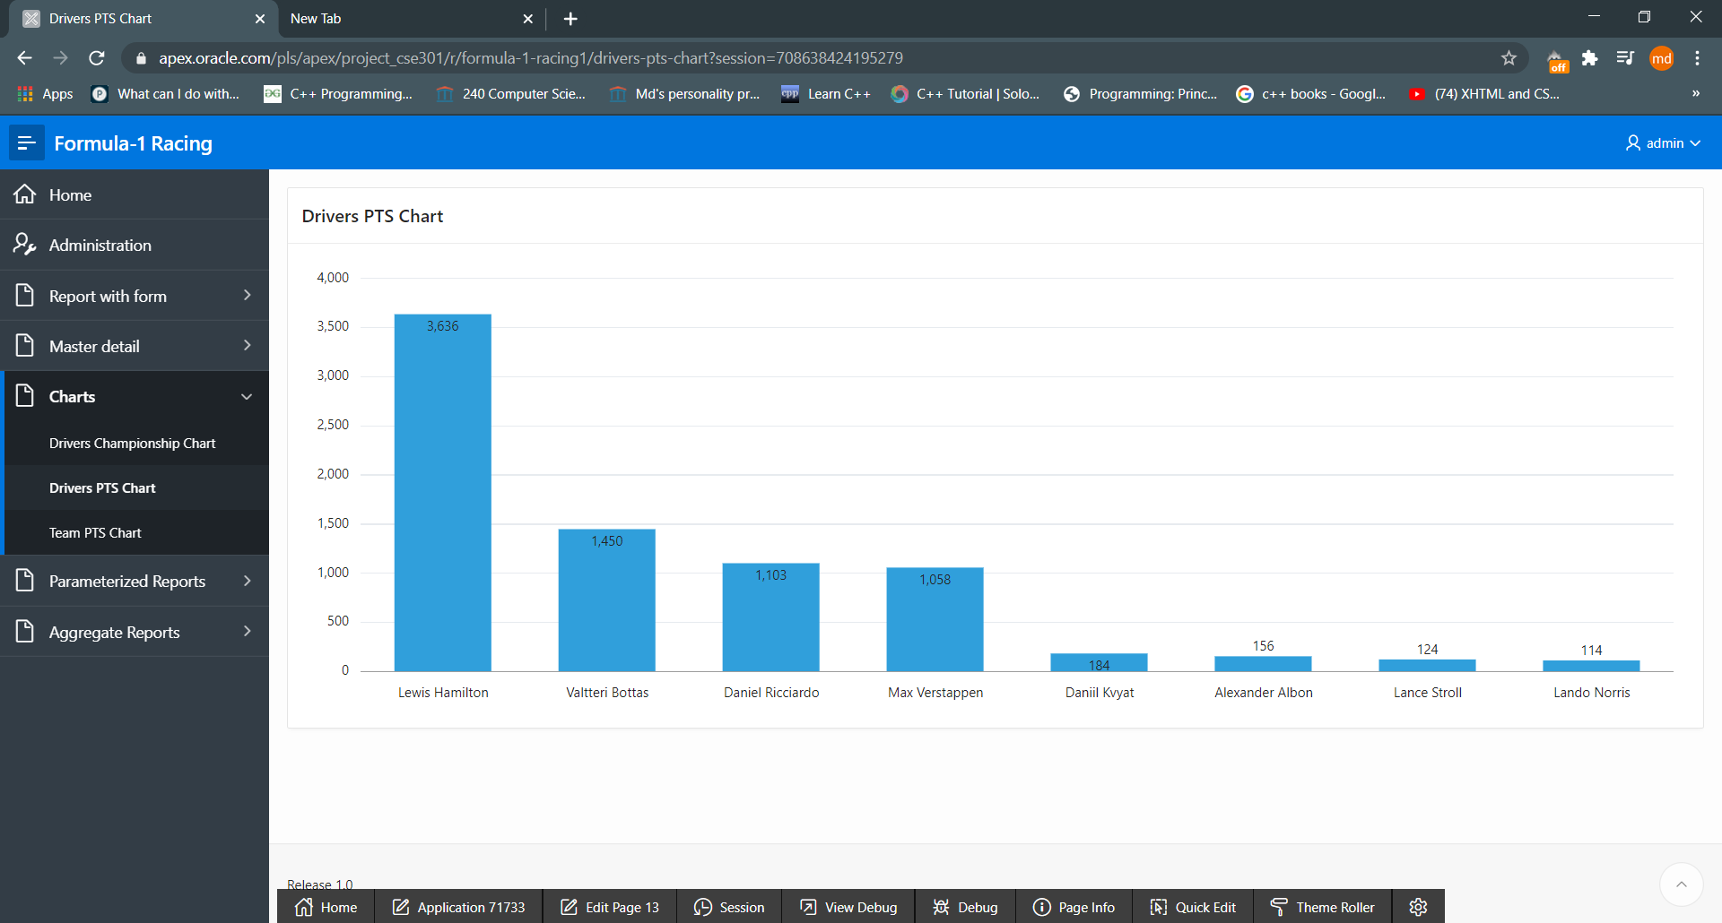

Fig: 8.2

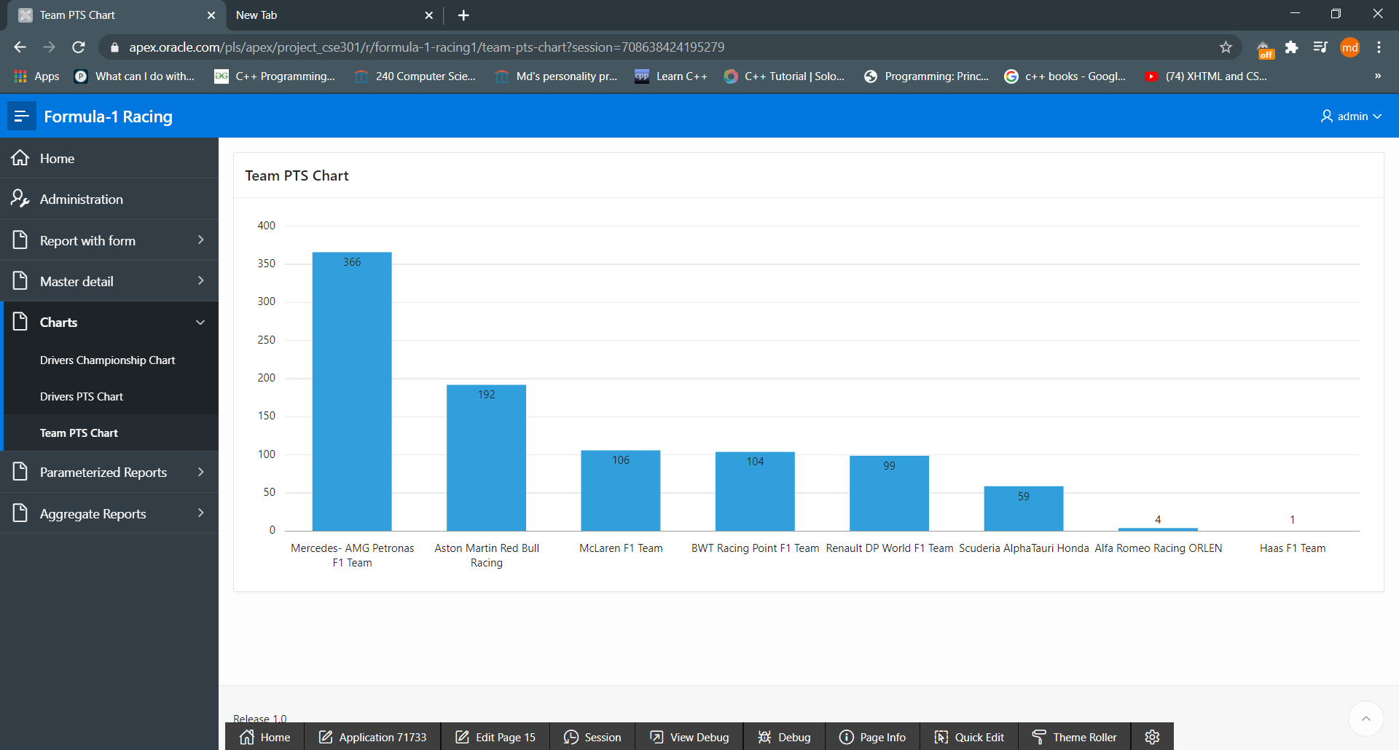

Fig:8.3

9. Authorization and User Role Assignment

**User Role Assignment**

|  |  |  |
| --- | --- | --- |
| User name | Password | Role |
| admin | admin123 | Administrator |
| User1 | User123 | Contributor |
| User2 | User123 | Reader |
|  |  |  |

**Page-wise Authorization Information**

|  |  |
| --- | --- |
| Page number and name | Authorization Level |
| P1. Home | Reader |
| P10000: Administration | Administrator |
| 2 - Team | Reader |
| 4 - Drivers | Reader |
| 6 – Race Schedule 1 | Reader |
| 8 - Race | Reader |
| 10 – Drivers In Race | Administrator |
| 18-Standing Race Results by Race | Reader |
| 20-Standing Race Results by Team | Reader |
| 24-Standing Race Results by Drivers | Reader |
|  |  |
| 3 – Team form | Contributor |
| 5 – Drivers form | Contributor |
| 7 – Race Schedule form | Contributor |
| 9 – Race form | Contributor |
| 11 – Drivers In Race form | Contributor |
| 19-Standing Race Results by Race Form | Contributor |
| Standing Race Results by Team Form | Contributor |
| 25-Standing Race Results by Drivers Form | Contributor |
|  |  |
| 26-Team wise Driver | Reader |
| 27-Drivers in races | Reader |
| 30-Drivers in race with name | Reader |
| 30-Number of driver per race | Reader |
| 17-Team to Driver | Reader |
| 32-per race detail | Reader |
|  |  |
| 29-Drivers Championship Chart | Reader |
| 19-Drivers PTS Chart | Reader |
| 15-Team PTS Chart | Reader |
|  |  |

10. Concluding Remarks

Making this project was fun. There were so many ups and down but we did what we could. Deciding the ER model was hard. But every time a new page was created it bring a joy. We will try to learn more from apex oracle. Thanks to our professor for teaching us and let we know about all of these.