Method Syntax
You have seen and used built-in methods like the length method (myString.length()). This unit deals with user-defined methods. Methods are composed of two parts, the header and the body.
SHAPE \* MERGEFORMAT
The method header contains several keywords to determine the method type. Next is the name of the method. Names of "[m]ethods should be verbs, in mixed case with the first letter lowercase, with the first letter of each internal word capitalized" (https://www.oracle.com/java/technologies/javase/codeconventions-namingconventions.html). Some examples include: greetTwice, addThree, findArea, etc. Parentheses are required but the parameter(s) within them are not. Any command(s) associated with the method should be indented and enclosed within curly braces {}. This command(s) comprises the body of the method.

Method Header
SHAPE \* MERGEFORMAT
The method header usually starts with a few keywords:
- public - Determines from where the method can be accessed. Other options include private and protected. For this module, we will be working with mostly public methods.
- static - Determines what can access the method. static methods can be accessed without needing a particular instance or object. If you want the method to be exclusive to an object, do not include static. For this module, we will be working with mostly static methods.
- void - Determines whether there is a return value or not for the method. If the method has no return value, use void. If the method returns an integer, use int, etc.
- greetTwice - This is an example of a method name. See above for naming conventions.
- () - Parentheses are required for all methods. Any parameters that the method takes in will go into the parentheses but they are optional.

Method Body
SHAPE \* MERGEFORMAT 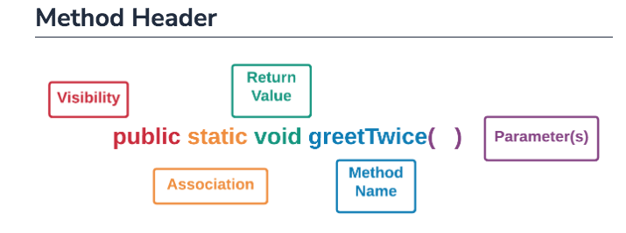
The method body is the list of actions the method performs. All of the code for the method body should be enclosed within curly braces {} and indented to show association. This convention is similar to how conditionals and loops are written.

Method Terminologies
Fill in the blanks below with the correct method terminologies.
- public
- Determines the visibility of the method.
- static
- Determines the association of the method.
- void
- Determines the return value of the method.
- parameters
- Are optional and go within the parentheses following the method name.

Order of Method and Main
On the other hand, the order of the classes themselves, main() versus greetTwice(), does not matter. What happens if you swap the position of main() with greetTwice() and vice versa?

Javadoc
Type into the blanks below the correct Java documentation code. Remember to include @ or you will not receive any credit for your work!
- Specifies any parameters that are used within the method:
No parameters@param
- Specifies any values that are returned from the method:
No returned@return
- Specifies the names of those who wrote or developed the method:
developer@author
- Specifies what version the method is currently on:
11.0@version

Global Scope - Referencing Variables
When a variable is declared inside a method, it has local scope. When a variable is declared in the main program within class, it has global scope. Global variables are declared outside of methods, but can be referenced inside a method. Look at the image below. The yellow block holds everything within the program including the variable greeting. This enables all methods within the program to access that variable since it is considered to be global. Copy and paste the code below and then click TRY IT.

Global vs. Local Scope
If a variable is declared and initialized both locally and globally, that variable will retain its content depending on how it is used. In the example below, myVar is declared and initialized globally as global scope and locally as local scope. Since the variable has differing scopes, it retains its value when called or printed.

The “final” Keyword
If you want a global variable to remain unchanged throughout the program, you can declare the variable as final. final variables are also referred to as constants. Constants never change and are denoted in all uppercase and underscores (_).

What is Recursion?
Solving a coding problem with functions involves breaking down the problem into smaller problems. When these smaller problems are variations of the larger problem (also know as self-similar), then recursion can be used. For example, the mathematical function factorial is self-similar. Five factorial (5!) is calculated as 5 * 4 * 3 * 2 * 1. Mouse over the image below to see that 5! is really just 5 * 4!, and 4! is really just 4 * 3! and so on.

What is base case?

Calculating a Fibonacci number is self-similar, which means it can be define with recursion. Setting the base case is important to avoid infinite recursion. When the number n is 0 the Fibonacci number is 0, and when n is 1 the Fibonacci number is 1. So if n is less than or equal to 1, then return n. That is the base case.

What is Polymorphism?
Polymorphism is a concept in object-oriented programming in which a single interface takes different forms (polymorphism means “many forms”). Often this means similar operations are grouped together with the same name. However, these operations with the same name will produce different results. You have already encountered a few examples of polymorphism. Enter the following code into the IDE.

Method Overriding
Method overriding is another example of polymorphism that you have already seen. Overriding a method means that you have two methods with the same name, but they perform different tasks. Again you see a single interface (the method name) being used with different forms (the superclass and the subclass). Create the following classes.

