
AMERICAN INTERNATIONAL UNIVERSITY-BANGLADESH
Faculty of Science and Technology
Department of Computer Science
CSC 3215: Web Technologies

Semester: Summer 2025-26 | Group No: 01 |  | Section: | L

Group Members:
SL. | Student ID | Name | Role | Signature
1 | 24-56292-1 | Ferdous Jaman | Group Leader
2 | 22-47510-2 | Md Reezwanul Haque Eashan | Member
3 | 23-53625-3 | Rabeya Bashri Sadia | Member
4 | 23-52535-2 | Akibul Hoque | Member
Project Title
Dental Clinic Management System
Short Description
Dental Clinic Management System is a centralized, role-based web application that is designed to replace a decade-old manual, paper-dependent clinic workflow. By leveraging modern web technologies, the platform digitizes traditional administrative tasks into an efficient, real-time clinical management ecosystem. This project unifies four key user roles, including admin, doctor, patient, and receptionist, into a digital workflow. Patients book appointments, select payment methods, track live waiting serials, and access digital prescriptions. Doctors can monitor real-time queues, access patient histories, and provide electronic prescriptions. Receptionists handle appointment desk bookings, generate service-taken bills, and allocate clinical equipment. Admin manages doctor schedules, equipment inventory, and monthly analytical reports.
Introduction
In the modern healthcare sector, efficient management and seamless communication are critical to providing quality patient care and optimizing daily clinical operations. For over a decade, dental care has relied on traditional manual paper logs and analog desk coordination to handle patient registrations, treatment records, doctors' schedules, and billing. This approach always carries a chance of mistakes happening. To overcome these challenges, the dental clinic management system is proposed as a centralized, role-based web application. Built using modern web technologies, the system transitions the clinic from an outdated, staff-heavy analog framework to an automated, data-driven system. This platform bridges the gap between all key stakeholders by providing dedicated interfaces for four primary user groups: Admin, Doctor, Patient, and Receptionist. There are several objectives of this system:
Empowering Patients: Patients gain access to an interactive portal where they can self-schedule appointments, monitor their real-time waiting queue serials, select preferred post-treatment payment methods, and securely view digital prescriptions.
Enhancing Clinical Precision: Doctors can instantly access organized patient medical histories, manage both scheduled appointments and active consultation queues, and generate standardized electronic prescriptions with zero risk of illegibility.
Optimizing Front Desk Operations: Receptionists can quickly schedule and verify appointments, generate itemized electronic bills, and allocate specialized dental equipment to operative without manual logging,

Centralized Governance: Administrators maintain complete visibility over clinical performance through monthly analytical reports, dynamic doctor schedule management, and centralized equipment monitoring.
Background Study
1. Introduction
In contemporary dental practice, administrative systems in healthcare centers have conventionally utilized front-desk personnel to execute managerial tasks through manual processes. Hard-copy appointment books, patient dossiers, handwritten prescriptions, and paper invoicing have been the order of the day. Although such methods have been effective in the past, especially when there were fewer patients to cater for, the rising demand for dental services calls for more efficient computerized systems.
Modern healthcare practice demands the use of computerized Practice Management Software and role-specific web applications to enhance operability. Shifting from hard copy managerial systems to computerized web applications will resolve many of the shortcomings associated with manual patient management.
2. Description of present operation of Safe Plus Dental Clinic
For more than ten years, the dental clinic has been using staff-driven manual processes to manage its operations. Some of the steps that have been implemented in the clinic include:

- Manual scheduling and queue management – In this dental clinic, patients schedule their appointments through direct interaction with the front-desk staff. After scheduling, patients arrive at the clinic on the day of their appointment and are issued with serial tokens. Furthermore, since the process of issuing tokens is done manually, patients are unable to monitor how fast or slow the line is moving, hence causing too many patients to crowd the waiting room.

- Paper-based medical records – Patients’ dental files and medical history are stored in hard copy form, hence causing delays, especially when retrieving patients’ case files from the store.

- Handwritten Prescriptions – In this clinic, dental prescriptions are handwritten, which creates the risk of misinterpretation and lack of a digital trail of the patient’s dental history.

- Manual allocation of clinic equipment – Dentists’ specialized equipment is allocated manually, resulting in scheduling conflicts among patients and poor monitoring of the use of materials by the clinic management.

- Manual invoicing and settling accounts – At the reception desk, bills are generated manually, hence creating delays at this station. Patients also fail to monitor their spending due to the lack of a detailed invoice and choose how they will pay their fees upon arrival at the reception desk.

3. Identified Deficiencies in Existing Workflows
Operational Area | Existing Way | Change on Client & Patients
Patient Queuing | Static handwritten serials; no real-time status updates. | Patient frustration due to unpredictable waiting times.
Appointment Booking | Restricted to front-desk phone calls and walk-in visits. | High administrative workload and potential double-booking.
Clinical Records & Prescriptions | Physical paper folders and handwritten slips. | Risk of loss, damage, illegibility, and lack of historical searchability.
Clinic Equipment | Unmonitored, ad-hoc physical allocation of tools. | Scheduling conflicts and lack of managerial inventory oversight.
Financial & Administrative Oversight | Manual billing calculations and manual monthly tallying. | Inefficient revenue audits and delayed managerial reporting.

4. Why a central web-based system is a better solution

The weaknesses of the current system at the dental clinic can only be resolved by installing a web-based system that will serve as a Practice Management System. Web-based systems have several strengths over the conventional manual processes used in many healthcare institutions.

A web-based patient management system offers easier access to the system as it operates through web browsers. Unlike the conventional processes that require complex software to operate, web-based systems can be operated with just a web browser. A web-based patient management system can also be accessed through multiple web browsers.

Furthermore, the Role-Based Access Control found in these systems allows different users to utilize the system according to their clearance. The system will have separate portals for Admin, Doctor, Patient, and Receptionist. Also, the live patient waiting list will enable patients to easily monitor the progress of their queue without crowding the waiting area. Lastly, a web-based system offers central management of all aspects involved in running a dental clinic, including monitoring of equipment and financial management.

It is necessary to computerize dental clinic operations by integrating a web-based system that will manage its operations more efficiently, protect the health records of the patients, and improve the quality of services it delivers.

ER Diagram

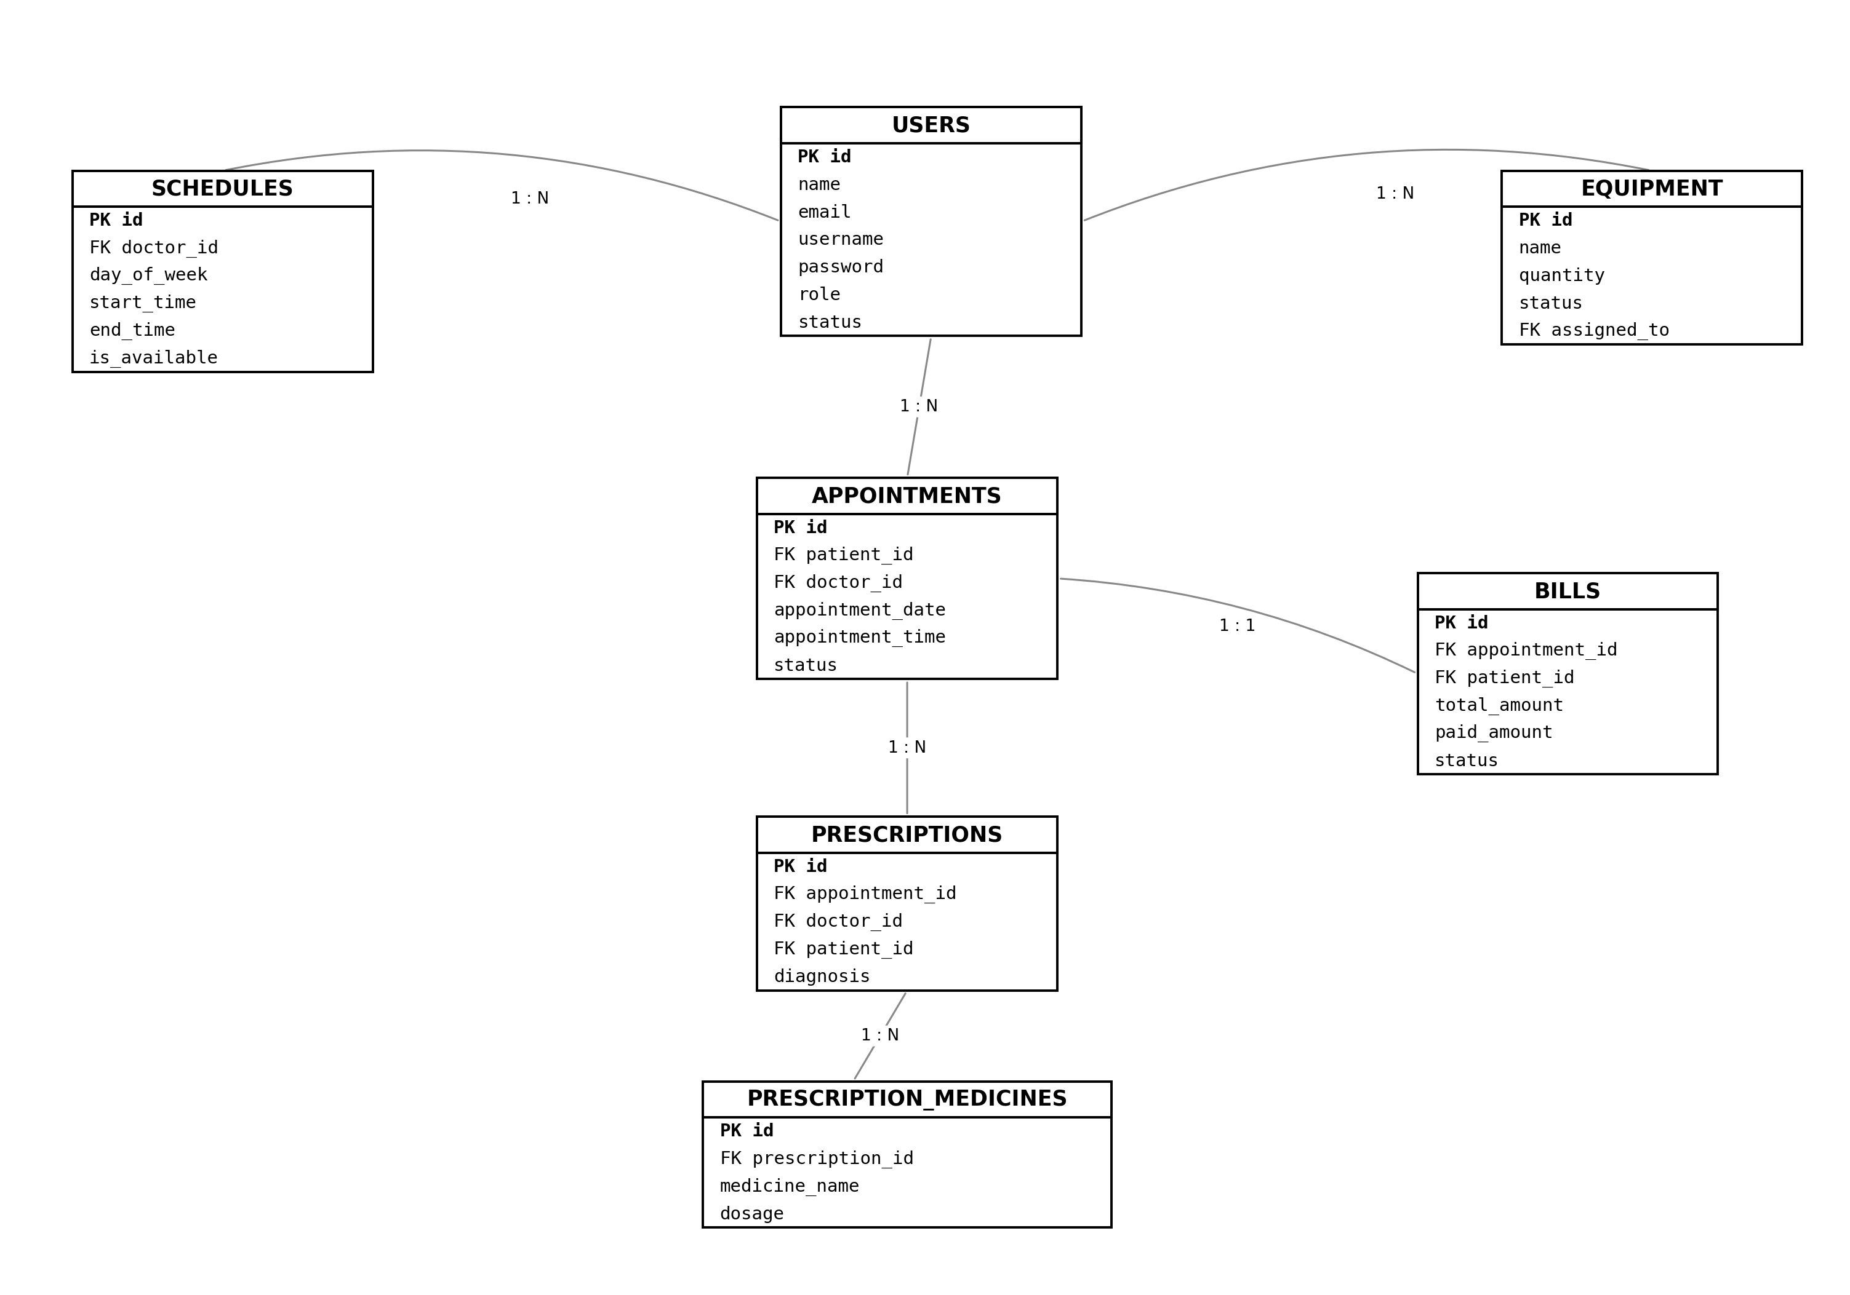

Fig:Dental Clinic Management System

Use Case Diagram
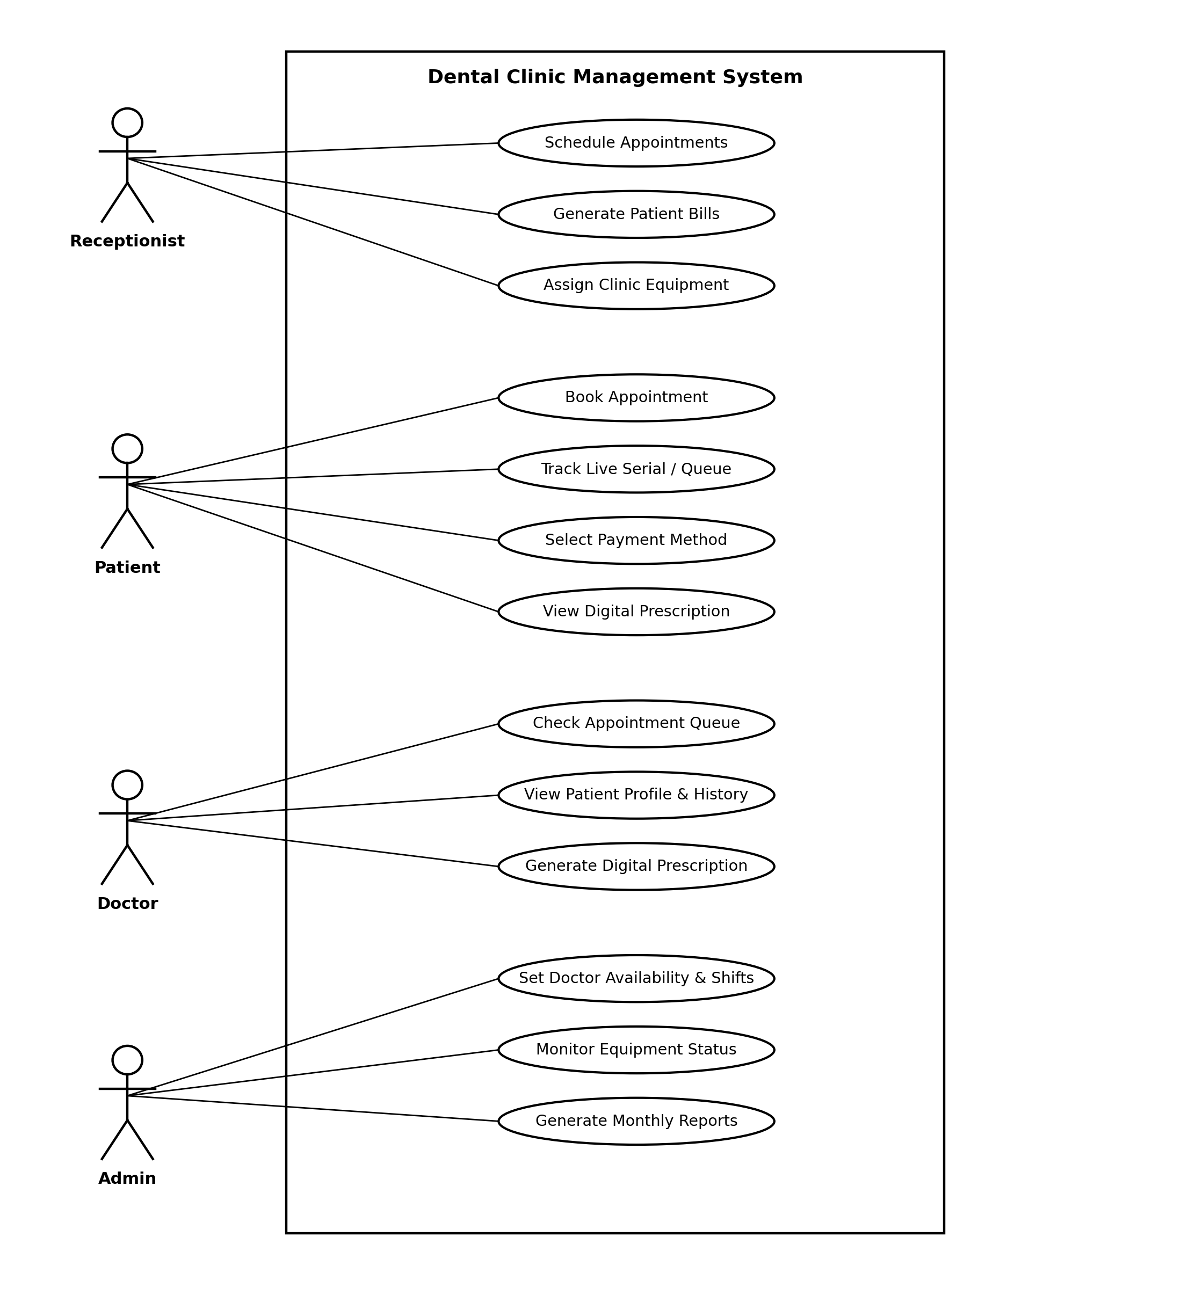

UI (Figma/Sketch)
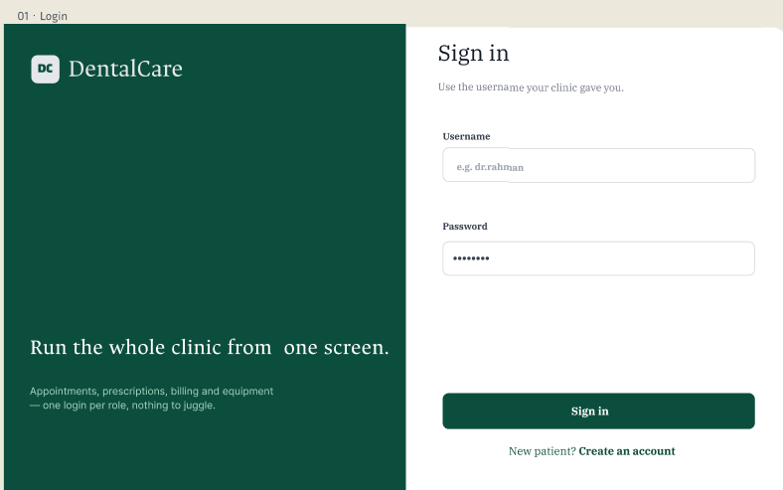

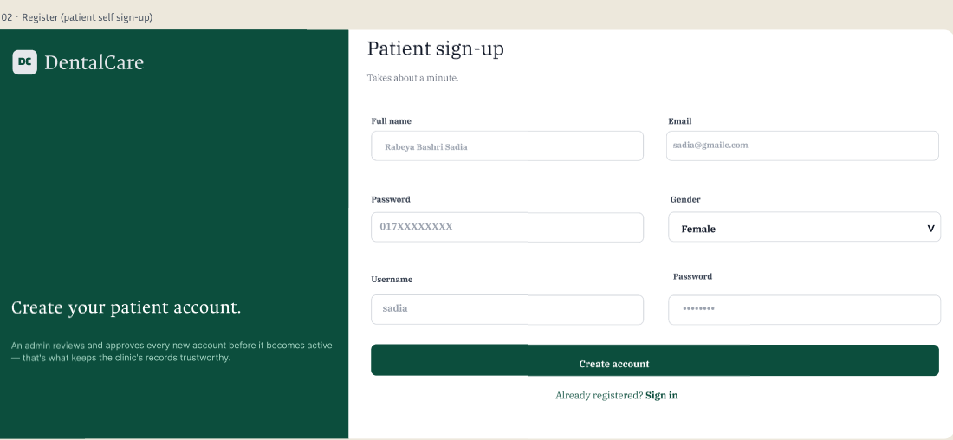

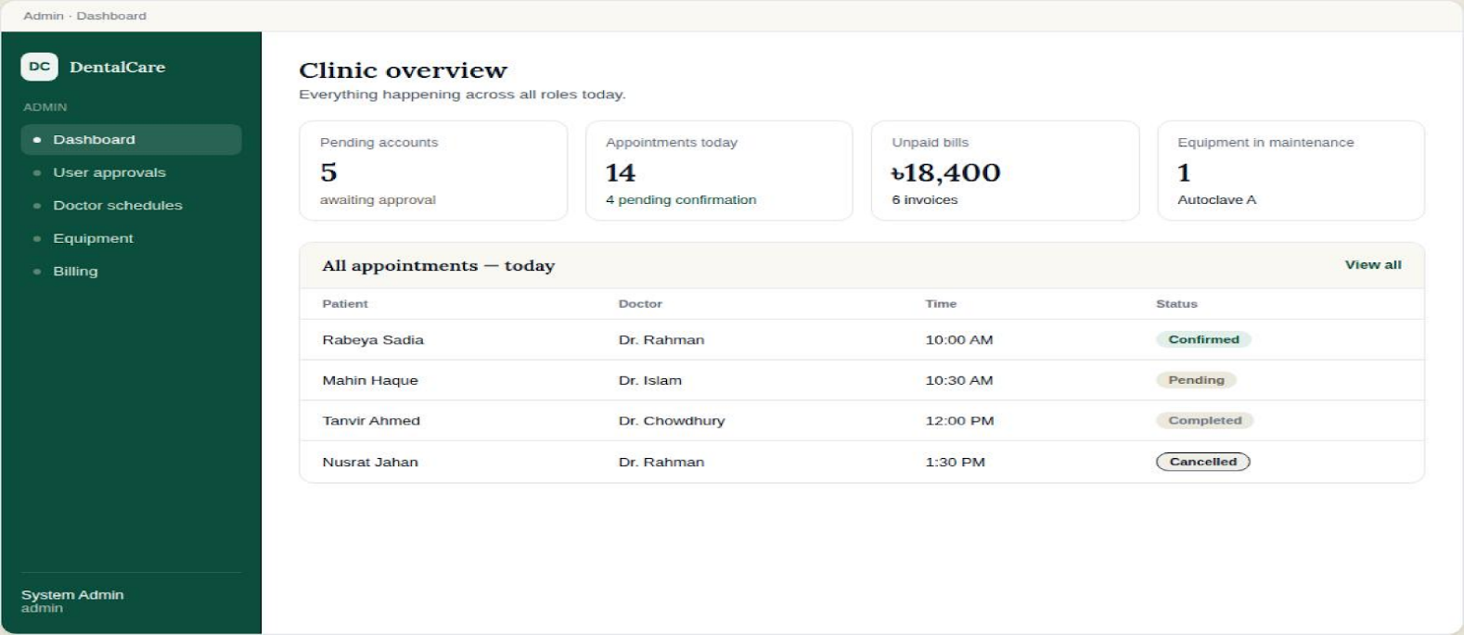
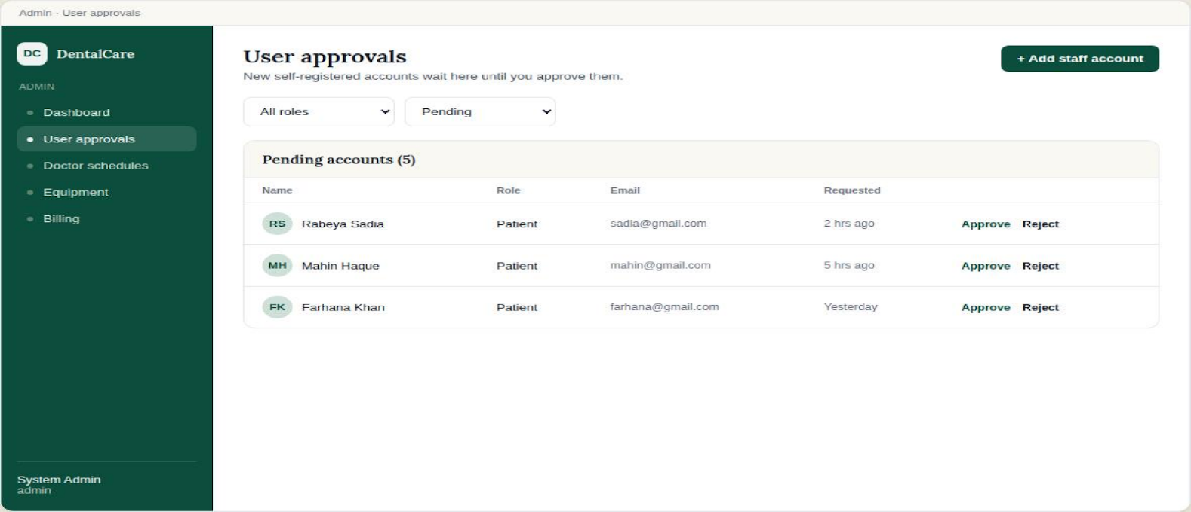
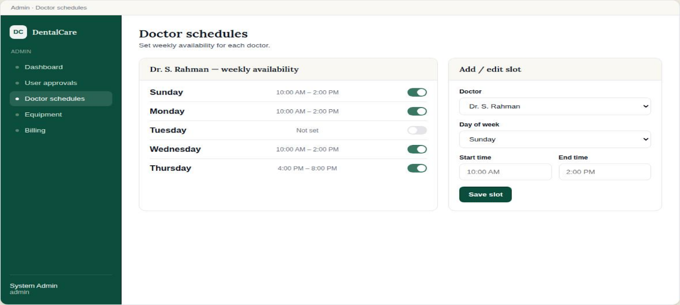
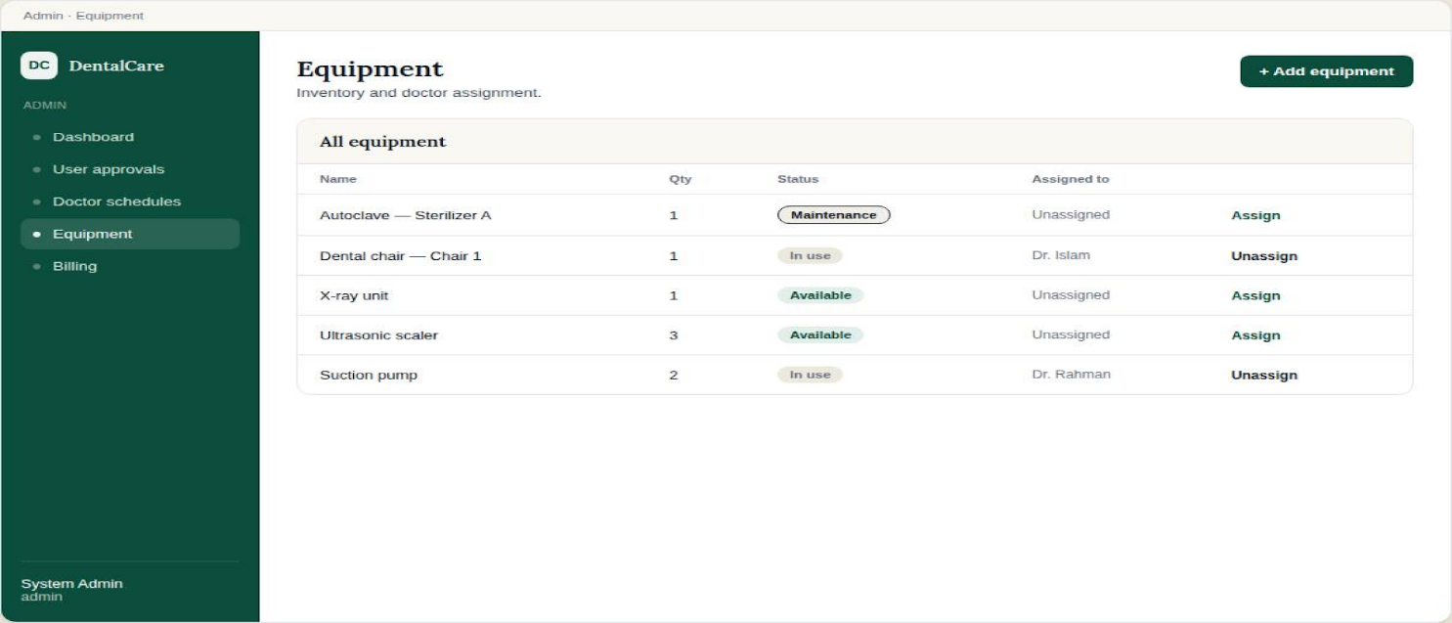
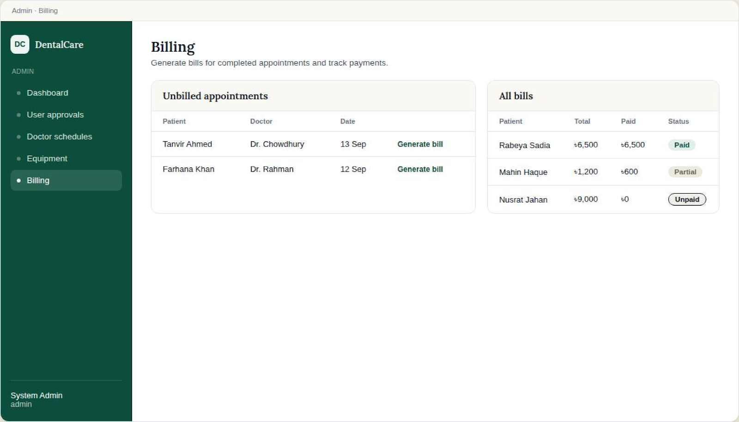
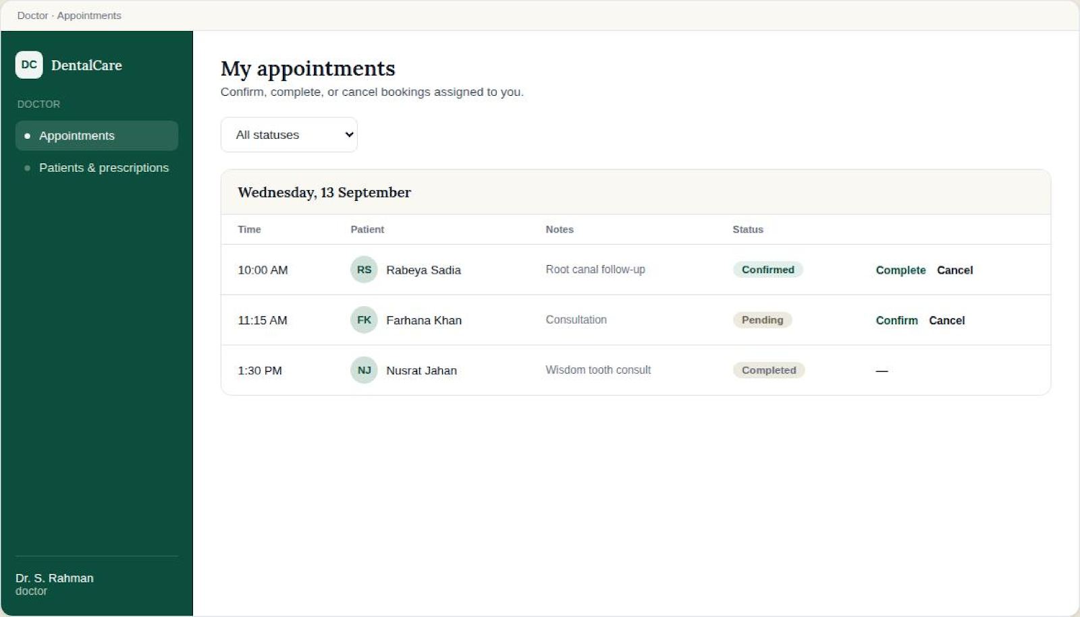
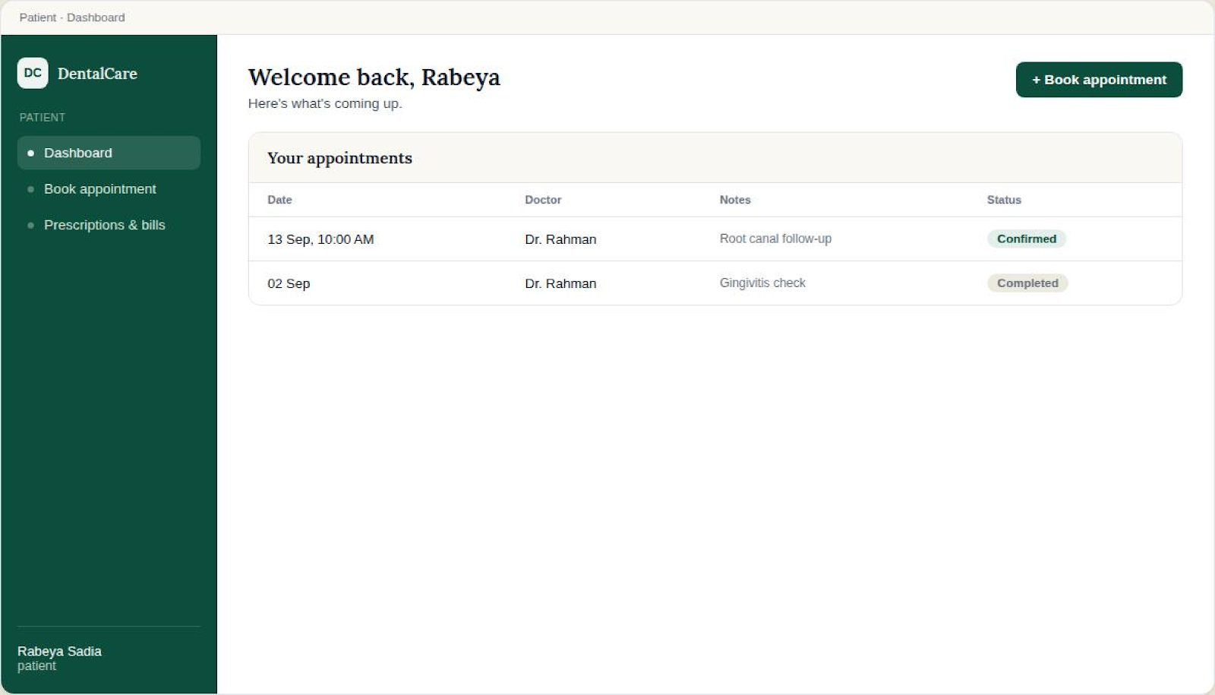
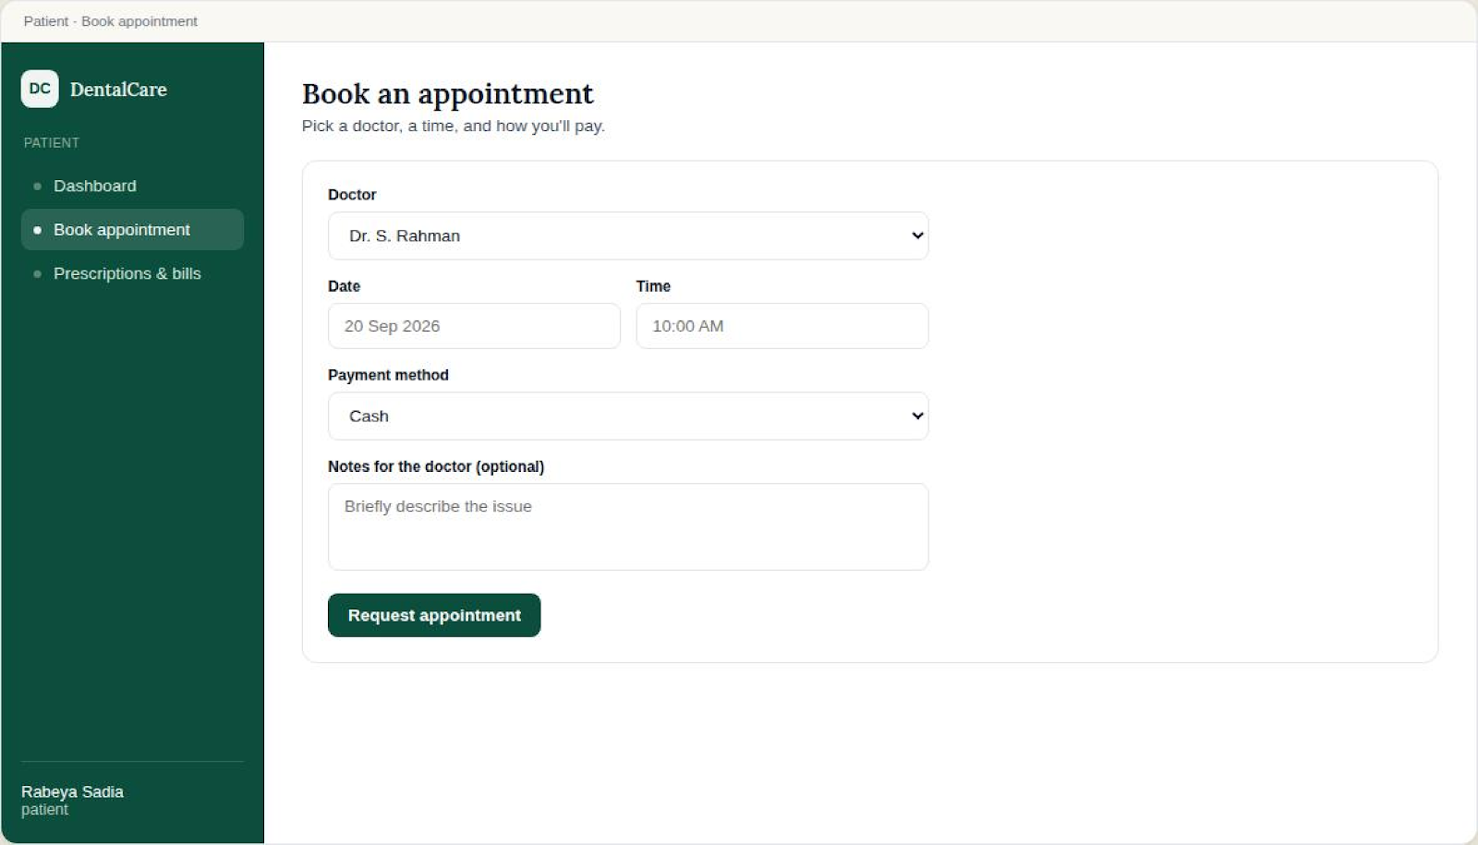
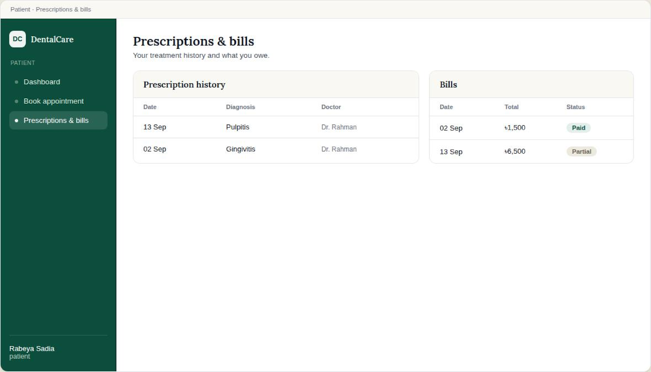
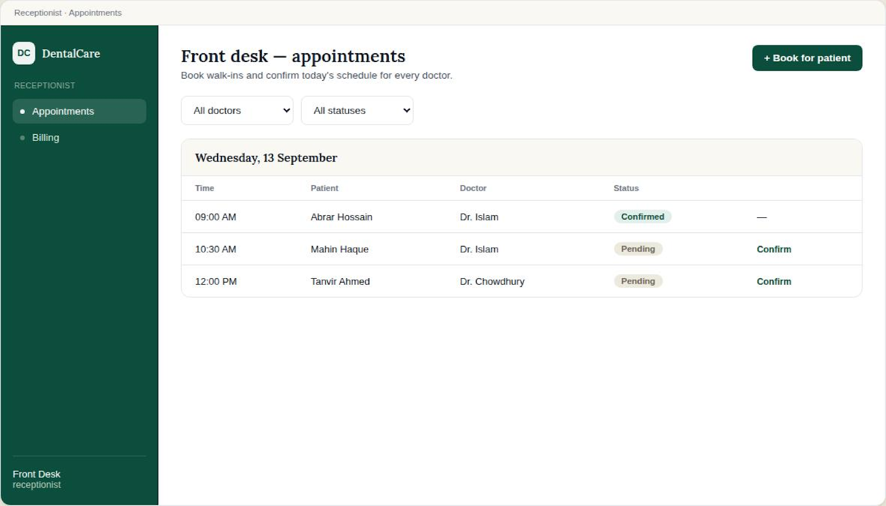
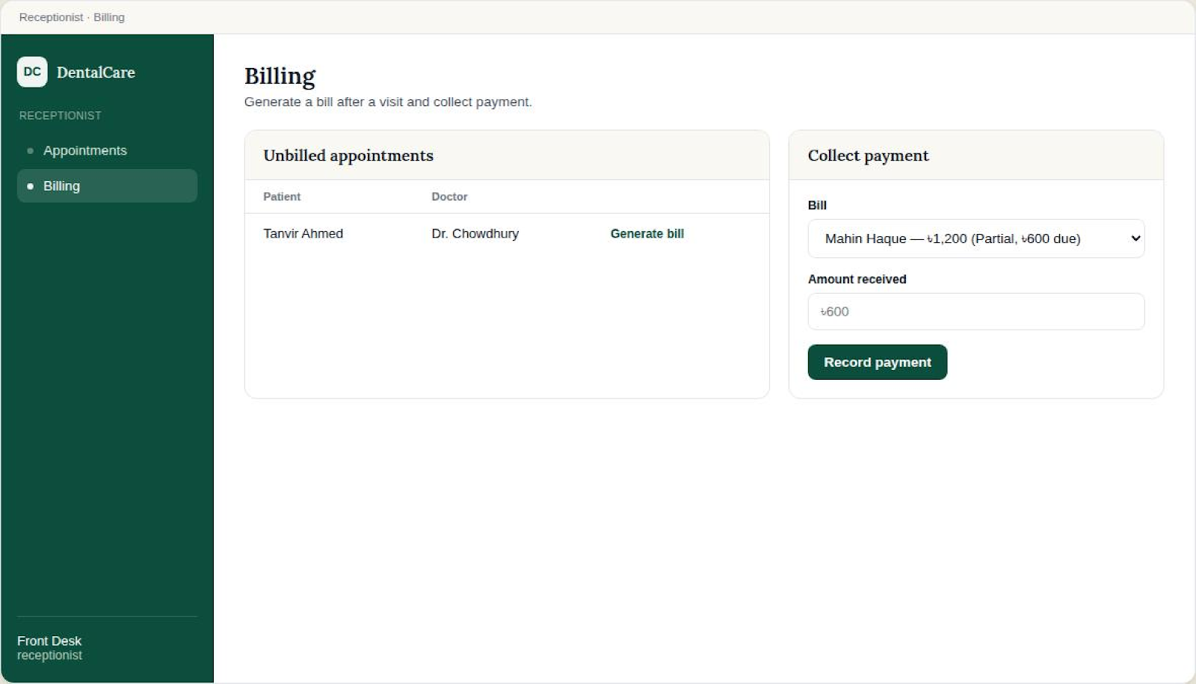
Types of Users: 1. Admin 2. Doctor 3. Patient 4. Receptionist
Common Features (Available to All Users)
- Authentication
- Login to the system
- Logout from the system
- User registration
- Account Management
- Change or reset password
- Manage profile information (view, edit, delete)
- Dashboard
- Access a personalized dashboard after login
Specific Features by User Type
- Features of Admin
- Set doctor availability & weekly schedules
- Monitor and manage equipment inventory status
- Generate monthly analytical reports
- Features of Doctor
- View real-time patient appointment queue
- Access organized patient histories and records
- Generate standardized electronic prescriptions
- Features of Patient
- Book appointments and view live waiting serial
- Track live queue status in real time
- Select preferred payment method
- View digital prescriptions online
- Features of Receptionist
- Manage appointment desk bookings
- Generate itemized bills and update payments
- Allocate and assign clinical equipment

N.B: Each user type must have at least 3 distinct features different from the others. Additional features may be added if desired. Proposals with generic, incomplete, or duplicated features across user types will receive reduced marks under the criteria below.

