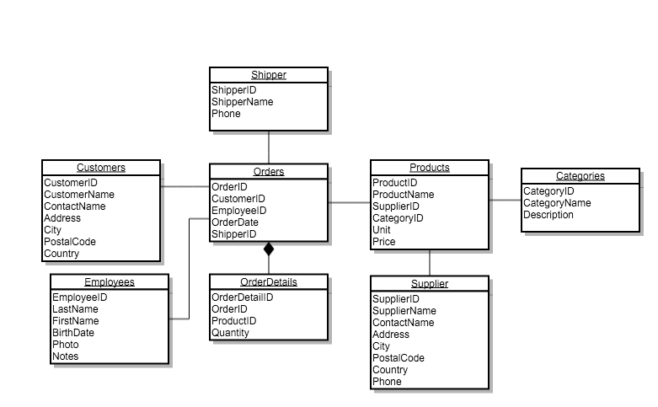

1. Select DISTINCT o.OrderID, c.CustomerName, e.FirstName, e.LastName,p.ProductName,od.Quantity,p.Price,(p.Price\*od.Quantity) as subtotal from Orders o

join Customers c on o.CustomerID=c.CustomerID

join Employees e on o.EmployeeID=e.EmployeeID

join OrderDetails od on o.OrderID=od.OrderID

join products p on od.Productid=p.ProductID

where e.FirstName='Steven' and e.LastName='Buchanan';

1. Select o.OrderID, c.CustomerName, o.OrderDate, sum((p.price\*od.quantity)) as GrandTotal from orders o

join customers c on o.CustomerID=c.CustomerID

join orderDetails od on o.OrderID=od.OrderID

1. join products p on od.ProductID=p.ProductID group by o.orderId;select p.productName, ca.CategoryName, su.SupplierID, su.SupplierName, su.ContactName, su.Address, su.City, su.PostalCode, su.Country, su.Phone from products p

join categories ca on p.CategoryID=ca.CategoryID

join Suppliers su on p.SupplierID=su.supplierID

ORDER BY CategoryName asc ;

1. select distinct sh.ShipperName, sh.phone, count(o.orderID) as NumberofOrder from shippers sh

join orders o on sh.ShipperID=o.shipperID group by sh.shippername

;

1. select ca.CategoryName, p.ProductName, count(p.unit)-od.quantity as UnitSold from categories ca

join Products p on ca.CategoryID=p.CategoryID

join orderDetails od on p.productID=od.ProductID

order by ca.CategoryName asc;