EXPT NO: 1 | BUILDING AND TRAINING A SIMPLE ARTIFICIAL NEURAL NETWORK (ANN) FOR REGRESSION AND CLASSIFICATION
DATE: 31/07/2026

PRE-LAB QUESTIONS (PROVIDE BRIEF ANSWERS TO THE FOLLOWING QUESTIONS)

- What is an Artificial Neural Network (ANN)?

Ans) An Artificial Neural Network (ANN) is a computational model inspired by the structure and functioning of the biological neurons in the human brain. It consists of interconnected nodes (neurons) arranged in layers, where each connection has an associated weight. The network learns patterns from data by adjusting these weights during training, enabling it to perform tasks such as regression and classification.
- What are the functions of the input, hidden, and output layers in an ANN?

Ans) The input layer receives the raw feature data and passes it into the network without any computation. The hidden layer(s) perform the actual learning by applying weights, biases, and activation functions to extract patterns and relationships from the data. The output layer produces the final result of the network, such as a predicted value for regression or a class probability for classification.
- Why is feature scaling important before training an ANN?

Ans) Feature scaling brings all input features to a comparable range, preventing features with larger magnitudes from dominating the learning process. This leads to faster and more stable convergence during gradient descent, avoids biased weight updates, and helps the network train more efficiently.
- Differentiate between regression and classification problems with examples.

Ans) Regression predicts a continuous numerical output, such as predicting the median house value from features like income and location. Classification predicts a discrete class label, such as classifying a tumor as malignant or benign. Regression models are evaluated using error-based metrics like MSE and MAE, while classification models are evaluated using metrics like accuracy and F1-score.
- What is the role of the activation function in a neural network?
Ans) The activation function introduces non-linearity into the network, enabling it to learn and represent complex, non-linear relationships in the data. Without an activation function, a neural network would behave like a simple linear model regardless of how many layers it has.

AIM
To understand the implementation of Artificial Neural Networks (ANN) using TensorFlow and evaluate their performance on regression and classification problems.

SOFTWARE REQUIREMENTS
- Python 3.x
- Google Colab / Jupyter Notebook
- TensorFlow 2.x
- NumPy
- Pandas
- Matplotlib
- Scikit-learn

LEARNING OBJECTIVES
After completing this experiment, students will be able to:
- Understand the architecture of an Artificial Neural Network.
- Build an ANN for regression problems.
- Build an ANN for classification problems.
- Train and evaluate neural network models.
- Compare different evaluation metrics used for regression and classification.

Task A – ANN FOR REGRESSION
DATASET: California Housing Dataset
SOURCE: Scikit-learn
DESCRIPTION
- Samples: 20,640
- Features: 8
- Target: Median House Value

FEATURES
Feature | Description
MedInc | Median Income
HouseAge | House Age
AveRooms | Average Rooms
AveBedrms | Average Bedrooms
Population | Population
AveOccup | Average Occupancy
Latitude | Latitude
Longitude | Longitude

ALGORITHM
- Import libraries.
- Load California Housing dataset.
- Split into training and testing sets.
- Standardize the features.
- Build ANN model.
- Compile the model.
- Train the model.
- Predict house prices.
- Evaluate using:
  - MSE
  - MAE
  - RMSE

SCREENSHOTS OF CODE AND OUTPUT :
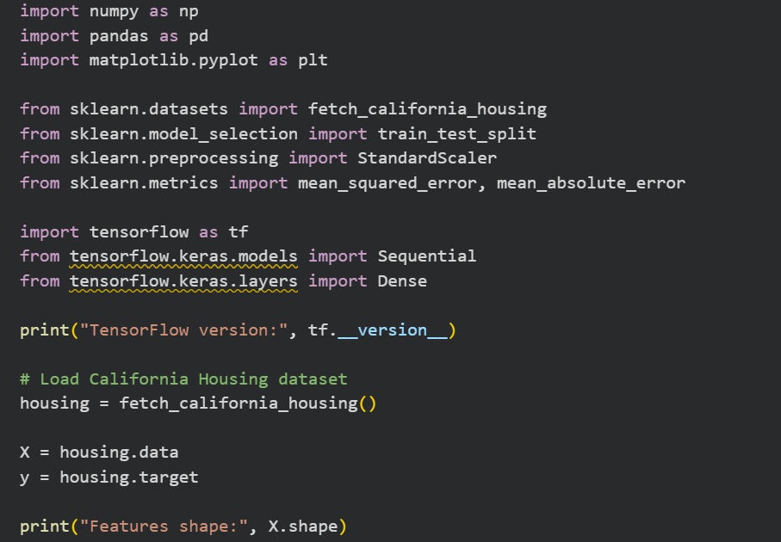
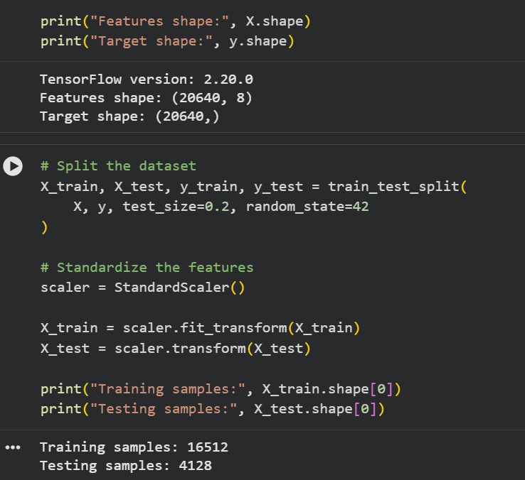
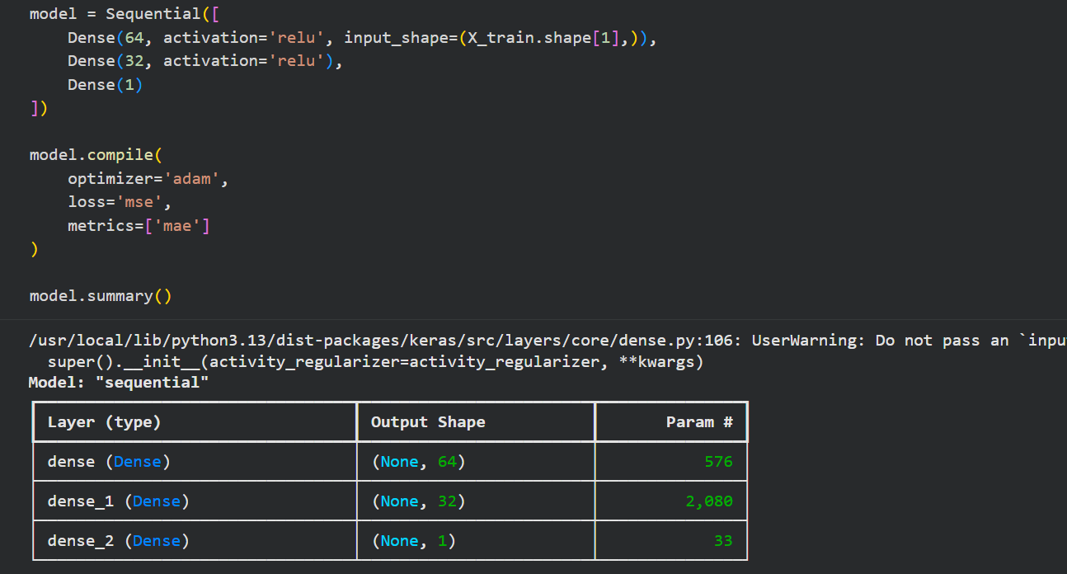
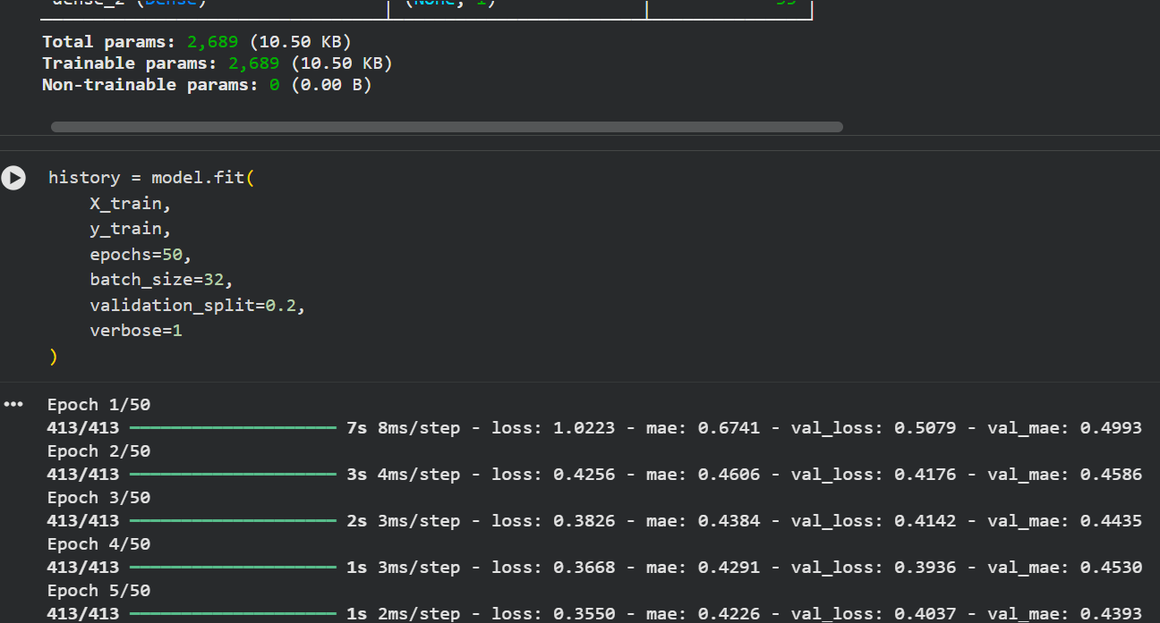
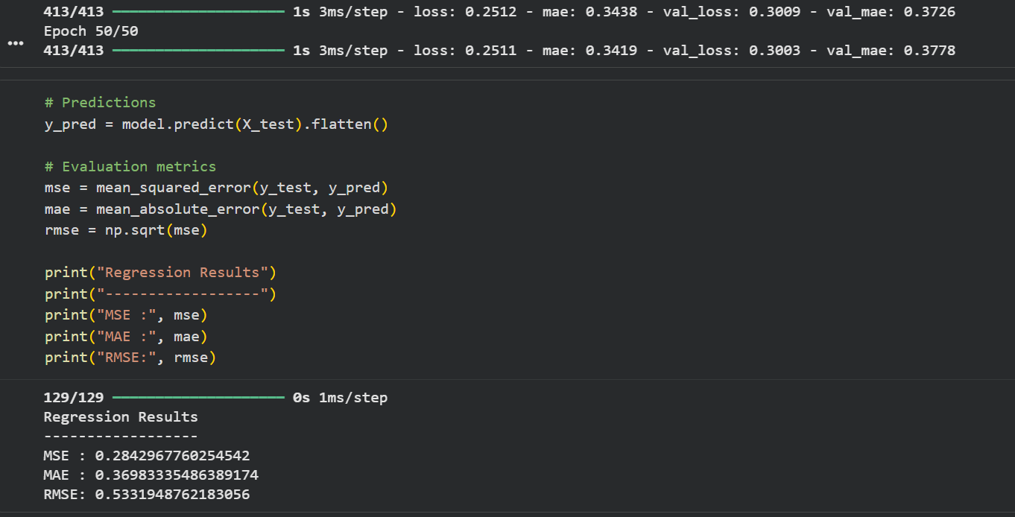
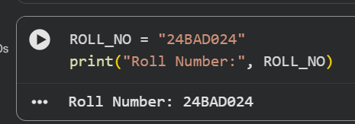

Task B – ANN FOR CLASSIFICATION
DATASET: Breast Cancer Wisconsin Dataset
SOURCE: Scikit-learn
DESCRIPTION
- Samples: 569
- Features: 30
- Classes:
  - Malignant
  - Benign

ALGORITHM
- Import libraries.
- Load Breast Cancer dataset.
- Split dataset.
- Standardize features.
- Design ANN.
- Compile model.
- Train model.
- Predict labels.
- Evaluate:
  - Accuracy
  - Precision
  - Recall
  - F1-score
  - Confusion Matrix

SCREENSHOT OF CODE AND OUTPUT:
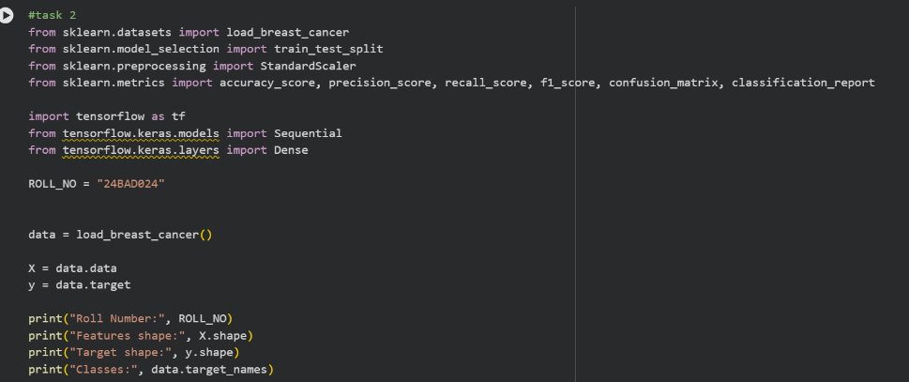
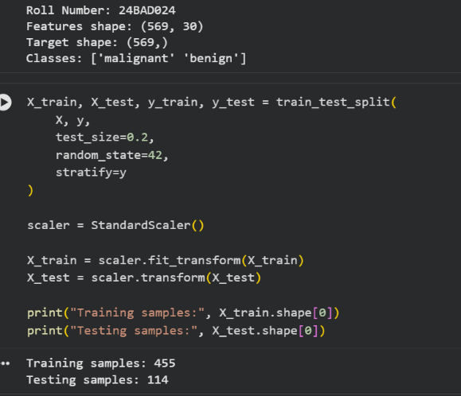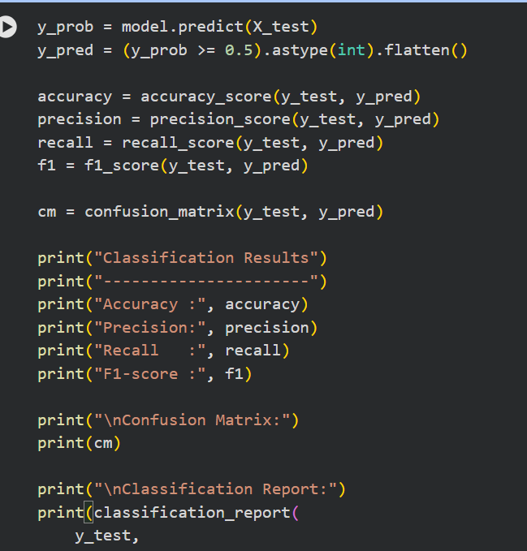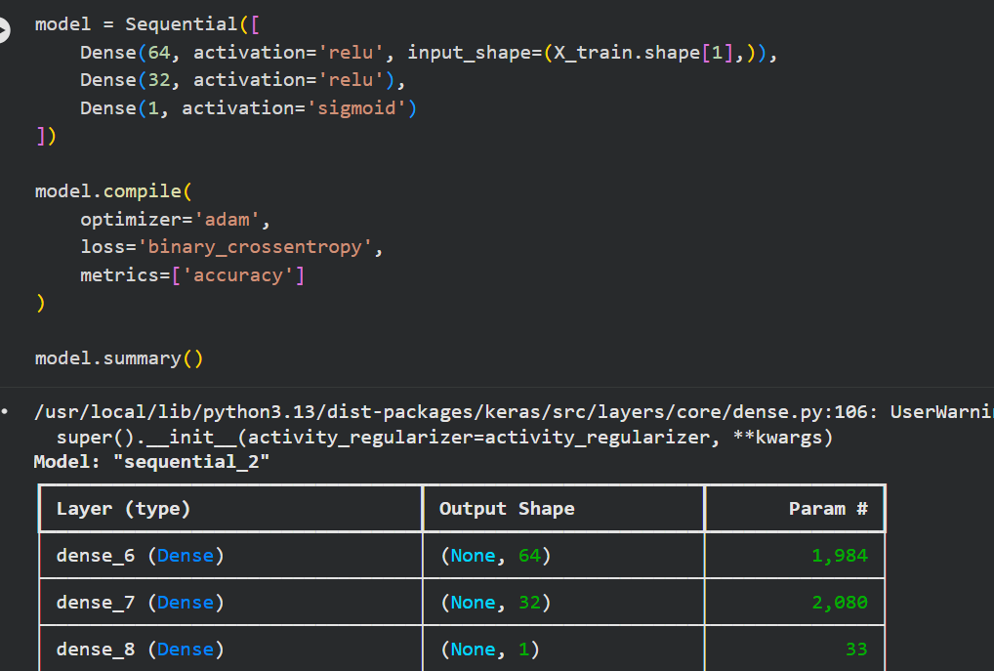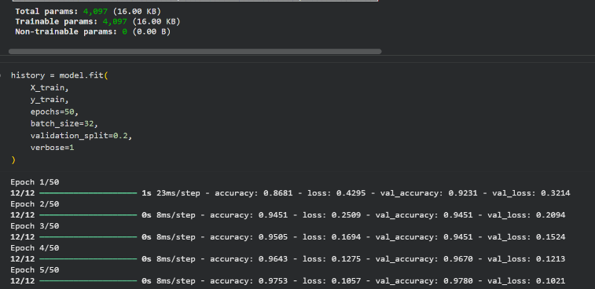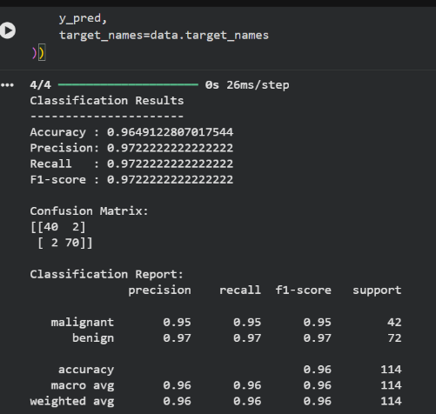
POST-LAB QUESTIONS (PROVIDE BRIEF ANSWERS TO THE FOLLOWING QUESTIONS)

- Why is the Adam optimizer commonly used in ANN training?

Ans) The Adam optimizer combines the benefits of Momentum and RMSProp by maintaining adaptive learning rates for each parameter based on estimates of both the first and second moments of the gradients. This results in faster convergence, better handling of sparse gradients, and more stable training, making it a popular default choice for training ANNs.
- Compare Mean Squared Error (MSE) and Mean Absolute Error (MAE). Which metric is more sensitive to outliers?

Ans) MSE squares the difference between predicted and actual values before averaging, which heavily penalizes large errors. MAE takes the average of the absolute differences, treating all errors proportionally. Because squaring amplifies large deviations, MSE is more sensitive to outliers than MAE.
- Why is the sigmoid activation function used in binary classification?

Ans) The sigmoid function squashes its output to a value between 0 and 1, which can be directly interpreted as the probability of the input belonging to the positive class. This makes it well-suited for the output layer of binary classification models, where a threshold (commonly 0.5) is used to assign the final class label.
- How does increasing the number of hidden layers affect the performance of an ANN?

Ans) Increasing the number of hidden layers allows the network to learn more complex and abstract representations of the data, which can improve performance on difficult tasks. However, adding too many layers can lead to overfitting, vanishing or exploding gradients, and higher computational cost, so the depth must be chosen carefully based on the complexity of the problem.
- Compare the evaluation metrics used for regression and classification tasks. Why are different metrics required for these problems?

Ans) Regression tasks use metrics such as MSE, MAE, and RMSE, which measure the magnitude of the difference between predicted and actual continuous values. Classification tasks use metrics such as Accuracy, Precision, Recall, F1-score, and the Confusion Matrix, which measure how correctly discrete class labels are predicted. Different metrics are needed because regression evaluates numerical closeness, whereas classification evaluates correctness of categorical decisions, which is especially important for imbalanced datasets.

ASSESSMENT
Description | Max Marks | Marks Awarded
Pre Lab Exercise | 5
In Lab Exercise | 10
Post Lab Exercise | 5
Viva | 10
Total | 30
Faculty Signature

