Nicholaus Ferguson
Thomas Scully
Joe Trammel
Ethan Watson
UU Carpool Project Report
Introduction
Our mission was to create a carpooling application that allows church members to plan rides with each other and allow for a simple feed showing what events were coming up, as well as announcements.
ERD
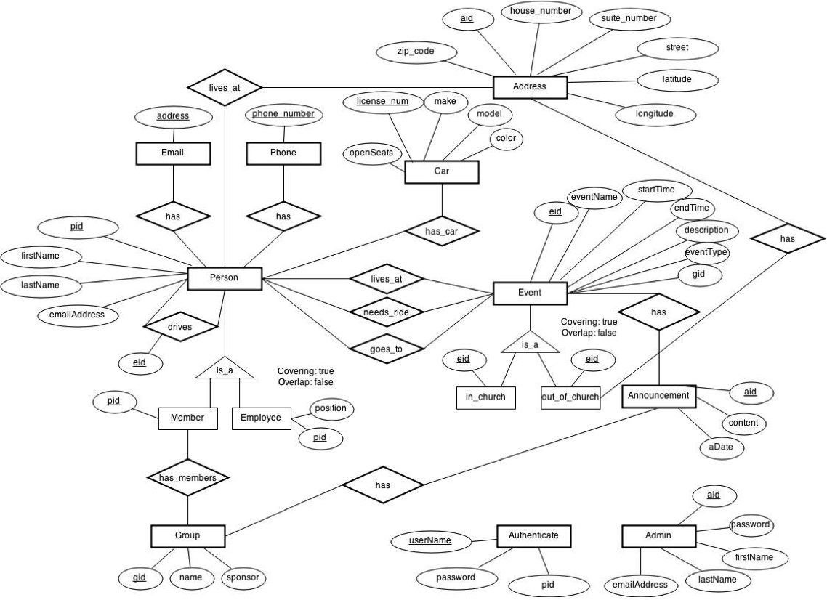
Queries
#1 Find all drivers' names and the number of seats each person has in their car. This query can give the total number of available drivers if there is a large event being planned.

SELECT P.firstName, P.lastName, C.openSeats FROM Person P INNER JOIN person_has_car INNER JOIN Car C;

#2 Find all events for a certain group. This query can be useful if a group is reviewing funding and sees that a group may need more funds for more frequent events.

SELECT E.eventName FROM Event E INNER JOIN Group G WHERE E.gid = ?;

#3 Find the names of everyone in a specific group. This query will be helpful in finding which groups are doing well and which groups may need restructuring.

SELECT P.firstName, P.lastName FROM Person P INNER JOIN group_has_members INNER JOIN Group G WHERE G.gid = ?;

#4 Find the names of everyone that will need a ride to an event. This query is useful for determining who needs a ride to and event, and can be used for coordinating carpools.

SELECT P.firstName, P.lastName FROM Person P INNER JOIN person_needs_ride_for_event INNER JOIN Event E WHERE E.eid = ?

#5 Find the email of a certain person. This can be used when someone needs to contact a specific individual.

SELECT E.address FROM Person P INNER JOIN Email E INNER JOIN person_has_email WHERE P.pid = ?;

#6 Find the names of all events that are outside the church. This can be useful for estimating budgets for travel.

SELECT E.eventName FROM Events E INNER JOIN event_out_of_church INNER JOIN event_has_address INNER JOIN Address A WHERE event_out_of_church.eid = ?;

#7 Find the name and ID of all people are going or not going to a certain event.

SELECT P.firstName, P.lastName, P.pid FROM Person P INNER JOIN person_goes_to_event INNER JOIN Event E WHERE E.eventName LIKE ? AND P.pid NOT IN (SELECT P.pid FROM Person P INNER JOIN group_has_members INNER JOIN GROUP G WHERE G.name LIKE ?);

#8 Find the names of everyone who does not have their email address or phone number saved in the database. This would be useful for updating contact lists or for making a list of individuals that need information mailed to them.

SELECT P.firstName, P.lastName FROM Person P WHERE P.pid NOT IN (SELECT P.pid FROM person_has_email) OR P.pid NOT IN (SELECT P.pid FROM person_has_phone);

#9 Find the names of all people who attend all events. This query can be used for awards or for picking community leaders.

SELECT P.firstName, P.lastName FROM Person P WHERE NOT EXISTS (SELECT E.eid FROM Events E WHERE E.eid NOT IN (SELECT Pae.eid FROM person_goes_to_event Pae WHERE Pae.pid = P.pid));

#10 Find all announcements for a certain group. This query can be used to see what announcements were made, and check for any gaps in information.

SELECT A.aid, content, aDate FROM Announcement A INNER JOIN group_has_announcements gha INNER JOIN Group G WHERE G.gid = ?;

#11 Find the events that a specific person attended. This query could be useful for checking on certain individuals and making sure they are meeting obligations.

SELECT eventName FROM Event E INNER JOIN person_goes_to_event INNER JOIN Person P WHERE P.firstName LIKE ? AND P.lastName LIKE ?;

#12 Find the names of everyone that has a ride to a certain event. This query can be used to make a list of people still needing rides, making carpooling easier.

SELECT P.firstName P.lastName FROM Person P INNER JOIN driver_drives_rider ddr INNER JOIN Event E WHERE P.pid = ddr.pid_rider AND E.eventName LIKE ?;

#13 Find the number of people that attended a specific event at a specfic time.

SELECT E.eventName, count(pid) AS number_of_people FROM person_goes_to_event pae INNER JOIN Event E WHERE E.eventName LIKE ? AND E.startTime = ? GROUP BY (E.eventName, E.startTime);

#14 Find how many people can drive to an event on a specific date. This is useful for knowing whether or not a shuttle or bus may be needed.

SELECT count(person_drives_for_event.pid) AS drivers FROM person_drives_for_event INNER JOIN Event E WHERE E.eventName = ? AND E.startTime = ? GROUP BY (person_drives_for_event.eid);

#15 Find the names of the top 10 people that attended the most events. This query is useful for making awards and recognizing greatness.

SELECT P.firstName, P.lastName FROM Person P INNER JOIN person_goes_to_event pae GROUP BY (pae.pid) ORDER BY count(pae.eid) DESC LIMIT 10;

#16 Find the names of those who are not adults. This would be useful for finding those who are eligible to be drivers.

SELECT P.name FROM Person P WHERE P.age < 18

#17 List all events in order of attendence. This is useful for finding which events have the best turnout as well as figuring out which events should be discontinued.

SELECT E.eventName FROM Event E INNER JOIN person_goes_to_event pge GROUP BY pge.eid ORDER BY count(pge.pid) DESC;

#18 Find the average attendance for all events. This query would be useful for tracking attendance and trends in participation.

SELECT avg(Ph.pid) AS average FROM person_goes_to_event Ph INNER JOIN Event E

#19 Find the top 10 events people go to the most. This is useful for finding trends in turnout.

SELECT E.eventName, count(pge.pid) FROM Event E INNER JOIN person_goes_to_event pge GROUP BY (pge.eid) ORDER BY count(pge.pid) DESC LIMIT 10;

#20 Find the names of everyone who has driven at least one. This is useful for finding out who can skip giving rides and allows for one to find out who should help more often.

SELECT DISTINCT P.firstName, P.lastName FROM Person P INNER JOIN person_drives_for_event pde;

Analytics

Normalization

Indexing Selection

Optimization and Tuning

Security Setting
The main aspects of security implemented in this project are preventative measures concerning SQL injection. The MySQLi library was used to implement prepared queries, preventing SQL injection. An admin table was also implemented to keep track of users.
User's Manual

