CS4380/7380 Database Management Systems –I
Final Project Planning Report (due 3/6/2015 by midnight)
Worth 5% of your final project
Project title: Columbia UU Church carpool webapp__________________

Team members
Last name | First name | E-mail | Major
Ferguson | Nicholaus | ngfnbf@mail.missouri.edu | CS
Watson | Ethan | edwzpd@mail.missouri.edu | CS
Scully | Thomas | tps9tb@mail.missouri.edu | CS/IT
Trammel | Joseph | jat284@mail.missouri.edu | CS/IT

Content needed in your report (follow the order)

- Data collection and client information.
- E-R Diagram (any format)
- Create tables using DDL in your group accounts (copy and paste your SQL statements for table creations). All members in the team should participate in creating tables.
- List at least 10 useful queries in English sentences, as well as in relational algebra and SQL. Make sure they are different types and really useful.
- Contribution by each member so far. (Members never showed up for meeting or difficult to work with and voted by the majority will be removed from the group and placed in a “turkey farm.”)
- Workload plan for each team member. (I expect all of you work on database planning, design, implementation, and report writing.)
- Weekly schedule
Data Collection and Client info
Client: Unitarian Universalist Church of Columbia MO (http://uuchurch.net)
Contact: Rev. Molly Housh Gordon (minister@uuchurch.net)
Data: The church has a list of their members and all their address already for us to use.
ERD
CREATE TABLE Member(
mid INTEGER AUTO_INCREMENT PRIMARY KEY,
fname VARCHAR(32) NOT NULL,
lname VARCHAR(32) NOT NULL,
email VARCHAR(64)
)ENGINE=InnoDB;

CREATE TABLE Event(
eid INTEGER AUTO_INCREMENT PRIMARY KEY,
title VARCHAR(64) NOT NULL,
description VARCHAR(1024),
type VARCHAR(32),
date_time TIMESTAMP NOT NULL
)ENGINE=InnoDB;

CREATE TABLE Address(
aid INTEGER AUTO_INCREMENT PRIMARY KEY,
street_number INTEGER NOT NULL,
suite_number VARCHAR(32),
street VARCHAR(64) NOT NULL,
city VARCHAR(64) DEFAULT='Columbia',
state CHAR(2) DEFAULT='MO',
zip CHAR(5) DEFAULT='65201'
)ENGINE=InnoDB;

CREATE TABLE member_lives_at_address(
mid INTEGER,
aid INTEGER,
PRIMARY KEY(mid, aid),
FOREIGN KEY(mid) REFERENCES Member(mid),
FOREIGN KEY(aid) REFERENCES Address(aid)
)ENGINE=InnoDB;

CREATE TABLE member_attends_event(
mid INTEGER,
eid INTEGER,
PRIMARY KEY(mid, eid),
FOREIGN KEY (mid) REFERENCES Member(mid),
FOREIGN KEY (eid) REFERENCES Event(eid)
)ENGINE=InnoDB;

CREATE TABLE event_occurs_at_address(
eid INTEGER,
aid INTEGER,
PRIMARY KEY(eid, aid),
FOREIGN KEY (eid) REFERENCES Event(eid),
FOREIGN KEY (aid) REFERENCES Address(aid)
)ENGINE=InnoDB;
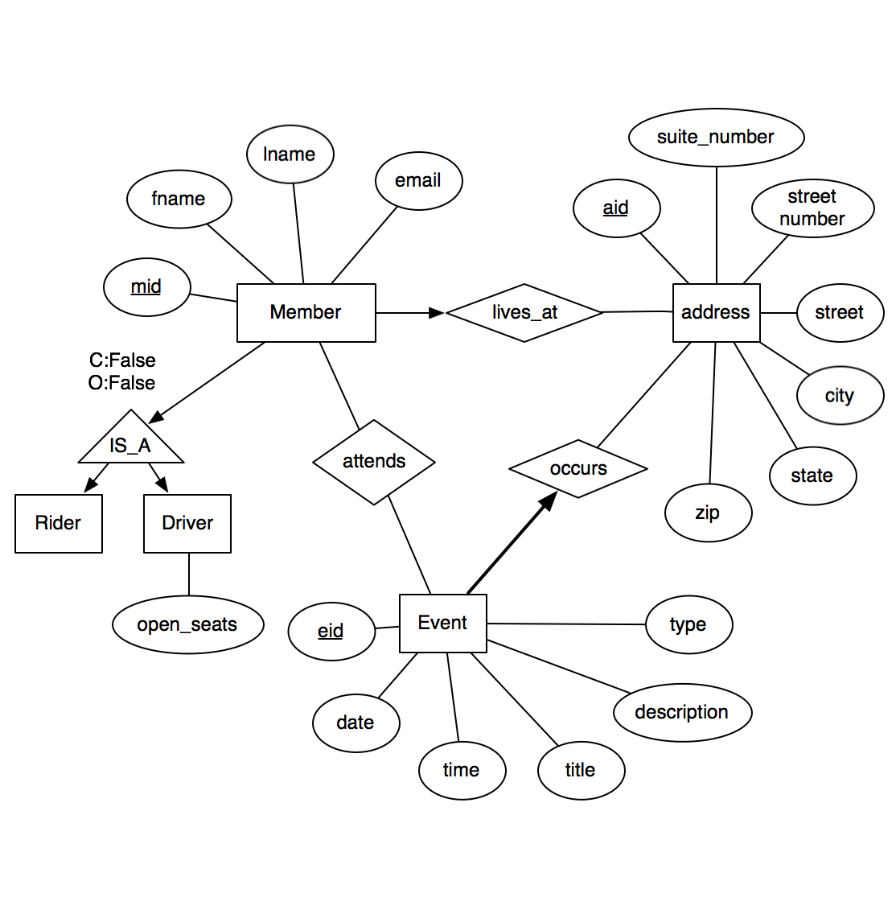
DDL

Queries
Examples:
- Number of members are at church every week
- Number of members who are above the age of 60 (seniors)
- Find all attendees within the past year who are not members
- Find members who haven’t attended a service in 3 months
- Find all members who are enrolled in at least one church activity
- Find the church activity with the highest attendance
- Find a list of all members who have completed confirmation
- Find the total attendance for popular services (ash wednesday, easter, christmas eve)
- Find which months have the highest attendance on sundays
- Find a list of all families who are members
- Find all attendees who are not members but have attended at least 10 services
- Find the average age of all members
- Find neighborhoods with the highest concentration of members.
- Number of members living in each neighborhood
- Members farthest away from church
- Members closest to church
(total 12)
Contributions
So far everyone has worked well together and we have worked mainly on coming up with a client for our project. We all worked on finding some options for clients and talked about which one we would all enjoy doing most. Aside from finding our client, we all worked together on creating our ERD’s and the structure of our database. We all gave our opinions on how we thought it should look and collaborated on the overall design and creating them in our group babbage account. We all talked about what queries we would like to see and all assisted in creating the relational algebra as well as the SQL for each query. We all made sure that we thought the queries were useful and would work well for our application. Overall, we all have been collaborating on each aspect of the project and working out how we all envision it and how we want it to run. Everything that we plan on doing, we confirm with the group and figure out if it is something that would work well for our project or not. No one from our group needs to be sent to the Turkey Farm.
Workload Plan
Thomas:
Back End, DB work
Ethan:
Back End, DB work
Joe:
Data integrity specialist, Front end, DB work
Nick:
Point of contact with client, Front end, DB work
Schedule
Our group currently has a group chat on Slack that we are using to constantly communicate with one another. We don’t have a schedule set in stone yet, but we will most likely be meeting once every week or two to go over what we have done and what else we need to change. We will also be constantly updating each other on the slack account as we update our program and make changes to the database/application. We will set goals to reach each week in order to keep ahead of the project and ensure that we are not working on the entire project last minute. Weekly meetings are scheduled for 5:30 p.m. Thursdays

