GRanD dam and river connectivity exploration

Emi, Brian, Korrina

8/20/2021

# Data exploration for GRanD and FFR dam purpose project

## Project overview

Exploratory analyses using the combined GRanD and FFR datasets. Our goal is to examine whether there are patterns among river connectivity measures and dams by their reported main use (e.g., hydroelectricity, irrigation) and by continent. We are interested in examining whether there are differences in river connectivity status by dam use - especially with regard to hydroelectricity.

##Data processing steps We merged the GRanD and FFR datasets using the unique GRAND_ID for a total of n = 7303 dams associated with river attributes in the FFR. We reduced the dataset to a subset of observations (n = 3278) that were used in Grill et al. 2019 as indicated by the field “INC”= 1. Dams are commonly used for multiple purposes that can have competing water management practices. We expect that hydroelectricity will have a dominant effect on river connectivity regardless of whether it is labeled as the primary or secondary main use for a dam. We created a new dam use class variable called “MAIN_HYDRO” which labels dams that have Hydroelectricity listed for any use as “Hydroelectricity”. We also created a new other category (“Other expanded”) that consolidated dams labeled as “Other”, “Fisheries”, and “Recreation”.

Below are summary statistics of river connectivity measures by dam use and exploratory box-plots of the distribution of connectivity measures by dam use and continent.

## Number of dams by dam use and continent

Note there are 714 dams missing a main use.

##   
## Hydroelectricity Flood control Water supply Irrigation  
## Africa 87 1 62 160  
## Asia 242 38 12 228  
## Australia 32 0 35 23  
## Europe 409 12 85 77  
## North America 309 125 145 113  
## South America 86 4 11 27  
##   
## Navigation Other expanded   
## Africa 0 3 47  
## Asia 1 1 445  
## Australia 0 0 7  
## Europe 3 13 84  
## North America 14 206 15  
## South America 0 0 116

## Summary statistics of river connectivity measures

Mean, standard deviation, and range of connectivity values are reported by dam use. Metrics include: CSI = connectivity status index; DOF = degree of fragmentation; DOR = degree of regulation

## MAIN_HYDRO mean_csi sd_csi min_csi max_csi mean_dof sd_dof min_dof  
## 1 Hydroelectricity 77.95 28.37 13.61 100 36.87 45.44 0  
## 2 Flood control 76.59 28.38 20.16 100 34.98 43.63 0  
## 3 Water supply 74.34 29.10 19.16 100 40.30 45.25 0  
## 4 Irrigation 69.14 30.85 6.88 100 47.46 46.51 0  
## 5 Navigation 80.55 25.64 31.81 100 33.50 46.20 0  
## 6 Other expanded 78.95 26.93 21.66 100 34.53 43.14 0  
## 7 77.73 27.05 17.12 100 38.21 45.15 0  
## max_dof mean_dor sd_dor min_dor max_dor  
## 1 100 20.76 35.10 0 100.0  
## 2 100 27.17 39.06 0 100.0  
## 3 100 26.67 38.09 0 100.0  
## 4 100 32.14 40.14 0 100.0  
## 5 100 16.63 24.91 0 80.4  
## 6 100 22.71 35.89 0 100.0  
## 7 100 19.36 32.76 0 100.0

## Boxplots of river attributes by dam use and continent

Boxplots illustrate the distribution of river attribute values by our dam use classes and across continents. Group differences within a continent are tested using Kruskal-Wallis non-parametric group mean test with p-values reported.

## Warning: Transformation introduced infinite values in continuous y-axis  
  
## Warning: Transformation introduced infinite values in continuous y-axis  
  
## Warning: Transformation introduced infinite values in continuous y-axis

## Warning: Removed 4 rows containing non-finite values (stat_boxplot).

## Warning: Removed 4 rows containing non-finite values (stat_compare_means).

## Warning: Removed 4 rows containing missing values (geom_point).

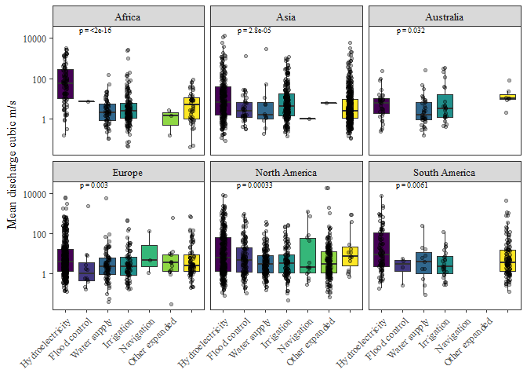

River discharge distributions are different across dam types for all of the continents, as indicated by the Kruskal-Wallis test (p-value <0.05). In general, rivers that have dams used for hydroelectricity, tend to be on larger rivers with greater discharge compared to dams used for other purposes. But there is a great deal of variation within these classes.

## Boxplots river connectivity measures

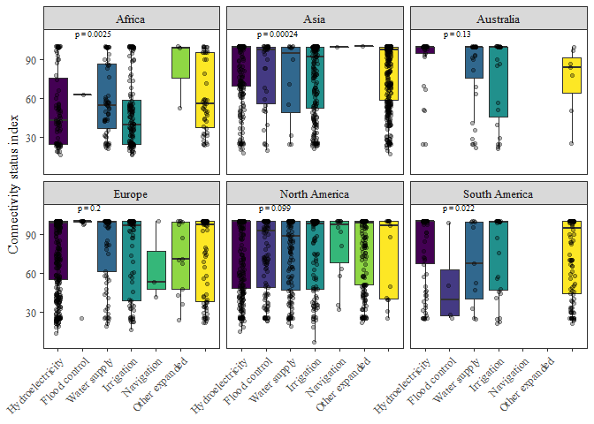

CSI values differed among dam use classes In Africa, Asia, and S America. We did not find significant differences in CSI mean values among dam types in Australia, Europe, and N America (kruskal-wallis p>0.05). In Africa, dams used for hydroelectric and irrigation had lower CSI compared to other dam types.

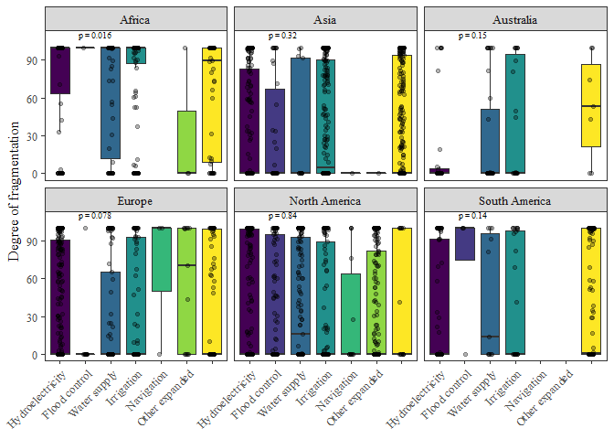

We did not find significant differences in degree of fragmentation values among dam types across most continents except Africa. This may not be surprising because dams regardless of how they are used can fragment river networks. We should read up more on how degree of fragmentation was determined.

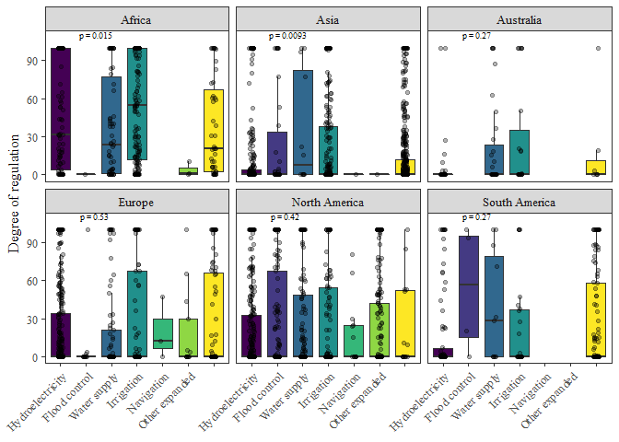

Dams used for hydroelectricity, water supply, and irrigation tended to have higher DOR values indicating that these particular uses may alter lateral and temporal connectivity of rivers compared to dams used for navigation and other purposes.

## Boxplots examining hydroelectric dams and all other dam types by river order

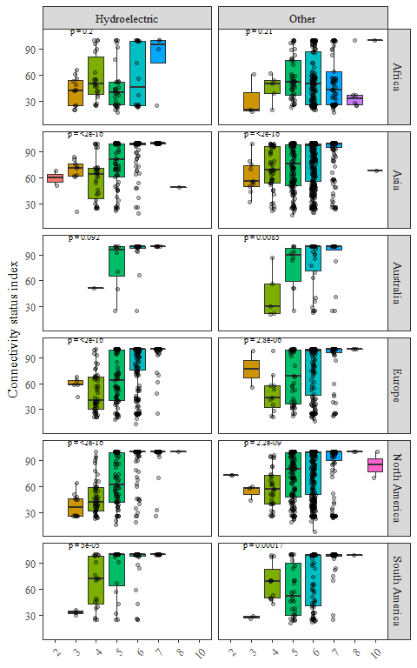

Here I collapsed dam types into Hydroelectric or other and plotted CSI against river order (where lower order numbers indicate larger rivers. We can see that connectivity measures decrease with larger rivers - there may be a threshold between rivers 6 and higher having greater connectivity compared to rivers <6.