**Object Design Document**

*Project Enlightenment*

*Computer Training For Visually Impaired Automation Tool (CTVIAT)*

Prepared By: Project Enlightenment

Date: December 28, 2010

Version No: v3.0

**Document Change Control**

The following is the document control for revisions to this document.

|  |  |  |  |
| --- | --- | --- | --- |
| Version Number | Date of Issue | Author(s) | Brief Description of Change |
| 1.0 | 14/10/10 | Project Enlightenment | Phase 1 - Preliminary draft for Phase 1 |
| 1.1 | 30/10/10 | Project Enlightenment | Update for Phase 1 deliverables |
| 1.2 | 30/11/10 | Project Enlightenment | Update for Phase 1 deliverables |
| 2.0 | 13/12/10 | Project Enlightenment | Phase 1 & 2 – conform to new framework template, update for Phase 2 deliverables |
| 3.0 | 28/12/10 | Project Enlightenment | Phase 2 & 3 – conform to new framework template, update for Phase 3 deliverables |
|  |  |  |  |

**Definition**

The following are definitions of terms, abbreviations and acronyms used in this document.

|  |  |
| --- | --- |
| **Term** | **Definition** |
| CTVI | Computer Training for Visually Impaired |
| RAD | Requirements Analysis Document |
| CTVIAT | Computer Training for Visually Impaired Automation Tool |
| JFW | JAWS for Windows |
| SDD | Software Design Document |
| ODD | Object Design Document |
| CPU | Central Processing Unit in a Computer |

Table of Contents

1. INTRODUCTION 4

1.1 Object Design Trade-Offs 4

1.2 Interface Documentation Guidelines 4

1.3 Definitions, Acronyms and Abbreviations 4

2. PACKAGES 5

2.1 Package Diagram 5

2.2 Package Definitions 6

2.2.1 Interface Package 6

2.2.2 Classes Package 6

2.2.3 Database Package 6

2.3 Class Diagrams 7

2.4 Class Definitions 8

2.4.1 LoginForm 8

2.4.2 CandidateMainForm 9

2.4.3 AdminMainForm 10

2.4.4 CandidateTestForm 11

2.4.5 QuestionCreationForm 12

2.4.6 TestCreationForm 13

2.4.7 UserCreationForm 14

2.4.8 ReportCreationForm 15

2.4.9 User 15

2.4.10 Candidate 16

2.4.11 Admin 16

2.4.12 Question 16

2.4.13 Descriptive Question 17

2.4.14 ActionBasedQuestion 17

2.4.15 ObjectiveQuestion 18

2.4.16 Answer 18

2.4.17 ObjectiveAnswer 19

2.4.18 DescriptiveAnswer 19

2.4.19 ActionBased Answer 19

2.4.20 Hint 20

2.4.21 Database Access Object Class 21

2.4.22 Test 22

# INTRODUCTION

# 1.1 Object Design Trade-Offs

In our project, there is a trade-off between performance and complexity. Since, CTVI Automation Tool will provide many functionalities to users, there should be a short respond time when carrying out these functionalities to satisfy user expectations. Because, during the usage of the application, visually impaired people will be alone and must not wait too much during testing phase. In another word, the performance of the application is the main issue in our design. However, to satisfy this, we should decrease degree of complexity. One solution is to keep size of sound files that inform the visually impaired user about the parts and usage of the program. In our previous design, we have decided to store such sound files in mp3 format in a directory and to keep the directory info for each sound file in the database. However, after our implementation goes further, we decided to use an API for this task, which comes with Visual Studio 2010 Packet to make the application more efficient and to decrease size of sound files. Also, we will increase the number of classes and subclasses. This will increase the readibility of the program and if anyone reads the documentation of the project, he will easily be familiar with the main architecture of the project. Thus, in result, modifiying parts of project will be easier. However, all this will come with a cost: more complexity and low performance. Furthermore, our application should provide a safe platform to users to store their personal data more securely. This of course will be handled through a more reliable database management and independent design of subsystems. However, this will increase size of the code and in result require more memory.

# Interface Documentation Guidelines

In our project, mainly, there are three packages are defined: Interface, Classes and Database. The Classes package containing the main classes used in the implementation of the CTVIAT application and in general each class consists of many subclasses. In Interface package, there are classes for login screen, admin screen and candidate screen and all classes responsible to handle interface operations. In Database package, there is a database access object class which is responsible to manage database connection and enable other classes to reach database through this class. This class includes User, Test, Question, Answer and Candidate-Test Medhods to handle Method related database operations.

Names of classes in the packages and class attributes are nouns starting with capital letters. If the name consists of more than one word, then the initial letter of each word is capitalized (e.g. TestsCandidates,IncompleteTestsCandidates,etc).

# Definitions, Acronyms and Abbreviations

**CTVI :** Computer Training for Visually Impaired

**CTVI AT :** Computer Training for Visually Impaired Automation Tool

# PACKAGES

# 2.1 Package Diagram

Interface Package

<<Form>>  
Candidate  
OldTest  
Form

<<Form>>  
CandidateMainForm

<<Form>>  
AdminMainForm

<<Form>>  
LoginForm

Database Package

<<Form>>  
StartNew  
Test  
Form

<<Form>>  
Candidate  
Test  
Form

<<Form>>  
Test  
Creation  
Form

<<Form>>  
Question  
Creation  
Form

<<Form>>  
Report  
Creation  
Form

<<Form>>  
User  
Creation  
Form

Classes Package

Candidate

User

Admin

Question

Objective

Descrip  
tive

Action  
Based

Objective

Descrip  
tive

Action  
Based

Test

Hints

Answer

Test  
Methods

Candidate Test Methods

User Method s

DATABASE PACKAGE

QuestionMethods

Tests  
Candidates   
Table

Tests  
Table

Quetions  
Table

Questions  
Tests Table

IncompleteTestsCandidates  
Table

Users  
Table

Figure 2.1 Package Diagram of the CTVIAT

There are three packages in object design model of CTVIAT. In Figure 2.1 these packages together with their classes shown.

# Package Definitions

# 2.2.1 Interface Package

In this package, there are mainly three classes, named “LoginForm”, “CandidateMainForm” and “AdminMainForm” to control and manage all the tasks related to user interfaces. Because of the central role in the CTVIAT application, these classes have interactions with all other packages and with the database. Also, Interface package includes some Candidate and Admin related classes to handle user specific operations. These classes are “candidateTestForm”, “candidateOldTestForm”, “startNewTestForm”, “testCreationForm” and “QuestionCreationForm”, “ReportCreationForm”, “UserCreateForm”. All the classes in the interface package has responsibility to enable users to use program interface efficiently. These classes takes inputs from users and according to these inputs users directed to related parts of program.

# 2.2.2 Classes Package

On the top of this package, there are five main classes named “User”, “Question”, “Answer”,“Hint” and “Test”. The “User” class is designed to control user related operations . Also there are two sub-classes inherited from this class, namely “Candidate” and “Admin”. The first one will be used to handle “CandidateMainForm” operations and the second one is designed to handle “AdminMainForm” operations. “Question” class enables admins to create questions in different types. To handle this, we will design 3 sub-classes inherited from this class: “ActionBased” class to create action-based questions, “Descriptive” class to create descriptive questions and “Objective” class to prepare objective questions. “Answer” class is designed to handle the answer part of the questions and “Hint ” class is designed to supply hints to users when they are failed to do an operation during exam. Lastly, “Test” class will be used to create test in different modules.

# 2.2.3 Database Package

In this package there is our database tables and a class named “DatabaseObject” to enable other classes to connect to database. By implementing this class, all database related operations such as loginning to system, creating a test, creating a question, taking a test, keeping user info, etc handled more easily.

# Class Diagrams

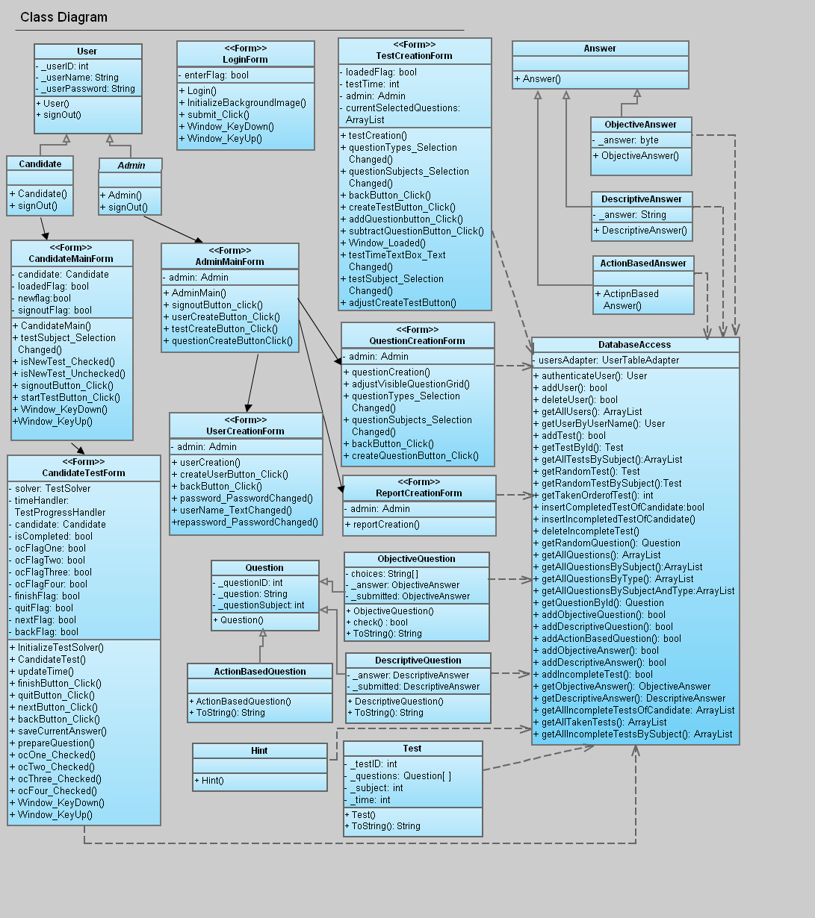

Figure 2.2 Class Diagram of the CTVIAT

The class diagram of the CTVIAT represents the classes, their attributes and methods, and the interactions between. Since we implement a lot, number of methods and members for each class incremented compared to old versions of ODD. Thus, in this version of the ODD, we changed our class diagram accordingly.

# Class Definitions

## LoginForm

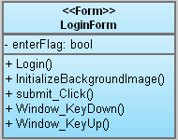

The LoginForm class is a part of Interface package and handles login operation of the users. This class create a database connection with user info through database access object class and check user. İf authorization succeeded, it hands over its job to User class by calling it. This class has one member and 5 methods:

**Members:**

* enterFlag: whether user has login or not

**Methods:**

* Login() : is the class constructor
* initalizeBackgroundImage(): this method sets a bitmap image as background image.
* Submit_Click(): when user pressed submit button in login screen this method called and authanticate of user starts.
* Window_KeyDown(): when user pressed a key this method capture the key
* Window_KeyUp(): when user release a key this method capture the key

## 2.4.2 CandidateMainForm

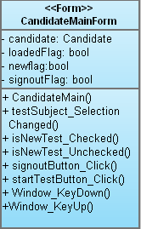

The candidateMainForm class is also a part of Interface Package and handles Visually Impaired users’ operation. This class has four members and eight methods. These class will be used to enable visually impaired users to select a test and take that test:

**Members:**

* candidate: Candidate object
* loadedFlag: when form loaded this flag sets to true
* newFlag: this flag sets to true if user select new test
* signoutFlag: if user press S-key, this flag sets to true such that user can sign out

**Methods:**

* CandidateMain(): this method is class constructor
* testSubject_SelectionChanged() : when user select a new test subject in drop down list this method called
* isNewTest_Checked():
* isNewTest_Unchecked():
* signoutButton_Click(): when user pressed sign Out button, user session closed.
* startTestButton_Click(): when user pressed start test button this method start a test for visually impaired.
* Window_KeyDown():when user pressed a key this method capture the key.
* Window_KeyUp():when user released a key this method capture the key

## AdminMainForm

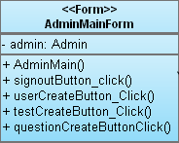

The AdminMainForm class is a part of Interface Package and handles admins’ operations. This class has one member and 5 methods in this design of ODD. These class will be used to enable admins to create questions and tests for visually impaired users.

**Members:**

* admin: Admin object

**Methods:**

* AdminMain(): this method is class constructor and enbles to create AdminMain type objects.
* signoutButton_Click(): when user pressed sign Out button, user session closed.
* userCreateButtonclick(): open User Creation Form
* testCreateButtonClick(): open Test Creation Form
* questionCreateButtonClick(): open Question Creation form

## CandidateTestForm

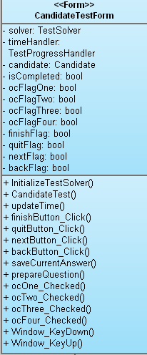

This class is inherited from candidateMainForm class and a part of Interface Package. We designed this class to enable visually impaired users to select a test for examination. In this class there are 12 members and 15 methods are implemented :

**Members:**

* solver: TestSolver object
* timeHandler: TestProgressHandler object
* candidate: Candidate object
* isCompleted: specify whether test is completed or not
* ocFlagOne: user selected first answer
* ocFlagTwo: user selected second answer
* ocFlagThree: user selected third answer
* ocFlagFour: user selected fourth answer
* finishFlag: specify whether user finished the test or not
* quitFlag: specify user pressed quit butoon or not
* nextFlag: specify whether user chose to go next question or not, namely next question button pressed or not
* backFlag: specify whether user chose to go previous question or not, namely previous question button pressed or not

**Methods:**

* initalizeTestSolver(): initalize a test for candidate
* CandidateTest(): is the class constructor
* updateTime(): controls remaining time for the test
* finishButton_Click(): when finish button pressed, related events handled here
* quitButton_Click():when quit button pressed, related events handled here
* nextButton_Click():when next question button pressed, related events handled here
* backButton_Click():when previous question button pressed, related events handled here
* saveCurrentAnswer(): stores the user answers during the examination
* prepareQuestion():
* ocOne_Checked():for objective type questions, if user choose first option, answer info stored
* ocTwo_Checked():for objective type questions, if user choose second option, answer info stored
* ocThree_Checked():for objective type questions, if user choose third option, answer info stored
* ocFour_Checked():for objective type questions, if user choose fourth option, answer info stored
* Window_KeyDown():when user pressed a key this method capture the key.
* Window_KeyUp():when user released a key this method capture the key

## 2.4.5 QuestionCreationForm

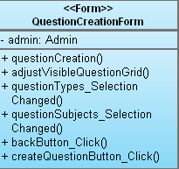

This class is also inherited from AdminMainForm class and is a part of Interface Package. The class has six methods and one member. it enables admins to create questions for users. This class needs a database connecton to complete its tasks.

**Members:**

* admin: Admin object

**Methods:**

* questionCreation(): is the class constructor.
* adjustVisibleQuestionGrid():
* questionTypes_SelectionChanged(): if admin chose a question type from drop down list this methd called.
* questionSubjects_SelectionChanged():if admin chose a question subjectfrom drop down list this methd called.
* backButton_Click(): when admin pressed back button he goes back to AdminMain Form screen.
* createQuestionButton_Click(): when admin pressed create question button this method creates the question with specified info.

## TestCreationForm

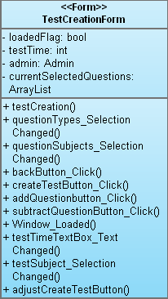

This class is also inherited from AdminMainForm class and is a part of Interface Package. The class has 4 members and 11 methods and enable admins to create tests for the visually impaired users. All operations run under a successful database connection.

**Members:**

* loadedFlag:when form loaded this flag sets to true
* testTime: store the time of the test
* admin: Admin object
* currentSelectedQuestions: an ArrayList object to store selected questions

**Methods:**

* testCreation(): is the class constructor.
* questionTypes_SelectionChanged(): when user select a new question type from drop down list this method called.
* questionSubjects_SelectionChanged():when user select a new question subject from drop down list this method called.
* backButton_Click():when admin pressed back button he goes back to AdminMain Form screen.
* createTestButton_Click():when admin pressed create test button this method creates the test with specified info.
* addQuestionbutton_Click(): this method enables to add a question to test
* subtractQuestionButton_Click(): this button enables to substract a question from the test.
* Window_Loaded(): sets loaded flag true
* testTimeTextBox_TextChanged():
* testSubject_SelectionChanged(): when admin select a new test subject from drop down list this method called.
* adjustCreateTestButton():

## UserCreationForm

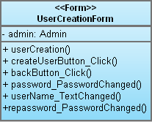

This class is also inherited from AdminMainForm class and is a part of Interface Package. The class has 1 member and 6 methods and enable admins to create candidate/admin type users. All operations run under a successful database connection:

**Members:**

* admin: Admin object

**Methods:**

* userCreation(): is the class constructor
* createUserButton_Click(): when admin pressed the create user button a new user with specified info created.
* backButton_Click(): enable admin to go back to AdminMain Form
* password_PasswordChanged(): checks user password and activate “create user button”
* userName_TextChanged():checks user name and activate “create user button”
* repassword_PasswordChanged():checks user password and activate “create user button”

## ReportCreationForm

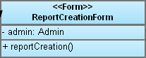

This class is also inherited from AdminMainForm class and is a part of Interface Package. The class has 1 member and 1 method and enable admins to create candidate related reports:

**Members:**

* admin: Admin object

**Methods:**

* reportCreation(): is the class constructor.

## User

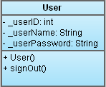

The User class is in Classes Package and handles users related oprations . This class has three members and two methods:

**Members:**

* userID : specify the user ID to bring data from database.
* userName: store users name info
* userType: specify whether user is an candidate or an admin

**Methods:**

* User() : is the constructor of the class.
* signOut() : enable users to end their session.

## 2.4.10 Candidate

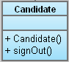

This class is inherited from User class and will be used to handle candidate related operations together with userMainForm class. It has 2 methods.

**Members:**

**Methods:**

* signOut() : enable log-off for candidate
* Candidate():is the constructor of the class.

## 2.4.11 Admin

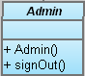

This class is also inherited from User class and will be used to handle admin related operations together with adminMainForm class. It has two methods.

**Methods:**

* signOut() : enable log-off for admin
* Admin(): is the class constructor

## 2.4.12 Question

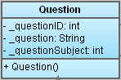

This class is also in Classes Package and designed to encapsulete the data of questions read from database. It has three members and one method:

**Members:**

* _quetionID : keeps primary key of question table
* _question: keeps the question info
* _questionSubject: specify whether the question is objective,desciptive or action-based.

**Methods:**

* Question(): is the class constructor

## 2.4.13 Descriptive Question

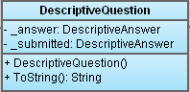

This class is inherited from Question Class and designed to encapsulate the data about descriptive question type. It has 2 members and two methods:

**Members:**

* _answer: DescriptiveAnswer object
* _submitted: DescriptiveAnswer object

**Methods:**

* DescriptiveQuestion(): is the class constructor.
* toString(): overrides toString method for descriptive type questions.

## 2.4.14 ActionBasedQuestion

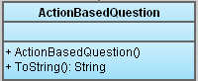

This class also inherited from Question Class and designed for action-based type questions. It has 2 methods:

**Methods:**

* ActionBasedQuestion(): is the class constructor
* toString(): overrides toString method for action based type questions.

## 2.4.15 ObjectiveQuestion

## 

This class also inherited from Question Class and designed for objective type questions. It has 3 members and 3 methods:

**Members:**

* choices: a string array that store the user choices
* _answer: ObjectiveAnswer object
* _submitted: ObjectiveAnswer object

**Methods:**

* ObjectiveQuestion(): is the class constructor.
* check(): controls the submitted answer.
* toString(): overrides toString method for objective type questions.

## 2.4.16 Answer

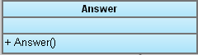

This class is in Classes Package and designed to encapsulete the data of answer for a spesific question. It has one method:

**Methods:**

* Answer(): is the class constructor

## 2.4.17 ObjectiveAnswer

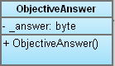

This class is in Classes Package and inherited from Answer class and designed to encapsulete the data of objective type answer for objective type questions. It has one method and one member:

**Members:**

* _answer : keeps the answer info as byte

**Methods:**

* ObjectiveAnswer(): is the class constructor

## 2.4.18 DescriptiveAnswer

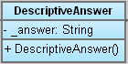

This class is in Classes Package and inherited from Answer class and designed to encapsulete the data of descriptive type answer for descriptive type questions. It has one method and one member:

**Members:**

* _answer : keeps the answer info as String

**Methods:**

* DescriptiveAnswer(): is the class constructor

## 2.4.19 ActionBased Answer

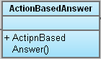

This class is in Classes Package and inherited from Answer class and designed to encapsulete the data of actionbased type answer for actionbased type questions. It has one method:

**Members:**

**Methods:**

* ActionBasedAnswer(): is the class constructor

## 2.4.20 Hint

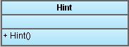

This class is in Classes Package and designed to encapsulete the data of hints for a spesific question. It has one method:

**Methods:**

* Hint(): is the class contructor

## 2.4.21 Database Access Object Class

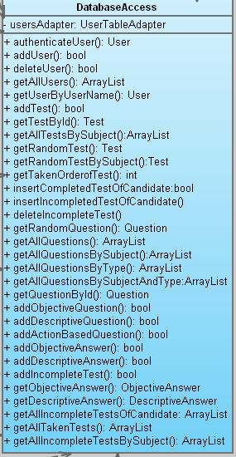

This class is a part of Database Package and enable all other classes to connect database efficiently. To handle database connection operation we implement ed one member and 31 methods for this class:

**Members:**

* userAdapter: userTableAdapter object that enable to search and bring data from database

**Methods:**

* authenticateUser(): authenticate users as Admin or Candidate.
* addUser(): enable adding a user to database.
* deleteUser(): deletes auser info from database.
* getAllUsers(): brings the information about all users.
* getUserByUserName(): brings user data for a specified name.
* addTest(): enable adding a new test to database.
* getTestById(): brings the information about a test specified by Test ID..
* getAllTestsBySubject():For a specified test subject brings all the test info.
* getRandomTest(): brings the data of a test randomly
* getRandomTestBySubject():For a specified test subject brings a test info randomly
* getTakenOrderofTest(): brings the taken order of a test
* insertCompletedTestOfCandidate(): insert a completed test info into database
* insertIncompletedTestOfCandidate():insert an incompleted test info into database
* deleteIncompleteTest(): deletes the info for an incompleted test
* getRandomQuestion(): brings the data of a random question
* getAllQuestions():brings the information about all questions.
* getAllQuestionsBySubject():brings the information about all question for a specified subject.
* getAllQuestionsByType():brings the information about all question for a specified type.
* getAllQuestionsBySubjectAndType: brings the information about all question for a specified subject and type.
* getQuestionById():brings the information about all question for a specified question ID.
* addObjectiveQuestion(): add data of an objective type question.
* addDescriptiveQuestion():add data of a descriptive type question.
* addActionBasedQuestion():add data of an action based type question
* addObjectiveAnswer():add data of an objective type answer
* addDescriptiveAnswer():add data of an objective type answer
* addIncompleteTest():add data of an incompleted test
* getObjectiveAnswer():brings data of an objective type answer
* getDescriptiveAnswer():brings data of an objective type answer
* getAllIncompleteTestsOfCandidate: for a candidate brings data of all incompleted tests.
* getAllTakenTests():brings data of all taken tests.
* getAllIncompleteTestsBySubject():brings data of all incompleted tests for a specified subject.

## 2.4.22 Test

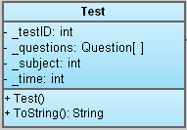

This class is also in Classes Package and designed to encapsulete the data of Test read from database. It has four members and two methods:

**Members:**

* _testID: keeps the primary key of the test in database
* _questions: keeps the information about question of the tests in a Qustion array
* _subject: keeps the subject of the test as int
* _time: keeps the time information of the test

**Methods:**

* Test(): is the class constructor
* toString(): overrides toString method