**INSTALLATION & USER MANUAL**

*Project Enlightenment*

*Computer Training For Visually Impaired Automation Tool (CTVIAT)*

Prepared By: Project Enlightenment

Date: January 8, 2011

Version No: v1.1

**Document Change Control**

The following is the document control for revisions to this document.

|  |  |  |  |
| --- | --- | --- | --- |
| Version Number | Date of Issue | Author(s) | Brief Description of Change |
| 1.0 | 01/05/11 | Project Enlightenment | Document created |
| 1.1 | 01/08/11 | Project Enlightenment | New key events |
|  |  |  |  |
|  |  |  |  |

**Definition**

The following are definitions of terms, abbreviations and acronyms used in this document.

|  |  |
| --- | --- |
| **Term** | **Definition** |
| CTVIAT | Computer Training for Visually Impaired Automation Tool |
| IUM | Installation & User Manual |
| WPF | Windows Presentation Foundation |
| SAPI | Windows Speech API |
|  |  |
|  |  |

Table Of Contents

1. INTRODUCTION 4

2. INSTALLATION 4

2.1 Preparing the Required System Environment 4

2.2 Creating the Database on the Server 4

2.3 Installing the CTVIAT 5

3. ADMIN OPERATIONS 10

3.1 Login 10

3.2 Create a User 11

3.3 Create a Question 12

3.4 Create a Test 13

3.5 Create a Report 14

4. CANDIDATE OPERATIONS 15

4.1 Login 15

4.2 Solve Test(s) 15

4.3 Keyboard Shortcuts 15

# INTRODUCTION

This document is for giving information about how to install and use the CTVIAT. The installation is consists of following steps:

* Preparing the required system environment
* Creating the database on the server
* Installing the CTVIAT

Moreover, the user manual part is divided into two main parts:

* Admin Operations
* Candidate Operations

# INSTALLATION

## Preparing the Required System Environment

Hardware Requirements:

* At least 256 MB display card with hardware acceleration
* 2 core CPU (recommended)
* 2 GB Ram Memory (recommended)
* Database server

Software Requirements:

* Windows Vista or Windows 7
* .NET 4.0 Client Profile
* WPF which comes in .NET 4.0 Client Profile
* Windows Speech API
* Microsoft SQL Server

## Creating the Database on the Server

The CTVIAT database must be created with provided script. Then, one login account must be matched with the created database. This login account will be used for client machines to connect the database server.

## Installing the CTVIAT

Installation steps:

* Double click the “ProjectEnlightenmentInstaller.msi” to start installation
* Click Next Button in the following screen

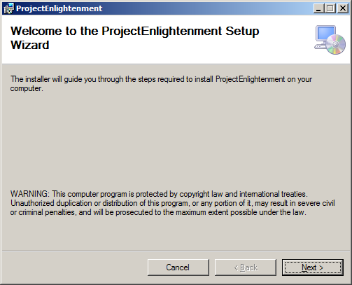

* Enter connection string that describes the database server like the following formats:

Data Source=*YourDatabaseServer*;Initial Catalog=*YourDatabaseName*;Integrated Security=False;User ID=Your*LoginAccount*;Password=*YourPassword*

Data Source= *YourDatabaseServer*;Initial Catalog= *YourDatabaseName*;Integrated Security=True

* After entering the connection string click the “Next” button

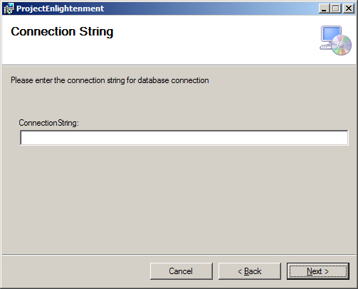

* Choose the application target installation directory and installation mode
* [Optional] You can learn disk space requirements by clicking the “Disk Cost” button
* After choosing the target folder, click the “Next ” button

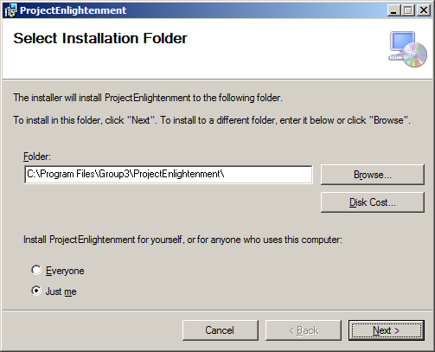

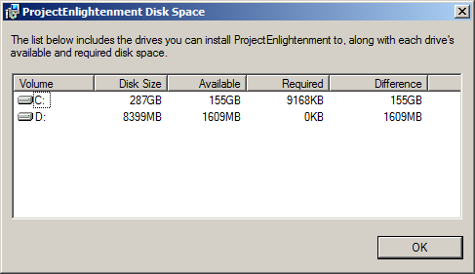

* Click the “Next” button to start the installation

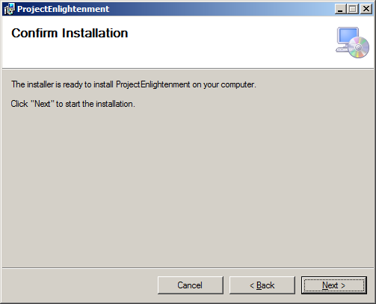

* Installation is in progress

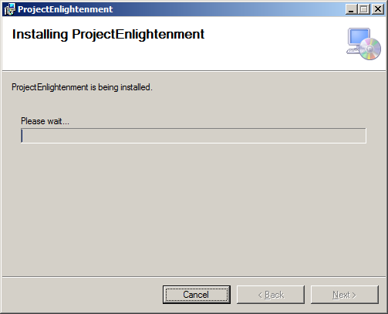

* Installation is completed, click the “Close” button to exit

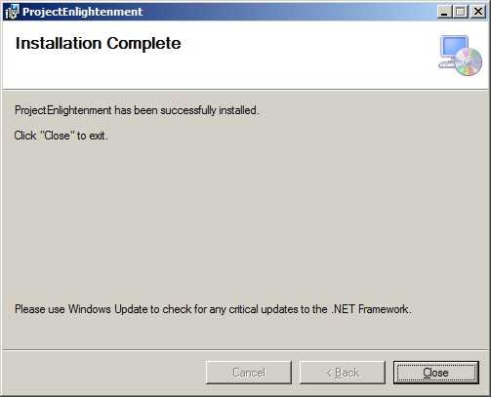

# ADMIN OPERATIONS

In this section, the operations that can be performed by the administrative user will be described.

## Login

* Enter username and password
* Click “Enter” button or press “Enter” key

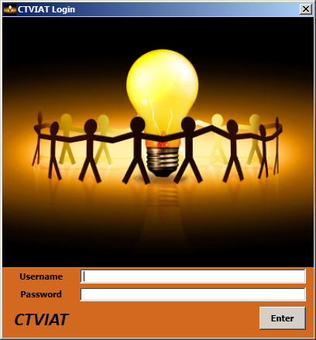

* After the successful login, you will see the following screen

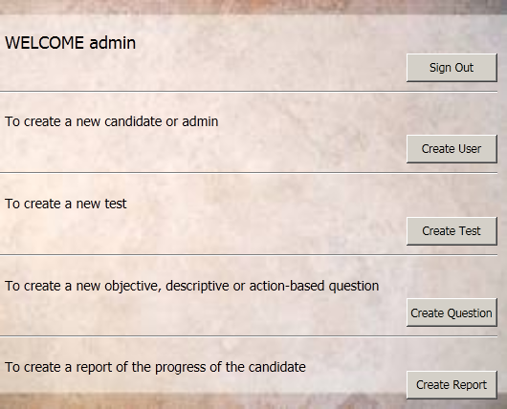

## Create a User

* Provide a username which has not given before
* Provide a password and retype it
* Choose a user type – default is candidate
* Press “Create User” button

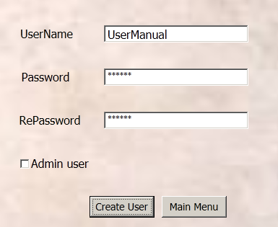

## Create a Question

* Choose the question type
* Choose the question subject
* Provide the question information
* Press the “Create Question” button

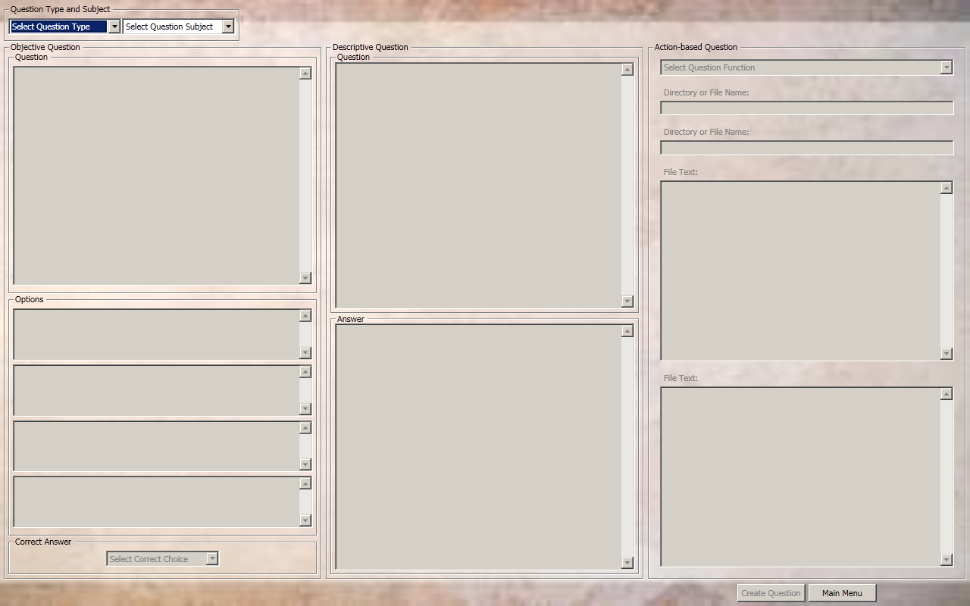

## Create a Test

* Choose the questions type
* Choose the questions subject
* Choose the test subject
* Select the questions you want to add to the test
* To add selected question(s) to the test, click “🡪” button
* To remove select question(s) from the test, click “🡨” button
* To create the test , click the “Create Test” button

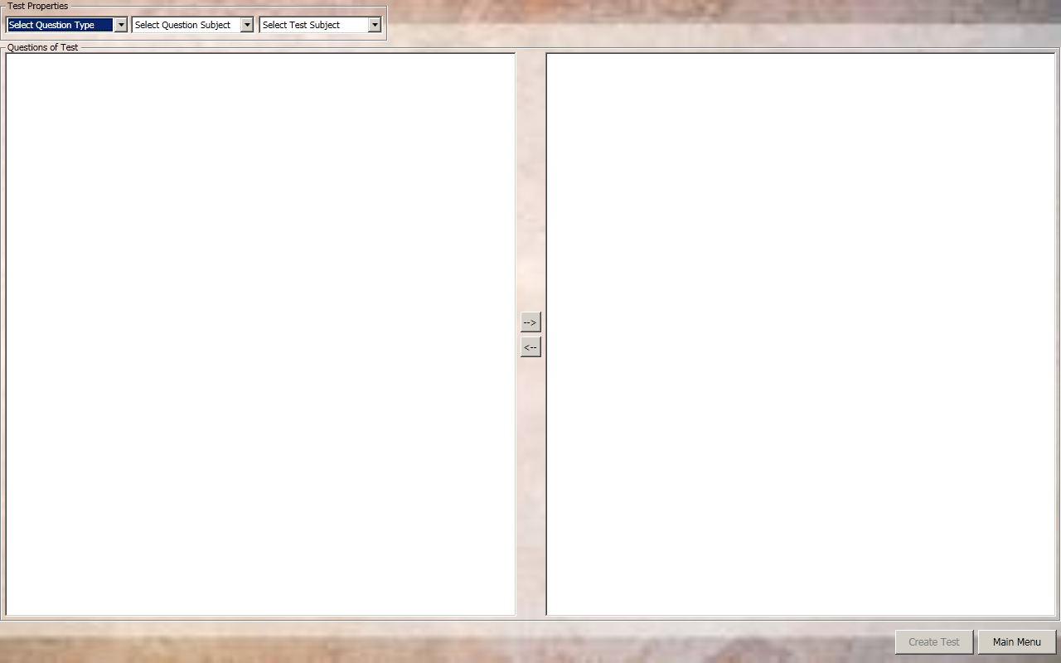

## Create a Report

* Search candidate usernames by providing the some part of the name
* Choose the candidate to report its progress
* Click the “Create Report“ button
* In the pop-up window, choose a directory to save the created report

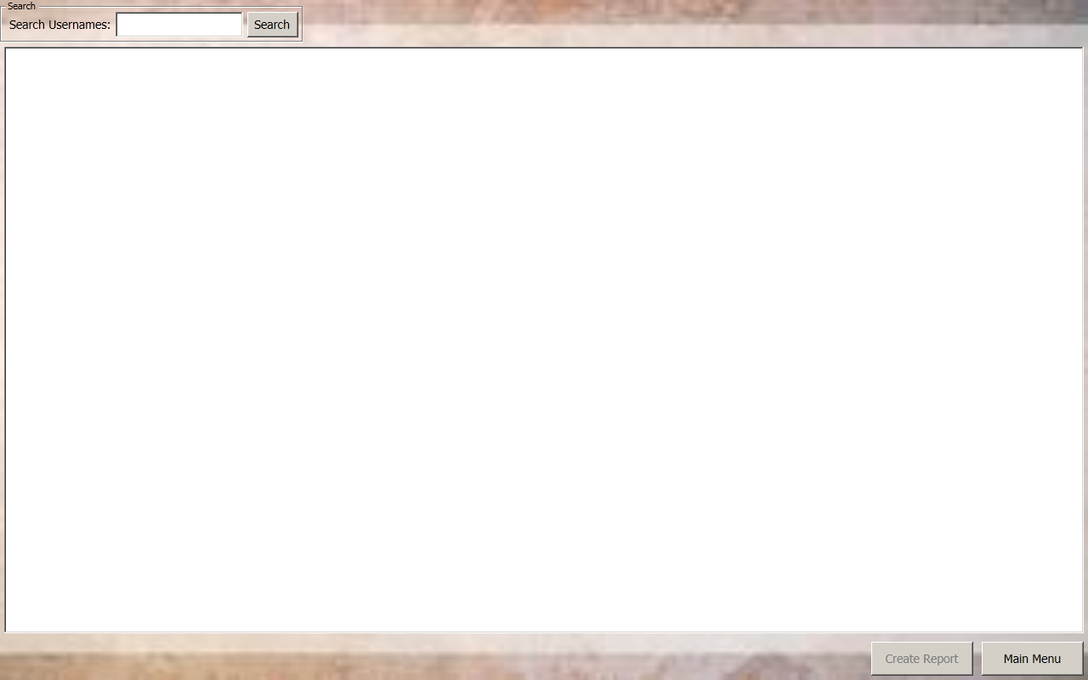

# CANDIDATE OPERATIONS

## Login

* Enter username and password
* Click “Enter” button or press “Enter” key



## Solve Test(s)

* Choose test subject (dialog or editing)
* Choose test freshness (old or new)
* Choose a test from the tests that are filtered according to selected properties
* Solve the test
* Listen the answers after finish
* Practice again or Sign out

## Keyboard Shortcuts

* At the beginning, candidate can listen the user manual by pressing Ctrl + M or can skip and interrupt the manual by pressing Ctrl + N.
* In the Test Subject Selection Screen
  + Press 1 for choosing dialog
  + Press 2 for choosing editing
  + Press Ctrl + N to continue next window
  + Press Ctrl + H for listening audio help
  + Press Ctrl + S to sign out
  + Press Ctrl + C to change voice
* In the Test Freshness Selection Screen
  + Press 1 for choosing new test
  + Press 2 for choosing old test
  + Press Ctrl + N to continue next window
  + Press Ctrl + H for listening audio help
  + Press Ctrl + S to sign out
  + Press Ctrl + B to return the previous window
  + Press Ctrl + C to change voice
* In Test Selection Screen
  + Press up or down to navigate in the test list
  + Press Ctrl + H for listening the audio help
  + Press Ctrl + N to start the selected test
  + Press Ctrl + B to return the previous window
  + Press Ctrl + S to sign out
  + Press Ctrl + C to change voice
* In Test Solving Screen
  + Press Ctrl + N to move next question
  + Press Ctrl + B to return the previous question
  + Press Ctrl + F to finish solving
  + Press Ctrl + D to discontinue solving
  + Press Ctrl +T to listen the elapsed time
  + Press Ctrl +R to listen the question
  + Press Ctrl + H to listen the audio help
  + For objective questions
    - Press 1 for option 1
    - Press 2 for option 2
    - Press 3 for option 3
    - Press 4 for option 4
    - Press 5 to unselect the options
  + Press Ctrl + C to change voice
* In Test Answer Listening Screen
  + Press Ctrl + N to move next question
  + Press Ctrl + B to return the previous question
  + Press Ctrl + F to finish listening the answers
  + Press Ctrl +R to listen the answer
  + Press Ctrl + H to listen the audio help
  + Press Ctrl + C to change voice
* In the last Screen
  + Press Ctrl + P to practice again
  + Press Ctrl + S to sign out
  + Press Ctrl + H to listen the audio help
  + Press Ctrl + C to change voice