**Requirements Analysis Document**

*Project Enlightenment*

*Computer Training For Visually Impaired Automation Tool (CTVIAT)*

Prepared By: Project Enlightenment

Date: November 24, 2010

Version No: v2.0

**Document Change Control**

The following is the document control for revisions to this document.

|  |  |  |  |
| --- | --- | --- | --- |
| Version Number | Date of Issue | Author(s) | Brief Description of Change |
| 1.0 | 21/10/10 | Project Enlightenment | Phase 1 - Preliminary draft for Phase 1 |
| 2.0 | 24/11/10 | Project Enlightenment | Phase 1 & 2 – conform to new framework template, update for Phase 2 deliverables |
|  |  |  |  |
|  |  |  |  |

**Definition**

The following are definitions of terms, abbreviations and acronyms used in this document.

|  |  |
| --- | --- |
| **Term** | **Definition** |
| CTVI | Computer Training for Visually Impaired |
| RAD | Requirements Analysis Document |
| CTVIAT | Computer Training for Visually Impaired Automation Tool |
| JFW | JAWS for Windows |
| SDD | Software Design Document |
| ODD | Object Design Document |
| CPU | Central Processing Unit in a Computer |

Table of Contents

1. INTRODUCTION 3

1.1 PURPOSE OF THE SYSTEM 3

1.2 SCOPE OF THE SYSTEM 3

1.3 OBJECTIVE AND SUCCESS CRITERIA OF THE PROJECT 4

1.4 DEFINITIONS, ACRONYMS AND ABBREVIATIONS 4

1.5 REFERENCES 5

1.6 OVERVIEW 5

2. CURRENT SYSTEM 5

3. PROPOSED SYSTEMS 6

3.1 FUNCTIONAL REQUIREMENTS 6

3.2 NONFUNCTIONAL REQUIREMENTS 7

3.2.1 USER INTERFACE AND HUMAN FACTORS 7

3.2.2 DOCUMENTATION 7

3.2.3 HARDWARE CONSIDERATION 7

3.2.4 PERFORMANCE CHARACTERISTICS 8

3.2.5 ERROR HANDLING AND EXTREME CONDITIONS 8

3.2.6 SYSTEM INTERFACING 8

3.2.7 QUALITY ISSUES 8

3.2.8 SYSTEM MODIFICATIONS 9

3.2.9 PHYSICAL ENVIRONMENT 9

3.2.10 SECURITY ISSUES 9

3.2.11 RESOURCE ISSUES 10

3.3 PSEUDO REQUIREMENTS 10

3.4 SYSTEM MODELS 10

3.4.1 SCENARIOS 10

3.4.2 USE CASE MODEL 11

3.4.3 DYNAMIC MODEL 13

3.4.4 OBJECT MODEL 15

3.4.5 NAVIGATIONAL PATHS FOR THE CTVI AUTOMATION TOOL 18

4. GLOSSARY 18

# INTRODUCTION

## PURPOSE OF THE SYSTEM

This paper describes the details of Computer Training for Visually Impaired (CTVI) Automation Tool. The CTVI enables visually impaired students to take some teaching courses followed some training exercises on the computers to test their knowledge at Enable India. Since process of correcting the exercises is currently done manually by trainers, it is an exhaustive and time consuming task. The Automation Tool we present here automates this process. Its main purpose is to make the training program more productive, efficient and accurate.

By automating the training process, the tool also aims to make evaluation process take no more than a minute. Also, since the automation is used, the evaluations are supposed to be 100% true. Moreover, tests are not needed to evaluate by instructors but by the automation, this automation decreases the efforts of instructors. From a student’s perspective, since each student will log in to the system, choose a test and with no help rather than automation tool finish the test by herself and at the end of test will see her score, this automation also speeds up feedbacks to students and that helps students improve. Besides, at any time, the student has a chance to repeat a test. Also, no manual intervention is needed to correct the exercises. All the controls, checks and hints will be provided by the Automation Tool. Furthermore, the tool presents a secure platform, because each student can log in to the system with their own accounts. This clearly prevents a third person to reach student’s private information.

From an admin or a trainer’s perspective, the tool purposes to reduce the burden of controlling, correcting and pursuing the testing process. Also, the tool allows creating tests in different modules of instructions (such as editing, word, excel) and in different types (e.g. objective, descriptive or action based), adding questions to question bank, designing specific question papers to perform examination of students. Besides, it monitors actions of students during the examination by both giving question specific assistance to help finish their tests and correcting the exercises when the student fails to handle a question. This alleviates the need for manual intervention of a trainer. Furthermore, the tool evaluates all examinations and creates a student specific report for the trainers.

The CTVI Automation tool also aims to have a friendly interface for the students to use tool efficiently.

## SCOPE OF THE SYSTEM

The CTVI Automation Tool is implemented for two kinds of users: vision-impaired students and CTVI trainers (or administrators). Those students who are capable of using a computer with the help of Braille-based tools are the primary users of Automation Tool. These users require no other additional computer experience. All the support to use the tool efficiently will be supplied by the tool itself.

The CTVI Administrators are the main beneficiaries of the Automation Tool. The tool performs all the tasks for each day the trainers perform manually. What administrators are required to do is just login to system and use the tool and benefit from the facilities of the tool. For example, trainers can create and add questions to question bank, create tests from the questions in the question bank for the students, analyze students’ testing performance from evaluation reports, etc.

The tool will be designed such that all the user related properties will be accessible by any user and she will require minimum knowledge when using the tool. Through this, users can receive more personalized services and obtain relevant information with relatively less effort and time.

## OBJECTIVE AND SUCCESS CRITERIA OF THE PROJECT

Security (or a secure platform) is one of the most important success criteria. Since users log in to system with their own accounts, secure maintenance of user-specific data is required. Otherwise, user data will be accessed by third-parties and testing process fails to satisfy both students’ and trainers’ trust.

System reliability which means system services will function correctly is also an important success criterion. If a system is unreliable, it is difficult to ensure system safety or security also. Thus, both reliability and security are inter-related issues.

Another important success criterion is scalability which means system should cope with new demands by adding new resources. This can be handled through careful design and implementation of the Automation Tool.

## DEFINITIONS, ACRONYMS AND ABBREVIATIONS

The acronyms and abbreviations used in the text are as follows:

CTVI : Computer Training for Visually Impaired

RAD : Requirements Analysis Document

CTVIAT : Computer Training for Visually Impaired Automation Tool

JFW : JAWS for Windows

SDD : Software Design Document

ODD : Object Design Document

CPU : Central Processing Unit in a Computer

## REFERENCES

* Advanced IT Education for the Vision Impaired via e-Learning <http://jite.org/documents/Vol8/JITEv8p243-256Armstrong685.pdf>
* NanoPac, Inc. , Technology for Independence<http://www.nanopac.com/>

## OVERVIEW

The Automation Tool is designed for the visually impaired students in order to give computerized help during the training and increase the independence and productivity of the students. This clearly means that no need for a trainer during examination and also this automation makes the process more efficient in terms of time and accuracy. To use the tool both admin and trainee should log in to system with their own accounts and thus, gets a variety of services from the tool.

In the following sections both functional and non-functional requirements, system models such as use case diagrams, scenario diagrams, class diagrams will be mentioned in detail.

# CURRENT SYSTEM

Computers are an invaluable tool in helping to level the playing field for people with visual impairments. Blind or visually impaired persons can be taught skills which include the use of special tools to enable word processing, data entry, use of Internet and more.

Although we designed CTVI Automation Tool from scratch, currently a wide range of computer based assistive technology is available to help the visually impaired. Popular tools include JAWS (which offers a complete line of screen readers for the vision impaired), JAWS JFW (jaws for windows, a version of jaws that reads information from a computer display and speaks it to you), **Braille Translation Software (that** allows anyone who may or may not be Braille literate to translate text to Braille) and GW Micro's Window-Eyes (designed to provide blind users access to Windows based computers by speaking the contents of the computer's screen). However, none of them can be thought as ancestor software for Automation Tool described in this document.

Some tools mentioned above use hardware modifications to completely replace the keyboard or mouse for visually impaired users who cannot operate these standard devices. Also, speech input provides another option for individuals with disabilities. Speech recognition systems allow users to control computers by speaking words and letters. For example, a particular system is "trained" to recognize specific voices. Some assistive technology programs that run on off-the-shelf computers can speak the text on the screen or magnify the text in a word processor, web browser, e-mail program or other application. For example, In Windows 2000, ME, XP and NT, there is an accessibility wizard, which walks the user through a series of Windows appearance options. These include adjustments for the font size, screen resolution, scroll bar size, icon size, color scheme, mouse cursor appearance and mouse cursor blink rate.

To sum up, PCs usually employ input devices like keyboards and mice for entering information and for controlling the system. Adapting PCs for use by visually impaired involves the modification of these standard input and output devices with assistive hardware or software. However, in this project, the implementation of the CTVI Automation Tool will not need such hardware modifications, since the Automation Tool will just run as an ordinary computer program and students will communicate with computer through Braille-based tools which are already presented to them. In other words the visually impaired students do not need any hardware rather than Braille-based tools which are not a part of our design, to use the Automation tool.

# PROPOSED SYSTEMS

## FUNCTIONAL REQUIREMENTS

The functional requirements of the CTVIAT can be grouped into three main parts: opening menu, administrator menu and candidate menu.

Opening menu of the CTVIAT will be a main window of the program. When a user opens the program, through opening menu users will see two options which are candidate menu and administrator menu. In addition, she can choose a language from available languages. Then, another window will open according to the user type and the language.

Administrator menu of the CTVIAT will be available for only administrators. To log in as an admin, one should have admin account of the CTVIAT. Administrator can log in by her username and password to the CTVIAT, in order to create questions for the question-bank, select the questions for to create and edit the questions that were previously set.

Candidate menu of the CTVIAT will be available for one who wants to take tests. The user logs in to CTVIAT with her individual account.

When an administrator logs in, at admin menu, there will be two options: either she will access the question form or test creates form. At question form part, administrator will be able to create new questions, edit questions and delete questions. On the other hand, at the test create form part, admin will be able to create new tests, edit tests and delete tests.

## NONFUNCTIONAL REQUIREMENTS

### USER INTERFACE AND HUMAN FACTORS

User Interface of the system is the initial nonfunctional requirement of the system. There will basically be two groups of users who will interact with the tool. The first group involves administrator and the second one consists of candidates. The admin has the privilege to create the questions for the question-bank. Also, she is supposed to select the questions to create and edit the questions that were previously set.

On the other hand, the candidate may be considered as the user who is administered with the test. The candidate logs into the program with her individual logins. She has the privilege to take tests which are created by admin. She is allowed to choose test about any subject. She is also informed about their test results, retakes tests.

In any case, the user interface of the application will be designated to have features that are as simple as possible and easy to use. Also, the menus and buttons will be self-explanatory enough to leave no doubts about their function.

### DOCUMENTATION

There will be no need for User Manual. Since the user interface will be designed as simple as possible, an extra printed documentation for users is not required. The customers will be able to access a Frequently Asked Questions and a help section from all the necessary screens.

Apart from the user documents, there will be other documents that are going to be delivered for the design phase, namely: RAD (Requirement Analysis Document), SDD (Software Design Document) ODD (Object Design Document), and TM (Test Document), Standard Security and Quality Document.

### HARDWARE CONSIDERATION

CTVI Automation Tool is implemented and designed to be a tool that automate the evaluation of visually impaired students undergoing basic computer training at an NGO called Enable India.

The system database is provided by a server. Each computer that CTVI Automation Tool is installed will be client. By means of this client-server architecture, the database is aimed to be updatable.

The tool is designed to operate in standard computers which Windows (XP, Vista or Windows 7) are used and have enough memory to hold databases, mp3 files, or any data that can be used by the tool.

### PERFORMANCE CHARACTERISTICS

The system should be fast enough to take data from database. The tool should have a good database connection. It should monitor the actions of the trainees during the test and at the end of the test, and it should come up with an evaluation of how well the trainee has performed. Because of these issues, performance of the system has an important part.

### ERROR HANDLING AND EXTREME CONDITIONS

Any unforeseen errors detected on the test phase are adjusted separately by the developers of the program in order to ensure system integrity. Error handling and the extreme conditions will be taken into account during the functional testing, environmental testing and performance testing.

In CTVI Automation Tool, error handling and extreme conditions should be handled by the developers of the program in order to ensure system integrity.

In CTVI Automation Tool, the user is supposed to log in to system. First of all, whether user name and password is in the database or these data is matched to each other should be checked. After that, in same exercises, the candidate is asked to save the file and provide the program with the location of the corrected document. For this kind of exercises, the possibility of that the file is not included in that location must be considered, and the user must be informed about that error.

### SYSTEM INTERFACING

CTVI Automation Tool will be in contact with two types of users: administrator and candidate. For the usability of the program, system interface must be as simple as possible. Also, the buttons must be explanatory for ease of the tool. System interfacing is also important for the other type of users, administrators. The administrator should be able to generate individual reports based on each individual user’s performance. The instructions/questions and the answer choices should be editable by the admin at any stage of the exercise/question bank preparation. So, system interfacing must be easy and usable to satisfy the users’ expectations.

### QUALITY ISSUES

Quality is considered as an important concept in our project. A good-quality product should have some properties. One of these properties is error-free running of the system. Some errors could be caused by software and some of them by hardware. Hardware errors are not under the responsibility of our project, but some hardware errors that caused by software are in this project’s responsibility.

Reliability, efficiency and ease of use stand as the most emerging part of the quality of service. Also another feature for quality that concerns this tool is functionality. The tool should be functional so that people can use it. The latter concerns the user interfaces, the functionality during the tool.

The number of bugs should be decreased as much as possible, handling of the extreme conditions should be as satisfactory as possible, and the ease of use of the tool should be maximized.

### SYSTEM MODIFICATIONS

The program is supposed to be upgraded to add new features to the tool if needed. According to the feedback from the users, new versions of the tool should be launched. Also, there can be added new question types, new subjects to be more helpful. Moreover, the system can be turned into a mobile applications or an internet application according to the requests of the users of the system.

### PHYSICAL ENVIRONMENT

Computer Training for Visually Impaired Automation Tool (CTVI Automation Tool) can be used in standard Windows (XP, Vista or Windows 7) environment. During the development of the tool, developers will try to take into account all existing computers. If tool cannot be compatible with all existing computers, then the newest computers will be considering as tool platform.

The speed of the CPU is not important as a physical environment because our tool is going to be able to be run in the computer that has the lowest CPU in the market now. Our tool should be suitable for personal computers in terms of memory usage.

### SECURITY ISSUES

Security is another important issue for that tool. All users have their own data. So, the access to the system must be controlled. The candidates should have individual logins to the application. Because, they are supposed to review their results, check their answers vis-à-vis that of the correct ones. So, we need to be sure of the security of the personal information of our users. The password system is an inevitable way to secure the system.

### RESOURCE ISSUES

In this project, this tool will be a product which has a candidate system, therefore candidate wants to install and use the application on her personal computers.

The system installation can be done by the developers and maintained by computer/software engineers or the system administrator who has sufficient knowledge about the underlying structure of the program.

## PSEUDO REQUIREMENTS

The tool is designated to operate in standard Windows (XP, Vista or Windows 7) environment. Therefore, it should be implemented to satisfy this constraint.

The input files for the questions are stored in text files. At this point of time, implementation of a database interface is not incorporated.

## SYSTEM MODELS

### SCENARIOS

1. A *CTVI Automation Tool* candidate who wants to take a test logs in the system using her username and password, which is given previously to her by the system administrator. After the submission of the username and password, they are checked for authentication, and if one of them fails, candidate is prompted to enter the username and password again. After the acceptance of the username and password, she is free to take a test. The candidate, who has already logged in, has the following options:

* One of them is taking a new test from one of available modules such as editing, dialog, windows explorer, word, excel.
* Another option is to retake a test that hasn’t been completed from one of available modules.
* The user can also retake a previously completed test from one of available modules to check his knowledge and performance progress in the selected test.
* The candidate, who has already logged in and selected a test, tries to perform the given instructions. While doing so, he is able to re-read the instructions/questions word by word or line by line or letter by letter, choose multiple choice answers by the use of numeric keys (instead of having to deal with radio buttons or combo boxes).

1. To perform an action-based instruction proceeds as follows: The program instructs the candidate to perform a specific task, and then the candidate does what is needed and acknowledges the system by clicking the “DONE” button. If the task was done correctly, the system gives alternative ways of performing the task if there is any. If not, the system warns the candidate, gives hints and waits until the candidate performs the task correctly.
2. To perform an objective type instruction as follows: The program instructs the candidate to answer a multiple choice question, and then the candidate chooses an answer and acknowledges the system by clicking the “DONE” button. The system gets the answer and gives next question. When the test is finished correctness of the answers is checked and results are shown.
3. To perform a descriptive type instruction as follows: The program instructs the candidate to answer a descriptive question, and then the candidate types an answer and acknowledges the system by clicking the “DONE” button. The system gets the answer and gives next question. When the test is finished, for each question, provided answer and its correct answer are shown.

The candidate, who is taking a test:

* She can complete the test
* She can give up the test to continue at a later time and log out.

A *CTVI Automation Tool* administrator logs in the system using his username and password. After the submission of the username and password, they are checked for authentication, and if one of them fails, candidate is prompted to enter the username and password again. After the acceptance of the username and password, he is free to do some operations.

1. The admin, who has already logged in, has the following options to do:

* One of them is to create a question of a certain type with specifying its module. There are three types of questions:
  + Action-based either in text or mp3 format.
  + Objective either in text or mp3 format.
  + Descriptive either in text or mp3 format.
* Moreover, he can supply some hints. After the completion of the question, the question is added to the question bank and the hint(s) are added to the hints database.
* Another option is to create a question paper with questions in the question bank with specifying its module.
* The other option is to generate individual reports based on each individual user’s performance.

### USE CASE MODEL

#### Actors

There are two types of actors in the system: the “candidate” and the “admin” actor. Each of them will have access to the system through different interfaces and will accordingly use the related routines to be serviced appropriately.

#### Use Cases

Six main use cases have been decided to manage the system. These are the “Login”, the “Generate Statistics”, the “Create Question Paper”, the “Create Question” and the “Logout” functions used by the “admin”, the “Login”, the “Solve Test” and “Logout” functions used by the “candidate”. The “Login” and the “Logout” cases are shared among the two actors.

Use case diagram below describes the interaction between the system actors and the related use cases.



Figure 3.1 Use case diagram

### DYNAMIC MODEL

#### Sequence Diagrams

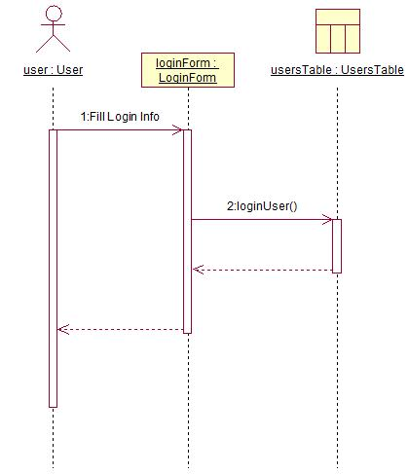

Figure 3.2 Sequence diagram of login into the system

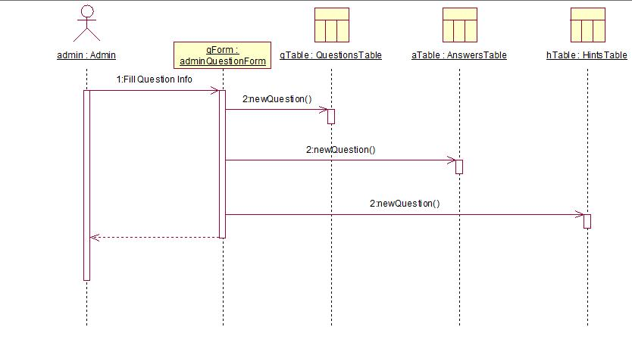

Figure 3.3 Sequence diagram of creating a question

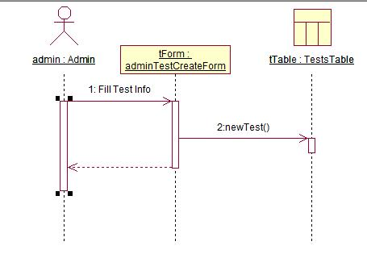

Figure 3.4 Sequence diagram of creating a question paper

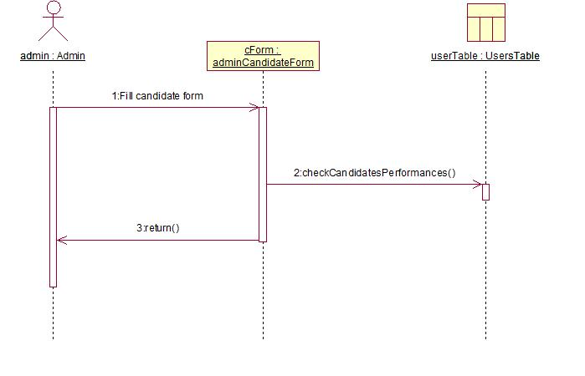

Figure 3.5 Sequence diagram of getting statistics of a candidate

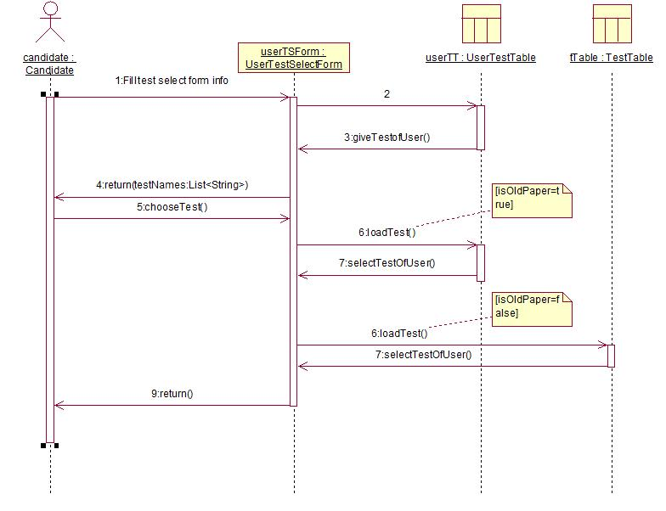

Figure 3.6 Sequence diagram of solving a test

### OBJECT MODEL

#### Data Dictionary

1. Users are the main actors of the Automation Tool. User ID uniquely identifies a customer and password is used for authentication purposes. Identification information includes name and user type. There will be two types of users, Admin and Candidate, which have different features in the tool.
2. Tests are the main objects of the tool which consists of Test ID, a list of Question IDs, a list of Answer IDs and a list of Hint IDs. Test ID uniquely identifies a test and we can select the test we want anytime easily with its answers.
3. User Tests (userTestsTable) will be the tests that a candidate takes. It consists of User Test ID, Test ID, User ID, Test Time and user answers. This structure lets us to users to find their past tests with their answers, to continue their unfinished test and to take a test several times.
4. Questions will be created by Admins and stored according to their Question ID. Besides there will be a decisive variable called Question Type ID which will help us to create the relevant interface for the question.
5. Answer and Hints will be objects which are special for Questions and their Ids uniquely identify them.

#### Class Diagram

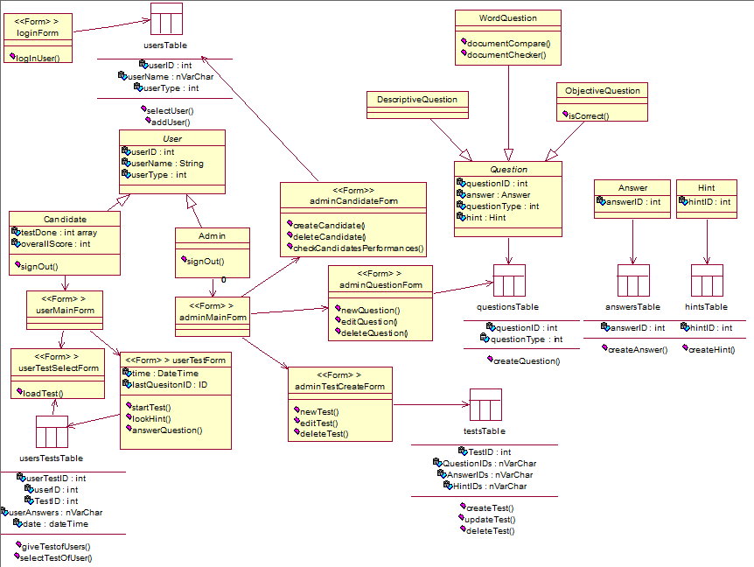

Figure 3.7 Class diagram

### NAVIGATIONAL PATHS FOR THE CTVI AUTOMATION TOOL

There are two different navigational paths present in the CTVI Automation Tool, corresponding to two different actors of the model. Candidates can only solve tests. Admins have three options, namely create question, create question paper and report statistics of a candidate.

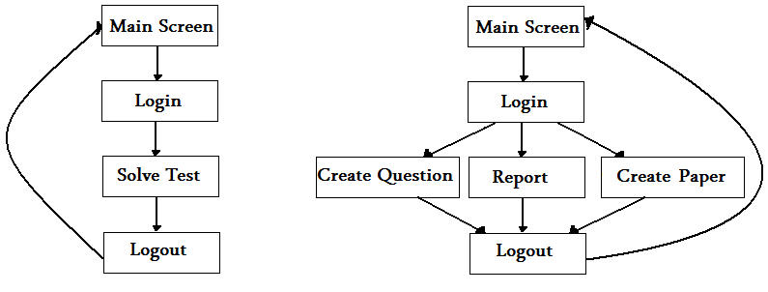

Figure 3.8 Navigational paths for candidate (left) and admin (right).

# GLOSSARY

**Action-based questions:** They require the candidate to perform a specified task on his computer while the test is being administered.

**Admin:** The admin has the privilege to create the questions for the question-bank, select the questions for a test, to create and edit the questions that were previously set.

**Analysis / Correct Answer List:** This is the repository of the correct answers to the Question Bank.

**Braille System:** It was devised in 1821 by Frenchman Louis Braille, is a method that is widely used by the blind to read and write. Each Braille character, or "cell," is made up of six dot positions, arranged in a rectangle containing two columns of three dots each. A dot may be raised at any of the six positions to form sixty-four combinations (including the combination in which no dots are raised).

**Candidate:** The user who is administered with the test is termed as the candidate. The candidate logs into the program with his individual logins and takes the test.

**CTVI (Computer Training for Visually Impaired):** The CTVI program consists of training visually impaired trainees with computer skills such as word processing, spreadsheets, document management etc. The trainees interact with the computer through Braille-based tools that act as replacements for the screen, the mouse and the keyboard.

**Descriptive questions:** They have descriptive answers which cannot be compared / checked by the program for its accuracy.

**Hints database:** This will contain the hints required for action based questions.

**Objective type questions**: They are multiple choice questions where the candidate is given 4-5 answer options from which he can choose the right answers.

**Question Bank:** A question bank is the set of all questions under each topic / module. The idea of creating a question bank is to build a repository of questions so that question papers can be created by choosing relevant questions.

**Question Paper:** The list of questions picked up from the Question Bank under each topic (usually each question paper consists of around 10-15 questions picked by the admin / test creator).