

Marmara University

Faculty of Engineering

CSE333 Operating Systems

Project #1 Report

150114012 – Onur İzmitlioğlu

150115009 – Ferhat Özkan

Due Date : 26.10.20171

Input control and error handling is done in every script. Menu script is done and it is working without bugs. Commends are written for every script attached with the report. Screenshots showing input and output values are included. The rar file also has a folder named as “testfolder” which includes our test files and test folders.

Question 1

**Test Input**

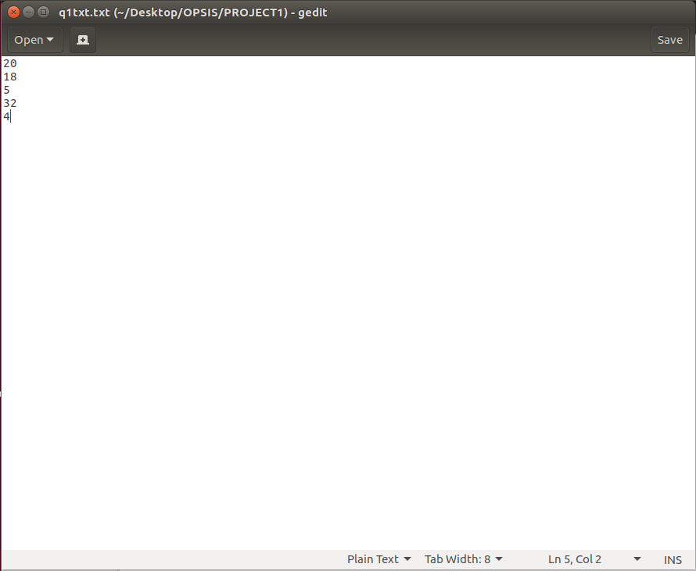

**Code**

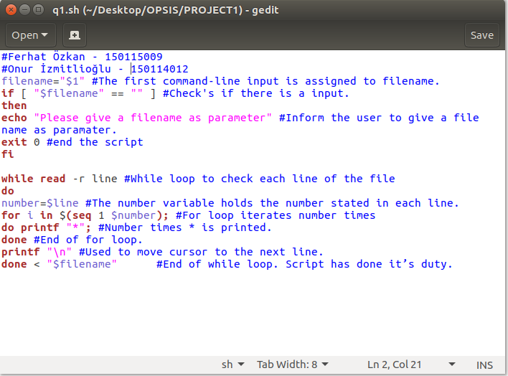

**Outputs**

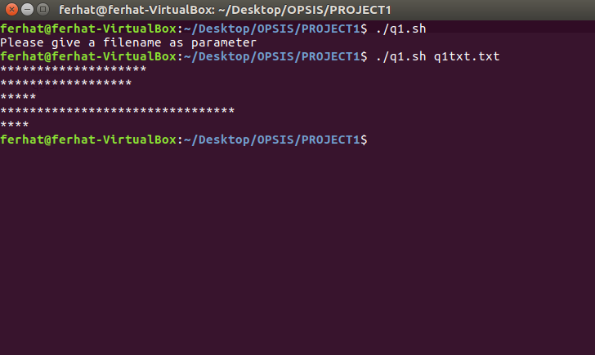

Question 2

**Test Input**

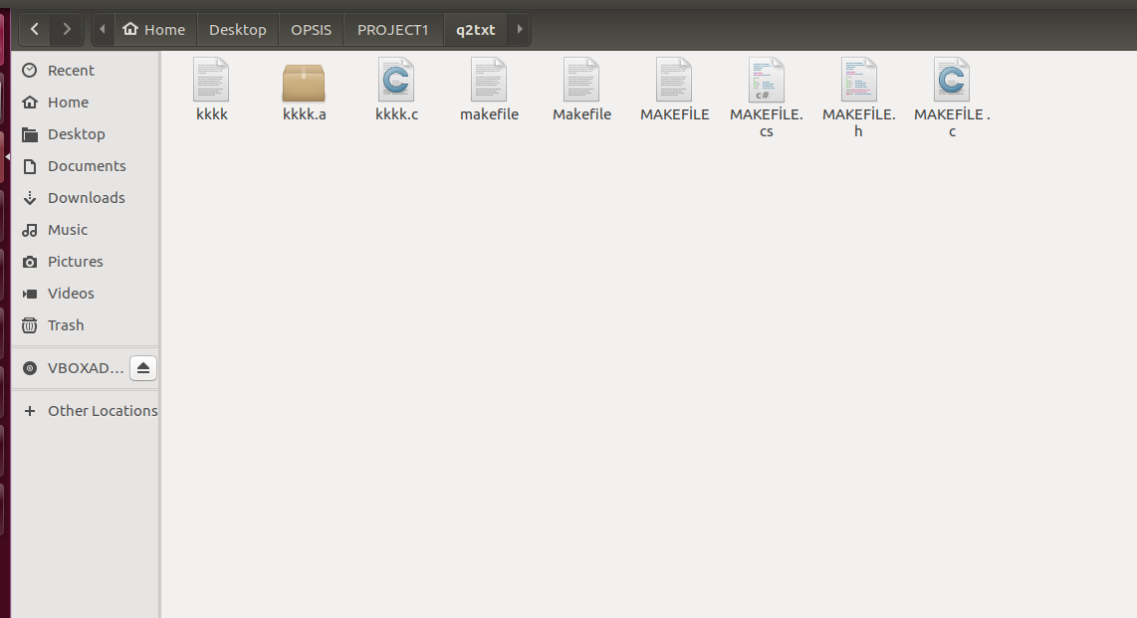

**Code**

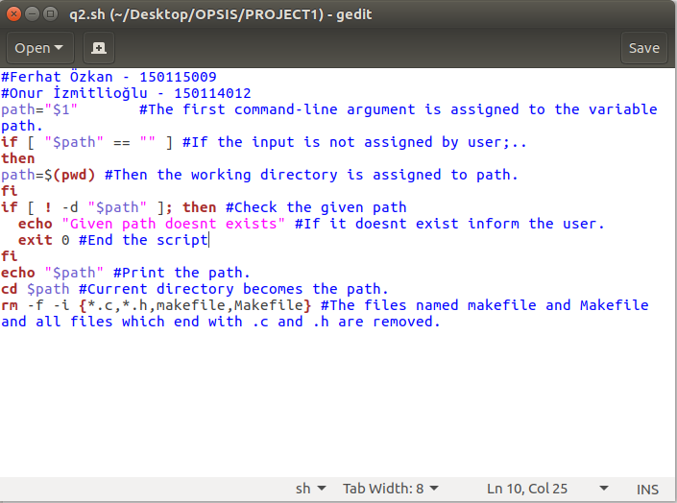

**Outputs**

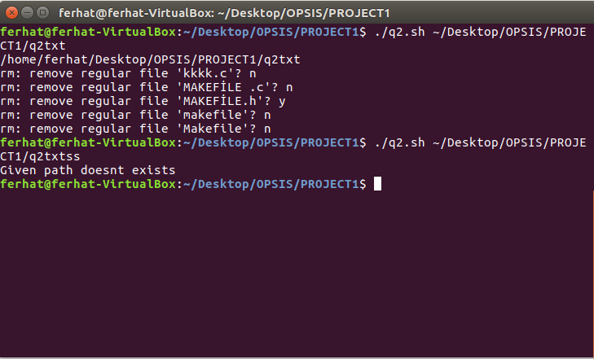

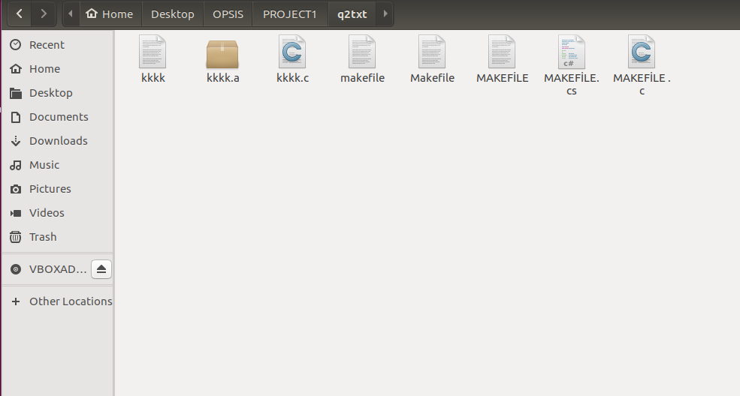

Question 3

**Test Input**

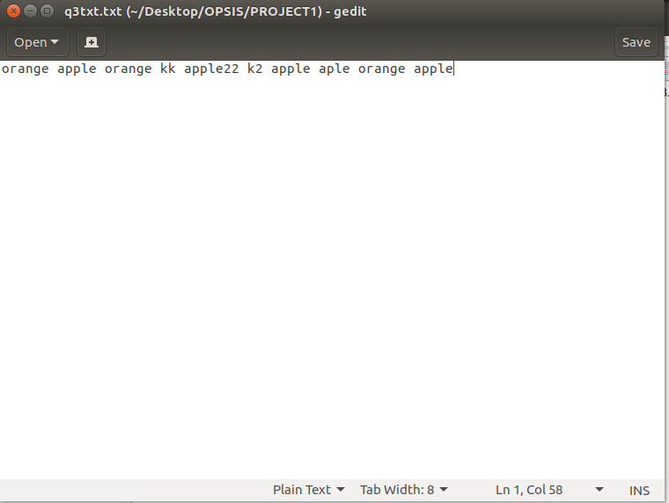

**Code**

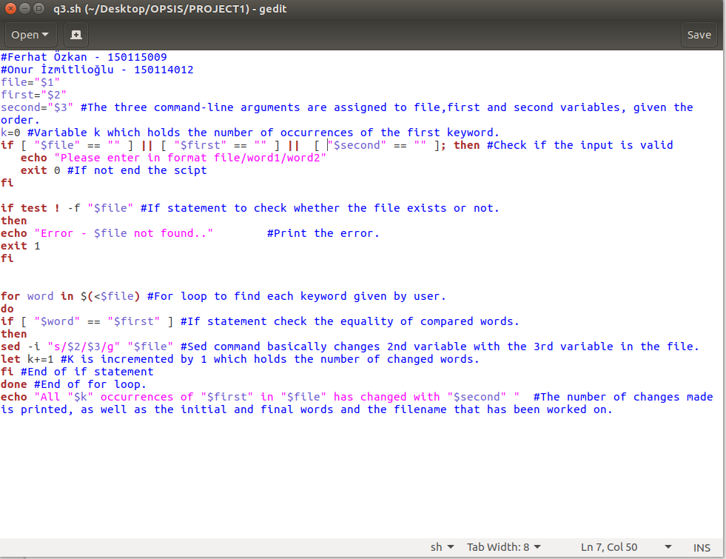

**Outputs**



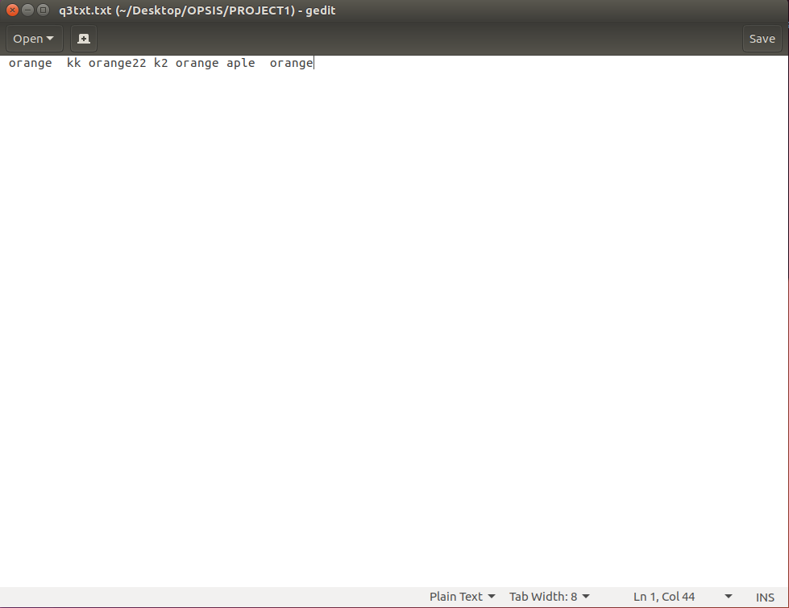

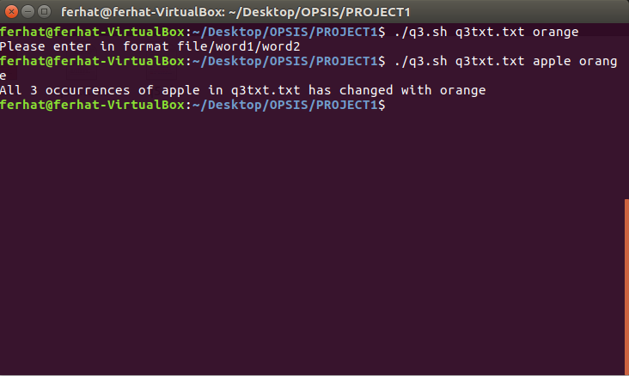

Question 4

**Test Input**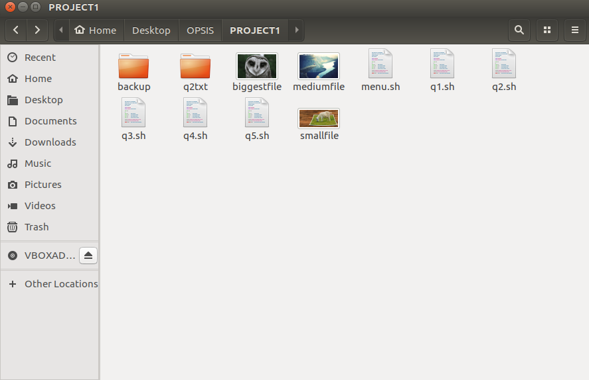

**Code**

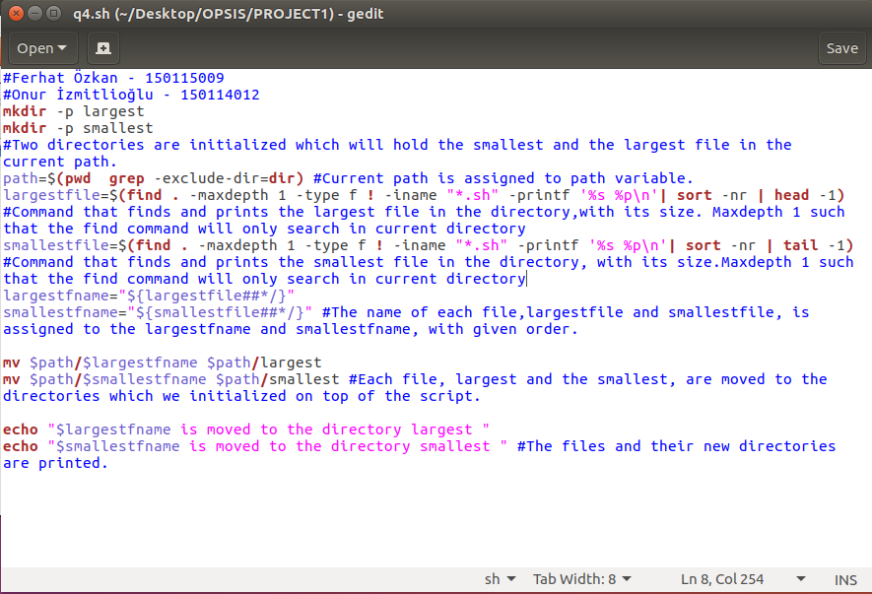

**Outputs**

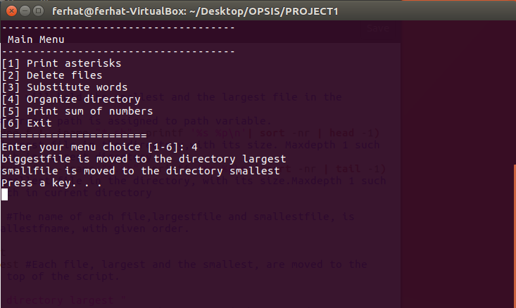

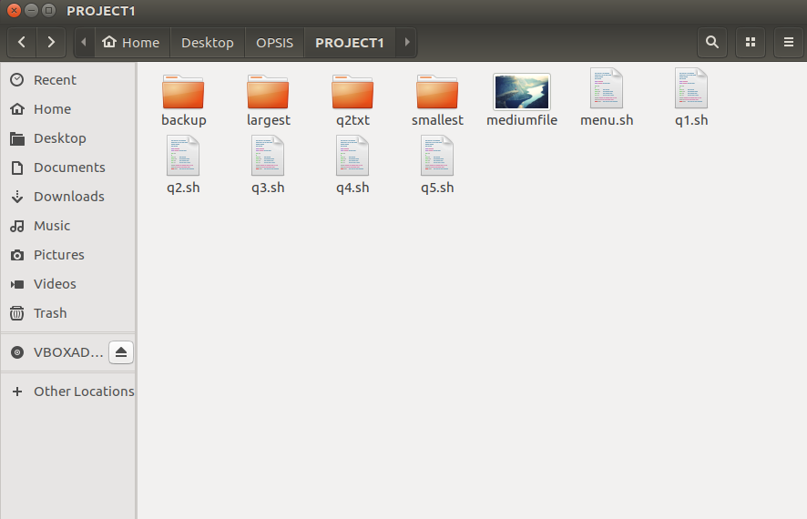

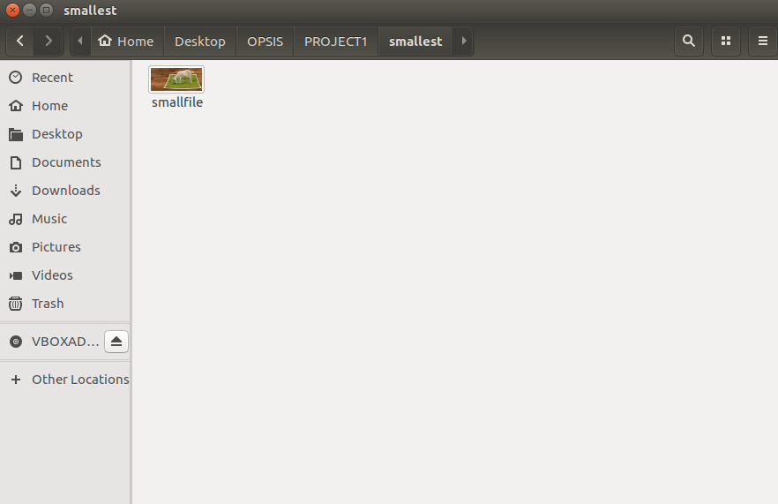

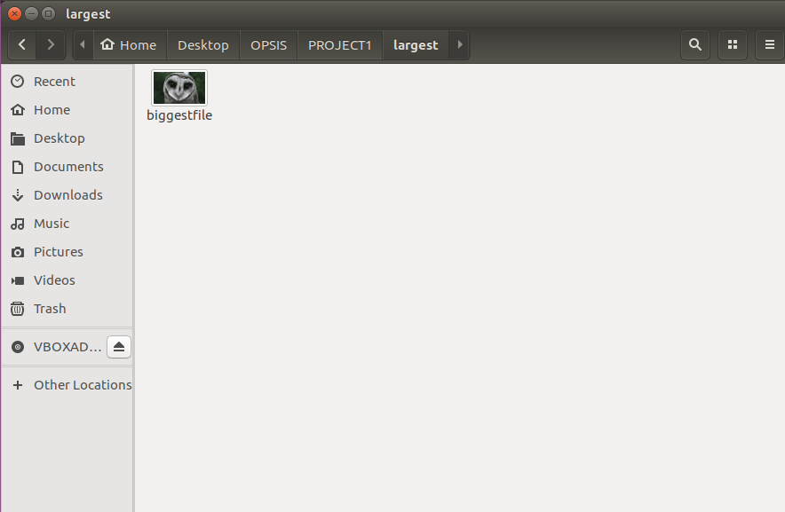

Question 5

**Test Input**

-9 🡪 Will give an error and inform about right input type

Jd 🡪 Will give an error and inform about right input type

5614 🡪 Will give result 122.

**Code**

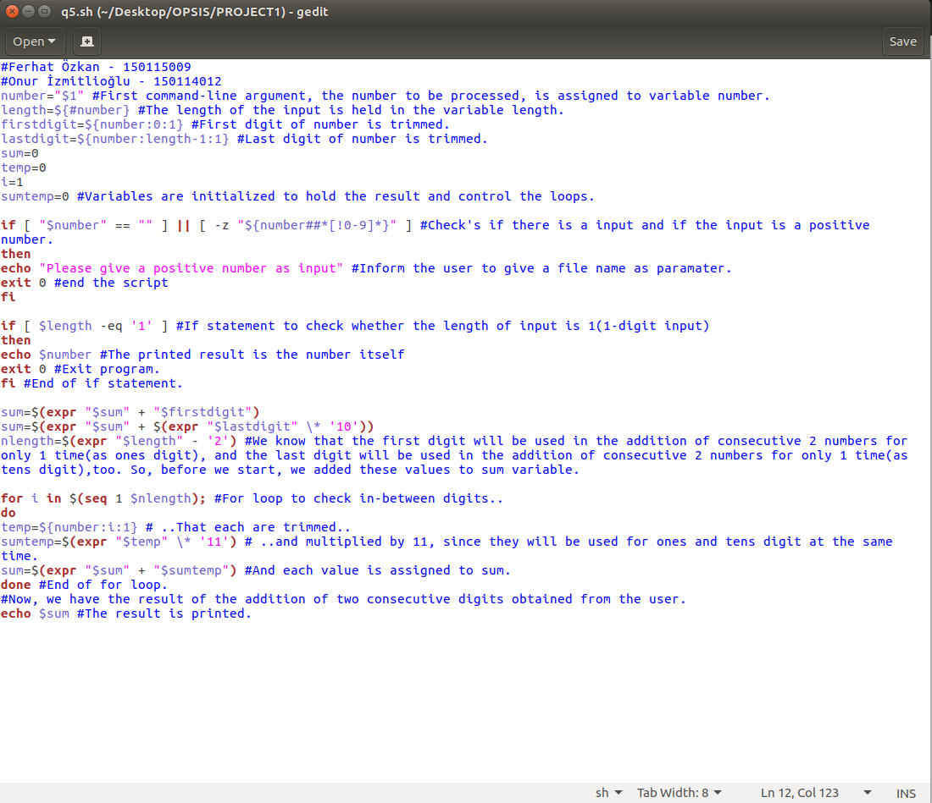

**Outputs**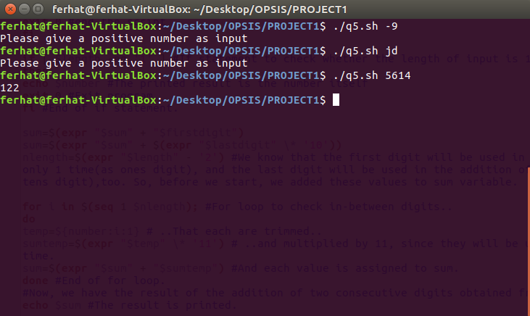

**MENU**

