Gebze Technical University
Computer Engineering

CSE 222 - 2018 Spring

HOMEWORK 3 REPORT

FERHAT ŞİRİN
161044080

Course Assistant:

INTRODUCTION

Problem Definition
Part 1)
Controling a list that has so many elements using a program. Easily access its data with the code and get a group of data.
Part 2)
Extra contol for java LinkedList. User can easly block data without removing it after done it can be enabled.
Part 3)
Circular list inside a circular list. Elements that is in the same group is connected each other via circular list.

System Requirements
Part 1)
public Course getByCode(String code)
public LinkedList<Course> listSemesterCourses(int semester)
public LinkedList<Course> getByRange(int start, int end)
Course class is used with this function.
public Course(int semester,String code,String name,int ECTS,int GTU)
Course class constructor

Part 2)
public boolean enable(E obj)
public boolean disable(E obj)
public void showDisabled()

Part 3)
public Course add(Course obj)
public Course remove(Course obj)
public Course next()
public Course nextInSemester()
Course Class is used with these functions like part 1.

METHOD

Class Diagrams
Part 1)
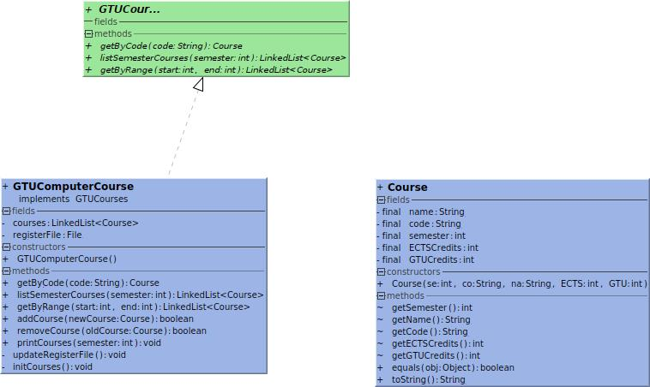

Part 2)

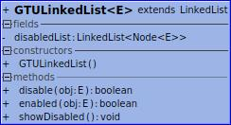

Part 3)

Use Case Diagrams
Part 1)
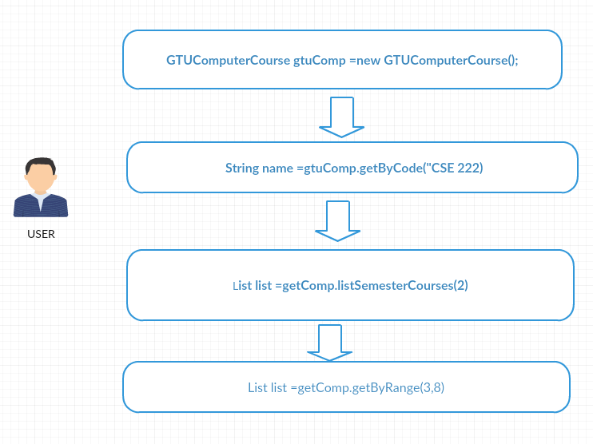

Part 2)

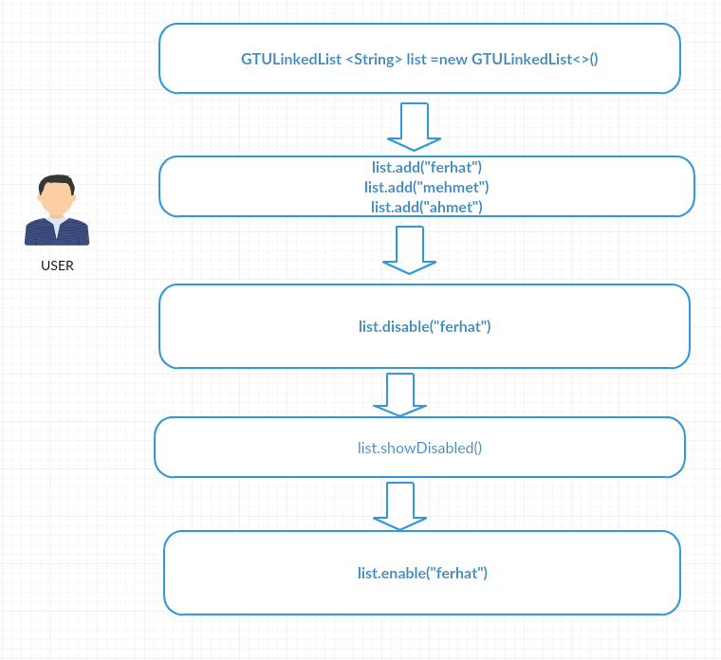

Part 3)
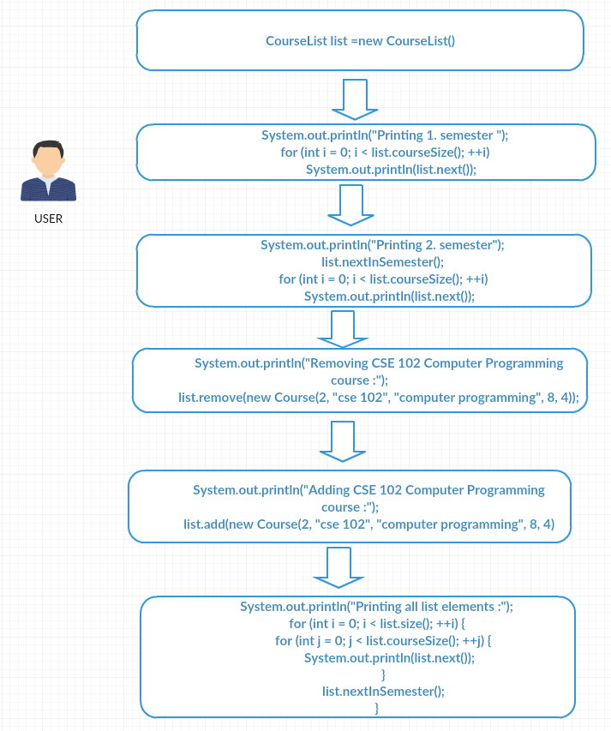

Problem Solution Approach
Part 1)
Java LinkedList used in this part. Course class is written to make data transfer easy among the function. Course class includes everthing about a course. GTUComputerCourse reads data from file and help user to use information in that file via getByCode, listSemesterCourse and getByRange.
Part 2)
Java LinkedList is extended in this part. Super class features stay as default. Disable enable and showDisabled added as helper. Another LinkedList data structure is used to hold disabled list data.
Part 3)
A data structure like CircularLinkedList is created in this part. Data is held via Nodes. There are two nodes which is NodeSemester and NodeCourses which is inside NodeSemester to hold data. NodeSemester hold semester first data (head) and NodeCourses hold the corresponsign courses data.

2.4 Asymptotic Notations
Part 1)
public Course getByCode(String code){
for(int i=0;i<courses.size();++i){
if(courses.get(i).getCode().equalsIgnoreCase(code)){
return courses.get(i);
}
}
throw new NoSuchElementException(code);
}
O(n)

public LinkedList<Course> listSemesterCourses(int semester){
if(semester < 1|| 8 < semester){
throw new ArrayIndexOutOfBoundsException(semester);
}
int i;
for(i=0; courses.get(i).getSemester() != semester;++i){
}
LinkedList<Course> list =new LinkedList<>();
for(;i < courses.size() && courses.get(i).getSemester() == semester ;++i)
list.add(courses.get(i));
return list;

n number of all course and k is number of that semester course
max(θ(n) + θ(k))

public LinkedList<Course> getByRange(int start, int end){
if(start < 0 || end <= start || courses.size() < end){
throw new ArrayIndexOutOfBoundsException(start);
}
LinkedList<Course> list =new LinkedList<>();
for(int i =start; i<=end ;++i)
list.add(courses.get(i));
return list;
n =end – start
θ(n)

Part 2)
public boolean disable(E obj){
int i =indexOf(obj);
if(i != -1){
remove(i);
disabledList.add(new Node(obj,i));
return true;
}
return false;
indexOf(obj) is O(n)
disable itself θ(1)
result is O(n)

public boolean enable(E obj){
for(int i=0;i<disabledList.size();++i) {
if (disabledList.get(i).data.equals(obj)){
add(disabledList.get(i).index,obj);
disabledList.remove(i);
return true;
}
}
return false;
disableList size n
O(n)

public void showDisabled(){
for(int i=0;i<disabledList.size();++i){
System.out.println(disabledList.get(i).data);
}
}
θ(n)
Part 3)
public Course add(Course obj) {
if(head ==null){
head =new NodeSemester(obj);
tail =head;
indexSemester =head;
indexCourse =indexSemester.courseHead;
courseSize =indexSemester.courseSize;
++size;
return obj;
}
NodeSemester semester =head;
for(int i=0;i< size;++i){
if(semester.courseHead.data.getSemester() == obj.getSemester()) {
NodeSemester.NodeCourse newCourse =new NodeSemester.NodeCourse(obj);
semester.courseTail.next =newCourse;
newCourse.next =semester.courseHead;
semester.courseTail =newCourse;
++semester.courseSize;
return obj;
}
semester =semester.nextSemester;
}
semester =new NodeSemester(obj);
tail.nextSemester =semester;
semester.nextSemester =head;
tail =semester;
++size;
return obj;
list size =n and different semester added
Tworst = O(n)
list size =0
Tbest =ɵ(1)

public Course remove(Course obj) throws NoSuchElementException {
if(head != null){
NodeSemester temp =head;
for(int i=0;i<size;++i){
if(temp.courseHead.data.getSemester() == obj.getSemester()){
if(temp.courseHead.data.equals(obj)){
if(indexCourse == temp.courseHead)
indexCourse =indexCourse.next;
temp.courseHead =temp.courseHead.next;
temp.courseTail.next =temp.courseHead;
--temp.courseSize;
return obj;
}
NodeSemester.NodeCourse course =temp.courseHead;
for(int j=0; j< temp.courseSize-1;++j) {
if(course.next.data.equals(obj)){
if(course.next == temp.courseTail){
temp.courseTail =course;
}
course.next =course.next.next;
--temp.courseSize;
return obj;
}
course =course.next;
}
}
temp =temp.nextSemester;
}
}
throw new NoSuchElementException(obj.toString());
}
Semester size n course size k
Tworst = O(n*k)
Tbest =ɵ(1)
public Course next() {
NodeSemester.NodeCourse old =indexCourse;
indexCourse =indexCourse.next;
return old.data;
}
ɵ(1)

public Course nextInSemester() {
NodeSemester old =indexSemester;
indexSemester =indexSemester.nextSemester;
indexCourse =indexSemester.courseHead;
courseSize =indexSemester.courseSize;
return old.courseHead.data;
}
ɵ(1)

RESULT

Test Cases
Part 1 )
All test cases in GTUCourseTest main function
Part 2)
All test cases in GtuLinkedListTest main function
Part 3)
All test cases in CourseListTest main function

Running Results
Part 1)
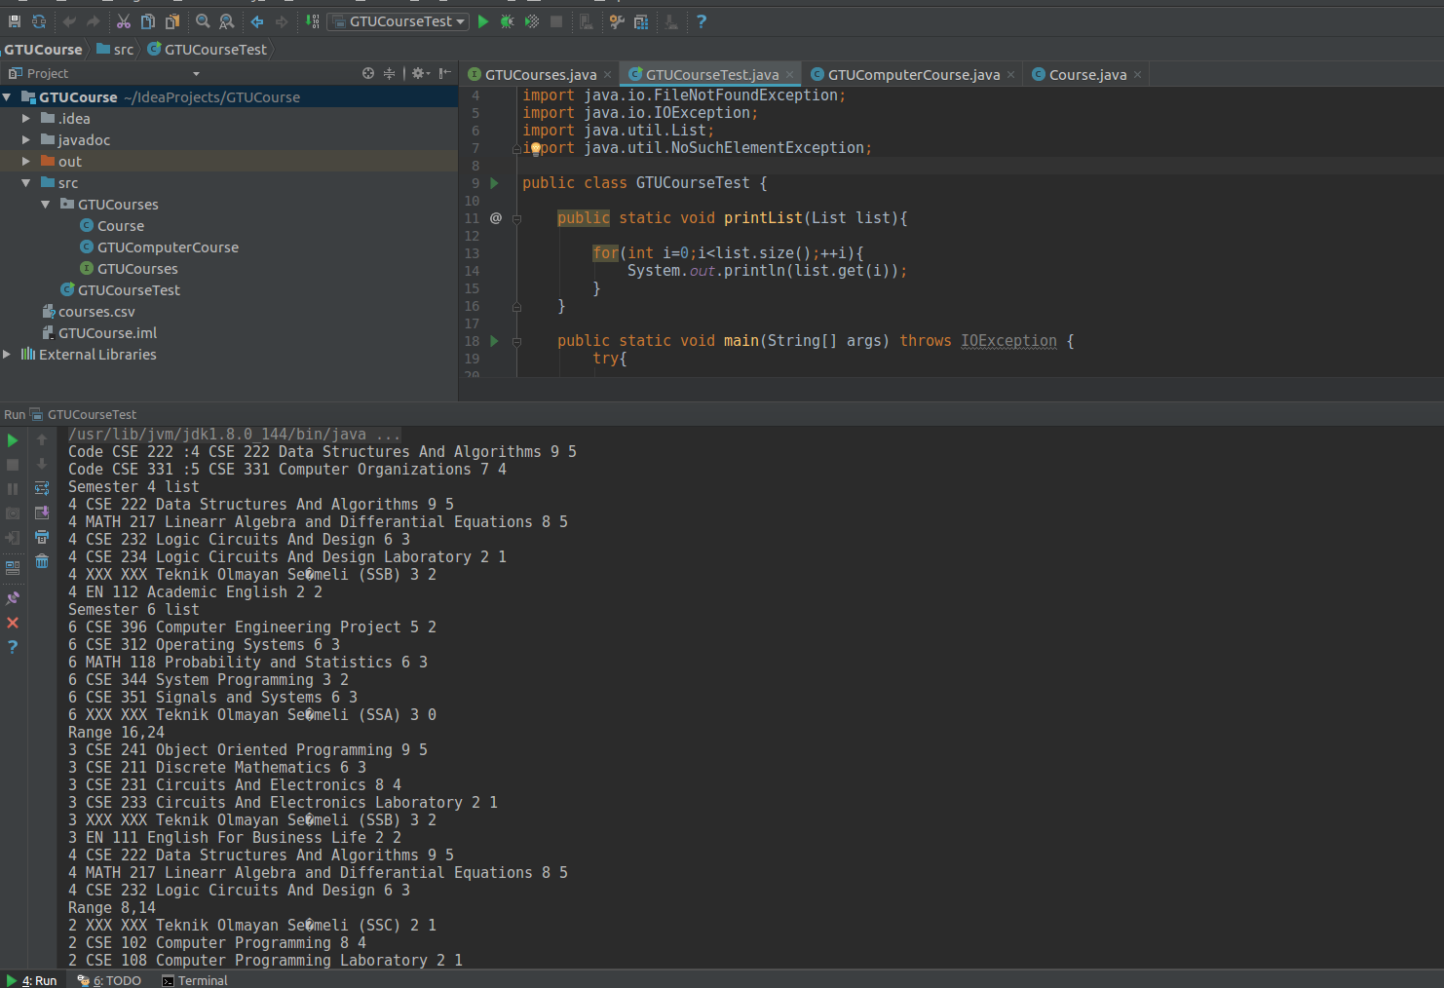

Part 2)
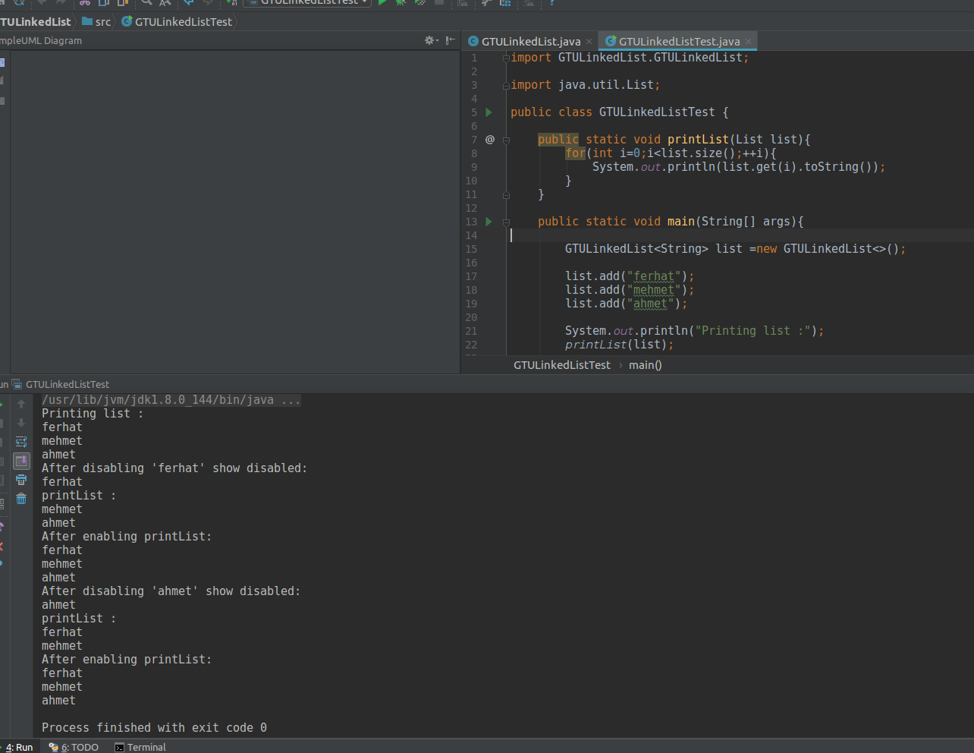

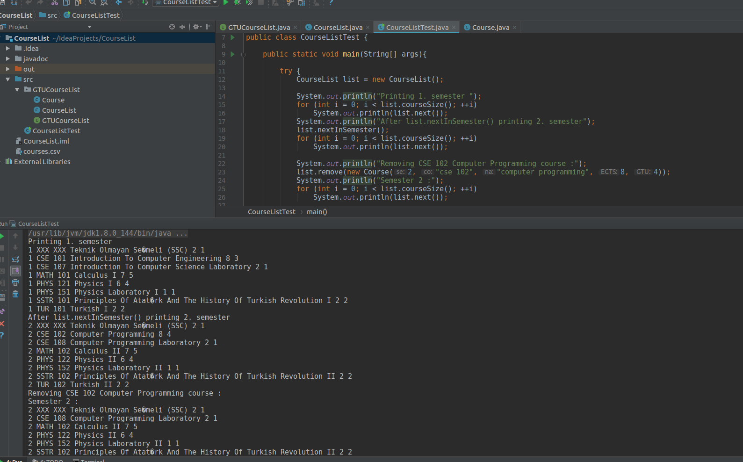
Part 3)

