Gebze Technical University
Computer Engineering

CSE 222 - 2018 Spring

HOMEWORK 4 REPORT

FERHAT ŞİRİN
161044080

Course Assistant:

INTRODUCTION

Problem Definition
Part 1)
General tree can have multiple child tree which can vary from each other. To represent a general tree we need a binary tree which first child is left node and others is right nodes of that left node.
Part 2)
Multidimensional search tree is a tree which every node is compared to others node related to their dimension. Left nodes is for smaller element at that dimension and right nodes for bigger element at that dimension. For each level down dimension increases.

System Requirements
Part 1 )
GeneralTree clas do not have any exception. Javadoc is written for all method about how to use them.

Part 2)
MultiDimenTree class is used with data types that implements List interface. (Vector, ArrayList, LinkedList..) Comparator class is needed for searching algorithm.
Class can be used like that.
CompareHelper<Integer> comp =new CompareHelper<>();
Comparator class for Integer type. This will be used in the constructor of MultiDimenTree class.
MultiDimenTree<Vector<Integer>> tree1 = new MultiDimenTree<>(comp);
Vector<Integer>[] arrList =new Vector[15];
arrList[0] =new Vector<>(Arrays.asList(new Integer[]{40,45,50}));
arrList[1] =new Vector<>(Arrays.asList(new Integer[]{20,70,60}))
Arrays.asList return a list with given array. This is used to make adding operation easy.
Tree1.add(arrList[0]); tree1.add(arrList[1]);

METHOD

Class Diagrams
Part 1 :
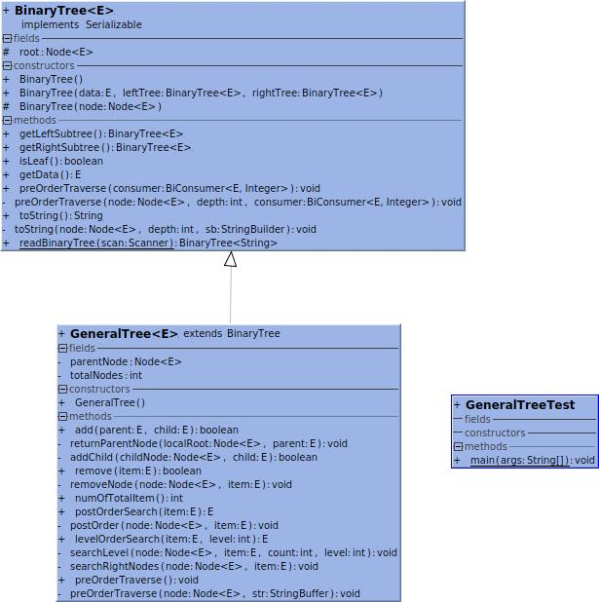

Part 2:
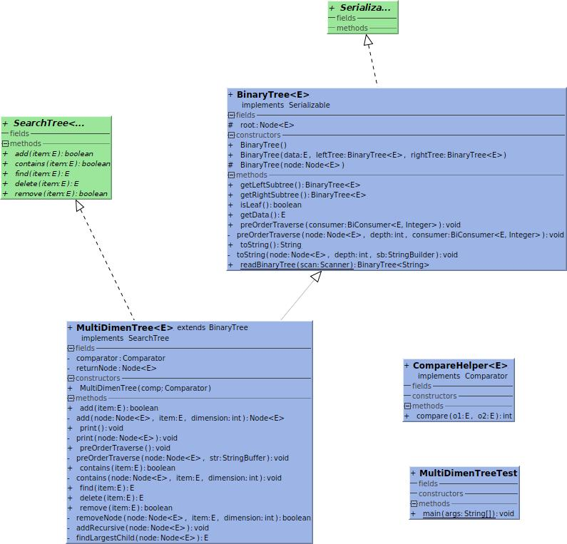

Use Case Diagrams
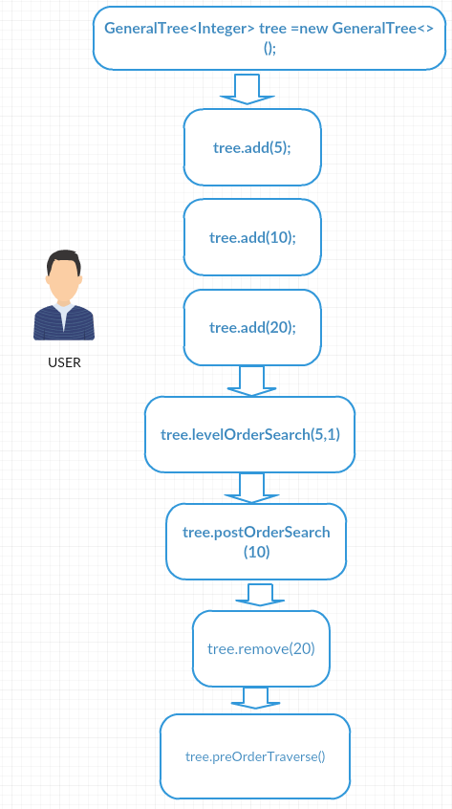
Part 1 :

Part 2 :
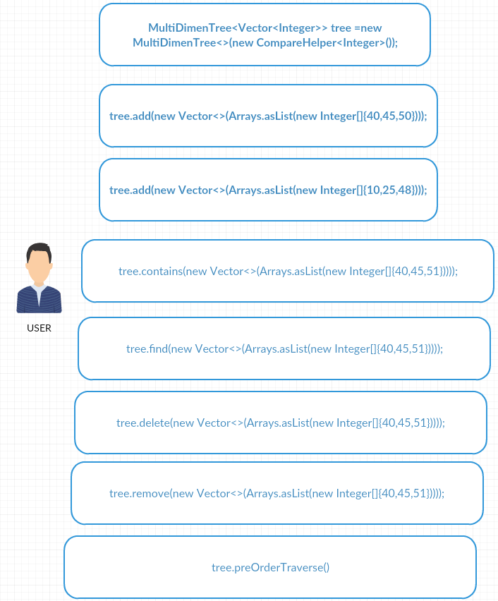

Problem Solution Approach
Part 1 )
All function uses recursive methods to solve problem. They have helper function to use recursive method with Node<E> class. These function private because Node<E> is private and root can not be accessed outside. Add function is used with a parent item to specify which parent child node is added to. Child node can be null when adding first node.
Remove method removes the leaf nodes because tree is general.
Part 2)
Multidimensional search tree is implemented in this part. For data type for this class should extend List interface. Every class implementing List interface can be used with this class.
(Vector , ArrayList, LinkedList...) and a proper Comparator class should be given for MultiDimenTree class. For Comparator class ComparatorHelper class can be used. All methods have helper function inside to solve the problem recursively.

2.4 Asymptotic Notations
Part 1)
public boolean add(E parent,E child){
if(root == null){
root =new Node<E>(parent);
++totalNodes;
if(child != null){
return add(parent,child);
}
else
return true;
}
else if(parent == null || child == null) {
return false;
}
parentNode = null;
returnParentNode(root,parent);
if(parentNode != null) {
if(parentNode.left ==null) {
parentNode.left = new Node<E>(child);
++totalNodes;
return true;
}
else{
return addChild(parentNode.left,child);
}
}
return false;
}

private void returnParentNode(Node<E> localRoot,E parent){
if(localRoot != null) {
if (localRoot.data.equals(parent)) {
parentNode =localRoot;
}
else {
if (localRoot.right != null) {
returnParentNode(localRoot.right, parent);
}
if (localRoot.left != null) {
returnParentNode(localRoot.left, parent);
}
}
}
}

private boolean addChild(Node<E> childNode,E child){
if(childNode.right == null){
childNode.right =new Node<E>(child);
++totalNodes;
return true;
}
else{
return addChild(childNode.right,child);
}
}

RESULT

Test Cases
All test cases are written to the main function of the programs.

Running Results
Part 1)
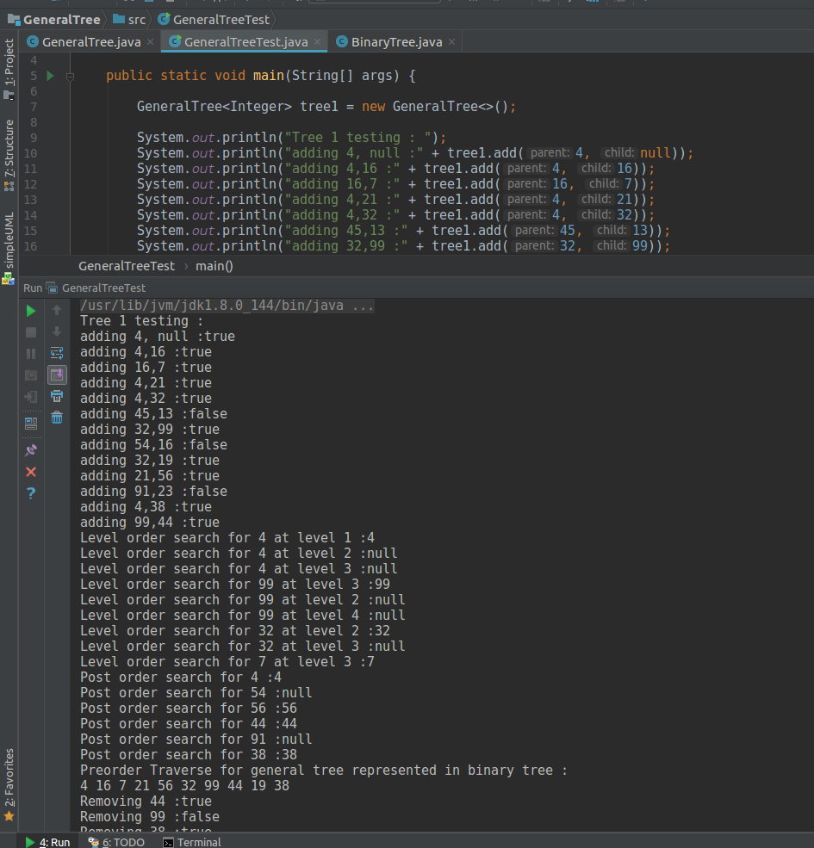

Part 2)
