**Insights into the spatiotemporal patterns of glacier algae across the Greenland Ice Sheet’s dark zone from integrating multispectral imaging and an inverse radiative transfer model.**

**Abstract**

The Greenland Ice Sheet (GrIS) is losing mass at an accelerating rate, mostly because of increases in surface melting. This is controlled by the surface albedo, which in turn is strongly influenced by the growth of glacier algae on the ice surface in the ice sheet ablation zone. This has been well-established at the local scale and methods for biomass detection exist but accurate biomass quantification at the regional scale remains a challenge. This limits our knowledge of glacier algae spatial ecology and biological albedo reduction. This paper demonstrates that simple band-ratio techniques borrowed from oceanography are not suitable for biomass detection over glacier ablation zones due to the confounding effect of ice physical development, meaning that the physical properties of the ice surface must be accounted for if we are to accurately quantify biomass concentration over ablating glacier ice. We propose a new system for biomass quantification using an inverse radiative tranfer model applied to the Sentinel-2 record at 3 day resolution over an area of 60,000 km2 that contains the so-called “dark zone” on the western GrIS. We use this system to examine the spatiotemporal development of the GrIS dark zone including the glacier algal coverage and biomass concentration, ice density and grain size.

**Introduction**

Greenland Ice Sheet (GrIS) mass balance increased by 47 ± 21 Gt/y between 1971-1980 but since then it has been consistently negative. Mass loss has accelerated from 51 ± 17 Gt/y between 1980-1990 to 286 ± 20 Gt/y between 2000-2018, an average acceleration of 80 ± 6 GT/yr per decade despite a recent series of anomalously cold summers and hjas raised sea levels by 13.7 mm since 1972 (Mouginot et al. 2019). This mass loss is the result of two processes: solid ice discharge into the oceans and surface mass balance (SMB), the latter of which is mainly due to surface melting. The proportion of the total mass loss contributed by each of these two processes has changed over time, with solid ice discharge contibuting most to overall mass loss over the past 46 years but SMB dominating the past two decades (Mouginot et al. 2019; Enderlin et al., 2014; van den Broeke et al., 2016). SMB is controlled by net solar radiation which is a function of incoming irradiance and surface albedo. The albedo changs dramatically over time, first when the winter snowpack retreats to reveal darker glacier ice (Ryan et al. 2019). The albedo of the glacier ice then changes as a porous crust develops on the surface and light absorbing particles accumulate on the ice surface (Tedstone et al. 2020; Cook et al. 2020). For this reason, quantifying, monitoring and modelling spatiotemporal variations in glacier ice configuration and light absorbing particles in the ablation zone of the Greenland Ice Sheet are critical for projecting sea level rise into the future.

In recent years the growth of glacier algae on the surface of the Greenland Ice Sheet and other smaller ice masses has been recognised as an important control on the surface energy balance, and consequently the surface mass balance. The presence of these algae explain the existence of a dark stripe that expands and contracts seasonally to cover 4-10% of the ablation zone (Shimada et al. 2016) on the western coast of the ice sheet. Cook et al. (2020) estimated up to 13% of the total runoff from the south-western sector of the ice sheet was attributed to algal growth in the dark zone in summer 2016. They posited a positive feedback whereby larger ablation zones in warmer summers offer wider areas for algal colonization while accelerated melting due to algal growth liberates liquid water and nutrients that stimulate more algal growth. The algal albedo reduction is primarily the result of a photo-protective phenolic pigment produced by the glacier algae (Yallop et al. 2012; Remias et al. 2012) that absorbs solar energy very effectively across the ultra-violet (UV) and visible wavelengths (Williamson et al. 2020) and gives the algae – and consequently the ice – a distinctive brownish-grey colour.

Field spectroscopy coupled to empirical measurements of glacier algae concentration can estimate the contribution of these algae to ice albedo at the local (centimeter to decimeter) scale (Yallop et al. 2012; Stibal et al. 2017; Cook et al. 2020), but to quantify their impacts at spatial scales relevant to glacier dynamics or contributions to sea level rise, remote quantification is a necessity. Identifying the absorption maximum of chlorophyll by taking the ratio of remotely measured reflectance in the red and near-infra red wavelengths is a well-known method for identifying oceanic algal blooms and also probably works as a diagnostic tool for photosynthetic algae on ice where red dusts are absent and the glacier algal concentration is sufficiently high (Wang et al. 2018, 2020). Wang et al (2018; 2020) applied this method to MERIS and Sentinel-3 data at 300 m ground resolution, while Cook et al. (2020) and Tedstone et al. (2020) used supervised classification, trained on field spectroscopic data, to identify glacier algae in the same area using Sentinel-2 data at 20 m ground resolution. There have therefore been multiple methods proposed for identifying glacier algae and quantifying surface coverage from multispectral imaging data. However, Tedstone et al. (2020) demonstrated that the development of the surface weathering crust is a primary driver of surface albedo on the GrIS and we demonstrate in this paper that weathering crust configuration also influences the cell concentrations predicted using band ratios, making correcting for the state of the weathering crust essential for remote quantification of biomass loading on the ice surface. Since this has not yet been achieved, we contend that remote quantification of supragacial biomass remains an outstanding challenge. Since biological colonization of glacier ice in Greenland and elsewhere is likely to increase in a warmer future, this knowledge gap is a source of uncertainty in projections of future deglaciation and sea level rise.

Radiative transfer theory provides a framework for predicting the spectral and broadband albedo of a mass of snow or ice given knowledge of its physical (density, shape, size, abundance and distributions of constituents) optical (single scattering optical properties of constituents) and illumination (spectral irradiance, solar zenith angle, ratio of direct/diffuse) conditions. The variables that describe the physical condition of the ice surface are the ice density (ρbi, kg m-3) and the effective grain size, (reff, μm), which we discuss and validate in the context of the surface weathering crust in this paper. We present a new system that integrates an inverse radiative transfer model with satellite remote sensing to estimate algal cell concentrations taking into account detailed glaciological properties of the ice surface. The radiative transfer model incorporates new empirically-measured in-vivo mass absorption coefficients for glacier algae. We deploy the new system to Sentinel-2 imagery for summers (June, July, August) 2016 - 2019 for the “dark zone” on the western Greenland Ice Sheet (65 - 70 degrees N) and extract time series of glacier algal concentration, ice reff, ρbi, albedo and ice surface-type distribution. We use these data to extract insights into biomass accumulation and distribution in the GrIS dark zone. Finally, we critique our system and highlight the issues limiting current understanding of biological albedo reduction on the GrIS and elsewhere.

**2. Methods**

**2.1 Overview:**

The overall aim of this paper is to present a system that integrates an inverted radiative transfer model with multispectral image analysis for the purpose of quantifying reff, ρbi and glacier algae biomass concentration over the western coast of the GrIS between 65 – 70° N. To achieve this, we developed a Python wrapper to the radiative transfer model DISORT (Stamnes et al. 2000) that includes biological impurities. Hereafter we will refer to this model as bioDISORT to distingish from other implementations of DISORT. New empirically-measured in-vivo mass absorption coefficients were used to generate single scattering optical properties for the glacier algae. The model was run across five solar zenith angles (0.3, 0.4, 0.5, 0.6, 0.7) providing a range that encompasses the solar zenith angle at the time of acquisition for all Sentinel-2 images used in this study. Each run iterated through a total of 2244 combinations of 11 values for ρbi, 17 values for algal biomass concentration and 12 values for reff. Each iteration, the spectral albedo was saved to a lookup table, one for each solar zenith angle.

Once the user has defined the locations and dates of interest, the system progresses through several distinct stages. First, the relevant images are downloaded from the Sentinel-2 archive. The ESA Sen2Cor processor is used for atmospheric correction, reprojection to 20m resolution and georectification. The system automatically determines whether the resulting level-2 image is of sufficient quality to be used in the subsequent analysis, based on a user-defined threshold of total ice coverage (the image must include a minimum percentage of ice rather than land/ocean) and cloud coverage (the percentage of cloudy pixels must not exceed a maximum value). Assuming the image passes this initial quality control, the system then applies a supervised classification algorithm to generate a classified surface map and a narrow-band to broadband albedo algorithm to generate an albedo map. The radiative transfer model inversion then begins. The appropriate LUT is selected by reference to the solar zenith angle calculated from the latitude and longitude of the centre of the image and its acquisition time. The LUT is reduced to the specific wavelengths that correspond to the available Sentinel-2 bands. For each pixel in the multispectral image, the vector of reflectance values is compared against each column in the LUT. The column with the lowest mean absolute error across all wavelengths is assumed to be the best approximation of the real ice surface and the ice grain size, density and algal cell concentrations used to generate that spectrum in the LUT are each assigned to the appropriate index in separate two-dimensional arrays for each variable, producing variable maps. Once the six variable arrays (surface class, albedo, grain size, density, dust, algae) have been generated, an interpolation function is applied to infill cells that are empty due to cloud cover. Non-ice areas in the image are masked out using the GIMP ice mask. Once this procedure has been completed for all dates in the specified date range, a second interpolation algorithm is applied. In this case, the algorithm identifies which dates are missing between the first and last specified date (which occurs because of missing data or images that do not pass quality control). These images are generated synthetically by identifying the closest past and closest future dates that have been sccessfully downloaded and analysed and running a linear regression between the past and future images to determine pixel values for the missing images in between. At the end of this process, six variable arrays exist for each tile for each day in the specified range. This generates a large volume of data, so there is then an option to downsample to a specified temporal resolution. In this paper we have downsampled to a temporal resolution of 3 days. These datasets are saved to NetCDF files on disk and are then available for analysis. In the following sections 2.2 – 2.8 the individual steps undertaken by the system will be explained individually, but we highlight that these various processes, including file selection and downloading, pre-processing, analysis, post-processing, and archiving of the final datasets are integrated into one system that is controlled in a straightforward manner by defining values in a single configuration text file.

**2.2 Radiative Transfer Modelling**

**2.2.1 Empirical MACs for glacier algae**

New in-vivo mass absorption coefficients (MAC) were calculated for the phenolic purpurogallin-type pigment that dominates absorption of solar energy in glacier algae (Williamson et al. 2020). This new MAC is an improvement upon previous estimates (Cook et al. 2020, Williamson et al. 2020) because it accounts for the shift of the absorption maximum for the phenol pigment that occurs as a result of the intracellular pH conditions contrasting with the pH of solutions for ex-vivo measurement and attachment to intracellular proteins, both of which alter the pigment absorption spectrum. At the same time, the packaging effect of pigments in the cells is accounted for in this correction factor, whereas previous estimates assumed the pigment to be evenly dispersed through the cell. Overall the correction for these intracellular processes depresses the absorption in the near-UV wavelengths and exaggerates the absorption across the visible wavelengths relative to ex-vivo absorption spectra. The single scattering optical properties of the glacier algae was then determined following Cook et al. (2020) where a pigment mixing model is used to determine the mass absorption coefficient and imaginary refractive index of a complete algal cell from the mass of each type of pigment present within it, assuming the pigments to be the only absorbing components of the cell and the remaining components to “look” like water. These data are then used along with the cell dimensions to predict the single scattering optical properties (single scattering albedo, asymmetry parameter, scattering and absorption coefficients) for the cell using geometric optics calculations. In this study, cells were assumed to be circular-based cylinders (following Lee and Pilon, 2003) with radii 6 μm and length 60 μm, approximating the mean cell dimensions measured in microscope images of glacier algae from south-west Greenland by Cook et al. (2020). The resulting optical data were then saved to a lookup library in order to incorportae them into the radiative transfer model BioDISORT.

**2.2.2 BioDISORT**

Our radiative transfer modelling was achieved using the new Python package BioDISORT. It was necessary to develop a new software package for this study because sensitivity tests revealed the cosine of the solar zenith angle to vary between 0.63 – 0.72 across all the Sentinel-2 images. This range of solar zeniths caused broadband albedo to vary by as much as 8%. Existing packages able to incorporate biological particles (BioSNICAR_GO: Cook et al. 2020) have known instabilities at certain solar zenith angles within our range of interest. Therefore, we developed new software that shares the intuitive user-interface and range of light absorbing particles as BioSNICAR_GO but uses the FORTRAN program DISORT for the radiative transfer calculations. This model is stable over the complete range of solar zenith angles and also enables directional as well as hemispheric fluxes to be calculated.

We used the bio-optical scheme from BioSNICAR_GO (Cook et al. 2020) where the single scattering optical properties of glacier algae are calculated from either empirically-measured mass absorption coefficients and cell dimensions for real glacier algae or by applying a mixing model to user-defined pigment concentrations and cell dimensions. The single scattering optical properties are calculated using geometrical optics in the case of elongate glacier algae or Mie theory in the case of small, spherical snow algae. For abiotic light absorbing particles, the single scattering optical properties can also be calculated sing either Mie or geometrical optics calculations depending upon the particle size and shape. In both the biological and abiotic case, the single scattering optical properties of the light absorbing particles are stored in external look-up tables. We then use an intermediate program to configure an input file for DISORT and run it using a Python wrapper to the original DISORT FORTRAN code. The radiative transfer model is a 16 stream model. In BioDISORT, the optical properties of ice grains are calculated from complex refractive indices from Brandt and Warren (2008) using Mie calculations for spherical grains between 1 and 2000 μm. For ice grains between 2000 and 20000 μm geometrical optics calculations are used instead, assuming the ice grains to have hexagonal columnar shapes with equal length and diameter. These larger grains are more applicable to ablating glacier ice than small spheres (Cook et al. 2020). User-prescribed ice layer thicknesses, grain sizes, densities, solar zenith angle and spectral irradiance, underlying surface albedo and mass-mixing ratio and vertical distribution of each light absorbing impurity are then used to determine the surface spectral and broadband albedo .

In this paper, the glacier algae used in our simulations have optical properties calculated using an empirically-measured mass absorption coefficient and algal cell particle size distribution derived as described in section 2.2.1. Grain sizes varied from 2000 to 15000 μm because comparison between our field-measured spectral albedo values and simulated spectral albedo indicate that this range of grain sizes realistically encompasses most of the varying states of ice surface weathering encountered in the field (over four field seasons in SW Greenland). In all cases, glacier algae were concentrated into the upper 1 mm of the ice, because this is consistent with field observations and that ice algae are known to inhabit a thin liquid water film on the upper surface of ablating ice grains. DISORT was run using the Henyey-Greenstein approximation for the scattering phase function, sixteen computational polar angles (‘streams’), five discrete vertical layers with thicknesses 0.001, 0.1, 0.1, 0.1, 0.5 m and no thermal emission.

**2.2.3 BioDISORT validation**

To validate our radiative transfer model inversion, we applied the inverse model to 34 spectra gathered on the GrIS surface using field spectroscopy (detailed in section 2.4). Each spectrum had associated metadata and field notes that were compared against the ice surface parameters predicted by the inverse model. The spectra were binned by surface class as determined by in-situ assessment by expert observers. The classes were heavy algae (‘HA’), light algae (‘LA’), clean ice (‘CI’) and snow (‘SN’). This classification has previously been validated by comparison to microscopy applied to melted field samples (Cook et al. 2020). For spectra from surfaces classed as HA the predicted algal concentration was highest (up to 250000 ppb), with lower predicted algal concentrations for LA, lower again for CI and lowest for SN (Fig 5). For a subset (n = 19) of our field data measured algal cell concentrations were available. We converted the predicted algal mass concentration in ppb to cells/mL for direct comparison with field observations.

To test the ability of our DISORT implementation to describe the GrIS surface taking into account the variable weathering crust, we collected 165 spectra collected from the GrIS surface and the surface of Foxfonna (Svalbard) that were labelled “clean ice”, i.e. the light absorbing impurity concentration was too low to be discernable by the naked eye. We then isolated the near-infra-red portion of the albedo spectra (0.9 – 1.1 um). We then ran our DISORT model with all possible combinations of 11 densities (in the range 400 – 900 kg m-3) and 15 grain sizes (in the range 5000 – 30000 μm), identical to those listed in Table 1. The spectral albedo in each model run was added to a lookup table and comapred against each field spectrum. The parameters used to generate the spectrum that provided the lowest mean absolute error across the wavelength range 0.9 – 1.1 um were recorded in a table along with the site name and the mean error. These data were then analysed to determine the spread of absolute errors associated with representations of the weathered crust using our DISORT model with the specified range of density and grain size values.

**2.2.3 Band ratio sensitivity tests**

In order to test the sensitivity of band ratios to changes in ice grain size, BioDISORT was run with all variables held constant except for systematic variations in the ice grain size and the mass mixing ratio of glacier algae. Three glacier algal mass mixing ratios were used (0, 10000, 20000, 30000, 40000, 50000 ppb) in simulations with each of four ice grain sizes (1000, 5000, 10000, 15000, 20000 μm) giving 30 simulations in total. For each model run, the values of six different band-ratios that have previously been suggested to be potential glacier algal biomarkers (Wang et al. 2020) were measured. These were the 2DBA index, 3DBA index, Normalised Difference Chlorophyll Index, Maximum Chlorophyll Index and Impurity Index as defined by Wang et al. (2020). The wavelengths used to determine these indexes are reported in Table 3. The radiative transfer model configiration was as shown in Table 1. The band ratio calculations were added as a default feature to the BioDISORT model.

From the location and acquisition time data we calculated the solar zenith angle for each image in our Sentinel-2 database. Variations in acquisition time caused the solar zenith angle to vary between 0.52 and 0.72. We tested the effects of variations of solar zenith within this range on the retrieved biomass using the 2DBA index proposed by Wang et al. (2018). We held the grain size constant at 2000 μm and the ice density constant at 650 kg m-3 and varied the biomass concentration and solar zenith angle. The retrieved index was converted to a cell concentration (cells/mL) using the exponential equation (Eq 1) proposed by Wang et al. (2018).

Eq 1

|  |  |  |
| --- | --- | --- |
| Parameter | Value for grain size experiment | Value for SZA experiment |
| Irradiance | Direct at SZA = 0.55, SBDART-predicted clear-sky day at Summit station (Flanner et al. 2009) | SBDART-predicted clear-sky day at Summit station (Flanner et al. 2009), cosine of slar zenith angle = 0.52, 0.72 |
| Layer thicknesses (m) (ordered downwards from surface) | 0.001, 0.01, 0.01, 0.01, 0.4 | 0.001, 0.01, 0.01, 0.01, 0.4 |
| Albedo of underlying surface | 0.2 | 0.2 |
| Ice density ( kg m-3) | 650 | 650 |
| Biomass concentration (ppb) | 0, 1000, 5000, 10000, 20000, 30000, 50000 | 0, 1000, 5000, 10000, 20000, 30000, 50000 |
| Algal cell length (μm) | 70 | 70 |
| Algal cell radius (μm) | 6 | 6 |

Table 1: Radiative transfer parameters used in band ratio tests.

**2.2.4 LUT Generation**

BioDISORT was run 2640 times using every possible combination of the variable values shown in Table 1. The illumination conditions, ice thickness and underlying surface albedo were all held constant, with the spectral irradiance being simulated using SBDART for Summit Station (Greenland) on a typical cloudy summer day (as per Flanner et al. 2009). The resulting spectral albedo and the model variable values were appended to a 5-dimensional .npy file for each instance, where dimensions exist for grain size, ice density, dust mass mixing ratio, algae mass mixing ratio and spectral albedo. Each spectrum therefore had a unique 5 dimensional index that could be used to gather the model variables from the spectrum that best matched the pixel reflectance values in the multispectral images, enabling the radiative transfer inversion. The inverse model was validated by applying it to spectra gathered in the field then comparing the predicted biomass concentration, ice density and grain size with surface classifications and descriptions in field metadata.

|  |  |
| --- | --- |
| Variable | Values used in LUT generation |
| Grain size (μm) | 3000, 5000, 7000, 9000, 12000, 15000 |
| Ice density (kg m-3) | 400, 500, 600, 700, 800 |
| Dust mass mixing ratio (ppb) | 0, 5000, 10000, 20000, 30000, 50000, 75000, 100000 |
| Algae mass mixing ratio (ppb) | 0, 5000, 10000, 20000, 30000, 50000, 75000, 100000, 150000, 175000, 200000 |
| Cosine of solar zenith angle (dimensionless) | 0.3, 0.4, 0.5, 0.6, 0.7, 0.8 |
| Ice layer thickness (m) | 0.001, 0.02, 0.02, 0.02, 0.2 |
| Underlying surface albedo (dimensionless) | 0.2 |

Table 2: Variable values used for populating the look-up table described in section 2.2.4.

**2.3 Downloading and Processing multispectral images**

The Python package SentinelSat was used to automate batch downloading of level 1C (L1C) Sentinel-2 images from the Copernicus Open Access Hub. For the downloaded files, the ESA Sen2Cor processor was used to apply atmospheric correction, georectification and reprojection to consistent 20m resolution, resulting in a level 2A (L2A) product. In our workflow, this was done for all images in the total tile and date range, which included tiles 22WET, 22WEU, 22WEV, 22WEA, 22WEB, 22WEC and all June, July and August days for 2016, 2017, 2018 and 2019. The L2A products were then automatically uploaded into Microsoft Azure blob storage, creating a fixed image repository from which individual images could be extracted for further analysis. This prevented the downloading and pre-processing of the images from being necessary each time the software was used. This part of the processing pipeline relied upon third party software in the form of the Sen2Cor command line tool which would only compute on a single processor, creating a bottleneck. Recently, however, Microsoft have added the Sentinel-2 L2A archive as an Azure native dataset, neutralizing this problem for future studies.

The images underwent an initial automated quality control procedure prior to their inclusion in any further analysis. This quality control consisted of a function to check that there was sufficient ice in the image and that the image was not dominated by tundra or ocean, and that the image was not obscured by cloud. The sensitivity of the quality control was controlled with two user-defined thresholds – one for the minimum fraction of ice-covered pixels in each image and one for the maximum tolerable cloud cover. The useable area was calculated by applying the Greenland Ice Mapping Project (GIMP) ice mask to each image as a binary layer that masked out non-ice areas. The percentage of the image covered by cloud was calculated from the cloud-probability layer downloaded along with the individual band images from the Copernicus Open Data Hub. This layer contains a probability of each pixel being cloudy. In our system the user defined a threshold tolerable probability. If the probability of cloud exceeded the user-defined threshold, the pixel was added to the ice mask, increasing the masked area. The ratio of the masked area to the unmasked area gave the fraction of the image that was ice-covered and therefore useable for analysis. This was compared to a user-defined minimum useable area threshold. If the ueable area exceeded the user-defined threshold, the image was deemed to have passed quaity control and was used in the downstream analysis, if the useable area was less than the threshold, the image was omitted from further analysis. For this paper we defined the minimum useable fraction as 50% and the cloud probability threshold as 10%, which we consider to be a stringent image quality control configuration.

**2.4 Image classification and albedo estimate**

Multispectral image classification was achieved using a random-forest classifier trained on field spectroscopic data as described in Cook et al. (2020) and Tedstone et al. (2020). In this paper a new model was trained using additional field spectroscopic data appended to the spectra used by Cook et al. (2020) and Tedstone et al. (2020). These field data were obtained following the protocols described by Cook et al. (2017, 2020) on Foxfonna Glacier in July/August 2019. Briefly, an ASD FieldSpec pro 3 (“ASD”) spectroradiometer was used to retrieve the spectral reflectance of the ice surface. The fibre optic cable from the ASD was inserted into an 8 degree collimating fore-optic positioned vertically on the end of a 1.5 m horizontal crossbar on a small tripod. The downwards-looking fore-optic was always between 40 – 50 cm above the ice surface. All spectra were collected under diffuse illumination due to consistent conditions of complete, unbroken cloud cover. Nevertheless, all spectra were collected within 2 hours of local solar noon. Each sample was qualitiatively assigned a surface-type label from the selection of labels defined by Cook et al. (2020) and Tedstone et al. (2020): HA (heavy algae), LA (light algae), CI (clean ice), SN (snow), WAT (water), CC (Cryoconite). All of the spectra collected on Foxfonna were in the categories CI, SN, WAT and CC. The complete database of spectra include spectral reflectance measurements made using an identical protocol in Upernavik (NW Greenland) in 2018 (Tedstone et al. 2020), Kangerlussuaq (SW Greenland) in 2016 and 2017 (Cook et al. 2020) and Foxfonna (Svabard) in 2019 (this paper), comprising a total of 280 individual labelled spectra which are shown in Figure 1.

A 64-tree random forest (RF) classifier was trained on these data using the Python package “sklearn-xarray” which wraps scikit-learn classifiers and regressors for xarray datasets. An 80:20 split between training and test data was used. The test data was removed from the dataset prior to training the model (‘hold-out’ data). The trained model was then applied pixel-wise to Sentinel-2 imagery across the SW GrIS (65º – 70º N) to assign a class label to each pixel. Liang et al.’s (2001) narrowband to broadband conversion was used to estimate the albedo of each pixel.

**2.5 Integrating the radiative transfer model into the image analysis pipeline**

A nine-value vector of reflectance values were available for each image pixel, with each element corresponding to the reflectance at a specific wavelength (0.480, 0.560, 0.665, 0.705, 0.788, 0.865, 1.610, 2.190 μm). The LUT containing simulated spectra was reduced down to only those same nine wavelengths. For each pixel in each image, the vector of reflectance values was compared column-wise to the vectors of simulated reflectance values in the LUT. The spectrum with the lowest mean absolute error across all nine wavelengths was identified as the closest match. The model values used to generate that spectrum were then assigned to that pixel, including values for ice grain size, ice density, dust concentration and glacier algae concentration. Applying this process pixelwise generated a two dimensional value array for each variable.

**2.6 Dataset post-processing and analysis**

Number of pixels in each surface class was converted to surface area by multiplying by the area of a single pixel (20 x 20 m = 0.004 km2). Algal mass concentration in cells/mL was converted to ppb for comparison with RTM paramaters by assuming the algae to be monodisperse with a radius of 6 μm and length 70 μm. The cell volume was then multiplied by the cell dry-weight density (1400 kg/m3) and then by a constant (0.8) for converting wet mass to dry mass. This gave the mass per mL ice. 1 mL of ice has mass equal to 0.917 kg, so the algal mass was multiplied by the reciprocal of 0.917 to give the mass of algae per gram of ice. This value was then multiplied by 10 to account for field samples being collected with a vertical resolution of 2 cm but the radiative transfer model concentrating the algae into the upper 1-2 mm of ice. The converse was applied to convert the predicted algal concentration in ppb to cells/mL.

Eq. 2

Eq. 3

where Appb = algal concentration in parts per billion, Acells/mL = algal concentration in cells per mL, Vcell = volume of cell, ρcell = cell dry mass density, ωcell = wet to dry mass conversion, C = constant accounting for concentration of algae into upper millimeter.

**2.6.1 Cloud interpolation**

While the cloudiness of each image is measured by the initial image quality control it is still possible that images passing quality control will nevertheless contain a number of cloudy pixels. The system includes a function for interpolating over those pixels that are obscured by cloud. Cloudy pixels are identified using the cloud probability layer downloaded with each tile from the Copernicus Open Access Hub. This takes the form of a two dimensional array where each pixel is assigned a value between 0 and 100 representing the probability that the pixel is obscured by cloud. In our system the user defines a threshold tolerance for cloud probability. For each pixel, the cloud porbability is compared to the user-defined threshold. Pixels where the probability exceeds the threshold, the pixel is labelled as cloudy, with other pixels assumed cloud-free. In this paper, we have infilled the cloudy pixels with the median value of each parameter across the rest of the tile. We also included a nearest neighbours interpolation scheme but decided not to use it to generate the data presented in this paper because it wasprohibitively computationally expensive for our spatial and temporal scaling.

**2.6.2 Image interpolation**

Sentinel-2 does not pass over each tile daily, and many overpasses are obscured by cloud, meaning there are many gaps in the time series of observations for a given tile. We have developed a temporal interpolation scheme in our system that infills missing images with synthetic ones generated by interpolating pixelwise between the most recent past and future ‘good’ images. The system first generates a full list of dates between the start and end of the observation period, which is compared to the full list of images that were downloaded and passed image quality control (“good image list”. The images present in the first list but not the second list are added to a new list of missing dates (“missing dates list”). For each date in “missing dates list” the system identifies the closest past and closest future images in “good images list”. For each parameter (albedo, algae, dust, grain size, density) the values on the missing date are estimated by pixel-wise linear interpolation between the past and future images, creating a synthetic image for the missing date that is added to the image repository. For the surface class, a function is used to determine whether or not to change the classification of the pixel according to its albedo. If the class is the same in the past and future images, it is unchanged in the interpolated image. However, if the pixel class changes between the past and future image, a decision must be made about when the appropriate time to change the class label occurs. In our system we make this decision by analysin the past, future and interpolated albedo values. A threshold change in albedo is calculated as one half of the difference between the past and future albedo values, representing the mid-point between the past and future. If, on the interpolated date the albedo change is more than the midpoint threshold, the surface class is upated to that of the future image, if it is less than the midpoint threshold the surface class remains that of the past image. In effect, we assume the surface class changes at (tfuture-tpast)/2. Once the system has iterated through all the missing dates, a full, unbroken time series exists for each of the measured parameters.

**2.6.3 Output data**

There is a large volume of data generated by this system. For each tile on each date we derive arrays for the classification, albedo, algae concentration, dust concentration, ice density, ice grain size along with coordinates for latitude and longitude, each of which is represented by a 30140100 element array, plus the associated metadata. Therefore, for a 90 day JJA period for 4 years, we have 4 * 90 * 8 * 30140100 = 86,803,488,000 elements. This data, along with the associated metadata, occupies almost 300 GB of disk space fr each tile over the measurement period. To manage this data, we made extensie use of the Python package “xarray” which enabled us to concatenate each variable for each tile for each date into a large multidimensional object and dave directly to NetCDF format. These NetCDF files were then automatically uploaded to Azure blob storage and removed from local storage at the end of the image analysis to avoid filling the available disk space on our Azure virtual machine. While it was important to generate and archive these full datasets, we were most interested in summary statistics. Therefore, we calculated descriptive statistics summarising each dataset and saved these summarie as separate files that each occupied less than 1MB of disk space. There were two types of summary data file generated for each tile. The first was a simple summary dataset that included the mean and standard deviation of each numeric variable (albedo, algae concentration, grain size, density, dust concentration) each day of the time series. The secnd divided the descriptions by surface class, so that the number of pixels in each class was counted, then the mean and standard deviation of each variable (albedo, algae concentration, grain size, density, dust concentration) for pixels assigned to each class (havy algae, light algae, clean ice, snow, water, cryoconite) individually was recorded. These files were also uploaded automaticaly to Azure blob storage and removed from local storage.

**2.7 Computational aspects**

The workflow described in sections 2.1 – 2.6 required careful data management and extensive distribution across multiple processing cores. This was achieved using the Python packages xarray and Dask, core packages from the Pangeo project, on a Microsoft Azure F72 vs3 Linux Data Science Machine (DSVM) with 72 processing cores and running Ubuntu 16.04. Examples of core packages from the Pangeo ecosystem on Azure are far less common than examples on other cloud platforms such as Amazon Web Services (AWS) or Google Cloud. Xarray enabled us to process arbitrarily large volumes of multidimensional data without exceeded the available RAM by keeping the data “out-of-core” and made the data management much easier because it persists data labels and metadata throughout the processing pipeline. Dask enbled us to distribute our processing across the 72 processing cores available on our DSVM, greatly reducing the time required for the software to run. Our approach was to establish the DSVM and run the software as Python scripts from the DSVM terminal. The main bottleneck in the system is the atmospheri correction and reprojection of the L1C data using Sen2Cor. The most computationally expensive part of the analysis is the radiative transfer model inversion. Future development may achieve additional acceleration by using a streamable, cloud-native data storage format such as Zarr, obtaining Sentinel-2 data directly from an Azure-native satellite data repository, interfacing with existing Pangeo deployments via JupyterHub and configuring a Kubernetes cluster to spin up an arbitrarily large number of virtual machines for the parallelizable parts of the processing pipeline.

**3. Results**

**3.1 Classifier performance**

The spectra used to train the RF classifier are plotted in Figure 1. The performance of the classifier on the training set and test set are reported in Table 3. The model performance on the test set is over 92% across the various metrics, indicating that the classifier does a good job of generalizing to unseen data. The distribution of the model uncertainty is demonstrated by the confusion matrices for the training and test data, which are presented in Figure 2. The occasional errors are mostly misclassifications between the optically similar surface classes that would also sometimes be difficult for an expert human operator to separate unambigiously (clean ice and rotten snow, water and cryoconite). The classifier does a very good job of distinguishing between algal and non-algal ice, although there is some error due to the boundary between light algae and heavy algae being somewhat fuzzy. The error distribution is therefore favourable for our analyses.

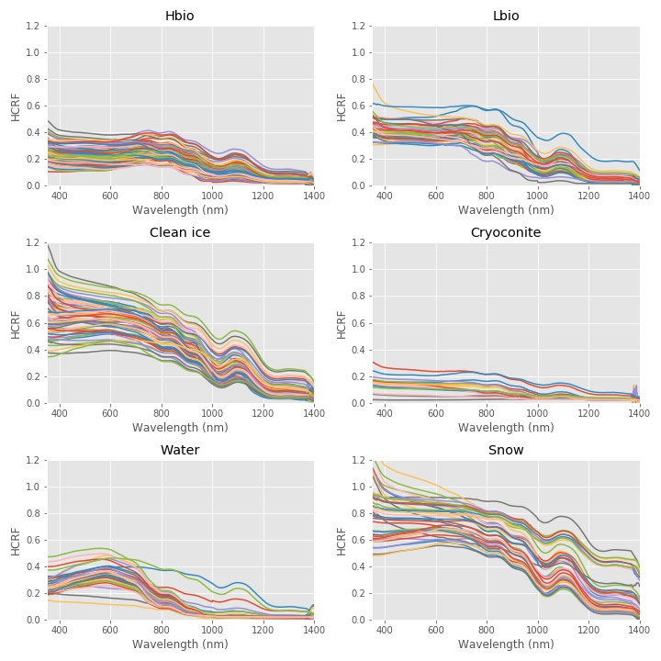

Fig 1: The spectra in the field spectroscopic dataset, separated by class label.

|  |  |  |
| --- | --- | --- |
| Performance Metric | Training Set | Test Set |
| Accuracy | 0.991 | 0.929 |
| F1 Score | 0.991 | 0.928 |
| Recall | 0.991 | 0.929 |
| Precision | 0.992 | 0.942 |
| Overall performance | 0.991 | 0.928 |

Table 3: Model performance on the training and hold-out test data



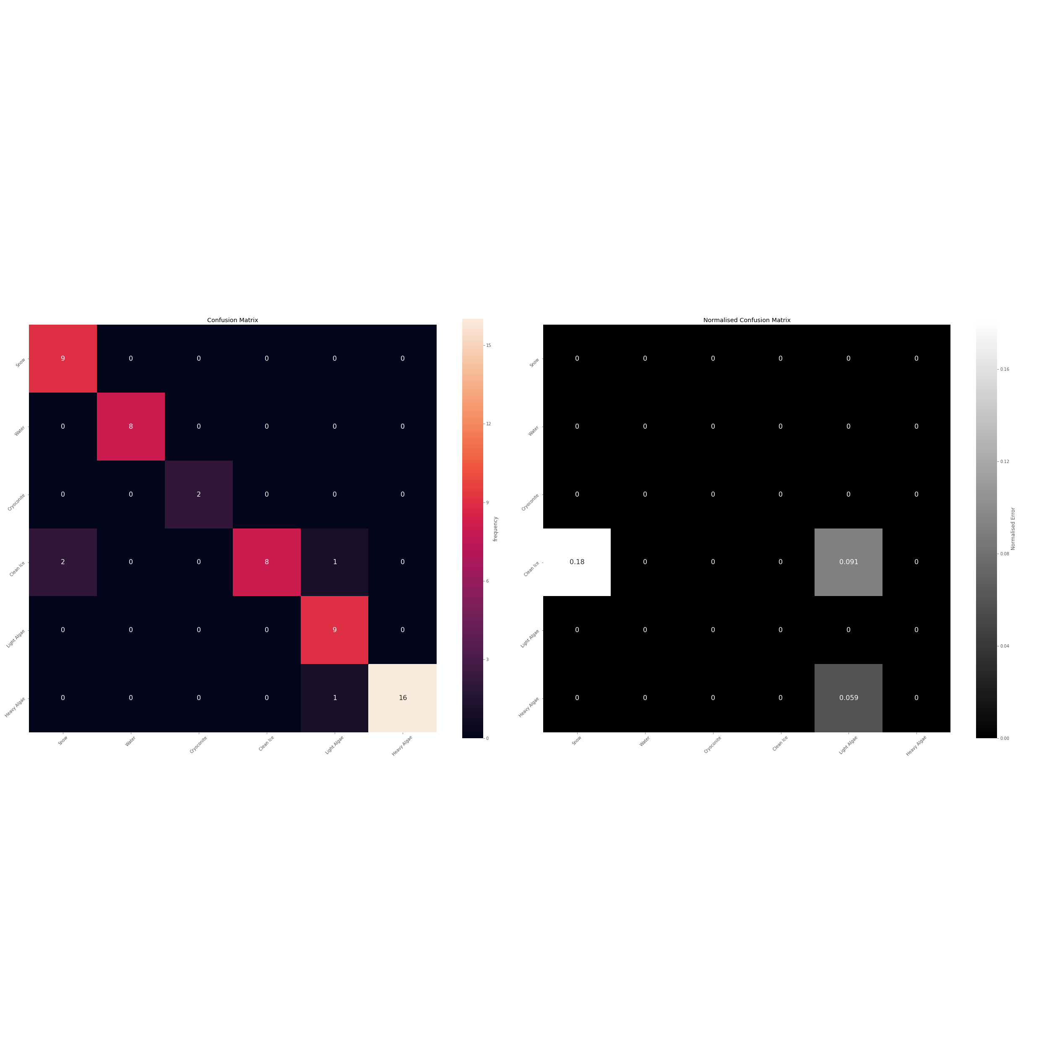

Figure 2: Confusion matrices for the training and test data (A, C) and normalised confusion matrices for the training and test data (B, D). The confusion matrices show absolute numbers of correct and incorrect classification in each class, whereas normalised confusion matrix demonstrates the error rate for each class.

**3.1 Pigment MAC measurements**

The new MAC values for the phenolic pigment control well for the pigment packaging effect and intra-cellular protein attachment especially at lower wavelengths, as evidenced by the fact that the shift in the absorption maximum to a longer wavelength closely matches what has been observed for real, live glacier algal cells (Fig 3). An important observation is that the absorption at near-ultra-violet to short-visible wavelengths is dramatically reduced, while the absorption across the remainder of the visible wavelengths is increased compared to the original ex-vivo MAC, leading to a shallower slope in the absorption coefficient between 350-750 nm. The shift in the absorption maximum to ~0.35 μm explains the “uptick” in surface reflectance at very short visible wavelengths observed in field reflectance values from ice with heavy algal concentrations (e.g. Cook et al. 2017, 2020). Overall, this change is likely to increase the amount of solar energy absorbed by the glacier algae, since the energy arriving at near-UV wavelengths, where the algal absorption is reduced, is much lower than that arri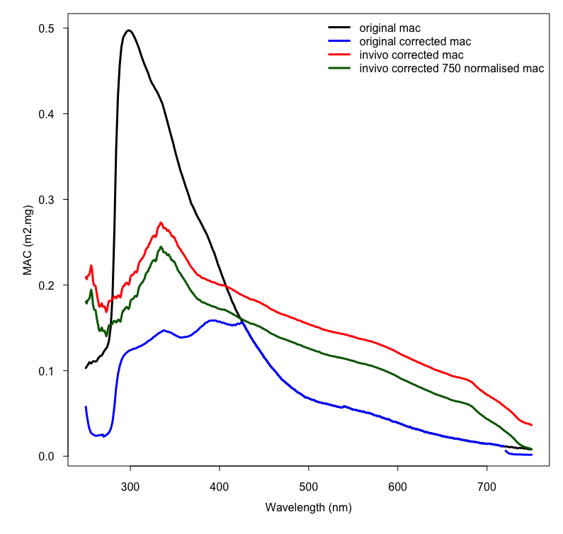ving at short visible wavelengths, where the algal absorption is increased.

Figure 3: MACs for the phenolic pigment under four measurement conditions: black: the original ex-vivo MAC; blue: the original ex-vivo MAC corrected for the packaging effect; red: the in-vivo MAC corrected for pigment packaging; green: the in-vivo MAC corrected for pigment packaging and normalised to the MAC of the ex-vivo pigment at non-absorbing 750 nm. The green line shows the MAC used in this study.

**3.2 Sensitivity of band ratios to grain size and solar zenith**

BioDISORT was used to simulate the spectral albedo of ice with six glacier algae concentrations and five ice-grain sizes to examine the sensitivity of five different band-ratio ‘index’ methods for glacier algae quantification. Regardless of the glacier algae concentration, reff changed the value of the 2DBA, 3DBA, NDCI, MCI and II indexes (Fig 4). There were several examples where altering the grain size from 1000 to 15000 μm caused a change in the indexes that exceeded that caused by glacier algae concentration increasing by 10000 ppb (1160 cells/mL) or more. For example, for clean ice a decrease in reff from 15000 to 1000 μm caused a change in the 2DBA index value (-0.04) with about twice the magnitude of that caused by adding 10000 ppb (1160 cells/mL) of glacier algae (-0.02) and about as great as the addition of 20000 ppb (2320 cells/mL) of glacier algae (-0.04). This indicates that changes in grain size potentially cause error in retrievals using the 2DBA index of the order of 103 cells/mL. At a grain size of 20000 μm the 2DBA index would mistake a biomass concentration of 20000 ppb (2320 cells/mL) for clean ice, and a biomass concentration of 10000 ppb (1160 cells/mL) would only be detected at grain sizes ≤ 1000 μm. For the 3DBA index the change caused by changing the clean ice grain size from 1000 to 20000 μm was greater than that caused by adding 20000 ppb (2320 cells/mL) glacier algae. All five indexes were sensitive to ice grain size in the range 1000 – 20000 μm.

We also tested the effects of solar zenith angle in the range 0.52 – 0.72 (the range of solar zeniths calculated from our imagery). The change in index value caused by changing the solar zenith angle increased with glacier algal concentration. For a low glacier algal concentration (5000 ppb / 580 cells/mL) the difference between the 2DBA index at the minimum SZA (cosine of SZA = 0.52, 2DBA = 0.96) and the 2DBA index value at the maximum SZA (cosine of SZA = 0.72, 2DBA = 0.97) was 0.01. According to the relationship proposed by Wang et al. (2018:Fig 2b, Eq 3) this corresponds to a change in retrieved algal concentration of 2.57 x 102 cells/mL. For a higher glacier algae concentration (30000 ppb / 3480 cells/mL ) the 2DBA index varied between 1.02 and 1.04, a change of 0.02. According to the relationship proposed by Wang et al. (2018) this corresponds to a change in cell concentration of 1.72 x 105 cells/mL. For a glacier algae concentration of 50000 ppb (5800 cells/mL), changing the cosine of SZA from 0.52 to 0.72 caused the 2DBA index to change from 1.09 to 1.07. We consider this to be outside of the valid range of cell concentrations for Eq 1, since the predicted change in algal cell concentration is 1.4 x 107 cells/mL – several orders of magnitude greater than any algal cell concentration measured in the field to date (Yallop et al. 2012; Stibal et al. 2017; Williamson et al. 2020; Cook et al. 2020). The larger biomass concentrations (up to 2.9 x 104 cells/mL) measured by Yallop et al. (2012), Stibal et al. (2017), Williamson et al. (2020) and Cook et al. (2020) are outside of the valid range of the exponential equation proposed by Wang et al. (2018). When this upper measured value was used, variations in solar zenith angle led to 2DBA index changes corresponding to 107 cells/mL according to Eq1. Therefore, the lack of solar zenith correction undermines the validity of the band ratio approach.

**3.3 RTM and classifier validation**

The algal cell concentration predicted by the inverted model agree well with measurements associated with the same spectra (Fig 6), with a linear regression coefficient of determination of 0.86 (p<0.001). The predicted algal concentration was therefore consistent with our expectations from field observations and microscopy analyses (Cook et al. 2020; Stibal et al. 2017) and are broadly of similar range to that estimated by Wang et al. (2018) for the same region. Comparison between field spectra for clean ice and NIR albedo predicted by bioDISORT showed that the two variables ρbi and reff could be tuned to recreate field-measured spectra with an absolute error of 0.06 +/- 0.009. Empirical measurements of ρbi and reff are not available for our field spectra, but we do have detailed qualitative descriptions of the surface in our field notes. There is good agreement between the reff and density predictions and qualitative descriptions of the ice surface, where descriptors associated with more broken, porous, well drained ice and thick weathering crusts were generally associated with lower ρbi and smaller reff, whereas descriptors associated with thin weathering crusts, smoother, denser, wetter ice were generally associated with larger predicted reff and higher predicted ρbi.

Comparisons between the surface classification and the values for albedo, algae concentration, reff and ρbi retrieved from our inverse radiative transfer model indicate that the classifier does a good job of detecting biomass on the ice surface and accurately distinguishes areas of high biomass from areas of lower biomass. The areas classified as HA invariably had a greater retrieved biomass than areas classified as LA or CI. When we ran our field spectra through our inverse radiative transfer model, the predicted algae concentration for HA sites was 2.64 x 104 +/- 9.95 x 103cells/mL, compared to the measured concentration 3.05 x 104 +/- 1.37 x 104. For LA sites, the predicted concentration was 9.67 x 103 +/- 1.67 x 103 compared to the actual measured concentration 8.54 x 103 +/- 6.23 x 103. As well as comparing well to each other, these predicted and measured values are consistent with the cell concentrations reported in Cook et al. (2020) for HA (2.9 x 104 +/- 2.01 x 104 cells/mL ) and LA (4.73 x 103 +/- 2.57 x 103 cells/mL) sites. In addition to the validation of the classifier provided in Cook et al. (2020), these observations support the use of our classification algorithm for biomass detection and mapping across the ice surface.

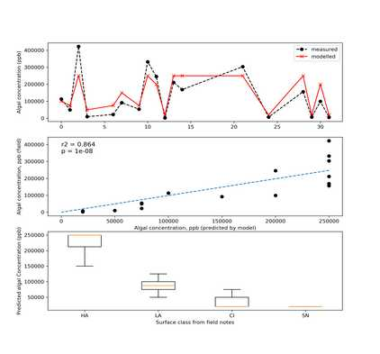

Fig 5: A) Comparison between algal concentration in ppb derived from field measurement and (black) and the inverse model applied to satellite imagery (red); B) Scatterplot and linear regression trend line between algal concentration predicted by the inverse model and measured in field samples; C) boxplots showing the spread of values for algal concentration predicted by the inverse model in each surface class predicted by our supervised classification algorithm. Orange lines indicate the mean, boxes indicate the interquartile range and the whiskers span the range.

**3.4 Glacier algae distribution**

We found that the spatial coverage and overall biomass concentration of glacier algae increased over each summer. However, glacier algae was not uniformly distributed across the ice surface, with both an elevational pattern and distinct “hotspots” recurring in each year. The relationship between glacier algae concentration and elevation was not positive monotonic as suggested by Wang et al. (2018). Glacier algae was concentrated into a central band with the highest algal concentrations occurring at the lower elevations within that band. We broadly agree with Wang et al. (2018) that four zones can be identified as alga hotspots and that these zones are near Jakobshavn Isbrae, Usugdlup Sermia Glacier, Ingugpiat Quat glacier and Russell glacier. Field observations have previously confirmed these regions to have extensive algal coverage with concentrations frequently of the order 104 cells/mL (Yallop et al. 2012; Stibal et al. 2018; Williamson et al. 2018; Cook et al. 2020).

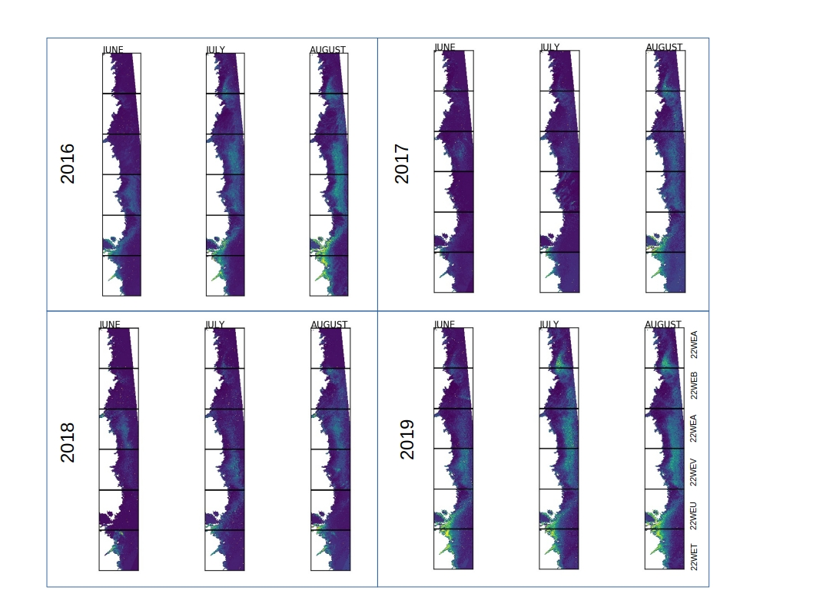

Fig 6: Mean algal concentration for June, July and August in each year

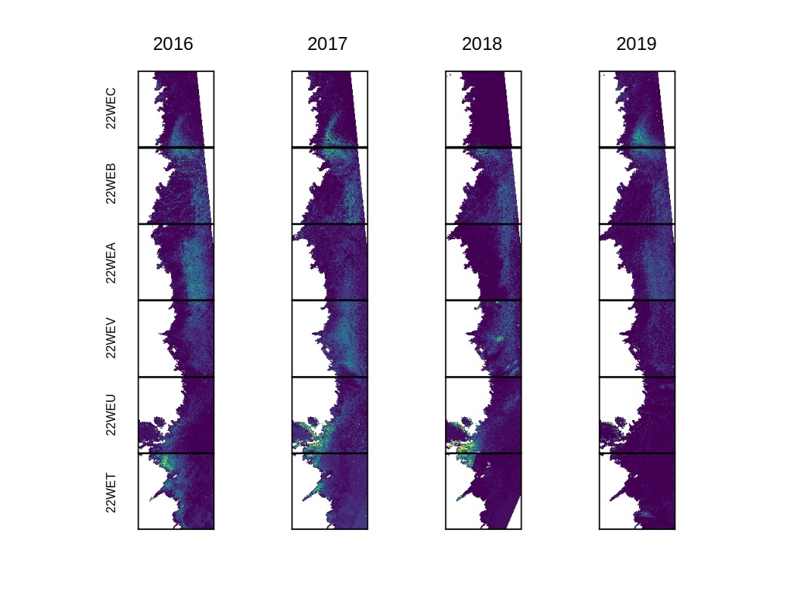

Fig 7: Change in biomass from the start of June to end of August for each year

These hotspot areas are consistent across all four years, consistently having the greatest algal biomass by the end of August. However, the biomass change maps (Fig 7) indicate that the darkest areas are not necessarily those that show the greatest change in biomass over the season. For example, Tile 22WEV (Kangerlussuaq) is a hotspot of biomass concentration by the end of August 2016 (Fig 6) but it is not a hotspot of biomass change – in fact it shows a conspicuously small change in biomass over summer 2016.

**3.3 Ice surface properties**

Our inverted radiative transfer model predicted values for albedo, reff, ρbi, algae concentration, and dust concentration in each 20m pixel across the GrIS Dark Zone at 3 day resolution between 1st June and 31st August for the years 2016-2019. Our classifier predicted spatial coverage of six surface types for the same time period. The time series for each radiative transfer variable and the surface classification are displayed in Fig 6. Each summer, there is a general decrease in the estimated albedo and ice density and increases in algal concentration and reff (Fig 6A-D). Values for ice density are generally in line with expectations, with means ranging from ~400 – 600 kg m-3, consistent with empirical measurements of near-surface ice density made along a transect on the SW GrIS surface by Cooper et al. (2018). This range of ice densities is typical for the weathered ice in the GrIS ablation zone (Cooper et al. 2018; Muller and Keeler, 1969). reff were generally varied between 5000 and 15000 μm with a general trend of increasing reff over the melt season. These large reff are consistent with the coarse-grained structure of the GrIS weathering crust. A range of reff between 5000 – 15000 μm was sufficient to recreate 65 field-measured clean-ice spectra with absolute error of 0.06 +/- 0.0009 in the near-infrared wavelengths (0.9 – 1.1 μm) (Cook et al. 2017; 2020; section 3.3) and across the entire DZ, our system only occasionally predcted grain sizes outside of this range (Fig 8).

The time series of surface class show that over the ablation season the snow cover decreases and the clean ice cover increases, while algae generally expand to cover a larger area over time. Significant negative linear trends existed for the ice albedo, ice density and snow cover against time for the JJA period in all four years (linear regression, p<0.05: Fig 7). The exception to this was albedo in 2018 when the negative linear trend was not significant at p=0.05. Significant positive linear trends were observed for algae concentration, reff, clean ice coverage, light algae coverage, heavy algae coverage and melt water coverage against time in each year (Fig 7). The exceptions are reff in 2018 and melt water coverage in 2017, 2018 and 2019 when the linear trends were not significant at p=0.05.

Pearson’s correlation coefficients (R ) between pairs of variables (Fig 8) demonstrate that the surface albedo is strongly correlated with reff (R = -0.97), density (R = 0.91) and algae concentration (R = 0.76). The day of year was not strongly correlated with any of the other variables (R < 0. 44). Albedo, reff, ρbi and concentration of glacier algae are all closely correlated (Fig 8 and Fig 9).

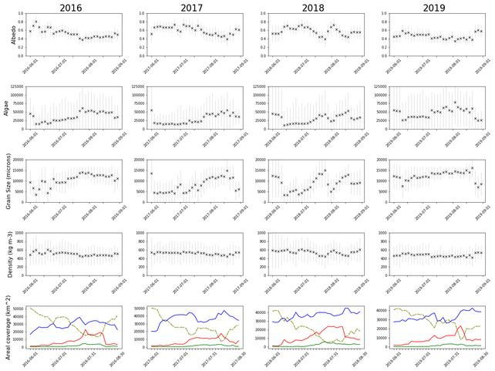

Fig 8: Time series of the mean (black cross) and standard deviation (grey error bars) for A) albedo; B) algal concentration; C) reff; D) ρbi, averaged over the whole dark zone as predicted by our inverted radiative transfer model. SD the best metric for the error bars? E): Time series for spatial coverage as determined by our supervised classification algorithm (yellow = snow, blue = clean ice, red = light algae, green = heavy algae).

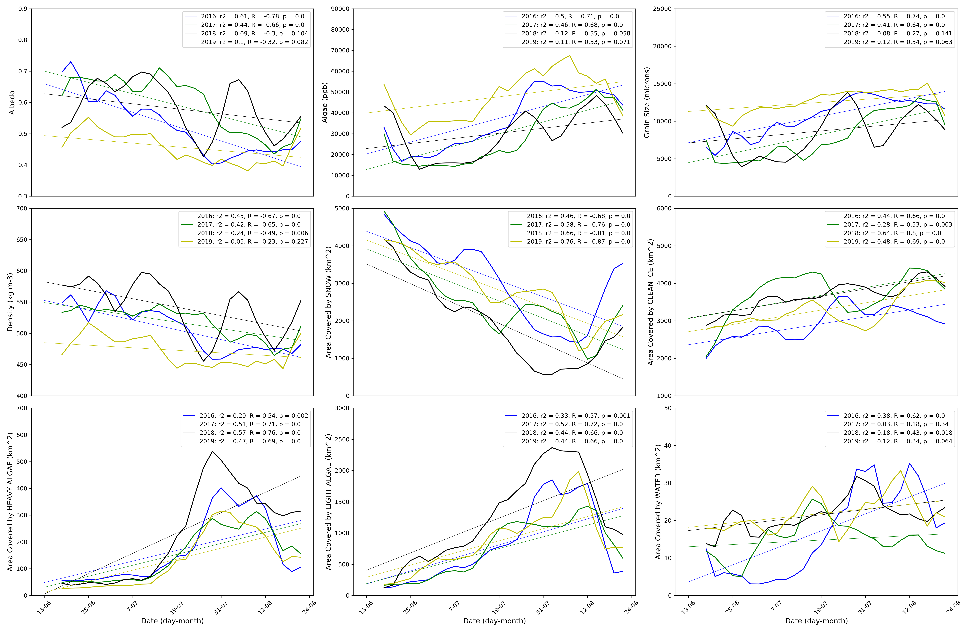

Fig 9: 9 day rolling mean for the JJA period in each year and their linear regression lines (blue = 2016, green = 2107, black = 2018, yellow = 2019) for A) albedo; B) algal concentration (ppb); C) ref (μm); D) dust concentration (ppb); E) ρbi (kg m-3). Linear regression statistics and Pearson’s correlation coefficient are reported in the legend for each panel

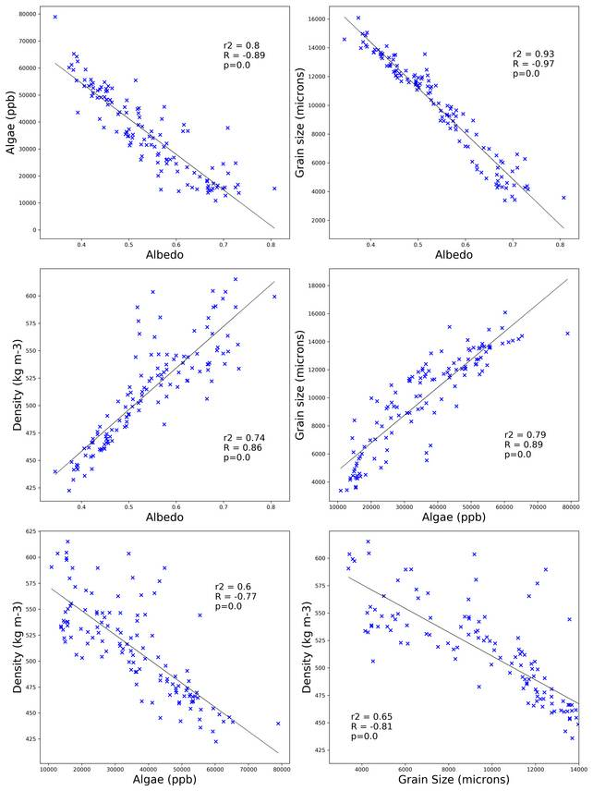

Fig 10: Correlations between each pair of variables. Each point is a dark-zone wide mean on a day between 1st June 2016 and 31 August 2019. For each pair of variables the linear regression line of best fit is also plotted and the coefficient of determination, linear regression p-value, Pearson’s correlation coefficient and associated p-value are displayed within the panel. P-values are rounded to 5 decimal places, so p=0 denotes p < 0.00001.

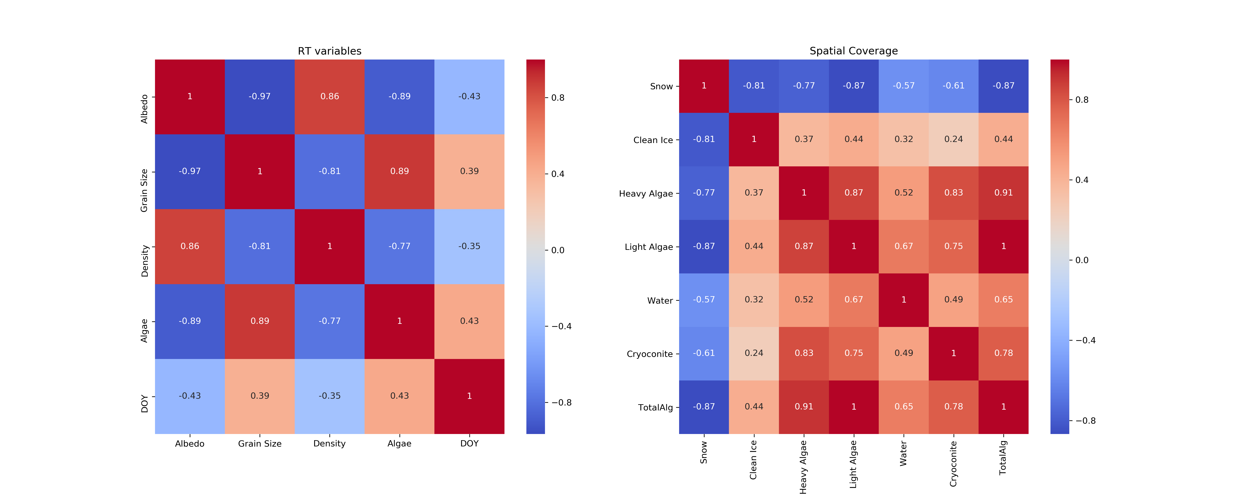

Fig 11: Correlation heatmaps for radiative transfer variables

**4 Discussion**

**4.1 Justifying the need for integrated RT and MS**

Several indexes based on the ratio of reflectance at various wavelengths have been proposed as viable methods for quantifying glacier algae over ablating ice (Wang et al. 2018, 2020). However, our sensitivity tests indicate that these indexes are prone to uncertainty due to variations in reff. This is not a surprising result since all of the indexes use reflectance at NIR wavelengths as a standard against which they compare reflectance at some lower wavelengths, usually those relating to chlorophyll absorption (around 680 nm). However, the NIR reflectance is well-known to vary widely according to the reff, making reff a critical confounding variable. Our sensitivity tests indicated that the effect of increasing reff from 1000 to 20000 μm was approximately equivalent to adding 20000 ppb of glacier algae for the well-known 2DBA index. Although the retrieved algal concentration varied widely across space and time, the mean algal concentration was generally less than 50000ppb, indicating that the uncertainty of the order 104 that is associated with the 2DBA index and shared by the other indexes is non-negligible in the context of predicting algal concentrations over the GrIS. Variations in the cell concentration of the order 103 cells/mL could actually be changes in the reff of the underlying ice. This demonstrates the need for a system that integrates inverse radiative transfer modelling with spectral image analysis, since the inverse radiative transfer modelling enables the effects of reff to be accounted for. The ability to more accurately quantify biological LAP concentration simultaneously to retrieving ice physical properties confers robustness to overestimating biological albedo reduction and better supports separation of biological from non-biological albedo reducing processes.

We found that solar zenith angle variations caused by different image acquisition times led to large changes to the 2DBA index. Specifically, for identical RT model configurations, we measured the 2DBA index for glacier algal concentrations near the upper and lower extremes of the range presented by Wang et al (2018, Fig 2b) at the minimum and maximum SZA calculated from the acquisition times for our imagery. By running our DISORT model with solar zenith angle calculated from the spatial and temporal coordinates for each specific image, the inverse model approach offers robustness to this source of error. The inverse RTM approach is therefore more skillful than band ratios for reducing error in GCM albedo schemes, enables deeper insights into glacier-algae spatial ecology and is also more easily refined as new process-knowledge and empirical data regarding the co-development of the ice surface and LAPs becomes available. At the same time, the inverse radiative transfer model also opens a wide range of potential future advances that are not available to band ratio techniques, most importantly the potential to use the model in a “forward” mode to test hypothetical scenarios or make future predictions, potentially with initial conditions set using the inverse model.

**4.1.2 Representing weathering crust development in a radative transfer model**

The grain size determines the distance travelled through the absorbing medium (ice) between scattering interfaces for a photon and determines the likelihood of absorption occurring per photon/ice grain interaction. Since the refractive indices of ice and water are so similar, accumulation of water in interstitial spaces between grains are often parameterised as increased effective grain size. Since larger grains increase the path length for photons in the absorbing medium (ice) compared to the non-absorbing medum (air) larger grains reduce the albedo of a mass of ice. The bulk ice density (ρbi) determines how many grains are encountered in a given volume of ice. The product of the volume and ρbi of a mass of ice gives its total mass, which can be multiplied by the mass-normalised absorption coefficient to give the total absorption in the bulk medium. As a surface weathers, it becomes more porous and less dense, whereas stripping of the weathering crust causes a surface to become denser and less porous. Thick, porous weathering crusts appear white and have high albedo because there are many opportunities for scattering near the ice surface and all wavelengths of light escape the medium. The opposite extreme is an absent weathering crust, where the ice surface is smooth and dense, has low albedo and appears blue because photons entering the ice follow a long path length in the absorbing medium where blue wavelengths are absorbed less efficiently and more likey to escape the medium. The surface albedo can therefore vary widely as a consequence of weathering crust development, resulting from the configuration of ice grains and air spaces in the medium. This is controlled in a radiative transfer context using the reff and ρbi of the ice, which in turn are used to calculate the optical thickness. It is not sufficient to descibe the weathered crust in terms of ρbi alone because high ρbi can be caused by many small grains being tightly packed (many air-ice interfaces per unit volume) or by the ice being solid and unbroken (few air-ice interfaces per unit volume). The effect of this on the material albedo depends upon the optical properties of the medium – a denser medium may increase the albedo if the likelihood of scattering exceeds the likelihood of absorption, such as for clean ice and snow, whereas a more densely packed arrangement of strongly absorbing particles has a lower albedo because of a higher ratio of absorbing material to non-absorbing materialper unit length. Distinguishing these cases is achieved using the effective grain size, where larger grains represent longer uninterrupted path lengths through ice (i.e. few air ice interfaces). The condition of the weathering crust is therefore likely best described by a combination of ρbi and reff. At present, there is a scarcity of empirical studies linking surface albedo to weathering crust properties, although some foundational work has been completed (Jonsell et al. 2003; Dadic et al. 2013; Tedstone et al. 2020). There remain important uncertainties regarding the representation of non-uniformaly distributed, irregularly shaped units of ice in radiative transfer models that generally assume homogeneity in grain shapes and sizes in discrete vertical layers. Furthermore, it is not obvious which empirical measurements are the most appropriate for validating and tuning radiative transfer models for weathered glacier ice. Nevertheless, it is known that the surface physical properties vary over sub-daily to seasonal timescales and that this causes the surface spectral albedo to vary (Jonsell et al. 2003), and that these changes are currently best described in radiative transfer models using the two ice-physical parameters reff and ρbi.

The state of the weathering crust causes changes in the size, frequency and distribution of air/ice interfaces in the three dimensional structure of the near-surface bulk of ice. The ice surface weathers under clear sky conditions because solar irradiance can penetrate the ice and cause internal melting along grain boundaries, causing the ice to transition from solid and dense to porous, with a concomitant transition from low to high albedo. In conditions where turbulent fluxes dominate the surface energy balance, surface lowering outpaces subsurface erosion, resulting in the weathered crust being “stripped” back to reveal the more solid, dense ice beneath. Furthermore, the weathering crust holds a water table that conducts melt-water produced in situ and delivered from up-glacier. Rain events can cause rapid stripping of the weathered crust. The thickness and porosity of the weathering crust responds to changing energy balance conditions at timescales of hours to days, and exerts an important control upon the surface albedo by changing the scattering efficiency of the ice surface and also by altering the concentration and distribution of light absorbing particles.

To represent this process in a radiative transfer model, we must translate the physical configuration of the near-surface ice into parameters that can be used to determine the optical thickness. For snow and ice with air bubbles the ice physical properties are usually described using a combination of the density and either the effective grain size or specific surface area (surface area per unit mass) which are related by:

where reff = effective radius, ρi = density of ice (917 kg m-3) and SSA = specific surface area. For snow reff can be expected to be close to observed grain size (Warren et al. 1980). reff changes the albedo by changing the average path length through the absorbing medium (ice). The larger the grain size, the further into the ice the photon will travel before changing direction at an air-ice interface, reducing the probability that the photon will escape back into the atmosphere and therefore reducing the albedo. The density of the ice controls the spacing of the grains, the frequency of air-ice interfaces and the total mass of ice contained within a given bulk volume. The combination of reff and ρbi is therefore sufficient for determining the optical thickness of the ice. Neither parameter alone is sufficient because density could mean close packing of small grains (high albedo) or solid ice with few inclusions (low albedo). In reality, there is usually a positive correlation between ρbi and reff (e.g. Dadic et al. 2013). For ice with light absorbing impurities, a higher density means a greater mass of the absorbing material per unit volume. Meltwater accumulation is often parameterised as an increase in reff because the refractive indices of water and ice are so similar. Therefore, the combination of reff and ρbi is sufficient to describe the optically-relevant ice-physical and hydrological conditions of the ice surface. Most of the previous literature on this subject has focused on snow albedo, and it is not necessarily true that these observations transfer well to the weathered ice of the glacier ablation zone, necessitating empirical validation of our ρbi and reff retrievals using bioDISORT.

To test the ability of bioDISORT to describe the GrIS surface taking into account the variable weathering crust, we compared simulated spectra to those measured in the field for sites classified as “clean ice”. We found that by tuning the grain size and density values in the ranges 400 – 900 kg m-3 and 5000 – 30000 μm we were able to simulate our 65 field-measured spectra with a mean absolute error of 0.03 +/- 0.009. This indicates that these two parameters do a good job of simulating the physical structure of the ice surface and are able to accurately recreate the spectral reflectance of the ice found in the GrIS ablation zone. However, it still remains challenging to prescribe the ρbi and reff values required to recreate in situ conditions and future studies should aim to establish empirical relationships between measurable parameters and those required for radiative transfer modelling.

**4.2 Glaciological and biological trends**

GRAIN SIZE/DENSITY

Glacier algae tended to concentrate into an approximately N-S oriented band on the ablation zone, with relatively clean ice bounding it in both the upglacier (East) and downglacier (West) directions. The clean ice on the downglacier side can be explained by high melt rates and greater slopes causing more washaway of algae preventing biomass accumulation. The clean ice on the up-glacier side may be due to the shorter duration of exposure, lower temperature and lower melt rate limiting the providence of nutrients and meltwater that stimulate algal growth, or possibly because algal growth is stimulated by mineral dust outcropping which is stratigraphically controlled. Within the band of glacier algae the biomass concentration was generally higher at lower elevations, likely because those areas had higher air temperatures and melt rates that stimulate algal growth as well as being exposed and able to accumulate biomass for longer durations.

Glacier algal concentration was strongly positively correlated with reff and ρbi, meaning high glacier algae concentrations are associated with the ice physical configurations associated with thin and/or saturated weathering crusts produced by rapid surface lowering. This is consistent with the existence of a positive feedback whereby glacier algae preferentially grow where meltwater is abundant and in doing so reduce the surface albedo, further accelerating the surface melting which in turn further accelerates algal growth (Cook et al. 2020; Williamson et al. 2020). Since the algae are concentrated on the ice surface they tend to exacerbate surface lowering, stripping the more porous weathering crust, leading to a more dense, larger grained ice matrix below (Tedstone et al. 2020). Thicker weathering crusts are associated with moderate to low glacier algal concentrations.Glacier algae concentration and ice physical properties (reff, ρbi) were closely correlated with surface albedo, supporting previous studies that identified these as the primary albedo-reducing factors on the GrIS.

Surface classification indicates that algal coverage increases over the summer season, with a larger area covered by LA than HA, with increases in HA coverage generally beginning later in the summer than increases in LA. This is suggestive of in situ biomass accumulation over the summer period since a sufficiently long exposure time is required for the algae concentration on the ice surface to increase sufficiently to transition from LA to HA. Pixels classed as HA were usually LA earlier in the season. This likely explains why at the end of the summer the dark band on the ice sheet surface is darkest at lower elevations as this ice has been exposed and able to accumulate biomass for longer than the ice closer to the snow line.

Areas that were hotspots of biomass concentration were not necessarily hotspots of biomass change across the melt season. This is because those areas already had high biomass concentration at the start of the observation period. This is the case for, for example, Tile 22WEV in 2016 which is consistent with the particularly early onset of melting (April 10th) that year and especially high surface melting for the Kangerlussuaq region (NOAA, 2016: https://www.arctic.noaa.gov/Report-Card/Report-Card-2016/ArtMID/5022/ArticleID/277/Greenland-Ice-Sheet). Early-onset surface melting, concentrated in the Kangerlussuaq region, was also a feature of the 2019 melt season (NOAA, 2019) and again, our retrievals indicate a high biomass concentration but small biomass change in the hotspot regions. In 2017, when our retrievals indicate a large change in biomass across the DZ but lower overall biomass concentration, the GrIS experienced lower-than-average melting and higher-than-average albedo. Despite an early start to the 2017 melting season (April) it was short lived and the surface melting over the whole melt season in the Kangerlussuaq region was the 5th lowest on record. Similarly, in 2018 the surface mass balance for the GrIS was below or close to the long term mean due to snow cover that lasted late into spring and a whole-GrIS albedo that was joint-highest on record. We therefore identify two lines of evidence to support in situ biomass accumulation within individual melt seasons as the primary source of glacier algal biomass in the DZ: first, the late retreat of the snowline in 2018 revealed a low biomass concentration on the ice beneath despite much higher biomass concentrations existing in the same areas at the end of August 2017. This is even more pronounced for 2016/2017, since the biomass concentration across the DZ at the end of August 2016 was very high and the biomass concentration across the DZ at the start of June 2017 was very low. Second, for individual locations, the biomass concentration increased after the exposure of bare ice, achieving greater biomass concentrations in warmer years with more surface melting, consistent with glacier algae growth being stimulated by the higher temperatures and the providence of liquid water and nutrients by melting. In general, areas we identified as biomass hotspots are areas of especially high biomass in all four years, but our observations of low biomass concentrations for these areas after snow retreat in 2017 and 2018 suggest that the hotspots are not the result of persistent active algal communities persisting year-to-year, but that the conditions in those areas are favourable for in situ biomass accumulation in each individual melt season. We cannot identify the specific set of conditions in this paperbut we point out that they may be meteorological (high air temperature, low snowfall, early onset of melting), glaciological (low slope gradient, mineral outcropping) or biological (legacy OC or nutrients from previous year’s blooms preconditioning the ice surface).

**4.5 System limitations and future development opportunities**

This paper presents an analytical system that integrates multispectral image analysis with inverse radiative transfer modelling to retrieve ice physical properties and light absorbing particle concentrations. This is a conceptual jump from the current state-of-the-art methods that deploy band ratios to quantify particle concentrations despite large uncertainty due to the highly variable spectral albedo of the underlying ice and illumination conditions. However, we identify five major improvements that could be made to this system to improve the accuracy of the retrievals. In most cases these have not been incorporated into the present version of the system because of a lack of critical empirical measurements that should become specific objectives for future field campaigns. These future improvements are detailed in sections 4.5.1 – 4.5.5. We provide this critical evalution of our system for two reasons: a) to provide a roadmap for improving the system in the future, and b) to highlight some of the current gaps in the field that are limiting the reliability of remotely sensed ice surface properties. The following discussion is structured to provide specific objectives for future research.

**4.5.1. Anisotropic Reflectance Factor / Bidirectional reflectance distribution function**

The bidirectional reflectance distribution function (BRDF) depends upon the inherent optical properties of the ice, specifically the phase function which determines the angular distribution of scattered light after interacting with an ice crystal. For ice, there is a strong preference for scattering in the forward direction after a singe scattering event. However, the spectral albedo is the emergent effect of many scattering events beneath the ice surface. Where the ice is more borken and porous, more scattering events occur before light “escapes” back into the atmosphere and the reflected light is more evenly distributed over the upwelling hemisphere. On the other hand, where ice is smoother and denser, there is more specular reflection from the ice surface which creates a strong reflectance peak at an angle determined by Snell’s Law and fewer subsurface scattering events, meaning the total reflected light is more concentrated in a narrow range of angles. Therefore, on glacier surfaces where the ice varies from heavily weathered, porous, broken crusts to waterlogged, smooth and solid over spatial scales of decimeters to meters, the BRDF varies dramatically. This indicates that a collection of BRDFs matched to specific ice physical configurations are required instead of a single BRDF applied to the entire glacier ablation zone. Future studies should use field goniometry to establish the BRDFs for a range of classes of ablating ice. Then, the appropriate BRDF could be applied pixel-wise according to a classification scheme applied to multispectral remote sensing imagery. Presently, this data does not exist and remote sensing data over glacier ablation zones are either uncorrected or corrected using a uniform BRDF transferred from measurements made over snow. We consider this to be a major source of uncertainty and have omitted to apply a BRDF correction in this paper, choosing instead to raise this issue here in the discussion and point it out as a priority future research objective.

**4.5.2. Availability of labelled data**

Supervised classification is an important part of the system because it provides a spatial map of the ice surface divided into a discrete set of classes. This was achieved by training a RF classifier on field spectroscopy data that was labelled using qualitative assessment on-site and subsequent laboratory analysis to determine the surface composition. This provides high label confidence but the cost per label, in terms of money, time and expertise, is very high and this limits the size of the available dataset. There are two options for addressing this issue in the future: 1) gather more field spectroscopic data; 2) develop methods for gathering labelled data from remote imagery. To gather more field data, there must be more expert operators in the field following standard measurement protocols to ensure spectral albedo and reflectance measurements are collected in combination with sufficient metadata and sample collection, and that these data are then collated into an open, community dataset that can then be used to train classifers. This requires collaboration across projects and groups and an open approach to sharing data and protocols. Even then, the total number of samples available for training classifiers will be 102 – 104. On the other hand, there is potential for this data resource to be very high quality in terms of the label accuracy because each spectrum is accompanied by expert assessment and empirical measurement of the ice surface properties. The alternative is to develop methods for obtaining labelled spectra from remote sensing imagery. The power of this is that the total number of training samples could easily be 105 – 106. However, process-level understanding of the processes occurring in the surface crust remains incomplete, limiting our ability to reliably assign labels to remotely gathered images. While the total number of labelled samples might be high, the label accuracy would likely be low because there would be no expert assessment of the sample area and no sample collection for laboratory confirmation of the labels. There is something of an internal contradiction in that using remote imagery to determine labels requires methods for labelling remotely sensed imagery, which brings us back to field spectroscopic data. It is also problematic that the majorty of existing field spectroscopc data is clustered around the PROMICE automatic weather station at S6 (near Kangerlussuaq, Greenland) because of ease of access. It is not necessaily the case that observations made at this site are representative of the rest of the GrIS or other locations across the cryosphere. Therefore, in the future, more field spectroscopic measurements from more field locations and gaining deeper process knowledge of the spectral properties of the surface crust should be research priorities. There is also high potential for radiative transfer modelling to provide a route to generating synthetic label data, especially for classes that ar eunder-represented in field datasets, but this requires further model development particularly taking crust development into account.

**4.5.3. Physical and numerical understanding of weathering crust dynamics**

Radiative transfer modelling enables the spectral albedo of snow and ice to be predicted from known reff, ρbi , illumination conditions and light absorbing particle types and concentrations and the single scattering optical properties of the individual components. There is a long history of radiative transfer modelling for snow and lake ice (Warren, 1984, Warren1984, Picard et al. 2010…) but the available models are potentially less well-suited to ablating glacier ice. This is because models developed for snow calculate the optical properties of the ice crystals and light absorbing particles are generally calculated using Mie theory which assumes that these components are spherical and small relative to the wavelength of the light interacting with it. These assumptions do not hold for glacier ice, where ice crystals are large and irregular and the algae that darken the surface are large and elongate. Cook et al. (2020) and this study used radiative transfer models that employed geometrical optics to circumvent these assumptions and produce a model more appropriate for glacier ice; however these models assume ice grains to be hexagonal columns which is still not an especially realistic way to describe the range of weathered glacier surfaces encountered on ablating glacier surfaces, that can be lightly weathered with small interstitial air spaces or heavily weathered with centimeter-scale air spaces between large, irregular ice blocks (‘coral ice’). It is difficult to develop a horizontally-uniform representation of this volume in a radiative transfer model. On the other hand, our comparison between field-measured spectra and simulations indicate that tuning the reff and ρi values can accurately recreate spectral albedo measured in the field for clean ice. This suggets that the numerical framework is sufficient for describing ablating glacier ice and the factor currently limiting our ability to recreate in situ conditions in radiative transfer models is uncertainty around the appropriate empirical measurements to be made in the field and the appropriate translations into radiative transfer parameters. Furthermore, there is only a small literature on the relationship between the development of glacier surface crusts and surface albedo, where spatial and temporal variations in crust development remain uncertain and physical modelling of crust evolution coupled to albedo has not yet been achieved. To accurately model the albedo of glacier ice requires that these models are developed and validated in the field. Then, they can be used to generate synthetic training data for classifying remote sensing data and inverted to improve ice physical properties and light absorbing particle concentrations over glacier ablation zones.

**4.5.4. In situ pigmentation and in vivo mass absorption coefficients for glacier algae**

In areas such as the western Greenland Ice Sheet, one of the main darkening processes is the growth of glacier algae. These algae have only been included in radiative transfer models in the past year (Cook et al. 2020) using optical properties inferred from those of the component pigments combined in a mixing model. In this paper we have presented an updated mass absorption coefficient for the major algal pigment that takes into account pigment packaging and intracellular protein attachement. However, these algae are known to change their pigmentation, and therefore their inherent optical properties, in response to local environmental conditions. Difficulties in culturing these algae have prevented systematic laboratory analyses of this process, meaning pigmentation changes cannot be accounted for in remote algal quantification or built int predictive radiative transfer models. Future developments that enable pigmentation of glacier algae to be predicted from known local environmental variables will enhance our ability to develop these models and improve our remote algal quantification over the GrIS and other ice masses.

**4.5.5. Issues of spatial scale and correspondence between sensors**

Tedstone et al. (2020) showed that glacier algae blooms on the GrIS often occur with patch sizes smaller than the resolution of Sentinel-2 (20 m), leading to underestimates of algal coverage using this sensor. Sentinel-2 has a relatively high spatial resolution compared to other satellite instruments, for example Sentinel-3 (300 m). This means that within each pixel there is heterogeneity of surface properties that is not resolved by the sensor, and the measured reflectance is actually the integrated signal from several surface types, which influences the ability of the sensor to realistically estimate the surface properties. For example, two hypothetical pixels may have identical algal distributions covering precisely 50% of the pixel area; however, the pixel spectral reflectance and therefore the retrieved biomass will vary according to the composition of the remaining 50% of the pixel. To give the most extreme example, in one pixel the remaining 50% may be covered by a melt pond with cryoconite on its floor, which will drag the albedo down dramatically while the other pixel may be 50% covered by fresh snow, pushing the albedo up. The spatially integrated reflectance of these two pixels will vary greatly and the system would not be able to recognise the similarity in biomass distribution because it would be obscured by the spatial averaging. This problem is common to band ratio methods as well as inverse-models and supervised classification tools and can only be fully addressed with sensors that provide higher resolution data where individual pixels are on average smaller than the typical algal blooms but still providing sufficient spectral resolution for discriminating surface types. Unmanned aerial vehicles such as quadcopters and fixed-wing aircraft can provide this data but cannot provide the wide spatial coverage of a satellite sensor. Planes may also be able to provide suitable data but at high financial and environmental cost. With the current suite of orbital sensors, we may look to make improvements through software rather than awaiting improved hardware. Some potential routes include developing algorithms that use spatial information from surrounding pixels to adjust the probability of certain labels or values being assigned in a given location, incorporating predictive modelling using process knowledge and sensitivities to environmental variables that are more easily measured or interpolated at sufficiently fine spatial resolution, developing linear unmixing models that are better able to reverse engineer proportional coverage from an integrated spectrum, and improving large scale “ground truthing” of satellite imagery with high resolution UAV imagery.

**4.5.6. Computational Efficiency**

The current system is relatively comutationally efficient. To ensure we were able to process a large volume of remotely-sensed data in a manageable amount of time we made extensive use of vectorisation, out-of-core processing and parralelization and deployed our system on a 72 core Azure DSVM. However, there were still design decisions made to reduce the computation time at the cost of accuracy. For example, the LUT approach to inverting the radiative transfer model was chosen because it was much more computationally efficient than running the radiative transfer model “on-the-fly” pixelwise, but it also reduced the degrees of freedom in the model by fixing the total number of model runs available for comparison to the remotely sensed spectra. The size of the LUT was constrained by computation time. Even though the LUT approach was much more efficient than on-the-fly modelling, it was still a computationally expensive procedure because every pixel in each image was compared column-wise to each column in the LUT. Some steps in this process were not vectorised. We decided the 2640 column LUT was the optimum balance of computation time and LUT size, but it is possible that algorithmic improvements may enable a larger LUT to be employed in future versions. Similarly, the interpolation regime for filling cloudy pixels was also very computationally expensive. In our development we tested a nearest-neighbours approach to infilling missing values but the computation time was prohibitive so we opted for a faster but less accurate image median fill instead. Future versions could focus on developing a more efficient interpolation regime for cloudy pixels.

**5. Conclusions**

Integrating inverted radiative transfer modelling into multispectral image analysis offers a route to accurately quantifying glacier algae on ablating ice, addressing issues of variable illumination conditions and ice physical configuration that hamper band ratio techniques. We have presented such a system and used it to quantify glacier algae concentration, albedo, effective grain size and ice density across the GrIS dark zone. The resulting maps and time series corroborated glacier algae and ice physical configuration as the primary factors controlling the ice surface albedo. High glacier algae concentrations were associated with dense, wet ice which supported the existence of a positive feedback whereby glacier algae preferentially grow in areas of rapid surface melting, which causes a biological albedo reduction that further accelerates melting. At the regional scale, we found that areas exposed for longer durations accumulated more biomass over the melting season and that the glacier algae concentration increased between initial exposure and the end of the melting season, supporting in situ biomass accumulation over year-to-year persistence of glacier algal communities. Recurrent “hotspots” of biomass accumulation indicate that certain locations are better optimised for algal growth, either because of preconditioning by past blooms or local meteorological, glaciological or hydrological conditions. Warmer years (2016 and 2019) had higher glacier algal concentrations over the GrIS DZ, corroborating the previously proposed positive feedback where melting seasons start earlier and last longer in warmer climates, stimulating more algal growth and accelerating the contribution of GrIS melting to sea level rise. We provide a clear road map to improving our inverse RTM and hyperspectral image analysis so that future iterations can be used to accurately monitor glaciological and biological changes at the ice sheet scale and help to reduce uncertainty in albedo components of regional climate models.

**References**

K. Stamnes, S.-C. Tsay, W. J. Wiscombeand I. Laszlo, “DISORT, a general-purpose Fortran program for discrete-ordinate-method radiative transfer in scattering and emitting layered media: documentation of methodology” (2000), ftp://climate.gsfc.nasa.gov/pub/wiscome/MultipleScatt/.