**Improved glacier algae quantification and retrieval of ice physical properties by integrating an inverted radiative transfer model into a hyperspectral imaging system.**

**Authors: TBC**

**1 Abstract: TBC**

**2 Introduction**

Greenland Ice Sheet (GrIS) mass balance increased by 47 ± 21 Gt/y between 1971-1980 but since then it has been consistently negative. Mass loss has accelerated from 51 ± 17 Gt/y between 1980-1990 to 286 ± 20 Gt/y between 2000-2018, an average acceleration of 80 ± 6 GT/yr per decade despite a recent series of anomalously cold summers and has raised sea levels by 13.7 mm since 1972 (Mouginot et al. 2019). Bamber et al (2018) found that 37% of the total contribution of the cryosphere to global sea level rise was attributed to mass loss from the GrIS. This mass loss is the result of two processes: solid ice discharge into the oceans and surface mass balance (SMB), the latter of which is mainly due to surface melting. SMB has exceeded solid ice discharge over the past two decades (Mouginot et al. 2019; Enderlin et al., 2014; van den Broeke et al., 2016). SMB is controlled by net solar radiation which is a function of incoming irradiance and surface albedo. The albedo changes dramatically over time, first when the winter snowpack retreats to reveal darker glacier ice (Ryan et al. 2019), then within the melt season as a porous crust develops on the surface and glacier algae accumulate (Yallop et al. 2012; Williamson et al. 2020; Tedstone et al. 2020; Cook et al. 2020). Several studies have found mineral dusts to be insignificant for GrIS surface albedo whereas glacier algae reduce the albedo dramatically (Yallop et al. 2012; Cook et al. 2020; Stibal et al. 2020) and posited the existence of a positive feedback whereby larger ablation zones in warmer summers offer wider areas for algal colonization while accelerated melting due to algal growth liberates liquid water and nutrients that stimulate more algal growth (Cameron et al. 2016; Cook et al. 2020; Williamson et al. 2020A; 2020b). For this reason, quantifying, monitoring and modelling spatiotemporal variations in glacier ice configuration and glacier algae concentrations in the ablation zone of the Greenland Ice Sheet are critical for accurately projecting sea level rise into the future. However, the interplay between ice surface development, light absorbing impurities and albedo in the GrIS ablation zone have not yet been studied in detail, limiting our ability to project their influence on SMB and sea level rise into the coming decades. Achieving this requires accurate methods for retrieving glacier algal concentration and ice physical properties at the regional scale from remote observations.

To date, Cook et al. (2020) have mapped the glacier algae presence across a 10,000 km2 area in the south-western region of the GrIS for summers 2016 and 2017 using supervised classification applied to Sentinel-2 imagery at 20m ground resolution. However, this method can only classify the ice surface into discrete classes and did not quantify algal cell concentration. Wang et al. (2018, 2020) have proposed the “2BDA” band ratio index to quantify glacier algal concentrations on the GrIS. The 2BDA index compares reflectance at a near-infrared wavelength to a shorter wavelength that is influenced by the presence of chlorophyll-a. Wang et al. (2018,2020) convert this index into a cell concentration using a statistical fit between the index value and cell concentrations gathered from past literature. Similar chlorophyll-sensitive bad ratios have been used extensively to measure microalgae concentration in ocean blooms and also terrestrial vegetation mapping. However, for glacier algae on the GrIS the index has only been validated using a small number of single-point-to-satellite-pixel comparisons (Wang et al. 2018) that were not synchronous in time to the satellite acquisitions they were applied to. Point-to-pixel validations have been shown to be inadequate for validating satellite albedo measurements (Tedstone et al. 2020; Moustafa et al., 2017; Ryan et al., 2017) due to large variations in surface characteristics within pixels. More importantly, there are several conceptual issues specific to ablating glacier ice that may limit the applicability of simple band ratio techniques for algal cell quantification. First, the ice surface undergoes dramatic changes in its physical configuration over a melt season in response to changes to the local energy budget (Muller and Keeler, 1969; Cook et al. 2015; Jonsell et al. 2003) which strongly influences the spectral albedo (Tedstone et al. 2020; Cook et al. 2020). Radiative transfer theory shows that such physical changes are concentrated in the near-infrared wavelengths (NIR: 0.9 – 1.1 μm) which is also the wavelength range used as a denominator in chlorophyll-targeting band ratios. Although Wang et al. (2020) reported negligibly small changes to the 2BDA index with variations in ice grain size using the SNICAR two-stream radiative transfer model they only tested clean ice without light absorbing particles and over a range of grain sizes relevant to snow but less relevant to ablating glacier ice. In Case 2 waters, similar indexes have been found to perform relatively poorly due to confounding abiotic processes (Moses et al. 2009; Salem et al. 2017), which may be analogous to the GrIS surface. Secondly, chlorophyll-sensitive band ratios similar to the 2BDA have previously been shown to be highly sensitive to illumination geometry including the solar zenith angle (SZA). Such geometrical effects have recently been shown to undermine the validity of chlorophyll-sensitive band ratio indexes for monitoring evergreen vegetation (Norris and Walker, 2020; Martin-Ortega et al., 2020) and Amazon forest canopies (Maeda et al. (2014). Therefore, there are strong reasons to test the validity of these band ratios more rigorously and develop more advanced methods for biomass quantification that can account for the confounding issues of ice physical properties and illumination geometry.

In this paper we address these issues by: 1) testing the sensitivity of a range of band ratios to ice physical properties and illumination angle; 2) Developing a new system that includes an inverse radiative transfer model with updated optical properties for GrIS glacier algae; 3) Deploy our new system over the western GrIS (65 – 70 N) for summers 2016-2019 and compare the results to the 2BDA band ratio; 4) Analyse the resulting maps and time series to extract information regarding spatiotemporal patterns in glacier algal concentration and ice physical properties. Finally, we critique our system and provide specific directions for future improvements that could be made through theoretical advances and new empirical data collection.

**3 Methods:**

**3.1 Radiative Transfer Modelling**

*Empirical MACs for glacier algae*

New in-vivo mass absorption coefficients (MAC) were calculated for the phenolic purpurogallin-type pigment that dominates absorption of solar energy in glacier algae (Williamson et al. 2020). The single scattering optical properties of the glacier algae was then determined following Cook et al. (2020) where a pigment mixing model is used to determine the mass absorption coefficient and imaginary refractive index of a complete algal cell from the mass of each type of pigment present within it, assuming the pigments to be the only absorbing components of the cell and the remaining components to “look” like water. These data are then used along with the cell dimensions to predict the single scattering optical properties (single scattering albedo, asymmetry parameter, scattering and absorption coefficients) for the cell using geometric optics calculations. In this study, cells were assumed to be circular-based cylinders (following Lee and Pilon, 2003) with radii 6 μm and length 70 μm, approximating the mean cell dimensions measured in microscope images of glacier algae from south-west Greenland by Cook et al. (2020). The resulting optical data were then saved to a lookup library in order to incorportae them into the radiative transfer model BioDISORT.

*BioDISORT*

Our radiative transfer modelling was achieved using the new Python package BioDISORT. It was necessary to develop a new software package for this study because sensitivity tests revealed the cosine of the solar zenith angle to vary between 0.52 – 0.72 across all the Sentinel-2 images. In radiative transfer experiments this range of solar zeniths caused broadband albedo to vary by up to 8%. Existing packages able to incorporate biological particles (BioSNICAR_GO: Cook et al. 2020) have known instabilities at certain solar zenith angles within our range of interest. Therefore, we developed new software that incorporates the range of light absorbing particles from BioSNICAR_GO (Cook et al. 2020) but uses the FORTRAN program DISORT for the radiative transfer calculations. This model is stable over the complete range of solar zenith angles and also enables directional as well as hemispheric fluxes to be calculated, although this paper concentrates on hemispheric spectral and broadband fluxes. Full details are available in the model documentation ([www.github.com/jmcook1186/bioDISORTpy](http://www.github.com/jmcook1186/bioDISORTpy)). Briefly, single scattering optical properties for ice, glacier algae and other light absorbing particles are calculated using either Mie scattering or geometrical optics depending on the particle size, after Cook et al. (2020). These optical properties are stored in look-up tables. We then use an intermediate driver program to configure an input file for DISORT and run it using a Python wrapper to the DISORT FORTRAN code. User-prescribed ice layer thicknesses, grain sizes, densities, solar zenith angle and spectral irradiance, underlying surface albedo and mass-mixing ratio and vertical distribution of each light absorbing impurity are then used to determine the surface spectral and broadband albedo. In all cases, glacier algae were concentrated into the upper 1 mm of the ice, because this is consistent with field observations and that ice algae are known to inhabit a thin liquid water film on the upper surface of ablating ice grains. In all cases, DISORT was run using the Henyey-Greenstein approximation for the scattering phase function, sixteen computational polar angles, five discrete vertical layers with thicknesses 0.001, 0.1, 0.1, 0.1, 0.4 m and no thermal emission.

*Inverse model*

BioDISORT was run 18480 times, representing every possible combination of the variable values shown in Table 1 (2640 runs per SZA). The spectral irradiance was simulated using SBDART for Summit Station (Greenland) on a typical cloudy summer day (as per Flanner et al. 2009). The resulting spectral albedo and the model variable values were appended to a .npy file, where dimensions exist for grain size, ice density, algae mass mixing ratio and spectral albedo. Each spectrum therefore had a unique 4 dimensional index that could be used to gather the model variables from the spectrum that best matched the pixel reflectance values in the multispectral images, enabling the radiative transfer inversion.

|  |  |
| --- | --- |
| Variable | Values used in LUT generation |
| Grain size (μm) | 500, 700, 900, 1100, 1300, 1500, 2000, 2500, 3000, 5000, 8000, 10000, 15000, 20000, 25000, 30000 |
| Ice density (kg m-3) | 400, 450, 500, 550, 600, 650, 700, 750, 800, 850 |
| Algae mass mixing ratio (ppb) | 0, 1000, 5000, 10000, 15000, 20000, 25000, 50000, 75000, 100000, 125000, 150000, 200000 |
| Cosine of solar zenith angle (dimensionless) | 0.3, 0.4, 0.5, 0.6, 0.7, 0.8 |
| Ice layer thickness (m) | 0.001, 0.02, 0.02, 0.02, 0.2 |
| Underlying surface albedo (dimensionless) | 0.2 |

Table 1: Variable values used for populating the look-up table described in section 2.2.4.

*Model validation*

Running BioDISORT in an inverse mode enabled us to retrieve ice physical properties and glacier algae concentration from remotely sensed data. To validate the inverse radiative transfer model, we collected 34 spectra gathered on the GrIS surface using field spectroscopy (detailed in section 2.4) for which detailed metadata were available. For 19 of those spectra, the metadata included cell concentrations measured using laboratory microscopy (see Cook et al. 2020). We ran each spectrum through the inverse model and compared the predicted cell concentrations and ice physical properties against measurements and field notes.

To test the ability of our DISORT implementation to describe the GrIS surface taking into account the variable weathering crust, we collected 65 spectra collected from the GrIS surface and the surface of Foxfonna (Svalbard) that were labelled “clean ice”, i.e. the light absorbing impurity concentration was too low to be discernable by the naked eye. We then isolated the near-infra-red portion of the albedo spectra (NIR: 0.9 – 1.1 um). The bioDISORT model was run with with all possible combinations of 11 densities (in the range 400 – 900 kg m-3) and 15 grain sizes (in the range 5000 – 30000 μm), identical to those listed in Table 1. The NIR spectral albedo in each model run was added to a lookup table and compared against each field spectrum. The parameters used to generate the spectrum that provided the lowest mean absolute error across the wavelength range 0.9 – 1.1 um were recorded in a table along with the site name and the mean error. These data were then analysed to determine the spread of absolute errors associated with representations of the weathered crust using our DISORT model with the specified range of density and grain size values.

**3.2 Field Spectra**

Our field data comprise spectral reflectance measured using an ASD FieldSpec Pro3 spectroradiometer during three field campaigns between 2016 and 2019. These field campaigns were to the GrIS (Kangerlussuaq region, July/August 2016 and 2017; Upernavik region, July/August 2018) and Foxfonna Glacier (Svalbard, July/August 2019). An ASD FieldSpec pro 3 (“ASD”) spectroradiometer was used to retrieve the spectral reflectance of the ice surface. The fibre optic cable from the ASD was inserted into an 8 degree collimating fore-optic positioned vertically on the end of a 1.5 m horizontal crossbar on a small tripod. The downwards-looking fore-optic was always between 40 – 50 cm above the ice surface. All spectra were collected under diffuse illumination due to consistent conditions of complete, unbroken cloud cover. Nevertheless, all spectra were collected within 2 hours of local solar noon. For a subset of the spectra, samples were removed for biomass quantification. For all sites, metadata included acquisition date and time, qualitative description of the ice surface, cloud cover and description of illumination conditions, and a surface class label (HA: heavy algae, LA: light algae, CI: clean ice, WAT: water, CC: cryoconite, SN: snow). The operator’s skill in determining surface classes was validated against laboratory measurements of biomass concentration in Cook et al. (2020). These spectra were appended to the spectral data collected using identical instruments and procedures on the GrIS in 2016, 2017 and 2018 that was presented by Cook et al. (2020) and Tedstone et al (2020).

**3.3 Supervised classification**

Supervised classification was achieved using a random forest (RF) classifier scripted in Python using the package sci-kit learn. The algorithm was trained on field spectroscopic data as described in Cook et al. (2020) and Tedstone et al. (2020). In this paper, additional spectra were added to the data used by Cook et al. (2020) and Tedstone et al. (2020). The new spectra were gathered on Foxfonna (Svalbard) in summer 2019, as described in Section 3.2. The spectra were binned into classes depending upon a qualitative assessment of the ice surface: HA (heavy algae), LA (light algae), CI (clean ice), SN (snow), WAT (water), CC (cryoconite). This qualitative assessment was validated by Cook et al. (2020) by comparing to cell concentrations measured in mciroscope images of melted ice samples. The classifier performance was measured against the training data and a hold-out test set using precision, accuracy, recall and F1 score and also by plotting the absolute error and error rate for each class as a confusion matrix.

**3.4 Band ratio sensitivity tests**

BioDISORT was run with all variables held constant except for systematic variations in the ice grain size and the mass mixing ratio of glacier algae. Six glacier algal mass mixing ratios were used (0, 10000, 20000, 30000, 40000, 50000 ppb) in simulations with each of five ice grain sizes (1000, 5000, 10000, 15000, 20000 μm) giving 30 simulations in total (model configuration is shown in Table 2). For each model run, the values of six different band-ratios that have previously been suggested to be potential glacier algal biomarkers (Wang et al. 2020) were measured. These were the 2BDA index, 3BDA index, Normalised Difference Chlorophyll Index, Maximum Chlorophyll Index and Impurity Index as defined by Wang et al. (2020) and the two-band ratio suggested by Di Mauro et al. (2020). The wavelengths used to determine these indexes are reported in Table 3. The radiative transfer model configiration was as shown in Table 1. The band ratio calculations were added as a default feature to the BioDISORT model.

From the location and acquisition time data we calculated the solar zenith angle for each image in our Sentinel-2 database. Variations in acquisition time caused the solar zenith angle to vary between 0.52 and 0.72. We tested the effects of variations of solar zenith within this range on the retrieved biomass using the 2BDA index proposed by Wang et al. (2018). We held the grain size constant at 2000 μm and the ice density constant at 650 kg m-3 and varied the biomass concentration and solar zenith angle. The retrieved index was converted to a cell concentration (cells/mL) using the exponential equation (Eq 1) proposed by Wang et al. (2018).

Eq 1

|  |  |  |
| --- | --- | --- |
| Parameter | Value for grain size experiment | Value for SZA experiment |
| Irradiance | Direct at SZA = 0.55, SBDART-predicted clear-sky day at Summit station (Flanner et al. 2009) | SBDART-predicted clear-sky day at Summit station (Flanner et al. 2009), cosine of slar zenith angle = 0.52, 0.72 |
| Layer thicknesses (m) (ordered downwards from surface) | 0.001, 0.01, 0.01, 0.01, 0.4 | 0.001, 0.01, 0.01, 0.01, 0.4 |
| Albedo of underlying surface | 0.2 | 0.2 |
| Ice density ( kg m-3) | 650 | 650 |
| Biomass concentration (ppb) | 0, 1000, 5000, 10000, 20000, 30000, 50000 | 0, 1000, 5000, 10000, 20000, 30000, 50000 |
| Algal cell length (μm) | 70 | 70 |
| Algal cell radius (μm) | 6 | 6 |

Table 1: Radiative transfer parameters used in band ratio tests.

|  |  |  |
| --- | --- | --- |
| **Index** | **Equation** | **Reference** |
| 2BDA | R709 / R665 | Wang et al. (2018, 2020) |
| 3BDA | (R709-1 – R665-1 / R753) | Wang et al. (2020), Moses et al. (2012) |
| MCI | (R709-R681) – (R753-R681) * (R709 -R681) / (R753-R681) | Wang et al. (2020), Binding et al. (2013) |
| NDCI | (R709 - R665)/(R709+R665) | Wang et al. (2020), Mishra and Mishra (2012). |
| II | logn(R560) / logn(R865) | Wang et al. (2020), Dumont et al. (2014) |
| 2BDA_2 | R740 / R665 | Di Mauro et al (2020) |

Table 2: Details of indexes used in band-ratio tests

We were also able to apply the 2BDA index to our field-measured spectra for which cell concentrations were measured using microscopy of melted ice samples (Cook et al. 2020). The indexes were converted into biomass concentration in cells/mL using Eq 1. First, we tested the 2DBA index as it could be applied to the Sentinel-2 sensor. To do so, we took the wavelength range and spectral response function of the Sentinel-2 bands equivalent to the OLCI bands used to calculate the 2BDA index by Wang et al. (2020). These were bands 4 (centre wavelength 0.665 μm, band width 0.65 – 0.68 μm) and 5 (centre wavelength 0.705 μm, band width 0.698 – 0.713 μm). We took our field spectra and measured the mean reflectance across the wavelengths associated with each Sentinel-2 band, weighted by the spectral response function of the sensor in that band. The 2BDA index was then calculated as the ratio of band 4 to band 5, which was converted to cells/mL using Wang et al.’s (2018) Eq 1. The measured cell concentration and the cell concentration predicted using the Sentinel-2 2BDA was then compared. Since the 2BDA index was orginally applied to sensors with narrower bands than Sentinel-2, we also tested the performance of the index when the spectral response function of the sensor was ignored, using only the reflectance at the centre wavelengths. To account for the fact that the available bands on satellite remote sensing platforms may not be ideally located for the 2BDA index, we also aplied the 2BDA index with an adjusted lower wavelength sensitivity that precisely aligned with the absorption maximum for chlorophyll and the usual red wavelength (i.e. 0.68 μm and 0.71 μm).

**3.5 Image analysis pipeline**

*Downloading and processing images*

The Python package SentinelSat was used to automate batch downloading of level 1C (L1C) Sentinel-2 images from the Copernicus Open Access Hub. The ESA Sen2Cor processor was used to apply atmospheric correction, georectification and reprojection to consistent 20m resolution, resulting in a level 2A (L2A) product. This was done for all images between 1st June and 31st August in 2016, 2017, 2018 and 2019 for tiles 22WEA, 22WEB, 22WEC, 22WET, 22WEU, 22WEV. The L2A products were then automatically uploaded into Microsoft Azure blob storage, creating a fixed image repository from which individual images could be extracted for further analysis.

Each L2A image underwent an initial quality control before being included in further analysis. The useable area was calculated by applying the Greenland Ice Mapping Project (GIMP) ice mask to each image as a binary layer that masked out non-ice areas. The percentage of the image covered by cloud was calculated from the cloud-probability layer downloaded along with the individual band images from the Copernicus Open Data Hub. In our system the user defined a threshold tolerable probability. If the probability of cloud exceeded the user-defined threshold, the pixel was added to the ice mask, increasing the masked area. The ratio of the masked area to the unmasked area gave the fraction of the image that was useable for analysis. This was compared to a user-defined minimum useable-area threshold. If the useable area exceeded the user-defined threshold, the image was deemed to have passed quaity control and was used in the downstream analysis, if the useable area was less than the threshold, the image was omitted from further analysis. For this paper we defined the minimum useable fraction as 50% and the cloud probability threshold as 20%.

*Integrating the radiative transfer model into the image analysis pipeline*

A nine-value vector of reflectance values were available for each image pixel, with each element corresponding to the reflectance at a specific wavelength (0.480, 0.560, 0.665, 0.705, 0.788, 0.865, 1.610, 2.190 μm). The LUT containing simulated spectra was reduced down to only those same nine wavelengths. For each pixel in each image, the vector of reflectance values was compared column-wise to the vectors of simulated reflectance values in the LUT. The spectrum with the lowest mean absolute error across all nine wavelengths was identified as the closest match. The model values used to generate that spectrum were then assigned to that pixel, including values for ice grain size, ice density, dust concentration and glacier algae concentration. Applying this process pixelwise generated a two dimensional value array for each variable.

*Dataset post-processing and analysis*

Number of pixels in each surface class was converted to surface area by multiplying by the area of a single pixel (20 x 20 m = 0.004 km2). Algal mass concentration in cells/mL was converted to ppb for comparison with RTM paramaters by assuming the algae to be monodisperse with a radius of 6 μm and length 70 μm. The cell volume was then multiplied by the cell dry-weight density (1400 kg m-3) and then by a constant (0.8) for converting wet mass to dry mass. This gave the mass per mL ice. 1 mL of ice has mass equal to 0.917 kg, so the algal mass was multiplied by the reciprocal of 0.917 to give the mass of algae per gram of ice. This value was then multiplied by 10 to account for field samples being collected with a vertical resolution of 1-2 cm but the radiative transfer model concentrating the algae into the upper 1 mm of ice. The converse was applied to convert the predicted algal concentration in ppb to cells/mL.

Eq. 2

Eq. 3

where Appb = algal concentration in parts per billion, Acells/mL = algal concentration in cells per mL, Vcell = volume of cell, ρcell = cell dry mass density, ωcell = wet to dry mass conversion, C = constant accounting for concentration of algae into upper millimeter.

*Cloud interpolation*

While the cloudiness of each image is measured by the initial image quality control it is still possible that images passing quality control will nevertheless contain a number of cloudy pixels. The system includes a function for interpolating over those pixels that are obscured by cloud. Cloudy pixels are identified using the cloud probability layer downloaded with each tile from the Copernicus Open Access Hub. This takes the form of a two dimensional array where each pixel is assigned a value between 0 and 100 representing the probability that the pixel is obscured by cloud. In our system the user defines a threshold tolerance for cloud probability. For each pixel, the cloud probability is compared to the user-defined threshold. Pixels where the probability exceeds the threshold, the pixel is labelled as cloudy, with other pixels assumed cloud-free. In this paper, we have infilled the cloudy pixels with the median value of each parameter across the rest of the tile. We also included a nearest neighbours interpolation scheme but decided not to use it to generate the data presented in this paper because it wasprohibitively computationally expensive for our spatial and temporal scaling.

*Image interpolation*

Sentinel-2 does not pass over each tile daily, and many overpasses are obscured by cloud, meaning there are many gaps in the time series of observations for a given tile. We have developed a temporal interpolation scheme in our system that infills missing images with synthetic ones generated by interpolating pixelwise between the most recent past and future ‘good’ images. The system first generates a full list of dates between the start and end of the observation period, which is compared to the full list of images that were downloaded and passed image quality control (“good image list”. The images present in the first list but not the second list are added to a new list of missing dates (“missing dates list”). For each date in “missing dates list” the system identifies the closest past and closest future images in “good images list”. For each parameter (albedo, algae, dust, grain size, density) the values on the missing date are estimated by pixel-wise linear interpolation between the past and future images, creating a synthetic image for the missing date that is added to the image repository. For the surface class, a function is used to determine whether or not to change the classification of the pixel according to its albedo. If the class is the same in the past and future images, it is unchanged in the interpolated image. However, if the pixel class changes between the past and future image, a decision must be made about when the appropriate time to change the class label occurs. In our system we make this decision by analysing the past, future and interpolated albedo values. A threshold change in albedo is calculated as one half of the difference between the past and future albedo values, representing the mid-point between the past and future. If, on the interpolated date the albedo change is more than the midpoint threshold, the surface class is upated to that of the future image, if it is less than the midpoint threshold the surface class remains that of the past image. In effect, we assume the surface class changes at (tfuture-tpast)/2. Once the system has iterated through all the missing dates, a full, unbroken time series exists for each of the measured parameters. We also performed a manual check of the images in each dataset and removed those that still had persistent cloud distortion effects, meaning the number of dates included in each tile/year dataset varied.

*Computational Aspects*

There is a large volume of data generated by this system. For each tile on each date we derive arrays for the classification, albedo, algae concentration, 2BDA index, 2BDA prediction, ice density, ice grain size along with coordinates for latitude and longitude, each of which is represented by a 30140100 element array, plus the associated metadata. Therefore, for a 90 day JJA period for 4 years, we have 4 * 90 * 10 * 30140100 = 108,504,360,000 elements. To manage this data, we made extensive use of the Python package “xarray” which enabled us to concatenate each variable for each tile for each date into a large multidimensional object and save directly to NetCDF format in a cloud-based blob container. It also enabled us to analyse the large datasets without exceeding the available RAM by keeping the data “out-of-core” and by persisting data labels and metadata. We also made extensive use of the Python package “Dask” to distribute the processing and analysis of these large datasets across a large number of processing cores. We ran our analysis on a Microsoft Azure F72s v3 Linux Data Science Virtual Machine (DSVM) with 72 processing cores and running Ubuntu 16.04. Our system was scripted in Python and run from the DSVM terminal.

**3.6 Data Analysis**

All data analysis was conducted using Python 3 (via Anaconda 3.6.8) on Ubuntu 20.04 LTS using the packages Numpy, Pandas, Matplotlib, seaborn, xarray, rasterio and scipy.

To determine JJA means across the DZ for particular variables we first calculated the mean across the temporal dimension for each tile. Then, the sum of all values was calculated across the tile and the total number of elements was counted. Then the total of all six tile-sums was divided by the total of all six element counts to give a DZ-wide mean. Similarly, the standard deviation was calculated for the DZ as a whole by taking the square root of the sum of squared differences between the value in each pixel and the DZ-wide mean. These methods avoiding assuming proportional representation across the tiles, which is problematic when summing tile means.

Similarly, Pearson’s R correlation coefficients between variables were calculated by pooling variable values from all tiles to create a whole-dark-zone dataset. This dataset included 180,840,600 values for each variable, for each time point, organised into 1D arrays. The Pearson’s R correlation coefficient was then calculated for pairs of variables using the Python package Dask.

To examine spatiotemporal changes in retrieved parameters in closer detail we defined six square test areas with length 40 km within the darkest region (tile 22WEV: Kangerlussuaq). These areas were used because we were able to analyse their classification, albedo and retrieved surface properties without the spatial and temporal averaging necessary for analyses of the entire dark zone. These areas are shown in Fig 3B. Time series of algal cell concentration and snow coverage for each sub-area were recorded.

**4 Results:**

**4.1 Sensitivity of band ratios to grain size and solar zenith and comparison to field spectra**

*Sensitivity tests*

BioDISORT was used to simulate the spectral albedo of ice with six glacier algae concentrations and five ice-grain sizes to examine the sensitivity of five different band-ratio index methods for glacier algae quantification. Since the band ratios are applicable to a wide range of sensors with

various spectral resolutions, we have not applied any specific spectral response function to the simulated spectra, we have used the wavelength at the specific wavelengths prescribed by the index method. Regardless of the glacier algae concentration, reff changed the value of the 2BDA, 3BDA, NDCI, MCI and II indexes (Fig 1). There were several examples where altering the grain size from 1000 to 15000 μm caused a change in the indexes that exceeded that caused by glacier algae concentration increasing by 10000 ppb (1160 cells/mL) or more. For example, for clean ice a decrease in reff from 15000 to 1000 μm caused a change in the 2BDA index value (-0.04) with about twice the magnitude of that caused by adding 10000 ppb (1160 cells/mL) of glacier algae (-0.02) and about as great as the addition of 20000 ppb (2320 cells/mL) of glacier algae (-0.04). This indicates that changes in grain size potentially cause error in retrievals using the 2BDA index of the order of 103 cells/mL. At a grain size of 20000 μm the 2BDA index would mistake a biomass concentration of 20000 ppb (2320 cells/mL) for clean ice, and a biomass concentration of 10000 ppb (1160 cells/mL) would only be detected at grain sizes ≤ 1000 μm. For the 3BDA index the change caused by changing the clean ice grain size from 1000 to 20000 μm was greater than that caused by adding 20000 ppb (2320 cells/mL) glacier algae. All five indexes were sensitive to ice grain size in the range 1000 – 20000 μm. The adjusted two-band index suggested by Di Mauro et al. (2020) showed similar variation with reff (Fig 1F).We also tested the effects of solar zenith angle in the range 0.52 – 0.72 (the range of solar zeniths calculated from the location and acquisition times of our imagery). The change in index value caused by changing the solar zenith angle increased with glacier algal concentration. For a low glacier algal concentration (5000 ppb / 580 cells/mL) the difference between the 2BDA index at the minimum SZA (cosine of SZA = 0.52, 2BDA = 0.96) and the 2BDA index value at the maximum SZA (cosine of SZA = 0.72, 2BDA = 0.97) was 0.01. According to the relationship proposed by Wang et al. (2018: Fig 2b, Eq 3) this corresponds to a change in retrieved algal concentration of 2.57 x 102 cells/mL. For a higher glacier algae concentration (30000 ppb / 3480 cells/mL ) the 2BDA index varied between 1.02 and 1.04, a change of 0.02. According to the relationship proposed by Wang et al. (2018) this corresponds to a change in cell concentration of 1.72 x 105 cells/mL. For a glacier algae concentration of 50000 ppb (5800 cells/mL), changing the cosine of SZA from 0.52 to 0.72 caused the 2BDA index to change from 1.09 to 1.07. We consider this to be outside of the valid range of cell concentrations for Eq 1, since the predicted change in algal cell concentration is 1.4 x 107 cells/mL – several orders of magnitude greater than any algal cell concentration measured in the field to date (Yallop et al. 2012; Stibal et al. 2017; Williamson et al. 2020; Cook et al. 2020). The larger biomass concentrations (up to 2.9 x 104 cells/mL) measured by Yallop et al. (2012), Stibal et al. (2017), Williamson et al. (2020) and Cook et al. (2020) are outside of the valid range of the exponential equation proposed by Wang et al. (2018). When this upper measured value was used, variations in solar zenith angle led to 2BDA index changes corresponding to 107 cells/mL according to Eq1. Therefore, the lack of reff and solar zenith corrections undermine the validity of the band ratio approach.

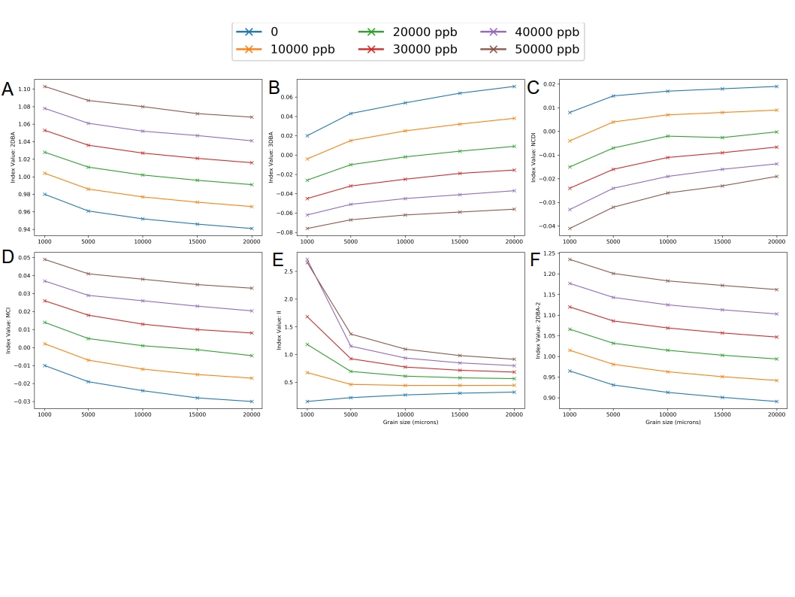

*Fig: Change in band ratio index value with reff for glacier algae concentrations from 0 – 50,000ppb*

*Comparison to field spectra*

We were also able to apply the 2BDA index to our field-measured spectra for which cell concentrations were measured using microscopy of melted ice samples (Cook et al. 2020). When the reflectance was asjucted for the spectral sensitivity of the Sentinel-2 sensor, 2BDA was unable to accurately predict the measured cell concentration. The mean absolute error between the Sentinel-2-equivalent 2BDA and the measured cell concentration was 1.16 x 106 +/- 4.99 x 106 cells/mL. This was strongly influenced by a single outlying value, but even when this was removed the mean absolute error was still high at 1.31 x 104 +/- 7.2 x 104 cells/mL. The very wide range of cell concentrations predicted by this index results from the frequent occurrence of index values that lie on the near vertical portion of Wang et al.’s (2018) exponential curve described by Eq. 1.

When we ignored the spectral response function of the sensor and instead only used the reflectance value at the centre-wavelengths for bands 4 and 5, the mean absolute error of the 2BDA index decreased, but it was still high at 1.35 x 104 +/- 1.45 x 104 cells/mL. A linear regression fit between

measured cell concentration and cell concentration predicted using the 2BDA index had a coefficient of determination of 0.52 (p<0.001). This is consistent with the coefficient of determination calculated by Di Mauro et al. (2020) in their analysis of the 2BDA index. Finally, when we used the reflectance at 0.68 and 0.71 μm the error distribution was almost the same as that for the Sentinel-2 wavelengths, with absolute error 1.35 x 104 +/- 1.44 x 104.

**4.2 Validation of RTM**

In this paper we have used a new interface to the RTM DISORT (Stamnes et al. 2000) that incorporates glacier algae. The optical properties of the glacier algae were obtained using a pigment mixing model that has previously been used to mix ex-vivo MAC values for the typical algal pigments and purpurogallin-type pigment that dominates light absorption in glacier algae (Cook et al. 2020). However, here we adjusted the MAC to better represent the in-vivo absorption by glacier algae in the natural environment. The adjustment accounts for the packaging of the pigment into discrete regions inside the glacier algal cells, as opposed to assuming uniform distribution throughout the cell volume, and attachment to intracellular proteins that influence the spectral MAC of the pigment. The absorption maximum for the in-vivo MAC is shifted relative to the ex-vivo MAC, occurring in the short visible wavelengths rather than the near-UV. This closely matches observations of real, live glacier algal cells (Fig 3D; Williamson et al. 2020). An important observation is that the MAC at near-ultra-violet to short-visible wavelengths is dramatically reduced, while the MAC across the remainder of the visible wavelengths is increased compared to the original ex-vivo MAC, leading to a shallower slope in the MAC between 350-750 nm. The shift in the absorption maximum to ~0.35 μm and sharp decline between 0.35 – 0.3 μm explains the sharp drop in surface reflectance at very short visible wavelengths observed in field reflectance values from ice with heavy algal concentrations (e.g. Cook et al. 2017, 2020) that we have previously interpreted as instrument error at the edge of the measurement range. Overall, the correction to the MAC increases the amount of solar energy absorbed by the glacier algae, since the energy arriving at near-UV wavelengths, where the algal absorption is reduced, is much lower than that arriving at short visible wavelengths, where the algal absorption is increased. The pigment was then incorporated into the cell along with chlorophyll-a, photosynthetic pigments, photoprotective pigments as defined in Cook et al. (2020) in the per-cell masses measured empirically by Williamson et al. (2020) for glacier algae from the GrIS surface. Non-pigment components of the cell were assumed to be non-absorbing and the cell cytoplasm was assumed to have optical properties equal to those of water.

We compared field measured spectral reflectance to spectral albedo simulated using our inverse RTM in the same way asfor the 2BDA index (section 4.1). The cell concentration that was measured in melted samples associated with each spectra was compared to the cell concentration estimated by running the spectrum through our inverse model. The predicted and measured algal cell concentrations agree well (mean absolute error of 7.4 x 103 +/- 8.48 x 103 cells/mL, Fig 3A) and a linear regression model fit between the predicted and measured cell concentrations had a coefficient of determination of 0.86, p<0.001(Fig 3B). The predicted algal concentration was therefore broadly consistent with our expectations from field observations. We also specifically tested the ability of the RTM to simulate the ice physical properties of the range of ice surfaces encountered in the GrIS ablation zone. This was achieved by comparing field spectra for clean ice with simulated spectra generated by running bioDISORT with a wide range of reff and ρbi values and no light absorbing impurities. This showed that the two variables ρbi and reff could be tuned to recreate field-measured spectra with an absolute error of 0.06 +/- 0.009 across the NIR wavelengths. Empirical measurements of ρbi and reff are not available for our field spectra, but we do have detailed qualitative descriptions of the surface in our field notes. There is good agreement between the reff and density predictions and qualitative descriptions of the ice surface, where descriptors associated with more broken, porous, well drained ice and thick weathering crusts were generally associated with lower ρbi and smaller reff, whereas descriptors associated with thin weathering crusts, smoother, denser, wetter ice were generally associated with larger predicted reff and higher predicted ρbi.

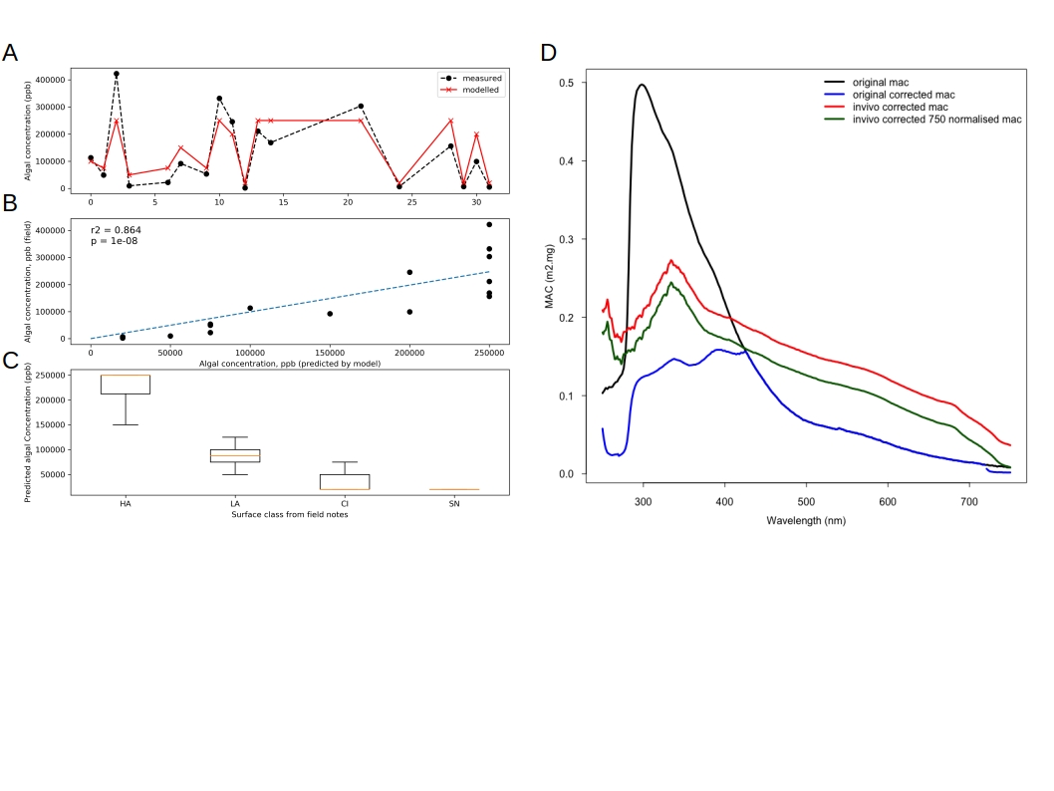

*Fig 1: A) Comparison between algal concentration in ppb derived from field measurement and (black) and the inverse model applied to satellite imagery (red); B) Scatterplot and linear regression trend line between algal concentration predicted by the inverse model and measured in field samples; C) boxplots showing the spread of values for algal concentration predicted by the inverse model in each surface class predicted by our supervised classification algorithm. Orange lines indicate the mean, boxes indicate the interquartile range and the whiskers span the range. D) MACs for the phenolic pigment under four measurement conditions: black: the original ex-vivo MAC; blue: the original ex-vivo MAC corrected for the packaging effect; red: the in-vivo MAC corrected for pigment packaging; green: the in-vivo MAC corrected for pigment packaging and normalised to the MAC of the ex-vivo pigment at non-absorbing 750 nm. The green line shows the MAC used in this study.*

**4.3 Validation of Classifier**

The spectra used to train the RF classifier are plotted in Supp Info 1. The performance of the classifier on the training set and test set are reported in Table 3. The model performance on the test set is over 92% across the various metrics, indicating that the classifier does a good job of generalizing to unseen data. The distribution of the model uncertainty is demonstrated by the confusion matrices for the training and test data, which are presented in Figure 2. The occasional errors are mostly misclassifications between the optically similar surface classes that would also sometimes be difficult for an expert human operator to separate unambigiously (clean ice and rotten snow, water and cryoconite). The classifier does a very good job of distinguishing between algal and non-algal ice, although there is some error due to the boundary between light algae and heavy algae being somewhat fuzzy. The error distribution is therefore favourable for our analyses.

|  |  |  |
| --- | --- | --- |
| Performance Metric | Training Set | Test Set |
| Accuracy | 0.991 | 0.929 |
| F1 Score | 0.991 | 0.928 |
| Recall | 0.991 | 0.929 |
| Precision | 0.992 | 0.942 |
| Overall performance | 0.991 | 0.928 |

*Table 3: Model performance on the training and hold-out test data*

Comparisons between the surface classification and the values for albedo, algae concentration, reff and ρbi retrieved from our inverse radiative transfer model also suggest that the classifier does a good job of detecting biomass on the ice surface and accurately distinguishes areas of high biomass from areas of lower biomass. The areas classified as HA invariably had a greater retrieved biomass than areas classified as LA or CI. When we ran our field spectra through our inverse radiative transfer model, the predicted algae concentration for HA sites was 2.64 x 104 +/- 9.95 x 103cells/mL, compared to the measured concentration 3.05 x 104 +/- 1.37 x 104 cells/mL. For LA sites, the predicted concentration was 9.67 x 103 +/- 1.67 x 103 cells/mL compared to the actual measured concentration 8.54 x 103 +/- 6.23 x 103 cells/mL (Fig 3C). As well as comparing well to each other, these predicted and measured values are consistent with the cell concentrations reported in Cook et al. (2020) for HA (2.9 x 104 +/- 2.01 x 104 cells/mL ) and LA (4.73 x 103 +/- 2.57 x 103 cells/mL) sites. In addition to the validation of the classifier provided in Cook et al. (2020), these observations support the use of our classification algorithm for biomass detection and mapping across the ice surface.

**4.3 Direct comparison of RTM and 2BDA**

The 2BDA index consistently overestimated algal abundance in our S2 imagery compared to the RTM. This is not a surprising result because the 2BDA index atributes all changes in the ratio of B5/B4 reflectance to algal abundance whereas we have shown it is sensitive to a range of physical processes. Furthermore, the calibration of the 2BDA index to field spectroscopic data was based on just a few samples and assumed that the high concentrations of algae that occurred at the scale of decimeters on the ice surface also existed at the scale of entire 300 x 300 m satellite pixels. The exponential function fit to field measurements by Wang et al. (2018) and applied to various satellite remote sensing platforms (Wang et al. 2018, 2020) drastically overestimated algal abundance when we applied it to Sentinel-2 data because index values often occurred that fell on the near-vertical portion of the exponential model, indicating low potential for that model to generalize to the range of scenarios that exist across the GrIS surface. 2BDA retrievals were often five or more orders of magnitude greater than our RTM retrievals and are not considered realistic based on field observations.

**4.4 Retrieved algal concentration, reff, Pbi and albedo.**

*Albedo*

The retrieved albedo was lower in 2016 and 2019 compared to 2017 and 2018 (Table 4). The darkest year was 2019 (0.47 ± 0.11) and the brightest year was 2018 (0.59 ± 0.13). There are four hotspots of low albedo that are common to all four years. The four areas are labelled DA (dark area) 1-4 in Fig 2A, located inland of Jakobshavn Isbrae Glacier (DA1), Usugdlup Sermia Glacier (DA2), Russell Glacier (DA3) and Marjorqaq Glacier (DA4) and they coincide with areas identified by Wang et al. (2018) as hotspots of algal concentration, which is also corroborated by our algal concentration retrievals. The albedo of the whole dark zone decreased from June to August in all four years.

|  |  |  |  |  |
| --- | --- | --- | --- | --- |
|  | Albedo | Algae concentration (cells/mL) | Reff (μm) | Density (kg m-3) |
| 2016 | 0.52 ± 0.12 | 4.46 x 103 ± 3.85 x 103 | 9861 ± 3431 | 495 ± 82 |
| 2017 | 0.58 ± 0.12 | 3.49 x 103 ± 2.73 x 103 | 7802 ± 4428 | 507 ± 109 |
| 2018 | 0.59 ± 0.13 | 3.21 x 103 ± 2.66 x 103 | 7907 ± 4458 | 535 ± 109 |
| 2019 | 0.47 ± 0.11 | 5.25 x 103 ± 4.17 x 103 | 11886 ± 3298 | 471 ± 81 |

Table 4: whole-dark zone annual mean values for albedo, algae concentration, reff and Pbi.

*Algal concentration*

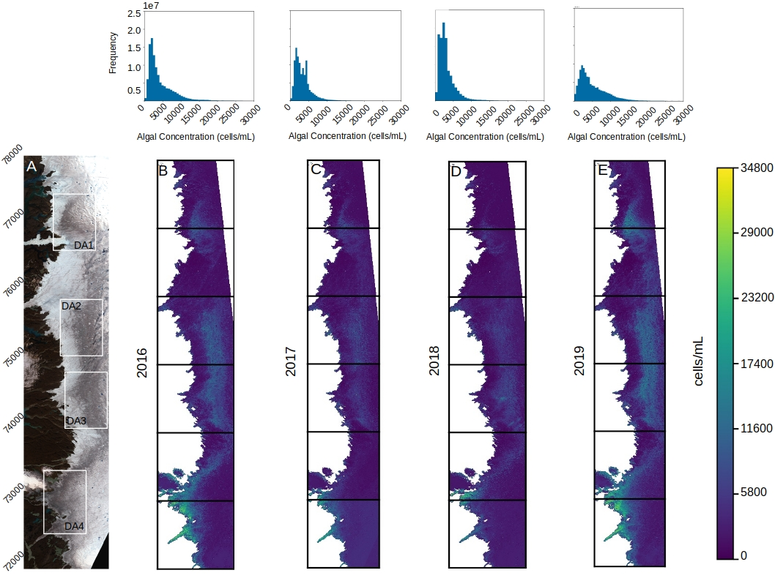

Fig 2: A) True colour image (composite of Sentinel-2 bands 2,3,4 from 17th August 2017, merged using gdal) with especially dark areas 1-4 shown in white squares; B) Mean algal concentration across the dark zone for summers 2016 – 2019

The algal concentration across the DZ varied spatially and over time. The two ‘dark’ years (2016 and 2019) had overall higher algal cell concentrations (Fig 2) than the two ‘bright’ years (2017 and 2018). The mean algal cell concentration was 4.46 x 103 +/- 3.85 x 103 cells/mL in 2016, 3.49 x 103 +/- 2.73 x 103 cells/mL in 2017, 3.21 x 103 +/- 2.66 x 103 cells/mL in 2018 and 5.25 x 103 +/- 4.17 x 103 cells/mL in 2019. The frequency distribution of algal concentrations in each year show a higher frequency of higher algal concentrations in 2016 and 2019 than in 2017 and 2018 (Fig 2). We broadly agree with Wang et al. (2018) that four areas can be identified as ‘hotspots’ of algal concentration. These are the same areas identified as especially low albedo. These areas tend to accumulate glacier algae earlier and to higher concentrations than other areas in the dark zone (Fig 2, 3). In contrast to Wang et al. (2018) we did not find a monotonic increase in algal cell concentration with elevation. Rather, we found that the highest algal cell concentrations were found immediately above a relatively clean marginal zone, with decreasing algal cell concentration closer to the snowline such that areas that had been exposed for the longest had the highest cell concentrations. This is easier to discern in the August retrievals (Fig 3) than in the annual maps (Fig 2).

In all four years there was an increase in algal concentration from June to August. The highest June, July and August algal concentrations all occurred in 2019 (3.43 x 103 ± 3.02 x 103, 5.63 x 103 ± 5.06 x 103 and 6.30 x 103 ± 5.26 x 103 cells/mL in June, July and August respectively). Overall, the region with the highest algal concentration was the Kangerlussuaq region (tile 22WEV). For this area, the highest algal concentrations were recorded in 2019 when the mean algal cell concentration in June, July and August was 3.44 x 103 ± 2.79 x 103, 6.58 x 103 ± 4.24 x 103 and 7.71 x 103 ± 4.53 x 103 cells/mL. The July cell concentration was actually slightly higher in 2016 for this region, with the June and August retrievals very similar to those in 2019 (June: 2.23 x 103 ± 1.94 x 103 cells/mL; July: 6.94 x 103 ± 4.24 x 103 cells/mL; Aug: 7.48 x 103 ± 5.17 x 103 cells/mL). In August 2017 the cell concentration across the dark zone was higher than in 2016, although it was much lower in June and July (Fig 2, Table 5).

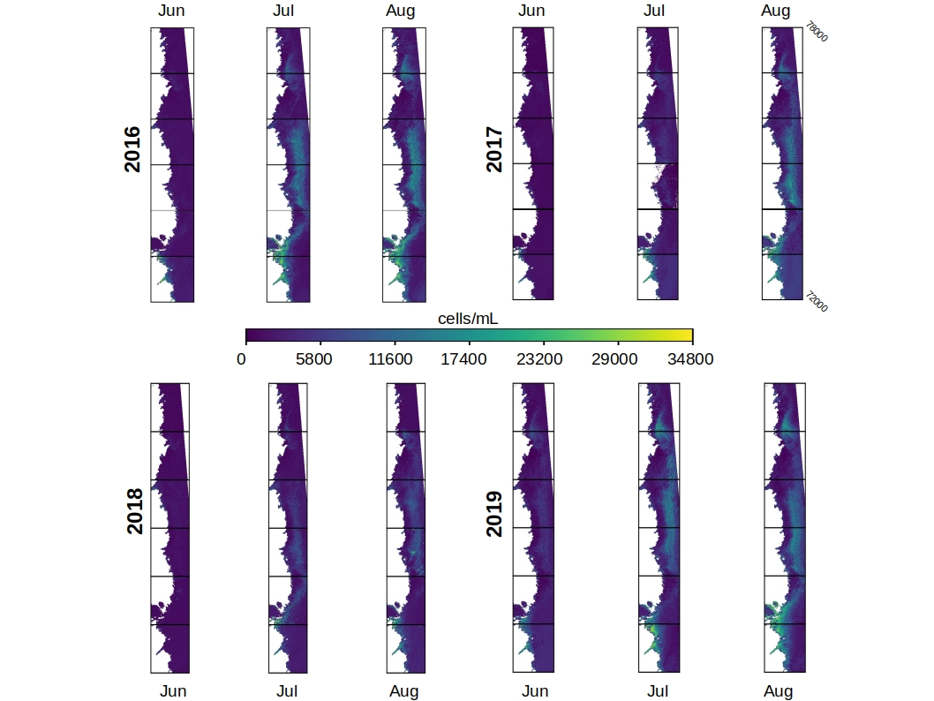

Fig 2: retrieved algal concentration maps for the dark zone in June, July and August 2016-2019.

*reff and ρbi*

The annual mean reff was lower in the darker years (9861 ± 3431 μm in 2016 and 11886 ± 3298 μm in 2019) than the brighter years (7802 ± 4428 μm in 2017 and 7907 ± 4458 μm in 2018). In all four years the retrieved reff increased from June to August, except that in 2019 the whole dark-zone reff was slightly lower in August than July. The spatial patterns observed for algal concentration were not also observed for the retrieved reff. The grain size was highest within the dark stripe on the ice surface but no trend with elevation within the dark stripe was observed. For ρbi the opposite trend was observed, with the GrIS dark zone becoming less dense from June to August in all four years (Table 5).

|  |  |  |  |  |  |  |  |  |  |  |  |  |
| --- | --- | --- | --- | --- | --- | --- | --- | --- | --- | --- | --- | --- |
|  | **2016** | | | **2017** | | | **2018** | | | **2019** | | |
|  | **June** | **July** | **August** | **June** | **July** | **August** | **June** | **July** | **August** | **June** | **July** | **August** |
| **Algae**  **(cells/mL)** | 2.23 x 103 ± 1.94 x 103 | 6.94 x 103 ± 4.24 x 103 | 7.48 x 103 ± 5.17 x 103 | 1.56 x 103 ± 1.99 x 103 | 3.39 x 103 ± 3.25 x 103 | 6.10 x 103 ± 4.67 x 103 | 1.65 x 103 ± 1.94 x 103 | 3.39 x 103 ± 3.27 x 103 | 3.95 x 103 ± 3.49 x 103 | 3.43 x 103 ± 3.02 x 103 | 5.63 x 103 ± 5.06 x 103 | 6.30 x 103 ± 5.26 x 103 |
| **reff (μm)** | 6.94 x 103 ± 4.19 x 103 | 1.38 x 104 ± 1.77 x 103 | 1.44 x 104 ± 1.62 x 103 | 4.78 x 103 ± 4.93 x 103 | 6.19 x 103 ± 4.81 x 103 | 1.68 x 104 ± 3.91 x 103 | 6.23 x 103 ± 4.80 x 103 | 1.23 x 104 ± 3.66 x 103 | 1.24 x 104 ± 2.42 x 103 | 1.21 x 104 ± 3.72 x 103 | 1.46 x 104 ± 1.39 x 103 | 1.38 x 104 ± 1.09 x 103 |
| **ρbi (kg m-3)** | 551 ± 141 | 461 ± 106 | 446 ± 100 | 495 ± 129 | 493 ± 257 | 422 ± 159 | 549 ± 150 | 453 ± 112 | 475 ± 110 | 480 ± 142 | 439 ± 106 | 449 ± 81 |

Table 5: June, July and August means for algal concentration, ice grain size and ice density

*Correlations between variables*

The Pearson’s R correlation coefficients revealed strong correlations between surface albedo and algal cell concentration. In the years where the retrieved algal concentration was lower, the correlation between algal concentration and albedo was weaker (R = 0.51, p<0.0001 in 2017, R = -0.57, p<0.0001 in 2018), whereas in the years where algal concentration was greater, the correlation between algal concentration and albedo was stronger (R = 0.74, p<0.0001 in 2016, R = 0.71, p<0.0001 in 2019). The correlation between reff and albedo was also strong in all four years, but the strongest correlations occurred in the two lower algal concentration years (2017 and 2018).

|  |  |  |  |  |  |  |
| --- | --- | --- | --- | --- | --- | --- |
|  | Algae:Albedo | Algae: reff | Algae: ρbi | reff:albedo | reff:ρbi | ρbi: albedo |
| 2016 | -0.74 | 0.46 | -0.20 | -0.84 | -0.23 | 0.11 |
| 2017 | -0.51 | 0.29 | -0.05 | -0.88 | -0.24 | 0.14 |
| 2018 | -0.57 | 0.39 | -0.17 | -0.91 | -0.45 | 0.36 |
| 2019 | -0.71 | 0.32 | -0.17 | -0.79 | -0.42 | 0.19 |

Table 6: Pearson’s R correlation coefficient for pair of variables. In all cases p<0.0001.

**4.5 Sub-region time series**

Fig 3: A) broadband albedo for a range of cell concentrations as simulated using our RTM. The other model configuration was as described in Table 1.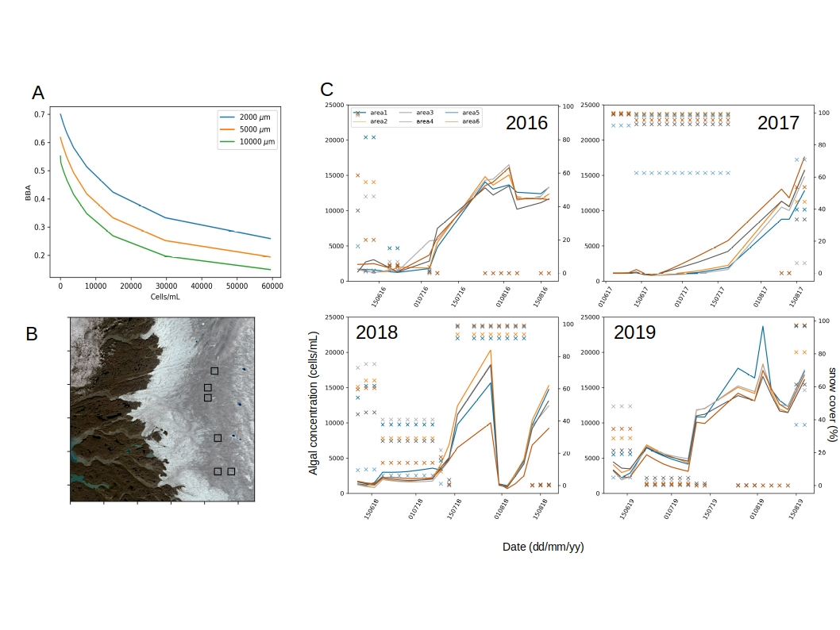 B) Sentinel-2 true-colour composite (created using gdal_merge from S2 bands 2,3,4) for the Kangerlussuaq region (tile 22WEV) with sub-areas 1-6 identified as black squares numbered from N to S. C) Time series for algal concentration in each sub-area in each year. Lines indicate mean algal concentration across the exposed ice in the sub-area and crosses indicate the percentage of the sub-area covered by snow.

**5 Discussion**

**5.1 Band ratios vs RTM**

Our sensitivity tests indicate that band ratio indexes are prone to uncertainty due to variations in reff and SZA. In our sensitivity tests we found that, using the 2BDA index, increasing reff from 1000 to 20000 μm was approximately equivalent to adding 20000 ppb (2320 cells/mL) of glacier algae. This range of reff is realistic across the GrIS according to our RTM validation and inverse model retrievals. Therefore, variations in the cell concentration of the order 103 cells/mL could actually be changes in the reff of the underlying ice. We also found that solar zenith angle variations caused by different image acquisition times led to non-negligible changes to the 2BDA index. Specifically, for identical RT model configurations, we measured the 2BDA index for glacier algal concentrations near the upper and lower extremes of the range presented by Wang et al (2018, Fig 2b) at the minimum and maximum SZA calculated from the acquisition times for our imagery. With a moderate glacier algal concentration (30000 ppb / 3480 cells/mL ) the biomass concentraton estimated using the 2BDA index varied by 1.72 x 105 cells/mL when the cosine of the SZA was changed from 0.52 to 0.72. Previous implementations of the 2BDA index have validated their retrievals against field spectra gathered from the literature. We tested the 2BDA index against field spectra directly, eliminating spatial heterogenity across a pixel as a source of error. We found large errors between cell concentrations predicted using Wang et al.’s (2018) equation and those measured using microscopy of melted field samples. When we resampled the field spectra to match the resolution of the Sentinel-2 sensor, the 2BDA index had a mean absolute error of 1.35 x 104 +/- 1.45 x 104 cells/mL. When we ignored the spectral response of the Sentinel-2 sensor the error decreased but was still high, indicating an inherent inability to account for processes affecting surface reflectance other than chlorophyll-a concentration, limiting the usefulness of this metric even when truly hyperspectral sensors are available. The inverse RTM compared much more favourably against the measured cell concentrations, with a mean absolute error of 7.4 x 103 +/- 8.48 x 103 cells/mL. A linear regression model fit between measured cell concentrations and those predicted by the inverse RTM had a coefficient of determination of 0.86 (p<0.001).

More evidence is available in the published literature. Wang et al. (2020: Appendix B) provided a scatterplot of 2BDA index values for spectra measured against measured cell concentrations, both from Cook et al. (2020). The existence of a positive correlation was interpreted as validation of the 2BDA index. However, when their conversion equation (Eq 1) is applied to the reported index values there are very large discrepancies between the predicted cell concentrations and those measured. We undertook this analysis and found that their reported index values were as high as 1.26 which corresponds to an estimated cell concentration of 5.19 x 1013 cells/mL. For the same spectrum, the measured cell concentration was 9.22 x 104, which is also the highest cell concentration yet reported from field measurements from the GrIS. Therefore, the 2BDA overestimates the greatest measured cell concentration acros all previous studies by 9 orders of magnitude. For all the spectra with measured cell concentrations above 10,000 cells/mL the mean measured cell concentration was 2.8 x 104 cells/mL but the cell concentration estimated using the mean 2BDA index (1.09) was 1.69 x 107 cellsmL.

The reasons for this low performance are likely: a) the indexes use reflectance at a NIR wavelength as a standard against which to compare reflectance at some lower wavelengths, such as those relating to chlorophyll absorption, but the NIR reflectance varies according to the reff, making reff a confounding variable; b) the conversion model was it to a very small number of spectra and does not generalise well to the range of cell concentrations and spectral albedos encountered across the GrIS; c) the conversion model was fit to index values from hyperspectral data gathered over homogenous ice patches covering areas of length 10-1 m that are probably not representative of satellite pixels with length 102 m; d) the model fit between 2BDA index and cell concentration is likely unique to specific localities due to strong multicolinearity between algal cell concentration and physical characteristcs of the ice.

We also deployed the 2BDA index over our Sentinel-2 imagery, finding large discrepancies between the cell concentrations predicted using the 2BDA and the RTM. The 2BDA often predicts unrealistically high cell concentrations (up to 109 cells/mL). The maximum measured cell concentration reported in the literature to date is 9.2 x 104 cells.mL (Cook et al. 2020). In addition to the explanations a) – d) above, this may also be the result of the increased spatial resolution of the Sentinel-2 sensor (20 m) compared to MERIS and Sentinel-3. As Tedstone et al. (2020) point out, patches of ice with high algal cell concentrations have relatively small length scales (100 – 101 m), so the integrated signal from a 300-m pixel will necessarily correspond to a lower cell concentration. At the smaller spatial resolution there is a greater chance of a pixel having a higher proportion of its area covered by high cell concentrations. This leads to more frequent retrievals that sit on the near-vertical part of Wang et al.’s (2018,2020) conversion model, giving unrealistically high cell concentrations.

Di Mauro et al. (2020) also investigated band ratios for quantifying glacier algae on alpine glaciers, finding that Sentinel-2 bands 6 and 4 were better than the OLCI equivalents for quantifying glacier algae. This was determined by comparison to hyperspectral field spectroscopic data that eliminated spatial integration as a source of error. Linear regression between their measured cell concentrations and the adjusted index yielded a coefficient of determination of just 0.53 (similar to Wang et al.’s 2BDA index). They ran this analysis for every possible combination of wavelengths and found the maximum possible coefficient of determination was ~0.6. Interestingly, the hotspots of coefficient of determination occurred for combinations of NIR wavelengths rather than combinations of VIS and NIR wavelengths (see their Figure 4). Since NIR wavelengths are influenced by ice physical processes and not by absorption by glacier algae, this suggests that the band ratios are really picking up an ice surface development signal moreso than an algal absorption signal and the correlation with measured cell concentrations reflects multicolinearity between ice surface development and glacier algae concentration (as discussed by Cook et al. 2020, Tedstone et al. 2020 and in our section 5.2).

This demonstrates the need for a system that integrates inverse radiative transfer modelling with spectral image analysis, since the inverse radiative transfer modelling enables the effects of reff and SZA to be accounted for and therefore offers a more skillful method for reducing error in GCM albedo schemes, enables deeper insights into glacier-algae spatial ecology and is also more easily refined as new process-knowledge and empirical data regarding the co-development of the ice surface and LAPs becomes available. At the same time, the inverse radiative transfer model also opens a wide range of potential future advances that are not available to band ratio techniques, most importantly the potential to use the model in a “forward” mode to test hypothetical scenarios or make future predictions, potentially with initial conditions set using the inverse model. Our inverse RTM system predicts measured cell concentrations much more accurately then band ratio techniques, as demonstrated by our validation experiments.

**5.2 Glacier algae**

A strong inverse correlation was observed between albedo and algal concentration. While the correlation itself does not imply causation, we can also demonstrate a mechanism of albedo reduction using our RTM. Adding glacier algae to a clean ice surface invariably reduced the albedo. The mean cell concentration across the GrIS dark zone retrieved using our inverse RTM in each year 2016 – 2019 caused albedo reductions of 0.23, 0.20, 0.14 and 0.20 when added to clean ice in our RTM (Table 6). In our RTM experiments (Fig 6) the albedo reducing effect of changing algal concentration diminishes as grain size increases (because the effect of adding a dark material to a darker substrate is smaller than adding a dark material to a bright substrate). Regardless of the reff used in the simulation, the ice albedo was most sensitive to changes in algal concentration in the range 15000 to 30000 cells/mL, the upper end of our measured cell concentrations. For higher or lower cell concentrations, the sensitivity of the ice albedo is smaller (Fig 3A).

Correlation coefficients between retrieved algal concentration and albedo across the GrIS dark zone varied year to year. The correlation was stronger when the algal concentration was higher and weaker when the algal concentration was lower. This likely results from the simultaneous influence of surface physical evolution. Lower algal concentrations have a smaller albedo reducing effect meaning the surface albedo is more sensitive to changes in ice physical properties. Conversely, where algal concentrations are high, they dominate the albedo change. At the same time, the existence of a feedback between ice physical properties and algal concentration may explain the variation in correlation coefficient. Because high algal concentrations and large reff codevelop, high algal concentrations likely exist on grain sizes that are sufficiently large that further changes have minimal impact on the optical thickness of the ice, whereas algal concentration retains a significant albedo reducing effect. This explanation is supported by the weaker correlation coefficients between reff and albedo in the years where the algal concentration was higher (2016 and 2019). The absolute values of algal cell concentrations retrieved by our system have a similar mean and range as field measurements made on the GrIS surface by Yallop et al. (2012), Stibal et al. (2017) and Cook et al. (2020).

The years we identified as having high mean algal concentrations were years with especially high air temperatures and surface melt rates, early and rapid removal of winter snow and below average surface mass balance. In contrast, the years we identified as having low mean algal concentration were characterised by low temperature, persistent snow cover and above average surface mass balance (NOAA Arctic Report Card). Examination of time series of retrieved algal concentration in sub-areas in tile 22WEV revealed increases across summers 2016 – 2019. In 2016 and 2019 there was a rapid accumulation of glacier algae through July, whereas in the brighter years (2017 and 2018) glacier algae accumulated more slowly. In 2017 there was a continuous but gradual accumulation of glacier algae throughout the summer, whereas in 2018 a rapid accumulation of glacier algae in late July was punctuated by a sudden dramatic decline which coincided precisely with a large snowfall event.

When we examined sub-areas in the Kangerlussuaq region (tile 22WEV) we observed similar algal concentration maxima across the six areas in all for years and the main differences were in how rapidly those maxima were reached and how persistent they were across the summer. The time series presented in Fig 3 show rapid increases in algal concentration following snow removal, however there is always a lag between the snow melting away and the maximum algal concentration, suggesting that algal biomass predominantly accumulates in situ rather than persisting at high concentrations year-to-year. In 2018, the tile remained largely snow covered throughout the majority of the season, so although the mean algal concentration was relatively high it only represents <10% coverage of the test areas.

**5.3 Ice physical properties**

Our analyses demonstrate that ice physical properties, along with solar zenith angle, exert an important influence on the optics of the ice surface that confound band ratio indexes that might otherwise be used to quantify chlorophyll-containing glacier algal cell concentration on the ice surface. We also identified close correlations between glacier algal concentration, reff and ρbi. This indicates that glacier algae preferentially exist where reff and ρbi are greater, conditions associated with thin or non-existent weathering crusts with wet or waterlogged ice. These ice physical conditions are associated with lower albedo. This suggests that there is a codevelopment process whereby lower albedo ice produced by surface lowering or meltwater accumulation cretaes favourable conditions for algal growth, or vice versa glacier algae accelerate surface lowering and degrade and/or wetten the weathering crust, a coupled process that darkens the ice by biological and physical means. Isolating the albedo effects caused by the biological and physical processes is therefore difficult, but radiative transfer modelling does enable us to estimate the individual contributions from each mechanism. We quantified the algal and ice physical contributions to albedo reduction by creating a realistic clean, dry ice surface by assigning the whole-DZ mean retrieved reff and ρbi values for the start of June 2017 when very little glacier algae was detected. The other RTM parameters were as described in Table 1, except that we took the mean albedo at each wavelength for SZA = 0.3, 0.4, 0.5, 0.6, 0.7, 0.8. We then replaced the reff, ρbi and algal concentration values retrieved in August of each year. We recorded the albedo change when each individual parameter was altered and the total albedo change when all three parameters were changed simultaneously. In all cases the algae caused the largest change in broadband albedo but large changes in broadband albedo also resulted from varying reff (Table 6). ρbi had a small but non-negligible effect on the broadband albedo. The total albedo change when all three parameters were altered to their August values was not equal to the sum of the albedo change caused by the three individual parameters, likely because at high grain sizes the albedo reducing effect of algal accumulation is diminished because the underlying ice has a lower albedo, and vice versa. These experiments clearly demonstrate that although glacier algae accumulation has the greatest individual albedo reducing effect it only accounts for a portion of the total observed albedo decline relative to clean ice, with the remainder being the result of changes to the physical configuration of the ice surface.

|  |  |  |  |  |
| --- | --- | --- | --- | --- |
|  | 2016 | 2017 | 2018 | 2019 |
| Clean ice albedo | 0.61 | 0.61 | 0.61 | 0.61 |
| reff | 0.48 (-0.13) | 0.46 (-0.15) | 0.50 (-0.11) | 0.48 (-0.13) |
| ρbi | 0.59 (-0.02) | 0.59 (-0.02) | 0.60 (-0.01) | 0.59 (-0.02) |
| algae | 0.38 (-0.23) | 0.41 (-0.20) | 0.47 (-0.14) | 0.41 (-0.20) |
| Reff, ρbi and algae | 0.29 (-0.32) | 0.29 (-0.32) | 0.37 (-0.24) | 0.31 (-0.30) |

Table 6: Simulated albedo when individual parameters were changed from their idealised “clean ice” values to their retrieved August values for each year. Values are simulated broadband albedo, values in brackets are change in broadband albedo relative to the clean ice simulation.

**5.3 Representing weathering crust development in a RTM**

The physical properties of ablating glacier ice change as the surface weathering crust develops in response to local energy balance conditions. Under clear sky conditions solar irradiance can penetrate the ice and cause internal melting along grain boundaries, causing the ice to transition from solid and dense to porous. This increases the size and frequency of air/ice interfaces in the three dimensional structure of the near-surface bulk of ice, with a concomitant transition from low to high albedo. When turbulent fluxes dominate the surface energy balance, surface lowering outpaces subsurface erosion, resulting in the weathered crust being “stripped” back to reveal the more solid, dense ice beneath. To represent this process in a radiative transfer model, we must translate the physical configuration of the near-surface ice into parameters that can be used to determine the optical thickness. For snow and ice with air bubbles the ice physical properties are usually described using a combination of the density and either the effective grain size (reff) or specific surface area (SSA: surface area per unit mass) which are related by:

Eq 2

where ρi = density of ice (917 kg m-3). For snow reff can be expected to be close to observed grain size (Warren et al. 1980). reff changes the albedo by changing the average distance travelled by an incident photon through the absorbing medium (ice) between scattering events at ice/air boundaries. Larger grain sizes therefore reduce the albedo. The density of the ice controls the spacing of the grains, the frequency of air-ice interfaces and the total mass of ice contained within a given bulk volume. The optical thickness of the ice can be determined from the complex refractive index, reff and ρbi. Neither reff nor ρbi alone are sufficient because high ρbi could represent close packing of small grains (high albedo) or solid ice with few inclusions (low albedo), although for ablating glacier ice there is usually a positive correlation between ρbi and reff (e.g. Dadic et al. 2013). For ice with light absorbing impurities, a higher density means a greater mass of the absorbing material per unit volume. Meltwater accumulation is often parameterised as an increase in reff because the refractive indices of water and ice are so similar. Therefore, the combination of reff and ρbi is theoretically sufficient to describe the optically-relevant ice-physical and hydrological conditions of the ice surface. However, although this theory has been well-tested for snow, it has not previously been validated for ablating glacier ice. Although we have not yet been able to conduct specific field work, we were able to conduct an empirical validation of bioDISORT with specific interest in its ability to represent the various degrees of surface weathering encountered on the GrIS surface. We compared simulated spectra to those measured in the field for sites classified as “clean ice”. We found that by tuning the grain size and density values in the ranges 400 – 900 kg m-3 and 5000 – 30000 μm we were able to simulate our 65 field-measured spectra with a mean absolute error of 0.03 +/- 0.009. This indicates that these two parameters do a good job of simulating the physical structure of the ice surface and are able to accurately recreate the spectral reflectance of the ice found in the GrIS ablation zone. There remain difficulties in forward modelling scenarios since there are currently no direct measurements of reff for weathered glacier ice and both reff and ρbi

vary over short timescales due to changes in the water table and the configuration of the crust itself. It is also awkward to prescribe representative values of reff and ρbi to non-uniformly distributed, irregularly shaped units of ice in radiative transfer models that generally assume homogeneity in grain shapes and sizes in discrete vertical layers. With weathered glacier ice in particular there is ambiguity in the definition of an ice “grain”, whereas the SSA is unambiguous and therefore a better target empirical measurement for future studies. In this study we have shown that the inverse model is able to accurately recreate field spectra in the NIR wavelengths by varying reff and ρbi only, suggesting that the two ice-physical parameters reff (or SSA) and ρbi are sufficient for describing the physical state of the weathering crust in radiative transfer models. The outstanding challenge is to determine field-measurable characteristics that can be converted into reff and ρbi for radiative transfer simulations and to gather measurements of the phase function for various ice configurations.

**5.3 Potential feedbacks**

The retrievals and analyses presented in this paper demonstrate a tight coupling between algal growth and ice physical properties on the surface of the GrIS. In our retrievals, reff was greater where algal concentrations were greater, and our RTM experiments showed that the observed albedo decline on the GrIS could not be explained by alagal growth alone. This is consistent with the existence of a positive feedback whereby glacier algae preferentially grow on ice that is rapidly melting due to the release of liquid water and nutrients (Cook et al. 2020; Tedstone et al. 2020). Both the glacier algal growth and the increasing reff due to grain development and meltwater accumulation reduce the albedo simultaneously, promoting melting and algal growth. In addition, our retrievals support the existence of a regional scale positive feedback posited by Yallop et al. (2020), Cook et al. (2020) and Williamson et al. (2019; 2020) where warm years characterised by early, rapid and persistent bare ice exposure provide larger areas, more liquid water and nutrients for algal growth and consequently the albedo of the GrIS ablation zone declines. Our retrievals demonstrate that this occurs over spatial scales of at least 104 km2 on the western GrIS. Future projections of GrIS SMB may therefore be systematically underestimated due to the omission of this biological feedback.

**5.4 System limitations and future development opportunities**

This paper presents an analytical system that integrates multispectral image analysis with inverse radiative transfer modelling to retrieve ice physical properties and light absorbing particle concentrations. This is a conceptual jump from the current state-of-the-art methods that deploy band ratios to quantify particle concentrations despite large uncertainty due to the highly variable spectral albedo of the underlying ice and illumination conditions. However, we identify five major improvements that could be made to this system to improve the retrievals in future. In most cases these have not been incorporated into the present version of the system because of a lack of critical empirical measurements that should become specific objectives for future field campaigns. The following discussion is structured to provide specific objectives for future research.

*Anisotropic Reflectance Factor / Bidirectional reflectance distribution function*

The bidirectional reflectance distribution function (BRDF) depends upon the inherent optical properties of the ice, specifically the phase function which determines the angular distribution of scattered light after interacting with an ice crystal (Warren et al. 1980). For ice, there is a strong preference for scattering in the forward direction in each scattering event. Where the ice is more porous (i.e. a more weathered crust), more scattering events occur before light “escapes” back into the atmosphere and the reflected light is more evenly distributed over the upwelling hemisphere. Where ice is smoother and denser (thin weathering crust) there is more specular reflection from the ice surface at an angle determined by Snell’s Law and fewer subsurface scattering events, meaning the total reflected light is more concentrated in a narrow range of angles. Therefore, on glacier surfaces where the ice varies from heavily weathered, porous, broken crusts to waterlogged, smooth and solid over spatial scales of decimeters to meters, the BRDF varies dramatically. Future studies should use field goniometry to establish BRDFs for a range of ablating ice surfaces. Presently, this data does not exist and remote sensing data over glacier ablation zones are either uncorrected for sensor geometry or corrected using BRDFs transferred from other environments. Due to the lack of empirical data we omitted to apply a BRDF correction in this paper, choosing instead to raise this issue here as a priority future research objective.

*Availability of labelled data*

Our RF classifier was trained on field spectroscopy data labelled using qualitative assessment on-site and validated by laboratory analysis that determined the surface composition (Cook et al. 2020). The label confidence is therefore high but so is the cost per label, in terms of money, time and expertise. This limits the size of the available dataset. There are two options for addressing this issue in the future: 1) gather more field spectroscopic data; 2) develop methods for gathering labelled data from remote imagery. To gather more field data, there must be more expert operators in the field following standard measurement protocols and collecting sufficient metadata and the data must be open and available to append to similar data from other projects. Even then, the total number of samples available for training classifiers will likely remain 102 – 104. The alternative is to develop methods for obtaining labelled spectra from remote sensing imagery. The power of this is that the total number of training samples could easily be 105 – 106. However, process-level understanding of the processes occurring in the surface crust remains incomplete, limiting our ability to reliably assign labels to remotely gathered images. While the total number of labelled samples might be high, the label accuracy would likely be low. There is something of an internal contradiction in that using remote imagery to determine labels requires methods for labelling remotely sensed imagery, which brings us back to field spectroscopic data. There is also high potential for radiative transfer modelling to provide a route to generating synthetic label data, especially for classes that are under-represented in field datasets, but this requires further model development particularly taking crust development into account (see section X.X).

*In situ, in-vivo pigmentation and mass absorption coefficients for glacier algae*

In areas such as the western Greenland Ice Sheet, one of the main darkening processes is the growth of glacier algae. These algae have only been included in radiative transfer models in the past year (Cook et al. 2020) using optical properties inferred from those of the component pigments combined in a mixing model. In this paper we have presented an updated mass absorption coefficient for the major algal pigment that takes into account pigment packaging and intracellular protein attachement. However, these algae are known to change their pigmentation, and therefore their inherent optical properties, in response to local environmental conditions. Difficulties in culturing these algae have prevented systematic laboratory analyses of this process, meaning pigmentation changes cannot be accounted for in remote algal quantification or built into predictive radiative transfer models. Future developments that enable pigmentation of glacier algae to be predicted from known local environmental variables will enhance our ability to develop these models and improve our remote algal quantification over the GrIS and other ice masses.

*Issues of spatial scale and correspondence between sensors*

Tedstone et al. (2020) showed that glacier algae blooms on the GrIS often occur with patch sizes smaller than the resolution of Sentinel-2 (20 m), leading to underestimates of algal coverage using this sensor. Sentinel-2 has a relatively high spatial resolution compared to other satellite instruments, for example Sentinel-3 (300 m). This means that within each pixel there is heterogeneity of surface properties that is not resolved by the sensor, and the measured reflectance is actually the integrated signal from several surface types, which influences the ability of the sensor to realistically estimate the surface properties.

**6 Conclusions**

Band ratios are insufficient for quantifying glacier algae on the GrIS because they are not able to take into account the varying optics of the underlying ice which can cause large variations in NIR reflectance. To address this issue we have developed an inverse radiative transfer model that accounts for ice physical properties and solar angle. We used this system to retrieve glacier algal concentrations over the western GrIS for summers 2016-2019. Although glacier algal concentration had the greatest albedo reducing effect, reff also had a large impact. Glacier algae concentration and reff were correlated and our analyses indicate a strong multicollinearity between glacier algae and reff. Our analyses agree with previously posited positive feedbacks whereby melting promotes algal growth which promotes further melting. Furthermore, our analyses support a regional scale feedback where warmer summers expose bare ice for longer and provide more liquid water and nutrients that stimulate algal growth, initiating the growth-melt feedback over areas of at least 103 km2 on the GrIS. We also identified specific issues of sensor correspondence, algal optical properties, labelled data availability and anisotropic reflectance that should be addressed to improve our system for retrieving algal and ice-physical properties from remote sensing data.

**7 References**

Martin-Ortega, P., Garcia Montero, L.G., Sibelet, N. 2020. Temporal Patterns in Illumination Conditions and Its Effect on Vegetation Indices Using Landsat on Google Earth Engine. Remote Sensing, 12 (2): 211; https://doi.org/10.3390/rs12020211

Moses, W.J., Gitelson, A.A., Berdnikov, S., Povazhny. Estimation of chlorophyll-a concentration in case II waters using MODIS and MERIS data – successes and challenges. Enrivonmental Research Letters, 4: 045005, doi:10.1088/1748-9326/4/4/045005

Norris, J.R., Walker, J.J., Solar and sensor geometry, not vegetation response, drive satellite NDVI phenology in widespread ecosystems of the western United States, Remote Sensing of Environment, 249, 112013, doi: 10.1016/j.rse.2020.112013

Salem, S. I., Higa, H., Kim, H., Kobayashi, H., Oki, K., & Oki, T. (2017). Assessment of Chlorophyll-a Algorithms Considering Different Trophic Statuses and Optimal Bands. *Sensors (Basel, Switzerland)*, *17*(8), 1746. https://doi.org/10.3390/s17081746