OpenCPI-Guard: A Leakage-Aware and Country-Portable Framework for Regional Inflation Pressure Detection from Official CPI Tables
Author(s): Ferian Fauzi Abdulloh et al. (draft)
Draft manuscript generated from BPS-CPI hardcore v2.1 experiment outputs

Abstract
Official consumer price index (CPI) tables are widely published by national statistical offices, yet computational studies of inflation often remain country-specific, difficult to reproduce, and vulnerable to temporal leakage. This paper proposes OpenCPI-Guard, a reproducible and country-portable framework for detecting regional inflation pressure from official CPI tables. The framework separates country-specific data acquisition from downstream modeling through a common CPI panel schema. It formulates inflation monitoring as an early-warning classification task: using information available up to month t, the model predicts whether a region will enter the top inflation-pressure group in month t+1. To avoid fixed thresholds that are not comparable across inflation regimes, pressure labels are defined using within-country relative rankings such as top-10% and top-20% regional inflation pressure. The empirical reference implementation uses Indonesia as a case study, drawing on monthly CPI and inflation data from Statistics Indonesia for 150 CPI observation areas and 11 expenditure groups from January 2024 to May 2026. Under a leakage-aware temporal split, validation-selected rank-average ensembles achieve strong performance for year-on-year pressure detection, with a test PR-AUC of 0.695 and ROC-AUC of 0.893 for top-20% annual pressure, and a test PR-AUC of 0.636 and ROC-AUC of 0.933 for top-10% annual pressure. Month-to-month pressure remains more difficult to detect using CPI history alone, suggesting that short-term shocks require additional high-frequency commodity, weather, transport, or policy-event signals. The results demonstrate that a simple, auditable, and portable machine-learning protocol can convert official CPI tables into actionable regional inflation risk rankings while preserving reproducibility and leakage safety.
Keywords: Consumer Price Index; inflation pressure detection; reproducible machine learning; temporal leakage; regional analytics; official statistics; explainable AI

1. Introduction
Consumer price indexes are among the most important official statistics for monitoring changes in household purchasing costs and inflation. National statistical offices often publish CPI tables not only at the national level but also by expenditure component and, in some countries, by province, city, or regional observation area. These tables are valuable for early warning, yet their use in machine-learning studies is often hindered by inconsistent data formats, ad hoc labeling decisions, and evaluation protocols that may accidentally use future information.
This paper addresses these issues by proposing OpenCPI-Guard, a reusable framework for turning official CPI tables into a leakage-aware supervised learning problem. The framework is designed for informatics and data-mining research rather than economic causal inference. It does not attempt to identify structural determinants of inflation; instead, it operationalizes regional inflation monitoring as a computational early-warning task with explicit data contracts, reproducible feature engineering, temporal validation, and exportable risk rankings.
The core design principle is separation of concerns. Data acquisition is country-specific, because each statistical office exposes CPI tables through different websites, APIs, or spreadsheets. Downstream modeling, however, is country-agnostic once the data are mapped into a common CPI panel schema. This allows the same feature builder, labeler, model zoo, evaluation code, and explainability module to be reused across countries.
Indonesia is used as the reference implementation because Statistics Indonesia publishes CPI and inflation tables for 150 CPI observation areas and 11 expenditure groups under the 2022=100 base. The case study is not framed as a purely Indonesian forecasting exercise, but as a demonstration that the proposed framework can be instantiated on official regional CPI data.

2. Contributions
• A common CPI panel schema that decouples country-specific data extraction from country-agnostic modeling.
• A leakage-aware feature engineering protocol that uses only information available up to the prediction month.
• Relative inflation-pressure labels based on within-country rankings, enabling comparison across different inflation regimes without fixed threshold assumptions.
• A validation-based model selection and rank-average ensemble procedure for robust regional risk ranking.
• A reference implementation on Indonesia’s 150 CPI observation areas, including reproducible outputs, metrics, feature importance, and latest regional risk rankings.

3. Background and Related Work
The CPI Manual 2020 states that its purpose is to help countries produce CPIs consistent with internationally recommended concepts, methods, and practices, and to improve the international comparability of CPIs. This international basis motivates a framework that operates on a generic CPI schema rather than on variables tied to a single national website.
The IMF CPI dataset further illustrates the cross-country structure of CPI information by publishing national CPI all-items indexes, detailed division-level indexes, associated weights, and contributions to national annual inflation where available. These data characteristics motivate the schema adopted in OpenCPI-Guard.
COICOP 2018 provides an international reference framework for grouping household consumption expenditures into purpose-based categories and is used in areas including consumer price indices. The expenditure-group features used in this paper are therefore described as COICOP-compatible rather than as purely local labels.
Existing machine-learning studies of inflation frequently focus on point forecasting of national headline inflation or disaggregated CPI components. For example, hierarchical recurrent neural networks have been used to forecast CPI inflation components by leveraging CPI hierarchy information. In contrast, OpenCPI-Guard focuses on a complementary task: detecting whether a region will enter a high-pressure group in the next month under a leakage-aware, reproducible, and country-portable protocol.

4. OpenCPI-Guard Framework
Figure 1 summarizes the proposed framework. The data source may differ by country, but all downstream steps operate on the same schema and temporal validation rules.
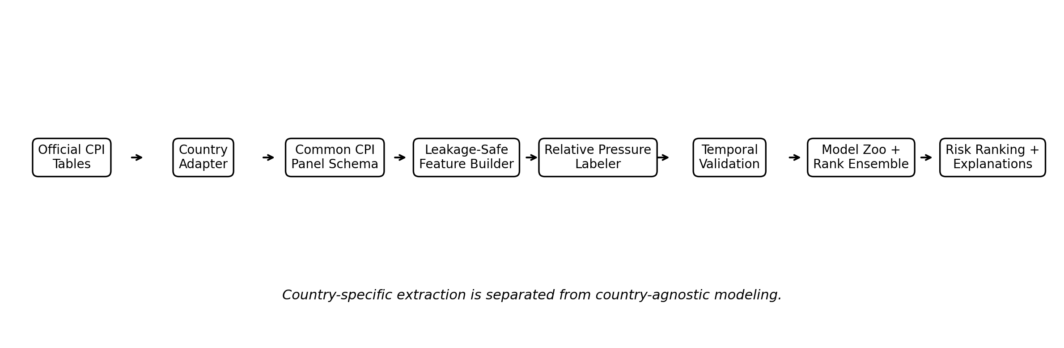
Figure 1. OpenCPI-Guard framework architecture.

4.1 Common CPI Panel Schema
The common schema is a monthly panel indexed by country, region, and month. The minimum required fields are country, region_id, region_name, month, cpi_all_items, and at least one inflation measure. When inflation rates are unavailable, they can be computed from CPI indexes when sufficient history exists. Optional expenditure-group fields allow component-aware explanations.
country, region_id, region_name, month,
cpi_all_items, inflation_mtm, inflation_yoy,
cpi_g01 ... cpi_g11,
inflation_mtm_g01 ... inflation_mtm_g11,
inflation_yoy_g01 ... inflation_yoy_g11

4.2 Country Adapter Layer
The country adapter is responsible only for transforming official data into the common schema. For Indonesia, the adapter uses the BPS WebAPI. For other countries, the same framework can use a generic CSV adapter, an IMF CPI adapter, a Eurostat HICP adapter, or a national statistical office adapter. This design prevents the modeling code from depending on BPS-specific variable identifiers.

4.3 Relative Inflation-Pressure Labeling
For each month and inflation type, regions are ranked within the same country. A high-pressure label is assigned when the next-month inflation value falls in the top q proportion of regions. In this study q is set to 0.20 and 0.10. This avoids fixed thresholds such as 3% that may not be portable across countries.
HighPressure_q(i,t+1) = 1 if rank_percentile(inflation(i,t+1)) >= 1 - q; otherwise 0

4.4 Leakage-Safe Feature Builder
Feature engineering uses only information available up to month t. The feature groups include lagged CPI and inflation variables, rolling means and standard deviations, momentum features, cross-sectional ranks and z-scores, current pressure flags, expenditure-group dispersion measures, and region and month categorical effects. Target columns, next-month values, and any variables containing future information are excluded by construction.

4.5 Temporal Validation and Model Selection
Model selection is based only on validation data. After selecting top-performing models by validation PR-AUC, the selected models are refit on the combined training and validation period and evaluated once on the held-out temporal test period. This avoids selecting models directly on the test set.
Train: 2024-01-01 to 2025-05-01
Validation: 2025-06-01 to 2025-11-01
Test: 2025-12-01 to 2026-04-01

5. Reference Implementation: Indonesia
The reference implementation uses monthly CPI and inflation tables from Statistics Indonesia for 150 CPI observation areas. The public BPS publication states that the 2025 CPI publication covers national CPI and 150 districts/cities, consisting of 38 provincial capitals and 112 additional districts/cities, by expenditure group and sub-group per month under the 2022=100 base. In the modeling dataset, Indonesia-level aggregate rows are excluded from regional targets, leaving 150 CPI observation areas.
The resulting machine-learning dataset contains 4,200 region-month observations. The next-month target ranges from February 2024 to May 2026, while feature months range from January 2024 to April 2026. The train, validation, and test sets contain 2,550, 900, and 750 observations, respectively.
A special metadata note is required for Jakarta. In the BPS-derived table, Jakarta appears as a CPI observation area label rather than a standard regency/city in the same administrative sense as other observations. The study therefore uses the term CPI observation area instead of claiming that all rows are administrative regencies/cities.
Item | Value
Rows in modeling dataset | 4200
Number of CPI observation areas | 150
Feature month range | 2024-01-01 to 2026-04-01
Next-month target range | 2024-02-01 to 2026-05-01
Training rows | 2550
Validation rows | 900
Test rows | 750
Table 1. Dataset and temporal split summary.

5.1 CPI Expenditure Groups
Code | Expenditure group
G01 | Food, beverages, and tobacco
G02 | Clothing and footwear
G03 | Housing, water, electricity, and household fuels
G04 | Furnishings, household equipment, and routine maintenance
G05 | Health
G06 | Transport
G07 | Information, communication, and financial services
G08 | Recreation, sport, and culture
G09 | Education
G10 | Restaurants and food-serving services
G11 | Personal care and miscellaneous services
Table 2. CPI expenditure-group features used in the framework.

6. Experimental Design
Four next-month detection targets are evaluated: top-20% and top-10% pressure for month-to-month inflation, and top-20% and top-10% pressure for year-on-year inflation. Because the targets are imbalanced ranking tasks, PR-AUC is used as the main model-selection metric, supported by ROC-AUC, macro-F1, recall at top 20%, and recall at top 10%.
The model zoo includes logistic regression with region and month fixed effects, random forest, extra trees, XGBoost, LightGBM, CatBoost, and a validation-selected rank-average ensemble. For each target, the top three models by validation PR-AUC are combined into a rank-average ensemble, which stabilizes risk ordering across model families.

7. Results
Task | Valid PR-AUC | Test PR-AUC | Test ROC-AUC | Test Macro-F1 | Test Recall@20% | Test Recall@10%
m-to-m top-20% | 0.315 | 0.340 | 0.637 | 0.566 | 0.344 | 0.204
y-on-y top-20% | 0.812 | 0.695 | 0.893 | 0.820 | 0.702 | 0.384
m-to-m top-10% | 0.174 | 0.193 | 0.687 | 0.561 | 0.385 | 0.205
y-on-y top-10% | 0.681 | 0.636 | 0.933 | 0.790 | 0.870 | 0.584
Table 3. Validation-selected ensemble performance on the temporal test set.
The strongest results are obtained for year-on-year pressure detection. For top-20% annual pressure, the ensemble reaches a test PR-AUC of 0.695, ROC-AUC of 0.893, and macro-F1 of 0.820. For top-10% annual pressure, the ensemble reaches a test PR-AUC of 0.636, ROC-AUC of 0.933, and macro-F1 of 0.790. Since the top-10% task has a baseline positive rate of roughly 10%, the PR-AUC indicates a substantial improvement over random ranking.
Month-to-month pressure detection is more difficult. The m-to-m top-20% and top-10% tasks achieve test PR-AUC values of 0.340 and 0.193, respectively. This suggests that short-term monthly shocks are less predictable from CPI history alone and may require commodity-level prices, weather, transport, holidays, or local policy-event variables.
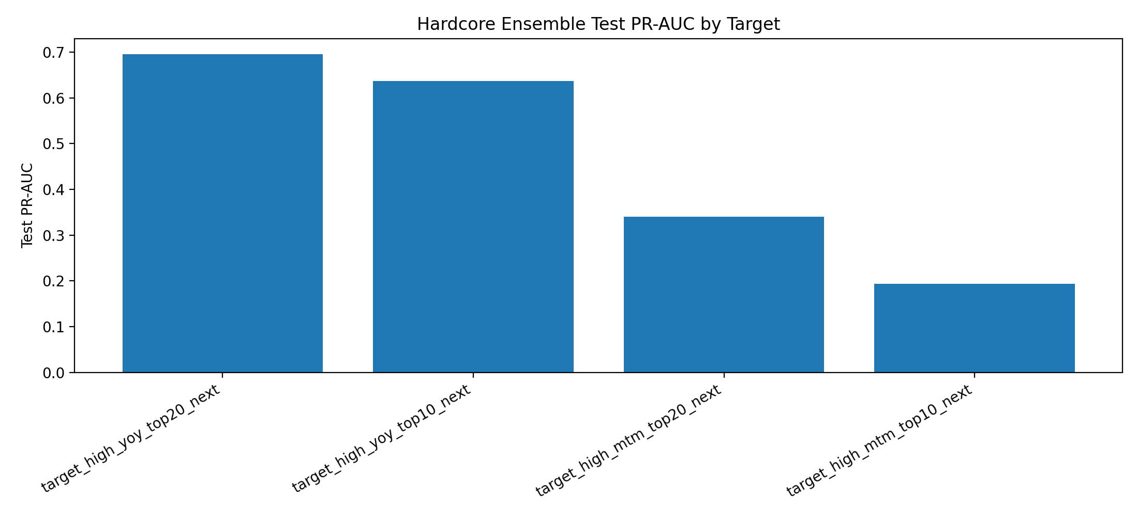
Figure 2. Test PR-AUC by target for the validation-selected ensemble.
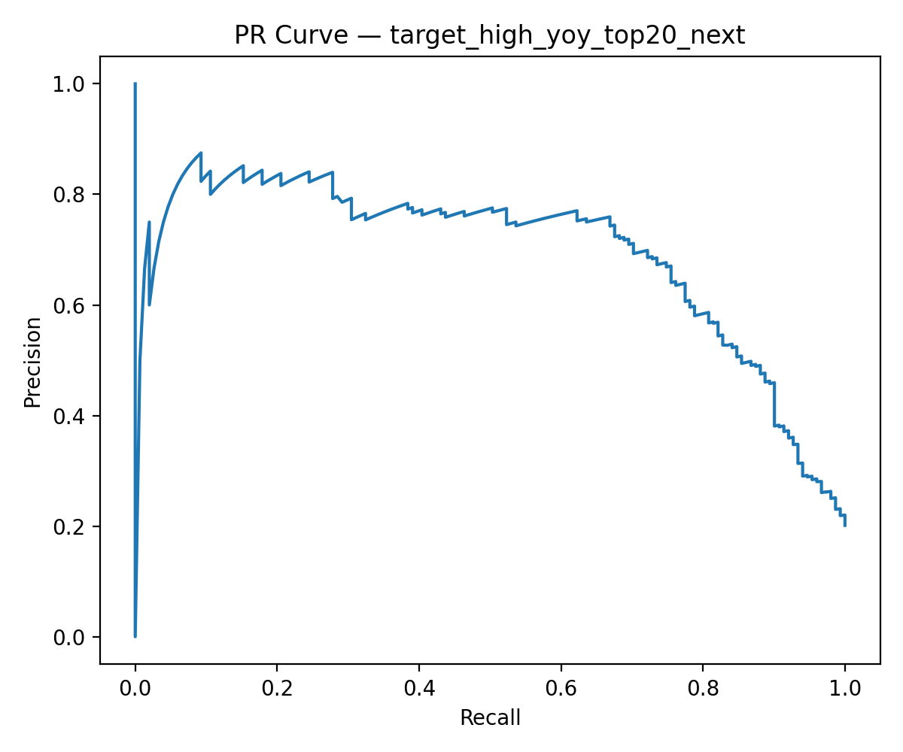
Figure 3. Precision-recall curve for y-on-y top-20% pressure detection.
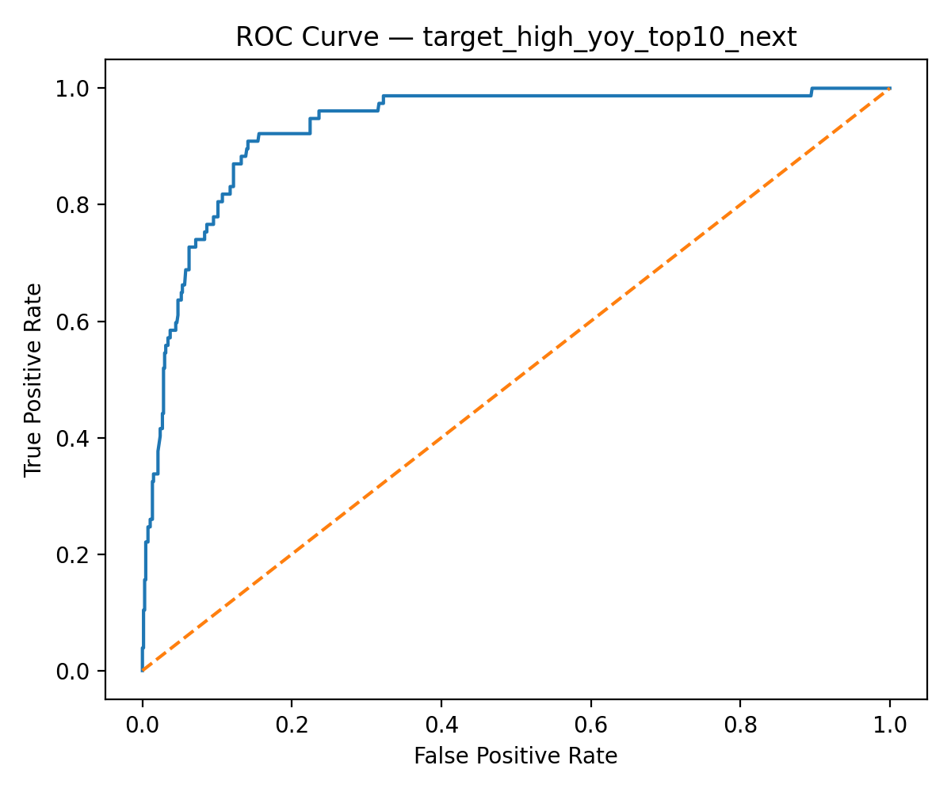
Figure 4. ROC curve for y-on-y top-10% pressure detection.
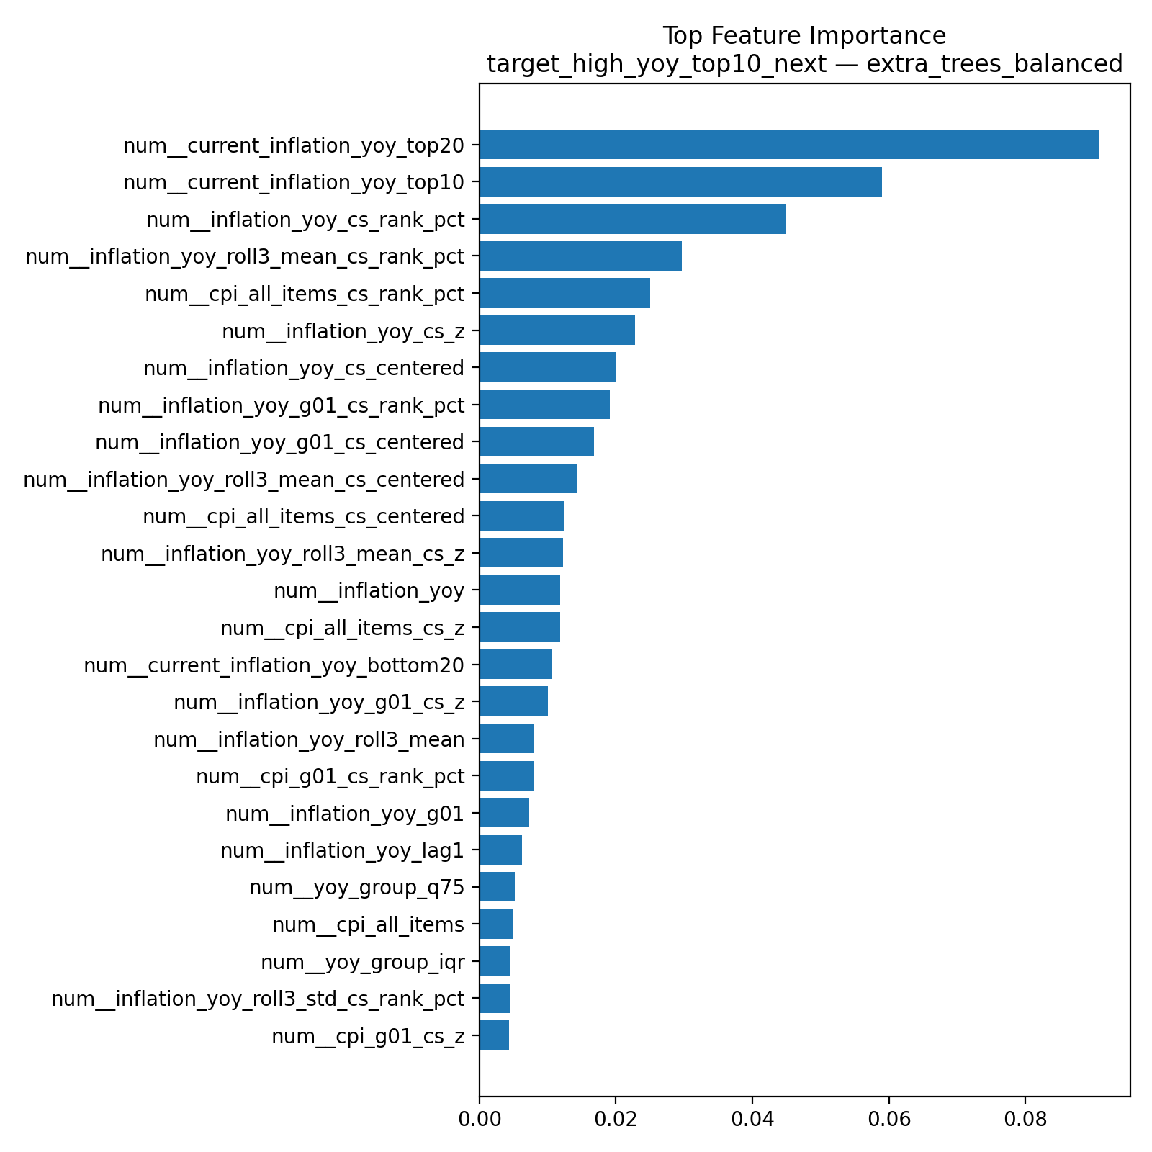
Figure 5. Feature importance for y-on-y top-10% pressure detection.

7.1 Interpretable Signals
Feature | Importance
current_inflation_yoy_top20 | 0.091
current_inflation_yoy_top10 | 0.059
inflation_yoy_cs_rank_pct | 0.045
inflation_yoy_roll3_mean_cs_rank_pct | 0.030
cpi_all_items_cs_rank_pct | 0.025
inflation_yoy_cs_z | 0.023
inflation_yoy_cs_centered | 0.020
inflation_yoy_g01_cs_rank_pct | 0.019
inflation_yoy_g01_cs_centered | 0.017
inflation_yoy_roll3_mean_cs_centered | 0.014
Table 4. Top feature-importance signals for y-on-y top-10% pressure detection.
The most important features are current annual pressure flags, current cross-sectional annual inflation rank, rolling annual inflation rank, all-items CPI rank, and food-related annual inflation rank. This pattern is consistent with the interpretation that annual pressure is persistent and that food-related components contribute strongly to regional annual inflation risk.

7.2 Latest Risk Ranking
Region | Risk score
KOTA GUNUNGSITOLI | 0.998
KAB ACEH TENGAH | 0.993
MANOKWARI | 0.984
KOTA LHOKSEUMAWE | 0.982
KOTA TUAL | 0.973
KAB JAYAWIJAYA | 0.960
KAB ACEH TAMIANG | 0.949
KOTA SIBOLGA | 0.944
KOTA BIMA | 0.940
SUMENEP | 0.933
Table 5. Example latest risk-ranking output for y-on-y top-10% pressure detection.

8. Discussion
The empirical results support the usefulness of OpenCPI-Guard as a reproducible early-warning framework rather than as a conventional point-forecasting model. The strongest performance appears in annual inflation pressure detection, where persistent relative positions across regions provide informative signals. This is useful for policy monitoring because regional annual pressure tends to reflect sustained price dynamics rather than only transient monthly disturbances.
The weaker m-to-m results are also informative. Monthly inflation shocks may be affected by sudden supply disturbances, seasonal holidays, weather, transport fares, commodity harvest cycles, or policy events that are not fully represented in monthly CPI history. Therefore, the framework can be extended with additional adapters for commodity prices, weather, logistics, and event calendars. Importantly, such extensions should retain the same leakage-aware temporal contract.
The framework is country-portable at the modeling-protocol level. It does not claim to automatically download data from all countries. Instead, it requires each country’s official CPI data to be mapped into the common schema. Once that schema is satisfied, the downstream modeling pipeline remains unchanged.

9. Limitations
• The Indonesian reference dataset covers a relatively short period under the 2022=100 base; longer histories would improve robustness.
• The framework detects relative pressure groups rather than estimating causal determinants of inflation.
• The reference implementation uses CPI expenditure groups, not item-level commodity prices; short-term monthly shocks may require more granular signals.
• Risk rankings should support expert monitoring rather than replace official statistical or policy analysis.
• Cross-country replication requires a valid adapter or CSV mapping into the common schema; the BPS adapter itself is not universal.

10. Conclusion
This paper introduced OpenCPI-Guard, a reproducible, leakage-aware, and country-portable framework for detecting regional inflation pressure from official CPI tables. The framework defines a common CPI panel schema, relative pressure labels, leakage-safe feature construction, validation-based model selection, and exportable risk rankings. In the Indonesian reference implementation, the framework achieved strong results for annual regional inflation pressure detection, especially for top-10% and top-20% y-on-y pressure tasks. The findings show that official CPI tables can be transformed into actionable early-warning outputs through an auditable machine-learning pipeline, while also clarifying the limits of CPI-only signals for short-term m-to-m shocks.

Appendix A. Reproducibility Checklist
• Data source adapter: BPS WebAPI adapter for Indonesia; generic CSV adapter recommended for other countries.
• Common schema: country, region, month, all-items CPI, inflation rates, and optional expenditure-group fields.
• Feature contract: only month t and earlier information may be used for predicting month t+1.
• Split: temporal train/validation/test split with model selection based on validation PR-AUC.
• Outputs: model metrics, predictions, risk rankings, feature importance, saved models, and run configuration logs.
• Code environment: Python, pandas, scikit-learn, XGBoost, LightGBM, CatBoost, and joblib; GPU optional.

References
Badan Pusat Statistik. (2026). Indeks Harga Konsumen 150 Kabupaten/Kota di Indonesia 2025 (2022=100). Statistics Indonesia.
Badan Pusat Statistik. (n.d.). WEB API BPS Documentation. Statistics Indonesia API documentation.
International Monetary Fund. (2020). Consumer Price Index Manual: Concepts and Methods. IMF, ILO, Eurostat, OECD, UNECE, and World Bank.
International Monetary Fund. (2026). Consumer Price Index (CPI) Dataset. IMF Data Portal.
United Nations Statistics Division. (2023). Classification of Individual Consumption According to Purpose 2018 (COICOP 2018). UNSD Classifications Registry.
Barkan, O., Benchimol, J., Caspi, I., Cohen, E., Hammer, A., & Koenigstein, N. (2023). Forecasting CPI inflation components with hierarchical recurrent neural networks. International Journal of Forecasting.
Paranhos, L. (2021). Predicting Inflation with Recurrent Neural Networks. arXiv:2104.03757.
Sengupta, S., Chakraborty, T., & Singh, S. K. (2023). Forecasting CPI inflation under economic policy and geopolitical uncertainties. arXiv:2401.00249.

Author Notes for Next Revision
• Strengthen related work with peer-reviewed regional inflation and early-warning literature before submission.
• Add exact GitHub repository link and DOI/Zenodo archive when code is finalized.
• Decide target journal formatting style and convert references accordingly.
• Consider adding a generic CSV adapter experiment or a small IMF national-level demonstration to support the country-portable claim.

