**Nama : Feri Darmawan**

**NPM : 5230411249**

**Mata Kuliah : Algoritma Pemrograman Praktik Vll**

**Projek : Projek Pertemuan 12**

**Codingan:**

**1.Create Database dan Tabel**

import sqlite3

connect = sqlite3.connect("database_hewan.db")

connect.execute(

    """

                CREATE TABLE HEWAN(

                id_hewan INT AUTO_INCREMENT PRIMARY KEY,

                nama_hewan VARCHAR(50),

                jenis VARCHAR(50),

                asal VARCHAR(50),

                jml_skrng INTEGER(10),

                thn_ditemukan INTEGER(10)

                )

                """

)

connect.close()

**2.Insert**

import sqlite3

connect = sqlite3.connect("database_hewan.db")

connect.execute(

    "INSERT INTO HEWAN (id_hewan, nama_hewan, jenis, asal, jml_skrng, thn_ditemukan) VALUES ('1', 'Orangutan', 'Mamalia', 'Sumatera', 14000, 2021)"

)

connect.execute(

    "INSERT INTO HEWAN (id_hewan, nama_hewan, jenis, asal, jml_skrng, thn_ditemukan) VALUES ('2', 'Harimau Sumatera', 'Mamalia', 'Sumatera', 400, 2020)"

)

connect.execute(

    "INSERT INTO HEWAN (id_hewan, nama_hewan, jenis, asal, jml_skrng, thn_ditemukan) VALUES ('3', 'Komodo', 'Reptil', 'Nusa Tenggara', 3000, 2019)"

)

connect.execute(

    "INSERT INTO HEWAN (id_hewan, nama_hewan, jenis, asal, jml_skrng, thn_ditemukan) VALUES ('4', 'Anoa', 'Mamalia', 'Sulawesi', 5000, 2022)"

)

connect.execute(

    "INSERT INTO HEWAN (id_hewan, nama_hewan, jenis, asal, jml_skrng, thn_ditemukan) VALUES ('5', 'Badak Jawa', 'Mamalia', 'Jawa', 72, 2021)"

)

connect.execute(

    "INSERT INTO HEWAN (id_hewan, nama_hewan, jenis, asal, jml_skrng, thn_ditemukan) VALUES ('6', 'Kuskus', 'Mamalia', 'Papua', 50, 2020)"

)

connect.execute(

    "INSERT INTO HEWAN (id_hewan, nama_hewan, jenis, asal, jml_skrng, thn_ditemukan) VALUES ('7', 'Trenggiling', 'Mamalia', 'Sumatera', 90, 2022)"

)

connect.execute(

    "INSERT INTO HEWAN (id_hewan, nama_hewan, jenis, asal, jml_skrng, thn_ditemukan) VALUES ('8', 'Burung Cendrawasih', 'Burung', 'Papua', 45, 2021)"

)

connect.execute(

    "INSERT INTO HEWAN (id_hewan, nama_hewan, jenis, asal, jml_skrng, thn_ditemukan) VALUES ('9', 'Penyu Hijau', 'Reptil', 'NTT', 20, 2022)"

)

connect.execute(

    "INSERT INTO HEWAN (id_hewan, nama_hewan, jenis, asal, jml_skrng, thn_ditemukan) VALUES ('10', 'Gajah Sumatera', 'Mamalia', 'Sumatera', 2500, 2023)"

)

connect.commit()

connect.close()

**3.Select All**

import sqlite3

connect = sqlite3.connect("database_hewan.db")

cursor = connect.cursor()

cursor.execute("SELECT * FROM HEWAN")

rows = cursor.fetchall()

print("Data HEWAN")

print("=" * 80)

print(

    "{:<5} {:<20} {:<20} {:<20} {:<10} {:<20} ".format(

        "id_hewan", "nama_hewan", "jenis", "asal", "jml_skrng", "thn_ditemukan"

    )

)

print("-" * 80)

for row in rows:

    print(

        "{:<5} {:<20} {:<20} {:<20} {:<10} {:<20} ".format(

            row[0], row[1], row[2], row[3], row[4], row[5]

        )

    )

connect.close()

**4.Select Where**

**a.Jenis = Mamalia**

import sqlite3

koneksi = sqlite3.connect("database_hewan.db")

kursor = koneksi.cursor()

kursor.execute("SELECT * FROM HEWAN WHERE jenis = 'Mamalia'")

baris_table = kursor.fetchall()

print("Data Pegawai:")

print("-" * 80)

print(

    "{:<5} {:<20} {:<20} {:<20} {:<10} {:<20}".format(

        "id_hewan", "nama_hewan", "jenis", "asal", "jml_skrng", "thn_ditemukan"

    )

)

print("_" * 80)

for baris in baris_table:

    print(

        "{:<5} {:<20} {:<20} {:<20} {:<10} {:<20}".format(

            baris[0], baris[1], baris[2], baris[3], baris[4], baris[5]

        )

    )

koneksi.close()

**b.Jumlahnya kurang dari sama dengan 1000 ekor**

import sqlite3

koneksi = sqlite3.connect("database_hewan.db")

kursor = koneksi.cursor()

kursor.execute("SELECT * FROM HEWAN WHERE jml_skrng <= '1000'")

baris_table = kursor.fetchall()

print("Data Pegawai:")

print("-" * 80)

print(

    "{:<5} {:<20} {:<20} {:<20} {:<10} {:<20}".format(

        "id_hewan", "nama_hewan", "jenis", "asal", "jml_skrng", "thn_ditemukan"

    )

)

print("_" * 80)

for baris in baris_table:

    print(

        "{:<5} {:<20} {:<20} {:<20} {:<10} {:<20}".format(

            baris[0], baris[1], baris[2], baris[3], baris[4], baris[5]

        )

    )

koneksi.close()

**5.Select Where And**

import sqlite3

koneksi = sqlite3.connect("database_hewan.db")

kursor = koneksi.cursor()

kursor.execute("SELECT * FROM HEWAN WHERE jenis = 'Mamalia' AND asal = 'Sumatera'")

baris_table = kursor.fetchall()

print("Data Hewan:")

print("-" * 80)

print(

    "{:<5} {:<20} {:<20} {:<20} {:<10} {:<20}".format(

        "id_hewan", "nama_hewan", "jenis", "asal", "jml_skrng", "thn_ditemukan"

    )

)

print("_" * 80)

for baris in baris_table:

    print(

        "{:<5} {:<20} {:<20} {:<20} {:<10} {:<20}".format(

            baris[0], baris[1], baris[2], baris[3], baris[4], baris[5]

        )

    )

koneksi.close()

**6.Select Where Or**

import sqlite3

koneksi = sqlite3.connect("database_hewan.db")

kursor = koneksi.cursor()

kursor.execute("SELECT * FROM HEWAN WHERE asal = 'Sumatera' OR jml_skrng <= '500'")

baris_table = kursor.fetchall()

print("Data Hewan:")

print("-" * 80)

print(

    "{:<5} {:<20} {:<20} {:<20} {:<10} {:<20}".format(

        "id_hewan", "nama_hewan", "jenis", "asal", "jml_skrng", "thn_ditemukan"

    )

)

print("_" * 80)

for baris in baris_table:

    print(

        "{:<5} {:<20} {:<20} {:<20} {:<10} {:<20}".format(

            baris[0], baris[1], baris[2], baris[3], baris[4], baris[5]

        )

    )

koneksi.close()

**7.Select SUM**

import sqlite3

conn = sqlite3.connect('database_hewan.db')

cursor = conn.cursor()

cursor.execute("SELECT SUM(jml_skrng) FROM hewan")

total_populasi = cursor.fetchone()[0]

print(f"Total Populsi Sejarang: {total_populasi}")

conn.close()

**8.Select Order By**

**a. Urutan nama hewan berdasarkan dari awal alpabetic**

import sqlite3

koneksi = sqlite3.connect('database_hewan.db')

kursor = koneksi.cursor()

kursor.execute("SELECT * FROM HEWAN ORDER BY nama_hewan ASC") #ASC|DESC

baris_table = kursor.fetchall()

print("Data Hewan:")

print("==============================================================")

print("{:<5} {:<20} {:<20} {:<20} {:<10} {:<20}".format( "id_hewan", "nama_hewan", "jenis", "asal", "jml_skrng", "thn_ditemukan"))

print("--------------------------------------------------------------")

for baris in baris_table:

    print("{:<5} {:<20} {:<20} {:<20} {:<10} {:<20}".format(baris[0], baris[1], baris[2], baris[3], baris[4], baris[5]))

koneksi.close()

**b.Urutan jumlah hewan saat ini berdasarkan dari yang terbanyak ke paling sedikit**

import sqlite3

koneksi = sqlite3.connect('database_hewan.db')

kursor = koneksi.cursor()

kursor.execute("SELECT * FROM HEWAN ORDER BY jml_skrng DESC") #ASC|DESC

baris_table = kursor.fetchall()

print("Data Hewan:")

print("==============================================================")

print("{:<5} {:<20} {:<20} {:<20} {:<10} {:<20}".format( "id_hewan", "nama_hewan", "jenis", "asal", "jml_skrng", "thn_ditemukan"))

print("--------------------------------------------------------------")

for baris in baris_table:

    print("{:<5} {:<20} {:<20} {:<20} {:<10} {:<20}".format(baris[0], baris[1], baris[2], baris[3], baris[4], baris[5]))

koneksi.close()

**c.Urutan tahun ditemukan saat ini berdasarkan dari yang terlama ke terbaru**

import sqlite3

koneksi = sqlite3.connect('database_hewan.db')

kursor = koneksi.cursor()

kursor.execute("SELECT * FROM HEWAN ORDER BY thn_ditemukan ASC") #ASC|DESC

baris_table = kursor.fetchall()

print("Data Hewan:")

print("==============================================================")

print("{:<5} {:<20} {:<20} {:<20} {:<10} {:<20}".format( "id_hewan", "nama_hewan", "jenis", "asal", "jml_skrng", "thn_ditemukan"))

print("--------------------------------------------------------------")

for baris in baris_table:

    print("{:<5} {:<20} {:<20} {:<20} {:<10} {:<20}".format(baris[0], baris[1], baris[2], baris[3], baris[4], baris[5]))

koneksi.close()

**9.Select Like**

import sqlite3

koneksi = sqlite3.connect('database_hewan.db')

kursor = koneksi.cursor()

nama = 'B%'  # Mencari nama yang dimulai dengan 'John'

kursor.execute(f"SELECT * FROM HEWAN WHERE nama_hewan LIKE ?", (nama,))

baris_table = kursor.fetchall()

print("Data Hewan:")

print("==============================================================")

print("{:<5} {:<20} {:<20} {:<20} {:<10} {:<20}".format("id_hewan", "nama_hewan", "jenis", "asal", "jml_skrng", "thn_ditemukan"))

print("--------------------------------------------------------------")

for baris in baris_table:

    print("{:<5} {:<20} {:<20} {:<20} {:<10}{:<20}".format(baris[0], baris[1], baris[2], baris[3], baris[4], baris[5]))

koneksi.close()

**10.Update Set**

**a. Update set jumlah saat ini**

import sqlite3

conn = sqlite3.connect('database_hewan.db')

cursor = conn.cursor()

# Data yang ingin diubah

id_hewan = 1

jml_skrng = 900

cursor.execute(f"UPDATE HEWAN SET jml_skrng = {jml_skrng} WHERE id_hewan = {id_hewan}")

conn.commit()

if cursor.rowcount > 0:

    print(f"Data hewan dengan id_hewan {id_hewan} berhasil diupdate.")

else:

    print(f"Tidak ada data hewan dengan id_hewan {id_hewan}.")

conn.close()

**b. Update Set Asal**

import sqlite3

koneksi = sqlite3.connect('database_hewan.db')

kursor = koneksi.cursor()

Id_hewan = 3

kursor.execute(*f*'''

               UPDATE HEWAN SET Asal = "Nusa Tenggara Timur" WHERE Id_hewan = {Id_hewan}

''')

koneksi.commit()

if kursor.rowcount> 0:

    print(*f*"DATA  DENGAN ID {Id_hewan} BERHASIL DIUBAH")

else:

    print(*f*"TIDAK ADA DATA HEWAN DENGAN ID{Id_hewan}")

koneksi.close()

**11.Delete From**

import sqlite3

conn = sqlite3.connect('database_hewan.db')

cursor = conn.cursor()

jenis = 'Mamalia'

cursor.execute(f"DELETE FROM hewan WHERE jenis = '{jenis}'")

conn.commit()

if cursor.rowcount > 0:

    print(f"Data HEWAN dengan Jenis {jenis} berhasil dihapus.")

else:

    print(f"Tidak ada data HEWAN dengan Jenis {jenis}.")

conn.close()

**Sceensshot Hasi Codingan:**

**1.Create Database dan Tabel**





**2.Insert**

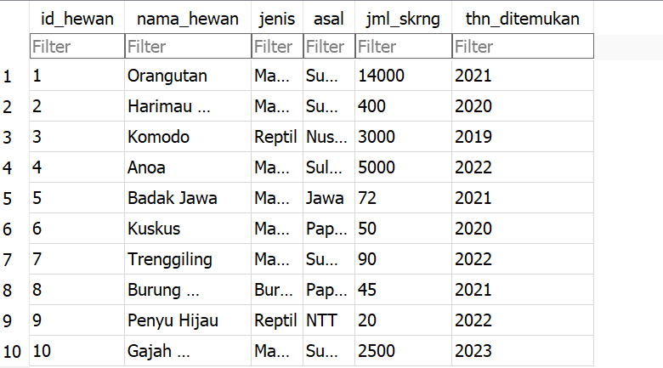

**3.Select All**

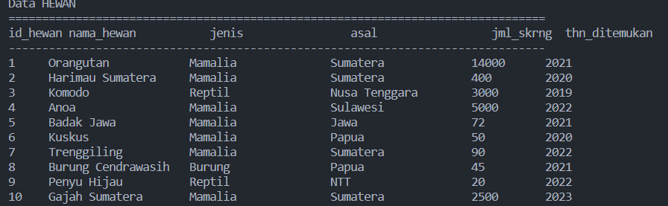

**4.Select Where**

**a.Jenis = Mamalia**

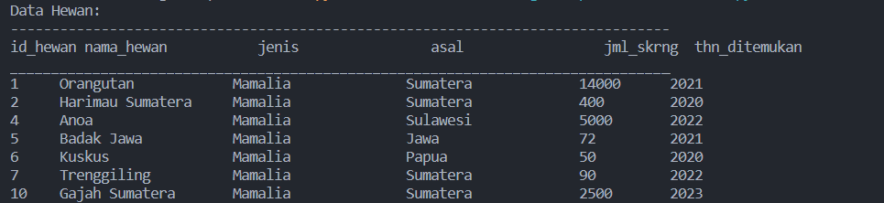

**b.Jumlahnya kurang dari sama dengan 1000 ekor**

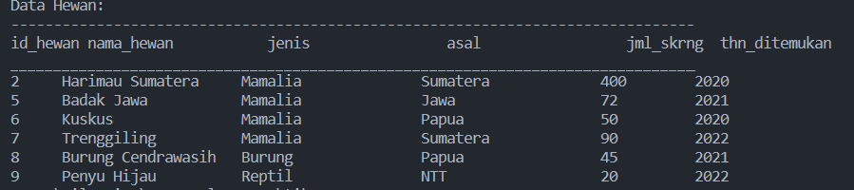

**5.Select Where And**

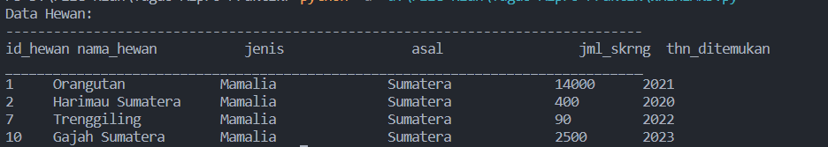

**6.Select Where Or**

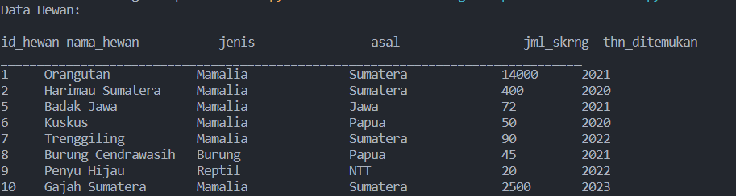

**7.Select Sum**



**8.Select Order By**

**a.Uruatan nama hewan berdasarkan dari awal alphabetic**

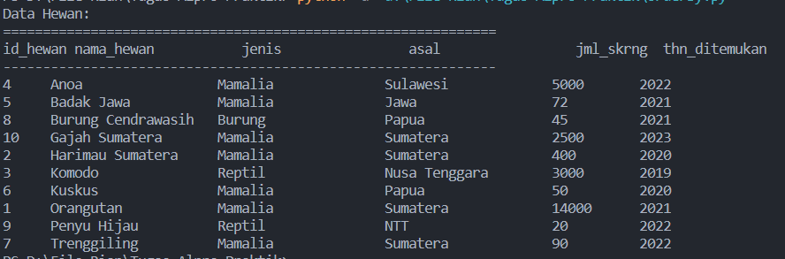

**b.Urutan jumlah hewan saat ini berdasarkan dari yang terbanyak ke paling sedikit**

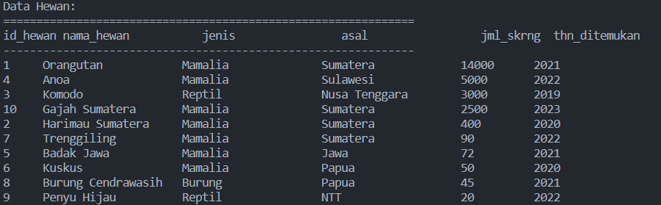

**c.Urutan tahun ditemukna hewan berdasarkan dari tahun yang terlama ke terbaru**

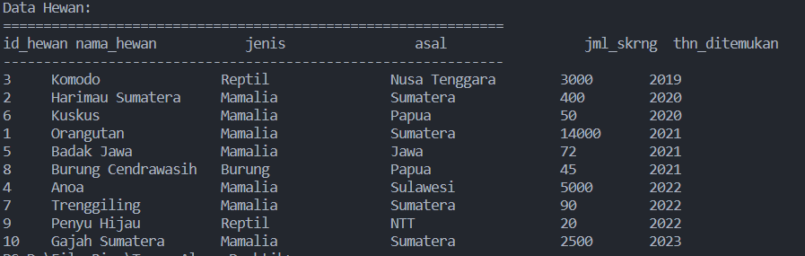

**9.Select Like**

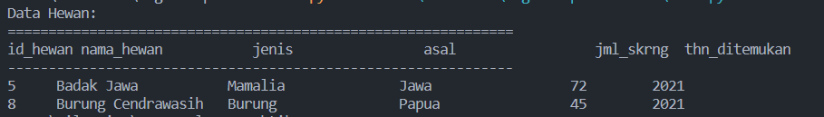

**10.Update SET**

**a. update set jumlah saat ini**

**- sebelum diubah**

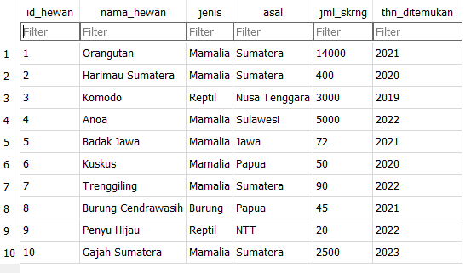

**-setelah diubah**



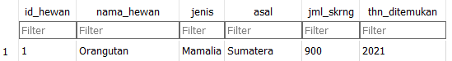

**b. update set asal**

**-sebelum diubah**



**- sesudah diubah**





**11.Delete from**

**a.Sebelum delete**

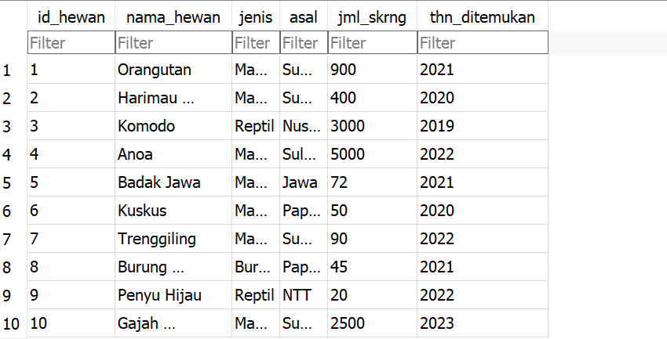

**b.Setelah delete**

