Tab = edit mode

C = select vertecis

Tool at the top = change if verticies or planes should be selected

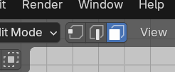

Ctrl + R =add another line

S = scale

G = move

E = make longer

* Z = along the z axis

Numbers = change view of planes

Shift + V = move along plane

Ctrl + B: round edges

Shift + a = add mesh

Y, x, z = scale, extrude, pull along a edge