AWS Cost Optimization Strategy

FinOps Consulting Case Study – Clara (Fintech)

Executive Summary
Clara’s AWS environment reflects rapid growth but also reveals structural inefficiencies in resource utilization and cost governance. Current cloud spend is heavily driven by overprovisioned compute and lack of lifecycle management in storage.
This proposal identifies an estimated 28–35% cost reduction opportunity (~$70K–$90K monthly) without compromising performance or scalability.
The approach focuses on three strategic priorities:
- Eliminating computing waste through rightsizing and autoscaling
- Optimizing storage lifecycle and unused resources
- Establishing FinOps governance for continuous cost control
The objective is not only cost reduction, but aligning cloud spend with business growth, operational efficiency, and long-term scalability.

Business Context
- Monthly AWS Spend: $250,000 USD
- Architecture: Microservices / Multi-account AWS environment
- Core Services:
  - EC2
  - EBS
  - RDS
  - S3
  - EKS
  - Lambda

Methodology
This analysis aligns with:
- AWS Cloud Financial Management (CFM Framework): See → Save → Plan → Run
- FinOps Lifecycle: Inform → Optimize → Operate
The goal is to move from reactive cost control to proactive financial engineering of cloud infrastructure.

Current Cost Distribution
Figure 1. Current cost distribution (chart referenced in source file: current_cost.png).
Service | Allocation | Monthly Cost
EC2 | 40% | $100,000
EBS | 20% | $50,000
RDS | 15% | $37,500
S3 | 10% | $25,000
EKS | 10% | $25,000
Lambda | 5% | $12,500
Total | 100% | $250,000

Key Insights

Compute Inefficiency
Compute inefficiency is driven by static provisioning that does not reflect actual workload demand. With an average CPU utilization of approximately 30%, the environment shows a structural misalignment between provisioned capacity and actual usage.

Storage Waste
Unattached EBS volumes and excessive snapshots indicate lack of lifecycle governance and automated cleanup policies.

S3 Cost Structure
A large portion of data remains in the S3 Standard storage class, suggesting missing lifecycle policies for tiered storage optimization.

EKS Utilization
Cluster sizing appears static and not aligned with workload variability, indicating opportunities for autoscaling, workload scheduling, and node optimization.

FinOps Maturity Gap
The current environment reflects a low-to-medium FinOps maturity level:
- Limited cost allocation visibility
- Reactive optimization practices
- Lack of clear cost ownership across teams
- Limited automation for cost controls
- No consistent lifecycle governance for storage and non-production resources
This proposal introduces:
- Cost accountability per workload
- Continuous monitoring and optimization
- Integration of cost into engineering decisions
- Governance through tagging, budgets, alerts, and automation

Optimization Strategy

1. Compute Optimization
Priority: High
Area: EC2 + EKS
Primary Driver: Overprovisioning and static capacity

Actions
- Rightsize EC2 instances based on utilization data
- Enable autoscaling for variable workloads
- Introducing Spot Instances where workload resiliency allows it
- Review EKS node group sizing
- Implement cluster autoscaler or Karpenter for EKS optimization

Estimated Impact
- Estimated savings: $42,500/month
- Approximate impact: ~17% of total AWS spend

2. EBS Optimization

Priority: High
Area: EBS volumes and snapshots
Primary Driver: Unused volumes and excessive snapshot retention

Actions
- Remove unattached EBS volumes after validation
- Reduce snapshot retention based on recovery requirements
- Move eligible workloads to gp3 where applicable
- Implement lifecycle policies for snapshot cleanup

Estimated Impact
- Estimated savings: $17,500/month
- Approximate impact: ~7% of total AWS spend

3. S3 Lifecycle Optimization

Priority: Medium
Area: S3 storage class management
Primary Driver: Excessive use of S3 Standard for infrequently accessed data

Actions
- Classify data based on access patterns
- Transition eligible data to Standard-IA, Glacier Instant Retrieval, or Glacier Flexible Retrieval
- Implement lifecycle policies by bucket and data type
- Review retention requirements with product, compliance, and engineering teams

Estimated Impact
- Estimated savings: $10,000/month
- Approximate impact: ~4% of total AWS spend

Total Estimated Savings
Category | Estimated Monthly Savings | Approx. Impact
Compute Optimization | $42,500 | ~17%
EBS Optimization | $17,500 | ~7%
S3 Lifecycle Optimization | $10,000 | ~4%
Total | ~$70,000/month | ~28%
Potential savings range after full implementation: 28–35%.

Optimized Cost Model
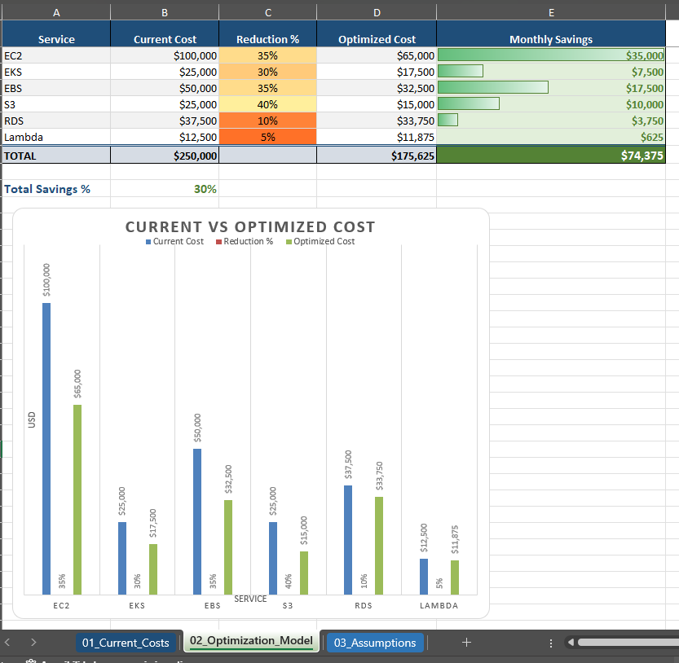

Assumptions

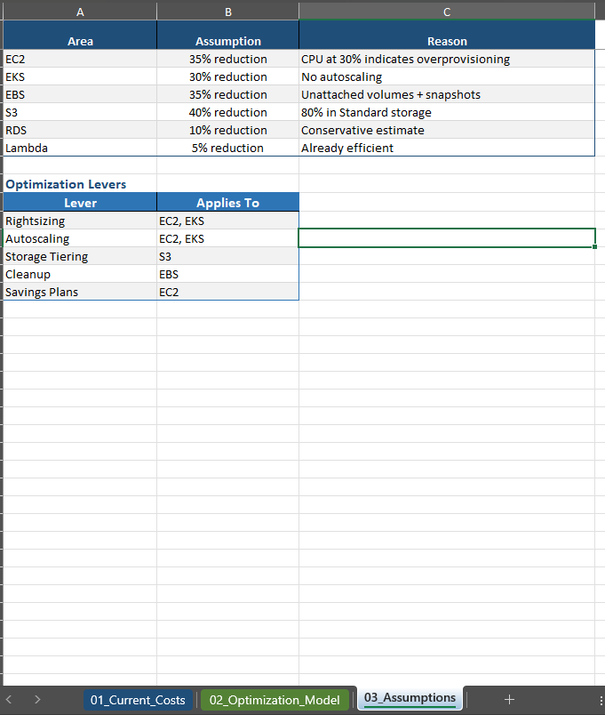
- Key modeling assumptions:
- Current monthly AWS spend is $250,000 USD
- Computers represent the largest optimization opportunity
- Average EC2 CPU utilization is approximately 30%
- Non-critical workloads may be eligible for autoscaling or Spot usage
- Unattached EBS volumes can be removed after owner validation
- Snapshot retention can be reduced without violating recovery requirements
- A portion of S3 Standard data is eligible for lower-cost storage classes
- Savings estimates are conservative and should be validated through AWS Cost Explorer, CUR, Compute Optimizer, and workload-level metrics

Architecture Overview

Current State
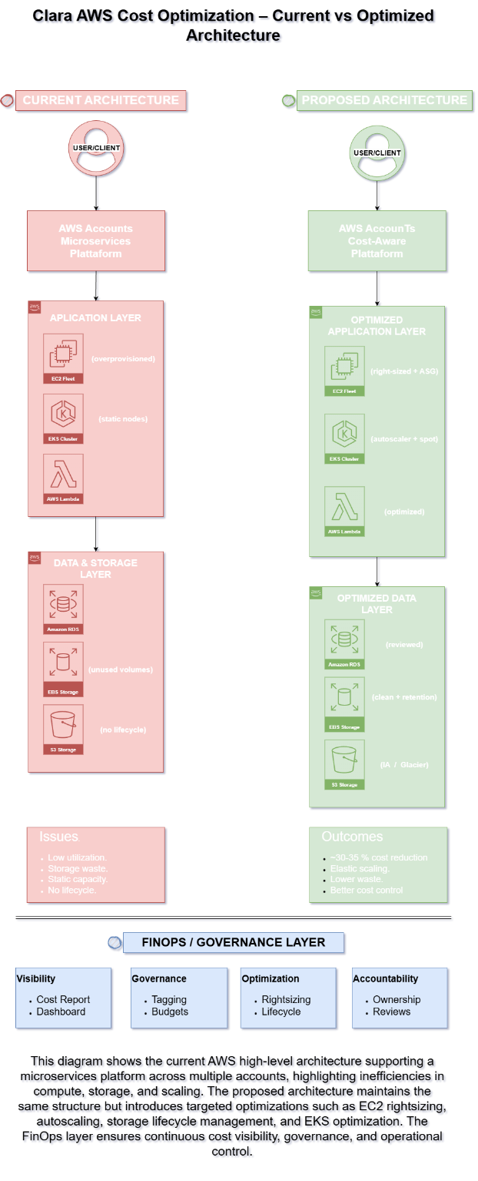
Current state characteristics:
- Overprovisioned EC2 compute resources
- Static EKS clusters
- Limited lifecycle governance for EBS and S3
- Limited cost allocation and accountability
- Reactive cost management

Proposed State
Proposed state characteristics:
Rightsized EC2 with autoscaling
- Optimized EKS node groups
- S3 lifecycle management
- EBS cleanup and snapshot governance
- FinOps governance and monitoring layer
- Continuous cost visibility and accountability

FinOps Operating Model
Flow: Engineering → Workloads → AWS Resources → Cost Data → FinOps Layer → Business Decisions
Cost becomes a first-class metric alongside performance, reliability, and security.
The FinOps operating model connects technical usage patterns with financial accountability, enabling engineering, finance, and business stakeholders to make better decisions.

Automation Layer
To ensure sustainability, the proposal includes an automation layer focused on continuous cost control.
Recommended controls:
Scheduled shutdown of non-production environments
- Budget alerts and anomaly detection
- Tagging enforcement through Infrastructure as Code
- Automated detection of unattached EBS volumes
- Snapshot retention automation
- Continuous cost reporting by environment, product, and owner

Governance Model
Recommended mandatory tags:
Tag | Purpose
environment | Identifies prod, staging, dev, sandbox
owner | Defines technical or business owner
product | Maps resource to business product
cost_center | Enables financial allocation
criticality | Defines operational importance
managed_by | Identifies Terraform, manual, or platform ownership
Governance should be enforced through:
- Terraform modules
- AWS Organizations
- Service Control Policies where applicable
- AWS Config rules
- CI/CD validation
- Periodic cost reviews

Implementation Plan

Phase 1: Quick Wins — Weeks 1–2
Objective: Reduce obvious waste with low operational risk.

Actions
- Validate and remove unattached EBS volumes
- Review and reduce excessive snapshot retention
- Implement initial S3 lifecycle policies
- Identify idle and underutilized EC2 instances
- Enable baseline budget alerts

Expected outcome
- Immediate cost reduction
- Better visibility into resource ownership
- Lower storage waste

Phase 2: Compute Optimization — Weeks 3–6
Objective: Reduce compute waste while preserving performance and scalability.

Actions
- Rightsize EC2 instances based on utilization metrics
- Apply autoscaling policies
- Optimize EKS node groups
- Evaluate Spot usage for resilient workloads
- Review Savings Plans or Reserved Instance opportunities

Expected outcome
- Reduced computes spend
- Improved resource efficiency
- Better alignment between capacity and actual demand

Phase 3: FinOps Governance — Ongoing
Objective: Establish long-term cost control and accountability.

Actions
- Enforce tagging standards
- Establish cost ownership by product/team
- Implement recurring FinOps reviews
- Track cost per workload or product
- Integrate cost checks into CI/CD workflows
- Monitor anomalies and forecast spend

Expected outcome
- Sustainable cloud cost governance
- Reduced risk of cost regression
- Improved financial accountability

Risk of Inaction
Without intervention, cloud costs will continue scaling linearly with infrastructure growth. This creates several risks:

- Reduced operating margins
- Lower infrastructure efficiency
- Poor cost attribution across teams
- Increased forecasting variance
- Continued accumulation of unused resources
- Higher financial risk as platform usage grows
In a fintech environment, unmanaged cloud cost growth can directly affect unit economics, product margins, and scalability.

Success Metrics
Recommended metrics to track after implementation:
Metric | Target
Monthly AWS spend reduction | 28–35%
EC2 average utilization | Improve from ~30% to 50–60%
Unattached EBS volumes | 0 after validation
Snapshot retention compliance | 90%+
S3 lifecycle coverage | 70%+ of eligible buckets
Tag compliance | 95%+
Budget alert coverage | 100% of critical accounts
Cost ownership coverage | 100% of production workloads

Business Impact
This proposal enables Clara to:
- Reduce AWS spend by approximately $70K–$90K per month
- Improve infrastructure efficiency
- Strengthen cost accountability
- Support scalable growth without uncontrolled spending
- Improve forecasting and budget planning
- Aligning engineering decisions with business value

Conclusion

This proposal demonstrates how applying FinOps principles and AWS-native capabilities can reduce cloud spend while preserving performance, scalability, and operational resilience.
The recommended approach moves Clara from reactive cost management to a structured Cloud Financial Management operating model based on visibility, optimization, governance, and accountability.

Author
Fernando Cuellar Rodriguez
Cloud Architect | FinOps-Oriented
AWS • Azure • OCI • Terraform • DevOps

