Table of Contents

DSA for Beginners
Printable Study Booklet
Generated on 2026-08-09

Index By Block
Update the page ranges in Word after making your manual layout edits.
Block | Page Range
1. Arrays | ______ to ______
2. Linked Lists | ______ to ______
3. Recursion | ______ to ______
4. Sorting | ______ to ______
5. Binary Search | ______ to ______
6. Trees | ______ to ______

1. Arrays

RAM and Arrays
Data structures are a way to store data efficiently inside a computer component called Random Access Memory (RAM).
Because RAM supports direct indexing by address, we can access any element in an array in constant time, $O(1)$.
RAM is often just referred to as memory. Let’s understand how an array is stored in RAM.

Arrays in Memory
An array is an ordered collection of contiguous elements, for example: [1, 3, 5].
However, computers represent everything as bits: 0s and 1s.
Most computers today have gigabytes (GBs) of RAM. For example, your machine might have 8 GB (about ${10}^{9}$ bytes per GB). A byte is made of exactly 8 bits.

Binary Representation Example
Each integer in [1, 3, 5] has a binary representation:
- 1 -> 00000001
- 3 -> 00000011
- 5 -> 00000101
If we use a single byte to store each value, those are the exact bit patterns.
When we store an array in RAM, each element is stored continuously and in order.

Addresses and Element Size
Integers commonly occupy 4 bytes (32 bits) in memory.
When an integer is stored in RAM, it is associated with:
- an address (its location in memory), and
- a value.
Since array elements are contiguous, each next element is placed right after the previous one.

Storing an Integer Array in RAM
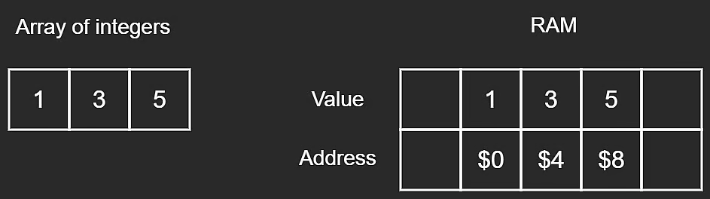
Integer array in RAM
Each integer occupies 4 bytes, so addresses are 4 bytes apart.
Instead of integers, we could also store characters in an array.

Storing a Character Array in RAM
Each character takes 8 bits = 1 byte, so addresses are 1 byte apart.
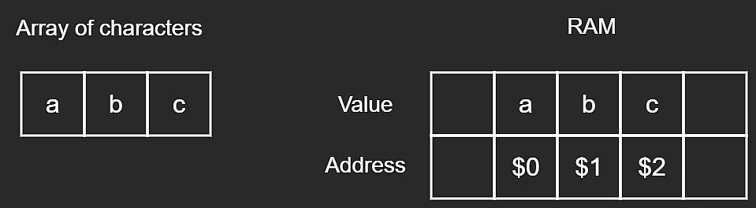
Character array in RAM
Each character occupies 1 byte of space, hence addresses are 1 byte apart.

Key Takeaway
The size or type of stored data does not fundamentally change the model, as long as address increments are relative to the data type’s size.
Most of this is abstracted away in day-to-day development, but this mental model is still very relevant for understanding algorithms, data structures, and system design.

Static Arrays
In statically typed languages like Java, C++, and C#, arrays must have a fixed size and type when initialized. These are called static arrays.
They are called static because their size cannot change after declaration. Once the array is full, it cannot store additional elements.
Some dynamically typed languages (such as Python and JavaScript) do not expose static arrays directly. They use alternatives, which are discussed in the next lesson.
Let’s cover key array operations and the time complexity of each.

1) Reading From an Array
To read an element, we access it by index.
// initialize myArray
let myArray = [1, 3, 5];
// access an arbitrary element, where i is the index of the desired value
myArray[i];
Accessing an element
Accessing one array element is constant time because each index maps directly to a RAM address.
- Time complexity: $O(1)$

Important Clarification About $O(1)$
There is a common confusion that $O(1)$ always means fast. Not necessarily.
An operation could do 1000 steps and still be $O(1)$ if that number does not grow with input size. Big-O measures growth, not absolute runtime.

2) Traversing an Array
To read all values, we traverse from start to end.
for (let i = 0; i < myArray.length; i++) {
console.log(myArray[i]);
}
// OR
let i = 0;
while (i < myArray.length) {
console.log(myArray[i]);
i++;
}
The last element is always at index $n−1$, where $n$ is array size.
If size is 3, the last valid index is 2.
Traversing an array of size $n$ takes:
- Time complexity: $O(n)$
The number of operations grows linearly with array size (10 elements -> about 10 visits, 100 elements -> about 100 visits, etc.).

3) Deleting From an Array

Deleting From the End
In statically typed languages, array slots are typically initialized with default values (like 0, null, etc.).
When removing the last element, we usually perform a soft delete:
- overwrite with a default/sentinel value (0, null, -1, etc.), and
- decrement logical length by 1.
// Remove from the last position in the array if the array
// is not empty (i.e. length is non-zero).
removeEnd(arr, length) {
if (length > 0) {
// Overwrite last element with some default value.
// We would also consider the length to be decreased by 1.
arr[length - 1] = 0;
length--;
}
}
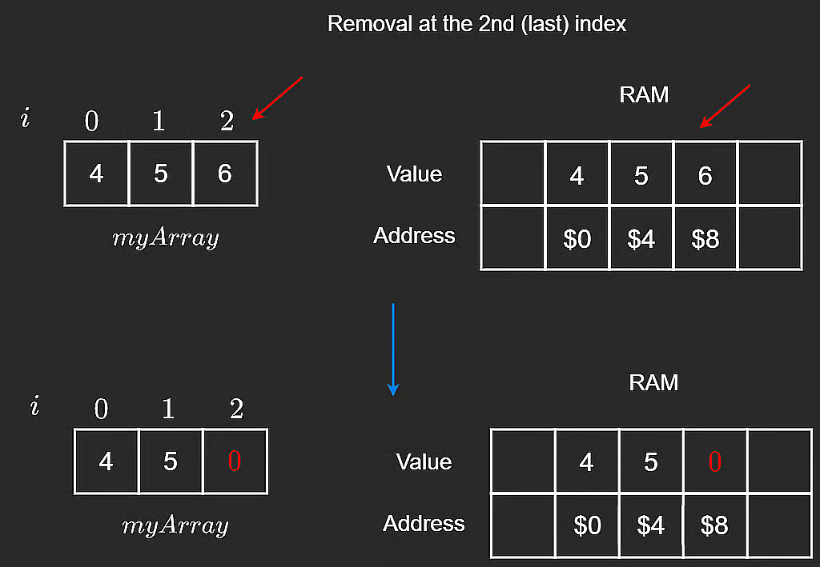
Removal from the end
In [4, 5, 6], value 6 is overwritten by 0 or -1 to mark it removed, and length becomes one less.

Deleting at an I-th Index
If we delete at a random index i, we cannot just replace with 0, because that would break contiguity in the middle.
Deleting from the end preserves contiguity. Deleting from the middle requires shifting.
Better approach:
- Given deletion index i.
- Iterate from i + 1 to end.
- Shift each element one position left.
- Optionally set last slot to 0/null and decrement length.
// Remove value at index i before shifting elements to the left.
// Assuming i is a valid index.
removeMiddle(arr, i, length) {
// Shift starting from i + 1 to end.
for (let index = i + 1; index < length; index++) {
arr[index - 1] = arr[index];
}
// No need to 'remove' arr[i], since we already shifted
}
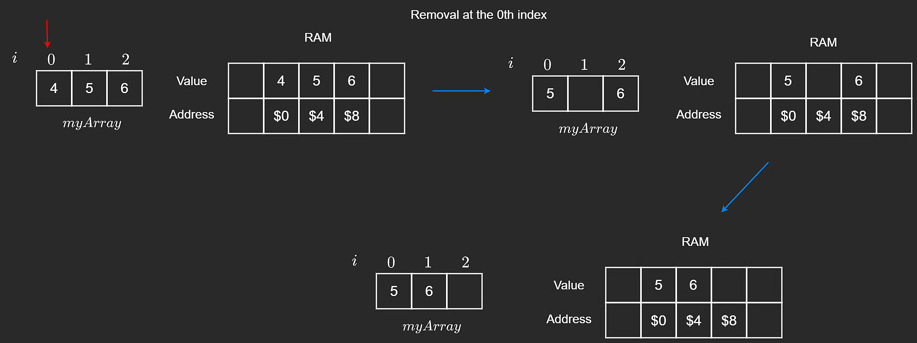
Removal at the 0th index
Worst case: deleting the first element requires shifting nearly all elements.
- Time complexity: $O(n)$

4) Insertion

Inserting at the End
To insert at the end, place the new value at index length (next free slot).
// Insert n into arr at the next open position.
// Length is the number of 'real' values in arr, and capacity
// is the size (aka memory allocated for the fixed size array).
insertEnd(arr, n, length, capacity) {
if (length < capacity) {
arr[length] = n;
}
}
This writes one value:
- Time complexity: $O(1)$
Note: length is current element count, while capacity is maximum storable elements.

Inserting at the I-th Index
Inserting at arbitrary index i is more involved because insertion may happen in the middle.
Example: array [4, 5, 6], insert at i = 1 (or i = 0).
We cannot overwrite existing values, so we shift values one step right, starting from the end down to i.
// Insert n into index i after shifting elements to the right.
// Assuming i is a valid index and arr is not full.
insertMiddle(arr, i, n, length) {
// Shift starting from the end to i.
for (let index = length - 1; index > i - 1; index--) {
arr[index + 1] = arr[index];
}
// Insert at i
arr[i] = n;
}
The image below shows inserting 8 at index 1 in [4, 5, 6]. If there is no extra capacity, last element 6 is lost.
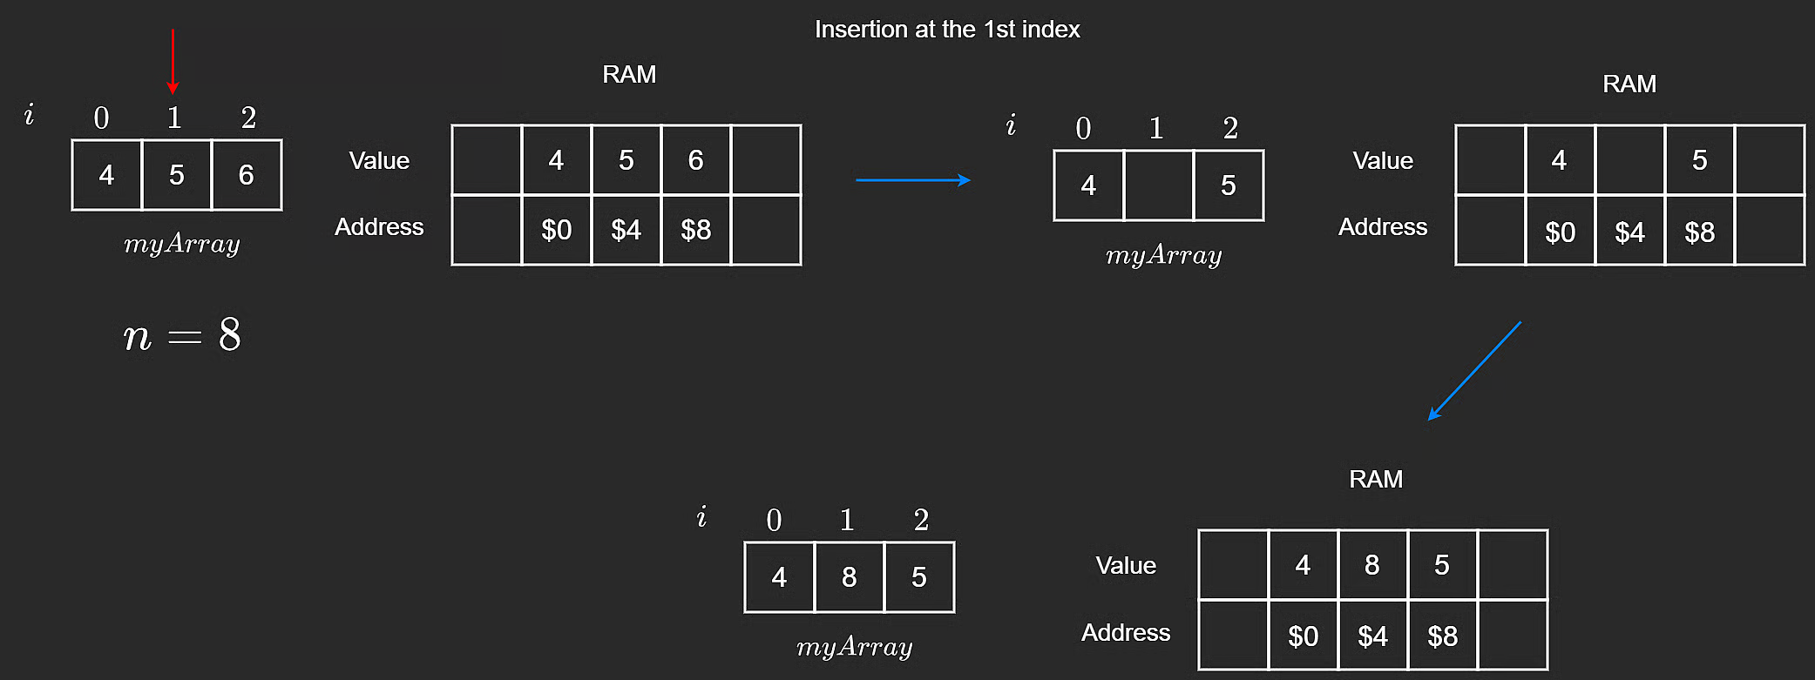
Insertion at the 1st index
This demonstrates why shifting must happen before insertion to avoid overwriting.

Static Array Time Complexity Summary
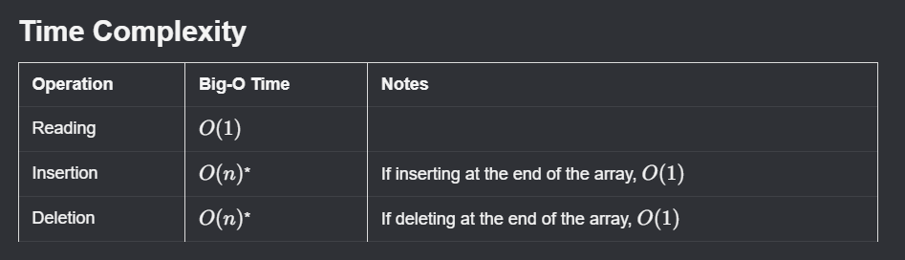
Time complexity for static arrays

NeetCode Practice (Static Arrays)
Use the problems below in pattern progression order: single pass -> two pointers (in-place) -> suffix maximum (right-to-left).

1) Max Consecutive Ones
- Difficulty: Easy
- Pattern: Single pass + running counter
- Core idea: Track the current streak of 1s. Reset on 0. Keep the best streak seen so far.
Problem statement (summary): Given a binary array nums, return the maximum number of consecutive 1s.
Example:
- Input: nums = [1,1,0,1,1,1]
- Output: 3
Complexity:
- Time: $O(n)$
- Space: $O(1)$
Intuition: Update the running streak on every element. If the value is 1, increment the streak; otherwise, reset it to 0. After each step, update the best answer seen so far.
Algorithm:
- Initialize res = 0 and cnt = 0.
- Traverse nums from left to right.
- If current value is 1, do cnt++; else set cnt = 0.
- Update res = Math.max(res, cnt).
- Return res.
TypeScript solution:
class Solution {
findMaxConsecutiveOnes(nums: number[]): number {
let res = 0;
let cnt = 0;
for (const num of nums) {
cnt = num === 1 ? cnt + 1 : 0;
res = Math.max(res, cnt);
}
return res;
}
}

2) Remove Element (Two Pointers, In-Place)
- Difficulty: Easy
- Pattern: Two pointers + in-place overwrite
- Core idea: Keep a valid range [0, n). When nums[i] === val, replace it with the last valid element (nums[n - 1]) and shrink n. Only advance i when current value is kept.
Problem statement (summary): Given an integer array nums and integer val, remove all occurrences of val in-place. Return k, the number of elements not equal to val.
Example:
- Input: nums = [3,2,2,3], val = 3
- Output: k = 2, nums = [2,2,_,_]
Complexity:
- Time: $O(n)$
- Space: $O(1)$
Intuition: When a value equals val, replace it with the last value in the current valid range and shrink the range. This avoids unnecessary shifting and keeps the operation in-place.
Algorithm:
- Initialize i = 0 and n = nums.length.
- While i < n:
- If nums[i] === val, set nums[i] = nums[n - 1], then decrement n.
- Otherwise increment i.
- Return n (count of kept elements).
TypeScript solution:
class Solution {
removeElement(nums: number[], val: number): number {
let i = 0;
let n = nums.length;
while (i < n) {
if (nums[i] === val) {
nums[i] = nums[n - 1];
n--;
} else {
i++;
}
}
return n;
}
}

3) Replace Elements with Greatest Element on Right Side
- Difficulty: Easy
- Pattern: Suffix maximum (right-to-left traversal)
- Core idea: Traverse from right to left while maintaining rightMax. At each index, write current rightMax, then update it with the current value.
Problem statement (summary): Given an array arr, replace every element with the greatest element among elements to its right, and replace the last element with -1.
Example:
- Input: arr = [2,4,5,3,1,2]
- Output: [5,5,3,2,2,-1]
Complexity:
- Time: $O(n)$
- Space: $O(1)$ auxiliary space (output array not counted)
Intuition: Scan from right to left while tracking rightMax. For each index, the current rightMax is exactly the greatest value to that element’s right.
Algorithm:
- Create ans with same length as arr.
- Set rightMax = -1.
- Traverse indices from n - 1 down to 0.
- Set ans[i] = rightMax.
- Update rightMax = Math.max(rightMax, arr[i]).
- Return ans.
TypeScript solution:
class Solution {
replaceElements(arr: number[]): number[] {
const n = arr.length;
const ans = new Array<number>(n);
let rightMax = -1;
for (let i = n - 1; i >= 0; i--) {
ans[i] = rightMax;
rightMax = Math.max(rightMax, arr[i]);
}
return ans;
}
}

Quick Study Tip
When reviewing static arrays, ask this first:
- Can I solve it in one pass?
- If not, can two pointers help me do it in-place?
- If not, should I scan from right to left with a suffix value?

Optional Follow-up
If you want additional practice, rewrite each of the three solutions to:
- Use different variable names and still explain the same invariant.
- Add one tricky edge case test input.
- State the invariant in one interview-ready sentence.

Dynamic Arrays
Dynamic arrays are a common alternative to static arrays because they can grow as elements are added.
In JavaScript and Python, these are the default arrays. Unlike static arrays, dynamic arrays do not require you to manually set a fixed size at initialization.
Some languages still start with a default internal capacity (for example, Java and C#), but that capacity grows automatically at runtime.

Push to the End (Append)
When appending, the new element is placed at the next free index.
// Insert n at the end of the array
pushBack(n) {
if (this.length === this.capacity) {
this.resize();
}
// Insert at next empty position
this.arr[this.length] = n;
this.length++;
}
If the array is full, we resize first.

How Resize Works
When capacity is reached, implementations usually double capacity. This reduces how often expensive resize operations happen.
Resizing creates a new, larger static array and copies existing elements into it.
resize() {
// Create new array with double capacity
this.capacity = 2 * this.capacity;
const newArr = new Array(this.capacity);
// Copy elements
for (let i = 0; i < this.length; i++) {
newArr[i] = this.arr[i];
}
this.arr = newArr;
}
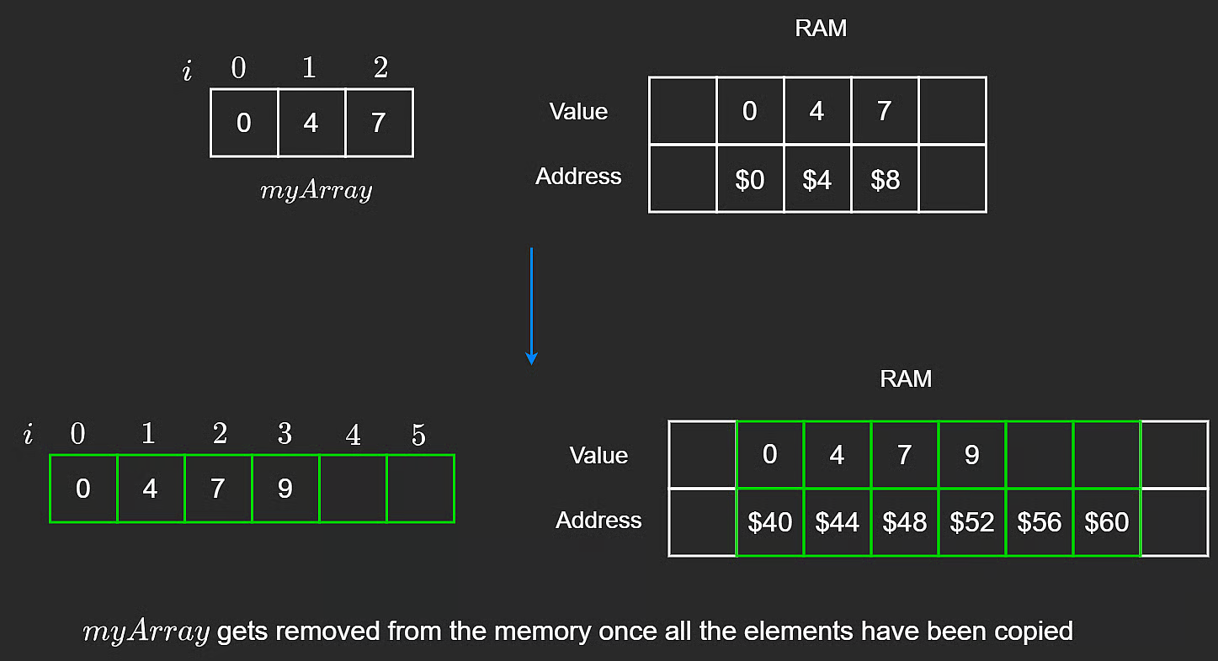
Dynamic array resize copy process
After copying completes, the old underlying array can be deallocated.

Amortized $O(1)$ Insertion
Appending to a dynamic array is $O(1)$ amortized.
Amortized time means average cost per operation over a sequence of operations.
- A resize event is expensive: $O(n)$
- Most appends are cheap: $O(1)$
- Averaged across many appends, each append is $O(1)$ amortized

Why Doubling Capacity Works
Suppose capacity grows as: 1 -> 2 -> 4 -> 8.
To reach size 8, total copied/placed work follows a geometric sum:
$$1+2+4+8=15$$
And $15<2⋅8$, so for general size $n$, total work is bounded by about $2n$, which is still linear:
$$O(2n)=O(n)$$
That is why inserting $n$ elements overall is $O(n)$, and per insertion (amortized) is $O(1)$.
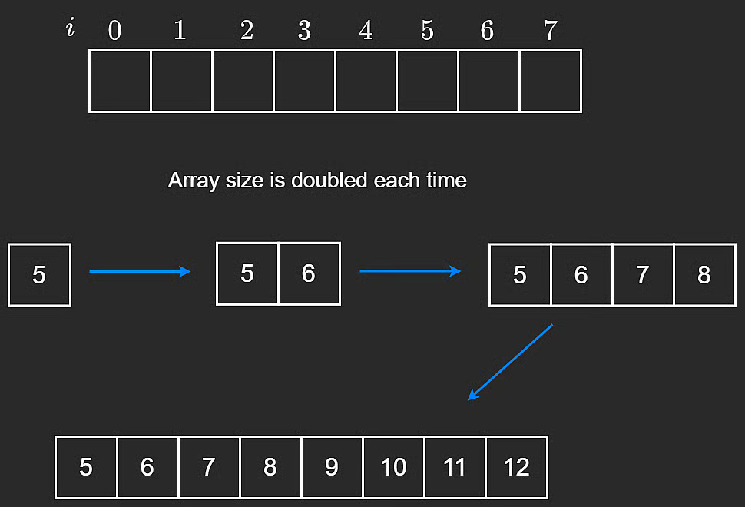
Dynamic capacity doubling visualization

Other Operations
Inserting or removing from the middle of a dynamic array is similar to static arrays: elements must be shifted left or right.
- Middle insertion: $O(n)$
- Middle deletion: $O(n)$

Dynamic Array Time Complexity Summary
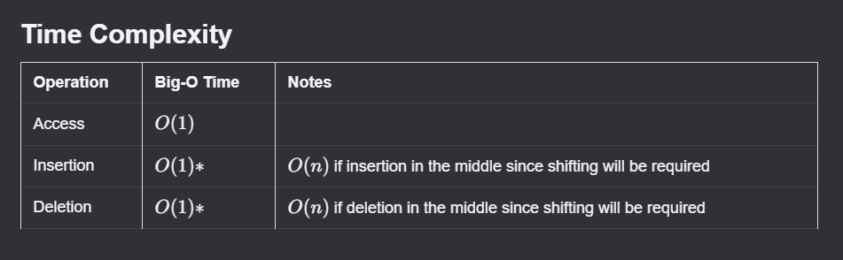
Time complexity for dynamic arrays

NeetCode Practice (Dynamic Arrays)

1) Concatenation of Array
- Difficulty: Easy
- Pattern: One-pass index mapping
- Core idea: Build a new array of size 2n, and for each index i, write the same value to ans[i] and ans[i + n].
Problem statement (summary): Given an integer array nums of length n, create an array ans of length 2n such that:
- ans[i] = nums[i]
- ans[i + n] = nums[i]
for 0 <= i < n.
Return ans.
Example:
- Input: nums = [1,4,1,2]
- Output: [1,4,1,2,1,4,1,2]
Intuition: Instead of looping twice, we can fill both required positions during the same iteration. For each nums[i], write it once in the first half and once in the second half.
Algorithm:
- Let n = nums.length.
- Create ans with size 2 * n.
- Loop i from 0 to n - 1:
- Set ans[i] = nums[i].
- Set ans[i + n] = nums[i].
- Return ans.
TypeScript solution:
class Solution {
getConcatenation(nums: number[]): number[] {
const n = nums.length;
const ans = new Array<number>(2 * n);
for (let i = 0; i < n; i++) {
ans[i] = nums[i];
ans[i + n] = nums[i];
}
return ans;
}
}
Complexity:
- Time: $O(n)$
- Space: $O(n)$ (output array of size 2n)

Stacks
A stack is a data structure that supports a subset of dynamic-array operations.
You can only add and remove elements from one end, called the top. In practice, stacks follow LIFO (Last In, First Out) behavior: the last element inserted is the first one removed.
An intuitive analogy is a stack of plates. You can only place a plate on top or take one from top.
Core stack operations are:
- push (insert at top)
- pop (remove from top)
- peek (read top without removing)

Push
Push inserts an element at the top of the stack. With a dynamic array, this is append-at-end and is typically $O(1)$.
push(n) {
this.stack.push(n);
}
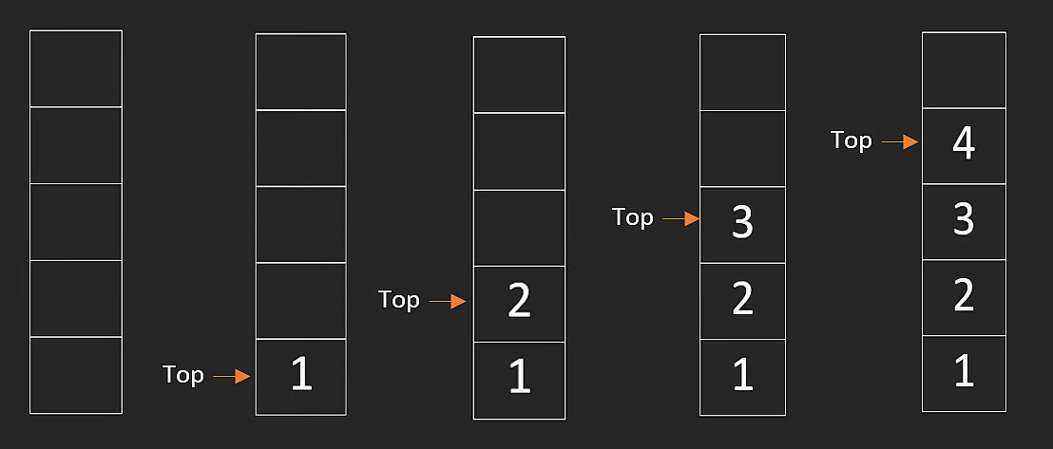
Stack push operation
In many languages, stacks are implemented directly with dynamic arrays.

Pop
Pop removes and returns the top element. With a dynamic array, this is remove-last and is typically $O(1)$.
pop() {
return this.stack.pop();
}
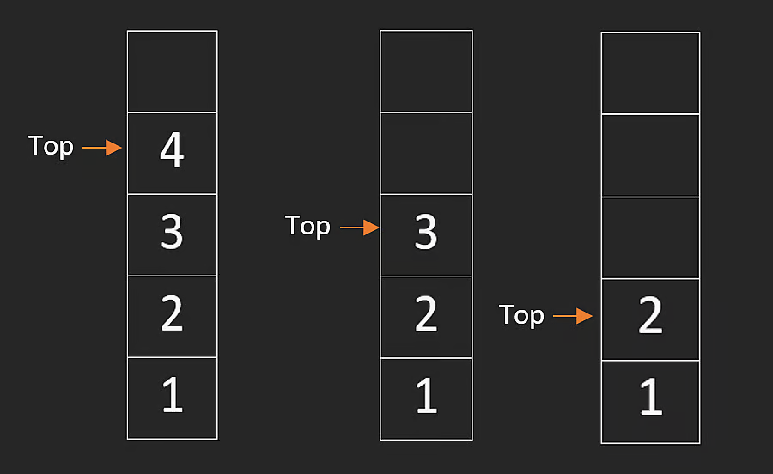
Stack pop operation

Peek
Peek returns the current top element without removing it.
peek() {
return this.stack[this.stack.length - 1];
}
This operation is also $O(1)$.

Stack Time Complexity Summary
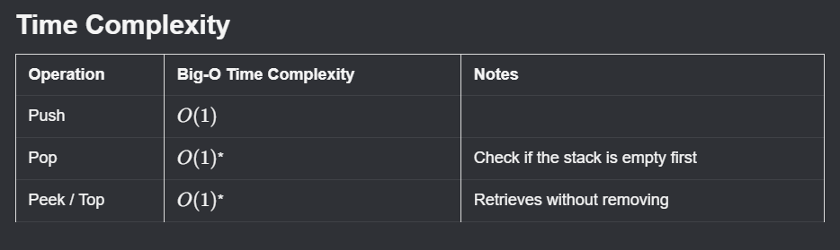
Time complexity for stack operations

NeetCode Practice (Stacks)

1) Baseball Game
- Difficulty: Easy
- Pattern: Simulation with stack
- Core idea: Use a stack to keep valid scores. Process each operation and maintain a running sum.
Problem statement (summary): Given a list of operations, process baseball scoring rules:
- Integer x: add score x
- +: add sum of previous two valid scores
- D: add double previous valid score
- C: remove previous valid score
Return total score after all operations.
Example:
- Input: ops = ["1","2","+","C","5","D"]
- Output: 18
Intuition: The operations only depend on recent valid scores, so a stack is ideal. Keeping a running total avoids an extra pass at the end.
Algorithm:
- Initialize empty stack and res = 0.
- For each operation:
- If +, sum top two scores, push result, add to res.
- If D, double top score, push result, add to res.
- If C, pop top score and subtract from res.
- Otherwise parse number, push it, add to res.
- Return res.
TypeScript solution:
class Solution {
calPoints(operations: string[]): number {
const stack: number[] = [];
let res = 0;
for (const op of operations) {
if (op === "+") {
const top = stack.pop() as number;
const newTop = top + stack[stack.length - 1];
stack.push(top);
stack.push(newTop);
res += newTop;
} else if (op === "D") {
const doubled = 2 * stack[stack.length - 1];
stack.push(doubled);
res += doubled;
} else if (op === "C") {
res -= stack.pop() as number;
} else {
const score = Number(op);
stack.push(score);
res += score;
}
}
return res;
}
}
Complexity:
- Time: $O(n)$
- Space: $O(n)$

2) Valid Parentheses
- Difficulty: Easy
- Pattern: Matching pairs with stack
- Core idea: Push opening brackets. On closing bracket, it must match the most recent opening bracket.
Problem statement (summary): Given a string containing only ()[]{}, return true if all brackets are correctly matched and nested.
Examples:
- Input: s = "[]" -> Output: true
- Input: s = "([{}])" -> Output: true
- Input: s = "[(])" -> Output: false
Intuition: Valid nesting requires last-opened to be first-closed, which is exactly stack behavior.
Algorithm:
- Create stack for opening brackets.
- Create map from closing to opening bracket.
- Iterate characters in s.
- If opening bracket, push it.
- If closing bracket, check top matches mapped opener.
- If not matched, return false; otherwise pop.
- At end, return whether stack is empty.
TypeScript solution:
class Solution {
isValid(s: string): boolean {
const stack: string[] = [];
const closeToOpen: Record<string, string> = {
")": "(",
"]": "[",
"}": "{",
};
for (const c of s) {
if (c in closeToOpen) {
if (stack.length > 0 && stack[stack.length - 1] === closeToOpen[c]) {
stack.pop();
} else {
return false;
}
} else {
stack.push(c);
}
}
return stack.length === 0;
}
}
Complexity:
- Time: $O(n)$
- Space: $O(n)$

3) Min Stack
- Difficulty: Medium
- Pattern: Stack with min tracking
- Core idea: Store encoded differences in one stack and maintain current minimum in a variable.
Problem statement (summary): Design a stack supporting:
- push(val)
- pop()
- top()
- getMin()
All operations must be $O(1)$.
Example:
- Input: ["MinStack", "push", 1, "push", 2, "push", 0, "getMin", "pop", "top", "getMin"]
- Output: [null, null, null, null, 0, null, 2, 1]
Constraints:
- $−2^{31}≤val≤2^{31}−1$​
- pop, top, and getMin are called only on non-empty stack
Intuition: Store val - min instead of raw values. Negative encoded values signal that a new minimum was introduced. On pop, a negative value lets us restore the previous minimum in constant time.
Algorithm:
- Track stack (encoded values) and min (current minimum).
- On first push, store 0 and set min = val.
- On next pushes, store val - min; if val < min, update min.
- On pop, if encoded value is negative, restore old minimum.
- On top, decode using current min.
- On getMin, return current min.
TypeScript solution:
class MinStack {
private min: number;
private stack: number[];
constructor() {
this.min = Infinity;
this.stack = [];
}
push(val: number): void {
if (this.stack.length === 0) {
this.stack.push(0);
this.min = val;
} else {
this.stack.push(val - this.min);
if (val < this.min) {
this.min = val;
}
}
}
pop(): void {
if (this.stack.length === 0) {
return;
}
const encoded = this.stack.pop() as number;
if (encoded < 0) {
this.min -= encoded;
}
}
top(): number {
const encoded = this.stack[this.stack.length - 1];
return encoded > 0 ? encoded + this.min : this.min;
}
getMin(): number {
return this.min;
}
}
Complexity:
- Time: $O(1)$ for all operations
- Space: $O(n)$

2. Linked Lists

Singly Linked Lists
A linked list stores elements in an ordered sequence, similar to an array. The key difference is that elements are not stored contiguously in memory.
Instead, a linked list is made up of objects called ListNodes, each with two attributes:
- value — the data stored in the node (a number, string, etc.)
- next — a reference to the next node in the list

Creating a Linked List
We start by defining the ListNode class:
class ListNode {
constructor(value) {
this.value = value;
this.next = null;
}
}
By chaining nodes together via next, we build a list. Suppose we have three nodes: ListNode1, ListNode2, ListNode3.
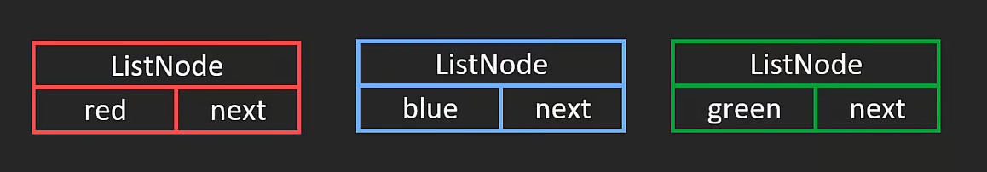
Singly linked list
In this example, values are strings — red, blue, green.
When nodes are instantiated, they are likely not stored contiguously in memory (unlike arrays). This is fine — the next pointer connects them regardless of location.
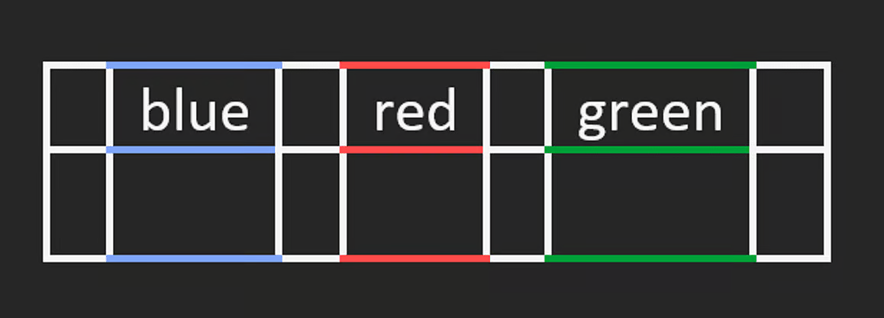
Singly linked list in memory
To connect the nodes:
ListNode1.next = ListNode2;
ListNode2.next = ListNode3;
ListNode3.next = null; // last node always points to null

Traversal
To traverse from start to end, use a while loop:
let cur = ListNode1;
while (cur) {
cur = cur.next;
}
- Start at the head of the list.
- Track position in cur.
- Loop until cur becomes null.
- Each iteration: advance via cur = cur.next.
- Time complexity: $O(n)$
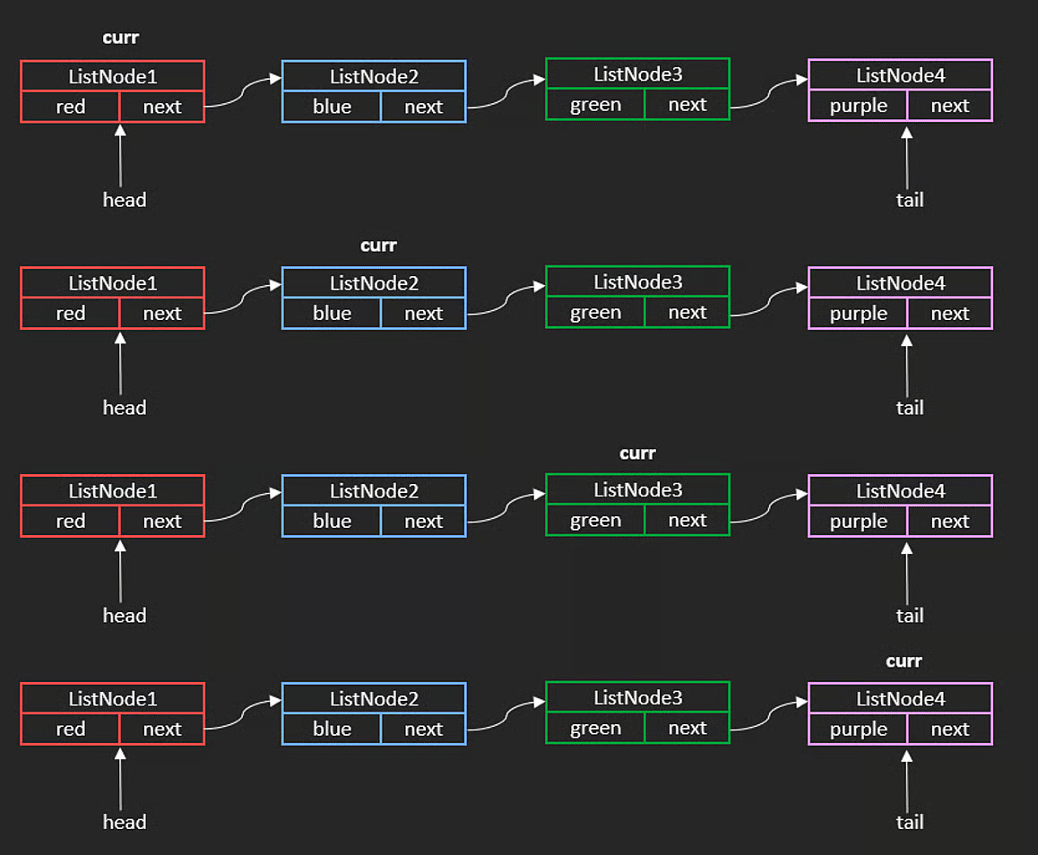
Singly linked list traversal

Circular Linked List
If the last node’s next points back to the first node instead of null, the result is a circular linked list.
Iterating through one without a cycle-detection mechanism would cause an infinite loop.

Operations
A linked list tracks two pointers: head (first node) and tail (last node). If there is only one node, both point to the same node.

Appending
Appending to the tail is $O(1)$ — we only update one pointer.
Key advantage over arrays: no shifting of elements is needed, since nodes do not have to be contiguous in memory.
Note: This $O(1)$ assumes we already hold a reference to the insertion point. If we have to traverse to find it first, the operation takes $O(n)$.
Steps to append ListNode4:
1. Connect the current tail to the new node.
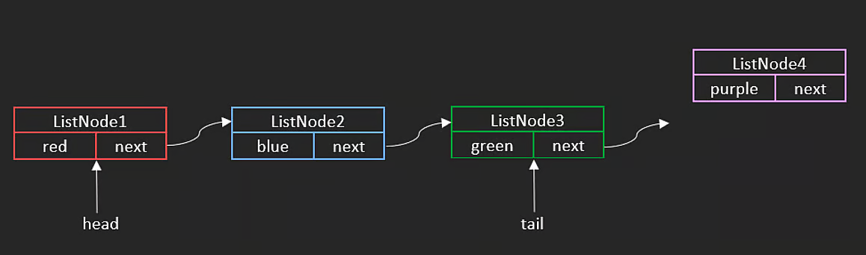
Append step 1
tail.next = ListNode4;
2. Update the tail pointer.
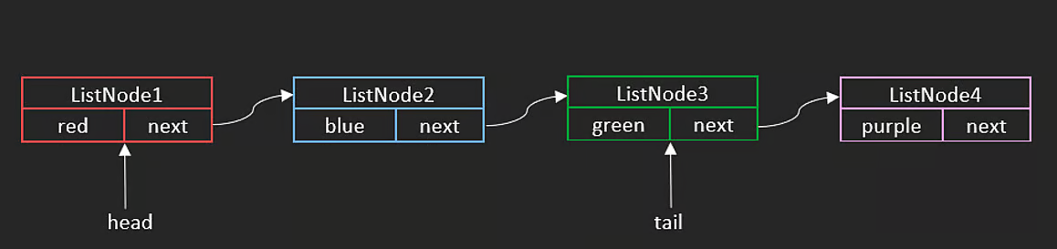
Append step 2
tail = ListNode4;
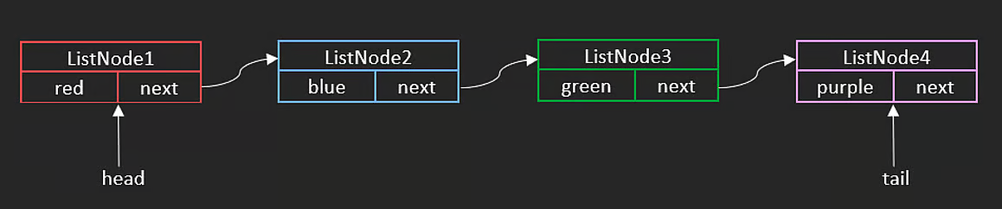
Append step 3 — final state

Deleting
Deleting a node (given a direct reference) is $O(1)$ — we only update one pointer.
Note: If we have to traverse to find the deletion point first, the operation takes $O(n)$.
To delete ListNode2, skip over it by relinking head.next to head.next.next:
head.next = head.next.next;
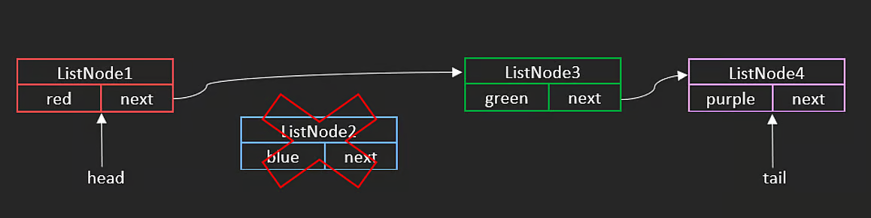
Delete ListNode2
ListNode1 now points directly to ListNode3. In garbage-collected languages, ListNode2’s memory is freed automatically. In languages like C, you must free it manually.

Singly Linked List Time Complexity Summary
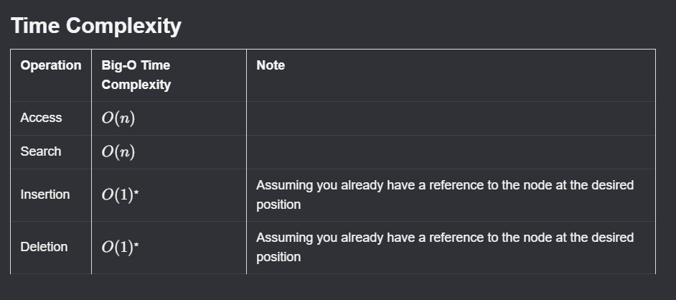
Time complexity for singly linked list

NeetCode Practice (Singly Linked Lists)

1) Reverse Linked List
- Difficulty: Easy
- Pattern: Pointer reversal
- Core idea: Flip every next pointer to face backward. Two approaches: iterative (preferred for space) or recursive.
Problem statement (summary): Given the head of a singly linked list, reverse the list and return the new head.
Example:
- Input: head = [0,1,2,3]
- Output: [3,2,1,0]

Approach 1: Iterative
Intuition: Walk left-to-right, flipping each next pointer backward at every step. Three pointers track the current node, the previous node, and the saved-next so the chain is not lost.
Algorithm:
- Set prev = null, curr = head.
- While curr exists:
- Save temp = curr.next.
- Flip: curr.next = prev.
- Advance: prev = curr, curr = temp.
- Return prev (new head).
TypeScript solution:
interface ListNode {
val: number;
next: ListNode | null;
}
class Solution {
reverseList(head: ListNode | null): ListNode | null {
let prev: ListNode | null = null;
let curr: ListNode | null = head;
while (curr) {
const temp = curr.next;
curr.next = prev;
prev = curr;
curr = temp;
}
return prev;
}
}
Complexity:
- Time: $O(n)$
- Space: $O(1)$

Approach 2: Recursive
Intuition: Recurse all the way to the last node — it becomes the new head. On the way back up the call stack, reverse one link per frame, then break the original forward link to avoid cycles.
reverseList(0)
-> reverseList(1)
-> reverseList(2)
-> reverseList(3) // base case: returns node 3 as newHead
// unwind: 3 -> 2
// unwind: 2 -> 1
// unwind: 1 -> 0
Algorithm:
- Base case: if head is null, return null.
- Recurse on head.next; save the returned new head.
- Reverse current link: head.next.next = head.
- Break forward link: head.next = null.
- Return the new head (original last node).
TypeScript solution:
class Solution {
reverseList(head: ListNode | null): ListNode | null {
if (!head) return null;
let newHead: ListNode = head;
if (head.next) {
// Recurse; newHead ends up as the original last node.
newHead = this.reverseList(head.next) as ListNode;
// Reverse the current link (e.g. 2 -> 3 becomes 3 -> 2).
head.next.next = head;
}
// Break the original forward link to avoid a cycle.
head.next = null;
return newHead;
}
}
Complexity:
- Time: $O(n)$
- Space: $O(n)$ — recursive call stack
Merge Two Sorted Linked Lists Easy Topics Company Tags Hints You are given the heads of two sorted linked lists list1 and list2.
Merge the two lists into one sorted linked list and return the head of the new sorted linked list.
The new list should be made up of nodes from list1 and list2.
Input: list1 = [1,2,4], list2 = [1,3,5]
Output: [1,1,2,3,4,5]
- Recursion Intuition Merging two sorted linked lists recursively works by always choosing the smaller head node of the two lists. Whichever list has the smaller value should appear first in the merged list. So we:
Pick the smaller node. Recursively merge the rest of the lists. Attach the result to the chosen node. Algorithm If one list is empty, return the other list — nothing left to merge. Compare the head values of list1 and list2: If list1.val <= list2.val: Set list1.next to the merged result of the remaining nodes. Return list1 as the current head. Otherwise: Set list2.next to the merged result of the remaining nodes. Return list2 as the current head. The recursion continues until both lists are fully merged.
mergeTwoLists(list1: ListNode | null, list2: ListNode | null): ListNode { /* Input: list1 = [1,2,4], list2 = [1,3,5]
RECURSION
*/
if (!list1) {
return list2
}
if (!list2) {
return list1
}
if (list1.val <= list2.val) {
list1.next = this.mergeTwoLists(list1.next, list2)
return list1;
} else {
list2.next = this.mergeTwoLists(list1, list2.next)
return list2;
}
}
Time complexity: O(n+m) Space complexity: O(n+m)
- Iteration Intuition To merge two sorted linked lists iteratively, we build the result step-by-step. We keep a pointer (node) to the current end of the merged list, and at each step we choose the smaller head node from list1 or list2.
Because the lists are already sorted, whichever head is smaller must come next in the merged list. We attach that node, move the pointer forward, and continue until one list is empty. Finally, we attach the remaining nodes from the non-empty list.
Using a dummy node makes handling the head of the merged list simple and clean.
Algorithm Create a dummy node and a node pointer pointing to it. While both lists have nodes: Compare list1.val and list2.val. Attach the smaller node to node.next. Move forward in the chosen list. Move node to node.next. When one list becomes empty: Attach the remaining nodes of the other list to node.next. Return dummy.next, which is the head of the merged list.
mergeTwoLists(list1: ListNode | null, list2: ListNode | null): ListNode {
const dummy = { val: 0, next: null };
let node = dummy;
while (list1 && list2) {
if (list1.val < list2.val) {
node.next = list1;
list1 = list1.next;
} else {
node.next = list2;
list2 = list2.next;
}
node = node.next;
}
if (list1) {
node.next = list1;
} else {
node.next = list2;
}
return dummy.next;
}
Time complexity: O(n+m) Space complexity: O(1) because we are not using any additional data structures that scale with input size.

Doubly Linked Lists
After learning singly linked lists, the next variation is the doubly linked list.
Each node has two pointers:
- next: points to the next node
- prev: points to the previous node
If prev is null, that indicates we are at the head of the list.
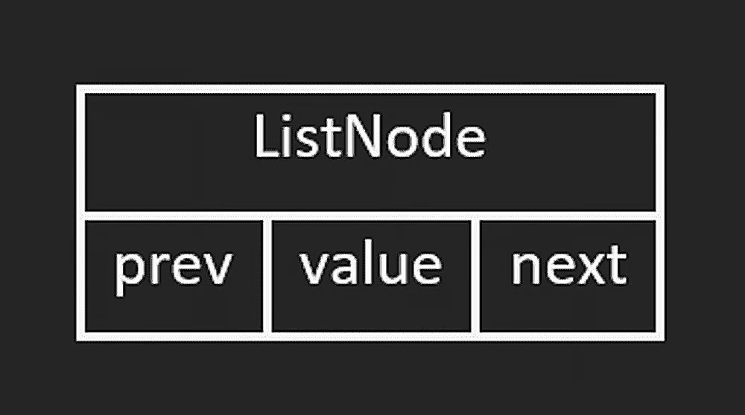
Doubly linked list structure

Insertion at the End
Like singly linked lists, inserting at the tail is $O(1)$ when we already track tail.
The difference is that we also update the prev pointer of the new node.
Example with ListNode1 -> ListNode2 -> ListNode3, inserting ListNode4 at the end:
tail.next = ListNode4;
ListNode4.prev = tail;
tail = tail.next;

Deletion at the End
Deleting at the tail is also $O(1)$.
Steps:
- Get reference to the node before tail (tail.prev).
- Set its next pointer to null.
- Move tail to that previous node.
- Optionally clear the old tail’s prev.
ListNode2 = tail.prev;
ListNode2.next = null;
tail = ListNode2;
Because both insertion and deletion at one end are $O(1)$, a linked list can theoretically implement stack behavior as well (though arrays are often more common in practice).

Access Pattern
As with singly linked lists, random access is not possible.
In the worst case, reaching a specific node requires traversing up to n nodes:
- Access by index/value search: $O(n)$
The advantage over singly linked lists is that traversal can happen in both directions.

Time Complexity Summary
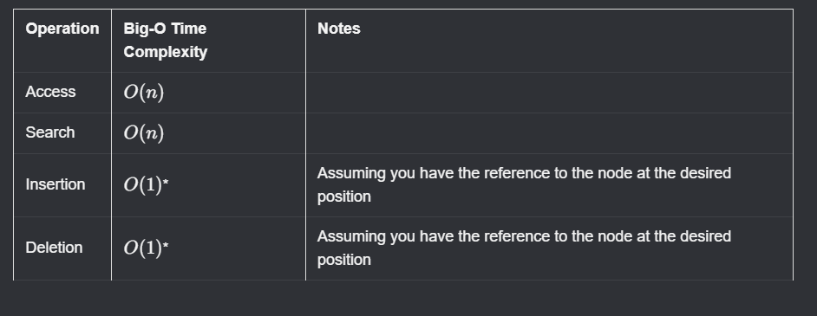
Doubly linked list time complexity

Queues
A queue is a data structure with FIFO (First In, First Out) behavior.
It is similar to stacks in being linear, but different in removal order:
- Stack: Last In, First Out
- Queue: First In, First Out
A real-world example is a line at a bank: the first person in line is the first person served.

Implementation and Core Operations
The easiest queue implementation is with a linked list.
You can also implement it with a dynamic array, but to match linked-list efficiency you generally need a circular array and extra index management.
Core queue operations:
- enqueue: add at the end (tail)
- dequeue: remove from the front (head)

Enqueue
enqueue inserts a value at the end of the queue. With a singly linked list and maintained head/tail references, this is $O(1)$.
enqueue(val) {
const newNode = new ListNode(val);
if (this.right != null) {
// Queue is not empty
this.right.next = newNode;
this.right = this.right.next;
} else {
// Queue is empty
this.left = newNode;
this.right = newNode;
}
}

Dequeue
dequeue removes and returns the value from the front of the queue.
dequeue() {
if (this.left == null) {
// Queue is empty
return;
}
// Remove left node and return value
const val = this.left.val;
this.left = this.left.next;
if (!this.left) {
this.right = null;
}
return val;
}
As with stacks, it is good practice to handle empty-structure checks before removals.

Deque Variation
A deque (pronounced “deck”) is a double-ended queue.
It allows insertion/removal from both head and tail in $O(1)$.

Common Use Case
Queues are fundamental for breadth-first search (BFS) in trees and graphs.

Time Complexity Summary
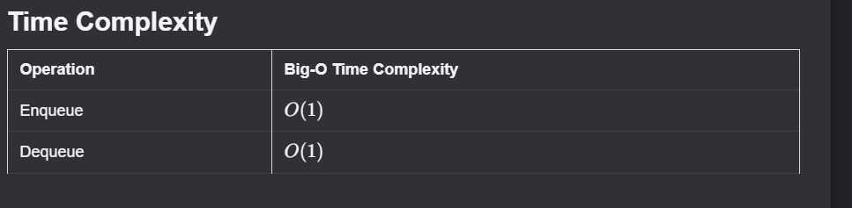
Queue time complexity

3. Recursion

Recursion (One Branch)
Recursion can feel unintuitive at first, so if it does not click immediately, that is normal.
At a high level, recursion means a function calls itself, usually with a smaller or simpler input.
A recursive function has two required parts:
- Base case: the stopping condition
- Recursive case: the part where the function calls itself
You can often convert recursive solutions to iterative ones, and vice versa.

Intuition
Recursion breaks one problem into smaller sub-problems, then combines those answers while unwinding back up.
A real-world analogy is a box inside another box, inside another box:
- smallest box -> base case
- outer boxes -> recursive cases
There are two common recursion patterns:
- one-branch recursion
- multi-branch recursion
This lesson focuses on one-branch recursion.

Factorial Example
To compute $n!$:
$$n!=n⋅(n−1)⋅(n−2)⋯1$$
Example:
$$5!=5⋅4⋅3⋅2⋅1=120$$
Key recursive relationship:
- $5!=5⋅4!$​
- $4!=4⋅3!$​
- …
Base case:
- $0!=1$​
- $1!=1$​
// Recursive implementation of n! (n-factorial)
function factorial(n) {
// Base case
if (n <= 1) {
return 1;
}
// Recursive case: n! = n * (n - 1)!
return n * factorial(n - 1);
}

Walkthrough: factorial(5)
Calls go down first:
- factorial(5) -> 5 * factorial(4)
- factorial(4) -> 4 * factorial(3)
- factorial(3) -> 3 * factorial(2)
- factorial(2) -> 2 * factorial(1)
- factorial(1) -> 1 (base case)
Then results come back up:
- factorial(2) = 2 * 1 = 2
- factorial(3) = 3 * 2 = 6
- factorial(4) = 4 * 6 = 24
- factorial(5) = 5 * 24 = 120
This upward phase is where sub-problem answers are combined.
If a recursion has no base case, it keeps calling forever and eventually causes stack overflow.

Time and Space Complexity
- Time: $O(n)$
- Space: $O(n)$
Reasoning:
- There are n calls.
- Each call does $O(1)$ extra work.
- Recursion uses the implicit function call stack, which stores up to n frames.

Iteration vs Recursion
Most recursive solutions can also be written iteratively.
let n = 5;
let res = 1;
while (n > 1) {
res = res * n;
n--;
}
Here we update res while decrementing n until n becomes 1.
For factorial specifically, the iterative version is simpler and more space efficient because it does not use the call stack.
Recursion becomes especially useful for tree-style problems, where the recursive structure closely matches the data structure.

NeetCode Practice (Recursion)

1) Reverse Linked List
- Difficulty: Easy
- Pattern: Recursive pointer reversal
- Core idea: Reverse the rest of the list first, then point the next node back to current.
Problem statement (summary): Given the head of a singly linked list, reverse the list and return the new head.
Example:
- Input: head = [0,1,2,3]
- Output: [3,2,1,0]
Intuition: Go all the way to the end recursively. The last node becomes the new head. While recursion unwinds, flip each next pointer backward, and finally set old head’s next to null.
Algorithm:
- If head is null, return null.
- Recursively reverse head.next.
- When returning, set head.next.next = head.
- Set head.next = null to avoid cycle.
- Return the new head from the deepest recursive call.
TypeScript solution:
/**
* Definition for singly-linked list.
* class ListNode {
* constructor(val = 0, next = null) {
* this.val = val;
* this.next = next;
* }
* }
*/
class Solution {
reverseList(head: ListNode | null): ListNode | null {
if (!head) {
return null;
}
let newHead = head;
if (head.next) {
newHead = this.reverseList(head.next);
head.next.next = head;
}
head.next = null;
return newHead;
}
}
Complexity:
- Time: $O(n)$
- Space: $O(n)$ (recursion stack)

Recursion (Two Branch)
A common form of recursion is multi-branch recursion.
In this lesson, we use the Fibonacci sequence as a classic two-branch example.

Fibonacci Sequence
The Fibonacci sequence starts as:
0, 1, 1, 2, 3, 5, 8, 13, 21, 34, ...
Each value is the sum of the previous two values.
Formally:
- $F(0)=0$​
- $F(1)=1$​
- $F(n)=F(n−1)+F(n−2)$​
Base cases are $F(0)$ and $F(1)$. Recursive case is $F(n)=F(n−1)+F(n−2)$.
Recurrence relation:
$$fib(n)=fib(n−1)+fib(n−2)$$
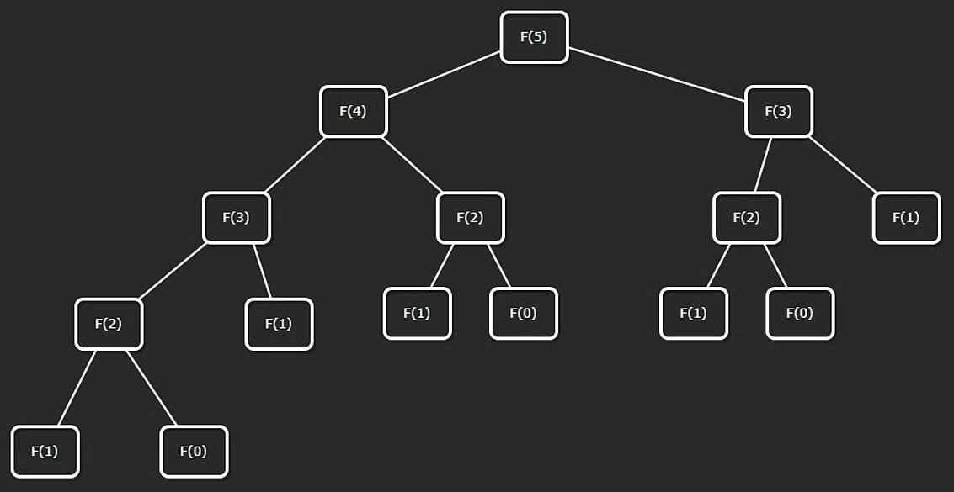
Fibonacci recursion tree
// Recursive implementation to calculate the n-th Fibonacci number
function fibonacci(n) {
// Base case
if (n <= 1) {
return n;
}
// Recursive case
return fibonacci(n - 1) + fibonacci(n - 2);
}

Walkthrough: fibonacci(5)
Start with:
- fibonacci(5) = fibonacci(4) + fibonacci(3)
Each branch recursively expands until base cases (0 or 1) are reached.
Then values are combined while returning back up:
- fibonacci(4) = 3
- fibonacci(3) = 2
- fibonacci(5) = 3 + 2 = 5

Complexity of Naive Recursion
At each level, calls can branch by about 2x.
An upper-bound node count follows a geometric sum:
$$1+2+4+8+…+2^{n}$$
So naive recursive Fibonacci has exponential time:
- Time: $O(2^{n})$
- Space: $O(n)$ recursion depth

NeetCode Practice (Recursion to DP)

1) Climbing Stairs
- Difficulty: Easy
- Pattern: Recursion -> Dynamic Programming
- Core idea: From step i, you can move to i + 1 or i + 2, which creates a Fibonacci-like recurrence.
Problem statement (summary): Given n steps, and moves of 1 or 2 steps, return the number of distinct ways to reach the top.
Example:
- Input: n = 2
- Output: 2
- Explanation: 1 + 1, 2

Approach 1: Top-Down DP (Memoization)
Intuition: Pure recursion repeats the same subproblems many times. Memoization stores each result once and reuses it.
Algorithm:
- Create cache initialized to -1.
- Define dfs(i):
- If i == n, return 1.
- If i > n, return 0.
- If cached, return cache value.
- Compute dfs(i + 1) + dfs(i + 2), store, return.
- Return dfs(0).
class Solution {
climbStairs(n: number): number {
const cache = new Int32Array(n).fill(-1);
const dfs = (i: number): number => {
if (i >= n) {
return i === n ? 1 : 0;
}
if (cache[i] !== -1) {
return cache[i];
}
cache[i] = dfs(i + 1) + dfs(i + 2);
return cache[i];
};
return dfs(0);
}
}
Complexity:
- Time: $O(n)$
- Space: $O(n)$

Approach 2: Bottom-Up DP
Intuition: Ways to reach step i come from i - 1 and i - 2, so:
$$dp[i]=dp[i−1]+dp[i−2]$$
Algorithm:
- If n <= 2, return n.
- Build dp array of size n + 1.
- Set dp[1] = 1, dp[2] = 2.
- Fill from 3 to n.
- Return dp[n].
class Solution {
climbStairs(n: number): number {
if (n <= 2) {
return n;
}
const dp = new Array<number>(n + 1).fill(0);
dp[1] = 1;
dp[2] = 2;
for (let i = 3; i <= n; i++) {
dp[i] = dp[i - 1] + dp[i - 2];
}
return dp[n];
}
}
Complexity:
- Time: $O(n)$
- Space: $O(n)$

Approach 3: DP (Space Optimized)
Intuition: Only the previous two states are needed, so we can replace the full DP array with two variables.
Algorithm:
- Initialize one = 1, two = 1.
- Repeat n - 1 times:
- newWays = one + two
- Shift: two = one, one = newWays
- Return one.
class Solution {
climbStairs(n: number): number {
let one = 1;
let two = 1;
for (let i = 0; i < n - 1; i++) {
const temp = one;
one = one + two;
two = temp;
}
return one;
}
}
Complexity:
- Time: $O(n)$
- Space: $O(1)$

4. Sorting

Insertion Sort
Insertion sort is a classic sorting algorithm used across many data structures.
It is simple and easy to understand, but not the most efficient choice for large datasets.

Concept
Given [2,3,4,1,6], the goal is to produce [1,2,3,4,6].
Insertion sort builds a sorted prefix one element at a time.
Key idea:
- A subarray of size 1 is already sorted.
- Treat the first element as the initial sorted portion.
- Insert each next element into its correct position inside that sorted portion.
Two-pointer view:
- i: points to the element being inserted.
- j: starts at i - 1 and moves left.
We keep swapping left while the current element is smaller than the previous element.
function insertionSort(arr) {
for (let i = 1; i < arr.length; i++) {
let j = i - 1;
while (j >= 0 && arr[j + 1] < arr[j]) {
const tmp = arr[j + 1];
arr[j + 1] = arr[j];
arr[j] = tmp;
j--;
}
}
return arr;
}
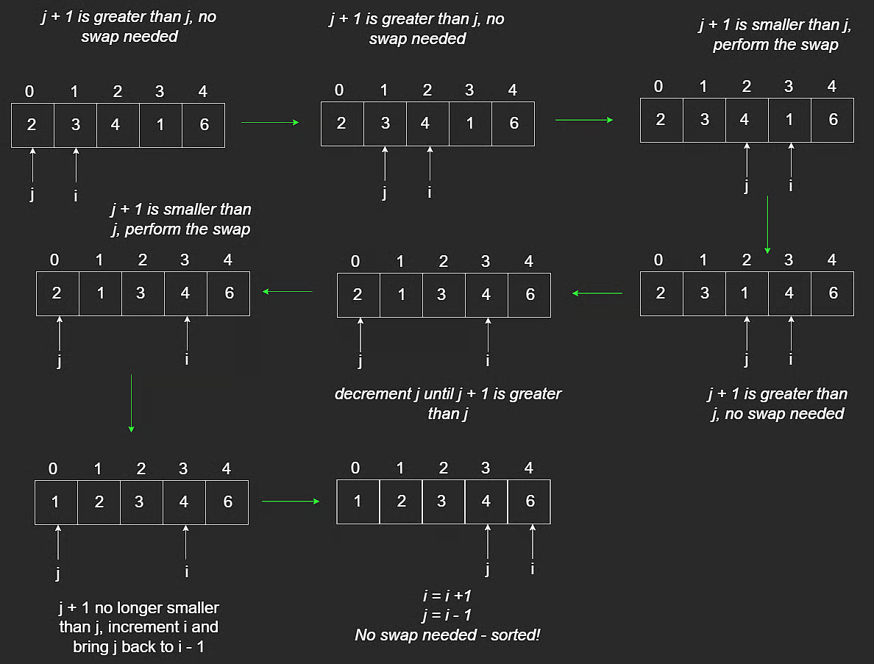
Insertion sort process
Insertion sort works on any comparable data type, not just integers.

Stability
A sorting algorithm is stable if equal values preserve relative order.
Example: [7,3,7].
After sorting, the 7 that originally appeared first still appears before the second 7.
Insertion sort is stable.

Time and Space Complexity

Time
- Best case (already sorted): $O(n)$
- Average case: $O(n^{2})$
- Worst case (reverse sorted, like [5,4,3,2,1]): $O(n^{2})$

Space
- $O(1)$ (in-place)

NeetCode Practice (Sorting)

1) Insertion Sort (Intermediate States)
- Difficulty: Easy
- Pattern: Stable in-place insertion + snapshots
- Core idea: Perform insertion sort, and after each outer-loop insertion, save a copy of the current array state.
Problem statement (summary): Given a list of key-value pairs, sort by key using insertion sort and return all intermediate array states.
If two pairs have equal keys, maintain their relative order.
Input constraints:
- 0 <= pairs.length <= 100
- each pair has integer key and string value
Example:
- Input: pairs = [(5, "apple"), (2, "banana"), (9, "cherry")]
- Output:
[
[(5, "apple"), (2, "banana"), (9, "cherry")],
[(2, "banana"), (5, "apple"), (9, "cherry")],
[(2, "banana"), (5, "apple"), (9, "cherry")]
]
There should be exactly pairs.length states.
Algorithm:
- Initialize result list res.
- For each index i, move pairs[i] left while previous key is larger.
- After finishing insertion for this i, push a shallow copy of pairs into res.
- Return res.
TypeScript solution:
// class Pair {
// constructor(public key: number, public value: string) {}
// }
class Solution {
insertionSort(pairs: Pair[]): Pair[][] {
const n = pairs.length;
const res: Pair[][] = [];
for (let i = 0; i < n; i++) {
let j = i - 1;
while (j >= 0 && pairs[j].key > pairs[j + 1].key) {
[pairs[j], pairs[j + 1]] = [pairs[j + 1], pairs[j]];
j -= 1;
}
res.push([...pairs]);
}
return res;
}
}
Complexity:
- Time: $O(n^{2})$ in the worst case
- Space: $O(n^{2})$ for storing all snapshot states in res

Merge Sort
Merge sort is a very common sorting algorithm and is used in many standard libraries.
It follows a divide-and-conquer strategy:
- Split the array into halves until subarrays have size 1.
- Recursively sort each half.
- Merge sorted halves back together.
This is a two-branch recursive pattern, similar to Fibonacci recursion.

Core Idea
Example input: [3,2,4,1,6]
Goal: sort in increasing (non-decreasing) order.
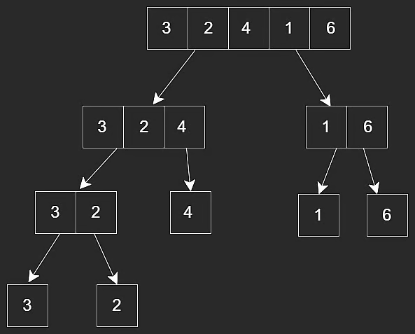
Merge sort split/merge overview
function mergeSort(arr, l, r) {
if (l < r) {
// Find middle
const m = Math.floor((l + r) / 2);
mergeSort(arr, l, m); // sort left half
mergeSort(arr, m + 1, r); // sort right half
merge(arr, l, m, r); // merge sorted halves
}
return arr;
}
Base case: subarray length is 1 (already sorted).
Recursive case:
- sort left half
- sort right half
- merge results
Important execution detail:
- merge() runs only after both recursive mergeSort() calls return for the current subarray.

Merge Function (Three Pointers)
During merge, we use three pointers:
- i: current index in left temporary array
- j: current index in right temporary array
- k: write index in original array
At each step:
- Compare left and right values
- Write smaller value to arr[k]
- Increment k and whichever side was chosen (i or j)
// Merges two subarrays of arr[]
// First subarray is arr[l..m]
// Second subarray is arr[m+1..r]
function merge(arr, l, m, r) {
const length1 = m - l + 1;
const length2 = r - m;
const L = new Array(length1);
const R = new Array(length2);
for (let i = 0; i < length1; i++) {
L[i] = arr[l + i];
}
for (let j = 0; j < length2; j++) {
R[j] = arr[m + 1 + j];
}
let i = 0;
let j = 0;
let k = l;
while (i < length1 && j < length2) {
if (L[i] <= R[j]) {
arr[k] = L[i];
i++;
} else {
arr[k] = R[j];
j++;
}
k++;
}
while (i < length1) {
arr[k] = L[i];
i++;
k++;
}
while (j < length2) {
arr[k] = R[j];
j++;
k++;
}
}
This merge step is a classic two-pointer technique and combines arrays in $O(n+m)$ for left length n and right length m.

Time and Space Complexity

Time
Merge sort runs in $O(nlogn)$.
Reasoning:
- Recursion tree height is about log n.
- Each level does O(n) work total during merges.
- Multiply: O(n) * O(log n) = O(n log n).
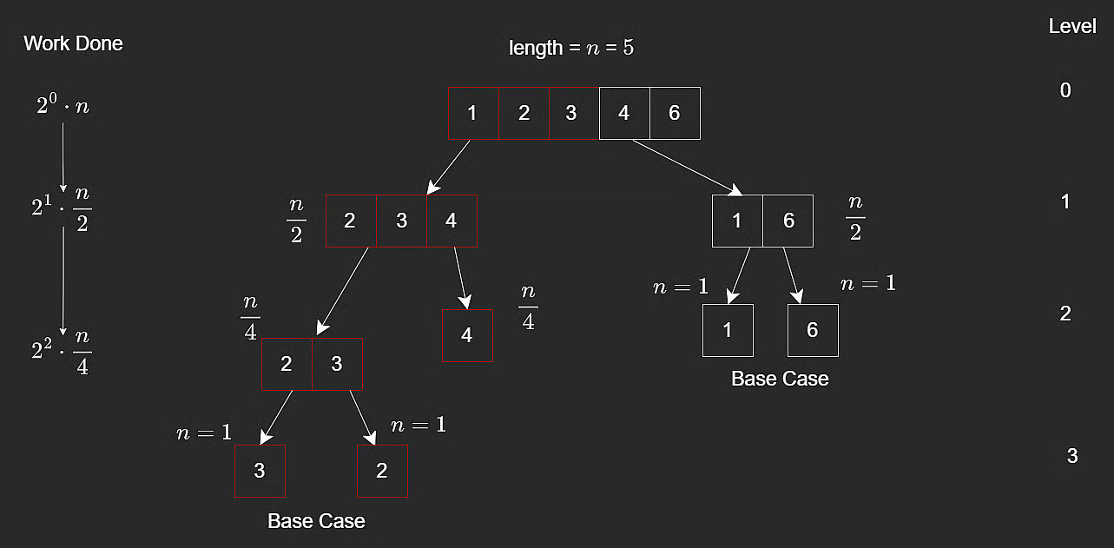
Merge sort recursion levels

Space
- Temporary arrays in merge steps: O(n)
- Recursion call stack: O(log n)
Total: $O(n+logn)=O(n)$.

Stability
Merge sort is stable.
If duplicates exist in both halves, choosing left first on equality preserves original relative order:
if (leftSubarray[i] <= rightSubarray[j]) {
arr[k] = leftSubarray[i];
i += 1;
}

Merge Sort vs Insertion Sort
- Insertion sort: worst-case $O(n^{2})$
- Merge sort: best/average/worst-case $O(nlogn)$
Merge sort is generally superior for larger arrays.
Insertion sort can still be preferable for small or nearly sorted arrays.

NeetCode Practice (Sorting)

1) Merge Sorted Array
- Difficulty: Easy
- Pattern: Two pointers / three pointers
- Core idea: Merge two sorted arrays into nums1 in-place.
Problem statement (summary): You are given sorted arrays nums1 and nums2, with counts m and n.
- First m elements of nums1 are valid.
- Last n elements of nums1 are placeholders (0).
Modify nums1 in-place so it becomes the sorted merge of both arrays.
Example:
- Input: nums1 = [10,20,20,40,0,0], m = 4, nums2 = [1,2], n = 2
- Output: [1,2,10,20,20,40]

Approach 1: Three Pointers With Extra Space
Intuition: Copy valid portion of nums1 first so front writes do not overwrite needed values.
Algorithm:
- Copy first m elements of nums1.
- Use i for copy, j for nums2, idx for write position in nums1.
- Write smaller value each step.
- Continue until idx == m + n.
class Solution {
merge(nums1: number[], m: number, nums2: number[], n: number): void {
const nums1Copy = nums1.slice(0, m);
let idx = 0;
let i = 0;
let j = 0;
while (idx < m + n) {
if (j >= n || (i < m && nums1Copy[i] <= nums2[j])) {
nums1[idx++] = nums1Copy[i++];
} else {
nums1[idx++] = nums2[j++];
}
}
}
}
Complexity:
- Time: $O(m+n)$
- Space: $O(m)$

Approach 2: Three Pointers Without Extra Space (Version I)
Intuition: Write from the back of nums1 (where free space exists), so no needed value is overwritten.
Algorithm:
- Set last = m + n - 1.
- While m > 0 and n > 0, place larger of nums1[m - 1] and nums2[n - 1] at nums1[last].
- Decrement corresponding pointer and last.
- Copy any remaining nums2 values.
class Solution {
merge(nums1: number[], m: number, nums2: number[], n: number): void {
let last = m + n - 1;
while (m > 0 && n > 0) {
if (nums1[m - 1] > nums2[n - 1]) {
nums1[last--] = nums1[m-- - 1];
} else {
nums1[last--] = nums2[n-- - 1];
}
}
while (n > 0) {
nums1[last--] = nums2[n-- - 1];
}
}
}
Complexity:
- Time: $O(m+n)$
- Space: $O(1)$ extra space

Approach 3: Three Pointers Without Extra Space (Version II)
Intuition: Cleaner loop: continue only while j >= 0, because leftover nums1 elements are already in correct place.
Algorithm:
- Set i = m - 1, j = n - 1, last = m + n - 1.
- While j >= 0, place max of nums1[i] and nums2[j] at nums1[last].
- Move pointers.
class Solution {
merge(nums1: number[], m: number, nums2: number[], n: number): void {
let last = m + n - 1;
let i = m - 1;
let j = n - 1;
while (j >= 0) {
if (i >= 0 && nums1[i] > nums2[j]) {
nums1[last--] = nums1[i--];
} else {
nums1[last--] = nums2[j--];
}
}
}
}
Complexity:
- Time: $O(m+n)$
- Space: $O(1)$ extra space

Common Pitfalls
- Merging from the front in-place This can overwrite values in nums1 that are still needed.
- Forgetting leftover nums2 elements After the main loop, remaining values in nums2 must be copied.

Your Version (Same In-Place Backward Merge)
Why it works: Your solution uses three pointers from the end of the arrays:
- writePointer: where the next largest value should go in nums1
- nums1Pointer: last valid value in nums1
- nums2Pointer: last value in nums2
By writing from the back, no still-needed values in nums1 get overwritten.
class Solution {
/**
* @param {number[]} nums1
* @param {number} m
* @param {number[]} nums2
* @param {number} n
* @return {void} Do not return anything, modify nums1 in-place instead.
*/
merge(nums1, m, nums2, n) {
let writePointer = nums1.length - 1;
let nums1Pointer = m - 1;
let nums2Pointer = n - 1;
while (nums1Pointer >= 0 && nums2Pointer >= 0) {
if (nums1[nums1Pointer] >= nums2[nums2Pointer]) {
nums1[writePointer] = nums1[nums1Pointer];
nums1Pointer--;
} else {
nums1[writePointer] = nums2[nums2Pointer];
nums2Pointer--;
}
writePointer--;
}
while (nums2Pointer >= 0) {
nums1[writePointer] = nums2[nums2Pointer];
writePointer--;
nums2Pointer--;
}
}
}
Complexity:
- Time: $O(m+n)$
- Space: $O(1)$ extra space

Quick Sort
Quick sort is another divide-and-conquer sorting algorithm, similar in spirit to merge sort.
Its main idea is to choose a pivot, partition the array around that pivot, and then recursively sort the left and right partitions.

Pivot Selection
Common pivot strategies include:
- first element
- last element
- median-of-three
- random pivot
Ideally, the pivot splits the array into two roughly equal halves.
For simplicity, this lesson uses the last element as the pivot.

Core Idea
After choosing a pivot, partition the array so that:
- values less than or equal to the pivot go on the left
- values greater than the pivot go on the right
Then recursively quick sort both sides.
Unlike merge sort, there is no merge step afterward. The partitioning itself does the key rearrangement work.
Quick sort can be seen as the opposite of merge sort:
- Merge sort: easy split, more involved merge
- Quick sort: more involved partition, no merge
Randomized quicksort reduces the chance of hitting the worst-case split and gives expected $O(nlogn)$ time, although worst-case still remains $O(n^{2})$.

Partition Step
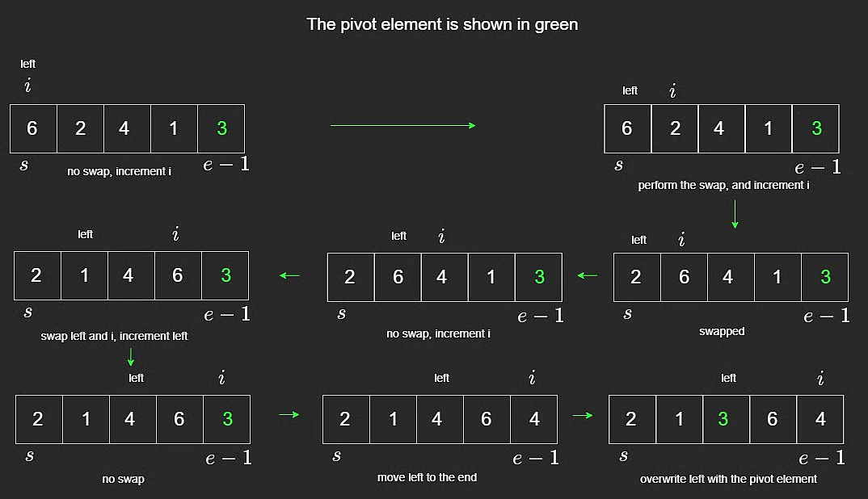
Quick sort partition example
The array is rearranged so values smaller than the pivot are on the left side, and the pivot lands in its final sorted position.
This happens in-place, without allocating new arrays for each partition.
function quickSort(arr, s, e) {
if (e - s + 1 <= 1) {
return arr;
}
const pivot = arr[e];
let left = s;
// Partition: elements smaller than pivot on left side
for (let i = s; i < e; i++) {
if (arr[i] < pivot) {
const tmp = arr[left];
arr[left] = arr[i];
arr[i] = tmp;
left++;
}
}
// Move pivot in-between left and right sides
arr[e] = arr[left];
arr[left] = pivot;
quickSort(arr, s, left - 1);
quickSort(arr, left + 1, e);
return arr;
}

Time and Space Complexity

Time
- Best case: $O(nlogn)$
- Average case: $O(nlogn)$
- Worst case: $O(n^{2})$
Why:
- Partitioning each level costs O(n).
- Best/average case gives about log n levels.
- Worst case happens when pivot choices are consistently poor, producing partitions of size n - 1 and 0.

Space
- Best/average recursion depth: $O(logn)$
- Worst-case recursion depth: $O(n)$

Stability
Quick sort is not stable because it swaps non-adjacent elements.
Example: [7,3,7,4,5]
The two 7s may reverse relative order after partitioning.

NeetCode Practice (Sorting)

1) K Closest Points to Origin
- Difficulty: Medium
- Pattern: Sorting by custom key
- Core idea: Sort points by squared distance from origin, then return the first k.
Problem statement (summary): Given points on a 2D plane and integer k, return the k closest points to (0, 0).
The Euclidean distance is:
$$\sqrt{(x_{1}−x_{2})^{2}+(y_{1}−y_{2})^{2}}$$
But for comparison, we can use squared distance instead:
$$d^{2}=x^{2}+y^{2}$$
Example:
- Input: points = [[0,2],[2,2]], k = 1
- Output: [[0,2]]

Approach 1: Sorting
Intuition: Square root is monotonic, so sorting by squared distance gives the same ordering as sorting by actual distance.
Algorithm:
- For each point (x, y), compute x^2 + y^2.
- Sort all points by that value.
- Return the first k points.
class Solution {
/**
* @param {number[][]} points
* @param {number} k
* @return {number[][]}
*/
kClosest(points, k) {
points.sort((a, b) => a[0] ** 2 + a[1] ** 2 - (b[0] ** 2 + b[1] ** 2));
return points.slice(0, k);
}
}
Complexity:
- Time: $O(nlogn)$
- Space: depends on sort implementation, often $O(logn)$ or more

Bucket Sort
Bucket sort is the last sorting algorithm in this section and an important one to know.
It is not as universally used as merge sort or quick sort, but it works very well when the values fall inside a small known range.

Core Idea
Suppose we have an array of size 6 containing only values in the range 0 to 2.
Example:
- input: [2,1,2,0,0,2]
We create a bucket for each possible value:
- bucket for 0
- bucket for 1
- bucket for 2
In this lesson, a bucket is just an index in a frequency array.
Once the counts are known, we overwrite the original array in sorted order.
function bucketSort(arr) {
// Assuming arr only contains 0, 1, or 2
const counts = [0, 0, 0];
// Count occurrences
for (let i = 0; i < arr.length; i++) {
counts[arr[i]] += 1;
}
// Rebuild array from bucket counts
let i = 0;
for (let n = 0; n < counts.length; n++) {
for (let j = 0; j < counts[n]; j++) {
arr[i] = n;
i++;
}
}
return arr;
}

How the Pointers Work
In the second phase:
- i = next write position in original array
- n = current bucket/value being written
- j = how many times current value has been placed so far
Example:
- counts = [2,1,3]
- original arr = [2,1,2,0,0,2]
When n = 0, we write 0 two times. When n = 1, we write 1 one time. When n = 2, we write 2 three times.
Final result:
- [0,0,1,2,2,2]
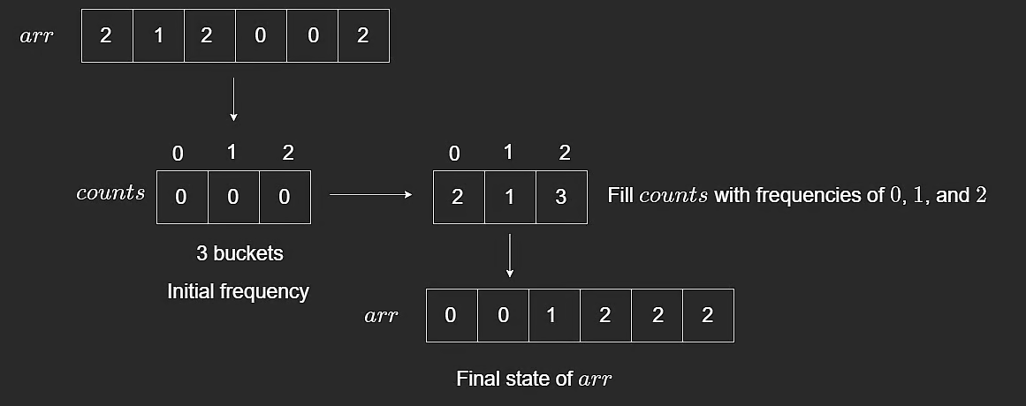
Bucket sort frequency rewrite

Time Complexity
At first glance, the nested loops may look like $O(n^{2})$, but that is not the right analysis.
Why:
- First loop counts all elements: O(n)
- Second phase writes each original element exactly once total
So total time is linear in the size of the input plus the bucket range.
For this fixed small-range example, we treat it as:
- Time: $O(n)$
This is a good reminder that nested loops do not always mean quadratic time.

Stability
This implementation is not stable.
Because the array is overwritten from frequency counts rather than preserving original element order, relative order among equal items is not kept.

Closing Notes
Bucket sort is powerful when the dataset lies in a specific bounded range.
For general-purpose algorithm problems, merge sort and quick sort are usually safer defaults.

NeetCode Practice (Sorting)

1) Sort Colors
- Difficulty: Medium
- Pattern: Counting sort / bucket frequency
- Core idea: Count how many 0s, 1s, and 2s appear, then overwrite the array in color order.
Problem statement (summary): You are given an array nums where:
- 0 = red
- 1 = white
- 2 = blue
Sort the array in-place so colors are grouped as 0, 1, 2.
Built-in sort functions are not allowed.
Example:
- Input: nums = [1,0,1,2]
- Output: [0,1,1,2]

Approach 1: Counting Sort
Intuition: There are only three distinct values, so it is efficient to count each one and then reconstruct the array.
Algorithm:
- Count occurrences of 0, 1, and 2.
- Overwrite array with all 0s first.
- Then write all 1s.
- Then write all 2s.
class Solution {
/**
* @param {number[]} nums
* @return {void} Do not return anything, modify nums in-place instead.
*/
sortColors(nums) {
const bucket = new Array(3).fill(0);
for (let i = 0; i < nums.length; i++) {
const num = nums[i];
bucket[num]++;
}
let j = 0;
for (let i = 0; i < bucket.length; i++) {
while (bucket[i] > 0) {
nums[j] = i;
j++;
bucket[i]--;
}
}
}
}
Complexity:
- Time: $O(n)$
- Space: $O(1)$ since bucket size is fixed at 3

Sorting Time Complexity Cheat Sheet
Use this chart as a quick reference for comparing the sorting algorithms covered in this module.
It is especially useful when deciding between:
- simpler algorithms like insertion sort
- divide-and-conquer algorithms like merge sort and quick sort
- range-based algorithms like bucket sort

Visual Summary
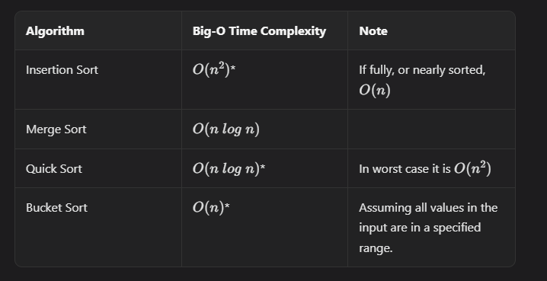
Sorting time complexity cheat sheet

How to Use It
When choosing a sorting approach, ask:
- Is the array small or nearly sorted?
- Do I need guaranteed $O(nlogn)$ performance?
- Is the value range small enough for counting or bucket-style sorting?
- Do I care whether the algorithm is stable?

5. Binary Search

Binary Search (Search an Array)
Binary search is an efficient way to find a target in a sorted array.
It works by repeatedly checking the middle element and discarding half of the search space each time.
Think of searching for a word in a dictionary: open near the middle, decide left or right, and repeat.

Core Idea
At each step:
- compare mid with the target
- if target is larger, search the right half
- if target is smaller, search the left half
- if equal, return the index
Two common binary-search problem types:
- Search Array: find a target in a sorted array
- Search Range: search over a numeric range using a helper or predicate

Example Walkthrough
Array: [1,2,3,4,5,6,7,8]
Target: 5
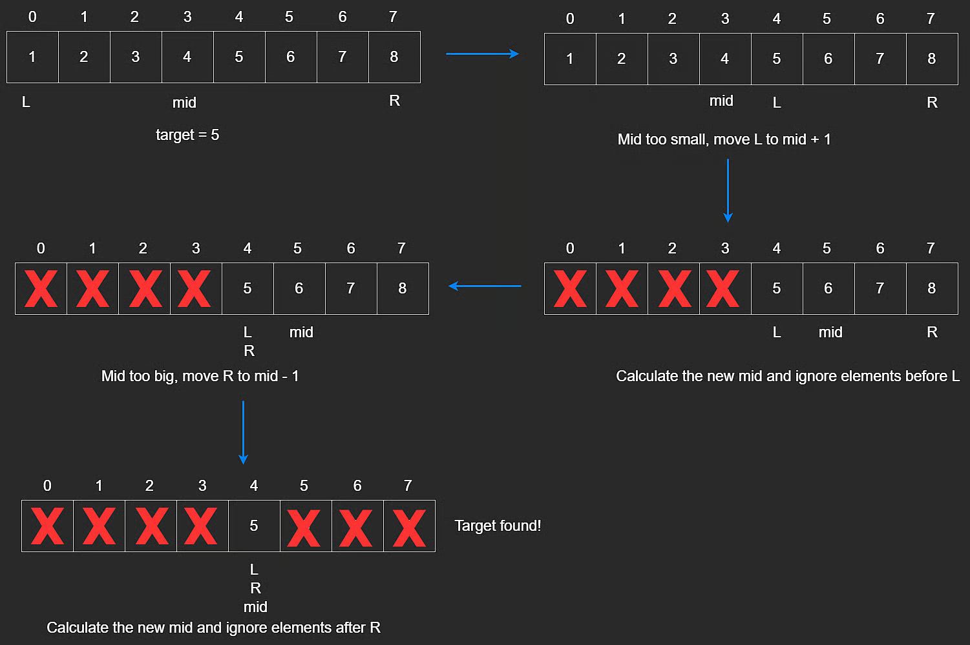
Binary search on array
Step-by-step:
- Start with the full array.
- Check middle index.
- Since 5 > 4, move right.
- Check the new middle.
- Since 5 < 6, move left.
- The target is found.

Implementation
Use two pointers:
- L / left / low
- R / right / high
Midpoint formula:
$$mid=L+\frac{R−L}{2}$$
This is preferred over (L + R) / 2 because it avoids overflow in languages with fixed-size integers.
const arr = [1, 3, 3, 4, 5, 6, 7, 8];
function binarySearch(arr, target) {
let L = 0;
let R = arr.length - 1;
while (L <= R) {
let mid = Math.floor((L + R) / 2);
if (target > arr[mid]) {
L = mid + 1;
} else if (target < arr[mid]) {
R = mid - 1;
} else {
return mid;
}
}
return -1;
}

Target Not Found
If the target does not exist, the search space eventually becomes empty.
At that point, L > R.
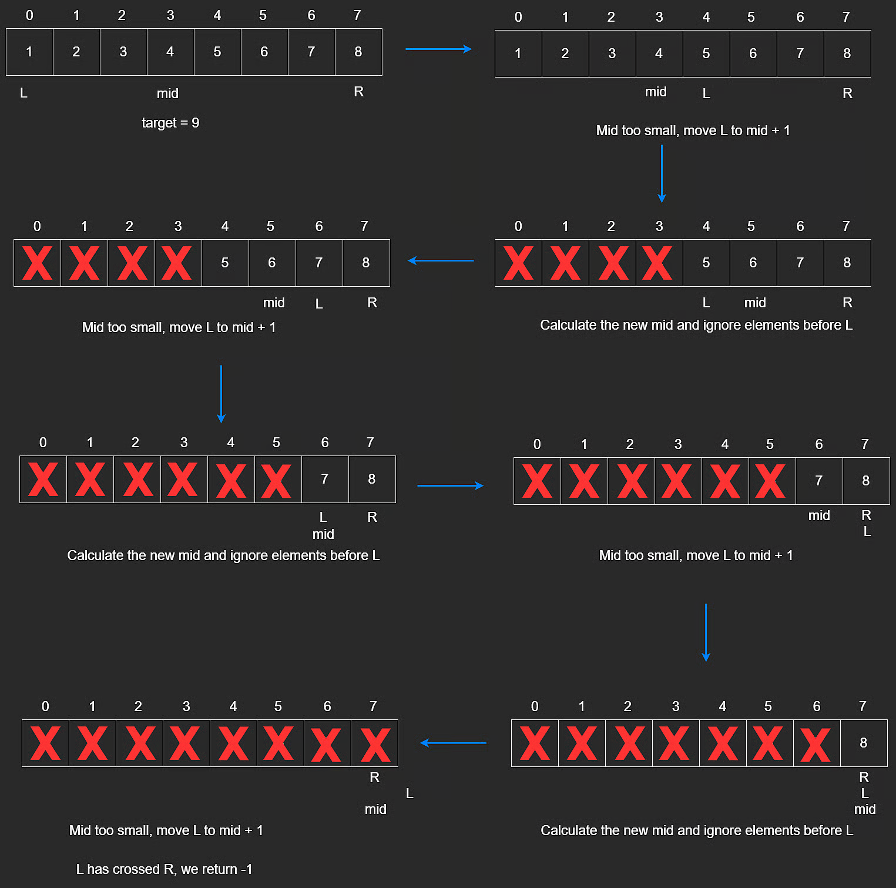
Target not found in sorted array

Time and Space Complexity
Binary search halves the search space each time.
If n is the array size, then the number of halvings is about:
$$1=\frac{n}{2^{x}}$$
Solving gives:
$$x=\log_{2}(n)$$
So:
- Time: $O(logn)$
- Space: $O(1)$

NeetCode Practice (Binary Search)

1) Binary Search
- Difficulty: Easy
- Pattern: Iterative binary search
- Core idea: Shrink the search range until the target is found or the pointers cross.
Problem statement (summary): Given a sorted array of distinct integers nums and a target, return the index of target or -1.
Example:
- Input: nums = [-1,0,2,4,6,8], target = 4
- Output: 3
Algorithm:
- Set l = 0 and r = nums.length - 1.
- While l <= r:
- Compute middle m.
- If nums[m] == target, return m.
- If nums[m] < target, search right half.
- If nums[m] > target, search left half.
- If not found, return -1.
class Solution {
search(nums: number[], target: number): number {
let l = 0;
let r = nums.length - 1;
while (l <= r) {
const m = l + Math.floor((r - l) / 2);
if (nums[m] > target) {
r = m - 1;
} else if (nums[m] < target) {
l = m + 1;
} else {
return m;
}
}
return -1;
}
}
Complexity:
- Time: $O(logn)$
- Space: $O(1)$

2) Search Range
- Difficulty: Medium
- Pattern: Lower bound binary search
- Core idea: Find the first index where a value is greater than or equal to the target.
Problem statement (summary): Find the first occurrence of a target in a sorted array, or return -1 if it does not exist.
Intuition: Instead of searching for equality directly, search for the leftmost index where the target could appear.
This naturally handles duplicates and avoids overshooting.
Algorithm:
- Set l = 0, r = nums.length.
- While l < r:
- Compute m.
- If nums[m] >= target, move left: r = m.
- Otherwise move right: l = m + 1.
- After the loop, check whether nums[l] === target.
- Return the index or -1.
class Solution {
search(nums: number[], target: number): number {
let l = 0;
let r = nums.length;
while (l < r) {
const m = l + Math.floor((r - l) / 2);
if (nums[m] >= target) {
r = m;
} else {
l = m + 1;
}
}
return l < nums.length && nums[l] === target ? l : -1;
}
}
Complexity:
- Time: $O(logn)$
- Space: $O(1)$

3) Search a 2D Matrix
- Difficulty: Medium
- Pattern: Binary search on flattened indices
- Core idea: Treat the matrix like one sorted array and map indices back to row/column coordinates.
Problem statement (summary): Given an m x n matrix where each row is sorted and the first value of each row is greater than the last value of the previous row, determine whether target exists.
Example:
- Input: matrix = [[1,2,4,8],[10,11,12,13],[14,20,30,40]], target = 10
- Output: true
Intuition: Because the matrix is globally sorted row by row, it behaves like one big sorted array.
Index mapping:
- row = mid / columns
- col = mid % columns
Algorithm:
- Set left = 0, right = rows * columns - 1.
- While left <= right:
- Compute mid.
- Convert mid to row and col.
- Compare matrix value to target.
- Move left or right accordingly.
- Return false if no match is found.
class Solution {
searchMatrix(matrix: number[][], target: number): boolean {
const rows = matrix.length;
const columns = matrix[0].length;
let left = 0;
let right = rows * columns - 1;
while (left <= right) {
const mid = Math.floor((left + right) / 2);
const col = mid % columns;
const row = Math.floor(mid / columns);
if (matrix[row][col] > target) {
right = mid - 1;
} else if (matrix[row][col] < target) {
left = mid + 1;
} else {
return true;
}
}
return false;
}
}
Complexity:
- Time: $O(log(mn))$
- Space: $O(1)$

Binary Search (Search Range)
Search range binary search applies the same core idea as array search, but the search space is a numeric range rather than an array.
Instead of comparing against arr[mid], we compare a guessed value against a hidden answer through a helper function.

Concept
Imagine guessing a number from 1 to 100.
After each guess, you are told whether it is:
- correct
- too small
- too large
That feedback is enough to shrink the search space just like normal binary search.
In many problems, the comparison is hidden behind an API or function such as isCorrect(n).
// Return 1 if n is too big, -1 if too small, 0 if correct
function isCorrect(n) {
if (n > 10) {
return 1;
} else if (n < 10) {
return -1;
} else {
return 0;
}
}

Range Binary Search
function binarySearch(low, high) {
while (low <= high) {
const mid = Math.floor((low + high) / 2);
if (isCorrect(mid) > 0) {
high = mid - 1;
} else if (isCorrect(mid) < 0) {
low = mid + 1;
} else {
return mid;
}
}
return -1;
}
This style is common in problems where the judge function is a black box.

Time and Space Complexity
- Time: $O(logn)$
- Space: $O(1)$

NeetCode Practice (Binary Search)

1) Guess Number Higher or Lower
- Difficulty: Easy
- Pattern: Binary search on a range
- Core idea: Use the guess() API to determine whether the hidden number is higher or lower.
Problem statement (summary): Pick a number from 1 to n. Each wrong guess returns whether the target is higher or lower. Return the picked number.
Example:
- Input: n = 5, pick = 3
- Output: 3
Algorithm:
- Set low = 1, high = n.
- While low <= high:
- Compute mid.
- Call guess(mid).
- If result is 0, return mid.
- If result is 1, search right half.
- If result is -1, search left half.
/**
* Forward declaration of guess API.
* @param {number} num your guess
* @return -1 if num is higher than the picked number
* 1 if num is lower than the picked number
* otherwise return 0
* function guess(num) {}
*/
class Solution {
guessNumber(n: number): number {
let low = 1;
let high = n;
while (low <= high) {
const mid = Math.floor((low + high) / 2);
const guessResult = guess(mid);
if (guessResult === 1) {
low = mid + 1;
} else if (guessResult === -1) {
high = mid - 1;
} else {
return mid;
}
}
return -1;
}
}
Complexity:
- Time: $O(logn)$
- Space: $O(1)$

2) Search Range
- Difficulty: Medium
- Pattern: Lower bound binary search
- Core idea: Find the first index where the target could appear, then verify it.
Problem statement (summary): Given a sorted array, return the first occurrence of a target or -1.
Intuition: Binary search for the leftmost position avoids overshooting and handles duplicates naturally.
Algorithm:
- Set l = 0, r = nums.length.
- While l < r:
- Compute m.
- If nums[m] >= target, move r = m.
- Otherwise set l = m + 1.
- After the loop, verify nums[l] === target.
class Solution {
search(nums: number[], target: number): number {
let l = 0;
let r = nums.length;
while (l < r) {
const m = l + Math.floor((r - l) / 2);
if (nums[m] >= target) {
r = m;
} else {
l = m + 1;
}
}
return l < nums.length && nums[l] === target ? l : -1;
}
}
Complexity:
- Time: $O(logn)$
- Space: $O(1)$

3) Koko Eating Bananas
- Difficulty: Medium
- Pattern: Binary search on answer space
- Core idea: The faster Koko eats, the fewer hours she needs. This monotonic behavior allows binary search over possible speeds.
Problem statement (summary): Given piles, where piles[i] is the number of bananas in the i-th pile, and a limit h hours, find the minimum integer eating speed k such that all bananas are eaten within h hours.
Each hour, Koko chooses one pile and eats up to k bananas from it. If the pile has fewer than k, she finishes it and cannot continue with another pile in the same hour.
Examples:
- Input: piles = [1,4,3,2], h = 9
- Output: 2
- Input: piles = [25,10,23,4], h = 4
- Output: 25

Approach 1: Binary Search
Intuition: Trying every speed from 1 to max(piles) is too slow. But the total required time decreases as speed increases, which gives us a sorted/monotonic search space.
So we binary-search the speed:
- low speed -> too many hours
- high speed -> feasible hours
Then we find the smallest feasible speed.
Algorithm:
- Set left = 1, right = max(piles).
- Track best answer res.
- While left <= right:
- Test speed mid.
- Compute hours needed: sum(ceil(pile / mid)).
- If hours <= h, record mid and search left half.
- Otherwise search right half.
- Return res.
class Solution {
/**
* @param {number[]} piles
* @param {number} h
* @return {number}
*/
minEatingSpeed(piles, h) {
let left = 1;
let right = Math.max(...piles);
let res = right;
while (left <= right) {
const mid = Math.floor((left + right) / 2);
let totalTime = 0;
for (const pile of piles) {
totalTime += Math.ceil(pile / mid);
}
if (totalTime <= h) {
res = mid;
right = mid - 1;
} else {
left = mid + 1;
}
}
return res;
}
}
Complexity:
- Time: $O(nlogm)$
- Space: $O(1)$
Where:
- n is the number of piles
- m is max(piles)

6. Trees

Binary Trees

Concept
Similar to linked lists, binary trees are data structures built from nodes and pointers.
In a linked list, nodes form a straight line with next (and sometimes prev).
In a binary tree, each node has at most two child pointers:
- left
- right
The first node is called the root.
class TreeNode {
constructor(val) {
this.val = val;
this.left = null;
this.right = null;
}
}
Node categories:
- Leaf node: no children
- Non-leaf node: at least one child
Unlike linked lists, tree edges conceptually point downward from parent to child, and cycles are not allowed.

Tree Terminology

Root Node
The root is the top-most node and has no parent. Every node in the tree is reachable from the root.

Leaf Nodes
Leaf nodes have no children. The bottom-most level is all leaves, but leaves can also appear earlier in uneven trees.
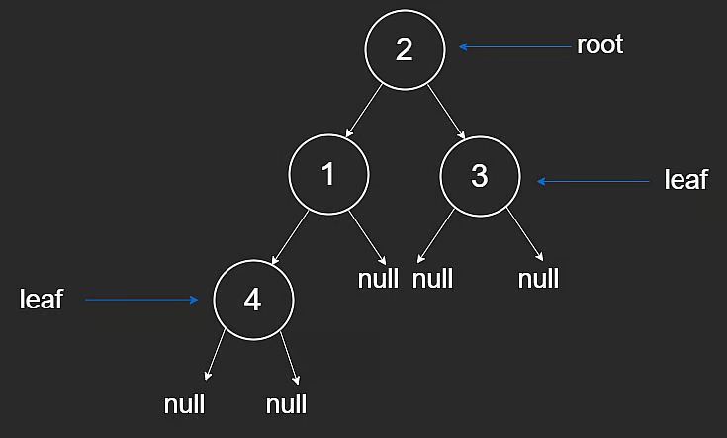
Binary tree representation

Height
Tree height is measured from the root down to the lowest leaf.
Two common conventions:
- count nodes in the path
- count edges in the path
For a path with n nodes, edge count is n - 1.
Example from the diagram:
- height by nodes: 3
- height by edges: 2
General fact for trees:
- number of edges = n - 1 where n is number of nodes

Depth
Depth of a node is measured from that node upward to the root.
As you move down the tree, depth increases.
Like height, depth may be measured by nodes or edges depending on convention.

Ancestor and Descendant

Ancestor
A node connected to nodes below it in the tree is an ancestor of those nodes.
The root is an ancestor of every node.

Descendant
A descendant of a node is:
- its child, or
- child of one of its descendants recursively

Binary Search Trees

Binary Trees vs Binary Search Trees
A Binary Search Tree (BST) is a binary tree with an added sorted property:
- every value in the left subtree is smaller than the current node
- every value in the right subtree is greater than the current node
This property is recursive and applies at every node.
It is conceptually similar to a sorted array, but with tree structure.

Why BSTs
BSTs are useful because they can support:
- search in $O(logn)$ on balanced trees
- insertion in $O(logn)$ on balanced trees
- deletion in $O(logn)$ on balanced trees
Sorted arrays can search in $O(logn)$, but insertion and deletion are typically $O(n)$ due to shifting.

BST Search
Because trees are recursive structures, recursion is a natural traversal method.
Example tree: [2,1,3,null,null,null,4]
Target: 3
Search logic:
- if target is greater than current value, go right
- if target is smaller, go left
- if equal, return true
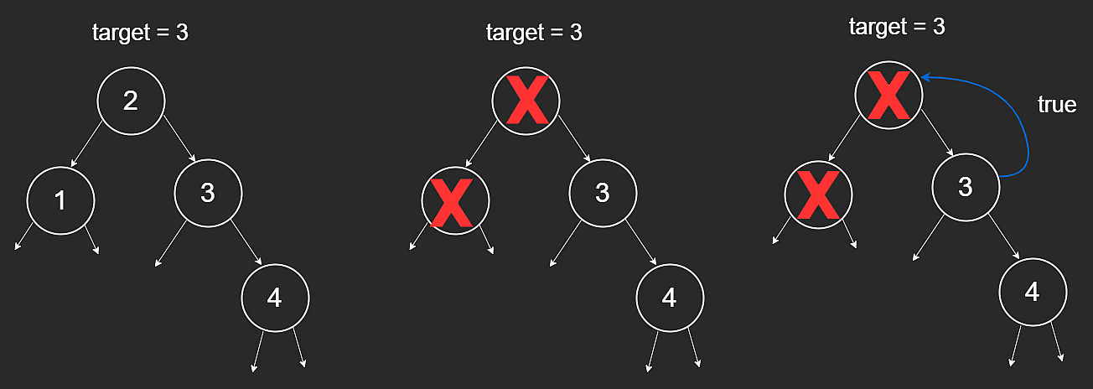
BST search path
function search(root, target) {
if (root == null) {
return false;
}
if (target > root.val) {
return search(root.right, target);
} else if (target < root.val) {
return search(root.left, target);
} else {
return true;
}
}

How It Works
- If node is null, target does not exist in that subtree.
- If target is greater, recurse right.
- If target is smaller, recurse left.
- If equal, return true.
Base cases:
- root == null -> false
- root.val == target -> true

Time Complexity
Let h be tree height.
- Search cost is proportional to height: $O(h)$
So:
- Balanced BST: $O(logn)$
- Skewed BST (worst case): $O(n)$
A balanced tree means left and right subtree heights are close (difference at most 1).

Insertion and Removal in a Binary Search Tree
One major advantage of BSTs over sorted arrays is efficient insertion and deletion.
On a balanced tree, these operations are typically $O(logn)$.

Insertion
To insert a value:
- Traverse the tree to find where it should go.
- Add it as a leaf while preserving BST order.
Example from root [4], inserting 6:
- [4,null,6]
- [6,4,null]
Both satisfy BST rules, but adding as a leaf is the standard process.
If we start with [4,null,6] and insert 5, we get [4,null,6,5,null].
// Insert a new node and return the root of the BST.
function insert(root, val) {
if (root == null) {
return new TreeNode(val);
}
if (val > root.val) {
root.right = insert(root.right, val);
} else if (val < root.val) {
root.left = insert(root.left, val);
}
return root;
}
Why this works:
- null spot means insertion point
- recursive return values reconnect to root.left or root.right
- tree structure remains valid
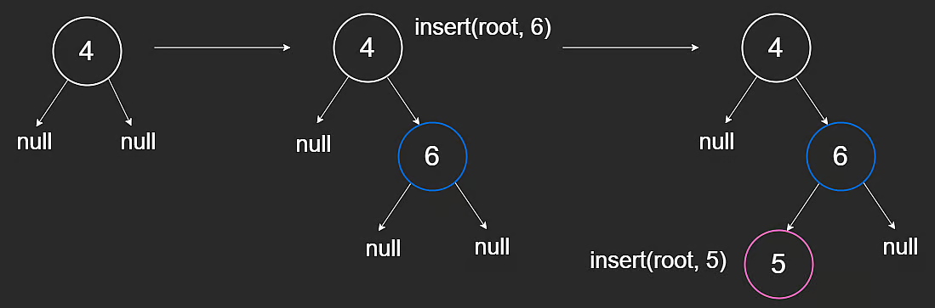
BST insertion example

Removal
Deletion depends on number of children in target node.

Case 1: 0 or 1 Child
- No child: remove node directly.
- One child: connect parent to that child.
Examples:
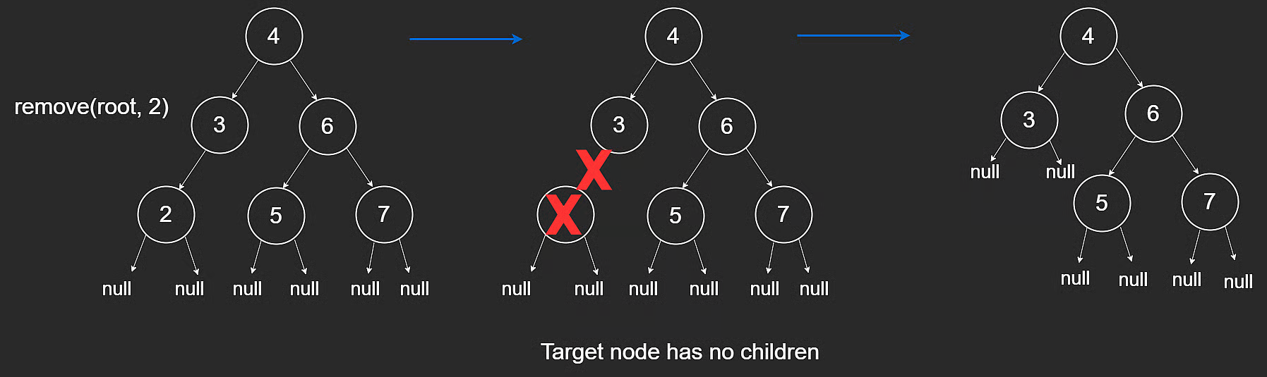
BST removal no child
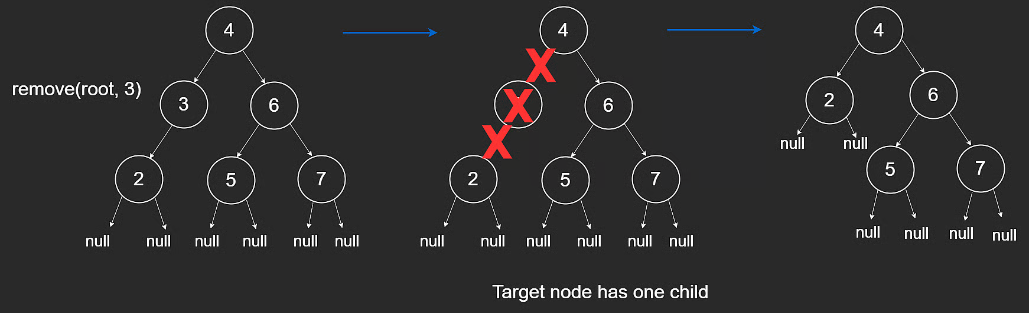
BST removal one child

Case 2: 2 Children
Replace target with its in-order successor:
- the left-most node in target’s right subtree
- equivalently, the smallest value greater than target
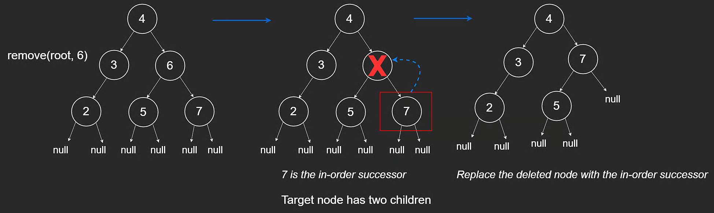
BST removal two children
// Return the minimum value node of the BST.
function minValueNode(root) {
let curr = root;
while (curr != null && curr.left != null) {
curr = curr.left;
}
return curr;
}
// Remove a node and return the root of the BST.
function remove(root, val) {
if (root == null) {
return null;
}
if (val > root.val) {
root.right = remove(root.right, val);
} else if (val < root.val) {
root.left = remove(root.left, val);
} else {
if (root.left == null) {
return root.right;
} else if (root.right == null) {
return root.left;
} else {
const minNode = minValueNode(root.right);
root.val = minNode.val;
root.right = remove(root.right, minNode.val);
}
}
return root;
}

Time and Space Complexity
Let h be tree height.
- Insertion time: $O(h)$
- Removal time: $O(h)$
So:
- Balanced BST: $O(logn)$
- Worst-case skewed BST: $O(n)$
Recursive space:
- Balanced: $O(logn)$
- Worst-case: $O(n)$

NeetCode Practice (BST)

1) Insert into a Binary Search Tree
- Difficulty: Medium
- Pattern: BST insertion (recursion and iteration)
- Core idea: Follow BST ordering until you hit a null child, then place the new node there.
Problem statement (summary): Given a BST root and a value val, insert val into the BST and return the root.
Multiple valid resulting trees may exist as long as BST property holds.
Example:
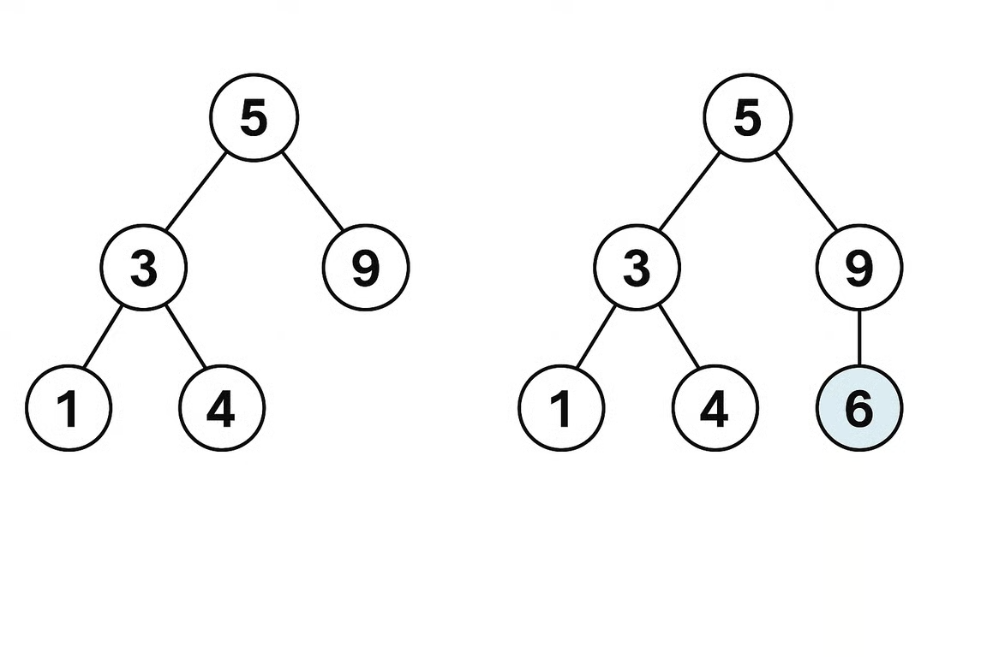
Insert example
- Input: root = [5,3,9,1,4], val = 6
- Output: [5,3,9,1,4,6]

Approach 1: Recursion
Intuition: Use BST comparisons to recurse left or right. Null means insertion point.
Algorithm:
- If root is null, return new node.
- If val > root.val, recurse right.
- Else recurse left.
- Return root.
/**
* Definition for a binary tree node.
* class TreeNode {
* constructor(val = 0, left = null, right = null) {
* this.val = val;
* this.left = left;
* this.right = right;
* }
* }
*/
class Solution {
insertIntoBST(root: TreeNode | null, val: number): TreeNode {
if (!root) {
return new TreeNode(val);
}
if (val > root.val) {
root.right = this.insertIntoBST(root.right, val);
} else {
root.left = this.insertIntoBST(root.left, val);
}
return root;
}
}
Complexity:
- Time: $O(h)$
- Space: $O(h)$ recursion stack

Approach 2: Iteration
Intuition: Same decision process as recursion, but with a loop.
Algorithm:
- If root is null, return new node.
- Traverse with curr.
- Move left/right by comparison.
- Insert once the desired child pointer is null.
/**
* Definition for a binary tree node.
* class TreeNode {
* constructor(val = 0, left = null, right = null) {
* this.val = val;
* this.left = left;
* this.right = right;
* }
* }
*/
class Solution {
insertIntoBST(root: TreeNode | null, val: number): TreeNode {
if (!root) {
return new TreeNode(val);
}
let curr: TreeNode = root;
while (true) {
if (curr.val < val) {
if (!curr.right) {
curr.right = new TreeNode(val);
return root;
}
curr = curr.right;
} else {
if (!curr.left) {
curr.left = new TreeNode(val);
return root;
}
curr = curr.left;
}
}
}
}
Complexity:
- Time: $O(h)$
- Space: $O(1)$ extra space

2) Delete Node in a BST
- Difficulty: Medium
- Pattern: BST deletion with structural cases
- Core idea: Find node, then handle 0-child, 1-child, or 2-child cases.
Problem statement (summary): Given BST root and key, delete node with key if present and return updated root.
Example:
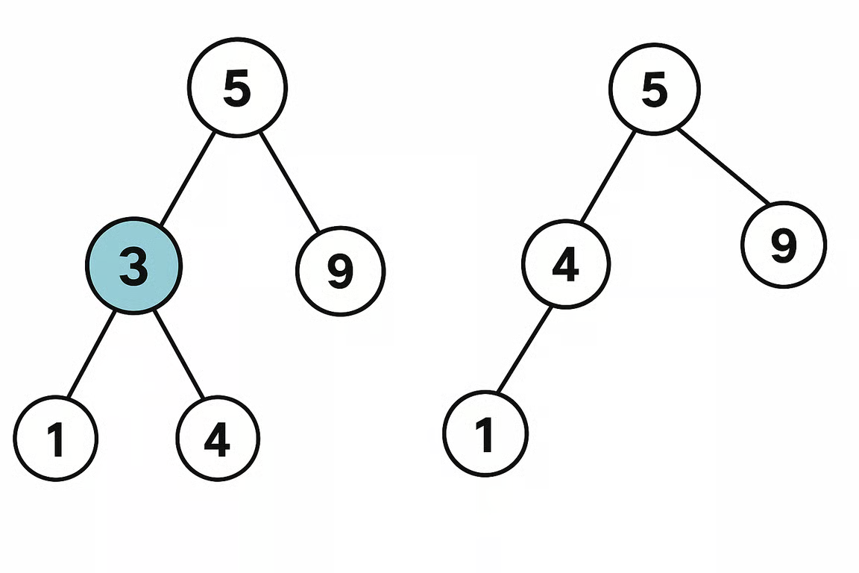
Delete example
- Input: root = [5,3,9,1,4], key = 3
- Output: [5,4,9,1]

Approach 1: Recursion
Intuition: Recursively search for target. For two-child case, use left-most node of right subtree as replacement anchor.
Algorithm:
- Recurse to find key.
- If found and one side is null, return the other side.
- If both sides exist, find successor in right subtree.
- Attach deleted node’s left subtree to successor’s left.
- Return right subtree as replacement root.
class Solution {
deleteNode(root: TreeNode | null, key: number): TreeNode | null {
if (!root) return root;
if (root.val > key) {
root.left = this.deleteNode(root.left, key);
} else if (root.val < key) {
root.right = this.deleteNode(root.right, key);
} else {
if (!root.right) {
return root.left;
}
if (!root.left) {
return root.right;
}
let curr = root.right;
while (curr.left) {
curr = curr.left;
}
curr.left = root.left;
return root.right;
}
return root;
}
}
Complexity:
- Time: $O(h)$
- Space: $O(h)$ recursion stack

Approach 2: Iteration
Intuition: Find node and parent with a loop, then update pointers directly.
Algorithm:
- Locate node and parent.
- If 0 or 1 child, replace node with child.
- If 2 children, locate inorder successor and its parent.
- Rewire successor and attach to deleted node position.
/**
* Definition for a binary tree node.
* class TreeNode {
* constructor(val = 0, left = null, right = null) {
* this.val = val;
* this.left = left;
* this.right = right;
* }
* }
*/
class Solution {
deleteNode(root: TreeNode | null, key: number): TreeNode | null {
if (!root) return root;
let parent: TreeNode | null = null;
let cur: TreeNode | null = root;
while (cur && cur.val !== key) {
parent = cur;
if (key > cur.val) {
cur = cur.right;
} else {
cur = cur.left;
}
}
if (!cur) return root;
if (!cur.left || !cur.right) {
const child = cur.left || cur.right;
if (!parent) return child;
if (parent.left === cur) {
parent.left = child;
} else {
parent.right = child;
}
} else {
let par: TreeNode | null = null;
const delNode = cur;
cur = cur.right;
while (cur.left) {
par = cur;
cur = cur.left;
}
if (par) {
par.left = cur.right;
cur.right = delNode.right;
}
cur.left = delNode.left;
if (!parent) return cur;
if (parent.left === delNode) {
parent.left = cur;
} else {
parent.right = cur;
}
}
return root;
}
}
Complexity:
- Time: $O(h)$
- Space: $O(1)$ extra space
Where h is the tree height for both approaches.

Depth-First Search
Depth-First Search (DFS) is one of the most common interview algorithms.
It is used for both trees and graphs. This lesson focuses on trees.

Concept
To traverse an entire tree, we must visit every node.
DFS goes as deep as possible along one path before backtracking.
For example:
- Keep moving left until null.
- Backtrack to parent.
- Explore right subtree.
DFS is naturally implemented with recursion, but can also be implemented iteratively with a stack.

DFS Traversal Orders
There are three standard traversal orders:
- Inorder
- Preorder
- Postorder

Inorder Traversal
Order: left -> node -> right
function inorder(root) {
if (root == null) {
return;
}
inorder(root.left);
console.log(root.val);
inorder(root.right);
}
Example order in diagram: [2,3,4,5,6,7]
Important:
- Inorder is sorted only if the tree is a BST.
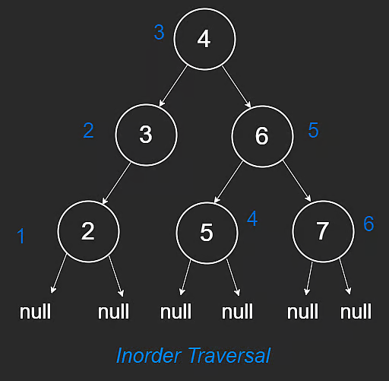
DFS inorder traversal

Preorder Traversal
Order: node -> left -> right
function preorder(root) {
if (root == null) {
return;
}
console.log(root.val);
preorder(root.left);
preorder(root.right);
}
Example order in diagram: [4,3,2,6,5,7]
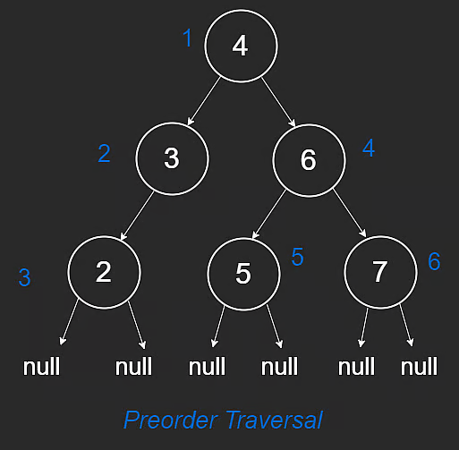
DFS preorder traversal

Postorder Traversal
Order: left -> right -> node
function postorder(root) {
if (root == null) {
return;
}
postorder(root.left);
postorder(root.right);
console.log(root.val);
}
Example order in diagram: [2,3,5,7,6,4]
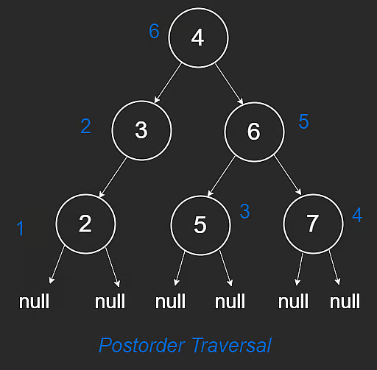
DFS postorder traversal

Time and Space Complexity
The following applies to all three traversals.

Time
Every node is visited once.
- Time: $O(n)$
where n is number of nodes.

Space
Recursive DFS uses call stack proportional to tree height h.
- Space: $O(h)$
So:
- balanced tree: $O(logn)$
- skewed tree: $O(n)$

NeetCode Practice (Trees)

1) Kth Smallest Integer in BST
- Difficulty: Medium
- Pattern: Inorder DFS with stack (iterative)
- Core idea: Inorder traversal of a BST visits nodes in sorted order, so the k-th visited node is the answer.
Problem statement (summary): Given the root of a BST and integer k (1-indexed), return the k-th smallest value.
BST constraints:
- left subtree values are smaller than node value
- right subtree values are greater than node value
- both subtrees are BSTs
Examples:
- Input: root = [2,1,3], k = 1
- Output: 1
- Input: root = [4,3,5,2,null], k = 4
- Output: 5

Approach 1: Iterative DFS (Optimal)
Intuition: Use a stack to simulate recursive inorder traversal:
- Push all left nodes.
- Pop one node (next smallest).
- Decrement k.
- If k == 0, this node is the answer.
- Move to right subtree and repeat.
This stops early at the k-th element instead of traversing all nodes.
Algorithm:
- Initialize empty stack and curr = root.
- While stack not empty or curr not null:
- Push left chain.
- Pop top node.
- Decrement k; if zero, return node value.
- Move curr to popped node’s right child.
/**
* Definition for a binary tree node.
* class TreeNode {
* constructor(val = 0, left = null, right = null) {
* this.val = val;
* this.left = left;
* this.right = right;
* }
* }
*/
class Solution {
/**
* @param {TreeNode} root
* @param {number} k
* @return {number}
*/
kthSmallest(root, k) {
const stack = [];
let curr = root;
while (stack.length > 0 || curr !== null) {
while (curr !== null) {
stack.push(curr);
curr = curr.left;
}
curr = stack.pop();
k--;
if (k === 0) {
return curr.val;
}
curr = curr.right;
}
}
}
Complexity:
- Time: $O(h+k)$ in the best stopping sense, up to $O(n)$ worst case
- Space: $O(h)$
Where:
- n is number of nodes
- h is tree height

