System : Supreme Student Government Election System

Company/Office : Holy Cross of Davao College.

Sta.Ana Avenue, Davao City

Project Stage : Requirements Specifications and Conceptual Data Model

Date : December 17, 2015

Class & Section : IT7/MWF 10:00-12:00nn

Group Name : Team Mangmang-Luceño

Group Members : John JeffritzMangmang/ 48474713

JhonLieveLuceño/ 48495592

Project Stage : Analysis

Project Title : Requirements Specifications and Conceptual Data Model

Deadline : 17 December 2015

1. **REQUIREMENTS SPECIFICATION**
2. Requirements Phase
3. Introduction

The Supreme Student Government (SSG) is an organization in school that plays

a major role towards the students. It is divided into 5 sections with corresponding responsibility and function. These sections are the Executive Department, House of Representative, Junior Auditing Team (JAT), COMELEC and CROSSROADS.

Executive department exercises the “executive power” of the government. House of Representative has the power to “PASS or DENY” any budget proposal of an event that must be made. Junior Auditing Team conducts the study of the clash flow in every department whether the money is use wisely or not. The COMELEC is responsible for the coming election and they are also responsible whether the candidate is suitable in handling candidacy. The CROSSROADS functions as the journalist and media in school, they also write school newspapers.

1. System Overview

Supreme Student Government uses only pens and papers just to choose and to count the number of votes for every candidate. The team decided to make a system just to make their work fast, easy and less hassle.

1. Identified Risk

* Manual computation is prone to errors.
* Counting of votes can be manipulated.

1. User Requirements

Functional Requirements:

* System should count the votes for every candidate
* System can view the list of the candidates

Non-functional Requirements:

* Easy to use
* Fast
* Reliable
* Easy to understand

1. Specifications Phase
2. System Overview of the Proposed System

Supreme Student Government Election System based on the user requirements is a system that has the capability of registration of voters and candidates, an honest counting of votes and reliable to the voters. The system should have the ability to update and maintain the voters and candidates’ information; it must be user friendly.

1. Capabilities and Limitations of the Proposed System

The proposed system can add new voters and candidates. It can accurately count the votes of the voters. It can prevent “flying voters” and any anomaly that may occur. The admin have the power to delete any candidates that is not suitable for the said position. The system can manage and view the status of the ongoing election. The proposed system is limited only in counting of votes and updating the voters and candidates information.

1. Hardware and Software Specification

Hardware

* + Computer Set

Software

* + Microsoft Office 2007
  + Microsoft Visual Studio 2008
  + Microsoft SQL Server 2005/2008

1. User Specification

* The User should know how to use a computer.
* The User should know how to fill out the registration form.

1. **CONCEPTUAL DATA MODEL**
2. **Identified User Views**

Login View:

­­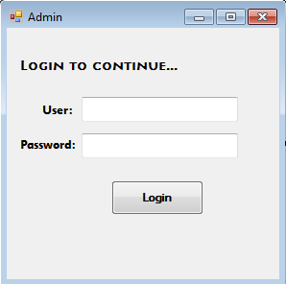

Registration View

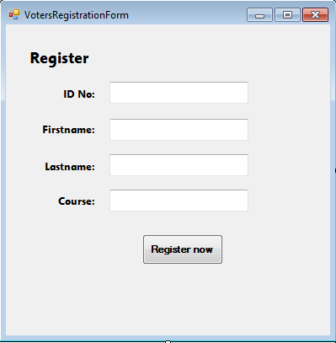

Voters View

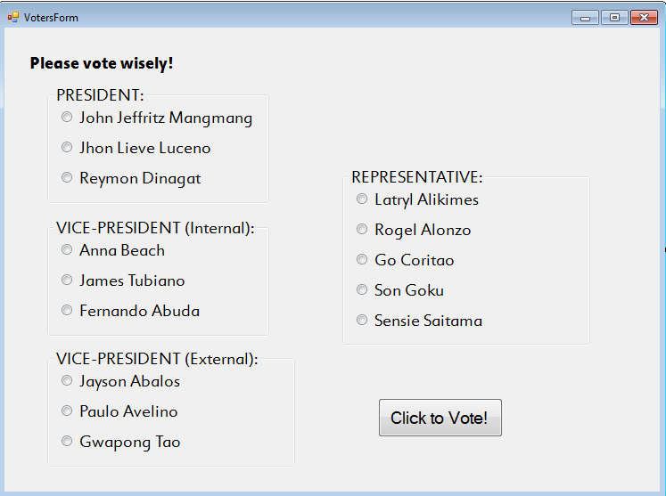

1. **Conceptual Data Model**
2. Students votes Candidates and Candidates is a Student.

Candidates

CandidatesID{Pk}

Students

VotersID{Pk}

Votes

1..* 1..*

Is a

1..* 1..1

1. Candidates belongs to Party.

Party

PartyID{Pk}

Candidates

CandidatesID{Pk}

Belongs to

1..* 0..1

1. Students has Course.

Students

StudentsID{Pk}

Course

CourseID{Pk}

Has

1..* 1..1

Course

CourseID{Pk}

Has

1..1

1..*

Candidates

CandidatesIDno{Pk}

Students

VotersIDno{Pk}

Party

PartyIDno{Pk}

Votes Belongs to

1..* 1..* 1..* 0..1

1..* 1..1

VoteDate

Is a