Fernando E Hernandez

November 17th, 2019

Working Functions

Assingment05

Adding Process and Input Functions to simplify and organize code.

# preface

## The purpose writing this program code is to call a data file to manipulate data and later save final data to a file. In order to complete the assignment, we consulted other sources (*i.e. Internet, Books*) for the purpose of finding additional alternatives and ways to solve the problem. In the beginning of our task we realized that the best approach was to work the code by defining and calling functions in order to make the code simpler and organized.

# adding functions

## Input-Output Functions – We started by simply adding functions that would capture the input from users for the tasks and priorities. These functions were defined as “Input_Task” and “Input_Priority” with the purpose of returning a task and a priority.

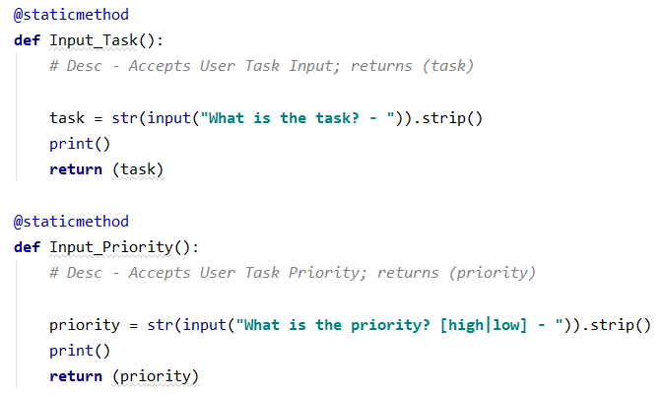

## During the initial test of the “Input_Task” function we noticed the following error:

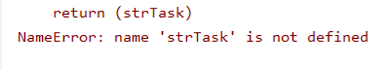

## By using the PyCharm Debugger we were able to find where the problem was and fixed it by changing the return value from a variable to a parameter:

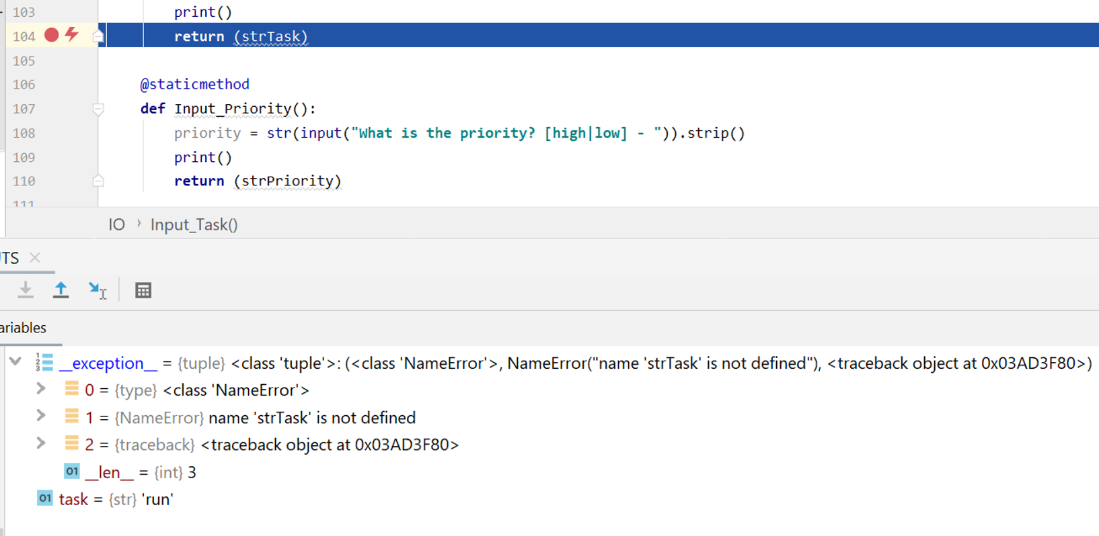

## Process Functions – After the IO functions we proceeded to add functions that would perform a process. These were defined as “WriteListDataToFile”, “AddRowToList”, and “SearchTable”.

### *WriteListDataToFile:* the job of this function is to save the list of tasks and priorities to an external file. Following is a snapshot of the definition as well as the calling of the function within the body of the code:

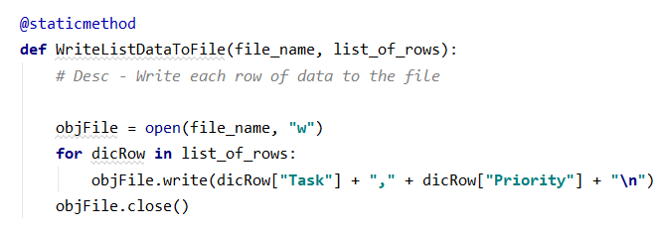

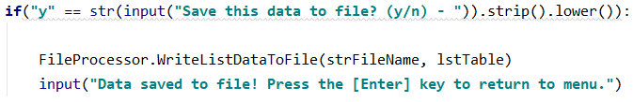

### Notice the change of text used when applying the parameters vs. the variables.

### *AddRowToList:* the job of this function is to create a new dictionary row and add it to the table. Following is a snapshot of the definition as well as the calling of the function within the body of the code:

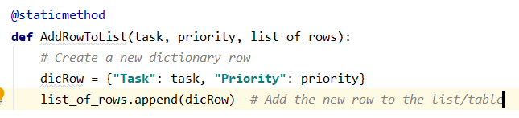

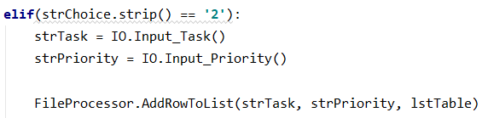

### *SearchTable:* the job of this function is to search though the table or rows for a match to the user's input in order to remove an item. Following is a snapshot of the definition as well as the calling of the function within the body of the code:

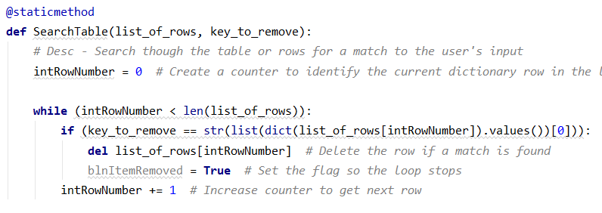

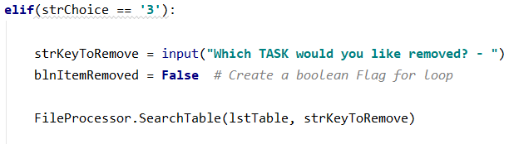

## Adding Data – No issues here however we were unsure if we needed to save *(“write”)* to file right after adding *(or modifying)* our lines of data. After testing the code through a few iterations we realized that this option would make the loop somewhat difficult to manage.

## Removing Data – Several possibilities were tried and tested but it seemed like nothing would work. We expect this to be a simple error to fix that is related to deleting a row from a list or dictionary; a string variable from input could not be found.

# Closeout

## We finalized our work by testing the program code with the added functions and another test was performed without the functions; they both executed flawlessly. This exercise taught us the importance of adding functions for the purpose of ordering and presenting a program code efficiently and easy to debug. Three important things we learned from this workshop:

• Functions can simplify code writing and make processes more understandable

• Bringing in code within “”” comments “”” helped tremendously easy on the eye

• Consult other sources has always been necessary