Fernando E Hernandez

November 23rd, 2019

Pickling and Exception Handling

Assingment07

# preface

## The purpose of this assignment is to understand how exception handling and Python’s pickle method works. We will start by giving a general explanation of “pickling” according to our research and then proceed to examine a programming code and how it applies the methods.

# Pickling

## This method refers to the basic principle of converting information from one state to another. According to <https://www.datacamp.com/community/tutorials/pickle-python-tutorial#what> picking is basically a way to convert an object into a byte stream for the purpose of saving the data and use it later. This action is also called serializing which means that information can be transferred to store objects (*or lists*) into a memory; like a database of a file. For example, in case you want to store some type of complex data (*not just text*) like maybe a database of values or a dictionary, you can convert this type of data into a single file by simply importing a module.

# Program code and executable

## Importing Pickle Module: The very first thing we do is pickling which allows us to store complex data into a file.

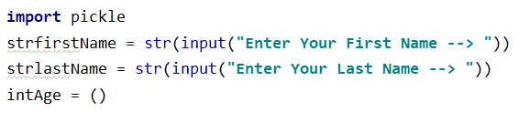

Program Code

## Exception Handling: Out next step here is to basically check for input errors in case the user types any erroneous or invalid information. Notice how we are being explicit about asking for the age in a numeric format. We are “trying” by asking the user for his/her age and evaluate the input as an Integer. We are using “except” command to treat anything different and handle it as invalid.

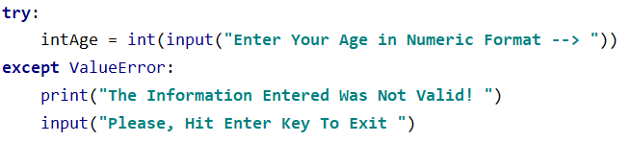

Program Code

## Here’s is an example of what would happen when the user enters the “age” as strings:

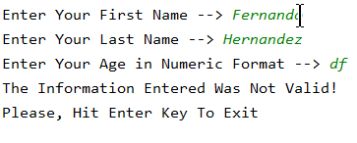

Program Being Executed

## Evaluating correct inputs: If the users enters the “age” as Integers then the program spits out the information entered as follows:

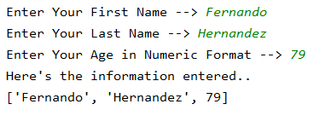

Program Being Executed

### *“Dumping”*:This saves pickled version of the data by storing it or “dumping” it to the named “AppData.dat” binary file. Notice how we employ the “wb” term for writing and replacing all contents; not to append.

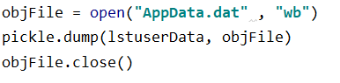

Program Code

### *“Loading”:* This extracts or “unpickles” the data by reading it or “loading” it from file named “AppData.dat”:

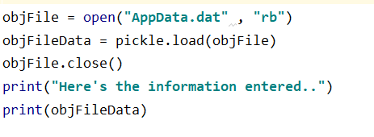

Program Code

# Closeout

## In this assignment we have learned about how to save a little more complex data as we utilize the pickling method. In general terms we may conclude that “pickling” is the process of transferring an object (*or other data structures)* into some type of format that can be saved into a file and later restructured. This explains why it is equally important to handle inputs by verifying correct format. As programs run into different scenarios and errors in data format it becomes important to verify data to avoid causing program sudden ending or running.