Fernando E Hernandez

November 9th, 2019

Working with Dictionaries and Files

Assingment05

Loading Data, Interacting with User’s Inputs, Displaying Results, and Saving to File by Providing a Menu

# preface

## The purpose writing this program code is to call a data file to manipulate data and later save final data to a file. In order to complete the assignment, we consulted other sources (*i.e. Internet, Books*) for the purpose of finding additional alternatives and ways to solve the problem. In the beginning of our task we realized that the best approach was to work the code by sections or “subroutines” separate from the main program.

# challenges

## Loading Initial Data – We contemplated the idea of using a “write” command from the program to save the data to the “ToDoList.txt” file. However, this was not implemented because we were unsure of the assignment requirements. In addition, creating a “write” command at the beginning go code could have made it difficult to read and understand. After reading the instructions several times and looking at the posted comments we decided that data was needed in a .txt file to pull information from it.

## Adding Data – No issues here however we were unsure if we needed to save *(“write”)* to file right after adding *(or modifying)* our lines of data. After testing the code through a few iterations we realized that this option would make the loop somewhat difficult to manage.

## Removing Data – Several possibilities were tried and tested but it seemed like nothing would work. We expect this to be a simple error to fix that is related to deleting a row from a list or dictionary; a string variable from input could not be found.

# Execution

## “Presenting the Menu”:

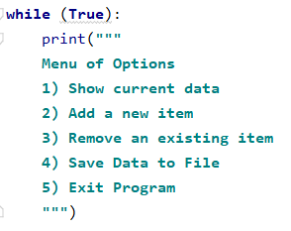

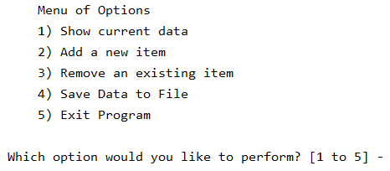

## “Displaying Current Data from ToDoList.txt” [1]:

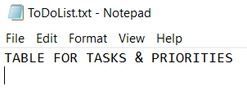

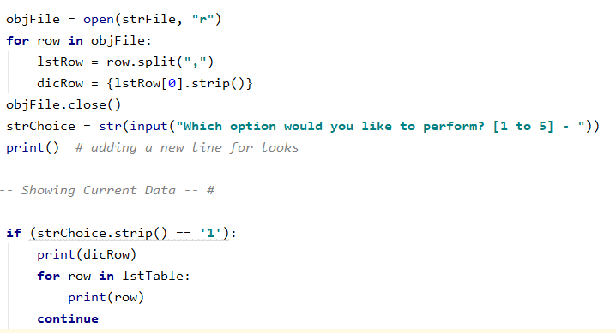 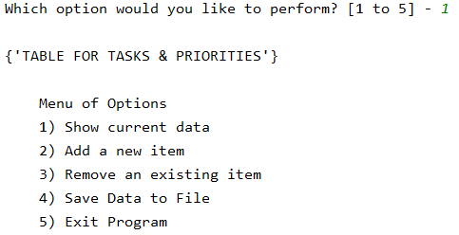

## “Adding new Tasks and Priorities” [2]:

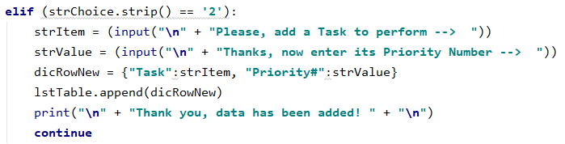

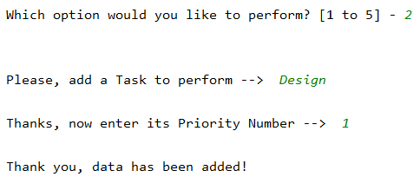

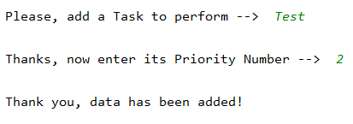

## “Deleting Tasks and Priorities” [3]: UNSUCCESSFUL

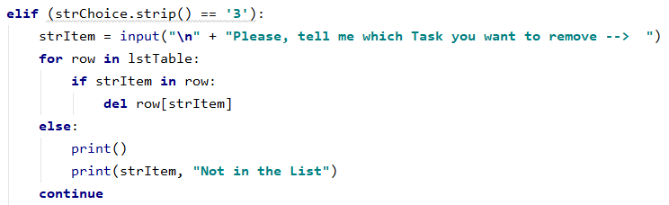

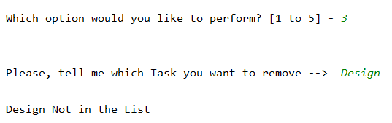

## “Saving to File” [4]:

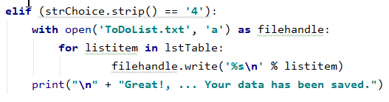

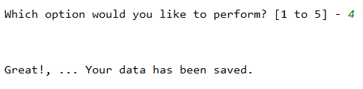

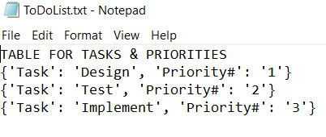

## “Exiting Program” [5]:

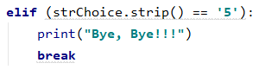

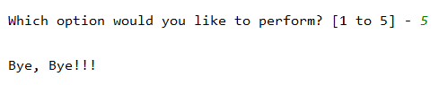

# Closeout

## Although deleting rows of data was not accomplished, this exercise was a great learning experience. We learned how to pull data of an external .txt file, modify the data, and save modifications to the same external .txt file. Three important things we learned from this workshop:

• Take 5 minute breaks

• Work aside with “subroutines”

• Consult other sources if necessary