Ejercicios del: 14/06/25

Nombre: Fernanda Lara Romero

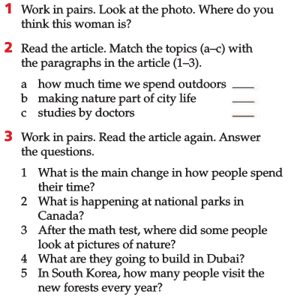

The woman is watching the nature in a museum. In front of her is found a big cube color black.



3

1

2