**Ejercicios de: 07/06/25**

**Nombre: Fernanda Lara Romero**

**Pag.159 ex. 1,2**

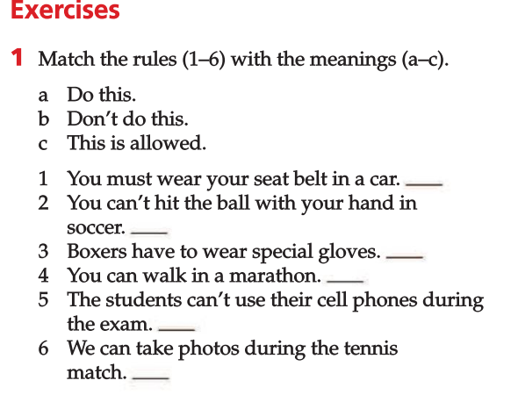

c

b

c

a

b

a

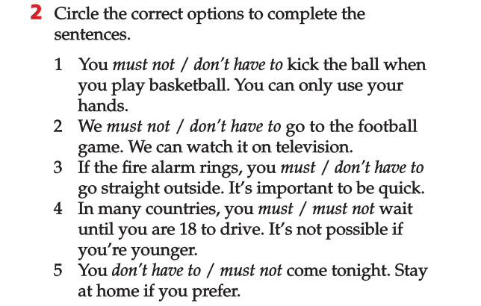

**Pag.23 ex. 7,8**

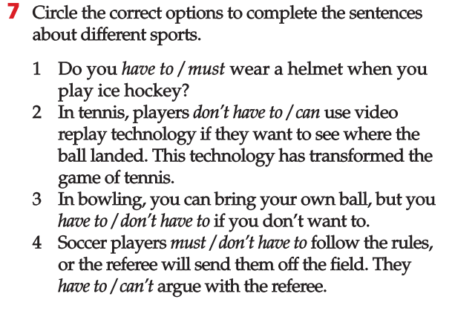

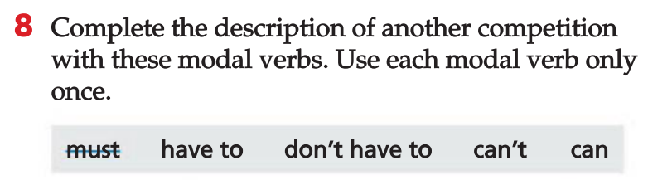

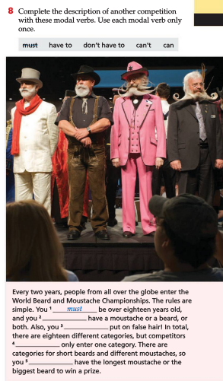

have to

Don´t have to

can

can´t