AI Student Assistant Chatbot

1. Problem Statement
Students often face difficulties in accessing academic information such as course details, library timings, examination schedules, study resources, and subject-related guidance. Information is usually scattered across different platforms, making it time-consuming for students to find what they need.

2. Project Objective
The objective of this project is to develop an AI-powered Student Assistant Chatbot that can provide instant responses to common student queries. The chatbot helps students quickly access academic information and educational resources through a simple conversational interface.

3. Solution Description
The AI Student Assistant is built using Botpress. It uses a knowledge base containing academic information and responds to user queries in natural language.
The chatbot can:
- Provide information about available courses.
- Inform students about library timings.
- Answer questions regarding examinations.
- Suggest study resources.
- Provide guidance for academic subjects such as DBMS.
The chatbot improves accessibility to information and reduces the time students spend searching for academic resources.

4. Project Features

Feature 1: Course Information
Provides details about courses available for students.

Feature 2: Library Information
Answers questions related to library working hours.

Feature 3: Examination Assistance
Provides information about examination schedules and related academic activities.

Feature 4: Study Resources
Recommends useful learning resources such as NPTEL, Coursera, GeeksforGeeks, and library materials.

Feature 5: Subject Guidance
Assists students with learning resources for subjects such as DBMS.

5. Technology Stack
- Chatbot Platform: Botpress Cloud
- Artificial Intelligence: Botpress AI Assistant
- Knowledge Base: Rich Text Knowledge Base
- Repository Hosting: GitHub
- Documentation: Microsoft Word / PDF

6. Project Screenshots

Screenshot 1: Botpress Chatbot Interface

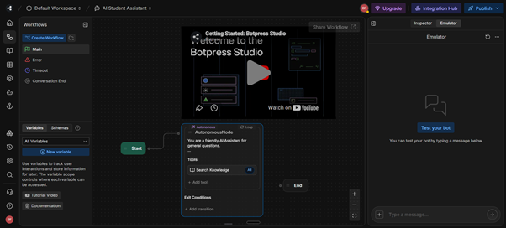

Screenshot 2: Available Courses Query

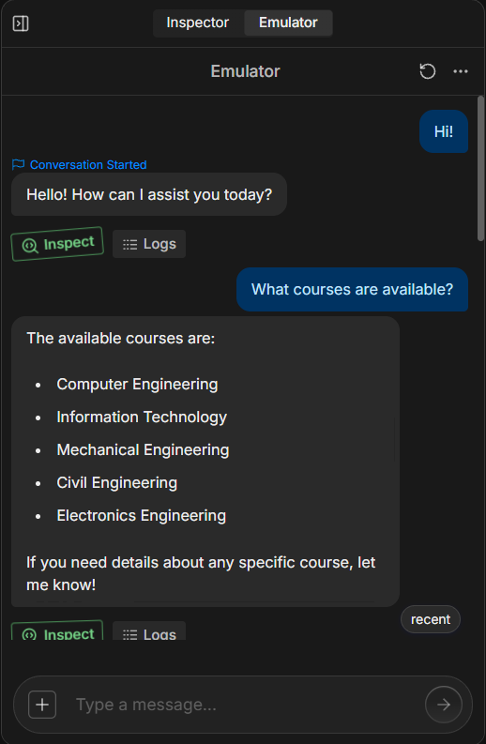

Screenshot 3: Library Timings Query

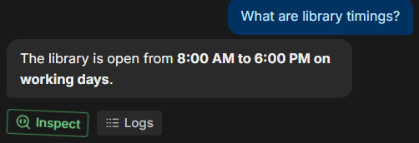

Screenshot 4: Examination Query

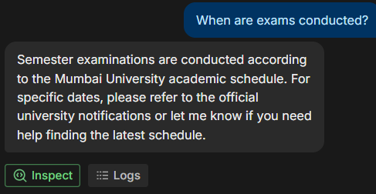

Screenshot 5: Study Resources Query

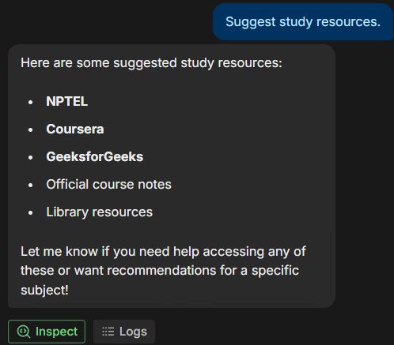

Screenshot 6: DBMS Assistance Query

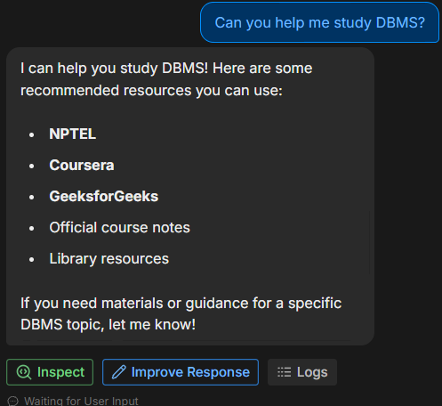

Screenshot 7: Chatbot Purpose Query

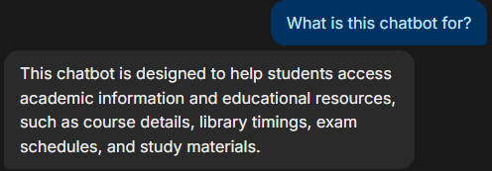

7. Open Source Repository
GitHub Repository Link:

https://github.com/fernandesbrian460/AI_Student_Assistant.git

8. Future Scope
The chatbot can be enhanced in the future by:
- Integrating real-time university databases.
- Providing personalized academic recommendations.
- Supporting multiple languages.
- Offering attendance and timetable tracking.
- Integrating with Learning Management Systems (LMS).
- Providing voice-based interaction.

Conclusion
The AI Student Assistant Chatbot successfully demonstrates the use of Artificial Intelligence in education. It provides students with quick access to academic information and learning resources, improving convenience and efficiency.

