ICE Assignment Part B

Alvin Fernandez – 19623175

Mohammad Omar Salauddin – 19244977

BitBucket is used for this project as repository:

<https://bitbucket.org/period1-2020-ICE/alvin_omar_project/>

Homepage

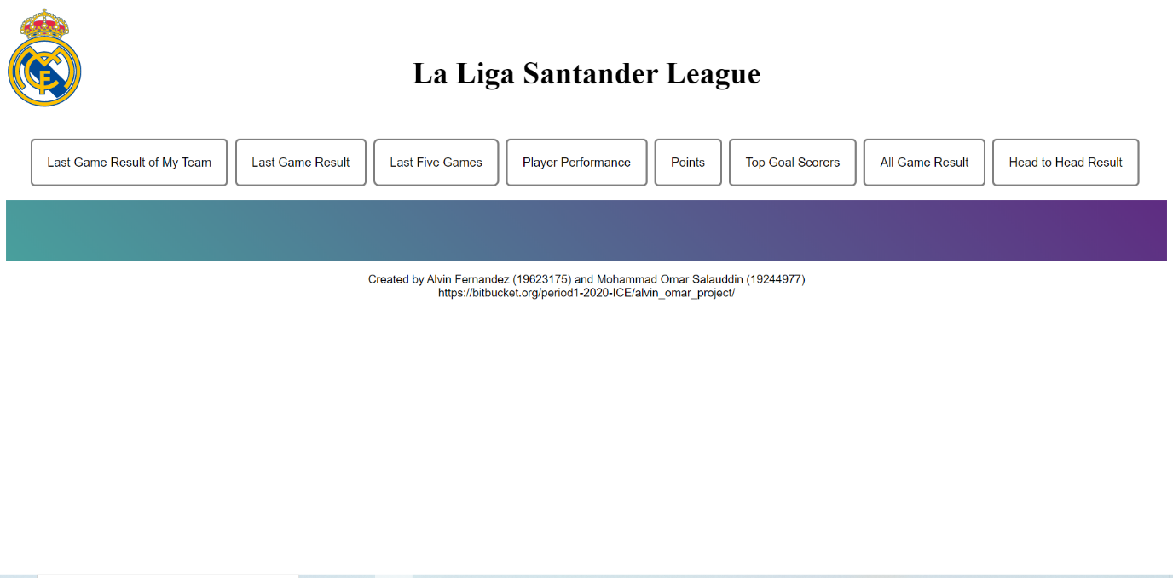

Snippet:

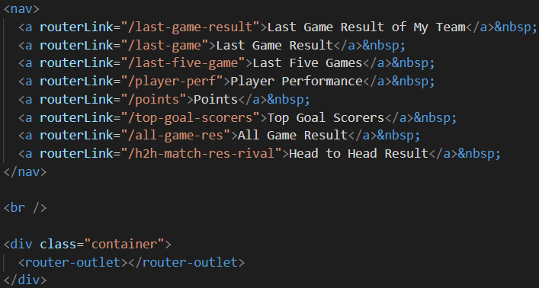

For the homepage, nav and div elements are used to divide the section in order to make the page more organized.

Last Game Result of My Team

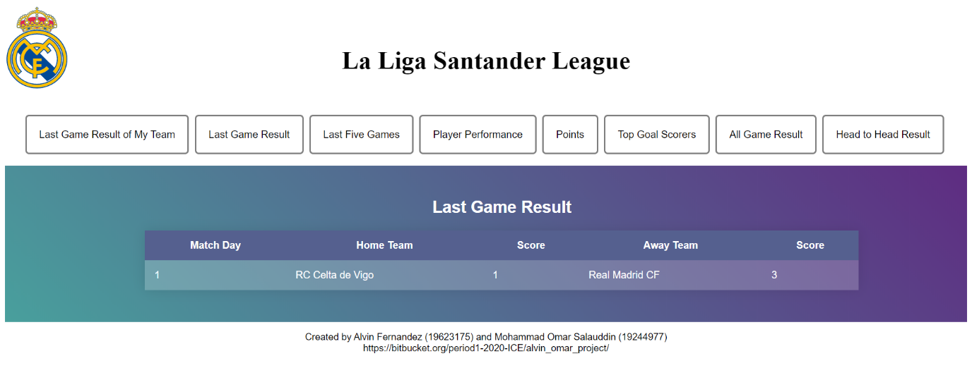

Snippet:

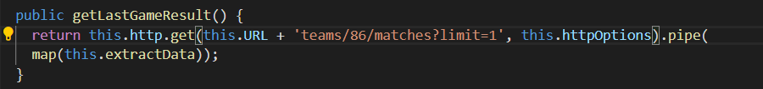

By using last-game-result.service, the webpage will display the result of the game that Real Madrid played.

Last Game Result

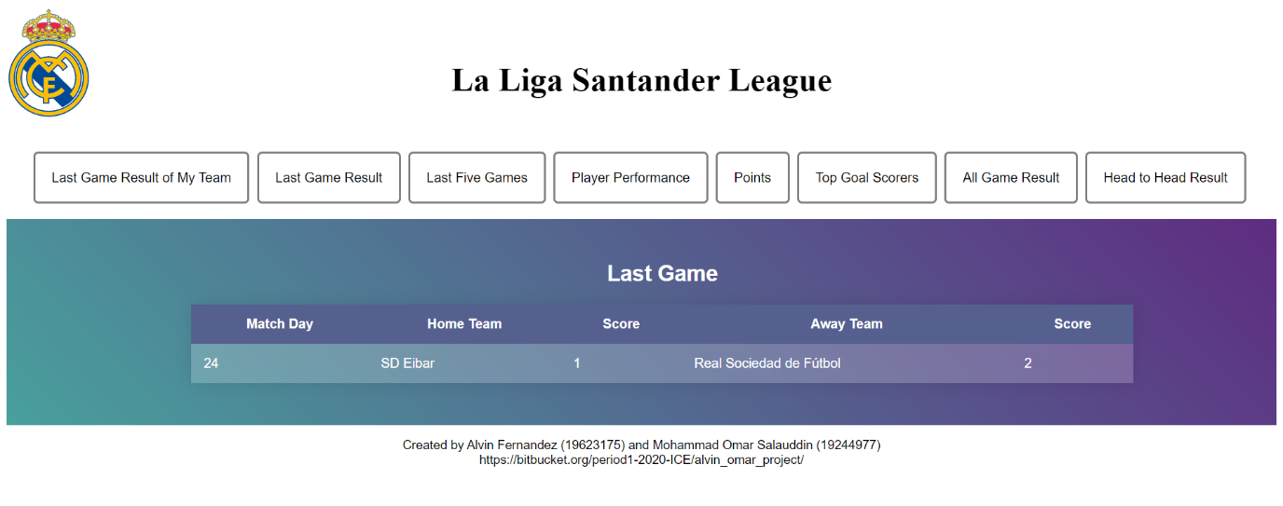

Snippet:

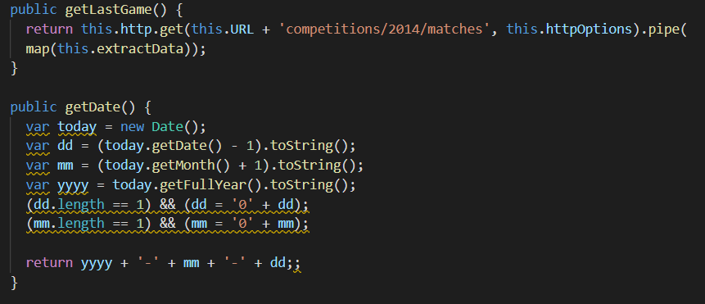

By using last-game-service.service, the webpage will display the last game result of the competition.

Last Five Games

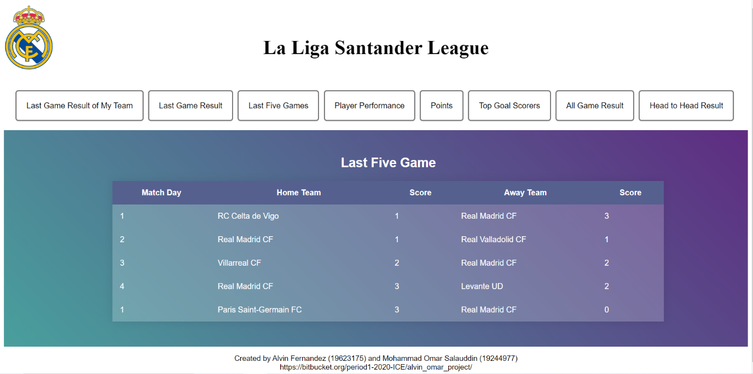

Snippet:

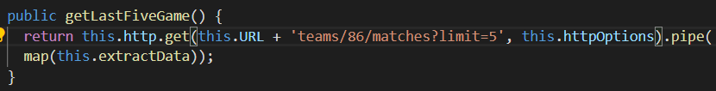

By using last-five-games.service, the webpage will be able to shopow the last match maximum 5 that the competition held.

Player Performance

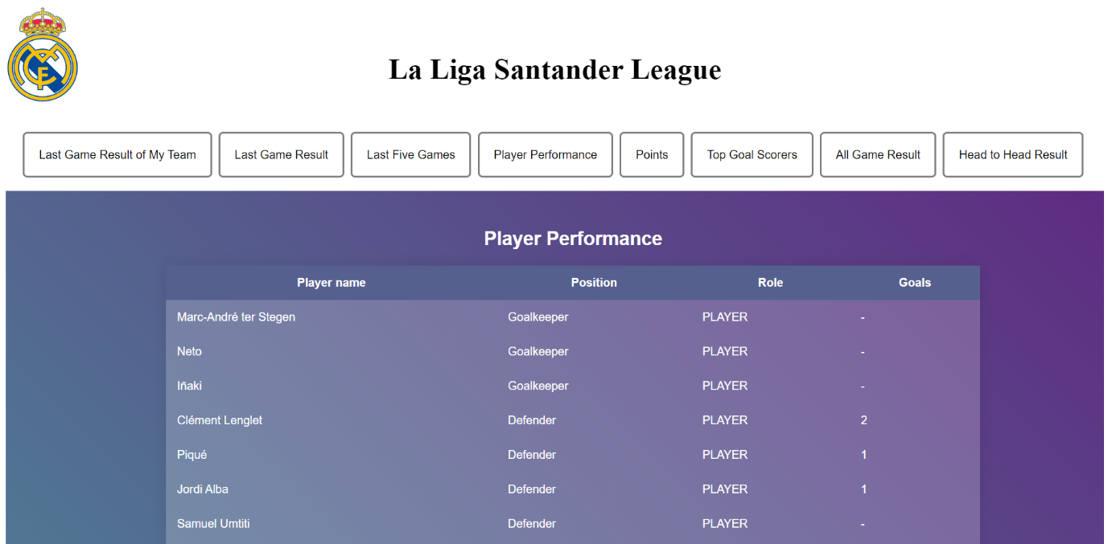

Snippet:

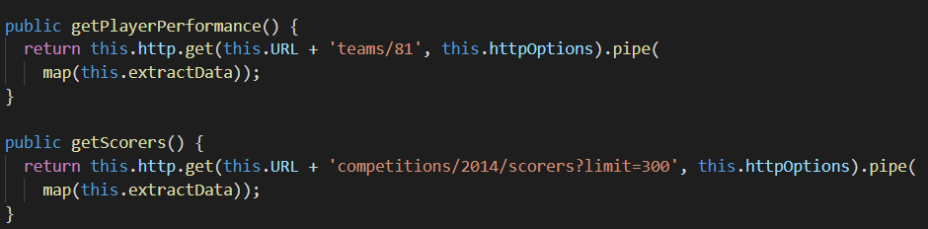

By using player-perf.service, the webpage will show the player performance on Real Madrid.

Points

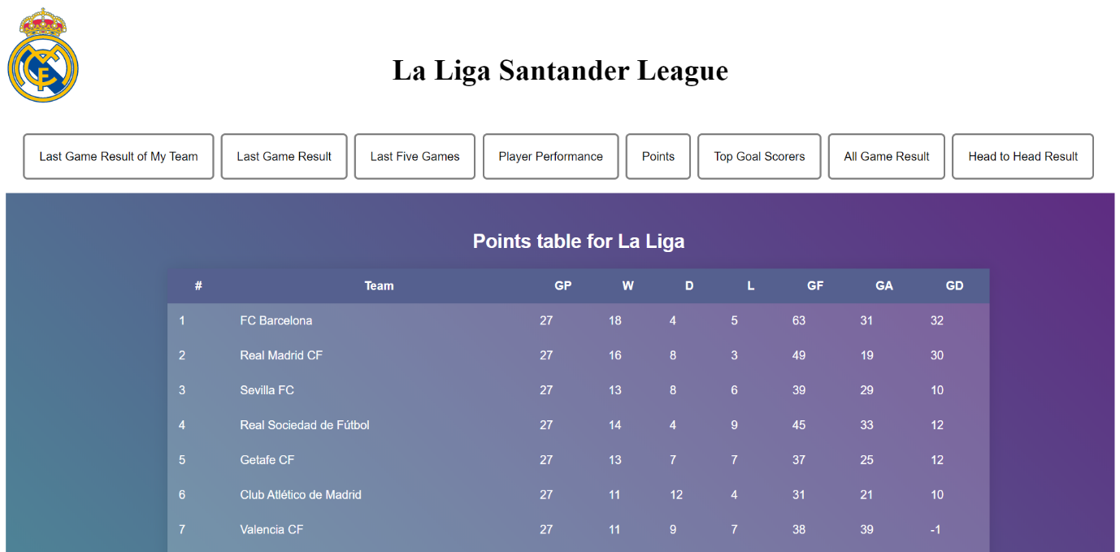

Snippet:

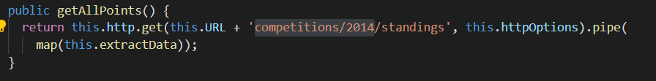

By using points.service, the webpage will display all of the points that every team have accumulated.

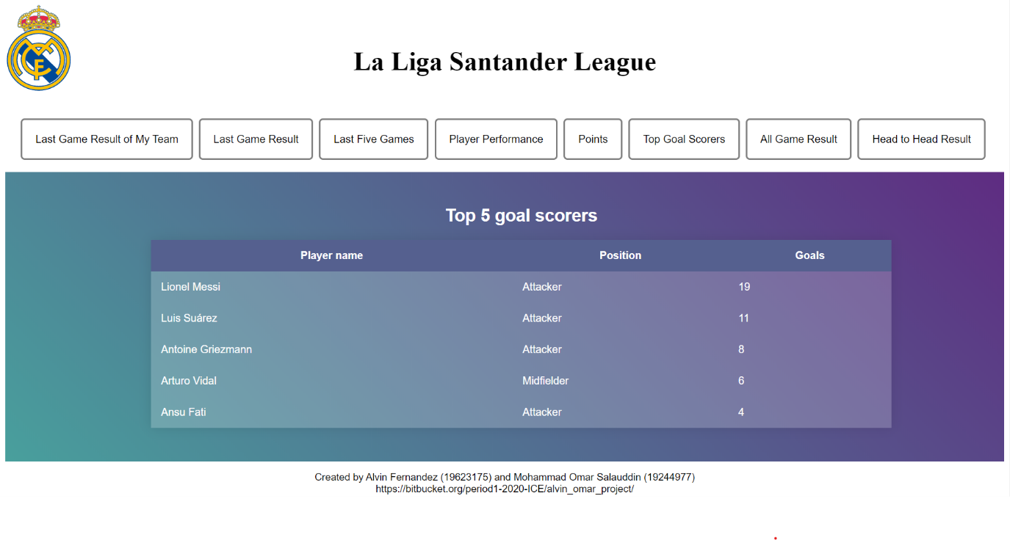Top Goal Scorer

Snippet:

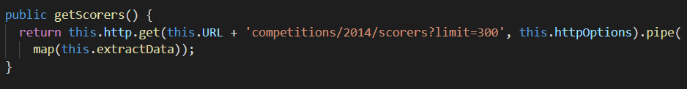

By using top-goal-scorers.service, the webpage will display the top 5 player that have the most goal during the competition.

All Game Result

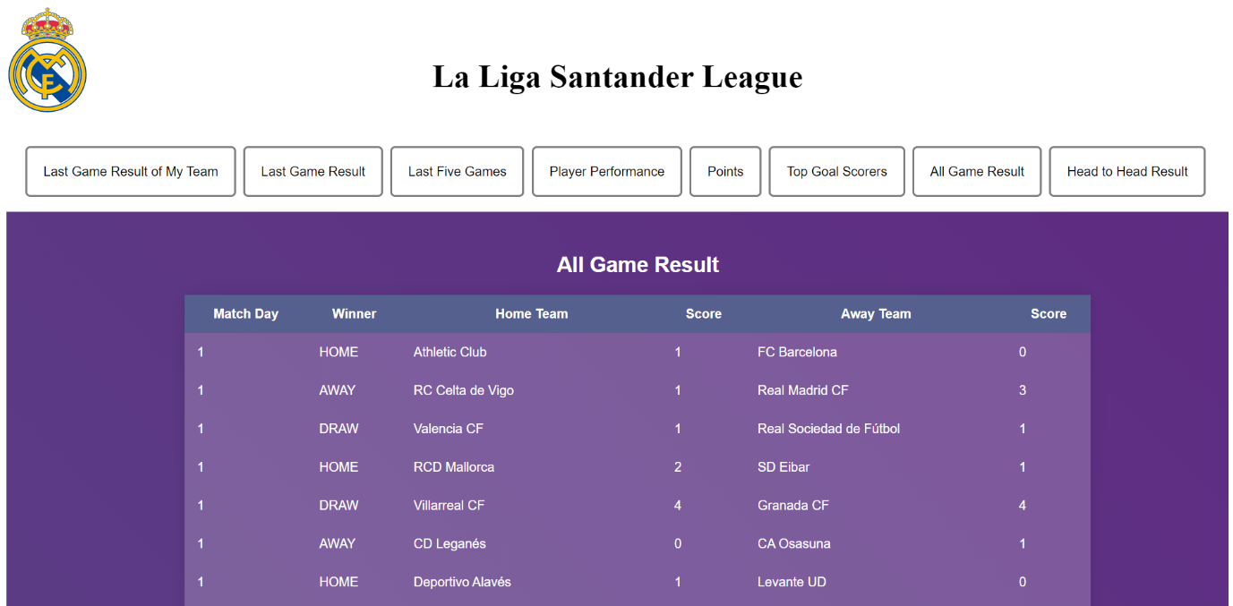

Snippet:

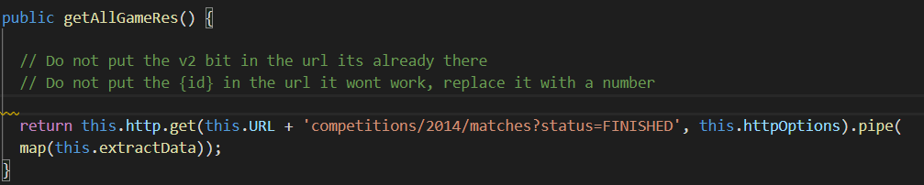

By using all-game-res.service, the ewebpage will display all of the result of the competition that season.

Head to Head Result

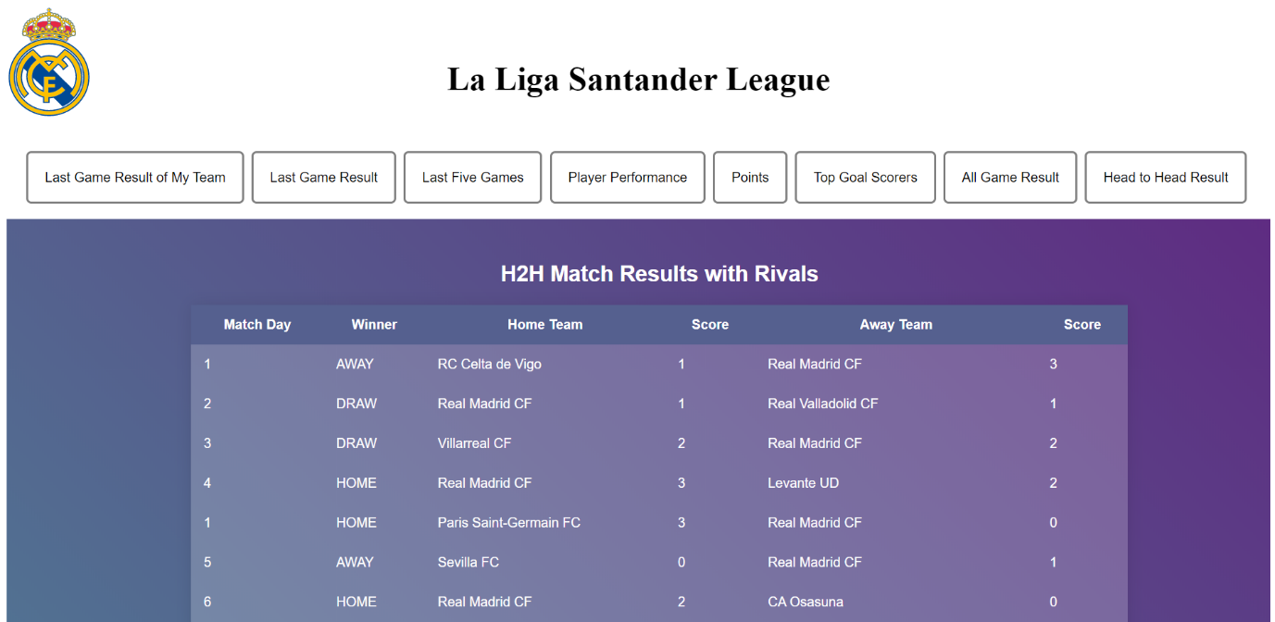

Snippet:

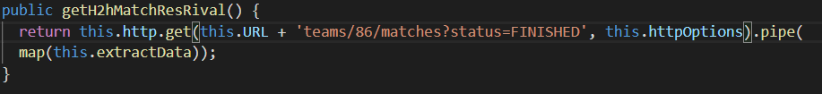

By using h2h-match-res-rival.service, the webpage will display the head to head game result.

API on the Service

Snippet:

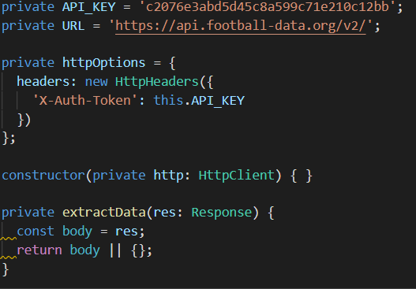

As we can see, the API require API_KEY in order to connect and get the JSON object.

And we are using the extractData() function to get all of the data asked for.

app.module.ts

Snippet:

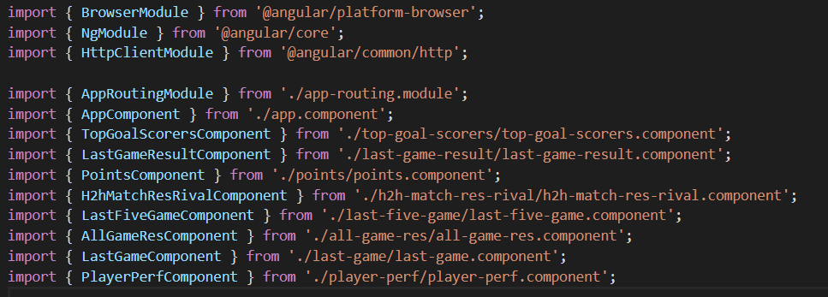

This is all of the services that we import in order to use them in this project.

Displaying the data

Snippet:

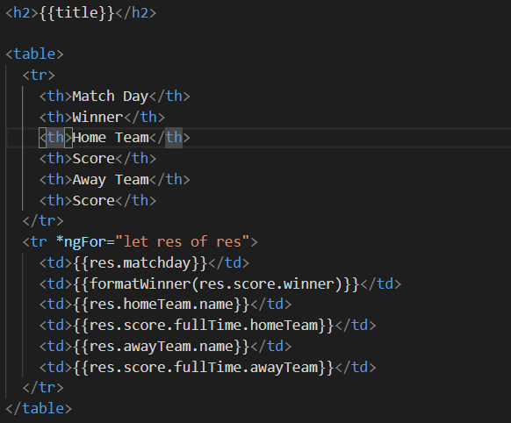

This is one of the example that we pick to demonstrate the way we display the data on the webpage. By using **interpolation**, we are able to display the data on thee page.

Responsive webpage

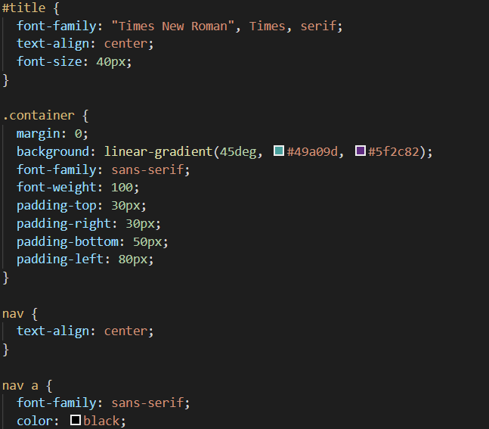Snippet:



To achieve this, we are using Bootstrap to have a responsive webpage, and CSS to support some of the design that we have on the page.

Services

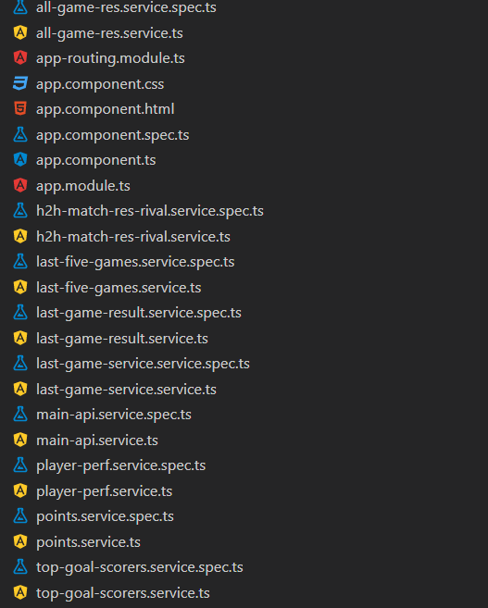Snippet:

This is all of the services that we use in order to achieve the requirement user story for this project.

Bitbucket Repository

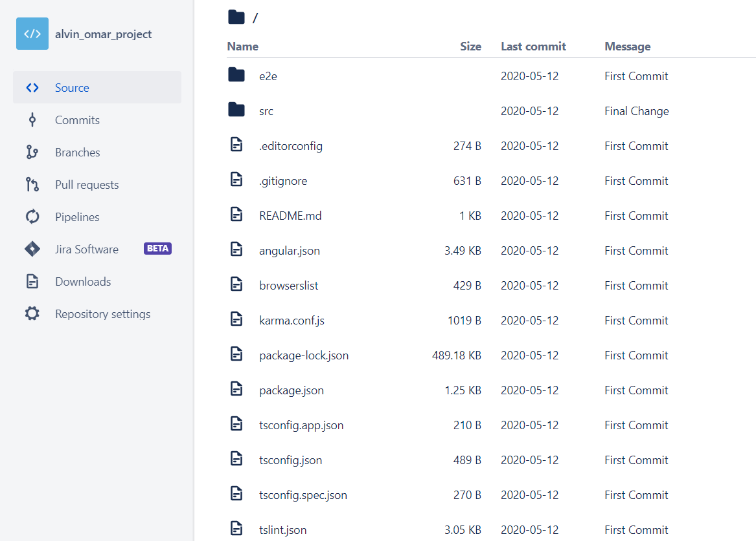

This is the snapshot of the repository that we use during the development of this project.