Grace Fernandez

GEOG 4084

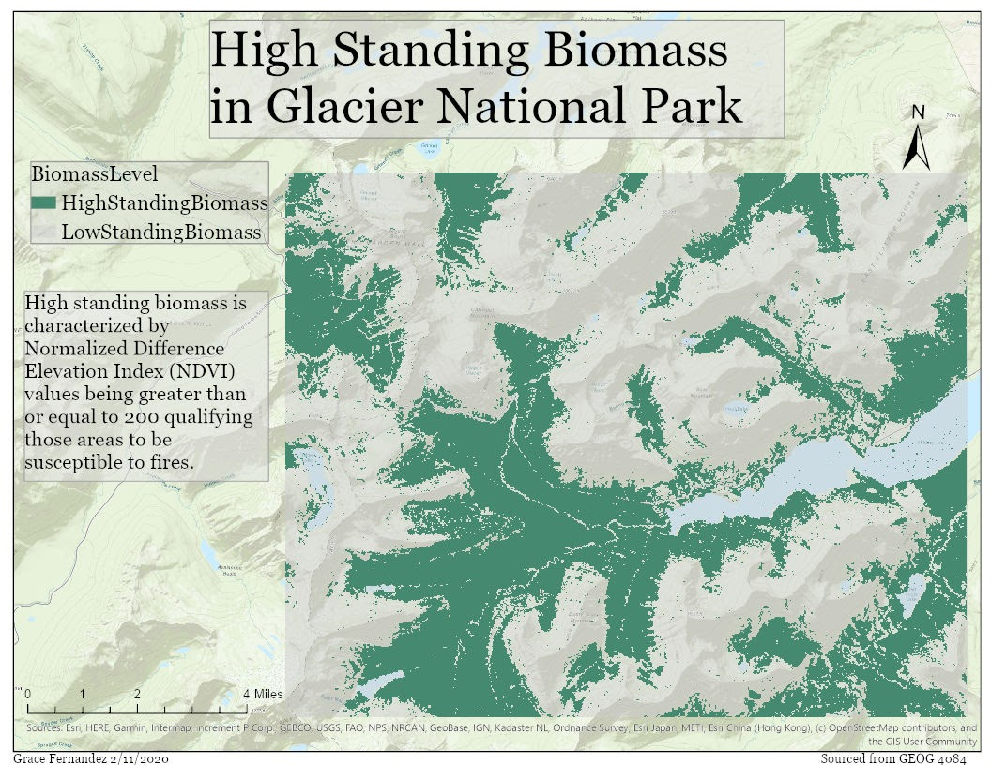Lab 3

A.

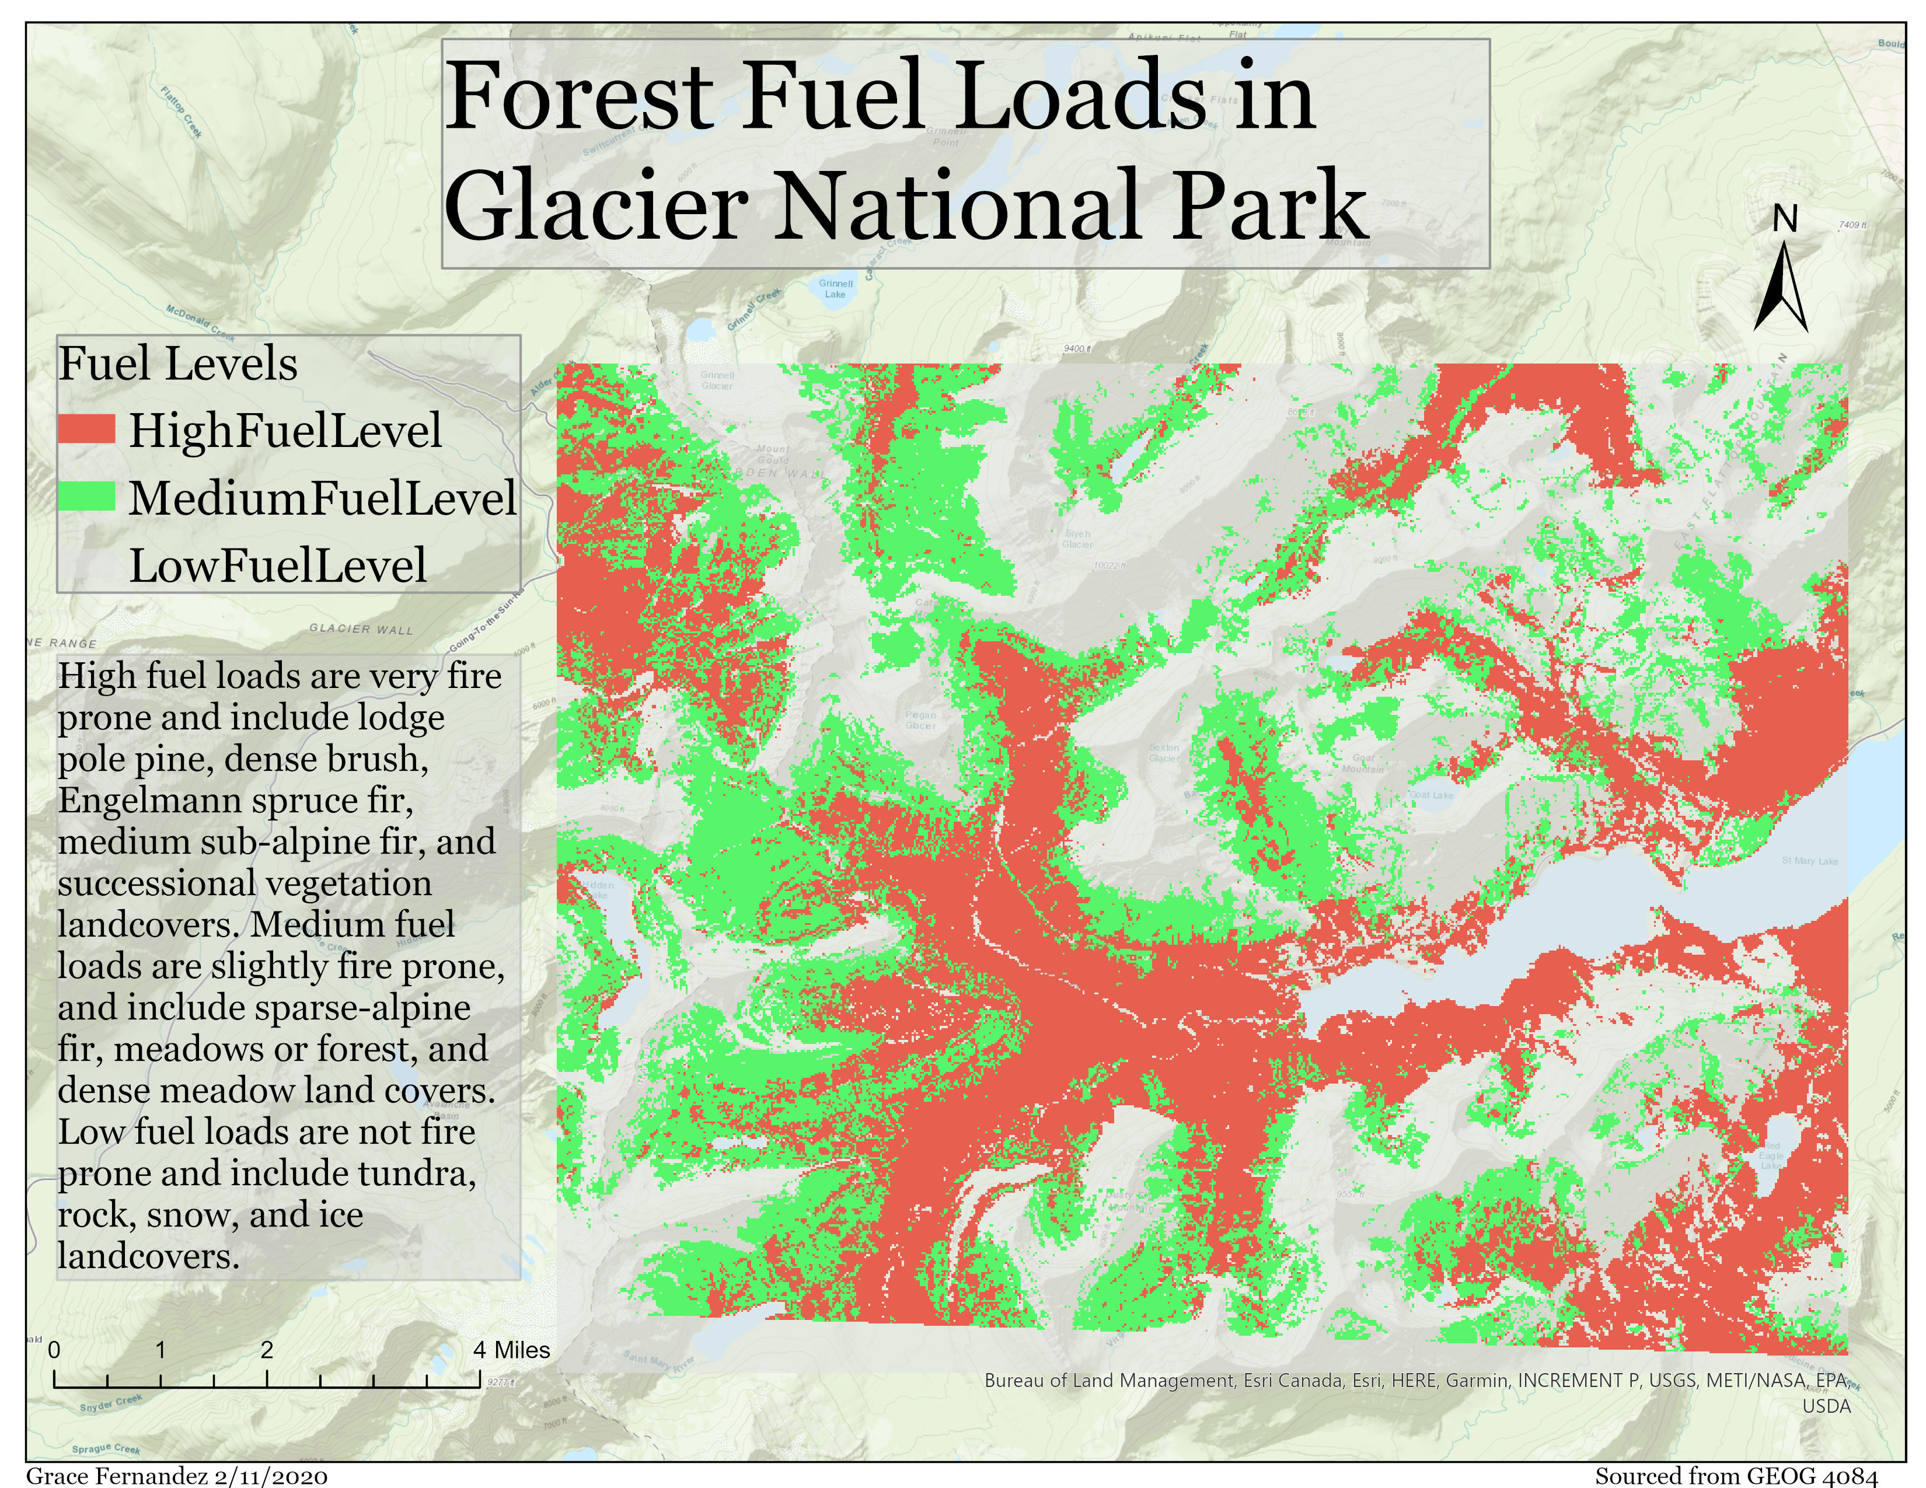B.

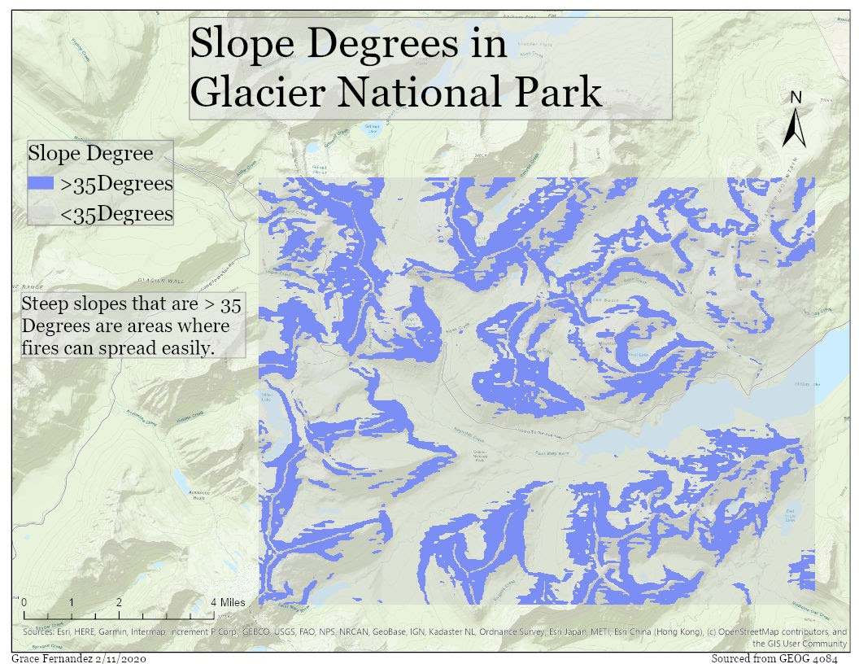C.

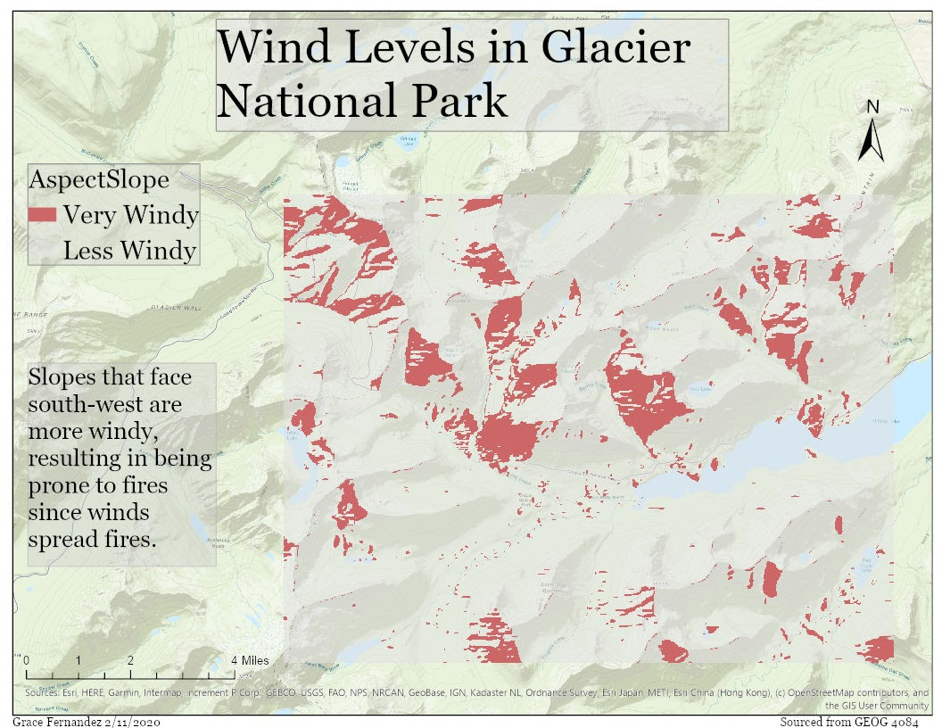

D.

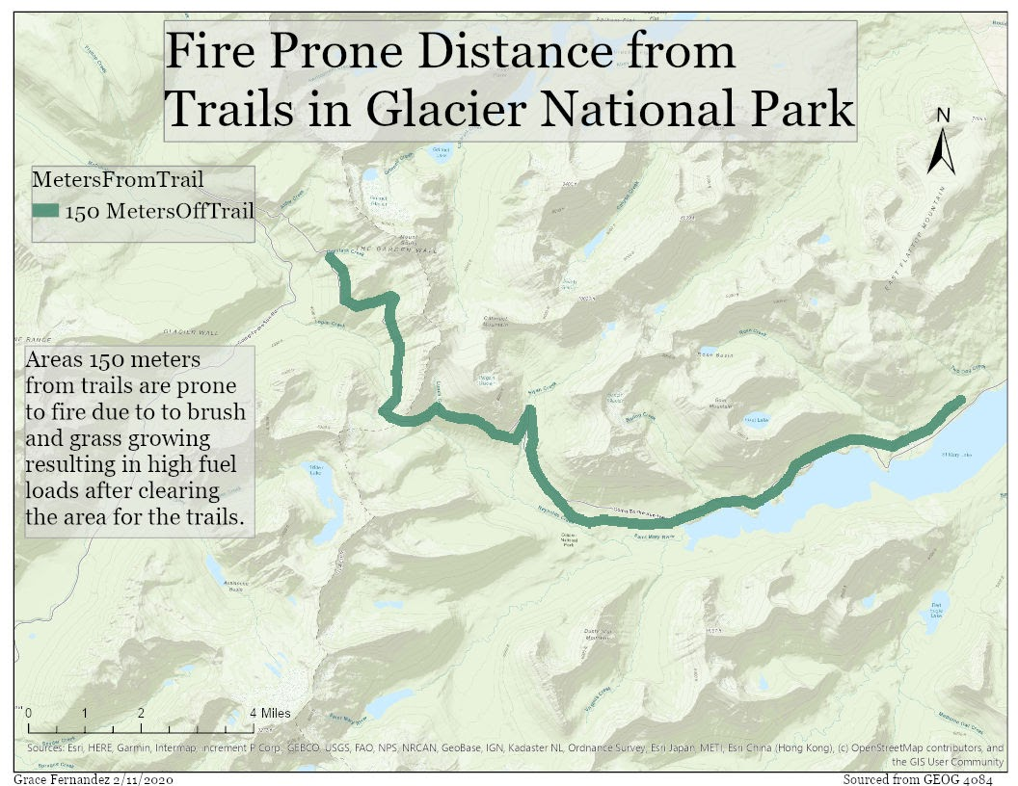E.

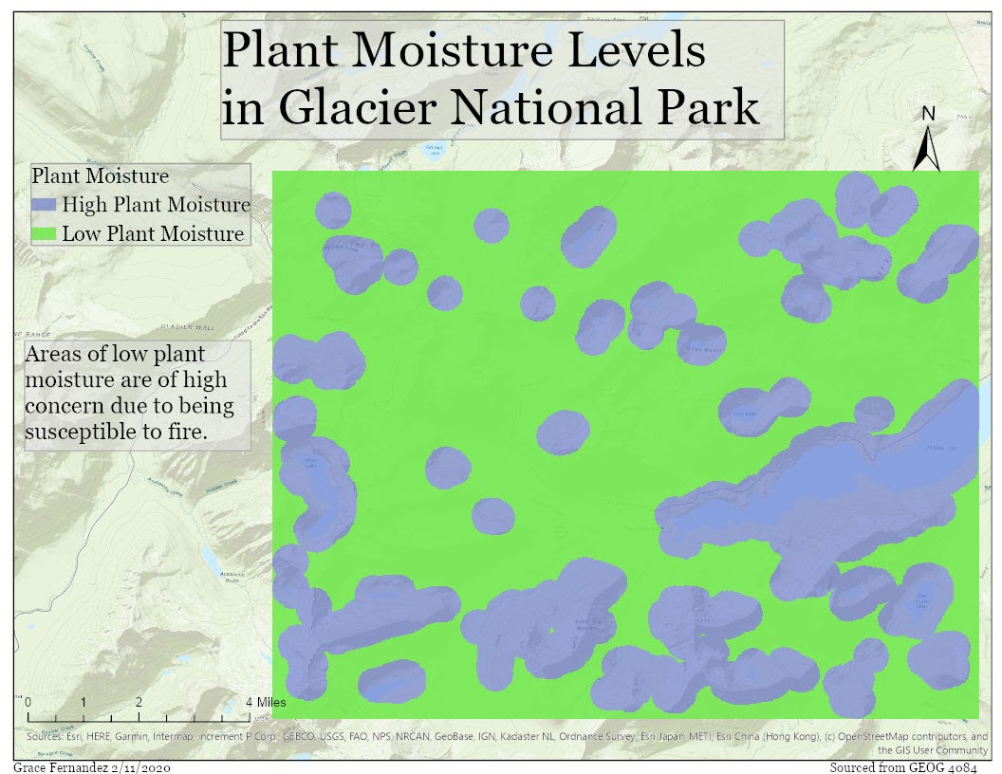

F.

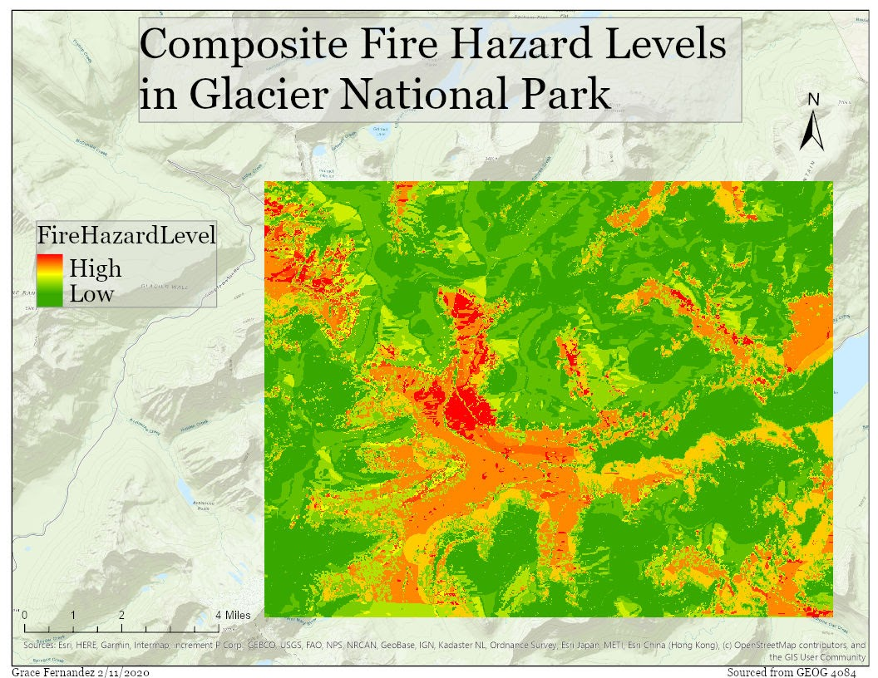G.

The six factors that went into creating Map G were Biomass Levels, Forest Fuel Loads, Steep Slopes, South-West Slopes, Areas that are 150 Meters from Trails, and Plant Moisture Levels. Each factor was weighted differently where the higher the weight the more important it was. The biomass level factor was weighted at 25% because the layer showed where the areas that were prone to fires are located. The forest fuel load layer was weighted at 30% because the layer shows the biomass areas broken into three levels of fuel: low, medium, and high. The fuel levels show the location of possible high-risk areas for fires. The steep slope factor was weighted at 10% because the layer shows the areas where the degree of the slope is greater than 35 degrees. The steep slopes allow fires to spread more easily, which is helpful but not incredibly important to know areas that are fire prone. The south west facing slope factor was weighted at 20% because the layer shows the slope areas that face towards south west. South western slopes tend to be windier, so they help fires spread easily; this factor I believe is more important since it shows exact slopes that are more fire prone. The areas 150 meters from trail factor was weighted at 5% because although they tend to have higher fuel levels due to the growth of brush and grass, it is not as important as other layers such as fuel level areas. The plant moisture level factor was weighted at 10% because the layer shows areas that tend to be fire prone. Compared to the fuel level layer, the plant moisture does not give as much vital details. Map G’s data is ranked from Low to High fire hazard levels. It is interesting that the area that appears to be the highest fire hazard is within the same areas of south west facing slopes, and the areas that have the highest level of fuel levels. It also is interesting that some medium hazard level areas are closer to the body of water. I believe that Glacier National Park will be able to support forest fire outbreaks since a good part of the area is not fire prone, however the diameter of the area that is medium to high hazard is quite large and very condensed.