Software Requirements Specification

for

Collaboration, Automation, Simplicity, Distributivity Tool Project

Prepared by

Team Name: HAPPY

Aline Busato <aline.busato@acad.pucrs.br>

Pedro Henrique <pedro.ecll@gmail.com>

Rodrigo Augusto <Rodrigo_augusto@outlook.com>

University: Pontifícia Universidade Católica do Rio Grande do Sul - PUCRS

Country: Brazil

10/08/2014

**Contents**

1 Introduction 4

1.1 Purpose 4

1.2 Scope 4

1.3 Definitions, Acronyms and Abbreviations 4

2 Overall Description 4

2.1 Constraints 5

2.2 Assumptions and dependencies 5

3 Specific Requirements 5

3.1 Functional Requirements 5

3.1.1 UC001 – Maintain Projects 5

3.1.2 UC002 – Maintain Users 9

3.1.3 UC003 – Maintain Sprints 12

3.3.4 UC004 – Create Tasks 15

3.3.5 UC005 – Maintain Tasks 17

3.1.6 UC006 – Generate Reports 20

3.1.7 UC007 – Login 21

3.1.8 UC008 – Issue Tracker Integration 22

3.1.9 UC009 – Team communication 24

3.2 Non-Functional Requirements 26

3.2.1 Performance Requirements 26

3.2.2 Safety and Security Requirements 27

3.2.3 Software Quality Attributes 27

3.3 Use Cases 28

Revision History

|  |  |  |  |
| --- | --- | --- | --- |
| **Date** | **Version** | **Description** | **Author(s)** |
| 20/10/2014 | 1 | First version of the document. | Aline, Pedro e Rodrigo. |
|  |  |  |  |
|  |  |  |  |

# Introduction

Collaboration, Automation, Simplicity, Distributivity (CASD) Software Development Project was created as a response for the need of a multi-university endeavour in which different teams attending a Collaborative Development discipline would be granted the chance to work together, in a distributed fashion, in order to raise and specify requirements, design, implement and test a system that will eventually be released to use by the participating universities.

## Purpose

This document is intended to contain a comprehensive specification of both functional and non-functional requirements for Project CASD. It will be used as a primary input for system design and codification, and will also serve as a secondary input for system testing.

## Scope

This document comprehends the specification of functional and non-functional requirements belonging to CASD Software Development Project, more specifically, the basic functionalities listed in the ProjectDescription_FinalVersion document. Advanced functionalities are not covered here.

## Definitions, Acronyms and Abbreviations

Non-applicable.

# Overall Description

The software tool to be produced as part of this project is intended to be a web-based project management system to support distributed software development. It will be centered around agile development principles, and it won’t represent a state-of-art, high-complexity or high-cost solution, but something simple, scalable and bells and whistles free. The application should allow:

• Initiative management: users should be allowed to create new initiatives, which in reality will be projects which against requirements and tasks will be created and associated. The initiatives will also have different statuses, for clear identification of their current situation.

• Product / Sprint Backlogs management: requirements / stories / tasks need to be created / updated / deleted, and to be moved in and out of the product and spring backlogs. A status should be available for each one of the stories / tasks registered within the system.

• User management: users need to be able to register themselves within the system. They also should be able to self-assign users to projects and tasks. Per last, users should be able to update and to inactivate their own accounts.

• Login functionalities: the system should block access to any internal functionalities, unless the users have logged-in successfully.

• Requirements complexity-level segregation: the system should allow the assignment of complexity points to requirements / stories / tasks, so that higher complexity/cost tasks clearly in evidence over lower complexity ones. The user who implements each task will earn the points of this task under his/her profile for the project in progress. The ranking of users based on the points earned will be available in system’s reports.

## Constraints

* This specification needs to be approved by November of 2014.

## Assumptions and dependencies

* There is no need for sophisticated project management control. No metrics, no graphs and no automated alerts are necessary.
* There won’t exist a central authority in the system, like an administrator. Every user can perform any role or action in the system, and will be primarily responsible for the integrity of their own user accounts confidential information.
* There won’t exist any integration with Microsoft Office or other kinds of tools.

# Specific Requirements

This section contains all software requirements both functional and non-functional. A requirement has the following properties:

|  |  |
| --- | --- |
| **Requirement ID** | Uniquely identifies requirement |
| **Title** | Gives the requirement a symbolic name |
| **Description** | The definition of the requirement |
| **Priority** | Defines the order in which requirements should be implemented. Priorities are designated (highest to lowest) from 1 to 3. Requirements of priority 1 are mandatory; 2 represents features nice to have, and 3 represents optional features. |
| **Risk** | Specifies the risk of not implementing the requirement. It shows how critical the requirement is to the system as a whole. The following risk levels are defined over the impact of not being implemented correctly.   * Critical (C) It will break the main functionality of the system. The system cannot be used if this requirement is not implemented. * High (H) It will impact the main functionality of the system. Some function of the system could be inaccessible, but the system can be generally used. * Medium (M) It will impact some system features, but not the main functionality. The system can still be used with some limitation. * Low (L) The system can be used without limitation, but with some workarounds. |

.

## Functional Requirements

### UC001 – Maintain Projects

|  |  |  |  |  |  |  |
| --- | --- | --- | --- | --- | --- | --- |
| **Priority:** |  | **Essential** |  | **Important** |  | **Desirable** |
| **Associated Use Cases** | UC00X (Login), UC002 (Maintain User) | | | | | |

#### 

#### Use Case Description

This use case is related to the creation, change and cancelation of projects. Any user is able to execute these tasks.

#### Graphic User Interface

Initial Project screen

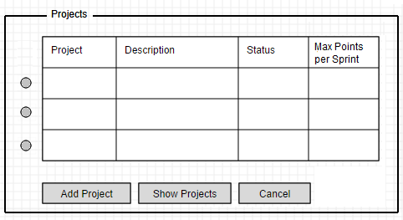

Project Screen showing all existing projects

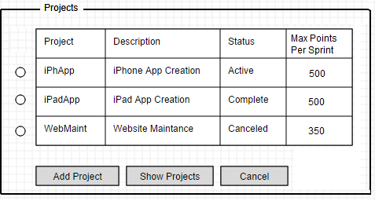

Project Screen allowing changes to existing projects

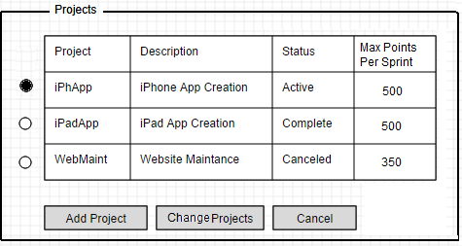

Add Project screen

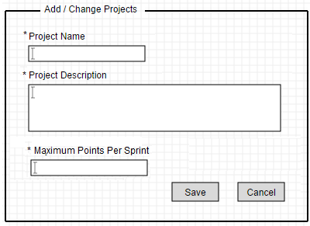

Change Project screen

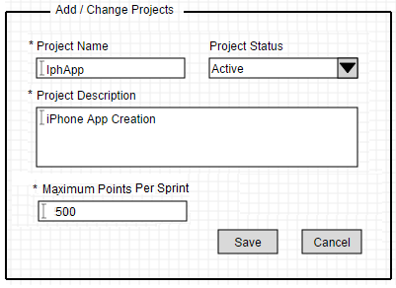

Blank fields’ validation message

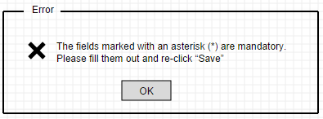

Project successful inclusion / change

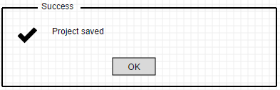

#### Inputs and Pre-conditions

* The user needs to be registered in the system;
* The user needs to be logged into the system;

#### Outputs

Project record registered (new) or changed in the system (refer to Main (MFE) / Alternative (AFE) and Exception (ExFE) flows of events);

#### MFE001 – Maintain Project Main Flow of Events

1. The system displays the options menu;
2. The user chooses the option “*Maintain Projects*”;
3. The system shows the Project Records screen, with the a blank list of projects (not loaded) with the fields “*Project Name*”, “*Project Description*”, “*Project Status*”, “*Max Points per Sprint*”, and the options “*Add Project*”, “*Show Projects*” [Refer to AFE001] and “*Cancel*” [Refer to AFE004];
4. The user clicks in the option “*Add Project*”;
5. The system shows the Project Inclusion / Change screen, with the fields “\**Project Name*” “\**Project Description*” and “*\*Maximum Points per Sprint*” in blank, and the options “*Save*”and “*Cancel*” [Refer to AFE003];
6. The user fills the available fields and clicks in the option “*Save*”. For fields left in blank, refer to ExFE001;
7. The system inserts the new Project record in the database, grants the status “*Active*” to the Project and displays the message “*Project saved*”. The system also displays the Option “*OK*”;
8. The user clicks in the option “*OK*”;
9. The system returns to step 3 of this Main Flow of Events;

#### Alternative Flow of Events (Alternative or Exception)

#### AFE001 – Show projects

1. For step 4 of MFE001, the user clicks in the option “*Show Projects*”;
2. The system loads the blank Projects list with all projects registered in the system, filling the fields “*Project Name*”, “*Project Description*”, “*Project Status*” and “*Maximum Points per Sprint*”. The system also shows the options “*Change*” [Refer to AFE002] and “*Cancel*” [Refer to AFE003];

#### AFE002 – Change Projects

1. The user chooses one Project;
2. The system changes the label of option “*Add Projects*” to “*Change Projects*”;
3. The user selects the option “*Change*”;
4. The system shows the Project Inclusion / Change screen, with the fields “\**Project Name*” “\**Project description*”, “*Project Status*” and “\**Maximum points per sprint*”, filled with the data retrieved from the database for the Project chosen. For the combo box “*Project Status*”, the options “*Complete*” and “*Canceled*” are also available for being selected. The system also shows the options “*Save*” and “*Cancel*” [Refer to AFE003];
5. The user makes the changes to the desired fields and click in the Option “*Save*”. For fields left in blank, refer to ExFE001;
6. The system alters the Project record in the database;
7. The system displays the message “*Project saved*”. The system also displays the Option “*OK*”;
8. The user clicks in the option “*OK*”;
9. The system returns to step 2 of Alternative Flow of Events AFE001;
10. The system changes the label of option “*Change Projects*” to “*Add Projects*”;
11. The system unselects any selected project;

#### AFE003 – Operation canceling, Mode 1

1. After the user click in the option “*Cancel*”, the system discards any changes done in the system’s screen and returns to step 3 of MFE001;

#### AFE004 – Operation canceling, Mode 2

1. After the user click in the option “*Cancel*”, the system discards any changes done in the system’s screen and returns to step 1 of MFE001;

#### ExFE001 – Mandatory fields left in blank

1. The system displays the message “The fields marked with an asterisk (*) are mandatory. Please fill them out and re-click “Save”. The system also displays the option “OK”;
2. The user clicks in the option “OK”;
3. The system returns to step 6 of MFE001 or to step 5 of Alternative Flow of Events AFE001;

### UC002 – Maintain Users

|  |  |  |  |  |  |  |
| --- | --- | --- | --- | --- | --- | --- |
| **Priority:** |  | **Essential** |  | **Important** |  | **Desirable** |
| **Associated Use Cases** | UC00X (Login), UC001 (Maintain Projects) | | | | | |

#### Use Case Description

This use case is related to the creation, change and deletion of user accounts. Any user is able to create new user accounts, but are only allowed to change or delete their own user account record in the system, via login.

#### Graphic User Interface

Login screen

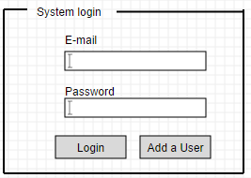

User Screen

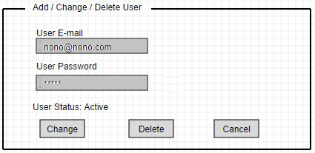

Add User screen

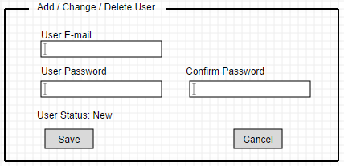

Change User Screen Project screen

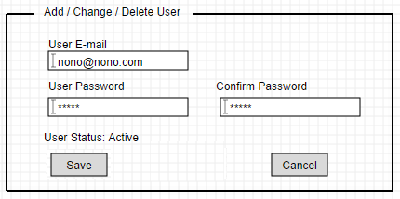

Blank fields validation message



User successful inclusion / change

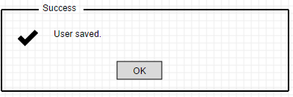

#### Inputs and Pre-conditions

* For adding new users:
  + Pre-conditions non-applicable;
* For changing / deleting users:
  + The user needs to be registered in the system;
  + The user needs to be logged into the system;

#### Outputs

User record registered (new), deleted or changed in the system (refer to Main (MFE) / Alternative (AFE) and Exception (ExFE) flows of events);

#### MFE002 – Maintain Users Main Flow of Events

1. The user accesses the system’s main URL;
2. The system shows the login screen with the blank fields “*User E-mail*” and “*Password*”. The system also displays the options “*Login*” [Refer to AFE005 or AFE006] and “*Add a User*”;
3. The user chooses the option “*Add a user*”;
4. The system shows the Add / Change / Delete User screen, with the blank fields “*User E-mail*”, “*Password*”, “*Confirm Password*” and the label “*User Status:* *New*”. The system also displays the options “*Save*”, and “*Cancel*” [Refer to AFE007];
5. The user fills the available fields and clicks in the option “*Save*”. For fields left in blank, refer to ExFE001;
6. The system inserts the new User record in the database, grants the status “*Active*” to the User and displays the message “*User saved*”. The system also displays the Option “*OK*”;
7. The user clicks in the option “*OK*”;
8. The system returns to step 1 of this Main Flow of Events;

#### Alternative Flow of Events (Alternative or Exception)

#### AFE005 – Change User

1. For step 3 of MFE001, the user logs into the system [Refer to UC00X];
2. The system displays the options menu;
3. The user chooses the option “*Maintain Users*”;
4. The system displays the Add / Change / Delete User screen, with the disabled but filled fields “\**User E-mail*”, “\**Password*” and the label “*User Status: Active*”. The system also displays the options “*Change*”, “*Delete*” [Refer to AFE002] and “*Cancel*” [Refer to AFE008];
5. The user chooses the option “*Change*”;
6. The system unlocks all fields for edition and now displays the field “*Confirm Password*”, also unlocked for edition. The system also disables the option “*Delete*” and now displays the option “*Save*”;
7. The user makes all desired changes and clicks in the option “*Save*”. For mandatory fields left in blank, refer to ExFE003;
8. The system updates the the user record in the system and displays the message “*User saved*”;
9. The system returns to step 4 of Alternative Flow of Events AFE005;

#### AFE006 – Delete User

1. For step 5 of AFE001, the user chooses the option “*Delete*”;
2. The system displays the message “*Are you sure you want to delete this user? The account will become permanently disabled, but the record will remain in the system. All tasks assigned to this user will need to be reassigned!*” The system also displays the options “*Delete*” and “*Cancel*”;
3. The user chooses the option “*Delete*”;
4. The system changes the user record status to “*Inactive*” in the database and displays the message “*User deleted successfully*”. The system also displays the option “*OK*”;
5. The user chooses the option “OK”;
6. The system returns to step 1 of MFE001;

#### AFE007 – Operation canceling, Mode 1

1. After the user click in the option “*Cancel*”, the system discards any changes done in the system’s screen and returns to step 2 of MFE002;

#### AFE008 – Operation canceling, Mode 2

1. After the user click in the option “*Cancel*”, the system discards any changes done in the system’s screen and returns to step 4 of Alternative Flow of Events AFE005;

#### ExFE002 – Mandatory fields left in blank

1. The system displays the message “The fields marked with an asterisk (*) are mandatory. Please fill them out and re-click “Save”. The system also displays the option “OK”;
2. The user clicks in the option “OK”;
3. The system returns to step 4 of MFE002 or to step 7 of Alternative Flow of Events AFE007;

### UC003 – Maintain Sprints

|  |  |  |  |  |  |  |
| --- | --- | --- | --- | --- | --- | --- |
| Priority: |  | Essential |  | Important |  | Desirable |
| Associated Use Cases | UC00X (Login), UC001 (Maintain Projects), UC00X (Maintain Tasks) | | | | | |

#### Use Case Description

This use case is related to the move of tasks and its subtasks from the product backlog into the sprint backlog or vice versa. The sprint is initiated when put into the “*Work in Progress*” status by the “*Start Sprint*” option.

#### Graphic User Interface

Sprint Control screen

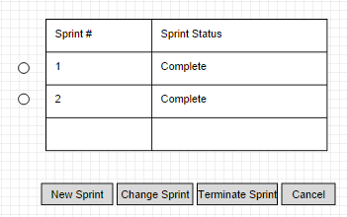

Sprint creation / change screen

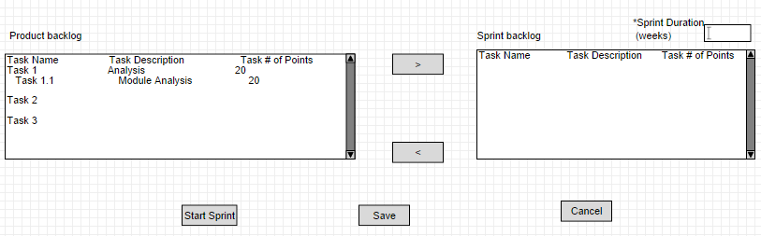

Validation messages

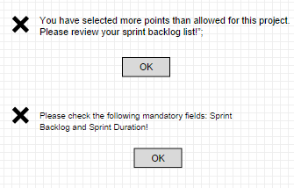

#### Inputs and Pre-conditions

* The user needs to be logged into the system.
* A Project needs to be created and to be in the Active status.
* Tasks (and subtasks, if applicable) need to be created and to be in the “*New*” status. Those tasks also need to be associated with the project.

#### Outputs

Sprint initiated or cancelled in the system (refer to Main (MFE) / Alternative (AFE) and Exception (ExFE) flows of events);

#### MFE003 – Maintain Sprints Main Flow of Events

1. The system displays the options menu;
2. The user chooses the option “*Maintain Sprints*”;
3. The system displays the Sprint Control Screen with a list of all valid sprints for the project in question, with the fields “*Sprint #*”, “*Sprint Status”*, the options “*New Sprint*”, “*Change Sprint*” [refer to AFE010], “*Terminate Sprint*” [refer to AFE011] and “*Cancel*” [refer to AFE012];
4. The user chooses the option “*New Sprint*”;
5. The system shows the Sprint creation/change screen, with the product backlog list of requirements recorded for the specific project;
6. The system shows a populated Product Backlog list with all the requirements associated with the project in question and not associated with a sprint. The fields “*Task Name*”, “*Task Description*” and “*Task Number of Points*” are in the list;
7. The system shows an empty Sprint Backlog list, with the fields “*Task Name*”, “*Task Description*”, “*Task Number of Points*” and the “*Sprint Duration*” field;
8. The system shows the inclusion and deletion buttons and the options “*Start Sprint*”, “*Save*” [refer to AFE009] and “*Cancel*” [Refer to AFE00X];
9. The user selects in the product backlog which tasks and subtasks he wants to add to the sprint backlog and clicks in the inclusion or deletion buttons;
10. The system moves the selected tasks / subtasks from the Product Backlog list into the Sprint Backlog list;
11. The user fills the field “*Sprint Duration*”;
12. The user chooses the option “*Start Sprint*”. For a selection of a total number of points that is higher than the threshold allowed, refer to ExFE003. For mandatory fields left in blank, refer to ExFE004;
13. The system starts a new sprint, defining its number as Zero (0) for a first project sprint, and incrementing the number in one (1) every time a new sprint is initiated;
14. The system associates the chosen tasks and subtasks in the sprint backlog with the newly opened sprint;
15. The system assigns the status “*Work in progress*” to the new sprint;
16. The system displays the message “*Sprint <# of the sprint> started successfully*!” The system also displays the option “*OK*”.
17. The user clicks in the option “*OK*”;
18. The system returns to step 1 of this Main Flow of Events;

#### Alternative Flow of Events (Alternative or Exception)

#### AFE009 – Save Sprint backlog

1. For step 12 of MFE003, the user chooses the option “*Save*”;
2. The system displays the message “*Sprint backlog saved successfully. To start the sprint, please select “Start Sprint” option*;
3. The system displays the option “OK”;
4. The user selects the option “OK”;
5. The system returns to step 3 of MFE003;

#### AFE010 – Change Sprint

1. For step 4 of MFE003, the user chooses a saved but not started sprint and the option “*Change Sprint*”;
2. The system shows the Sprint creation/change screen, with the product backlog list of requirements recorded for the specific project with the fields “*Task Name*”, “*Task Description*”, “*Task Number of Points*;
3. The system shows a populated sprint backlog list, with all the requirements previously associated with the sprint in question and the fields “*Task Name*”, “*Task Description*”, “*Task Number of Points”* and the *“Sprint Duration”* field.
4. The system displays the inclusion and deletion buttons and the options “*Start Sprint*”, “*Save*” [refer to AFE009] and “*Cancel*” [Refer to AFE00X];
5. The user makes the desired changes in the requirements selection and sprint duration;
6. The user selects the option “*Start Sprint*”. For a selection of a total number of points that is higher than the threshold allowed, refer to ExFE003. For mandatory fields left in blank, refer to ExFE004;
7. The system starts a new sprint, defining its number as Zero (0) for a first project sprint, and incrementing the number in one (1) every time a new sprint is initiated;
8. The system associates the chosen tasks and subtasks in the sprint backlog with the newly opened sprint;
9. The system displays the message “*Sprint <# of the sprint> started successfully*!” The system also displays the option “*OK*”;
10. The system assigns the status “*Work in Progress*” to the sprint;
11. The user clicks in the option “*OK*”;
12. The system returns to step 1 of this Main Flow of Events

#### AFE011 – Terminate Sprint

1. For step 4 of MFE003, the user chooses an initiated sprint;
2. The user chooses the option “*Terminate Sprint*”;
3. The system shows the message “*Are you sure you want to terminate this sprint? All associated tasks and subtasks will return to the Product Backlog*”;
4. The system shows the option “*OK*”;
5. The user chooses the option “*OK*”;
6. The system returns all tasks and subtasks to the Product Backlog;
7. The system changes the sprint Status to “*Terminated*”;
8. The system displays the message “*Sprint terminated successfully*”;
9. The system displays the option “*OK*”;
10. The user chooses the option “*OK*”;
11. The system returns to step 3 of MFE003;

#### AFE0012 – Operation canceling, Mode 1

1. After the user click in the option “*Cancel*”, the system discards any changes done in the system’s screen and returns to step 1 of MFE003;

#### AFE0013 – Operation canceling, Mode 2

1. After the user click in the option “*Cancel*”, the system discards any changes done in the system’s screen and returns to step 3 of MFE003;

#### ExFE003 – Points selected higher than project’s threshold

1. The system displays the message “You have selected more points than allowed for this project. Please review your sprint backlog list!”;
2. The system displays the option “OK”;
3. The user clicks in the option “OK”;
4. The system returns to step 8 of MFE003 or to step 4 of Alternative Flow of Events AFE010;

#### ExFE004 – Mandatory fields left in blank

1. In case no tasks and subtasks have been included in the Sprint Backlog, or the sprint duration has not been filled, the system displays the message “*Please check the following mandatory fields:* *Sprint Backlog and Sprint Duration!”*. The system also displays the option “OK*”;*
2. The user clicks in the option “*OK*”;
3. The system returns to step 8 of MFE003 or to step 4 of Alternative Flow of Events AFE010;

### UC004 – Create Tasks

|  |  |  |  |  |  |  |
| --- | --- | --- | --- | --- | --- | --- |
| Priority: |  | Essential |  | Important |  | Desirable |
| Associated Use Cases | UC001 (Maintain Projects), UC002 (Maintain User), UC005 (Login) | | | | | |

#### Use Case Description

This use case is related to the creation, change and cancelation of tasks. Any user is able to execute these tasks.

#### Graphic User Interface

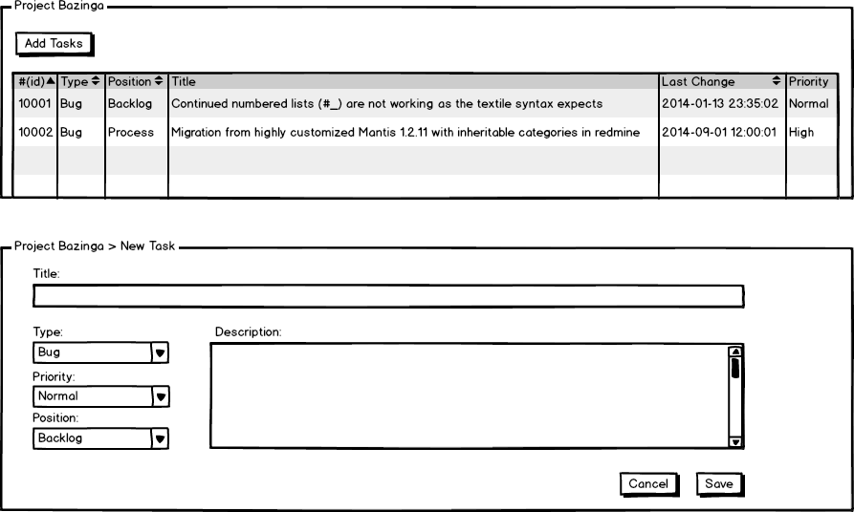

#### Inputs and Pre-conditions

* The user needs to be registered in the system;
* The user needs to be logged into the system;
* Necessary have at least one project registered in the system.
* Necessary kinds of types are registered in system (Bug, Feature).
* Necessary kinds of priority are registered in system (Normal, High and Low).
* Necessary kinds of position are registered in system (Backlog, Process, Done, Testing and Canceled).

#### Outputs

* Tasks record registered (new) in the system (refer to Main (MFE) / Alternative (AFE) and Exception (ExFE) flows of events);

#### MFE004 – Maintain Tasks Main Flow of Events

1. The system displays the options menu;
2. The user choose the option “*Add Tasks*”;
3. The system show the window to create a new task. Default arguments are filled.
4. The user fill all available fields and have the option button *Save*” and “*Cancel*” [Refer to AFE013].
5. The user choose “*Save*” button.
6. The system insert on database a new task associated a project.
7. The system return to the main page of tasks project.

#### Alternative Flow of Events (Alternative or Exception)

**AFE013 – New Task**

1. For step 3 of MFE004, the user clicks in the option “*Cancel*”;
2. The system return on the main page of the tasks project and don’t save a new task.

**ExFE005 – Mandatory fields left in blank**

1. The system displays the message “*All fields are mandatory. Please fill them out and re-click “Save*”. The system also displays the option “OK*”;*
2. The system maintains the fill fields by the user and highlights missing fields.
3. The user fill missing fields.
4. The user clicks in the option “*OK*”;
5. The system returns to step 4 of MFE004;

### UC005 – Maintain Tasks

|  |  |  |  |  |  |  |
| --- | --- | --- | --- | --- | --- | --- |
| Priority: |  | Essential |  | Important |  | Desirable |
| Associated Use Cases | UC001 (Maintain Projects), UC002 (Maintain User), UC005 (Login), UC003 (Create Task) | | | | | |

#### Use Case Description

This use case is related to the creation, change and cancelation of tasks. Any user is able to execute these tasks.

#### Graphic User Interface

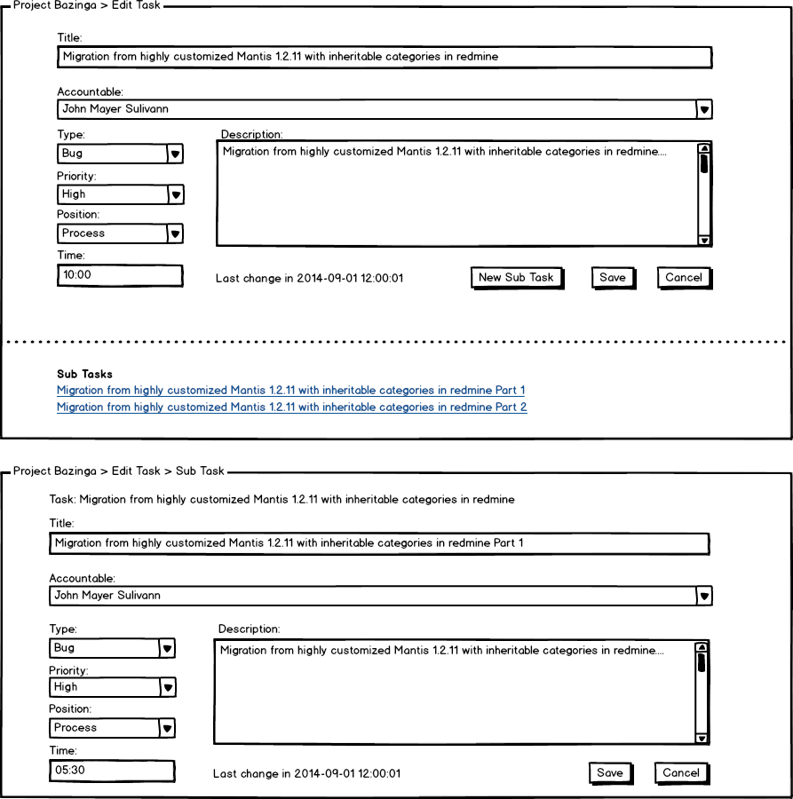



#### Inputs and Pre-conditions

* The user needs to be registered in the system;
* The user needs to be logged into the system;
* Necessary have at least one project registered in the system.
* Necessary have at least one task registered in the system.
* Necessary have resources (accountable) registered in system.
* Necessary kinds of types are registered in system (Bug, Feature).
* Necessary kinds of priority are registered in system (Normal, High and Low).
* Necessary kinds of position are registered in system (Backlog, Process, Done, Testing and Canceled).

#### Outputs

* Tasks changed in the system (refer to Main (MFE) / Alternative (AFE) and Exception (ExFE) flows of events);

#### MFE005 – Maintain Tasks Main Flow of Events

1. The system displays the window of tasks project.
2. The user click on one task.
3. The system open the window to edit task.
4. The user fill available fields and have the option to “*Save*”, “*Cancel*” or “*New Sub Task*”. [Refer to AFE014, AF015]
5. The user choose “*Save*” button.
6. The system update information about the task on database.
7. The system return to the main page of the tasks project.

#### Alternative Flow of Events (Alternative or Exception)

#### AFE014 – Cancel Task

1. For step 4 of MFE005, the user clicks in the option “*Cancel*”;
2. The system return on the main page of the tasks project and don’t save a new task.

#### AFE015 – New Sub Task

1. For step 4 of MFE005, the user clicks in the option “*New Sub Task*”;
2. The system open a new page with on top the name of the original task.
3. The system allows fields to be fill by the user and show the options to “*Save*” or “*Cancel*”. [Refer to AFE016, ExFE007]
4. The user choose “*Save*” button.
5. The system update information about the task on database.
6. The system return to the main page of the tasks project.

#### AFE016 – Cancel Sub Task.

1. For step 3 of AFE015, the user clicks in the option “*Cancel*”;
2. The system return to the main page of the tasks project and don’t save any information.

#### AFE017 – The task has an accountable.

1. The system do not show available edition on any field. Only button available is “*Cancel*”.
2. Refer to AFE014.

#### AFE018 – The sub task has an accountable.

1. The system do not show available edition on any field. Only button available is “*Cancel*”.
2. Refer to AFE016.

#### ExFE006 – Mandatory fields left in blank on new task.

1. The system displays the message “*All fields are mandatory. Please fill them out and re-click “Save*”. The system also displays the option “OK*”;*
2. The system maintains the fill fields by the user and highlights missing fields.
3. The user fill missing fields.
4. The user clicks in the option “*OK*”;
5. The system returns to step 4 of MFE005;

#### ExFE007 – Mandatory fields left in blank on new sub task.

1. The system displays the message “*All fields are mandatory. Please fill them out and re-click “Save*”. The system also displays the option “OK*”;*
2. The system maintains the fill fields by the user and highlights missing fields.
3. The user fill missing fields.
4. The user clicks in the option “*OK*”;
5. The system returns to step 4 of AFE015;

### UC006 – Generate Reports

|  |  |  |  |  |  |  |
| --- | --- | --- | --- | --- | --- | --- |
| Priority: |  | Essential |  | Important |  | Desirable |
| Associated Use Cases | UC001 (Maintain Projects), UC002 (Maintain User), UC005 (Login) | | | | | |

#### Use Case Description

This use case is related to the reports generation of projects. Any user is able to execute these tasks.

#### Graphic User Interface

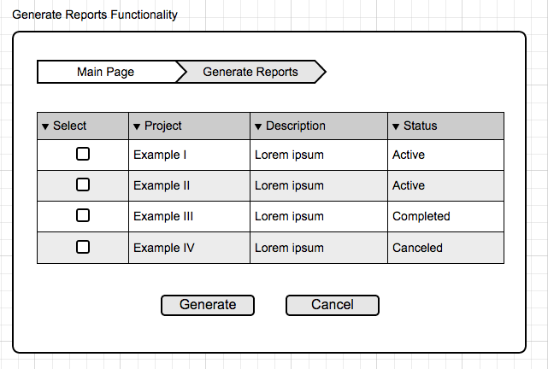

#### Inputs and Pre-conditions

* The user needs to be registered in the system;
* The user needs to be logged into the system;
* Necessary to have at least one project registered in the system.

#### Outputs

* Report of a selected project (refer to Main (MFE) / Alternative (AFE) and Exception (ExFE) flows of events);

#### MFE006 – Maintain Tasks Main Flow of Events

1. The system displays the options menu;
2. The user choose the option “*Generate Report*”;
3. The system show a list of registered projects. By default, none project is selected.
4. The user select at least one of the projects and have the buttons “*Generate*” and “*Cancel*” [Refer to AFE019].
5. The user choose “*Generate Report*” button.
6. The system creates a file (a *pdf* for example) containing the report of the selected projects.
7. The system return to the main page of generate reports.

#### Alternative Flow of Events (Alternative or Exception)

#### AFE019 – Generate Report

1. For step 3 of MFE006, the user clicks in the option “*Cancel*”;
2. The system return on the main page of the generate reports and don’t create the report file.

#### ExFE008 – Mandatory fields left in blank

1. The system displays the message “No project was selected. Please select at least one and re-click “Generate”. The system also displays the button “OK”;
2. The user clicks in the button “OK”;
3. The system returns to step 4 of MFE006.

### UC007 – Login

|  |  |  |  |  |  |  |
| --- | --- | --- | --- | --- | --- | --- |
| Priority: |  | Essential |  | Important |  | Desirable |
| Associated Use Cases | UC001 (Maintain Projects), UC002 (Maintain User), UC003 (Create Tasks), UC004 (Maintain Tasks) | | | | | |

#### Use Case Description

This use case is related to the access to the system. Any user with an account is able to execute these tasks.

#### Graphic User Interface



#### Inputs and Pre-conditions

* The user needs to be registered in the system.

#### Outputs

* Access to the system (refer to Main (MFE) / Alternative (AFE) and Exception (ExFE) flows of events);

#### MFE007 – Maintain Tasks Main Flow of Events

1. The user access the system’s main URL.
2. The system shows the login screen with blank fields “*User E-mail*” and “*Password*”. The system also displays the options “*Login*” and “*Add a User*” [Refer to UC002].
3. The user fill available fields.
4. The select the option “*Login*”.
5. The user is granted access to the system.

#### Alternative Flow of Events (Alternative or Exception)

#### ExFE009 – Mandatory fields left in blank.

1. The system displays the message “*All fields are mandatory. Please fill them out and re-click “Login*”. The system also displays the option “OK*”;*
2. The user clicks in the option “*OK*”;
3. The system maintains the fill fields by the user and highlights missing fields;
4. The user fill missing fields;
5. The system returns to step 4 of MFE007.

#### ExFE010 – User doesn’t exist or Password is incorrect.

1. The system displays the message “User is not registered or Password is Incorrect. Please check them and re-click “Login”. The system also displays the option “OK”;
2. The user clicks in the option “OK”;
3. The system returns to step 3 OF MFE007.

### UC008 – Issue Tracker Integration

|  |  |  |  |  |  |  |
| --- | --- | --- | --- | --- | --- | --- |
| Priority: |  | Essential |  | Important |  | Desirable |
| Associated Use Cases | UC001 (Maintain Projects), UC005 (Maintain Tasks), UC002 (Maintain Users) | | | | | |

#### Use Case Description

This use case is related to the insert of an issue with the integration of the system with an issue tracker tool. Any user is able to perform this action.

#### Graphic User Interface

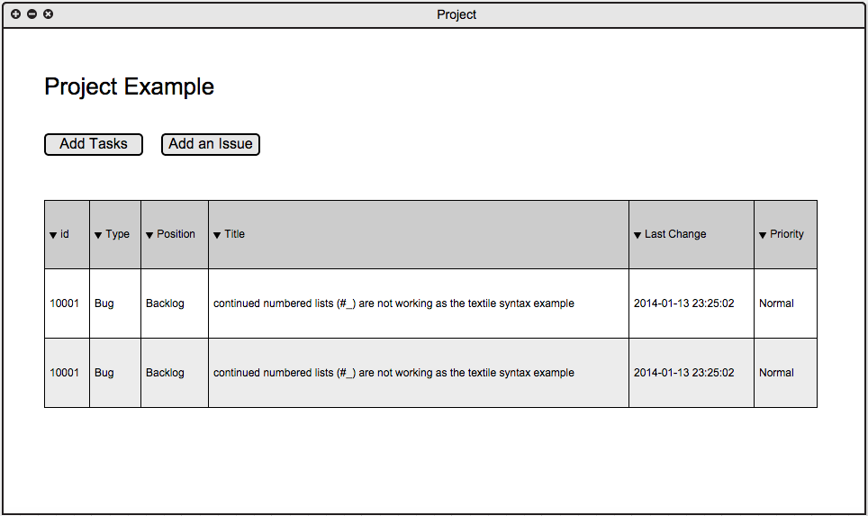

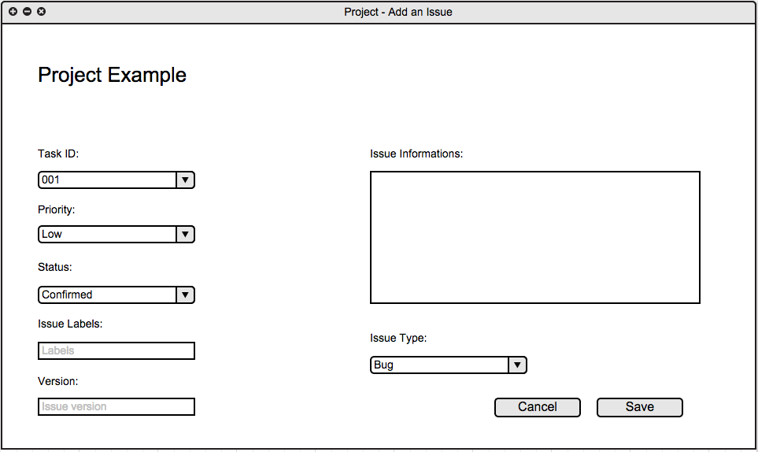

#### Inputs and Pre-conditions

* Necessary to have at least one project registered in the system.
* There must be at least one task/sub task registered and associated with a project in the system.
* The user must be registered and logged in the system.
* Necessary kinds of priorities are registered in the system (Low, Normal and High).
* Necessary kinds of status are registered in the system (Confirmed, Deferred, Fix-Committed, In-Progress, Incomplete, Rejected, Resolved).
* Necessary kinds of labels are registered in the system.
* Necessary kinds of issue type in the system (Bug, Feature, Idea, Invalid, Support, Task).

#### Outputs

Issues found on tasks and sub tasks get inserted and associated in an external issue tracker tool (refer to Main (MFE) / Alternative (AFE) and Exception (ExFE) flows of events);

#### MFE008 – Maintain Tasks Main Flow of Events

1. The user accesses the project page.
2. The user select a task or sub task.
3. The select the option “Add an Issue”.
4. The system show a new window to add an issue. Default arguments are filled.
5. The user fill all available fields and have the option button “Save” and “Cancel” [Refer to AFE702].
6. The user choose “Save” button.
7. The system sends the issue information to the issue tracker tool where it will be saved.
8. The system returns to the main page of tasks of the selected project.

#### Alternative Flow of Events (Alternative or Exception)

#### ExFE011 – Mandatory fields left in blank.

1. The system displays the message “*All fields are mandatory. Please fill them out and re-click “Save*”. The system also displays the option “OK*”;*
2. The user clicks in the option “*OK*”;
3. The system maintains the fill fields by the user and highlights missing fields;
4. The user fill missing fields;
5. The system returns to step 6 of MFE008.

#### ExFE012 – Add issue.

1. For step 6 the user choose “Cancel” button;
2. The system returns to the tasks page of the selected project.

### UC009 – Team communication

|  |  |  |  |  |  |  |
| --- | --- | --- | --- | --- | --- | --- |
| Priority: |  | Essential |  | Important |  | Desirable |
| Associated Use Cases | UC001 (Maintain Projects), UC005 (Maintain Tasks), UC002 (Maintain Users),UC0003(Maintain Sprints) | | | | | |

#### Use Case Description

This use case related to the way of communication of the development team. Any user can perform this action.

#### Graphic User Interface

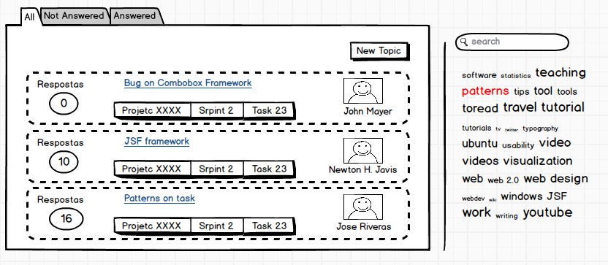

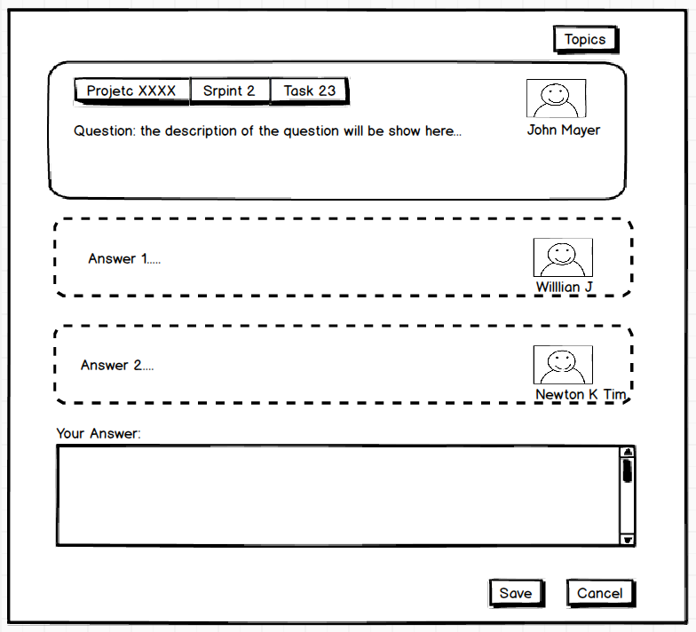

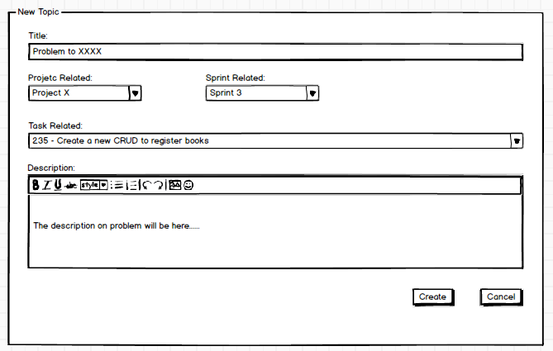

#### Inputs and Pre-conditions

* Necessary to have at least one project registered in the system.
* There must be at least one task/sub task registered and associated with a project in the system.
* The user must be registered and logged in the system.
* Tasks need to be created in the system.
* Sprint need to be created in the system.

#### Outputs

Issues found on tool of communication team (refer to Main (MFE) / Alternative (AFE) and Exception (ExFE) flows of events);

#### MFE009 – Communication team

1. The system show window of the topics to user the main page.
2. The system gives the options to “*new topic*” and see a topic [Refer to AF020].
3. The user click on “*new topic*”.
4. The system open a new window to create a new topic.
5. The system show fields to be filed by the user.
6. The user filed the fields.
7. The use clicks on button “create” [Refer to Refer to ExFE013].
8. The system return to the main page.

#### Alternative Flow of Events (Alternative or Exception)

#### AFE020 – See a topic and answer

1. For step 2 of MFE901, the user clicks on link in the name of topic.
2. The system open a new page with the history of the topic.
3. The system gives the option to return of main page, to save an answer or cancel [Refer to AFE021, AFE022].
4. The user filed the field “*Your answer*” and click on button “*Save*” [Refer to ExFE013].
5. The system returns to the main page.

#### AFE021 – Only see a topic

1. For step 3 of AFE020, the user clicks on button “*topics*”.
2. The system return to the main page.

#### AFE022 – See a topic and cancel

1. For step 3 of AFE901, the user clicks on button “*cancel*”.
2. The system return to the main page.

#### ExFE013 – Mandatory fields left in blank

1. The system displays the message “Please filed all field”. The system also displays the button “OK”;
2. The user click on button “*OK*”.
3. The system return to the page state before the click.

## Non-Functional Requirements

### Performance Requirements

[NFR001] - The system should not take more than 4 seconds to load a page;

[NFR002] - The system should not take more than 5 seconds to process information of any function;

[NFR003] - The system should be able to handle more than 5 requests per seconds;

[NFR004] - The system should have an uptime of no less than 95%;

[NFR005] - The system should be able to support 1000 users - 50 logged in simultaneously;

[NFR006] - The system’s database should be able to support the storage of up to 20GB of records.

### Safety and Security Requirements

[NFR007] - The system should validate mandatory data before insertion;

[NFR008] - The system should take logs of persistent operations;

[NFR009] - The system should backup its database in a daily basis;

[NFR010] - All external communications of the system should be encrypted;

[NFR011] - All sensitive data (passwords, etc…) should be encrypted;

[NFR012] - There must be at least one server backup of the main host server in case of any kind of problem or disaster.

### Software Quality Attributes

[NFR013] - The system should work on the following browsers and OSs: Firefox, Chrome, IE, Safari, Windows, OS X and Linux Distros);

[NFR014] - It must be possible to navigate through the system options only with the keyboard (hot keys).

## Use Cases

