DEVELOPMENT OF MEDICAL ALERT BUTTON SYSTEM TO IMPROVE CLASSROOM EMERGENCY RESPONSE AT ATEC TECHNOLOGICAL COLLEGE INC.
A Thesis Study Presented to the Faculty Members
of Senior High School,
ATEC Technological College Inc.
At Sta. Rita, Guiguinto, Bulacan
In Partial Fulfillment of the Requirements for
Research Capstone

Fernandez, Jomarie S.
Villamil, Jaime F.
Cabigao, Jean Gabrielle S.
Cunanan, Nativity Rose C.
De Guzman, Jejomar Prince E.

January 2026


APPROVAL SHEET

In partial fulfilment of the requirements for the Academic Track with specialization in SCIENCE, TECHNOLOGY, ENGINEERING &
MATHEMATICS (STEM), this thesis entitled Development of Medical Alert Button System to Improve Classroom Emergency Response at ATEC Technological College which was prepared and submitted by MR. JOMARIE FERNANDEZ, MR. JAIME VILLAMIL, MS. JEAN CABIGAO, MR. JEJOMAR PRINCE DE GUZMAN, MS. NATIVITY ROSE CUNANAN is hereby recommended for approval and acceptance.

ANALYN V. HERNANDEZ
Research Capstone Teacher

Approved in partial fulfillment of the requirements for the Academic Track specialization in SCIENCE, TECHNOLOGY, ENGİNEERING AND MATHEMATICS (STEM) by the Oral Examination Committee.

Panelist Panelist

Accepted in partial fulfillment of the requirements for Academic Track with specialization in SCIENCE, TECHNOLOGY, ENGINEERING AND MATHEMATICS (STEM).

Date: MS. JANET D. BONGAT
Academic Head
ATEC TECHNOLOGICAL COLLEGE, INC.

Certificate of Originality
We hereby declare that this submission is my own work and that, to the best of our knowledge and belief, it contains no material previously published or written by another person, nor material which relates to substantial events, except where due to acknowledgement is made in the thesis.
Any contribution made to the research by colleagues, with whom researchers have worked or elsewhere, during our candidature, is fully acknowledged. We also declare that the intellectual content of this thesis is the product of my own work, except to the extent that assistance from others in the project’s design and conception or in style, presentation and linguistic expression is acknowledged.

Researcher/s
Fernandez, Jomarie S.
De Guzman, Prince Jepoy
Villamil, Jaime
Cabigao, Jean Gabrielle
Cunanan, Nativity Rose

Date:

Attested by:
ANALYN V. HERNANDEZ
Research Capstone Adviser

Date: _____________________

ACKNOWLEDGEMENT
The researchers would like to express their deepest gratitude to Mrs. Analyn Hernandez, the Capstone Adviser of this study, for her continuous guidance and encouragement and her close monitoring of the group’s progress which greatly contributed to the successful completion of this research. The researchers express their gratitude to Mrs. Jossa Navejas who served as the Classroom Adviser because she provided support together with her research process reminders and motivational encouragement. The researchers express their gratitude to Mr. Roi Sinson who provided valuable tips and advice which resulted in better research study results. The researchers express their gratitude to all respondents who dedicated their time for research study and provided their cooperation and truthful answers and to their families who showed them enduring affection and support and understanding. The researchers acknowledge ATEC Technological College for their support which included research resources and academic resources that enabled them to complete their Research Capstone project. The researchers dedicate their study to God who provided them with guidance and strength and wisdom and blessings throughout their research process.

ABSTRACT
The research project developed and assessed a Web-Based Medical Emergency Alert Button System which serves ATEC Technological College as a quick dependable and easy-to-use emergency alert system that school staff members need to respond to medical emergencies through tablet device and wired speaker system. The research used a quantitative approach which involved 60 participants who included both students and teachers to complete survey questionnaires and simulation tests that evaluated system usability and system reliability and system efficacy. The study found that traditional emergency reporting methods created operational problems which resulted in response delays while most participants evaluated the new emergency alert system as a faster more effective method for alerting staff and managing their duties. The participants assessed the system as precise which they found simple to operate while it successfully detected emergency events and provided instant help. The research results show that the system achieved better communication results and better emergency response capabilities and it raised user competence to handle medical emergencies which occur in classrooms. The research demonstrates that educational institutions should implement web-based medical emergency alert systems because they provide effective safety solutions which enhance school security and link to better emergency response functions. KEYWORDS: Medical emergency alert system, Web-based system, School safety Emergency response, Classroom emergencies

TABLE OF CONTENTS

Preliminaries Page
Title Page……………………………………………....…………………….…. I
Approval Sheet……………………………………………....…...…….......…. II
Certificate of Originality……………………………………………..........……III
Acknowledgement…………………………………………………..........……IV
Abstract…………........................................................................................V
Table of Contents………………………………………….............................VI
List of Figures………………………………………………………………... VIII
Chapter I: The Problem and its Setting
Introduction and Background of the Study…………….………………...…. 1
Statement of the Problem………………………………………………...…. 3
Significance of the Study……………………………………….…….……… 4 Scope and Delimitation………………………………………………………. 6
Hypothesis……….………………………………………………………….... 7
Chapter II: Literature Review
Literature Review ……………………………………………………………. 8
Synthesis…………………………………………….………………….........13
Chapter III: Research Methodology
Research Methods…………………………………………………………...15
Research Design…………………………………………….……………….21
Research Respondents………………………………………………..…… 21
Data Gathering Procedures………………………………………………… 23
Statistical Treatment of Data………….……………………….………….... 24
Chapter IV: Analysis, Presentation, and Interpretation of Data
Data Analysis………………………………………………………………… 25
Data Presentation and Interpretation……..………………….……………. 26
Chapter V: Summary, Conclusion and Recommendations
Summary.…………………………………………………………….………...35 Findings…………………………………………………………….…………..36
Conclusion………………………………………………………….……….....37
Recommendations………………………………………………….………….37
Bibliography……………………………………………….………….………...37
Appendixes
Parent/Guardian Permission ……………..………………………….……….38
Mentor Information………….……………………………………………….....42
Pictures of Procedure…………………………………….………….………...44
Curriculum Vitae………………………………………………………...…......48

LIST OF FIGURES
No. | Title | Page
3.1 | Data Gathering Procedure | 22
4.1 | Distribution of Age | 25
4.2 | Distribution of Gender | 25
4.3 | Distribution of Sections | 26
4.4 | Waste Produce | 26
4.5 | Waste Management | 27
4.6 | Solar Power | 27
4.7 | BioCompost Bin in Households | 28
4.8 | Composing Waste for  Environmental Sustainability | 28
4.9 | Waste to Compost | 29
4.10 | Compost | 29
4.11 | Space Outside for Compost Bin | 30
4.12 | Challenges when Composting at  Home | 30
4.13 | Learn more about Composting | 31

CHAPTER I

THE PROBLEM AND ITS SETTING

Introduction and Background of the Study
The primary mission of educational institutions is to protect the health and safety of their students and faculty members. The classroom environment requires immediate medical help for unexpected accidents and sudden dizziness, asthma attacks, allergic reactions, seizure events and other medical emergencies. Emergency situations require fast response systems that must operate efficiently because these systems protect people from deteriorating health conditions while also creating life-threatening medical situations. The conventional methods that schools use to request assistance remain operational because schools currently use telephone calls, leaving the classroom to look for help, or sending a student to the school clinic or faculty to connect with help. The procedures create considerable delays because emergency response personnel must travel from their distant locations to handle emergencies which depend on their ability to communicate with emergency responders.
Emergency response systems that experience delays will cause worsened medical conditions which lead to increased danger for patients. The technological progress brings new solutions which now deliver faster and more efficient methods to solve existing issues. According to Nwufoh, Olanrewaju, and Akanbi (2022), web-based emergency alert systems are effective in providing real-time notifications and improving response time during critical situations. The Medical Emergency Alert Button System provides classrooms with an advanced emergency response solution through a compact and easy-to-use alert system. The system allows instant emergency notification to designated offices and the school clinic and authorized faculty members through a single button press which removes the need for extensive emergency procedures. The system provides a user-friendly experience which maintains reliable performance under high-pressure situations.
Researchers developed a web-based Medical Emergency Alert Button System which implements dedicated buttons to handle various medical emergency situations. The system will be accessed through a tablet device installed on the third floor of the school, positioned at the center of the hallway wall to ensure high visibility and accessibility. The tablet connects to a wired speaker system which covers the faculty office area and the school clinic space because these locations function as the primary alert receiving stations. The speaker system delivers an audio alert when an emergency button gets pressed to inform faculty members and medical personnel about the situation, which helps them to respond more quickly and effectively. The primary objective of this study is to develop and evaluate the effectiveness of the system in reducing emergency response time, improving communication among school staff, and enhancing overall safety within the school environment.

Statement of the Problem
This research aims to determine the effectiveness of a dedicated medical alert button system in reducing response times and improving student safety during health-related emergencies.
Specific (Minor) Problems:
1. What challenges do students and teachers face when reporting classroom medical emergencies such as fainting, asthma attacks, or injuries?
2. What benefits does a digital alert system provide in terms of communication and response speed compared to traditional methods?
3. What is the effectiveness of the alert button in improving response time and communication during simulated emergency situations?
4. What is the efficiency of the system’s design in accurately identifying the specific type of medical emergency without verbal explanation?
5.What is the user-friendliness of the device for students and teachers when operating it during high-pressure, real-world situations?

Significance of the Study
The research project called Development of a Medical Alert Button System to Improve Classroom Emergency Response is quite crucial to different parties involved in the educational process. By doing so, it would not only raise the level of safety but also the efficiency and the preparedness in schools.
Students: The faster emergency response provided by this system leads to fewer complications and, thus, gives students a more secure environment in which to learn. Having immediate help available can be crucial for life, particularly with students who have chronic illnesses.
Teachers: The Medical Alert Button System gives teachers a very fast and dependable method of calling for help in emergencies without having to exit the room. These de-stresses the teachers and allows them to concentrate on the provision of the initial care and the upkeep of order in the classroom.
School Nurses and Medical Personnel: The system makes it possible for the school health staff to get instant notifications, thus allowing them to react quickly and also to get ready with the right medical interventions before being on the spot.
School Administrators: This project helps school managements in revising their policies on safety and emergency preparedness. The system might easily be a tool for communication, quickly reduce the response time, and showcase the school’s priority on student welfare.
Parents and Guardians: The presence of an effective emergency alert system in school boosts parents’ confidence in the institution’s capability to safeguard their children and to deal with medical emergencies in a responsible manner.
Future Researchers and Developers: This research project can be cited in the future as a basis for further studies and technological advancements revolving around the topics of school safety systems, emergency response technologies, and health-related innovations in educational institutions. To sum up, a Medical Alert Button System has been developed which actually helps to make a place
Researchers: The research study helps to develop valuable experience and knowledge through its evaluation of a web-based emergency alert system design and development process. The researchers develop their system development and data analysis and problem-solving skills through this research study which also introduces new findings to the educational safety technology field.

Scope and Delimitations
This study focuses on the development and evaluation of a web-based Medical Emergency Alert Button System intended to improve response time to medical emergencies occurring in classroom settings. The scope of the study includes the system’s design, development, implementation, and basic testing in selected classrooms of one school, utilizing a tablet installed on the third-floor hallway that allows users to activate specific medical emergency buttons, which then send immediate alerts through a wired speaker installed in the faculty office or school clinic to notify designated school personnel such as teachers, nurses, and administrators. The study evaluates the system’s effectiveness in terms of response time, usability, reliability, and clarity of alerts based on system testing and feedback from selected users. However, the study is limited to medical emergencies within classrooms and does not cover other emergency situations such as fires, security threats, or natural disasters; it is confined to a single school and does not account for differences in infrastructure or policies of other institutions; it does not include coordination with external emergency service providers; and it excludes considerations related to long-term maintenance, large-scale implementation, scalability, and cost analysis. Furthermore, the findings are based on a limited number of classrooms and participants, which may affect the generalizability of the results.

Hypothesis
To determine whether the implementation of a medical alert button system has a significant effect on improving emergency response in classrooms, the researchers formulated the null and alternative hypotheses to guide the predictions of the study.
Null Hypothesis (H₀): The implementation of a medical alert button system has no significant effect on the response time and effectiveness of handling medical emergencies in the classroom.
Alternative Hypothesis (H₁): The implementation of a medical alert button system has a significant effect on the response time and effectiveness of handling medical emergencies in the classroom.

CHAPTER II

LITERATURE REVIEW
This chapter elaborates on the diverse and relevant literature and studies which are related to the medical emergency alert button systems. This part is crucial as it underpins the current research by putting forth pertinent information from prior research and thus rendering the study more trustworthy, besides, it is a way for the readers to have an in-depth view of the medical emergency alert technologies and their use case.
Literature Review

Medical Emergency Alert Systems in Schools
Emergency alert systems in schools are designed to quickly notify staff and responders during emergencies, including medical incidents in classrooms. The unified mass notification system enables school administrators to deliver instant alerts through multiple communication channels which include SMS and email and mobile apps and web platforms. Critical situations see improved communication which leads to faster response times according to EdTech Magazine (2025). The school nurse and faculty members and administrators receive emergency alerts through real-time notifications which enable immediate emergency response.

Recent research shows that web-based emergency alert systems in schools provide greater flexibility and reliability compared to traditional methods (Implementation of an Institution-Based Emergency Alert Management System, 2024). These systems allow alerts to be logged and tracked in a centralized database, enabling administrators to monitor emergency response times and adjust protocols to improve efficiency. Schools that adopt web-based and cloud-enabled systems demonstrate higher coordination between classrooms and medical staff, ensuring that students receive timely assistance.

Usability and Effectiveness of Emergency Alert Devices
Emergency alert systems in modern times use web-based platforms along with cloud computing and integrated communication technologies to achieve better system reliability. School emergency systems that use web interfaces allow administrators to trigger alerts centrally which then reach all relevant personnel immediately EdTech Magazine 2025. The system proves valuable for school buildings that require immediate connection between classrooms and school clinics and faculty offices.
Research demonstrates that multiple communication channels in mass notification systems enhance both campus safety and emergency preparedness efforts (Crises Control, 2025). The systems enable school personnel to issue alerts through web-based dashboards which guarantee message delivery even when one communication channel becomes inoperable.
In addition, usability studies on mobile panic button applications indicate that intuitive interface design significantly improves response time, accuracy, and communication during emergency situations (Android-based Mobile Panic Button UI application, 2022). Features such as accessible buttons, visible alerts, and fast notifications ensure that users can operate the system effectively, particularly during high-stress classroom emergencies. This highlights the importance of designing emergency alert systems that are both reliable and easy to operate.

Technology Integration in Alert Systems
Current emergency alert systems operate with their web-based platforms and cloud computing capabilities and their integrated communication systems to achieve better operational performance. The web-based emergency system of schools enables their administrators to initiate emergency alerts which will instantly notify all necessary staff members (EdTech Magazine, 2025). The system proves valuable for educational institutions which require fast response times between their classroom areas and school health facilities and teacher work areas.
Research indicates that using various communication methods for mass notification systems enhances both campus security and emergency response capabilities (Crises Control, 2025). The systems enable school personnel to issue emergency alerts through web-based control panels which guarantee message delivery even when one communication method fails. Studies on dual-activation emergency notification systems using Progressive Web Application (PWA) technology demonstrate that alerts can be delivered and stored even when offline, ensuring reliability during Internet disruptions (Dual-Activation Emergency Situation Notification System, 2023). Systems using APIs like Twilio and geolocation tracking provide additional functionality such as message confirmation and precise location alerts, which is critical for improving emergency response accuracy.
Offline and Dual-Activation Emergency Systems
A Dual-Activation Emergency Situation Notification System (DA-ESNS) was developed using PWA technology, allowing alerts to be delivered through web browsers and stored in the browser even when offline (IISSE, 2023). The system uses APIs for message delivery and geolocation for tracking, ensuring continuous alert functionality even during network interruptions. This feature is particularly relevant for school emergency alert systems that need to operate in classrooms where Internet access may be inconsistent.
The study concluded that offline functionality, dual activation methods, and integrated communication channels enhance the reliability, speed, and effectiveness of emergency alerts. These features can be incorporated into school-based systems to ensure students, teachers, and medical personnel receive timely alerts and can respond appropriately during emergencies.

Inclusive and Reliable Emergency Alert Practices
Research on inclusive alert systems shows that traditional alert messages often fail to reach all groups effectively, especially those with limited English proficiency or accessibility needs. Best practices in emergency alerts suggest using multiple communication formats, clear instructions, and culturally appropriate messaging to ensure that diverse users receive and understand alerts during critical situations. This kind of research highlights the importance of designing school alert systems that communicate effectively to everyone on campus, regardless of language or disability.

Mass Notification and Risk Mitigation in School Safety
Mass notification systems are considered essential components of modern school safety strategies. These systems are designed to provide rapid and reliable communication across school communities, helping administrators disseminate critical information during emergencies to students, staff, and visitors. Research emphasizes that integrating mass notification with risk mitigation tools contributes to greater situational awareness and faster incident response, ultimately improving overall campus safety.

Synthesis
The literature review which covers research published between 2020 and 2025 shows that web-based emergency alert systems and mobile emergency alert systems enable better emergency response capabilities during both medical emergencies and school emergency situations. Research consistently shows that these systems enable fast and dependable alert delivery which users can easily operate to receive immediate alerts even when they cannot use verbal communication or phone calls (Implementation of an Institution-Based Emergency Alert Management System 2024; Android-based Mobile Panic Button UI application 2022). The research on panic button applications and dual-activation systems demonstrates that touch-based designs and offline capabilities and built-in communication features enable users to achieve better accuracy while decreasing response times and enhancing teamwork between staff members and emergency responders (Panic Button Mobile Application Usability Study 2022; DA-ESNS 2023). The campus security system achieves complete message delivery through its three notification channels which enable all users to receive alerts about emergency situations regardless of their accessibility requirements or language preferences (Barriers and Best Practices 2025; Inclusive Alerts for Colorado 2025). The use of wearable emergency buttons and stationary emergency buttons in educational settings has proven to deliver quicker emergency responses while enhancing emergency situation awareness (Centegix 2023). The study results indicate that classroom-based emergency alert systems which use web technology and device integration will improve emergency preparedness and institutional safety and coordination according to the study results which indicate that classroom-based emergency alert systems which use web technology and device integration will improve emergency preparedness and institutional safety and coordination.

CHAPTER III

RESEARCH METHODOLOGY

Research Methods
This chapter discusses the research methods used in the development of the Web-Based Medical Emergency Alert Button System. It presents the materials, preparation, and procedures involved in creating the prototype and the actual system. The researchers developed one (1) prototype and one (1) actual system to demonstrate how medical emergencies can be reported quickly through a web-based interface and how alerts can be delivered to medical staff.

Prototype Materials
The following materials were used in developing the prototype of the Web-Based Medical Emergency Alert Button System together with their purposes:
- Laptop/Computer – Used for developing and testing the website.
- Internet Connection – Used for system access and communication.
- Web Browser – Used to display and test the website.
- Code Editor – Used for writing and editing the website code.
- HTML – Used to create the structure of the website.
- CSS – Used to design the layout and buttons.
- JavaScript – Used to handle button functions and alert actions.
- PHP – Used for processing alert requests.
- Database (MySQL) – Used to store emergency alert records.
- Tablet – Used as a temporary monitor for displaying the website.
- Cardboard – Used to create the base body or casing of the monitor.

A. Gathering of Materials and Equipment for the Prototype
The researchers prepared the necessary software tools and devices needed for the prototype. The laptop, tablet, and internet connection were provided by the researchers. Web development tools and programming languages used in the study were open-source and freely available online. Cardboard materials were used to design a simple monitor stand for demonstration purposes.

B. Preparation for the Prototype
The following preparations were conducted prior to developing the prototype:
- Planning the system layout and emergency process
- Designing buttons for different medical conditions such as asthma, fainting, and others
- Setting up the database for recording alerts
- Preparing the tablet and cardboard casing to act as a monitor
- Testing website accessibility on the tablet

C. Process of Making the Prototype
The following procedures illustrate the development of the prototype system:
- Design the website interface using HTML and CSS.
- Create emergency buttons for different types of sickness.
- Program button actions using JavaScript.
- Develop server-side processing using PHP.
- Create a database to store emergency alert details.
- Display the website on a tablet used as a monitor.
- Construct a simple monitor casing using cardboard.
- Test the prototype to ensure alerts are properly generated.

Actual System
Materials
The following materials were used in developing the actual Web-Based Medical Emergency Alert Button System together with their purposes:
- Tablet (Monitor Device) – Displays the website with emergency buttons.
- Plywood Casing – Serves as the body of the tablet device and another one for the speaker.
- Web-Based Application – Contains the emergency buttons and alert system; can operate offline.
- Database Server – Stores emergency alert records.
- Speaker Device – Produces an alarm sound to notify medical staff.
- Internet Connection – Necessary only for storing emergency records on the database and for website development; the system works offline during emergencies.
- USB to 3.5mm External Sound Card – Connects the speaker to the wire for proper audio output.
- USB to USB Cable (10 meters) – Extends the wire connection for the speaker and other devices.
- USB to Type-C Cable – Connects the wire of the speaker to the tablet.
- Power Bank or Adapter – Provides power supply for the speaker.
A. Gathering of Materials and Equipment for the Actual System
The researchers collected all essential materials which they needed for building the actual system. The researchers provided both the tablet and the Internet connection. The team purchased plywood casing through local stores while their speaker and cables and power supply and additional components were purchased through online platforms. The team acquired both web hosting and database services through internet-based platforms. The faculty alert device was designed to receive emergency alerts which would trigger its speaker system to activate.
B. Preparation for the Actual System
The following preparations were made before deploying the actual system:
- Finalizing the website design and emergency buttons to work offline.
- Configuring the database server for logging emergency alerts.
- Setting up the tablet as a fixed monitor inside a plywood casing.
- Setting up the tablet as a fixed monitor Connecting the speaker device to the tablet using the USB to Type-C cable and USB to 3.5mm external sound card.
- Extending connections with the USB-to-USB cable (10 meters) as needed.
- Testing sound alerts, tablet display, and overall system response.
- Ensuring the speaker is powered using a power bank or adapter.

C. Process of Making the Actual System
The following procedures illustrate the development of the actual system:
- Finalize and load the web-based system onto the tablet; ensure it can run offline.
- Install the tablet inside the plywood casing and set it up as a fixed monitor.
- Display the emergency alert website on the monitor.
- Connect the speaker device to the tablet using the USB to Type-C cable and USB to 3.5mm external sound card; extend connections with the 10-meter USB cable if needed.
- Power the speaker using a power bank or adapter.
- Allow students or users to press the appropriate emergency button during incidents.
- Send alert data to the database server (records can be stored online if Internet is available).
- Activate the speaker to alarm medical staff upon receiving an alert.
- Monitor and record emergency alerts.
- Test the system to ensure timely notifications, proper operation, and accurate alert detection.

Research Design
This research will make use of an experimental research design. The method is a quantitative one and it evaluates the efficiency of a medical emergency alert button system in speeding up the classroom emergency response. Besides, an experimental study will be conducted by the researchers in this design. The researchers will come up with a medical emergency alert button system and put it into use in simulations of classroom medical emergency situations. Data will be gathered through observation and surveys and the perspectives of teachers and staff will be understood and their experiences with the system evaluated. In this study, the purpose of the experiment is to find out how much the medical emergency alert button system rates against the traditional emergency response methods that is how effective it is.

Research Respondents
The non-probability purposive sampling method will be used to select the most appropriate participants to evaluate the Medical Alert Button System. This method is chosen because the study needs the opinion of people who are directly involved in managing classrooms and emergency response procedures.
There will be a total of 60 respondents, all of whom will be drawn from ATEC Technological College Inc. at Sta. Rita, Guiguinto, Bulacan, and will comprise of classroom teachers, school nurses, and students. The researchers have specifically chosen these groups because they are the main users who would either initiate or respond to a medical alert, thus their opinions are vital for assessing the system’s efficiency in a real academic environment. The participants will be restricted to those individuals who are currently working at the institution and have the professional experience that allows them to provide informed feedback on school safety and response times.
The researchers believe that by focusing on the selected participants, they will be able to obtain reliable data on the usability and reliability of the system during high-stress medical emergency situations. The actual number of participants will depend on the availability of fully staffed classrooms and medical personnel during the pilot testing phase. To ensure ethical research practices, all participants will be required to sign an informed consent form, confirming that they are fully informed about the purpose of the study and that their personal information will be kept strictly confidential.

Data Gathering Procedure
This part indicates the step-by-step process of data gathering for this research study. It demonstrates the procedure of gathering, observing, and analyzing the data gathered to support the claim of this research study.

1
•
Looking for possible survey questions which are related
to the statement of the problem
.
2
•
Approving of survey questions by the Capstone Research
Teacher to create survey questions through Google Form
.
3
•
Distribution of questions to the participants
.
4
•
Gather all the data and information from the participants
.
5
•
Analyzing the data and identifying which data is most
relevant to the study.

Figure 3.1: Data Gathering Procedure
The diagram above illustrates the step-by-step process of gathering data, which also includes observing, collecting, and analyzing the data. The researcher's first step was to look for possible questions related to the problem statement. After the survey questions were prepared, they were clarified and approved by the research teacher. The researchers will then create survey questions using an online Google Form. Once the survey is created, it will be distributed to the selected participants via chat. The researchers will gather all the data and information provided by the chosen participants. Lastly, the information that has been gathered will be analyzed by the researchers.

Statistical Treatment of the Data
Statistical treatment of data is a process used to convert raw data into something interpretable as stated by Vishak V. (2024). The data to be gathered in this study will be subjected to the following statistical treatment:
1. Frequency and Percentage
Frequency and percentage distribution will be used to determine the number and proportion of respondents who selected each response option in the survey questionnaire. This method will be applied to analyze the respondents’ demographic profile (such as age, role, and experience) as well as their responses regarding the system’s usability, effectiveness, and reliability. The percentage will be computed using the formula:
P = f/N (100)
where:
P = percentage of respondents per category
F = frequency of each response
N = total number of respondents
CHAPTER IV

Analysis, Presentation and Interpretation of Data

Data Analysis
This study utilized a quantitative research approach and employed a non-probability purposive sampling method to gather data from respondents who were familiar with the Web-Based Medical Emergency Alert Button System. Data were collected through Google Forms, which allowed automated computation and ensured an organized and accurate analysis of the responses. The gathered data were presented using pie charts and tables to clearly illustrate the results.
To analyze the demographic profile of the respondents, particularly their section or grade level, the frequency and percentage distribution were used to identify the number of respondents per section. This statistical treatment helped determine which sections were most represented in the study and ensured that the data reflected the views of the intended respondents.
The analysis of the survey responses provided meaningful insights into the respondents’ perceptions of the usability, effectiveness, and responsiveness of the medical emergency alert button system. The results served as the basis for interpreting how the system supports faster emergency reporting and improves communication between students and medical staff within the school environment.

Data Presentation and Interpretation
The charts below that had been gathered through Google Forms by surveys represents the following:
- How challenging is it to communicate the type of medical emergency without a dedicated alert system?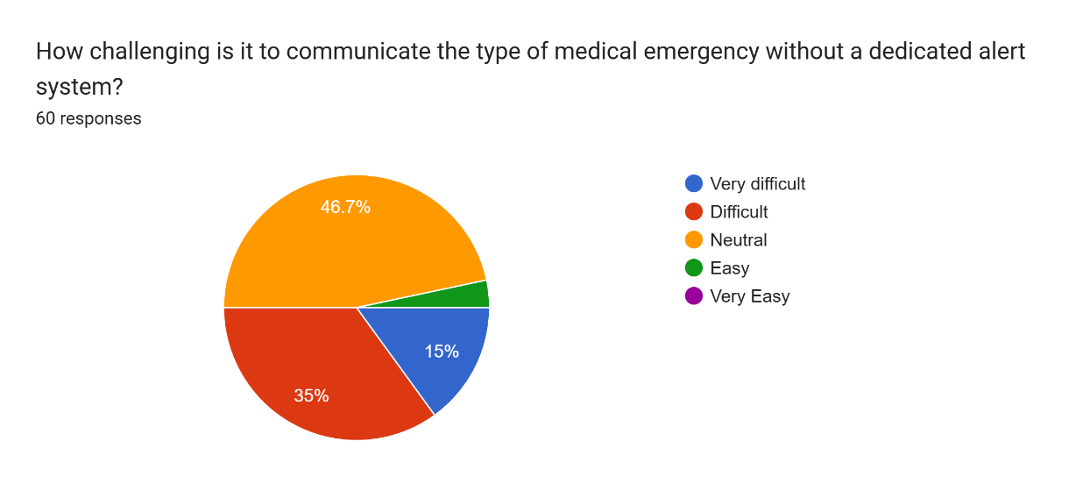
Figure 4.1: How Challenging

For the first question, 46.7% (28 respondents out of 60) answered Neutral; 35% (21 respondents) answered Difficult; and 15% (9 respondents) answered Very difficult. This revealed that most of the respondents find it challenging or are uncertain about communicating a medical emergency without a dedicated system.
- How often do you experience difficulty in alerting teachers or staff during a classroom medical emergency?
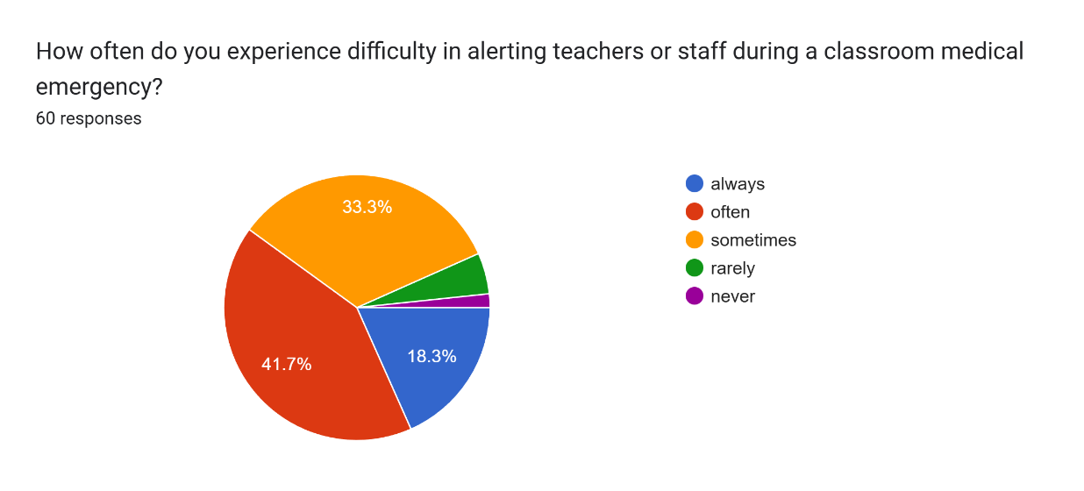
Figure 4.2: Difficulty Alerting

Regarding question number 2, 41.7% (25 respondents out of 60) answered Often; 33.3% (20 respondents) answered Sometimes; and 18.3% (11 respondents) answered Always. This indicated that a large majority of the participants frequently encounter difficulties when trying to alert staff during a crisis.

- How much faster do you think a digital alert system could notify teachers or staff during an emergency compared to traditional methods? 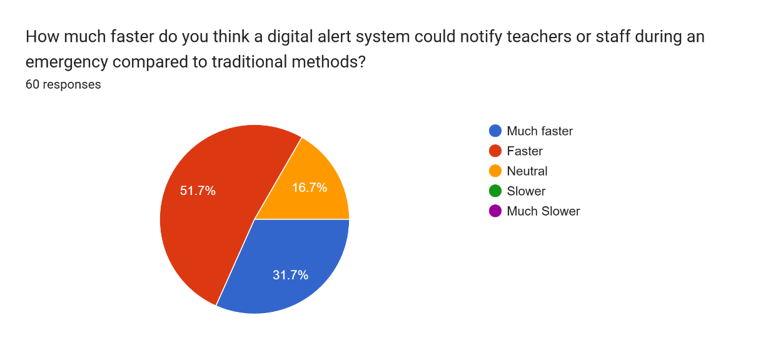
Figure 4.3: Faster/Improvement

Based on question number 3, 51.7% (31 respondents out of 60) answered Faster; 31.7% (19 respondents) answered Much faster; and 16.7% (10 respondents) answered Neutral. This confirmed that the respondents believe a digital alert system would drastically improve response speeds compared to current methods.

4. How helpful do you believe a digital alert system would be in ensuring timely response to emergencies?
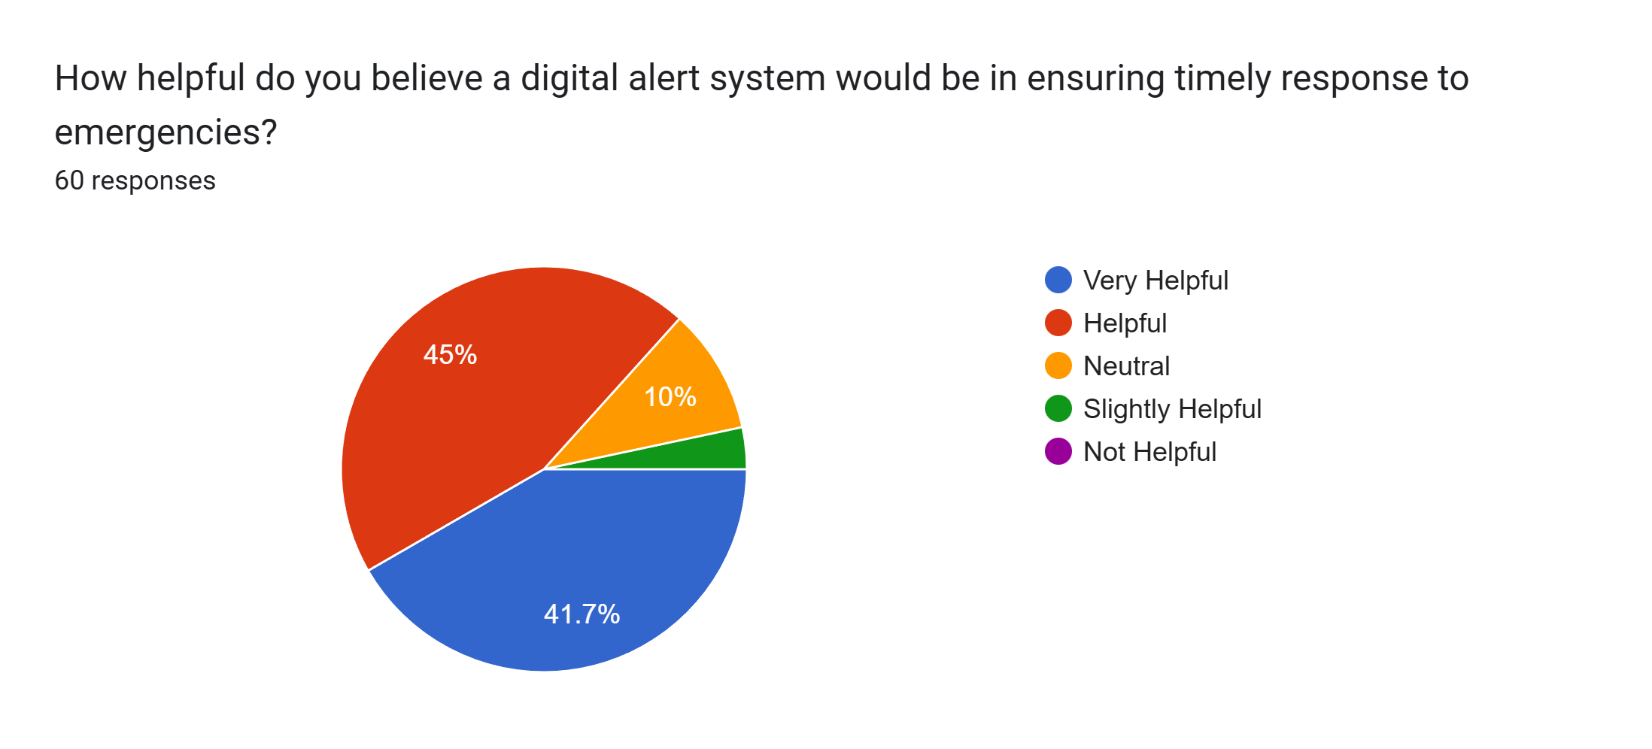

Figure 4.4: Helpfulness

When asked question number 4, 45% (27 respondents out of 60) answered Helpful; 41.7% (25 respondents) answered Very helpful; and 10% (6 respondents) answered Neutral. These results showed that the system is perceived as a valuable tool for ensuring timely emergency assistance.
5. During the simulation, how quickly were teachers or staff able to respond to an emergency alert using the button system? 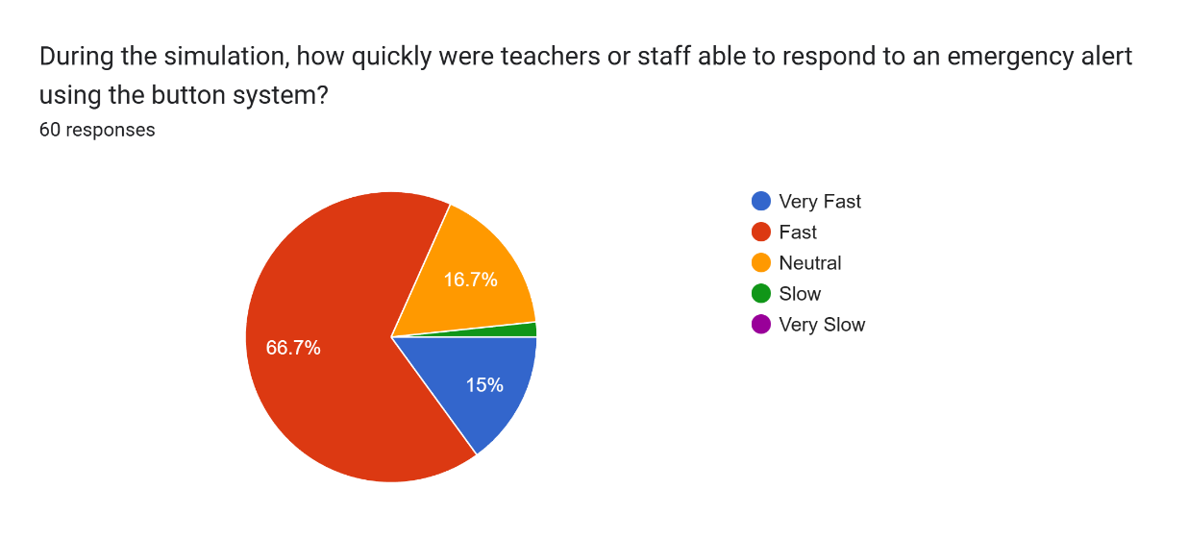
Figure 4.5: Response Time

Based on question number 5, 66.7% (40 respondents out of 60) answered Fast; 16.7% (10 respondents) answered Neutral; and 15% (9 respondents) answered Very fast. This demonstrated that the button system effectively facilitated a rapid response from staff during the simulation.
6. How effective was the alert button in improving communication compared to traditional verbal or manual reporting methods? 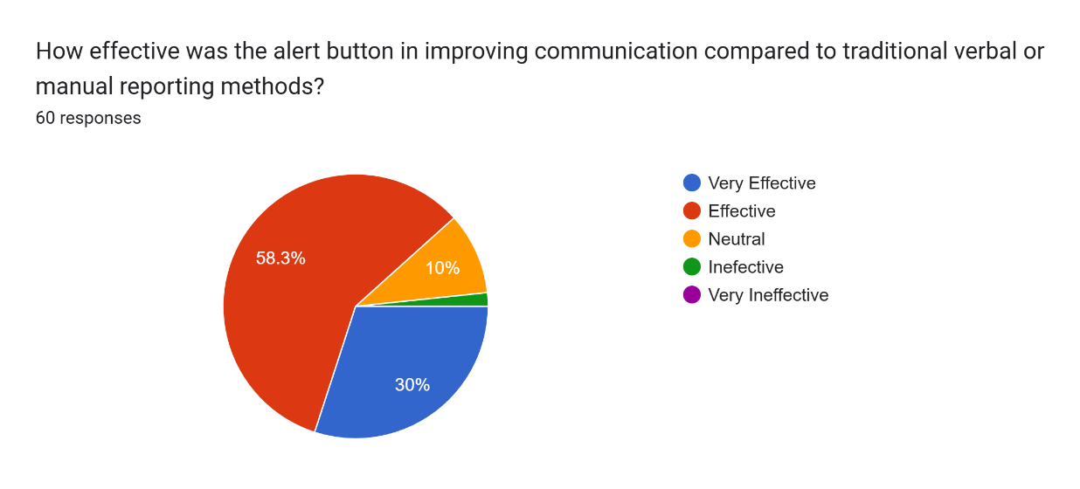

Figure 4.6: Effectiveness
In question number 6, 58.3% (35 respondents out of 60) answered Effective; 30% (18 respondents) answered Very effective; and 10% (6 respondents) answered Neutral. This highlighted that the alert button is a more efficient communication method than traditional verbal reporting.
7. How accurately did the alert button system indicate the type of medical emergency during the test?
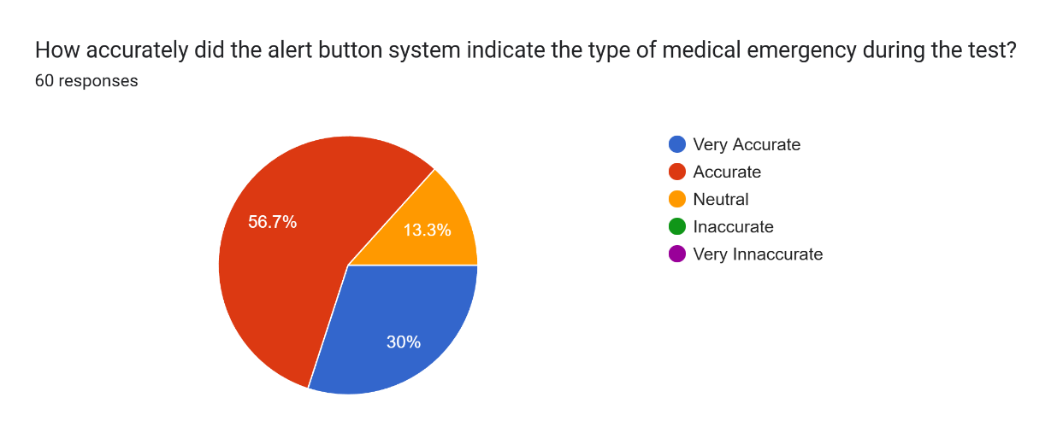

Figure 4.10: Accuracy
In question number 7, 56.7% (34 respondents out of 60) answered Accurate; 30% (18 respondents) answered Very accurate; and 13.3% (8 respondents) answered Neutral. These findings reflected high confidence in the system's ability to correctly identify the type of medical emergency.
8. How reliable do you think the system is in distinguishing different types of medical emergencies without verbal input?
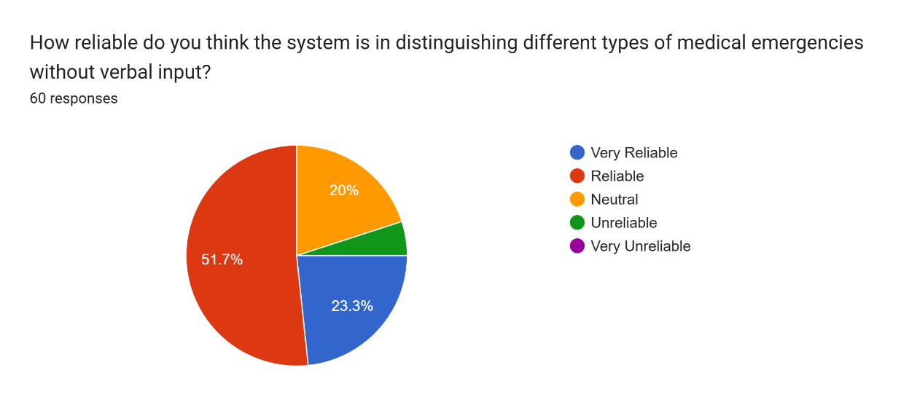
Figure 4.11: Reliability
Regarding question number 8, 51.7% (31 respondents out of 60) answered Reliable; 23.3% (14 respondents) answered Very reliable; and 20% (12 respondents) answered Neutral. This showed that the participants trust the system to function correctly even in situations where they cannot speak. In question number 9, 56.7% (34 respondents out of 60) answered Easy; 26.7% (16 respondents) answered Very easy; and 16.7% (10 respondents) answered Neutral. This revealed that the majority of users found the alert button design to be intuitive and simple to operate.
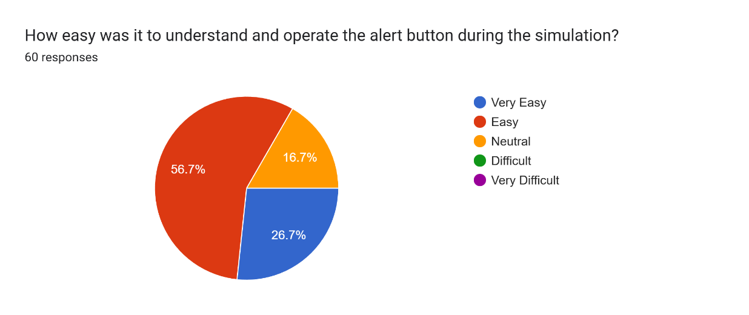

9. How easy was it to understand and operate the alert button during the simulation?

Figure 4.12: Simplicity

In question number 9, 56.7% (34 respondents out of 60) answered Easy; 26.7% (16 respondents) answered Very easy; and 16.7% (10 respondents) answered Neutral. This revealed that the majority of users found the alert button design to be intuitive and simple to operate.
10. How confident are you that you could use the alert button correctly in a real classroom emergency?
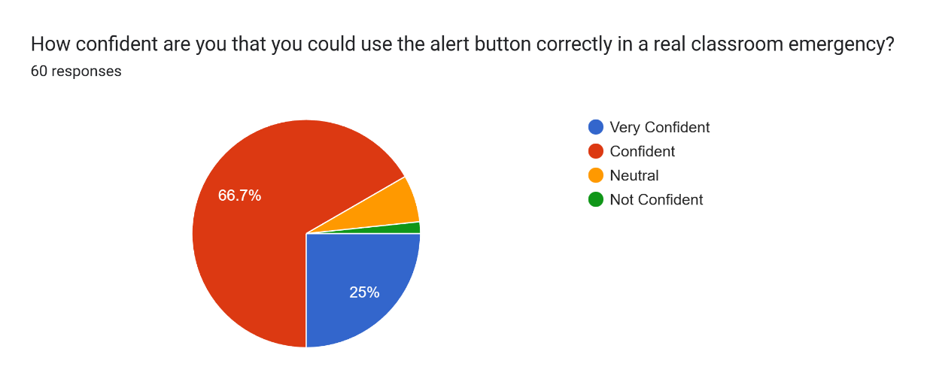

Figure 4.13: Confidence of Users
For question number 10, 66.7% (40 respondents out of 60) answered Confident; 25% (15 respondents) answered Very confident; and a few answered Neutral. This concluded that the respondents feel fully prepared to utilize the system during a real classroom emergency.

The Medical Emergency Alert Button System was evaluated through a survey which included 60 participants. The results show that most participants find it challenging or uncertain to communicate a medical emergency without a dedicated system, with 46.7% answering Neutral and 35% answering Difficult. The study found that 41.7% of participants experienced crisis alerting issues because staff members needed help while 33.3% of participants experienced these issues at times. The majority believed that digital alert systems would make response times better because 51.7% chose Faster and 31.7% chose Much faster. The system was also perceived as helpful, with 45% rating it Helpful and 41.7% rating it Very helpful. The simulation results showed that 66.7% of respondents believed the system allowed staff to react quickly while 15% of respondents experienced the response time as Very fast. The alert button received positive ratings from participants, who found it effective and efficient because 58.3% of participants considered it Effective and 30% of participants rated it Very effective. The system was considered reliable by 51.7% of respondents and very reliable by 23.3%, indicating trust in its functionality even when users cannot speak. The system turned out to be easy to use for most users, because 56.7% of users found it Easy and 26.7% of users found it Very easy. The system received strong emergency use confidence from respondents, because 66.7% of participants stated they were Confident and 25% of participants said they were Very confident. Overall, the survey results suggest that the Medical Emergency Alert Button System is seen as an effective, reliable, and user-friendly solution for improving emergency response in classrooms.

CHAPTER V

Summary, Conclusion and Recommendations

Summary
The Medical Emergency Alert Button System aims to improve safety and emergency response within classrooms by providing a fast, reliable, and user-friendly alert mechanism. The system operates through a web interface which requires a tablet device to function that is located in the third floor hallway and connects through wired speakers to the faculty office and school clinic. The button allows users to contact designated school staff members which include the school nurse and teachers inside the faculty for immediate medical assistance. The study involved 60 participants who evaluated the system through surveys and simulation testing. The results show that most respondents face challenges when communicating medical emergencies using traditional methods and believe that a digital alert system would significantly improve response time. The system received positive user feedback because it provided useful functions which operated with high accuracy and system reliability while remaining simple to operate and most users reported they could handle emergency situations with it. The Medical Emergency Alert Button System enables schools to conduct quicker emergency responses which maintain efficient organizational procedures according to the study findings.

Findings
Based on the survey results of 60 respondents, the study revealed that the existing method of reporting medical emergencies is often challenging and can be improved. The system enables participants to communicate emergency situations but many participants reported difficulties or uncertainties in using this system. The majority reported that they face difficulties which prevent them from properly notifying staff during emergency situations. The web-based alert button system allowed respondents to improve response time because most users selected either the "Faster" or "Much faster" options. The system provided essential emergency assistance which the users found to be useful and beneficial for their needs. The system enabled rapid staff response together with efficient communication according to respondents who took part in the simulation. The system correctly identified emergency types according to most participants who found it reliable and easy to use. The majority of respondents expressed confidence in operating the system during actual classroom emergency situations which indicates that users accepted the system and showed potential for using it in practical situations.

Conclusion
The web-based Medical Emergency Alert Button System shows effective classroom emergency response improvement. The system succeeds in delivering immediate alerts to school staff through its tablet interface and wired speaker system which eliminates delays that occur with standard reporting procedures. The system received positive feedback from participants who considered it easy to use and dependable because it functioned precisely as expected which creates higher chances of its usage in educational institutions. The system enables faster communication which results in better response coordination that protects student and teacher safety during medical emergencies.

Recommendations
Students - Students are encouraged to use the Medical Emergency Alert Button System during classroom emergencies to quickly notify school staff and ensure faster medical response. Regular practice and awareness training will help students become more confident in using the system.
Teachers and School Staff - School personnel should support the implementation of the system by monitoring alerts promptly and responding immediately during emergencies. They should also participate in training sessions to understand how the system works and how to act quickly when an alert is received.
School Administration - School administrators should consider installing the system in key locations, such as hallways and classrooms, and provide proper training for staff and students. The system can be used as part of the school’s emergency preparedness plan to improve overall safety.
School Clinic - The school clinic should maintain the alert system and ensure that the wired speaker and tablet are always functioning properly. Regular testing and maintenance are recommended to ensure reliability during emergencies.
Researchers - Future researchers may expand the study by testing the system in more classrooms and different schools to validate its effectiveness. Additional research could also explore integrating the system with external emergency services and improving system features such as notification methods, user interface, and scalability.

Bibliography

Implementation of an Institution-Based Emergency Alert Management System. (2024). ResearchGate.

LINK: https://www.researchgate.net/publication/370871966_Implementation_of_an_Institution_Based_Emergency_Alert_Management_System

EdTech Magazine. (2025). A unified system streamlines emergency alerts in K–12 schools.

LINK: https://edtechmagazine.com/k12/article/2025/06/unified-system-streamlines-emergency-alerts-k-12-schools

Crises Control. (2023). School mass notification system: Case study on safer emergency communication.

LINK: https://www.crises-control.com/blogs/school-mass-notification-system/

Panic Button Mobile Application Usability Study. (2022). International Journal of Engineering and Innovative Research.

LINK: https://dergipark.org.tr/en/pub/ijeir/issue/71193/1085846

Android-based Mobile Panic Button UI application. (2022). Emerald Insight.

LINK: https://www.emerald.com/ijes/article-abstract/11/3/445/130210/Android-based-Mobile-Panic-Button-UI-application?redirectedFrom=fulltext

Dual-Activation Emergency Situation Notification System (DA-ESNS). (2023). IET International Journal of Safety and Security Engineering.

LINK: https://www.iieta.org/journals/ijsse/paper/10.18280/ijsse.130406

Barriers and Best Practices for Inclusive Emergency Alerts and Warnings. (2025). International Journal of Disaster Risk Reduction.

LINK: https://www.sciencedirect.com/science/article/pii/S2212420925004054

Inclusive Alerts for Colorado: An Assessment and Recommendations for Language and Disability Considerations. (2025). Natural Hazards Center.

LINK: https://hazards.colorado.edu/uploads/freeform/Inclusive-Alerts_7-2-25.pdf

Emergency Alerts and Warnings and Language Access. (2023). Annotated Bibliography.

LINK: https://hazards.colorado.edu/uploads/freeform/annotated-bibliography-emergency-alerts-and-warnings-and-language-access.pdf

Abukhalaf, A. H. I., & Von Meding, J. (2021). Integrating international linguistic minorities in emergency planning at institutions of higher education. Natural Hazards.

LINK: https://link.springer.com/article/10.1007/s11069-021-04859-7

Appendixes

Parents Permit/Consent
Parent/Guardian Permission
Parent or Guardian’s Name: Ferna S. Fernandez
Address: #526 Casbah Sta. Rita Guiguinto Bulacan
Parent/Guardian’s Phone Number(s): 09972632018
As a parent/guardian of Jomarie S. Fernandez, I am aware that my son/daughter must complete a Senior Capstone Project.
For the project, my son/daughter has chosen to:
develop a Medical Emergency Alert Button System. This project is intended to provide a quick and reliable way to report medical emergencies, reduce response time, and improve safety through timely communication within the school or community.
I have read the Menu of Options for College & Career Ready Demonstrations manual and have reviewed it with my child. He/she has my permission to complete a Capstone Project on the topic listed above.

Parent/Guardian Signature:

Date: 01-19-2026

Parent/Guardian Permission
Parent or Guardian’s Name: Annabie Cabigao
Address: #314 purok 5 Daisy St. Sumapang Bata Malolos Bulacan
Parent/Guardian’s Phone Number(s): 09541805007
As a parent/guardian of Jean Gabrielle S. Cabigao, I am aware that my son/daughter must complete a Senior Capstone Project.
For the project, my son/daughter has chosen to:
develop a Medical Emergency Alert Button System. This project is intended to provide a quick and reliable way to report medical emergencies, reduce response time, and improve safety through timely communication within the school or community.
I have read the Menu of Options for College & Career Ready Demonstrations manual and have reviewed it with my child. He/she has my permission to complete a Capstone Project on the topic listed above.

Parent or Guardian’s Name: Michelle Mioten Carisma
Address: 149 Main Street Purok 3, Pritil, Guiguinto, Bulacan
Parent/Guardian’s Phone Number(s): 09777963444
As a parent/guardian of Nativity Rose C. Cunanan, I am aware that my son/daughter must complete a Senior Capstone Project.
For the project, my son/daughter has chosen to:
develop a Medical Emergency Alert Button System. This project is intended to provide a quick and reliable way to report medical emergencies, reduce response time, and improve safety through timely communication within the school or community.
I have read the Menu of Options for College & Career Ready Demonstrations manual and have reviewed it with my child. He/she has my permission to complete a Capstone Project on the topic listed above.

Parent/Guardian Signature:

Date: 01-19-2026
Parent or Guardian’s Name: Reynalyn Galang
Address: Rocka Village, Phase 5 Annex, Chico Street 2731 Tabang Plaridel, Bulacan
Parent/Guardian’s Phone Number(s): 09229271915
As a parent/guardian of Jejomar Prince E. De Guzman, I am aware that my son/daughter must complete a Senior Capstone Project.
For the project, my son/daughter has chosen to:
develop a Medical Emergency Alert Button System. This project is intended to provide a quick and reliable way to report medical emergencies, reduce response time, and improve safety through timely communication within the school or community.
I have read the Menu of Options for College & Career Ready Demonstrations manual and have reviewed it with my child. He/she has my permission to complete a Capstone Project on the topic listed above.

Parent or Guardian’s Name: Geraldine F. Villamil
Address: #058, Ilangilang St., Ligas, Malolos, Bulacan Bulacan
Parent/Guardian’s Phone Number(s): 09912429917
As a parent/guardian of Jaime F. Villamil, I am aware that my son/daughter must complete a Senior Capstone Project.
For the project, my son/daughter has chosen to:
develop a Medical Emergency Alert Button System. This project is intended to provide a quick and reliable way to report medical emergencies, reduce response time, and improve safety through timely communication within the school or community.
I have read the Menu of Options for College & Career Ready Demonstrations manual and have reviewed it with my child. He/she has my permission to complete a Capstone Project on the topic listed above.

Parent/Guardian Signature:

Date: 01-19-2026
Parent or Guardian’s Name: Renato Quintano Villarante
Address: 3770 St Ignatius Rocka Phase 7 Tabang Plaridel Bulacan Parent/Guardian’s Phone Number(s): 09666300406
As a parent/guardian of Khing Rennier P. Villarante, I am aware that my son/daughter must complete a Senior Capstone Project.
For the project, my son/daughter has chosen to:
develop a Medical Emergency Alert Button System. This project is intended to provide a quick and reliable way to report medical emergencies, reduce response time, and improve safety through timely communication within the school or community.
I have read the Menu of Options for College & Career Ready Demonstrations manual and have reviewed it with my child. He/she has my permission to complete a Capstone Project on the topic listed above.

Parent/Guardian Signature:

Date: 01-19-2026

Parent or Guardian’s Name: Emelyn Versoza Dalisay
Address: 628 Old Cagayan Valley Rd Taal Pulilan Bulacan Bulacan
Parent/Guardian’s Phone Number(s): 09757655249
As a parent/guardian of Kalvin Luis Dalisay, I am aware that my son/daughter must complete a Senior Capstone Project.
For the project, my son/daughter has chosen to:
develop a Medical Emergency Alert Button System. This project is intended to provide a quick and reliable way to report medical emergencies, reduce response time, and improve safety through timely communication within the school or community.
I have read the Menu of Options for College & Career Ready Demonstrations manual and have reviewed it with my child. He/she has my permission to complete a Capstone Project on the topic listed above.

Parent/Guardian Signature:

Date: 01-19-2026

Mentor Information
Capstone Mentor Name: Analyn V. Hernandez
(Capstone mentor cannot be an immediate family member and must be over 21 years of age.)
Phone: 09153140790 Email: analynhernandez@gmail.com
Occupation: Teacher
Name of Business/Company: ATEC Technological College, Inc.
Address: 495 Sta. Rita, Guiguinto Bulacan
Mentor Responsibilities
- Mentors are expected to verify a minimum of 25 hours of fieldwork on the Capstone Project Log Form.
- Mentors must evaluate and verify the completed project by signing the Capstone Project Log Form.

Mentor Signature: Analyn V. Hernandez

Date: 01-19-2026

Pictures of Procedure
DAY 1-3
Making of the website
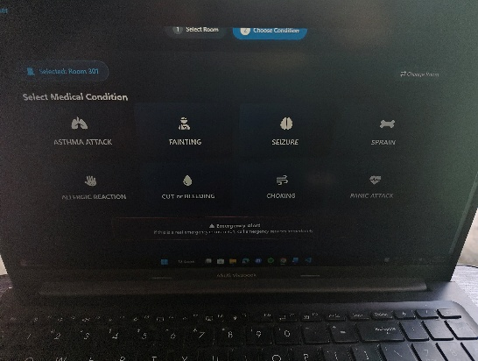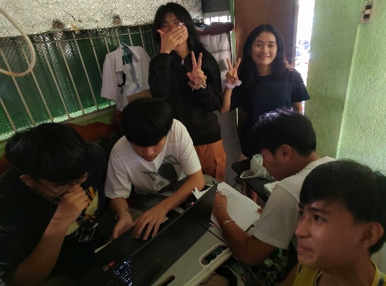

DAY 4
Testing of the wires of the wired speaker

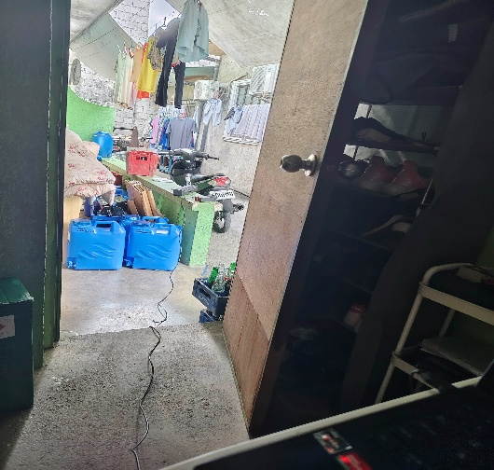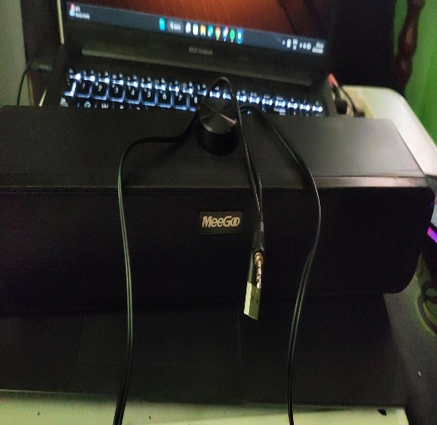
DAY 5
