Curso de Inglês:

Technical English for Reading and Comprehension

Happy is the man who findeth wisdom, and the man that getteth understanding. For the merchandise of it is better than the merchandise of silver, and the gain thereof than fine gold.
Proverbs 3:13-14

Most people I ask little from. I try to give them much, and expect nothing in return and I do very well in the bargain.
Francois Fénelon

He didn't see what I saw.
He didn't do what I did.
He didn't take what I took.
He didn't fly where I flew.
He didn't go where I went
He didn't drive where I drove.
Richard Vaughan – English Teacher

Lazy Mary, will you get up, will you get up, will you get up,
Lazy Mary, will you get up, will you get up today?
No, no Mother, I won't get up, I won't get up, I won't get up
No, no Mother, I won't get up, I won't get up today?.
Lazy Mary - Children's Song

If god had wanted us to fly, he would have given us tickets.
Mel Brooks

If you are a dreamer, come in,
If you are a dreamer, a wisher, a liar,
A hope-er, a pray-er, a magic bean buyer...
If you're a pretender, come sit by my fire
For we have some flax-golden tales to spin,
Come in! Come in!
Shel Silverstein

Version 0.1

Principals Words

Fonetics

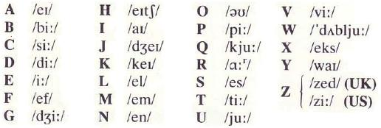

Question Words
How
What
When
Where
Which
Who
Whose
Whom
Why
How Many
How Much
How Often
How Far
How Long
How Wide
How Old
How Tall
How High

Frequency Adverbs
Always
Usually
Often
Sometimes
Hardly Ever
Never

Prepositions
In
On
Over
Under
Near
Next to
In front of
Opposite
Behind
Beside
Between
Among

Family
Father
Mother
Parent
Brother
Sister
Son
Daughter
Grandfather
Grandmother
Grandparent
Nephew
Uncle
Father-in-law
Mother-in-law
Cousin
Brother-in-law
Sister-in-law
Son-in-law
Daughter-in-law
Grandson
Granddaughter
Grandchild
Niece
Aunt

Parts of Body
Body
Bone
Head
Hair
Forehead
Eyebrow
Eyelash
Eyelid
Eye
Skin
Muscle
Neck
Throat
Back
Chest
Belly
Shoulder
Arm
Nose
Ear
Cheek
Mouth
Lip
Tooth
Tongue
Brain
Heart
Blood
Vein
Lung
Elbow
Hand
Finger
Nail
Leg
Knee
Foot
Stomach
Kidney
Liver
Intestine
Spine

Clothes
Hat
Scarf
Raincoat
Coat
Jacket
Glove
Pantaloons
Shoe
Boot
Slipper
Pyjamas
Dress
Waistcoat
Tie
Shirt
T-shirt
Suit
Underwear
Vest
Pants
Bra
Panties
Tights
Sock

Zones of Home
House
Door
Living Room
Foyer
Window
Wall
Floor
Ceiling
Roof
Chimney
Balcony
Hall
Dining Room
Bedroom
Bathroom
Study
Staircase
Garage
Garden
Kitchen
Toilet

Elements of Home
Table
Chair
Armchair
Sofa
Rocking Chair
Clock
Painting
Carpet
Mirror
Bath
Shower
Light
Lamp
Desk
Vase
Plant
Furniture
Upstairs
Closet
Chest of Drawers
Beside Table
Drawer
Shelve
Bed
Bedstead
Mattress
Pillow
Bedspread
Sheet
Blanket
Fireplace
Central Heating
Cooker
Fridge
Cupboard
Downstairs

Months
January
February
March
April
May
June
July
August
September
October
November
December

Seasons
Spring
Summer
Autumn (Fall)
Winter

Holidays
Christmas
New Year
Easter

Grammar 1 – To Be
The verb “To Be” is the “King” between the verbs, show in 70% in all this texts, this are your forms:
Present Tense
Affirmative |  | Negative |  | Interrogative
Singular | Plural | Singular | Plural | Singular | Plural
I'm | We're | I'm not | We're not | Am I? | Are we?
You're |  | You're not |  | Are you?
He's  she's  it's | They're | He's not  She's not  It's not | They're not | Is he  Is she  Is it? | Are they?

Past Tense
Affirmative |  | Negative |  | Interrogative
Singular | Plural | Singular | Plural | Singular | Plural
I was | We were | I wasn't | We weren't | Was I? | Were we?
You were |  | You weren't |  | Were you?
He was  She was  It was | They were | He wasn't  She wasn't  It wasn't | They weren't | Was he  Was she  Was it? | Were they?

Future Tense
Affirmative |  | Negative |  | Interrogative
Singular | Plural | Singular | Plural | Singular | Plural
I'll be | We 'll be | I won't be | We won't be | Will I be? | Will we be?
You'll be |  | You won't be |  | Will you be?
He'll be  She'll be  It'll be | They'll be | He won't be  She won't be  It won't be | They won't be | Will he be?  Will she be?  Will it be? | Will they be?

Present Perfect
Affirmative |  | Negative |  | Interrogative
Singular | Plural | Singular | Plural | Singular | Plural
I've been | We've been | I haven't been | We haven't been | Have I been? | Have we been?
You've been |  | You haven't been |  | Have you been?
He's been  She's been  It's been | They've been | He hasn't been  She hasn't been  It hasn't been | They haven't been | Has he been?  Has she been?  Has it been? | Have they been?

Conditional
Affirmative |  | Negative |  | Interrogative
Singular | Plural | Singular | Plural | Singular | Plural
I'd be | We'd be | I wouldn't be | We haven't be | Would I be? | Would we be?
You'd be |  | You wouldn't be |  | Would you be?
He'd be  She'd be  It would be | They'd be | He wouldn't be  She wouldn't be  It wouldn't be | They wouldn't be | Would he be?  Would she be?  Would it be? | Would they be?

Grammar 2 – Pronouns
Is the word used in place of name (substantive) for prevent your repetition and agree, in gender and number with substantive that represent.
Subject |  | Object |  | Possessive |  | Adjectives |  | Reflexive
Singular | Plural | Singular | Plural | Singular | Plural | Singular | Plural | Singular | Plural
I | We | Me | Us | My | Our | Mine | Ours | Myself | Ourselves
You | You | You | You | Your | Your | Yours | Yours | Yourself | Yourselves
He  She  It | They | Him  Her  It | Them | His  Her  Its | Their | His  Her  Its | Theirs | Himself  Herself  Itself | Themselves

Indefinite |  |  | Demonstrative |  | Relative |  | Interrogative
People | Things | Places | Singular | Plural | People | Object | Variable | Invariable
Someone  Somebody  Anyone  Anybody  Everyone  Everybody  No one  Nobody | Something  Anything  Everything  Nothing | Somewhere  Anywhere  Everywhere  Nowhere | This  That | These  Those | Who  Whom  Whose  That | Which  What  That | How much?  Many?  What? | What?  Who?  Where?

Exercices
01. I often see______ at the bus stop when I'm going to work. (their/they/theirs/them)
02. She is our neighbor. She lives near ____ since last year. (us/we/our/they)
03. Susan is my girlfriend._______ usually walk to work together . (us/our/we/they)
04. My father is a teacher. _____ teaches English twice a week at my school (their/theirs/His/He)
05. I study with my brother and he seats near _______ in the classroom. (their/theirs/them/me)
06. Paul and John are brothers. I know both of _______ very well. (their/theirs/they/them)
07. I always speak to ______ in English and he understands very well. (their/he/them/him)
08. What's the matter with _______ today? Susan looks very sad (me/she/them/her)
09. We like our teacher because he explains the lesson to _______ very clearly. (we/theirs/us/they)
10. Are there any letters for ________ today ? (their/they/I/me)
11. It's too much work for one. We need to divide it between _______ (us/theirs/we/she)
12. Sheila and Rosa aren't Mexican. _______ are both Brasilian (their/theirs/them/they)
13. I know Mary has a sister but I don't know _________ very well. (their/her/she/they)
14. Paul is the most intelligent student of ___ class. He always get good marks. (she/theirs/we/our)
15. To show his love for Mary David sends ______ a present evry month. (her/him/she/they)
16. He seldom speaks to _____ in Spanish because we don't know that language. (we/theirs/me/us)
17. They must take care of _______ lives as I take care of mine. (theirs/their/them/they)
18. The bread price has gone up again. That's the fourth time ______ 've increased it this year. (their/theirs/them/they)
19. Nobody will know the secret unless you tell ______ yourself. (their/theirs/them/they)
20. I've never seen such a strange rock band. It looks like ________ are crazy. (their/theirs/them/they)

Grammar 3 – Adjectives – Part 1
A city of Adjectives
Pete: New York can be called a City of Adjectives . Do you know why?
Dave:I really don't know, but I suppose it's because in New York many World Records were broken
Pete: You're right! In New York was built the first building using the idea of vertical city in the world.
Dave: Really? What building are you talking about?
Pete: The Empire State Building ! It was the highest building in the world in 1931.
Dave:Yeah I know it! But after even higher buildings were built, like the Twin Towers in the World Trade Center 420 meter high, that doesn't exist anymore. What else can you tell me about New York?
Pete: Well, at Rockefeller Center you have the largest theater in the world with more than 6,200 seats. Do You know its name?
Dave: It’s the Radio City Music Hall . I’ve been there to watch a Rock Concert.
Pete: You have also Macy´s which is self named as the world's largest store and in Manhattan there are the most expensive estates in the world. And the most famous statue in the world is in New York, It’s the...
Dave: Don’t tell me! It's the Statue of Liberty, right?
Pete: Yes right! It is 154 feet high statue which makes it one of the biggest sculptures in the world.
Dave: That’s the” Big Apple" I know. But there's a negative point in it. The worst crimes happened there, mainly at Central Park at night.
Pete: Well, nothing is perfect but the good part is bigger than the bad one. Don’t you think so?
Dave: Yes I do. In New York there's always someone or something that is richer,higher,faster,more beautiful or more dangerous than in any other place in the world.
Pete: So you see why it's called the City of Adjectives.
Dave: I do! Specially the superlative ones.
By the way: Big Apple is the nickname of New York City.

Comparative Degree
1 – Equality degree – AS + Adj. + AS
John is as tall as Fred
That plane is as fast as this one
Sharon is as attractive as Julia
2 – Superiority degree – Adj. + ER + Than
Peter is stronger than me
A horse is taller than a donkey
Mary is thinner than Susan
Honey is sweeter than sugar
Many men say the blondes are prettier than other women
• Many two syllable adjectives make the comparative using "more"
• Finish in: by/Y/ow/er/le, can have both forms:
Lovely - lovelier / more lovely
Shallow - shallower / more shallow
Slender - slenderer / more slender
• For majority (95%) with 2, 3 or more syllables, use: More + adj + than
Bob is more famous than his brother
She is more careful than his mother as a driver
You are more intelligent than Dave
Speaking English is more difficult than reading it
3 – Inferiority degree – Less + Adj. + Than
He is less famous than his brother
It is less hot today than it was yesterday
This lesson is less difficult than the previous one
REMEMBER – Adjectives are invariable
THIN man THIN men
THIN woman THIN women
SMALL car SMALL cars
If you found any word with similar an adjectives in plural, search your meaning, probably is a false friends. Examples: Good (adj.) - Goods New (adj.) - News

Grammar 4 – Adjectives – Part 2
Superlative Degrees
1 – Superiority – The + Adj. + EST + in / on
For adjectives with one or two syllables ending in Y/OW/ER/LE:
This is the cheapest car in the market
Jennifer is the loveliest girl in the classroom
She the thinnest girl in the group
• The most + Adj. + in/of... For adjectives of two or more syllables
This is the most modern car of all
He is the most intelligent student in college
That is the most famous soccer player in the world
• Some adjectives finish in Y/OW/ER/LE, make the superlative with MOST:
Lovely – loveliest / most lovely
Shallow – shallowest / most shallow
Slender – slenderest / most slender
Simple – simplest / more simple
2 – Inferiority - The Least + Adj. + in / of
He was the least important of all candidates
She is the least nervous student during the tests
That car is the least safe of the market
Some adjectives have irregular forms, see the table:
Normal | Comparative | Superlative
Bad | Worse | The Worst
Far | Farther | The Farthest
Far | Further | The Furthest
Good | Better | The Best
Little | Less | The Least
Many | More | The Most
Much | More | The Most
In general used when we talk about distance: Brasilia is farther than Rio from São Paulo
Used for "more complementary" or "a posteriori": I will send you further information next week. Wait for further confirmation.
Here are some Adjectives ready to use!
Normal | Comparative | Superlative |  | Normal | Comparative | Superlative
Bad | Worse | The worst |  | Big | Bigger | The biggest
Cheap | Cheaper | The cheapest |  | Cold | Colder | The coldest
Difficult | More difficult | The most difficult |  | Easy | Easier | The easiest
Expensive | More expensive | The most expensive |  | Famous | More famous | The most famous
Fast | Faster | The Fastest |  | Fat | Fatter | The fattest
Good | Better | The Best |  | Intelligent | More intelligent | The most intelligent
Lovely | Lovelier | The most lovely |  | Many / much | More | The most
Modern | More modern | The most modern |  | Old | Older | The oldest
Poor | Poorer | The poorest |  | Simple | Simpler | The Simplest
Small | Smaller | The Smallest |  | Strong | Stronger | The strongest
Sweet | Sweeter | The sweetest |  | Tall | Taller | The Tallest
Thin | Thinner | The Thinnest |  | Weak | Weaker | The weakest

Grammar 5 – Adjectives – Part 3
Adjective Order
In English normally use this order for the adjectives:
1 – Opinion: an interesting film, a boring person, a great concert.
2 – Dimension: a big house, a small dog, a thin book
3 – Age: a new car, a modern TV set, an ancient theater, an old person.
4 – Shape: a square picture, a round table, an oval loudspeaker.
5 – Color: a pink blouse, a blue tie, a yellow hat, a black suit.
6 – Origin: a Italian car, A Canadian girl, an American actor.
7 – Material: A wooden bed, an iron box, a plastic toy, a woolen sweater.
Examples:
• A new red Italian car. (observe the order: age/color/origin)
• I bought a beautiful new brown French leather coat. (observe the order: opinion/age/color/origin/ material)
• Dave has a big old red brick house. (observe the order: dimension/age/color/material)
• I saw a strange big new square white Japanese steel robot at the science fair. (observe the order: opinion/dimension/age/shape/color/origin/material)

Exercices
Mr. Smith is _________ than I thought (mais velho) oldest/old/oldrest/older
Chicago is as _____ as Paris (tão grande quanto) big/bigger/bigest/bigen
Today it is ________ than yesterday (menos frio que) colder/more cold/less cold/codest
This exercise is as ______ as the last one (tão facil quanto) easiest/coolest/easier/easy
Jane's cousin is ________ in our classroom (a mais alta) tall/high/the tallest/more tall
My car is __________ a Rolls Royce.(mais barato que) cheap/cheaper than/cheapest/cheap than
The weather in Caracas is ___ in New York (mais quente que) hotest/more hot/hot than/hotter than
They returned _______ from the beach this year (mais cedo) more early/earliest/early than/earlier
My teacher explains _______ yours (melhor que) best/gooder/better than/gooder than
She speaks French _______ she speaks English (tão bem quanto) so good than/more well/as well than/as well as
Grace is ________ in our classroom (a mais velha) the oldest/more old/older than/the more old
This is _______ book I've ever seen (o mais barato) more cheap/the cheapest/so cheap/the cheaper
Tom is _________ student is class (o pior) worst/the worst/badder/badest
Paul is _________ student of our class. He always get good marks. (o mais inteligente) very intelligent/less intelligent/more intelligent/the most intelligent
That rock show was ______ I've seen in my life (o melhor) the best/best/better/the better
The Herald is _________ newspaper in town (o mais importante) the more important/the importantest/the much important/the most important
Helen was the ________ girl in the party (a mais atraente) more attractive/most attractive/attractivest/attractivier
Which is ______ route from Miami to New Jersey? (a mais curta) the short/shorter than/more short/the shortest
Mount Everest is ________ mountain in the world.(a mais alta) the more hight/he higher/the highest/the more higher
These exercises are the _________in this site (mais fáceis) easier/more easy/less easy/easiest.

Answers from Grammar

Grammar 2
01. them
02. us
03. we
04. he
05. me
06. them
07. him
08. her
09. us
10. me
11. us
12. they
13. her
14. our
15. her
16. us
17. their
18. they
19. them
20. they

Grammar 3/4/5
01. older
02. big
03. less cold
04. easy
05. the tallest
06. cheaper than
07. hotter than
08. earlier
09. better than
10. as well as
11. the oldest
12. the cheapest
13. the worst
14. the most inteligent
15. the best
16. the most important
17. most atractive
18. the shortest
19. the highest
20. easiest

Read the Grammar
How can you best study and remember certain aspects of English grammar (e.g. tenses)? When reading English texts (lyrics, novels, news, textbooks) look out for the grammar aspect you want to remember. Mark it and reflect on why it is used there. Problems with the English tenses? Have a look at the time line, it might help you understand when to use which tense. As there is a similarity between past, present and future tenses, there are just a few rules to keep in mind. If you know how to use the present progressive correctly to express present actions, you will as well be able to use the past progressive correctly to express past actions.
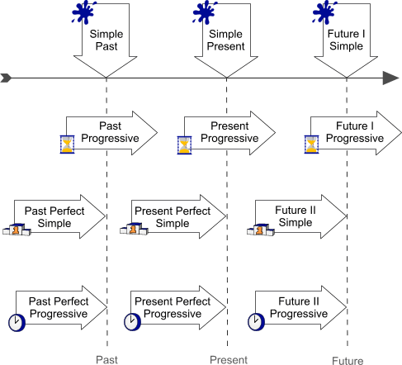
Legend
  moment in time | ■ action that takes place once, never or several times  ■ actions that happen one after another  ■ actions that suddenly take place
period of time | ■ action that started before a certain moment and lasts beyond that moment  ■ actions taking place at the same time
Result | ■ action taking place before a certain moment in time  ■ puts emphasis on the result
  Course / Duration | ■ action taking place before a certain moment in time  ■ puts emphasis on the course or duration of the action

Simple present is also called present simple.
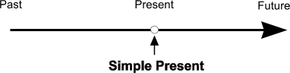
The simple present expresses an action in the present taking place once, never or several times. It is also used for actions that take place one after another and for actions that are set by a timetable or schedule. The simple present also expresses facts in the present.

Present Progressive
The present progressive puts emphasis on the course or duration of an action.
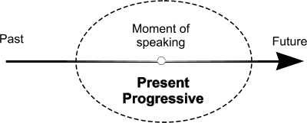
The present progressive is used for actions going on in the moment of speaking and for actions taking place only for a short period of time. It is also used to express development and actions that are arranged for the near future. Present progressive is also known as present continuous.
 | Explanation | Past | Present | Future
 |  | Simple Past | Simple Present | Future I Simple
Moment | Action that takes place once, never or several times | He played football every Tuesday. | He plays football every Tuesday. | He will / is going to play football every Tuesday.
Moment | Actions that happen one after another | He played football and then he went home. | He plays football and then he goes home. | He will play football and then he will go home.
Moment | State | He loved football. | He loves football. | He will love football.
 |  | Past Progressive | Present Progressive | Future I Progressive
Period | Action going on at that moment | He was playing football. | He is playing football. | He will be playing football.
Period | Actions taking place at the same time | He was playing football and she was watching. | He is playing football and she is watching. | He will be playing football and she will be watching.
 |  | Past Perfect Simple | Present Perfect Simple | Future II Simple
Result | Action taking place before a certain moment in time emphasizes the result | He had won five matches until that day. | He has won five matches so far. | He will have won five matches by then.
 |  | Past Perfect Progressive | Present Perfect Progressive | Future II Progressive
Duration | action taking place before a certain moment in time (and beyond), emphasizes the duration | He had been playing football for ten years. | He has been playing football for ten years. | He will have been playing football for ten years.

Read 1 – Present Tense
In North America when people meet each other for the first time, they talk about things like family, work, school, or sports. They ask questions like "Do you have any brothers or sisters?", "Where do you work?", "What school do you go to?", and "Do you like sports?", they also ask questions like "Where do you come from?" and "Where do you live?". These are polite questions. They are not personal or private.
But some things are personal or private, and questions about them are not polite. People don't ask questions about a person's salary. They don't ask how much someone paid for something. It is OK to ask children how old they are, but it is not polite to ask older people their age. It is also not polite to ask people questions about politics or religion unless you know them very well. People don't ask unmarried people "Why are you single?", and they don't ask a married couple with no children "Why don't you have any children?"

Read 2 – Past Tense
Yesterday was Saturday, John took his girlfriend Mary out dinner. The restaurants were crowded many people go out on Saturday nights.
John and Mary had to wait for a table. They waited for over an hour at the bar. They were not angry because the piano player was very good and the music nice and romantic. John had two shots of scotch and Mary two cocktails.
Finally the maitre d' showed them to their table. The restaurant was not as pleasant as the bar because is was noisy.
Mary ordered a shrimp cocktail. Sirloin steak with fried onions and French fries and apple pie with ice cream for dessert. John had a lettuce and tomato salad, roast beef with peas and mashed potatoes and peaches with cream for dessert. They had wince their meal and coffee with the dessert. The food was not very good but it is never really good on Saturday nights. They left the restaurant a little “high” and went to a discotheque. They didn't stay at the discotheque because it was too crowded and noisy.

Read 3 – Future (going to)
Mary's mother-in-law is ill. She is on a diet. Mary is going to the supermarket to buy fruit and vegetables for her. She's going to buy some apples, pears, peaches, figs, plums and bananas. She isn't going to buy any grapes because they're expensive. She's going to buy fish and chicken.
Mary's going to bet at the supermarket until 11 o'clock. Then, she is going home to prepare lunch. She's a good cook and so is her husband. Next Sunday they are going to prepare a good meal for the whole family. They are going to celebrate Mary's birthday.

Read 4 – Future (will)
John will go to the United States sometime next year. Before going he wants to improve his English, because he realizes that without knowing English, he will not be able to enjoy his trip. He will not understand people and people will not understand him. John is taking his English course very seriously.
John will not go in December because it is very cold there. It is too cold for a South American. Many Americans and Europeans like winter because they can skate and ski. April and especially May are beautiful months in the States. There are flowers everywhere, the weather is pleasant, and people are happy because the sun is warm. John will probably go in May if he can get his vacation that month. If not, he will have to go either in the summer or in the fall. Summers in the United States are very hot and not really different from summers here.
In the fall the weather begins to cool off, but it is a beautiful season; probably as beautiful as spring. The leaves begin to change color and fall is the season for fruit. Fruit in the United States is wonderful. If John cannot go in the spring, he will be in the States next fall.

Read 5 – Past Continuous
John and Mary decided to spend last weekend in the mountains. They got up early on Saturday, got the children, the bags and the dogs in the car and were on the road by 7 o'clock.
When they got out of town, they had their first problem. The motor started coughing and died. While John was looking at the motor, several cars stopped and people wanted to help him. But as usual, everyone was the worst mechanic but the advisor. Luckily a mechanic who was going by, stopped and fixed the car. Two hours later, much hotter and a bit upset, the were back on the road.
They were beginning to relax again when they had a flat tire. John had to take out all the baggage because the spare tire and the jack were way inside the trunk. While he was changing the tire, some drivers stopped to give him moral support. Finally after a lot of joking, they helped John and Mary put the baggage back into the trunk and the family was off again.
Fortunately, this was their last problem. They got to the hotel in the mountains while the guests were having lunch. They did not even bother to unload car. They washed up and joined the others for lunch. Everyone was awfully hungry after all that exercise and delay. The rest of their weekend was better and a lot more pleasant than that first morning.

Read 6 – Present Perfect
John and Mary have been engaged for six years. Six years ago Mary's parents gave them a big engagement party. They invited a lot of people because they wanted everyone to know that their daughter was getting married.
Ever since their engagement party John and Mary have seen each other several times a week. They have gone to movies and plays together. John has often had lunch or dinner at his fiancee's house John's life has been very pleasant and comfortable. He that a six-year engagement isn't long enough.
Mary has enjoyed this situation very much too. She has had constant escort who has been loving and understanding.
They have spent six pleasant years in perfect harmony. They feel that they know each other pretty well now but maybe in another six years they will know each other well enough to get married.

Read 7 – Present Perfect
John had a bad accident last weekend. It isn't the only one he's had since his father gave him his first car about two years ago. As a matter of fact he has already had half a dozen, including three bad ones where he completely wrecked the cars. Although John hasn't killed himself yet, there's a chance he will if he doesn't drive more carefully.
John's father is a wealthy businessman who gives John a lot of money but hardly ever any time and love. He says that he wants his son to have a better life than he's had, but probably John's life will be much shorter than his father's.
John's father is not completely responsible for his son's dangerous driving. If he stops buying John new cars everything he wrecks them it will help, but it's important that John starts growing up. He has already failed the college entrance exams three times because he learns more slowly than he drives. John says that he's very unhappy because the world is against him, but by the way he drives, it seems to be the other way round.

Exercices
Locate in the text, the following tenses:

■ Simple Past (Active) - action or situation in the past (emphasizes who did something)
■ Simple Past (Passive) - action or situation in the past (emphasizes what was done)
■ Present Perfect - action or situation over a period of time (from the past to the present)
■ Simple Present - situation now
■ Present Progressive - changing situation in the present

A Look at the Intriguing History of Snowboarding
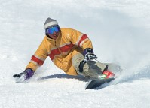
By Keith Kingston
To say who actually invented the sport of snowboarding would be impossible because people have always loved to slide down a snow-covered hill. Soaring through the snow on some kind of seat or board is nothing new. The ways to enjoy the snow are numerous, and people have devised ways to turn garbage can lids and cardboard into ‘snow boards’ to enjoy an afternoon frolic outdoors. The various ways to glide through snow have become more sophisticated and have evolved into using polished boards or skis in much the same manner as a surfboarded would ride a wave.
There have been many attempts at developing a modern snowboard. In 1965, the ‘Snurfer’ (a word play on ‘snow’ and ‘surfer’) was developed as a child’s toy. Two skis were bound together and a rope was placed at the front end to afford control and stability. Over 500,000 ‘Snurfers’ were sold in 1966 but they were never seen as more than a child's plaything even though organized competitions began to take place. The year 1969 brought a slightly more sophisticated snowboard based on the principles of skiing combined with surfboard styling.
The ‘Flying Yellow Banana’ was developed in 1977. This was nothing more than a plastic shell covered with a top surface like that of a skateboard, but at the time it was considered a major advance in the little known sport of snowboarding. The first national snowboard race was held in the area outside Woodstock and was known as ‘The Suicide Six.’ The race consisted of a steep downhill run called The Face in which the main goal was probably mere survival.
Snowboarding continued to increase in popularity over the next several years. In 1985 the first magazine dedicated specifically to snowboarding hit the news stands with huge success and furthered the popularity of this exciting sport. Hoards of fans began to organize regional events and pretty soon snowboarding events were held in all parts of the world. In the year 1994 snowboarding was finally declared an Olympic event, much to the delight of fans. The not-so-new sport of snowboarding was finally recognized and meant a huge victory for serious snowboarders across the globe.
A collection of snowboarding tricks and stunts was released on video in 1996. Filmed in Alaska, the breathtaking beauty and captivating snowboarding techniques featured in the video exposed snowboarding to a new generation, and by 1998 snowboarding constituted almost 50% of all winter activity. Today, nearly all ski resorts accept snowboarders. There are still a few holding on to the past but this is unlikely to continue as the number of snowboarders continually increases.
From the first crudely built snowboards to the advanced and specialized models available today, snowboarders have carried a ‘bad boy’ image. This rebel reputation is still common today in spite of the fact that snowboarding appeals to men, women, and children of all nationalities and social groups. At most major ski resorts you can find snowboarding gear, information, and lessons. Olympic and world wide snowboarding events are among the most popular of winter sports and the competition to be the best is fierce.
Retailers nation wide and around the world carry many types of snowboards, and the choice in specially made snowboarding gear is immense. Snowboarders have participated in the X Games and even charity events such as Boarding for Breast Cancer. From its early meager beginnings snowboarding has progressed into a fully recognized sport, and large numbers of people are turning to snowboarding for adventure, fun, and professional recognition.
Keith Kingston is a professional web publisher offering information on snowboards, skiing, ski vacations, snow removal and snowmobiles at all-4-snow.com.

Resume
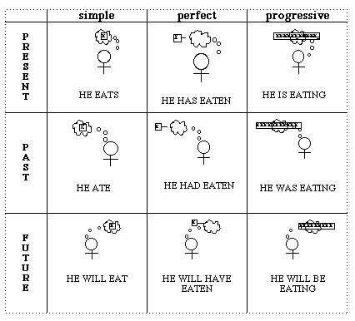

Answers from Read the Grammar

Simple Past (Active)
invented
began
brought
was
consisted
continued
hit
furthered
began
meant
exposed
constituted

Simple Past (Passive)
was developed
were bound
was placed
were sold
were never seen
was developed
was considered
was held
was known
were held
was finally declared
was finally recognized
was released

Present Perfect
have always loved
have devised
have become
have evolved
have been
have carried
have participated
has progressed

Simple Present
is
are
accept
increases
appeals
can
carry

Present Progressive
are turning

Verbs

Verbs Tenses in Images
Imagine new phrases in the Present Perfect for these images, e.g.:

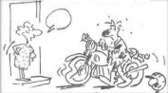
She is angry because he has torn his new clothes.
He is sorry because he has broken his motorbike.

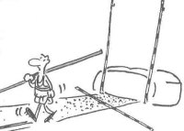 He is disappointed because he hasn't broken the record.
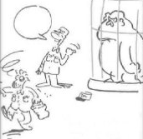 He is dizzy because the gorilla has hit him.
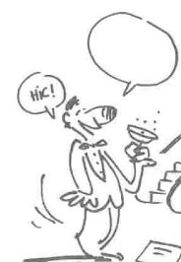 He is drunk because he has had too much champagne.
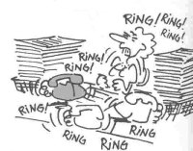 She is twitching because she has received too many phonecalls.

Irregular Verbs – Today / Yesterday
Practice conform example for another verbs, e.g.: (obs. Negative and Questions use DID)
Did you drive a bus yesterday? No, I didn't drive a bus yesterday. I drove my car yesterday.
List of Irregular Verbs
is / was
are / were
do / did
can / could
have / had
eat / ate
drink / drank
sit / sat
gets up / got up
sleeps / slept
meets / met
think / thought
go / went
come / came
read / read |redi|
leave / left
make / made
say / said |sede|
drive / drove
write / wrote
run / ran
see / saw
ear / heard |hurd|
take / took
swim / swam
sing / sang
ride / rode

How to Cook an Omelet
Choose the correct verbs.
1. ___ the eggs in a large bowl.
a. Add
b. Beat
c. Stir
2. ___ in the tiger prawns, chicken and mushrooms.
a. Add
b. Mix
c. Chop
3. ___ the oil in a large frying pan.
a. Heat
b. Mix
c. Stir
4. ___ the mixture into the pan.
a. Chop
b. Pour
c. Mix
5. ___ the mixture until it is golden brown.
a. Beat
b. Add
c. Cook
6. ___ the omelet on a large plate.
a. Put
b. Mix
c. Cook
7. ___ the omelet into squares and serve it.
a. Cut
b. Chop
c. Put

Transitive Phrasal Verbs
ASK OUT - I'm going to ask her out.
BACK UP - The senator backed up the President's economic plan.
BLOW OUT - He blew out the match after lighting the stove.
BLOW UP - The war plane fired a missile that blew up the bridge.
BREAK IN - Before you feel comfortable in your new shoes, you have to break them in.
BREAK OFF - The U.S. broke off relations with Cuba in the 1960's.
BREAK UP - Break up the chocolate in small pieces.
BRING ABOUT - Economic problems brought about the devaluation of the Brazilian real.
BRING FORWARD - The meeting has been rescheduled for an earlier time. They decided to bring it forward one week.
BRING IN - The government will bring in new legislation to prevent economic power abuse.
BRING UP - Parents have the responsibility to bring up their children.
BRUSH OFF - Pentagon brushes off criminal complaint against Rumsfeld.
BURN DOWN - The fire burned down the house in a short time.
BURN UP - We burned up all of the wood in the fireplace.
CALL OFF - I'm going to call off my medical appointment because I feel much better now.
CALL UP - I'm going to call up my sister tonight.
CALM DOWN - They're having an argument. Let's calm them down.
CARRY OUT - The manager has an assistant to carry out general tasks like typing and answering the telephone.
CHECK OUT - Where did you get this information? I'll check it out.
CLEAN UP - Clean up your room, please.
CLEAR UP - I'm going to the bank to clear up the problem with my credit card.
CLIMB UP - It takes more than 4 hours to climb up that mountain.
COUNT IN - If you are going for a picnic, count me in.
COUNT OUT - If you support the war, count me out!
CROSS OUT - I crossed out all the errors in the essay.
CUT OFF - The electric company cut off our service until we paid our bill.
DRIVE BACK - Our brave soldiers drove back the enemy forces.
FIGURE OUT - The technician figured out the problem.
FILL IN - We need your phone number. Please fill it in on this form.
FILL OUT - Fill out the application form, please.
FIND OUT - The journalist found out that the politician was lying.
GET BACK - I want to get my money back.
GET DOWN - Don't let this situation get you down.
GET OUT - Get out of here!
GIVE AWAY - She gave away her old dress.
GIVE UP - He gave up tennis.
HAND IN - Please answer the questions, put your name on this sheet and hand it in.
HAND OUT - The teacher handed out the answer sheet.
HANG UP - Hang up your coat in the closet after you take it off.
KEEP AWAY - Keep the children away from dangerous places.
KEEP OFF - Keep your hands off me!
KEEP ON - The company will keep him on the job.
KEEP UP - Keep up the good work.
KICK OFF - The bad players were kicked off the team.
KNOCK DOWN - He was knocked down three times during the fight.
LEAVE BEHIND - My books were too heavy, so I left them behind at the school.
LET DOWN - Don't let me down.
LET IN - Let me in!
LET OUT - I let the dog out and the cat in.
LIGHT UP - Light up the candles with these matches.
LOCK UP - The police locked him up.
LOOK UP - You have to look up the dollar exchange rate every day.
MAKE UP - You can attend classes on Saturdays to make up for the classes you missed.
MARK DOWN - The shoes are really cheap. The store has marked them down by 30%!
PASS OVER - Don't bogart that joint my friend, pass it over to me.
PAY BACK - I'll pay you back as soon as I can.
PICK UP - He picked up the newspaper to read.
PLAY DOWN - He tries to play down the seriousness of his wife's illness.
POINT OUT - He pointed out the boat in the distance.
PULL OFF - Nobody thought he could win the election, but he pulled it off in the end.
PULL OVER - The police pulled him over for speeding.
PUMP UP - The coach really knows how to pump up the team.
PUT AWAY - Put your things away and clean up the room!
PUT BACK - When you are finished reading the book, please put it back on the shelf.
PUT DOWN - He put down the newspaper and took off his glasses.
PUT OFF - I think I'll have to put off my dental appointment.
PUT ON - He took his glasses out of his pocket and put them on.
PUT OUT - The firemen put out the fire.
PUT TOGETHER - They are planning to put together a new company.
RIP 0FF - The man who ripped me off is well-known to the police.
RULE OUT - The government ruled out a cut in income tax.
RUN OVER - He ran over my bicycle with his car.
SET APART - The quality of his work sets him apart from other painters.
SET UP - He had a wealthy and influential father, who set him up in business right after college.
SEX UP - They say that intelligence was sexed up to provide a reason to go to war.
SHUT DOWN - Shut the computer down and let's go.
SHUT OFF - A device that automatically shuts off the gas in case of an earthquake.
SORT OUT - After collecting all the information, we have to sort it out.
SPELL OUT - Let me spell out the problem again.
STAND UP - Her new boyfriend stood her up on their second date.
TAKE APART - In order to fix the machine you have to take it apart.
TAKE AWAY - Take it away from here.
TAKE BACK - You should take back your purchase if you are not satisfied.
TAKE OFF - Hang up your coat in the closet after you take it off.
TAKE OUT - He took his glasses out of his pocket and put them on.
TAKE OVER - Our teacher is leaving and a new one is taking over next week.
TAKE UP - I'm planning to take up English next semester.
TALK OUT - I'm going to drink tonight and don't try to talk me out of it.
TALK OVER - We should talk over the plan and come to an agreement.
TEAR DOWN - The old building is going to be torn down.
THROW AWAY - Did you throw those papers away?
THROW OUT - Did you throw out the old newspapers?
TRY ON - She's going to try on the new dress.
TRY OUT - He's going to try out the new car.
TURN DOWN - He turned down the job offer.
TURN IN - The witnesses turned the thief in to the police.
TURN OFF - I turned the TV off and went to sleep.
TURN ON - Mike turned on the gas heater.
WAKE UP - Wake up the children!
WARN OFF - Authorities in Rio warn off tourist from taking city buses.
WASH DOWN - We had a sandwich washed down with beer.
WORK OUT - I was unable to work out the crossword puzzle.
WRITE DOWN - Why don't you write it down, so that you don't forget it.

Intransitive Phrasal Verbs
BACK OUT - I hope he doesn't back out of the deal.
BREAK DOWN - The poor woman broke down in tears.
BREAK UP - The couple decided to break up after their argument.
CATCH ON - The teacher repeats grammar exercises until the students catch on.
COME BACK - He came back to Brazil after two years abroad.
DIE OUT - Many languages have died out in the history of mankind.
EAT OUT - We don't have any food at home. Why don't we eat out?
FALL OFF - The door handle fell off.
GET DOWN - When I saw the boy up in the tree, I told him to get down.
GET UP - I usually get up early.
GIVE IN - He gave in to the pressure.
GO BACK - Why don't you go back home?
GO OFF - I'm sorry I'm late; my alarm didn't go off.
GO UP - Peace agreements and international cooperation will go up like colorful balloons bringing joy to the world.
GROW UP - He wants to be a doctor when he grows up.
PULL OUT - The best player pulled out of the tournament because of an injury.
SETTLE DOWN - When he was about 30 he decided to settle down and raise a family.
SHOW UP - She waited for an hour but he never showed up for the date.
SHUT UP - Shut up and listen to me!
SINK IN - Reality is finally beginning to sink in for the supporters of the former government.
SIT DOWN - Sit down, please.
SLEEP IN - Every morning I sleep in now that I'm retired.
STAND UP - You have to stand up when the national anthem is played.
STAY OVER - It's late to drive home. Why don't you stay over?
STRIKE BACK - The empire strikes back.
THROW UP - After getting totally drunk he started to throw up.
TURN UP - I invited a lot of people but only a few turned up.
WORK OUT - From now on, instead of eating junk food, I'm going to work out at the gym.

Prepositional Verbs
ALLOW FOR - Airplane passengers should allow for delays at the check-in counter.
APPLY FOR - He wants to apply for the job.
APPROVE OF - My mom doesn't approve of me arriving home after midnight.
ATTEND TO - The clerk will attend to your problem as soon as she is free.
BREAK INTO - We put an alarm in our house after a thief broke into it last year.
CALL FOR - The job calls for English fluency.
CALL ON - I sometimes call on my friends for help with problems.
CARE FOR - He is not the kind of person who cares for others.
CHEAT ON - Mary's husband has been cheating on her.
COME ACROSS - He came across an old friend.
COMMENT ON - The reporter commented on the need for better health care.
CONFORM TO - The army requires that all soldiers conform to strict rules.
CONSENT TO - He will only consent to signing the contract if it complies with his demands.
COUNT ON - We can't count on you because you are never here when we need you.
DEAL WITH - You'll have to deal with the situation.
DO WITHOUT - I don't have a car, so I'll have to do without one until I get a job.
GET INTO - She got into the Federal University in her first try.
GET OVER - She got over the flu after being sick for a week.
GO INTO - I went into the museum when it started raining.
GO OVER - She will go over the essay to check for errors.
GO THROUGH - My grandmother went through difficult times when my grandfather died.
INSIST ON - I insist on having a native speaking English teacher.
LEAF THROUGH - I like to leaf through books at the bookstore but I rarely buy any.
LISTEN TO - I like to listen to jazz music.
LIVE ON - They live on a small retirement pension.
LOOK AFTER - When you grow up you'll have to look after your parents.
LOOK FOR - What are you looking for?
LOOK INTO - I'll look into that matter after the meeting.
RESORT TO - There is no need to resort to violence when resolving a problem.
RUN INTO - I ran into an old friend yesterday.
SEND FOR - You are very sick. I'll send for the doctor.
STAND BY - He stood by her during the good times and the bad.
STAND FOR - BBC stands for British Broadcasting Corporation.

Phrasal Prepositional Verbs
BE UP TO - He'll probably fail; he's not up to the challenge.
BREAK UP WITH - I broke up with girlfriend.
CARRY ON WITH - The doctor told her to carry on with the treatment.
CATCH UP WITH - I've been getting low grades, but I'll study hard and catch up with the other students.
CHECK OUT OF - You have to check out of the hotel before noon.
COME UP TO - He came up to me and said: 'you are under arrest'.
COME UP WITH - He came up with an unbelievable explanation.
CRACK DOWN ON - The police need to crack down on burglary.
DO AWAY WITH - The school should do away with some of the regulations.
DROP OUT OF - Teenagers are dropping out of school in large numbers.
FOOL AROUND WITH - He's been fooling around with girls for years.
GET ALONG WITH - How are you getting along with your girlfriend?
GET AWAY WITH - He got away with shoplifting at first, but now he's in trouble.
GET BACK AT - I'm going to get back at him for what he did.
GET BACK FROM - She's just got back from her trip.
GET DOWN TO - The boss told us to stop fooling around and get down to work.
GET ON WITH - It seems that he's getting on well with his new girlfriend.
GET OUT OF - Get out of here!
GET THROUGH WITH - I have to get through with my work first.
GO DOWN ON - The book provides step-by-step instructions for going down on a woman.
KEEP OUT OF - Keep out of this room.
KEEP UP WITH - Keep up with the good work.
KICK OUT OF - The rowdy man was kicked out of the bar.
LOOK FORWARD TO - We are looking forward to meeting you.
LOOK OUT FOR - Look out for the careless drivers.
PUT UP WITH - I'm not going to put up with it.
RUN AWAY WITH - Don't let your emotions run away with you.
RUN OUT OF - They ran out of gas in the middle of the desert.
SUCK UP TO - Now that he's the boss they're all sucking up to him, hoping to get big raises.
WATCH OUT FOR - Watch out for the careless drivers.

Answers from Verbs

Verbs – How to Cook an Omellete
1. b
2. a
3. a
4. b
5. c
6. a
7. a

Read the Journal

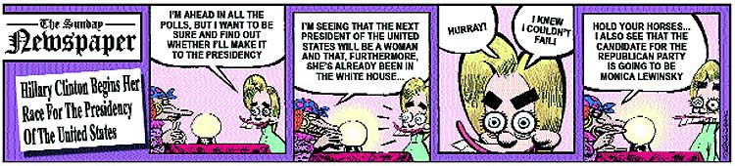

Read 1 – Twitter Scams Proliferate in tough Economy
July 6, 2009
Scams have arrived on Twitter. Credit: waltercolor via Flickr. The hot spot for online scam artists has moved again -- from e-mail and Google to Twitter, according to the Better Business Bureau. Websites, e-mails and tweets have been popping up since late spring promising to help job seekers make hundreds of dollars a day, simply by tweeting from home. But here's the hitch: Customers first have to sign up for a “free” trial for an informational CD or training packet and submit their credit card information to pay a minor shipping fee. Most people don't notice the provision, nestled deep in a mass of terms and conditions, that the trial period begins when the customer places the order and includes the time spent shipping the product. What happens next, according to the bureau, is that customers don't cancel their membership in time and end up shelling out $50, even $100 or more, every month. Unfortunately, high unemployment caused by a rough economy makes people especially vulnerable to such schemes. (L.A. Times)

Read 2 – Google Plans a PC Operating System
July 8, 2009
In a direct challenge to Microsoft, Google announced late Tuesday that it is developing an operating system for PCs that is tied to its Chrome Web browser. The software, called the Google Chrome Operating System, is initially intended for use in the tiny, low-cost portable computers known as netbooks, which have been selling quickly even as demand for other PCs has plummeted. Google said it believed the software would also be able to power full-size PCs. The move is likely to sharpen the already intense competition between Google and Microsoft, whose Windows operating system controls the basic functions of the vast majority of personal computers. “Speed, simplicity and security are the key aspects of Google Chrome OS,” said Sundar Pichai, vice president of product management, and Linus Upson, engineering director, in a post on a company blog. “We're designing the OS to be fast and lightweight, to start up and get you onto the Web in a few seconds.” Mr. Pichai and Mr. Upson said that the software would be released online later this year under an open-source license, which would allow outside programmers to modify it. Netbooks running the software will go on sale in the second half of 2010. (The New York Times)

Read 3 – The typing monkey
July 4, 2009
You know the theory. A monkey randomly hitting typewriter keys for an infinite amount of time will eventually write the works of Shakespeare. The idea has been hotly debated in pubs for years. Now it is being put to the test. But instead of trying to write Hamlet, Jimmy the monkey is taking bets on whether or not he can type your name. The makers of theluckymonkey.net – who say no monkeys are being hurt in the experiment – reckon the odds on him writing my first name are more than 13 million to 1. On the other hand, the odds of my winning the lottery are 50 million to 1. The first chimp on Twitter, Jimmy is also typing short tweets so we can follow his progress. - However, the chances of Jimmy writing a name any time soon don't look great. His tweets are gobbledegook, and a video of him in action shows a chimp who seems keener on peeling bananas than on typing. The debate looks to remain unsettled for some time yet. (The Times)

Read 4 – Nokia: Not Smart Enough This Time
July 13, 2009
In most of the world, Nokia is synonymous with mobile phones. Whether it's building cheap handsets for emerging markets or selling sophisticated smartphones in Europe, Nokia is a dominant player, with more than 36% of global volume, according to market analyst Gartner Group (IT). Yet in the U.S., the Finnish giant is an also-ran.
"We are the incumbent in the world at large," says Nokia CEO Olli-Pekka Kallasvuo. "In the U.S., we are the underdog." Yet despite the challenges of a market chock-full of interesting smartphones from the likes of Apple, Palm, and Research In Motion, Nokia, which has made several previous efforts to be a top-tier handset supplier in the U.S., is making one more try to expand its toehold in the market by bringing in some high-end products. "The only possibility," says Kallasvuo, "is to push something that is good, strong, and appealing enough."
The E71x is a perfectly good product, with all the features a smartphone user has come to expect: 3G and Wi-Fi networking for fast data; good e-mail, including support for corporate systems using Microsoft Exchange; a decent Web browser based on the same WebKit software used by the iPhone; solid music and video players; and a 3.2-megapixel video-capable camera.
The problem is that it will be difficult to make a dent in such a crowded field with a product that lacks truly distinctive features. Making matters worse, the E71x comes up short in downloadable software applications, which have played at least as big a role in the iPhone's success as any feature of the device itself. Nokia is gathering the thousands of apps available for its phones into its Ovi store, but AT&T is not making the store accessible to E71x users "at this time," a company spokesman says without elaborating. That leaves customers with the lame offerings of AT&T's MEdia Mall—mostly ringtones, wallpaper, and a few games. For all of these reasons, Nokia's assault on the U.S. market is likely to be ineffectual. And that's a shame for consumers, because the company makes some of the world's most interesting, not to mention popular, handsets. (Business Week)

Read 5 – Nascar gives Ask.com time for a few more laps
July 10, 2009
Ask.com is still fighting for a piece of the search market, hoping that Nascar dads can give it a leg up against Google, The Intimidator of search. Dale Earnhardt's car was No. 3, but Ask.com is No. 4 in the search market, trailing Google, Yahoo, and Bing among active searchers. Still, Scott Garell, president of Ask Networks, believes that his company can grow its presence in search as the market comes around to Ask's longtime strategy of presenting Internet search as a series of questions and answers. "We spend a lot of time figuring out how we can answer questions better than everybody else," Garell said. Ask thinks that the rise of semantic search--the idea that a search engine will understand the intent behind your query, not just the keywords--complements its approach to presenting search results.
All major search engines are examining different ways of presenting search results with semantic technology in mind. The idea is to allow queries to be presented in a more natural format instead of a series of keywords, and to present results with different types of data--pictures, graphs, videos, and the like--rather than page after page of search results. Of course, the quality of your search results only matters from a business perspective if people use your site to conduct searches and click on an ad every now and then. This is a fundamental question for everyone whose brand is not synonymous with the verb "to search": Yahoo says it attracts searches from the massive traffic it enjoys on its myriad properties, and boosting that traffic will boost searches. Microsoft is spending millions of dollars to market Bing as a superior search experience. It's hard to see how Ask.com can break out of its niche, but the company is certainly trying something different in the search market, which always bears watching. Old habits die hard, however; the company has brought back Jeeves the butler in the U.K. in response to popular demand. (cnet News)

Read 6 – Samsung to invest in green future
July 20, 2009
Samsung says it wants to develop energy-efficient products. The giant South Korean company Samsung Electronics has said it will invest more than $4bn (£2.4bn) to cut emissions from its plants. The company also said it wants to develop more energy-efficient products. It said it hoped that by the year 2013, the greenhouse gas emissions from its manufacturing facilities will be reduced by 50%. It also wants to develop its range of more energy-efficient products, such as new refrigerators and air conditioners. The company's green initiative follows the South Korean government's plan to pursue an environmentally friendly agenda. South Korea is the world's tenth biggest producer of greenhouse gases and has vowed to spend $84 bn over the next five years on improving energy efficiency and reducing pollution. Analysts believe that combined efforts between the public and private sectors would help boost economic growth as well as reducing greenhouse gases. (BBC News)

Read 7 – Why did Big Brother remove paid-for content from Amazon's Kindles?
July 22, 2009
George Orwell always had a fine ear for hypocrisy. Even so, quite what he would have made of last week's Kindle debacle, in which Amazon was accused of tactics reminiscent of Big Brother, is unclear. When it emerged that the company had secretly deleted copies of Orwell's novels from people's Kindle ebook readers because of a legal issue, the irony was too delicious to ignore: the writer who best charted authoritarian attitudes in 1984 and Animal Farm had become the victim of a sort of eerie censorship. It turned out to be a copyright issue – MobileReference, the company that sold the copies, did not have the rights to use Orwell's work; the ebooks had slipped through the net and Amazon was trying to erase its mistake. The removal was enough to set off angry customers and, despite the company's efforts to try and explain the mix-up, the outrage continued.
"Being able to pull the books out of your paid-for and legal library doesn't sound right," wrote one puzzled user on the Kindle Boards website. "Once it's sold, they no longer own the rights to that copy, or at least, that's what I thought." Others verged on the splenetic. "Amazon offered a product, which I legally purchased, and had in my possession until their electronic burglar stole it from me," said another affected user. "Amazon has no right to go into my Kindle's memory and delete something without my knowledge or permission."
Why were people so offended? Customers weren't really angry about the gadget, or the legality of the booksin question – they were furious with the sleight of hand Amazon performed by secretly removing them from their machines. They were aggrieved because they thought they had bought the books when in fact, it turned out, they were merely renting them. "We have long been concerned that digital rights management is essentially tricking people," says Cindy Cohn, legal director of the Electronic Frontier Foundation, the campaign group based in San Francisco. "It's creating a situation where people think they've purchased something – in the way you might purchase a pair of shoes, for example. But from the perspective of the seller, and often from the perspective of the law, it's quite a lot less.". (The Guardian)

Lesson 1 – Any and Some
Use "some" in positive sentences. We use some for both countable and uncountable nouns:
- I have some friends.
Use "any" in negative sentences or questions. We use any for both countable and uncountable nouns:
- Do you have any cheese?
- He doesn't have any friends in Chicago.
Use "some" in questions when offering or requesting something that is there:
- Would you like some bread? (offer)
- Could I have some water? (request)
Use "any" in negative sentences or questions. We use any for both countable and uncountable nouns:
- Do you have any cheese?
- He doesn't have any friends in Chicago.
Use "some" words - somebody, someone, somewhere and something - in positive sentences:
- He lives somewhere near here.
Use "any" words - anybody, anyone, anywhere and anything - in negative sentences or questions:
- Do you know anything about that boy?
- She doesn't have anywhere to go.

Exercises
01: Is there ________ who can help me? (anyone / someone)
02: I don't have ____ friends in Chicago. (any / some)
03: Have we got ___ milk in the fridge? (any / some)
04: Janet has ____ money in the bank. (any / some)
05: Would you like ____ cream in your coffee? (any / some)
06: He doesn't have _____ milk in the fridge. (some / any)
07: Could I have ____ water, please? (any / some)
08: Would you like _____ coffee after dinner? (any / some)
09: She has _____ time to help you today. (any / some)
10: My friends said ________ would be here today. (anyone / someone)

Lesson 2 – Prepositions of Place
IN
Use 'in' with spaces:
- in a room / in a building
- in a garden / in a park

Use 'in' with bodies of water:
- in the water
- in the sea
- in a river
Use 'in' with lines:
- in a row / in a line
- in a queue
AT
Use 'at' with places:
- at the bus-stop
- at the door
- at the cinema
- at the end of the street
ON
Use 'on' with surfaces:
- on the ceiling
- on the wall / on the floor
- on the table
Use 'on' with small islands:
- I stayed on Maui.

Use 'on' with directions:
- on the left
- on the right
- straight on
TO
Use 'to' with movement from one place to another:
- I went to school.
- Did you go to work?
- Let's go to the shopping mall.
DO NOT Use 'to' with 'home'

Commons Expressions
AT | IN | ON
At once  At dinner, at breakfast  At war, at peace  At last, at least | In a hurry  In fun, in earnest  In love  In public, in private  In danger, in trouble | On holiday, on vacation  On business  In foot, on horseback  One one’s own  On the contrary, on the other hand

Exercises
01: That is a beautiful painting ____ the wall. (in/at/on/to)
02: Did you go _____ school last week? (in/at/on/to)
03: He works ____ a bank. (in/at/on/to)
04: Let's meet ____ the museum. (in/at/on/to)
05: We went ____ a concert yesterday evening. (in/at/on/to)
06: Put the book ____ the table. (in/at/on/to)
07: I met my wife _____ the university. (in/at/on/to)
08: I drove _____ Seattle last weekend. (in/at/on/to)
09: He is ____ the building. (in/at/on/to)
10: It's _____ the city center, isn't it? (in/at/on/to)

Lesson 3 – Prepositions of Time
Read the story below:
I was born in Seattle, Washington on the 19th of April in 1961. Seattle is in the State of Washington in the United States. That was many years ago. Now, I live in Leghorn in Italy. I work at the British School. I sometimes go to a movie on the weekend. I meet my friends at the movie theater at 8 o'clock or later. In the summer, usually in August, I go home to visit my family in America. My family and I go to the beach and relax in the sun in the morning and in the afternoon! In the evening, we often eat at a restaurant with our friends. Sometimes, we go to a bar at night.
Look at the chart below:
IN | We use in with months - in May
IN | seasons - in winter
IN | country - in Greece
IN | city or town names - in New York
IN | times of the day - in the morning, afternoon or evening (BUT at night!)
ON | We use "on" with specific days - on Friday, on New Year's Day, on April the 19th
ON | American English - "on the weekend OR on weekends"
AT | We use "at" with specific times - at 7 o'clock, at 6.15
AT | At night
AT | specific places in a city - at school
AT | British English - "at the weekend OR at weekends"
TO | We use "to" with verbs which show movement such as go and come - He goes to school.
TO | She returned to the store.
TO | They are coming to the party tonight.

Exercises
Fill in the gaps in this paragraph with the prepositions - in/on/at/to:
Janet was born ___ Rochester ___ December 22nd ___ 3 o'clock ___ the morning. Rochester is ___ the state of New York ___ the United States. Now, she goes ___ classes ___ the university. She usually arrives ___ the morning ___ 8 o'clock. ___ weekends, she likes driving ___ her friend's house ___ Canada. Her friend lives ___ Toronto. She usually arrives ___ 9 ___ the evening and leaves ___ Sunday morning. ___ Saturday, they often meet friends ___ a restaurant. ___ night, they sometimes go ___ a disco. ___ summer, ___ July for example, they often go ___ the countryside.

Lesson 4 – Articles
a – indefinite article (not a specific object, one of a number of the same objects) with consonants:
- She has a dog.
- I work in a factory.
an – indefinite article (not a specific object, one of a number of the same objects) with vowels (a,e,i,o,u):
- Can I have an apple?
- She is an English teacher.
the – definite article (a specific object that both the person speaking and the listener know)
- The car over there is fast.
- The teacher is very good, isn't he?
The first time you speak of something use "a or an", the next time you repeat that object use "the".
- I live in a house. The house is quite old and has four bedrooms.
- I ate in a Chinese restaurant. The restaurant was very good.
DO NOT use an article with countries, states, counties or provinces, lakes and mountains except when the country is a collection of states such as "The United States".
- He lives in Washington near Mount Rainier.
- They live in northern British Columbia.
Use an article with bodies of water, oceans and seas:
- My country borders on the Pacific Ocean
DO NOT use an article when you are speaking about things in general:
- I like Russian tea.
- She likes reading books.
DO NOT use an article when you are speaking about meals, places, and transport
- He has breakfast at home.
- I go to university.
- He comes to work by taxi.

Exercises
01: We stayed in _____ hotel near the city center. (the / a / an)
02: _____ book was written by Jane Anders. (The / A / An)
03: I had _____ exciting vacation in Spain. (the / a / an)
04: He bought _____ new car last weekend. (the / a / an)
05: My father is _____ director of this company. (the / a / an)
06: I live in _____ house in Smallville. (the / a / an)
07: _____ hotel I'm at is on the other side of town. (The / A / An)
08: Is there _____ hospital near here? (the / a / an)
09: _____ students will soon arrive. (The / A / An)
10: I think that is _____ intelligent choice. (the / a / an)

Lesson 5 – Like
'Like' can be used as a verb or as a preposition. There are a number of common questions with 'like' that are easy to confuse.
- What's he like? - 'What … like?' is used to ask about a person's or object's character and is general in nature.
- What does he like? - This use of the verb 'like' is for general preferences. 'Like' as a verb is generally followed by the 'ing' form of the verb (I like playing tennis).
- What does she look like? - 'Like' is used as a preposition to express physical appearance. In this case, 'like' can also mean 'similar to' if you are making a comparison to other people.
- What would you like to drink? - Another common use of 'like' is in 'would like' to express wishes. Note that 'would like' is followed by the infinite form of the verb NOT the '-ing' form.

Exercises
01: What ____ your boss like? - He is very hard-working. (is/does/has/did)
02: What _____ you like to drink? - A glass of water, please. (are/do/would/did)
03: What _____ he like doing in his free time? (is/does/would)
04: What _____ she look like? - She's very tall and beautiful. (is/does/would/did)
05: What ____ the weather like today? - It's raining! (is/does/would/did)
06: What ____ your boss like? - He enjoys playing tennis. (is/does/has/did)
07: What _____ you like to drink in hot weather? - Water and coke. (are/do/would/did)
08: What _____ he like to do this evening? (is/does/would)
09: What _____ she like? - She's a lot of fun. (is/does/would/did)
10: What ____ you like to do? (is/does/would/did)

Answers from the Lessons

Lesson 1
01: anyone
02: any
03: any
04: some
05: some
06: some
07: some
08: some
09: some
10: someone

Lesson 2
01: on
02: to
03: at
04: at
05: to
06: on
07: on
08: to
09: in
10: in

Lesson 3
Janet was born in Rochester on December 22nd at 3 o'clock in the morning. Rochester is in the state of New York in the United States. Now, she goes to classes at the university. She usually arrives in the morning at 8 o'clock. On (AM) or At (BR) weekends, she likes driving to her friend's house in Canada. Her friend lives in Toronto. She usually arrives at 9 in the evening and leaves on Sunday morning. On Saturday, they often meet friends at a restaurant. At night, they sometimes go to a disco. In summer, in July for example, they often go to the countryside.

Lesson 4
01: a
02: The
03: an
04: a
05: the
06: a
07: The
08: a
09: The
10: an

Lesson 5
01: is
02: would
03: does
04: does
05: is
06: does
07: do
08: would
09: is
10: is

Group 1 – Conjunctions & Prepositions

Conjunctions
We will come after we make plans.
Although the sun was shining it wasn't very warm.
Though they know the war is lost, they continue to fight.
Throw on another log of wood against father comes home.
Try and you will see.
We all respect him as a writer.
It was as if he had lost his last friend.
She looked at me as though I were mad.
Brave as well as loyal.
Rested because he was tired.
Call me before you go.
Prized both for its beauty and for its utility.
It never rains but it pours.
Can be used either as a guest room or as an office.
I'll get there, even if I have to walk.
Interesting film, for the screenplay was written by Mae West.
She has the window open, however cold it is outside.
Asked if the mail had come.
Worried lest she should be late.
I neither knew nor cared what had happened to him.
Neither here nor there.
Now that we are here.
Do you prefer Coffee or Tea?
Ever since I was a child.
Don't want to go, so every note is clear.
So, that's who did it.
Older than I am.
Said that he was afraid.
First came the clowns, then came the elephants.
He's only 17 and therefore not eligible to vote.
Unless I'm mistaken, she was back at work yesterday.
Play continue until it got dark.
Went fishing when he was a boy.
One arrived promptly, whereas the others hung back.
Wondered whether to stay.
They've only been married a very few weeks, whether or no.
Take a nap while I'm out.
It's a small car, yet it's surprisingly spacious.

Prepositions
A mature wisdom about him.
Not above taking undue credit.
Swam across the river
Was asking after you.
Spoke against his enemies.
A house along the river.
Amid the crown.
Look around you.
Staying at a hotel.
Speaking before the conference.
The sun went behind a cloud.
Please do not write below this line.
Beneath the surface.
Walk beside me.
No one besides us.
Talks between the three.
Beautiful beyond measure.
This letter is nothing but an insult.
Standing by the window.
He asked several questions concerning the your future.
Fell down the stairs.
Swims every day during the summer.
Daily except Sundays.
Except for you I would be dead
From London.
There is some water in the bottle.
The briefcase is in front of the television.
Inside an hour.
A bird flew into the kitchen through the window.
She looked at me like I was stupid.
The umbrella is near the keys.
The comb is next to the hairbrush.
The motion passed, our objection notwithstanding.
North of the lake.
A path off the main walk.
There is a label on the bottle.
Put me onto your methods.
Outside the law.
Flew over the lake.
Past playing with dolls.
She has said nothing regarding your request.
Round the year.
They knew nothing about her save her name.
Since when did he ever listen to me?
Drove a nail through the board.
Cities throughout the United States.
Faithful till death.
Went to lunch.
Driving toward town.
The wallet is under the newspaper.
Write the date underneath the address.
Stayed until morning
They became a world unto themselves.
Went up the stairs.
The decision was based upon two considerations
Had a fight with his brother.
Gone within a week.
Fight without fear.

Group 2 – Cognates & False Friends
False friends are words similar with words in our idiom, however your meaning is different. For example 'actually' in Portuguese is 'na verdade' not 'atualmente'. Translate: 'Actually, I study English, not Spanish'. How do we say 'atualmente' in English? Use: at present, currently or nowadays. Another that causes confusion is beef, your translation is 'carne bovina' in general. Already our 'bife' is steak. In this way, when asking 'bife grelhado' not translate to grilled beef. The correct is grilled steak and 'bife à milanesa' is breaded steak. See this list with Cognates, words similar in Portuguese and English with same meaning, and another list with False Friends:

Cognates
Admire
Alphabet
Angel
Appreciate
Area
Aspect
Banana
Brave
Check
Chocolate
Coffee
Company
Computer
Contrast
Correct
Creative
Dance
Dentist
Destroy
Dictionary
Different
Distinct
Divorce
Document
Equal
Exam
Family
Fundamental
Government
History
Honest
Human
Important
Individuality
Influence
Integrate
Interesting
International
Introduce
Investment
Justice
Liberty
License
Method
Modern
Moment
Move
Music
Musician
Name
Necessary
Negative
Normal
Number
Object
Official
Origin
Paint
Passport
Patient
Personal
Photograph
Positive
Preposition
Production
Project
Pronunciation
Prosperity
Protection
Publish
Receive
Relation
Revolution
Secret
Secretary
Similar
Simple
Situation
Student
Supermarket
Telephone
Time
Tomato
Vegetarian
Vocabulary

False Friends
Actually
Adept
Agenda
Amass
Anticipate
Application
Appointment
Appreciation
Argument
Assist
Assume
Attend
Audience
Balcony
Baton
Beef
Cafeteria
Camera
Carton
Casualty
Cigar
Collar
College
Commodity
Competition
Comprehensive
Compromise
Contest
Convenient
Costume
Data
Deception
Defendant
Design
Editor
Educated
Emission
Enroll
Eventually
Exciting
Exit
Expert
Exquisite
Fabric
Genial
Gratuity
Grip
Hazard
Idiom
Income tax return
Ingenuity
Injury
Inscription
Intend
Intoxication
Jar
Java
Journal
Lamp
Large
Lecture
Legend
Library
Location
Lunch
Magazine
Mayor
Medicine
Moisture
Motel
Notice
Novel
Office
Parents
Particular
Pasta
Policy
Port
Prejudice
Prescribe
Preservative
Pretend
Private
Procure
Propaganda
Pull
Push
Range
Realize
Recipient
Record
Refrigerant
Requirement
Resume
Resume
Retired
Senior
Service
Stranger
Stupid
Support
Tax
Trainer
Turn
Vegetables

Group 3 – Using proverbs and quotations
As the saying Goes…
As they say…
You know what they say:…
I always say…
Well, just goes to show…
There's an old saying…
My father used to say…
I believe it was (Socrates) who said…
There's a famous quote…
Someone once Said…
I don't remember who it was that once said…

Some proverbs which are common to both English and Portuguese:
Looks can be deceiving.
He who laughs last laughs best.
Don't look a gift horse in the mouth.
The grass is always greener on the other side.
Haste makes waste.
Tomorrow's a new day.
Business is business.
Better than nothing.
Better late than never.
The lesser of two evils.
All for one and one for all.
Every cloud has a silver lining.
No use crying over the split milk.
Don't leave for tomorrow what you can do today.
Do unto others as you would have done to you.
Never say never.
You're only as old as you feel.
Don't bite the hand that feeds you.
Practice makes perfect.
Variety is the spice of life.
Seeing is believing.
If you want something done right, you have to do it yourself.
Money talks.
Two heads are better than one.
A bird in the hand is worth two in the bush.
Easier Said than done/ Talk is cheap.
It's better to be safe than sorry.
Where there's a will, there's a way.
Don't count your chickens before they hatch.
Scratch my back, I'll scratch yours.
If you can't beat them, join them.
Goods things come to those who wait.
When the cat's away, the mice will play.
The eyes are the mirror of the soul.
Don't judge a book by its cover.
Love is blind.
Don't put the cart before the horse.
Don't put all your eggs in one basket.
Don't make a mountain out of a molehill.
No pain, no gain.
Out of sight, out of mind.
Absence makes the heart grow fonder.
Nothing ventured, nothing gained.

Basic lists

Personal Information
What's your name? Peter.
Where are you from? I'm from ...
Where do you come from? I come from ...
What's your [surname|family name]? Smith.
What's your first name? Tom.
What's your address? 7865 NW Sweet Street
Where do you live? I live in San Diego.
What's your (tele)phone number? 209-786-9845
How old are you? Twenty-five. I'm twenty-five years old.
When were you born? I was born in 1961.
Where were you born? I was born in Seattle.
Are you married? What's your marital status? I'm single.
What do you do? What's your job? I'm a librarian.
Where did you go? I went to a friend's house.
What did you do? We played video games.
Where were you? I was in New York for the weekend.
Have you got a [car|job|house]? Yes, I've got a good job.
Have you got any [children|friends|books]? Yes, I've got three children - two boys and a daughter.
Can you play [tennis|golf|football]? Yes, I can play golf.
Can you speak [English|French|Japanese]? No, I can't speak Japanese.
Could you speak [English|French|Japanese]? Yes, I could speak English
when you were [five|two|fifteen] years old? Yes, I was five years old.
How do you do? How do you do. Pleased to meet you.
How are you? Fine, thanks. And you?

Shopping
How can I help you? May I help you? Yes. I'm looking for a sweater.
Can I try it on? Sure, the changing rooms are over there.
How much does it cost? How much is it? It's $45.
How would you like to pay? By credit card.
Can I pay by [credit card|check|debit card]? Certainly. We accept all major cards.
Have you got something [bigger|smaller|lighter]? Certainly, we've got a smaller sizes as well.

Asking Something Specific
What's that? It's a cat!
What time is it? It's three o'clock.
[Can|May] I open the window? Certainly. It's hot in here!
Is there a [bank|supermarket] near here? Yes. There is a bank on the next corner next to the pharmacy.
Where is the nearest [bank|supermarket|pharmacy]? The nearest pharmacy is on 15th street.
Who [wrote|invented|painted] the ...? Hemingway wrote "The Sun Also Rises".
Is there any [water|sugar|rice]? Yes, there's a lot of sugar left.
Are there any [apples|sandwiches|books]? No, there aren't any apples left.
Is this [your|his|her] [book|ball|house]? No, I think it's his ball.
Whose is [this|that]? It's Jack's.

Questions with 'Like'
What do you like? I like playing tennis, reading and listening to music.
What does he look like? He's tall and slim.
What would you like? I'd like a steak and chips.
What is it like? It's an interesting country.
What's the weather like? It's raining at the moment.
Would you like some [coffee|tea| food]? Yes, thank you. I'd like some coffee.
Would you like something to [drink|eat]? Thank you. Could I have a cup of tea?

Asking for an Opinion
What's it about? It's about a young boy who encounters adventures.
What do you think about your [job|that book|Tim]? I thought the book was very interesting.
How [big|far|difficult|easy] is it? The test was very difficult!
How [big|far|difficult|easy] are they? The questions were very easy.
How was it? It was very interesting.
What are you going to do [tomorrow|this evening|next week]? I'm going to visit some friends next weekend.
Suggestions What shall we do this evening? Let's go see a film.
Why don't we go out [play tennis|visit friends] this evening? Yes, that sounds like a good idea.

Speaks in discussions lists - 1

In 99% of time
Are you sure?
Be careful.
He's good at languages.
He's too shy to speak English.
How old are you?
I feel like drinking a …
I feel sorry for them.
I have a headache.
I was just passing by.
I'd like to drink.
I'm cold. /… hungry. /… afraid. /… sleepy.
I'm grounded in my work.
I'm in a hurry.
I'm leaving.
I'm not able to work. / I can't work.
I'm not afraid of dogs.
I'm on duty.
I'm on vacation. on holidays.
I'm short of money.
I've got a headache.
It looks like rain.
It wasn't my fault.
It's all mixed up.
It's my day off.
It's out of order.
It's upside down.
That's not funny.
We agree.
We were lucky.
What's wrong?
You are right.
You must be patient.

Idioms Politeness and Getting Acquainted
Are you enjoying yourself?
Are you having a good time?
Are you having fun?
Are you OK?
Be my guest.
Beg your pardon? / What? (less polite)
Can I help you?
Do you want to go for a walk?
Don't let it get to you.
Don't mention it.
Don't worry. / Never mind.
Either one. / Whatever.
Excuse me? / Pardon?
Excuse me.
Fortunately nothing happened.
Get it off your chest.
Go ahead. (informal)
Good thing?
Have a nice day.
Have a nice trip!
Help yourself.
Hi, how's it going?
How are you doing?
How are you?
How did you spend the weekend?
How do you do.
How is it going?
How was your weekend?
I'll (I will) see you later (tomorrow).
I'll always be there for you.
I'll be right back.
I'll take care of it.
I'm glad to know you.
It doesn't make any difference.
It doesn't matter.
It makes no difference.
It was not your fault.
It'll be OK. / It'll be all right.
It's a pleasure to know you.
It's been a long time.
It's my pleasure.
It's OK with me.
It's up to you.
Let me know if you change your mind.
Let's go for a drive.
Let's go for a walk.
Let's keep in touch.
Let's take a walk.
Look on the bright side.
Make yourself at home.
Make yourself comfortable.
Nice to meet you.
Not at all.
Poor thing.
Regards. / Give my best.
See you.
Sure! / Of course! (acceding to a request).
Take it easy.
Thank God?
That's OK.
The same to you. / You too.
What can I do for you?
What can I get for you?
Would you like to go for a drive?
Yes, may I help you?
You can count on me.
You can lean on me.
You're welcome.

Speaks in discussions lists - 2

Approving, Praising, Congratulating and Celebrating
Congratulations on your birthday.
Exactly. Absolutely.
Good idea! Sounds good.
Good job!
Good thinking.
Great!
He's doing all right.
I got it! / I did it!
I really like your.
Safe and sound!
You look good!
You look great!

Describing People
… a lot of balls.
… a lot of nerve.
He has a heart condition.
He has a short fuse.
He is in a bad mood today.
He's a brownnoser.
He's a hunk.
He's a nerd.
He's a pain.
He's a real character.
He's a snitch.
He's a spoiled child.
He's an apple-polisher.
He's an ass-kisser.
He's got a lot of gall.
He's slick.
He's turning 30.
He/she's very nice.
She's cute.
She's really stunning.

Expressing thoughts and feelings
As a last resort?
At last!
At worst?
Be careful!
By no means.
Definitely! / Without any question!
Don't bring it up.
Don't let it slip away.
Don't let this opportunity go by.
Exactly.
First of all,.
Give me a break!
Heaven forbid. God forbid.
I can't stand it any longer.
I can't stand it.
I don't feel comfortable.
I don't think so.
I guess not.
I guess so.
I hope not.
I hope so.
I made it a point to help her when she was in need.
I miss home.
I miss you.
I sank into despair.
I think so.
I want to pay the bill; I insist.
I'm counting on you.
I'm fed up with it.
I'm homesick.
I'm not so sure.
I'm sick and tired of this.
I'm starving.
I'm very sorry for those people.
If worse comes to worst?
If worst comes to worst?
It doesn't help.
It doesn't make any sense.
It won't help.
It's no help.
It's no use.
It's no wonder?
It's nonsense.
It's OK with me.
Just between the two of us,?
Just between you and me,?
Let's flip a coin.
My heart sank.
No way!
Of course not!
On second thought?
Sooner or later?
Sure! Of course!
Take care of yourself.
Take care.
That's impossible.
That's life?
There's no way.
To a certain extent?
Watch out!
We don't want to set a precedent.
We have to help each other.
We have to help one another.
What a shame! How embarrassing!
You bet.

Speaks in discussions lists - 3

Asking
Are you driving?
Can I ask you something?
Can you do me a favor?
Can you give me a ride?
How do you spell it?
May I ask you a favor?
May I ask you a question?
What are you talking about?
What are you trying to say?
What do you call … in English?
What do you mean?
What does. mean?
What's going on in here?
What's the meaning of … ?
Will you … ?
Would you … ?

Declining, Regretting and Apologizing
…, I did the best I could.
I didn't mean to do it.
I didn't mean to hurt you.
I don't regret it.
I was just kidding … I was joking.
I'm not sorry.
It was all for nothing.
It was my fault.
It was unintentional.
It wasn't on purpose.
It's not my fault, I did my best.
It's too late.
Maybe some other time.
No problem.
Sorry for being late.
Sorry I'm late.
Sorry to be late.
That's all right.
Too bad you didn't tell me this before.
What a pity … !
What a shame … !
You should apologize.

Informing or Making Comments
… before the end of the month.
… is on the phone.
… to run a risk. to take a risk.
As soon as possible.
At least? / At the least?
At most? / At the most?
At the latest.
Better not take any chances.
Did you ever go to …?
Dogs are supposed to be man's best friend.
Don't forget to flush the toilet after you pee.
Fair enough.
Fifty-fifty. / Half and half.
Have you ever been to …?
He has a brand new …
He isn't coming today.
He looks familiar to me.
He was caught red-handed.
He was supposed to be here. o'clock.
How long did it take you to get from here to…?
I don't have anything to do.
I hurt myself.
I met your … yesterday.
I need to see a doctor (dentist).
I practice … every other day.
I usually walk to … but sometimes…
I was born in 19.
I was caught in a traffic jam.
I work for myself. / I work on my own.
I'm self employed.
I'm still trying, I haven't given up yet.
I've got nothing to do.
It doesn't work. / It's out of order.
It isn't worthwhile.
It took us an hour and a half to get there.
It's kind of expensive.
It's not worth it.
Just between the two of us,?
Just for the record? / Just as a reminder?
Let's make all the arrangements tomorrow.
Let's talk about it tomorrow.
Me neither. / I don't either. / Neither do I.
Most of the times.
My father drives to work.
Now it's your turn.
Off the record.
So far, so good.
The line is busy. The phone is busy.
The more you study, the more you learn.
The noise is too loud.
The salesman is helping a customer.
The secretary is answering the phone.
The watch is slow/fast.
There's nothing left.
There's somebody who wants to talk to you.
We can settle this tomorrow.
We don't want to gamble.
We don't want to take any chances.
We were driving.
We were going for a drive.
We were taking a walk.
We were walking around.
You have to pay by the end of the month.
You must have this document notarized.

Speaks in discussions lists - 4

Complainign and Demanding, Reprimainding and Criticizing
Do I look like a fool?
Don't argue.
Don't bother me!
Don't jump to conclusions.
Get lost!
Get off my back!
Get to the point.
He cut in line.
How disgusting! That's gross!
Hurry up!
I don't buy that!
I don't think that's funny.
I feel cheated.
I feel like life has cheated me.
I was falsely accused.
I was ripped off.
It doesn't make (any) sense!
It drives me crazy!
It really pisses me off!
It serves you right. You asked for it.
Leave me alone.
Leave me out of this.
Let me go.
Mind your own business.
Out!
Put your things away and clean up your room.
Shame on you!
Shut up! Stay out of it.
Stop that! Stop it! Cut it out!
Thanks for nothing.
That sucks! That's bullshit! That's enough!
That's not fair.
That's not nice.
This doesn't concern you.
This is none of your business.
Watch your language!
Watch your tongue!
What a dirty trick!
What a disappointment!
What a drag!
What a let down!
What a pain!
What are you complaining about?!
What do you mean (by that)?!
What's the matter with you?
What's the point? You, stupid!

Despising or Disregarding
And so what? / Who cares?
Big deal! How should I know?
I don't care.
I don't give a damn.
I don't mind. I have no idea. I got no idea.
It doesn't matter. No problem.
Never mind. Forget it.
What's that to me?

Expressiong Surprise
Are you serious?
Do you mean it?
Guess what!
I can't believe it!
I got scared.
I was left speechless. / My chin dropped.
I was shocked. / I was taken aback.
It came as a complete surprise.
My goodness!
No kidding! / You must be joking!
Oh my God! / Jesus Christ!
Oh, really?! / Is that right?
What for!?
You don't say! / Don't tell me!

Interjections (Express Emotion)
Aha, now I understand! (mild surprise caused by a discovery or recognition)
All right, I'll do it. (agreement and obedience)
Hello, who's speaking? (on the telephone)
Hey! What are you doing? (call for attention)
Hi! How are you? (greeting) / Hello, my friend. (greeting)
Oh no! That's really bad news. (dismay, bad surprise)
Oh! That's different. (surprise caused by understanding)
Okay, let's do it. (acceptance and agreement)
Oops! (Whoops!) I've spilled the milk. (mild embarrassment caused by a small accident)
Ouch! I've hurt my foot. (sudden pain)
Phew, what a day! (expressing relief after a tiring, hard or dangerous experience)
Uh-huh, I think so too. (affirmative opinion)
Uh-oh, here comes your Mom. (alarm, dismay, concern, or realization of a small difficulty)
Wow! Look at that! (great surprise, admiration and approval caused by something exciting)
Yuck! That's disgusting. (expressing rejection or disgust)

Speaks in discussions lists - 5

Marketing
20% off.
As a down payment.
At retail prices.
At wholesale prices.
Bad check.
Bounced check. Rubber check.
Brand new.
Business writing. Business letters.
Discontinued.
Find common ground.
I got a good deal.
I got ripped off.
In installments.
It pays to advertise.
It's a good deal.
It's a real bargain.
It's a rip-off.
It's all marketing.
It's up for sale. For sale. For Rent
Market share.
On sale. / Clearance.
Pay cash.
Pay in advance.
Post-dated check.
Terms of payment.
The balance.
The customer is always right.
The customers are not placing many orders.
The remaining balance
The salesman is helping a customer.

At Work
… he was dismissed.
… I take my car.
A new manager will be hired.
After hours.
After working hours.
All the workers must punch their time cards.
C/O (care of).
During business hours.
Fill out the application form.
He makes a. dollars a month.
He's going to retire.
He's here on business.
He's on call.
He's on duty.
I can't.
I have to work overtime.
I heard he was fired.
I used to work for a bank.
I usually walk to work, but when it rains I drive.
I was told that he was.
I won't be able to attend the meeting this.
I'll go on vacation (holidays) in … days.
I'm going to take a day off.
I'm not able …
I'm not going to be able.
I'm the boss around here!
I've been working here for two years.
Is anybody missing?
It's been taken care of.
Personnel only.
Please let me know
She's on leave.
She's on sick leave.
The (labor) union is not cooperating.
The social security system is bankrupt.
The workers are planning to go on strike.
There are two days left before I go on vacation.
There is a shortage of money in the market.
Today's payday.
Unauthorized entry prohibited.
Working hours are from 8 to 12.
You can leave a message on the answering machine.

Studying
… in all my classes.
… in all my courses.
… to cut classes.
Did you already hand in (turn in) your paper?
Each student must write a paper (an essay).
He cheated on the test.
He likes to skip classes.
He misses class a lot.
He's majoring in economics.
He's studying economics.
I did an internship at.
I did my master's in.
I did well in all subjects.
I got a good grade.
I graduated from.
I took an exam (test) and did well.
I'm going to college.
I'm going to graduate school.
I'm going to undergraduate school.
I'm taking 4 courses this semester.
I'm taking an English course.
I'm taking English lessons.
It'll be on the test.
The professor handed out the bibliography
For the semester.
We have to memorize the dialog.

Final Reading - Relax

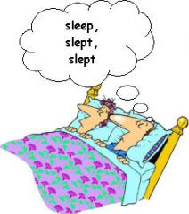

Coal & Diamond
I would like to share with you a quote that l like a lot. The quote goes something like “Diamond is just a piece of coal that did well under pressure”. The author of this quote, as many great quotes somehow chose to remain anonymous. Well, we all are stressed and tired right in the middle of our very first year of MBA or that all important project that is running behind schedule or the new boss that keeps hovering over your head while to slog . We are now a bit unsure of our abilities to excel in the chosen fields. This is perfect time to remember this quote; and understand that it is this pressure of the current situation that is going to transform us into diamonds.
It is the experiences that we have in our lives when were in school, in college, at our job or in our personal life that make us who were are. The “right” experiences help us remove our short comings and enhance our innate abilities. The “right” experiences also help us prepare for future challenges, generate confidence and inculcate that “Can Do” attitude in us. Life is a learning experience and by developing our qualities in this school called as life we can achieve great things.
But to take full advantage to this learning experience, we need to handle stress, which can make us implode. Rather than stress affecting our performance in a negative way we must utilize the pressure generated by stress as a motivator. This motivation will help us not only succeed at the task at hand but also reduce the negative effect of stress on future endeavors, as now we will have the ability to channel the effects of stress as a constructive force. So the newly cast positive effects of stress accelerate the learning process.
As a manufacturing process that adds value to the raw materials, the testing times in our life add value to our qualities and help us succeed, help us become a diamond by handling the pressure associated with life's trials. Now any time you are feeling down, stressed, tired, remember this is just your metamorphosis in progress.

A Day at Work
In the morning I attended a meeting between management and union representatives. The discussion was very comprehensive, covering topics like working hours, days off, retirement age, etc. Both sides were interested in an agreement and ready to compromise. The secretary recorded everything in the notes. Eventually, they decided to set a new meeting to sign the final draft of the agreement.
Back at the office, a colleague of mine asked me if I had realized that the proposed agreement would be partially against the company policy not to accept workers that have already retired. I pretended to be really busy and late for an appointment, and left for the cafeteria. Actually, I didn't want to discuss the matter at that particular moment because there were some strangers in the office.
After lunch I attended a lecture given by the mayor, who is an expert in tax legislation and has a graduate degree in political science. He said his government intends to assist welfare programs and senior citizens, raise funds to improve college education and build a public library, and establish tougher limits on vehicle emissions because he assumes this is what the people expect from the government.

How to pitch your CV successfully
Clare Whitmel, aka jobgoddess, is one of our CV experts in the career forums. Here we have pulled out some of her tips and advice gathered from a number of discussions. There is more than one way to write a CV, but which ever way you decide upon, ensure everything you include focuses on marketing yourself to the employer for the specific job you are applying for. There is no such thing as a generic CV – it needs to be tailored, considered and targeted.
It helps to think of your CV as a sales pitch, where your aim is to market your skills, achievements and experience to get the interview.
Chronological Vs functional?
Chronological CVs present work history in reverse-chronological order, with the most recent job first. They show how you've progressed during your career or in a company, and are useful if you've had continuous employment in one sector and you're applying for something similar.
Functional CVs focus less on career history and more on skills: a potentially good choice if you're changing career or returning after a break and you don't have much relevant experience. Career changers, while not having direct, relevant experience in their new career, should still be able to find examples from their previous careers that show off important talents and skills. You may find that a hybrid skills-chronological CV is a good choice when applying for jobs in a different sector. Basically, this is where you group your workplace skills at the beginning of the CV, then add a section for career history to show your dates of employment, with the most recent (or relevant) first. Skills can be grouped into different headings such as leadership skills, mentoring skills, administrative skills, budgeting skills and so on. Under each section add key accomplishments which illustrate your expertise in these areas.
There's a fair amount of flexibility when writing a CV, so you can slant your skills in such a way that they reflect the skills required for the job you want. If the ad asks for 'proven leadership ability' for example, put 'leadership skills' first on your CV. For career changers, it also helps to have a sort of positioning statement at the beginning of your CV. This isn't a career objective but a short paragraph which sums up who you are, your working strengths, and which helps the person reading your CV visualize you in the role you want.

What to include on your CV
You'll need to demonstrate you meet the requirements of the job. Decide what's most important and highlight your 'fit'. If the job specifies 'proven track record in sales' lead with something that reflects this in your profile or in your skills/achievements section. What you include also depends on the stage you've reached in your career. If you have significant work experience, include an achievements section, but if you're less experienced, highlight your work skills.
Contact information
Put your name, address, telephone and email on each page, and add a link to your LinkedIn profile, professional website or blog.
Professional profile/summary
Write a couple of sentences summarizing you and your value to an employer. One way to do this (if you're not already doing it) is to start your CV with a professional profile. Write a couple of sentences that sum you up, for example, health administrator with x years' experience and background in …' Pull out a couple of the key words from the job ad, and try to demonstrate that you have these qualities in your profile. Alternatively, you can write a one-line career objective at the end of your profile to show what you want to achieve, for example, 'An organized and resourceful manager with medical and technical background seeking a position as full-time health administrator'.
Key skills/key achievements
Your skills section shows you can do the job. Bullet point your skills, or group them in themes, such as PR, HR, administration… Chronological CVs (those which list work experience from most recent backwards) are generally preferred by employers, but you could also add a section before your work history where you outline your skills. If you like, you can bullet point them in a box so anyone reading can see at a glance how many skills you have. Or you can group them under major themes, such as PR, HR, office management... After this section, list your most recent work (20 years is too much unless what you did back then is still pertinent today). Don't forget to include significant achievements which show that you either saved or made the company money. This could be as simple as 'reorganized archive systems to simplify and shorten ordering times' or more exciting such as 'researched suppliers to make savings of 20% on corporate travel'.
One way to start is to think about the work skills employers like to see, such as problem-solving or analytical skills, planning and organizational skills, computer skills and so on. Then think about how you can demonstrate you have these skills. For example, are you a 'skilled communicator across all levels of a company'? Are you an 'exceptionally fast and accurate typist'?
These are the sorts of brief points you can make in your skills section. If you can't think of anything specific, you can still write something like 'experienced problem-solver' but make sure that you have an example to back it up if asked. A 'key achievements' section is an excellent opportunity to prove your worth. Find concrete examples of accomplishments, and use figures or percentages to quantify them, for example, 'increased sales by 10%'. You can have one section to cover your entire career, or a section for each job.

Career history
Give dates and job titles and include voluntary work or unpaid placements. Avoid long job descriptions and focus on specifics. So, instead of 'I was responsible for...' write 'managed...' or 'developed...
Education and training
Unless you're applying for a job specifying academic achievements, keep this section brief with dates and names of university, training and qualifications. Unless you are straight out of school including your GCSE results is not really relevant.
What you shouldn't include
References and interests can be omitted. Don't include date of birth, marital status, religious or political beliefs, your photograph (unless requested) or your salary expectations.
If you have a question about your CV ask Clare for some advice in the forums (http://careers.guardian.co.uk/forums)

Remember The 7 Rules
1. Learn Phrases
2. Don't Study Grammar
3. Focus On Listening
4. Learn Deeply (Repeat A Lot)
5. Use Point of View Stories
6. Use Only Real English Materials
7. Use Listen & Answer Stories
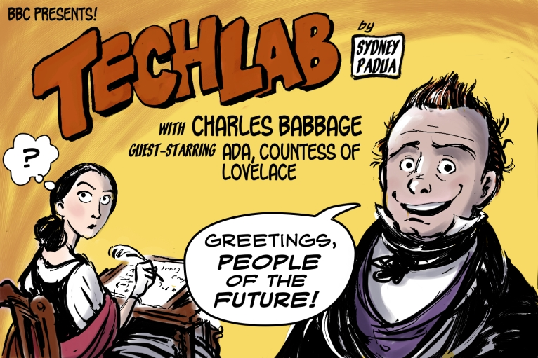

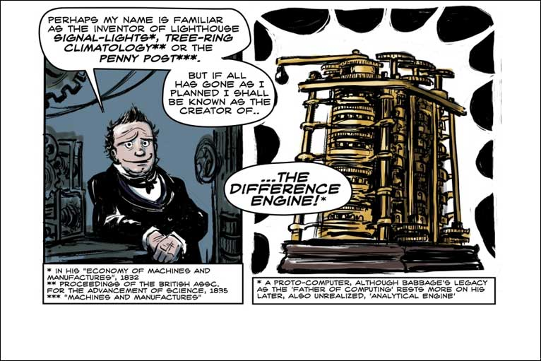
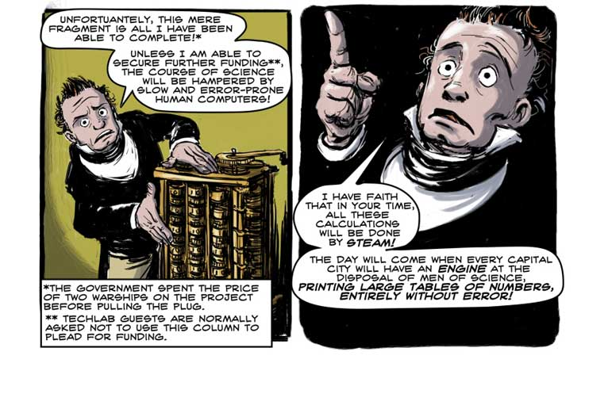

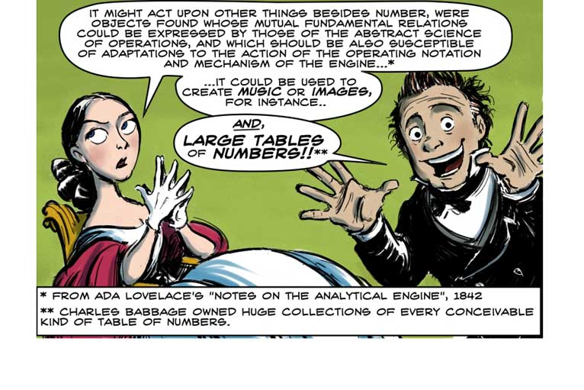
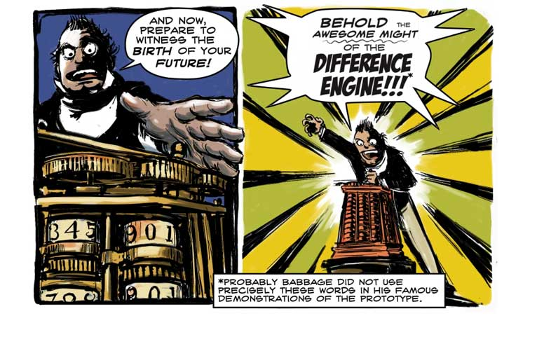

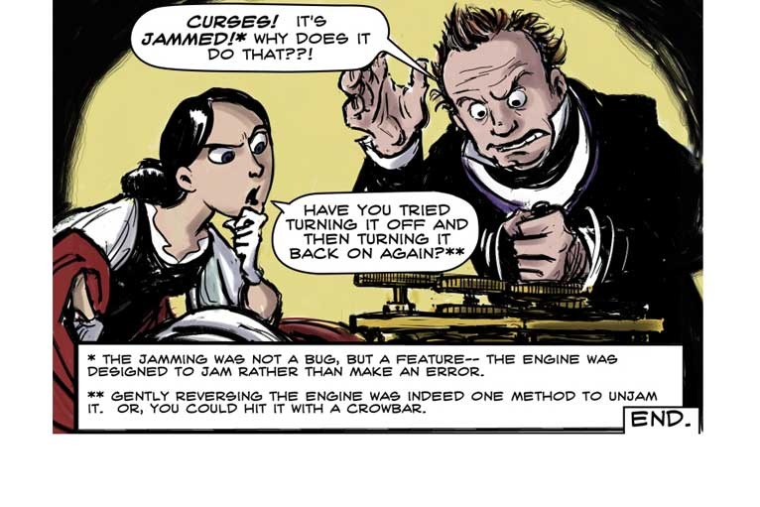

Two poems by Shel Silverstein
Sheldon Alan "Shel" Silverstein (September 25, 1930–May 10, 1999) was an American poet, singer-songwriter, musician, composer, cartoonist, screenwriter, and author of children's books. He sometimes styled himself as Uncle Shelby, especially for his early children's books.
Silverstein confirmed he never studied the poetry of others therefore, developed his own quirky style: laid-back and conversational, occasionally employing profanity and slang.
Whatif by Shel Silverstein
Last night, while I lay thinking here,
some Whatifs crawled inside my ear
and pranced and partied all night long
and sang their same old Whatif song:
Whatif I'm dumb in school?
Whatif they've closed the swimming pool?
Whatif I get beat up?
Whatif there's poison in my cup?
Whatif I start to cry?
Whatif I get sick and die?

Whatif I flunk that test?
Whatif green hair grows on my chest?
Whatif nobody likes me?
Whatif a bolt of lightning strikes me?
Whatif I don't grow talle?
Whatif my head starts getting smaller?
Whatif the fish won't bite?
Whatif the wind tears up my kite?
Whatif they start a war?
Whatif my parents get divorced?
Whatif the bus is late?
Whatif my teeth don't grow in straight?
Whatif I tear my pants?
Whatif I never learn to dance?
Everything seems well, and then
the nighttime Whatifs strike again!

Ations by Shel Silverstein
If we meet and I say, "Hi,"
That's a salutation.
If you ask me how I feel,
That's a consideration.
If we stop and talk a while,
That's a conversation.
If we understand each other,
That's a communication.
If we argue, scream and fight,
That's an altercation.
If later we apologize,
That's reconciliation.
If we help each other home,
That's a cooperation.
And all these actions added up
Make Civilization.
(And if I say this is a wonderful poem,
Is that exaggeration?)

Summary
Principals Words 3
Grammar 1 – To Be 5
Grammar 2 – Pronouns 6
Grammar 3 – Adjectives – Part 1 7
Grammar 4 – Adjectives – Part 2 8
Grammar 5 – Adjectives – Part 3 9
Answers from Grammar 10
Read the Grammar 11
Answers from Read the Grammar 16
Verbs 17
Answers from Verbs 22
Read the Journal 23
Lesson 1 – Any and Some 26
Lesson 2 – Prepositions of Place 27
Lesson 3 – Prepositions of Time 28
Lesson 4 – Articles 29
Lesson 5 – Like 30
Answers from the Lessons 31
Group 1 – Conjunctions & Prepositions 32
Group 2 – Cognates & False Friends 33
Group 3 – Using proverbs and quotations 34
Basic lists 35
Speaks in discussions lists - 1 36
Speaks in discussions lists - 2 37
Speaks in discussions lists - 3 38
Speaks in discussions lists - 4 39
Speaks in discussions lists - 5 40
Final Reading - Relax 41

