I wouldn't have the heart to take an eye out of a rat itself; I got half a dozen of them from the butcher, and only used three of them." So all came again into the other room, and Jack was made sit down, and everybody drank his health, and he drank everybody's health at one offer. And six stout fellows saw himself and the master home, and waited in the parlour while he went up and brought down the two hundred guineas, and double wages for Jack himself. When he got home, he brought the summer along with him to the poor mother and the disabled brothers; and he was no more Jack the Fool in the people's mouths, but " Skin Churl Jack."  The End  Collection   | Jack and His Master  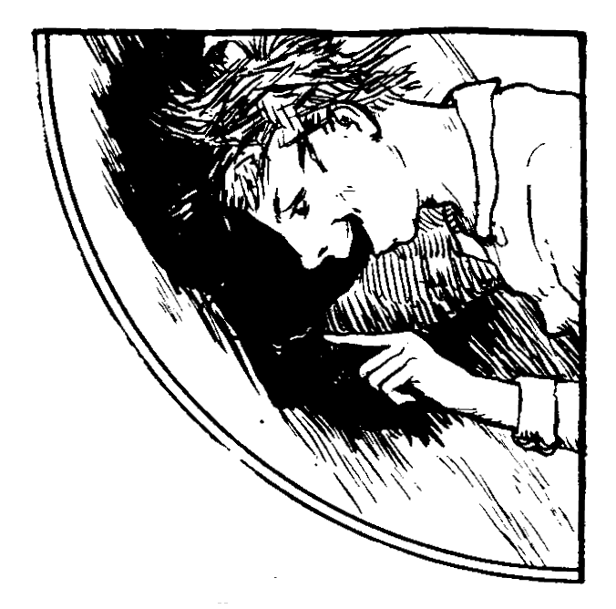  Joseph Jacobs  Book 2
If you're there before, you may throw a sheep's eye at me, and I'll be sure to see that they'll give you something for yourself." About eleven o'clock, while the master was in great spirits, he felt something clammy hit him on the cheek. It fell beside his tumbler, and when he looked at it what was it but the eye of a sheep. Well, he couldn't imagine who threw it at him, or why it was thrown at him. After a little he got a blow on the other cheek, and still it was by another sheep's eye. Well, he was very vexed, but he thought better to say nothing. In two minutes more, when he was opening his mouth to take a sup, another sheep's eye was slapped into it. He sputtered it out, and cried, "Man o' the house, isn't it a great shame for you to have any one in the room that would do such a nasty thing ?"  "Master," says Jack, "don't blame the honest man. Sure it's only myself that was throwin' them sheep's eyes at you, to remind you I was here, and that I wanted to drink the bride and bridegroom's health. You know yourself bade me."  "I know that you are a great rascal; and where did you get the eyes ?" - "An' where would I get em' but in the heads of your own sheep? Would you have me meddle with the bastes of any neighbor, who might put me in the Stone Jug for it?" "Sorrow on me that ever I had the bad luck to meet with you." | A poor woman had three sons. The eldest and second eldest were cunning clever fellows, but they called the youngest Jack the Fool, because they thought he was no better than a simpleton. The eldest got tired of staying at home, and said he'd go look for service. He stayed away a whole year, and then came back one day, dragging one foot after the other, and a poor wizened face on him, and he as cross as two sticks.  When he was rested and got something to eat, he told them how he got service with the Gray Churl of the Townland of Mischance, and that the agreement was, whoever would first say he was sorry for his bargain, should get an inch wide of the skin of his back, from shoulder to hips, taken off. If it was the master, he should also pay double wages; if it was the servant, he should get no wages at all. "But the thief," says he, "gave me so little to eat, and kept me so hard at work, that flesh and blood couldn't stand it; and when he asked me once, when I was in a passion, if I was sorry for my bargain, I was mad enough to say I was, and here I am disabled for life.". Vexed enough were the poor mother and brothers; and the second eldest said on the spot he'd go and take service with the Gray Churl, and punish him by all the annoyance he'd give him till he'd make him say he was sorry for his agreement. "Oh, won't I be glad to see the skin coming off the old villain's back !" said he.
10 | 3
"What are you doing there, you rascal?" - "Sure, I'm looking for the heifers, poor things!" - "What would bring them there?" - "I don't think anything could bring them in it ; but I looked first into the likely places, that is, the cow-houses, and the pastures, and the fields next 'em, and now I'm looking in the unlikeliest place I can think of. Maybe it's not pleasing to you it is." - "And to be sure it isn't pleasing to me, you aggravating goose-cap!" - "Please, sir, hand me one pound thirteen and four pence before you sit down to your dinner. I'm afraid it's sorrow that's on you for hiring me at all."  "May the div -- oh no; I'm not sorry. Will you begin, if you please, and put in the thatch again, just as if you were doing it for your mother's cabin?" - "Oh, faith I will, sir, with a heart and a half;" and by the time the farmer came out from his dinner, Jack had the roof better than it was before, for he made the boy give him new straw. "Go and search for them as if they were your own. The heifers were all in the paddock before sunset. Next morning, says the master, "Jack, the path across the bog to the pasture is very bad; the sheep does be sinking in it every step ; go and make the sheep's feet a good path." About an hour after he came to the edge of the bog, and what did he find Jack at but sharpening a carving knife, and the sheep standing or grazing round. | Next day Jack was to go clamp turf on the bog. They weren't sorry to have him away from the kitchen at dinner time. He didn't find his breakfast very heavy on his stomach ; so he said to the mistress, "I think, ma'am, it will be better for me to get my dinner now, and not lose time coming home from the bog." "That's true, Jack," said she. So she brought out a good cake, and a print of butter, and a bottle of milk, thinking he'd take them away to the bog. But Jack kept his seat, and never drew rein till bread, butter, and milk went down the red lane.  "Now, mistress," said he, " I'll be earlier at my work to-morrow if I sleep comfortably on the shelter side of a pile of dry peat on dry grass, and not be coming here and going back. So you may as well give me my supper, and be done with the day's trouble." She gave him that, thinking he'd take it to the bog; but he fell to on the spot, and did not leave a scrap to tell tales on him; and the mistress was a little astonished. He called to speak to the master in the haggard, and said he, "What are servants asked to do in this country after ate their supper?" "Nothing at all, but to go to bed." - "Oh, very well, sir." He went up on the stable-loft, stripped, and lay down, and some one that saw him told the master. He came up. "Jack, you anointed scoundrel, what do you mean?" "To go to sleep, master. The mistress, God bless her, is after giving me my breakfast, dinner, and supper, and yourself told me that bed was the next thing. Do you blame me, sir?"
8 | 5
 Books also publisher:  01. The Frog King or Iron Heinrich (Jacob and Wilhelm Grimm)  02. Jack and His Master (Joseph Jacobs)  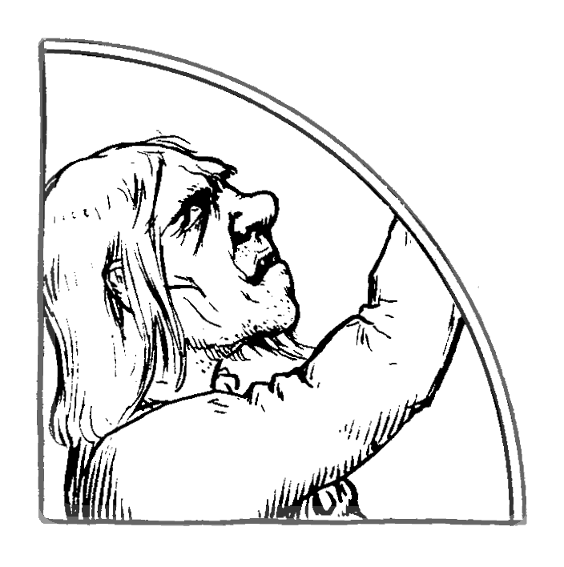 | "You're all witness," said Jack, "that my master says he is sorry for having met with me. My time is up. Master, hand me over double wages, and come into the next room, and lay yourself out like a man that has some decency in him, till I take a strip of skin an inch broad from your shoulder to your hip." Every one shouted out against that; but, says Jack, "You didn't hinder him when he took the same strips from the backs of my two brothers, and sent them home in that state, and penniless, to their poor mother." When the company heard the rights of the business, they were only too eager to see the job done. The master bawled and roared, but there was no help at hand. He was stripped to his hips, and laid on the floor in the next room, and Jack had the carving knife in his hand ready to begin.  "Now you cruel old villain," said he, giving the knife a couple of scrapes along the floor, "I'll make you an offer. Give me, along with my double wages, two hundred guineas to support my poor brothers, and I'll do without the strap." - "No!" said he, "I'd let you skin me from head to foot first." - "Here goes then," said Jack with a grin, but the first little scar he gave, Churl roared out. " Stop your hand ; I'll give the money." - "Now, neighbors," said Jack, "you mustn't think worse of me than I deserve.
2 | 11
All they could say had no effect : he started off for the Town land of Mischance, and in a twelvemonth he was back just as miserable and helpless as his brother. All the poor mother could say didn't prevent Jack the Fool from starting to see if he was able to regulate the Gray Churl. He agreed with him for a year for twenty pounds, and the terms were the same. "Now, Jack," said the Gray Churl, "if you refuse to do anything you are able to do, you must lose a month's wages." - "I'm satisfied," said Jack ; "and if you stop me from doing a thing after telling me to do it, you are to give me an additional month's wages." - "I am satisfied," says the master. "Or if you blame me for obeying your orders, you must give the same." - "I am satisfied," said the master again. The first day that Jack served he was fed very poorly, and was worked to the saddle skirts. Next day he came in just before the dinner was sent up to the parlor. They were taking the goose off the spit, but well becomes Jack he whips a knife off the dresser, and cuts off one side of the breast, one leg and thigh, and one wing, and fell to. In came the master, and began to abuse him for his assurance. "Oh, you know, master, you're to feed me, and wherever the goose goes won't have to be filled again till supper. Are you sorry for our agreement ?" The master was going to cry out he was, but he bethought himself in time. "Oh no, not at all," said he. "That's well," said Jack. | "Is this the way you are mending the path, Jack ?" said he.  "Everything must have a beginning, master," said Jack, "and a thing well begun is half done. I am sharpening the knife, and I'll have the feet off every sheep in the flock while you'd be blessing yourself." "Feet off my sheep, you anointed rogue! and what would you be taking their feet off for?"  "An' sure to mend the path as you told me. Says you, 'Jack, make a path with the foot of the sheep.' " - "Oh, you fool, I meant make good the path for the sheep's feet." Says the master when he came out, "Go, Jack, and look for the heifers, and bring them home." "And where will I look for 'em?"  "It's a pity you didn't say so, master. Hand me out one pound thirteen and fourpence if you don't like me to finish my job."  "Divel do you good with your one pound thirteen and fourpence!" - "It's better pray than curse, master. Maybe you re sorry for your bargain?" - "And to be sure I am -- not yet, any way." The next night the master was going to a wedding; and says he to Jack, before he set out : "I'll leave at midnight; and I wish you to come and be with me home, for fear I might be overtaken with the drink.
4 | 9
"Yes, you rascal, I do." - "Hand me out one pound thirteen and fourpence, if you please, sir." - "One divel and thirteen imps, you tinker! what for?" - "Oh, I see, you've forgot your bargain. Are you sorry for it ?" - "Oh, ya -- NO, I mean. I'll give you the money after your nap." Next morning early, Jack asked how he'd be employed that day. "You are to be holding the plough in that fallow, outside the paddock." The master went over about nine o'clock to see what kind of a ploughman was Jack, and what did he see but the little boy driving the bastes, and the sock and coulter of the plough skimming along the sod, and Jack pulling ding-dong again' the horses. "What are you doing, you contrary thief?" said the master. "An' ain't I strivin' to hold this divel of a plough, as you told me; but that uncrown of a boy keeps whipping on the bastes in spite of all I say; will you speak to him?" - "No, but I'll speak to you. Didn't you know, you bosthoon, that when I said 'holding the plough,' I meant reddening the ground." - "Faith, an' if you did, I wish you had said so. Do you blame me for what I have done?" The master caught himself in time, but he was so stomached, he said nothing. "Go on and redden the ground now, you knave, as other ploughmen do." - "An' are you sorry for our agreement?" - "Oh, not at all, not at all !" - Jack ploughed away like a good workman all the rest of the day. In a day or two the master bade him go and mind the cows in a field that had half of it under young corn. | "Be sure, particularly," said he, "to keep Brownie from the wheat ; while she's out of mischief there's no fear of the rest." About noon, he went to see how Jack was doing his duty, and what did he find but Jack asleep with his face to the sod, Brownie grazing near a thorn-tree, one end of a long rope round her horns, and the other end round the tree, and the rest of the beasts all trampling and eating the green wheat. Down came the switch on Jack. "Jack, you vagabond, do you see what the cows are at?" - "And do you blame, master?" - "To be sure, you lazy sluggard, I do ?" - "Hand me out one pound thirteen and four pence, master. You said if I only kept Brownie out of mischief, the rest would do no harm. There she is as harmless as a lamb. Are you sorry for hiring me, master?" - "To be -- that is, not at all. I'll give you your money when you go to dinner. Now, understand me; don't let a cow go out of the field nor into the wheat the rest of the day." - "Never fear, master!" and neither did he. But the churl would rather than a great deal he had not hired him. The next day three heifers were missing, and the master bade Jack go in search of them. "Where will I look for them?" said Jack. "Oh, every place likely and unlikely for them all to be in." The churl was getting very exact in his words. When he was coming into the bawn at dinner-time, what work did he find Jack at but pulling armfuls of the thatch off the roof, and peeping into the holes he was making?
6 | 7

