Collection   | Sweet Porridge    Jacob and Wilhelm Grimm  Book 6
We'll soon find that out," thought the old queen. But she said nothing. She went into the bed-room, took all the bedding off the bedstead, and laid a pea on the bottom; then she took twenty mattresses and laid them on the pea, and then twenty eider-down beds on top of the mattresses. On this the princess had to lie all night. In the morning she was asked how she had slept.  "Oh, very badly!" said she. "I hardly closed my eyes all night. God only knows what was in the bed… I was lying on something hard.  It was horrible!" Now they knew that she was a 'real' princess because she had felt the pea right through the twenty mattresses and the twenty eider-down beds. Nobody but a real princess could be as sensitive as that. So the prince took her for his wife, for now he knew that he had a 'real' princess; and the pea was put in the museum, where it may still be seen, provided no one has stolen it!  The End | There was a poor but good little girl who lived with her mother. They had nothing to eat. One day, the child went into the forest, and there an aged woman met her who was aware of her sorrow. She gifted her with a little pot, which when she said, "cook, little pot, cook", would cook good, sweet porridge, and when she said, "stop, little pot", it ceased to cook.  The girl took the pot home to her mother, and soon they were freed from their poverty and hunger, and ate sweet porridge as often as they chose.  Once on a time when the girl had gone out, her mother said, cook, little pot, cook. And it did cook and she ate till she was satisfied, and then she wanted the pot to stop cooking, but did not know the word.  So it went on cooking and the porridge rose over the edge, and still it cooked on until the kitchen and whole house were full, and then the next house, and then the whole street, just as if it wanted to satisfy the hunger of the whole world, and there was the greatest distress, but no one knew how to stop it.
10 | 3
"Serves me right," growled the Wolf as he crept into the bushes. "I'm a butcher by trade, not a doctor." Stick to your trade.  The End  The Princess and the Pea  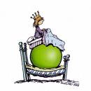 | A sailor, bound on a long voyage, took along with him a Monkey to amuse him while on shipboard. As he sailed off the coast of Greece, a violent storm arose in which the ship was wrecked and he, along with his Monkey and all the crew were thus forced to swim for their lives.  A Dolphin saw the Monkey fighting with the waves, and thinking him to be a man (whom he is always said to befriend), came and placed himself under him, to convey him on his back safely to the shore.  When the Dolphin arrived with his burden in sight of land not far from Athens, he asked the Monkey if he were an Athenian.  The latter replied that he was, and that he had a very noble origin. The Dolphin then inquired if he knew the Piraeus-the famous harbor of Athens. Supposing that a man was meant, the Monkey answered boastfully that he knew him very well and that he was his close friend. The Dolphin, indignant at these false words, dipped the Monkey under the water and drowned him in the deep blue sea.
8 | 5
 Books also publisher:  01. The Frog King or Iron Heinrich (Jacob and Wilhelm Grimm)  02. Jack and His Master (Joseph Jacobs)  03. Rapunzel (Jacob and Wilhelm Grimm)  04. The Shepherdess and the Sweep (Hans Christian Andersen)  05. The Ugly Duckling (Hans Christian Andersen)  06. Sweet Porridge (Jacob and Wilhelm Grimm) | About These Stories  "Sweet Porridge" is a folkloric German fairy tale recorded by the Brothers Grimm, as tale number 103 in Grimm's Fairy Tales, in the 19th century.  "The Monkey and the Dolphin" and "The Wolf and the Ass" are an Aesop´s short stories which brings some moral. It isn't the entire fable, but just the main idea of it. Aesop (620-560 BC), known only for the genre of fables ascribed to him, was by tradition a slave who was a contemporary of Croesus and Peisistratus in the mid-sixth century BC in ancient Greece.  "The Princess and the Pea" is a fairy tale by Danish poet and author Hans Christian Andersen (1805–1875). The story tells of a young woman whose royal identity is established by a test of her physical sensitivity, and was first published with three others by Andersen in an inexpensive booklet on 8 May 1835, in Copenhagen, Denmark.
2 | 11
At last when only one single house remained, the child came home and just said, stop, little pot, and it stopped and gave up cooking, and whosoever wished to return to the town had to eat his way back!  The End  The Monkey and the Dolphin  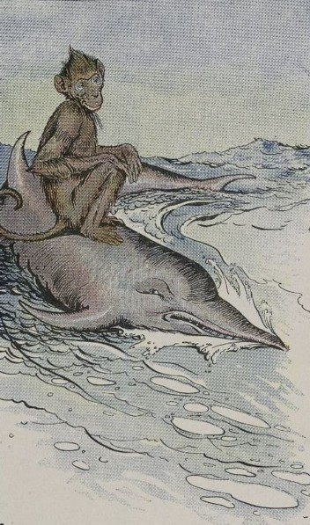 | Once upon a time there lived a prince who wanted to marry a princess; but she would have to be a 'real' princess.  He traveled far and wide to find one but nowhere could he get what he wanted.  There were many princesses, but it was hard to decide how far 'real' they were. So he returned home sadly.  One evening a terrible storm rose along with thunder and lightning, and rain poured down heavily. Suddenly a knock was heard at the castle gate.  On opening it was found that a princess was standing at the door.  But, good gracious! what a sight the whether had done to her.  The water ran down from her hair and clothes; and she was in a very bad condition and "yet she said that she was a real princess"?!, thought the queen.
4 | 9
Moral of the story:  Those who pretend to be what they are not, sooner or later, find themselves in "deep" trouble.  The End  The Wolf and the Ass  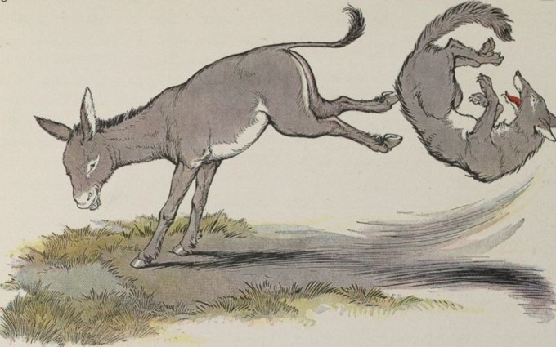 | An Ass was feeding in a pasture near a wood when he saw a Wolf lurking in the shadows along the hedge. He easily guessed what the Wolf had in mind, and thought of a plan to save himself. So he pretended he was lame, and began to hobble painfully.  When the Wolf came up, he asked the Ass what had made him lame, and the Ass replied that he had stepped on a sharp thorn.  "Please pull it out," he pleaded, groaning as if in pain. "If you do not, it might stick in your throat when you eat me." The Wolf saw the wisdom of the advice, for he wanted to enjoy his meal without any danger of choking. So the Ass lifted up his foot and the Wolf began to search very closely and carefully for the thorn.  Just then the Ass kicked out with all his might, tumbling the Wolf a dozen paces away.  And while the Wolf was getting very slowly and painfully to his feet, the Ass galloped away in safety.
6 | 7

