Caminho das Cifras
Livreto Gerado Automaticamente

Sumário
Sumário 2
Yesterday (F) - The Beatles 3

Yesterday (F) - The Beatles
Tom: F

[Intro] G

[Tab - Intro]

G
E|----3-3-3----3-3-3----3-3-3----3-3-3------|
B|----3-3-3----3-3-3----3-3-3----3-3-3------|
G|----0-0-0----0-0-0----0-0-0----0-0-0------|
D|------------------------------------------|
A|------------------------------------------|
E|-3---------3--------3--------3------------|

[Primeira Parte]

[Tab - Primeira Parte]

Parte 1 de 3
G F#m
E|---3-3-3---3-3------2-2-2-----------------|
B|---3-3-3---3-3------2-2-2-----------------|
G|---0-0-0---0-0------2-2-2-----------------|
D|------------------------------------------|
A|------------------------------------------|
E|-3-------3-----0--2-----------------------|

B7 Em
E|---2-2-2----0-0-0---0---0-----------------|
B|---0-0-0----0-0-0---0---0-----------------|
G|---2-2-2----0-0-0---0---0-----------------|
D|----------2-------2---0-------------------|
A|-2----------------------------------------|
E|------------------------------------------|

Parte 2 de 3
C7M D7 G G/F#
E|---0-0-0----2-2-2----3-3-3---3---3--------|
B|---0-0-0----1-1-1----3-3-3---3---3--------|
G|---0-0-0----2-2-2----0-0-0---0---0--------|
D|----------0-------------------------------|
A|-3----------------------------------------|
E|-------------------3-------3---2----------|

Em7 A7
E|---0-0-0---0-0----------------------------|
B|---3-3-3---2-2----------------------------|
G|---0-0-0---0-0----------------------------|
D|------------------------------------------|
A|---------0-----0--------------------------|
E|-0----------------------------------------|

Parte 3 de 3
C G
E|-0-----3--3--3-3-3------------------------|
B|-1-----3--3--3-3-3------------------------|
G|-0-----0--0--0-0-0------------------------|
D|------------------------------------------|
A|-3----------------------------------------|
E|-------3--3-------------------------------|

Parte 3 de 3 (Variação)
C G
E|-0-----3--3--3-3--------------------------|
B|-1-----3--3--3-3--------------------------|
G|-0-----0--0--0-0--------------------------|
D|------------------------------------------|
A|-3----------------------------------------|
E|-------3--3-------0-----------------------|

G
Yesterday
F#m B7 Em
All my troubles seemed so far away
C7M D7
Now it looks as though
G G/F#
They're here to stay
Em7 A7 C G
Oh, I believe in yesterday

G
Suddenly
F#m B7 Em
I'm not half the man I used to be
C7M D7 G
There's a shadow hanging over me
G/F# Em7 A7 C G
Oh, yesterday came suddenly

[Segunda Parte]

F#m B7 Em D C7M B7 D7/A
Why she had to go? I don't know
D7 G
She wouldn't say
F#m B7 Em D C7M
I said something wrong
B7 D7/A D7 G
Now I long for yesterday

[Tab - Segunda Parte]

Parte 1 de 3
F#m B7 Em D C7M B7
E|---2-2-2----2-2-2---0---2--3----2--0------|
B|---2-2-2----0-0-0----------0----0---------|
G|---2-2-2----2-2-2-------------------------|
D|------------------------0-----------------|
A|----------2----------------3----2---------|
E|-2------------------0---------------------|

Parte 2 de 3
D7/A D7 G
E|---2-2-2----2-2-2-----3-3-3-----3-3-------|
B|---1-1-1----1-1-1-----3-3-3-----3-3-------|
G|---2-2-2----2-2-2-----0-0-0-----0-0-------|
D|----------0-------------------------------|
A|-0----------------------------------------|
E|--------------------3--------3------0-----|

Parte 1 de 3
F#m B7 Em D C7M B7
E|---2-2-2----2-2-2---0---2--3----2--0------|
B|---2-2-2----0-0-0----------0----0---------|
G|---2-2-2----2-2-2-------------------------|
D|------------------------0-----------------|
A|----------2----------------3----2---------|
E|-2------------------0---------------------|

Parte 3 de 3
D7/A D7 G
E|---2-2-2----2-2-2---3---------------------|
B|---1-1-1----1-1-1---3---------------------|
G|---2-2-2----2-2-2---0---------------------|
D|----------0-------------------------------|
A|-0----------------------------------------|
E|--------------------3---------------------|

[Terceira Parte]

G
Yesterday
F#m B7 Em
Love was such an easy game to play
C7M D7 G
Now I need a place to hide away
G/F# Em7 A7 C G
Oh, I believe in yesterday

[Segunda Parte]

F#m B7 Em D C7M B7 D7/A
Why she had to go? I don't know
D7 G
She wouldn't say
F#m B7 Em D C7M
I said something wrong
B7 D7/A D7 G
Now I long for yesterday

[Terceira Parte]

G
Yesterday
F#m B7 Em
Love was such an easy game to play
C7M D7 G
Now I need a place to hide away

[Tab - Terceira Parte]

C G
E|-0-----3--3--3-3-3------------------------|
B|-1-----3--3--3-3-3------------------------|
G|-0-----0--0--0-0-0------------------------|
D|------------------------------------------|
A|-3----------------------------------------|
E|-------3--3-------------------------------|

G/F# Em7 A7 C G
Oh, I believe in yesterday

[Tab - Final]

(Frase Final)
E|-3-3-3-3--3-3-3-3--3---3---3--------------|
B|-3-3-3-3--2-2-2-2--1-1h3-1h3--------------|
G|-0-0-0-0--0-0-0-0--0---0---0--------------|
D|------------------------------------------|
A|------------------------------------------|
E|------------------------------------------|

(Frase final)
Hum hum hum hum hum hum hum

Dicionário de Acordes:
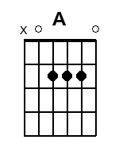 | 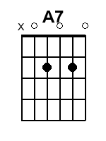 | 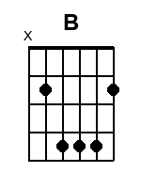 | 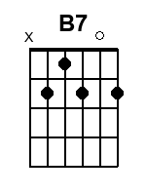 | 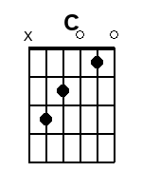 | 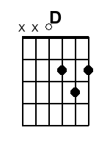
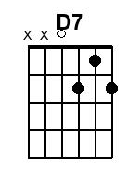 | 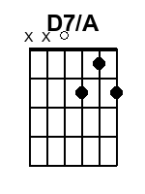 | 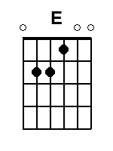 | 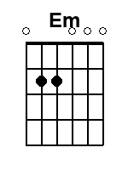 | 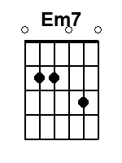 | 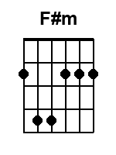
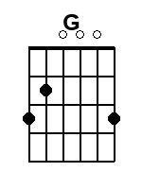 | 