Nome: Fernando de Barros e Gabriel Lampert do Amaral

Turma: 4I

Data: 31/10/23

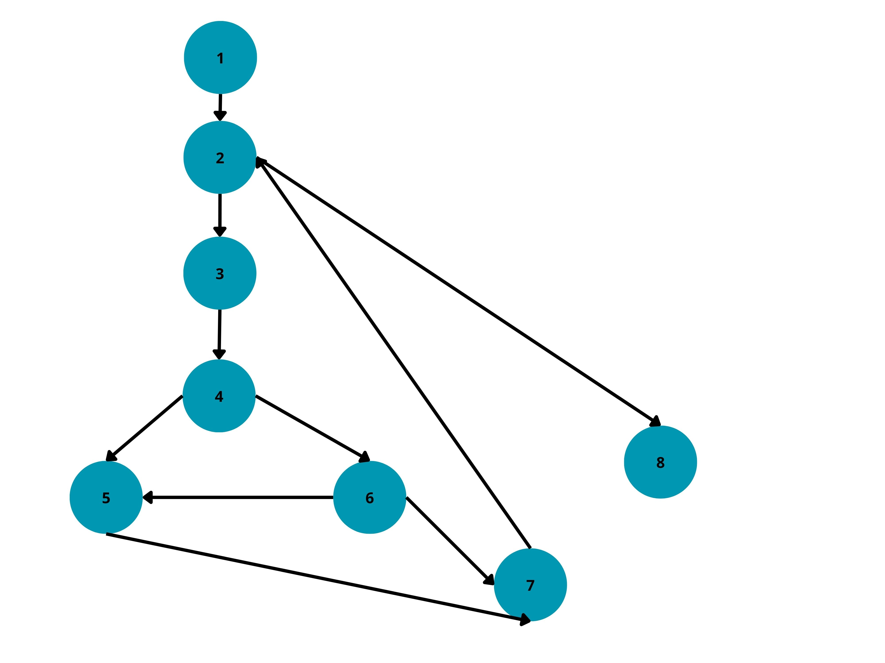

1. 1-2-8
2. 1-2-3-4-5-7-2-8
3. 1-2-3-4-6-5-7-2-8
4. 1-2-3-4-6-7-2-8