Donea Fernando-Emanuel
Grupa 243
Laborator 6

Ex E1
- Cursor clasic
COD:
DECLARE
v_job_id JOBS.JOB_ID%type;
v_job_title JOBS.JOB_TITLE%type;
v_nume EMPLOYEES.LAST_NAME%type;
v_salary EMPLOYEES.SALARY%type;
k NUMBER; --contor pentru a nr cati angajati avem per job
--cursor pentru joburi
CURSOR cursor_j IS
SELECT
J.JOB_ID, J.JOB_TITLE
FROM JOBS J;
--cursor paramtrizat pentru a afla angajatii din fiecare job
CURSOR cursor_ang_j(p_job_id JOBS.JOB_ID%type) IS
SELECT
E.LAST_NAME, E.SALARY
FROM EMPLOYEES E
WHERE E.JOB_ID=p_job_id;
BEGIN
OPEN cursor_j;
LOOP
--preluam un job
FETCH cursor_j INTO v_job_id,v_job_title;
EXIT WHEN cursor_j%NOTFOUND;
DBMS_OUTPUT.PUT_LINE(' ');
DBMS_OUTPUT.PUT_LINE('JOB:' || v_job_title);
k :=0; --resetam
OPEN cursor_ang_j(v_job_id);
LOOP
FETCH cursor_ang_j INTO v_nume, v_salary;
EXIT WHEN cursor_ang_j%NOTFOUND;
k:=k+1;
DBMS_OUTPUT.PUT_LINE(v_nume || 'cu salariul' || v_salary);
end loop;
CLOSE cursor_ang_j;
if k=0 then
DBMS_OUTPUT.PUT_LINE('nu exista angajati cu jobul' || v_job_title);
end if;
end loop;
CLOSE cursor_j;
END;

Print Screen:
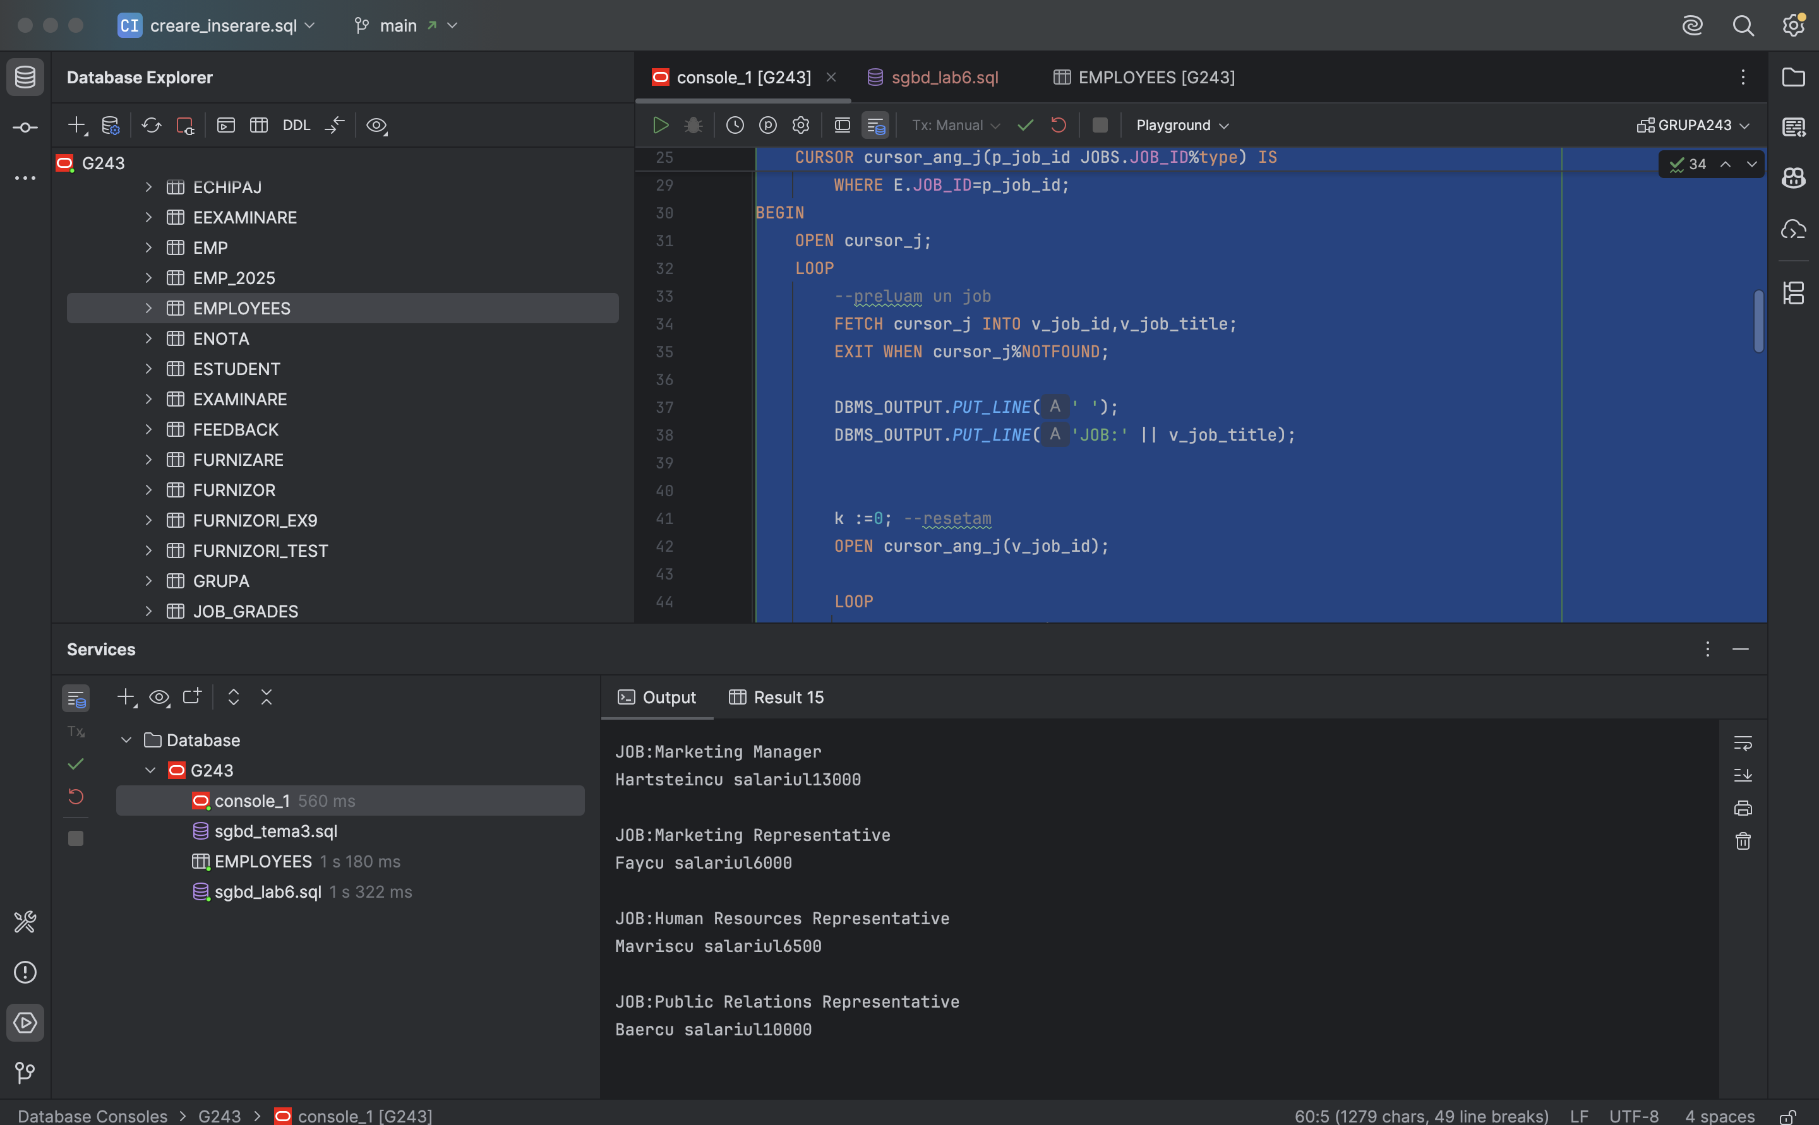

- Ciclu cursor
Cod:
DECLARE
--cursor pentru joburi
CURSOR cursor_j IS
SELECT
J.JOB_ID, J.JOB_TITLE
FROM JOBS J;
--cursor paramtrizat pentru a afla angajatii din fiecare job
CURSOR cursor_ang_j(p_job_id JOBS.JOB_ID%type) IS
SELECT
E.LAST_NAME, E.SALARY
FROM EMPLOYEES E
WHERE E.JOB_ID=p_job_id;
k NUMBER;
BEGIN
FOR v_job IN cursor_j LOOP
DBMS_OUTPUT.PUT_LINE(' ');
DBMS_OUTPUT.PUT_LINE('JOB:' || v_job.JOB_TITLE);
k:=0;
for v_ang IN cursor_ang_j(v_job.JOB_ID) LOOP
DBMS_OUTPUT.PUT_LINE(v_ang.LAST_NAME || ' cu salariul ' || v_ang.SALARY);
k:=k+1;
end loop;
if k=0 then
DBMS_OUTPUT.PUT_LINE('nu exista angajati cu jobul ' || v_job.JOB_TITLE);
end if;
end loop;
end;

Print Screen:
