SGBD-Laborator 2
Donea Fernando-Emanuel
Grupa 243

Ex 1
- Tabelul MEMBER: cheie primara in coloana member_id
- Tabelul TITLE: cheie primara in coloanal title_id
- Tabelul TTILE_COPY: cheie primara compusa din coloanele (copy_id, title_id)
- Tabelul RENTAL: cheie primara compusa din coloanele (book_date, copy_id, title_id, member_id)
- Tabelul RESERVATION: cheie primara compusa din coloanele (res_date, member_id, title_id)

Ex 4

Cod:

WITH categoria_cea_mai_ceruta AS (
SELECT T.CATEGORY
FROM RENTAL R
JOIN TITLE T ON R.TITLE_ID = T.TITLE_ID
GROUP BY T.CATEGORY
ORDER BY COUNT(*) DESC
FETCH FIRST 1 ROW ONLY
)
SELECT
'Număr de titluri diferita' AS TIP,
COUNT(DISTINCT R.TITLE_ID) AS NUMAR
FROM RENTAL R
JOIN TITLE T ON R.TITLE_id = T.TITLE_id
WHERE T.CATEGORY = (SELECT CATEGORY FROM categoria_cea_mai_ceruta)
UNION ALL
SELECT
'Numar exemplare imprumutate' AS Tip,
COUNT(*) AS numar
FROM RENTAL R
JOIN TITLE T ON R.TITLE_id = T.TITLE_id
WHERE T.CATEGORY = (SELECT CATEGORY FROM categoria_cea_mai_ceruta);

Print Screen
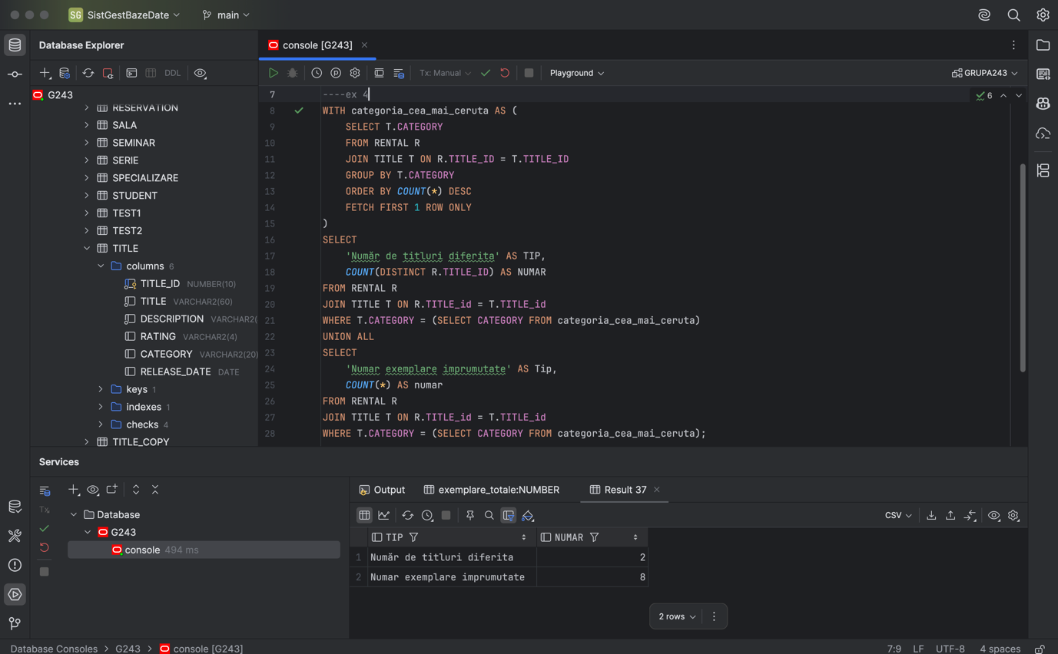

Ex 5
--ex 5
SELECT
T.TITLE_ID,
T.TITLE,
COUNT(TC.COPY_ID) AS Exemplare_disponibile
FROM TITLE T
JOIN TITLE_COPY TC ON T.TITLE_ID = TC.TITLE_ID
LEFT JOIN RENTAL R ON R.COPY_ID = TC.COPY_ID
AND R.TITLE_ID = TC.TITLE_ID
AND R.ACT_RET_DATE IS NULL
WHERE R.BOOK_DATE IS NULL
GROUP BY T.TITLE_ID, T.TITLE;

Print screen:
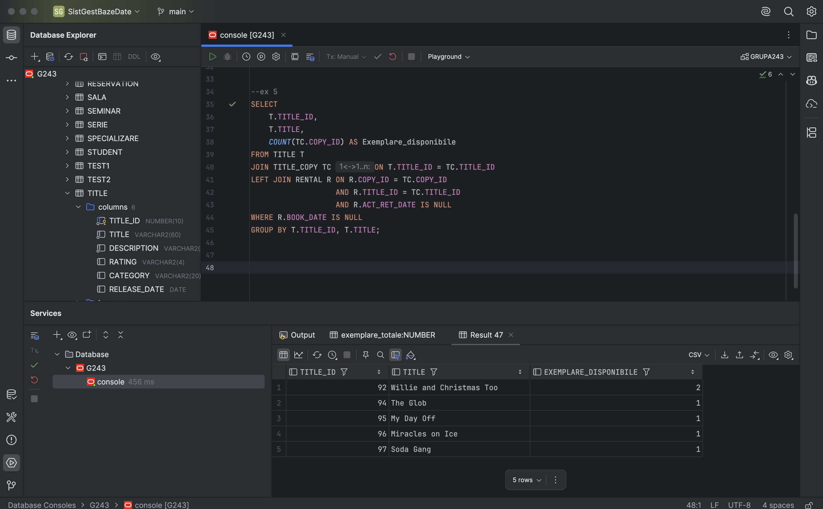

Ex 6

SELECT
T.TITLE,
TC.COPY_ID,
TC.STATUS,
CASE
WHEN R.BOOK_DATE IS NOT NULL THEN 'RENTED'
ELSE 'AVAILABLE'
END AS Status_corect
FROM TITLE T
JOIN TITLE_COPY TC ON T.TITLE_ID = TC.TITLE_ID
LEFT JOIN RENTAL R ON R.COPY_ID = TC.COPY_ID AND R.TITLE_ID=TC.COPY_ID AND R.ACT_RET_DATE IS NULL;

Print screen:

