Fernando Becerra

IT 3212u03a01

1/27/2019

Unit 3 Assignment 1

Github url: <https://fernandofernz.github.io/3212.u03a01/>

Chrome Developer Tools:

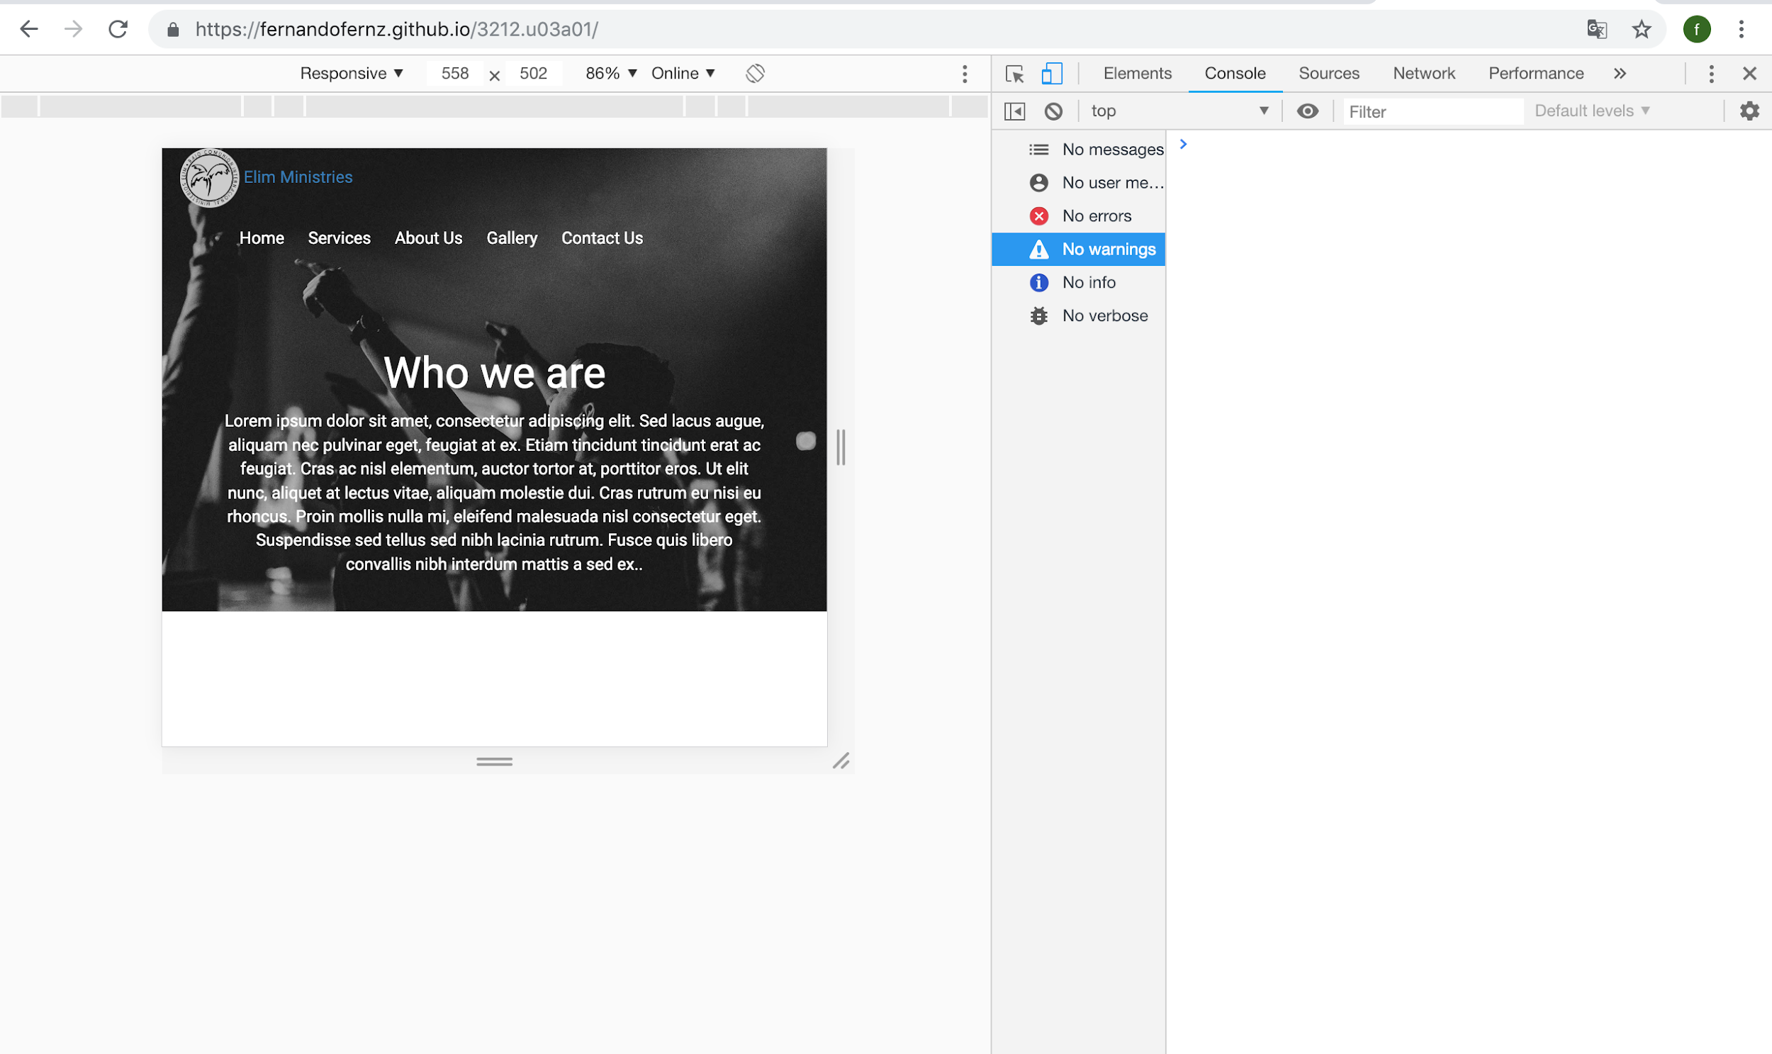

Safari Web Inspector: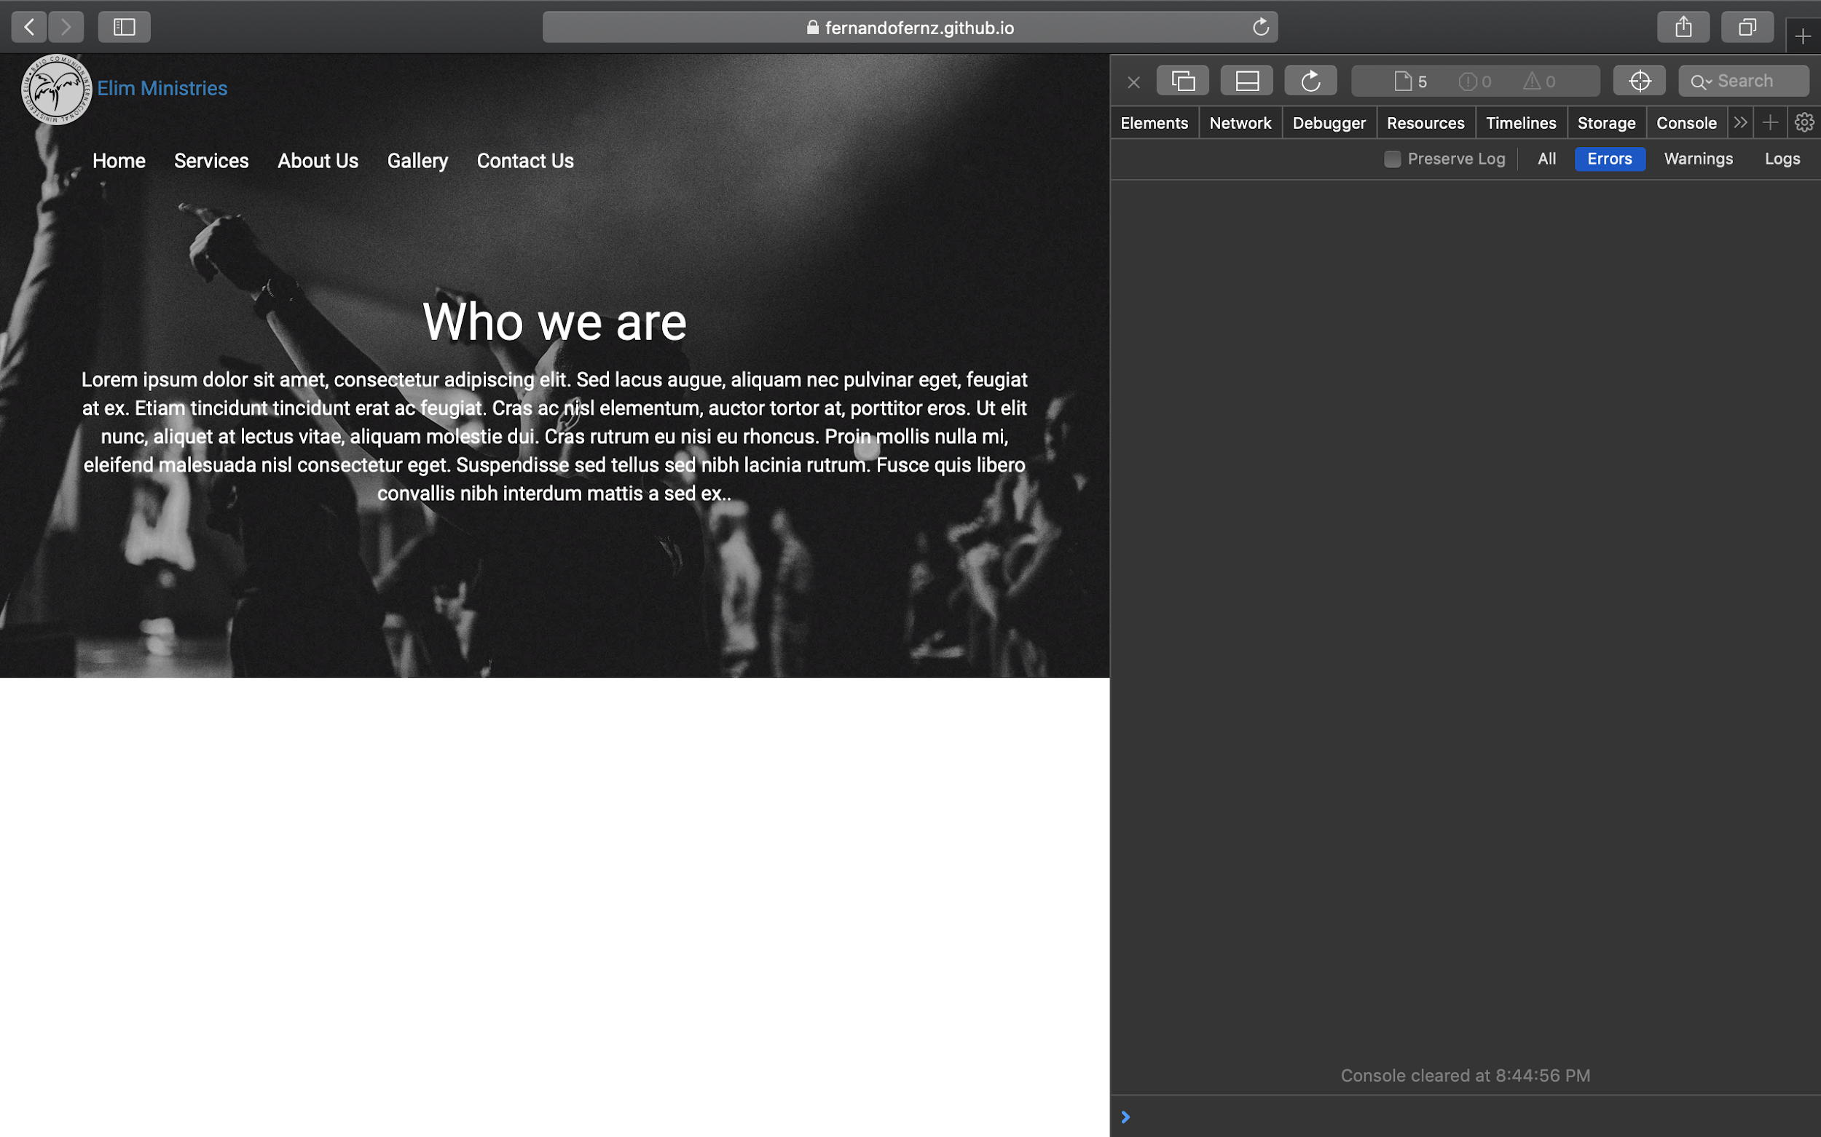Markup Validation Service: