Fernando Becerra

IT 3212 u05a01

02/08/2019

Assignment 5

Github url:

<https://fernandofernz.github.io/3212.u05a01/pages/contactUs.html>

Google Chrome Developer Tools:

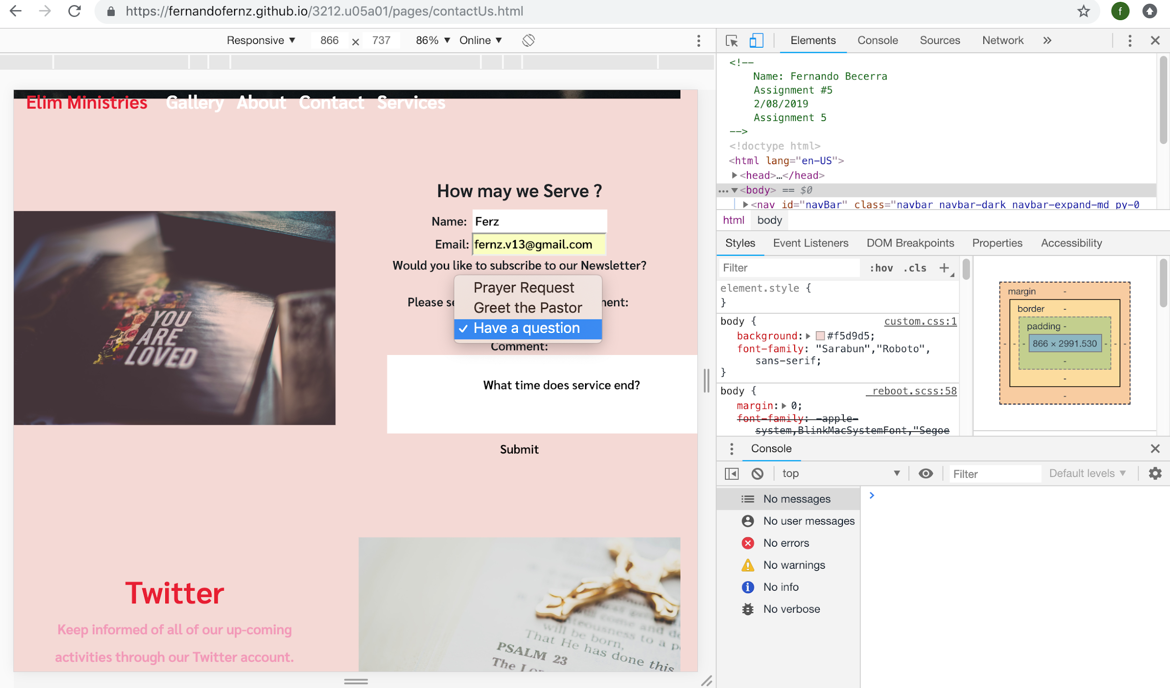

Safari Web Inspector Tools:

