Fernando Becerra

IT 3215 u03a01

1/27/2019

Assignment 1 Unit 3

Github url:

<https://fernandofernz.github.io/3215.u03a01/index.html>

Chrome Developer Tools:

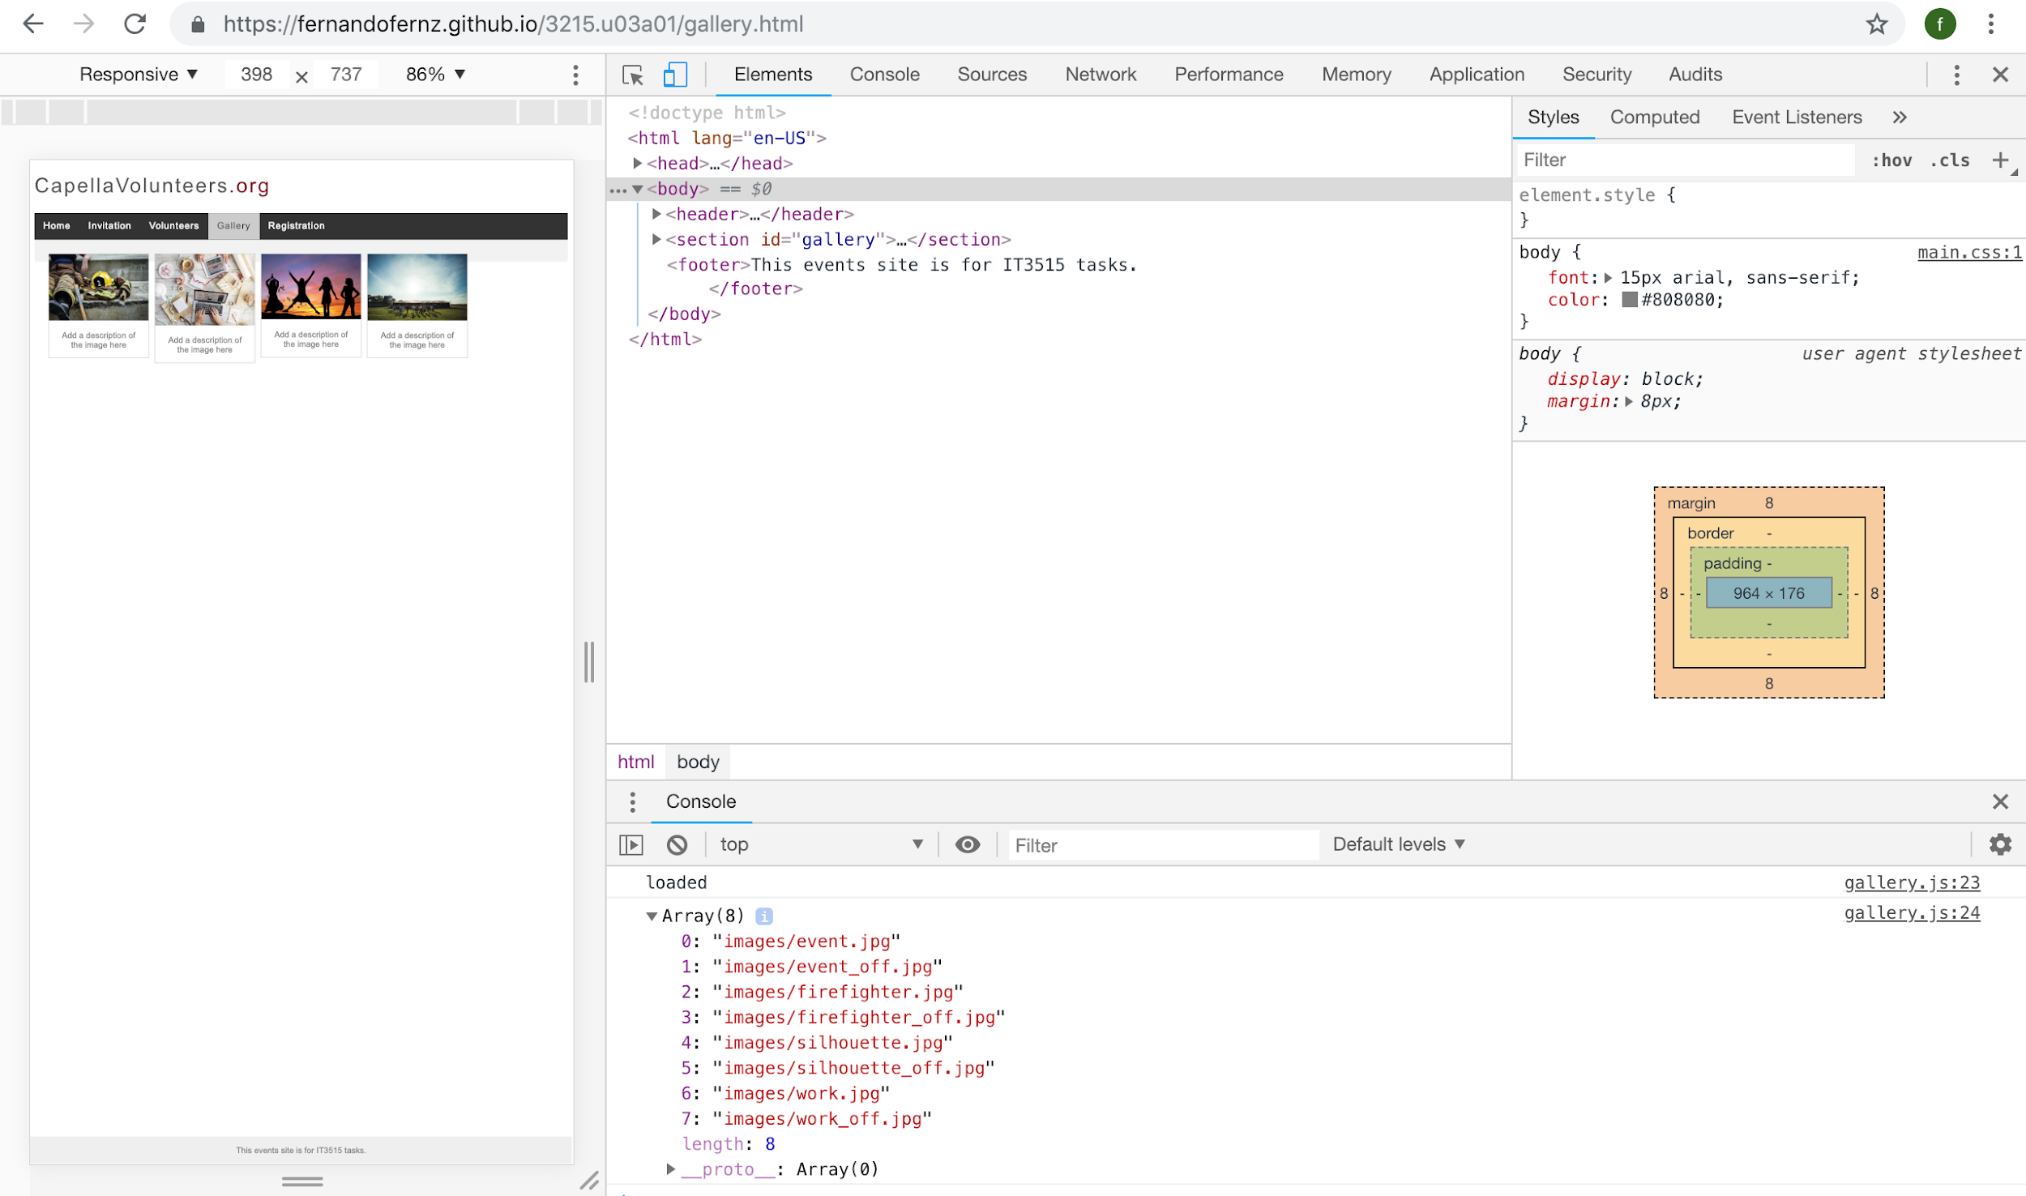

Safari Web Inspector Tools:

