Fernando Becerra

IT 3215 u04a01

2/03/2019

Assignment #4

GIthub url:

<https://fernandofernz.github.io/3215.u04a01/registration.html>

Google Chrome Developer Tools:

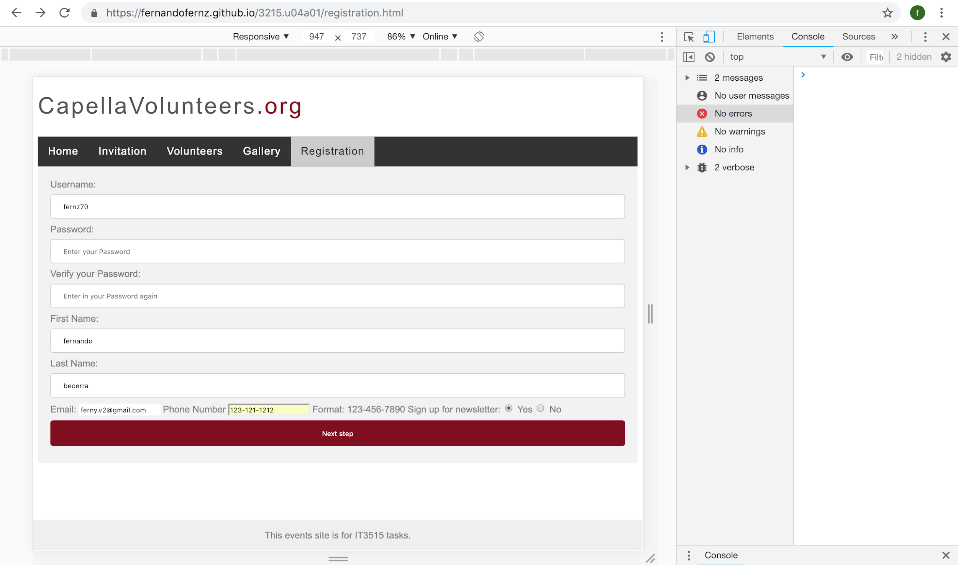

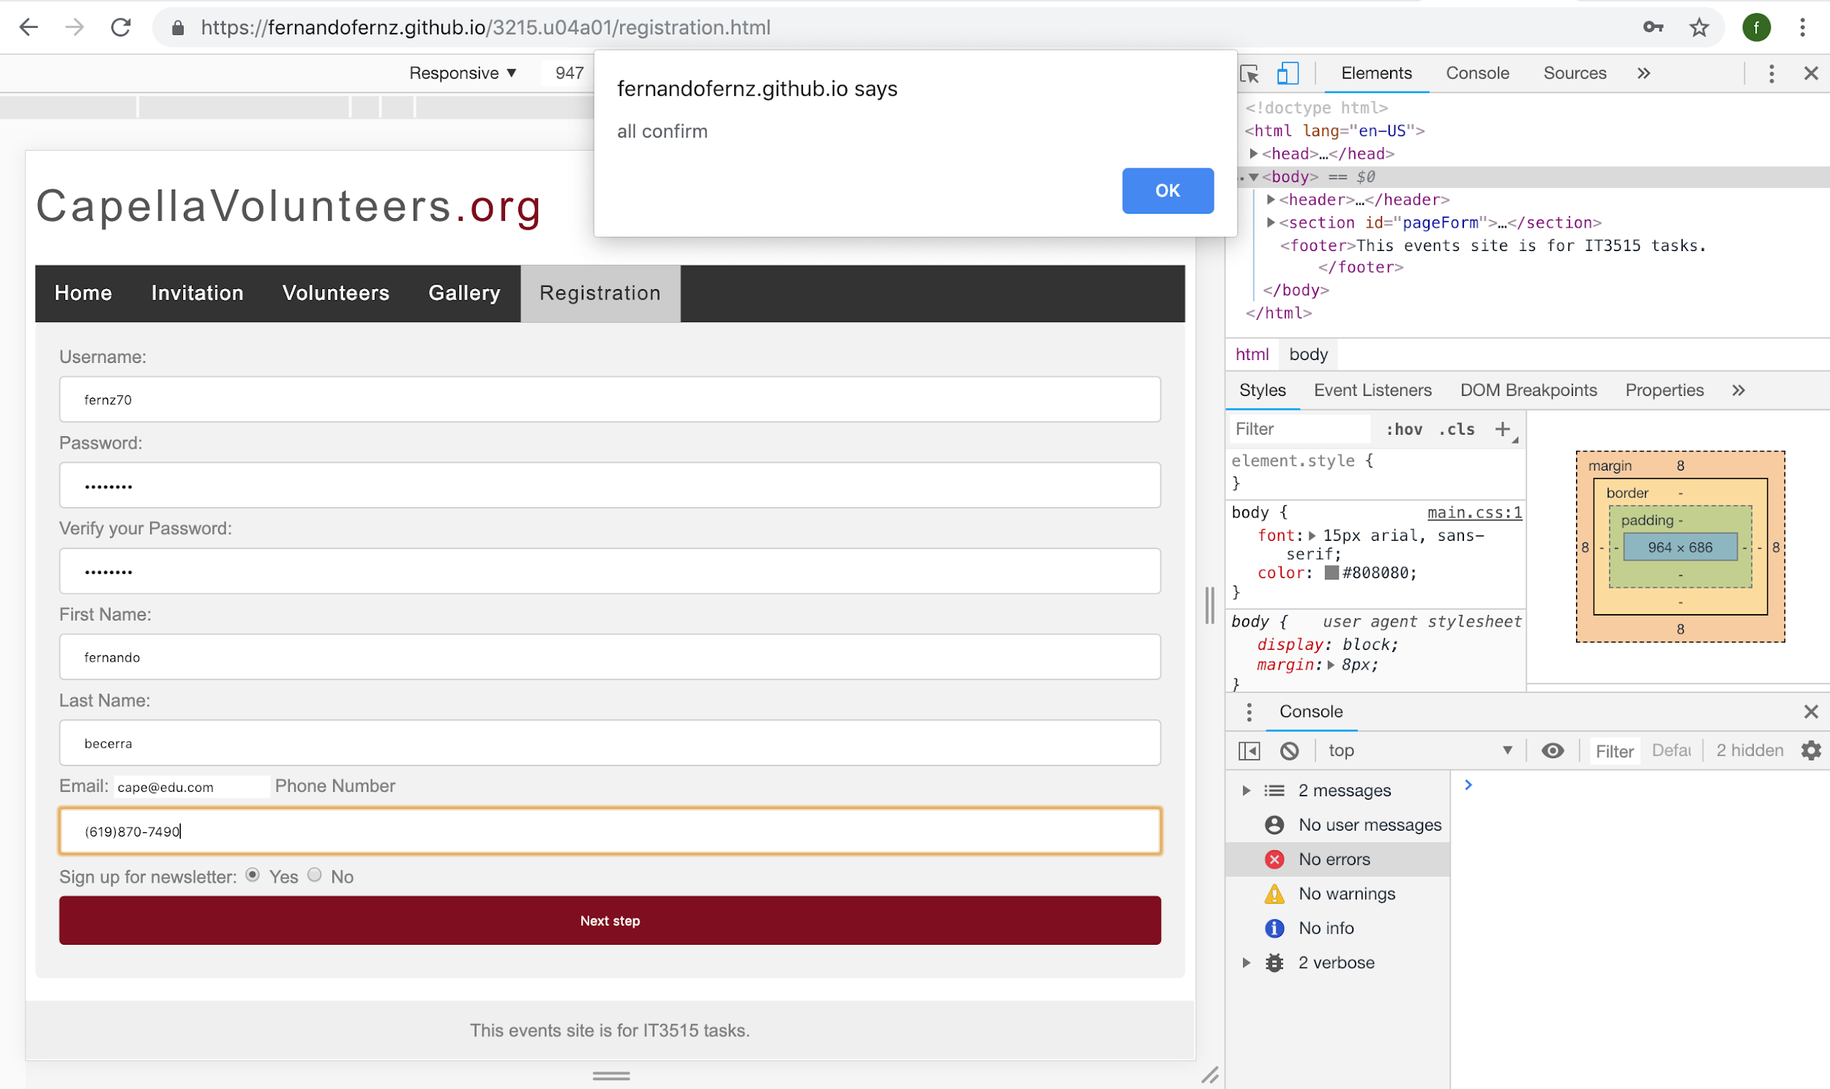

Safari Web Inspectors Tools

