Fernando Becerra

IT 3215 u05a01

2/08/2018

Assignment 5

Github url:

<https://fernandofernz.github.io/3215.u05a01/registration.html>

Chrome Developer Tools:

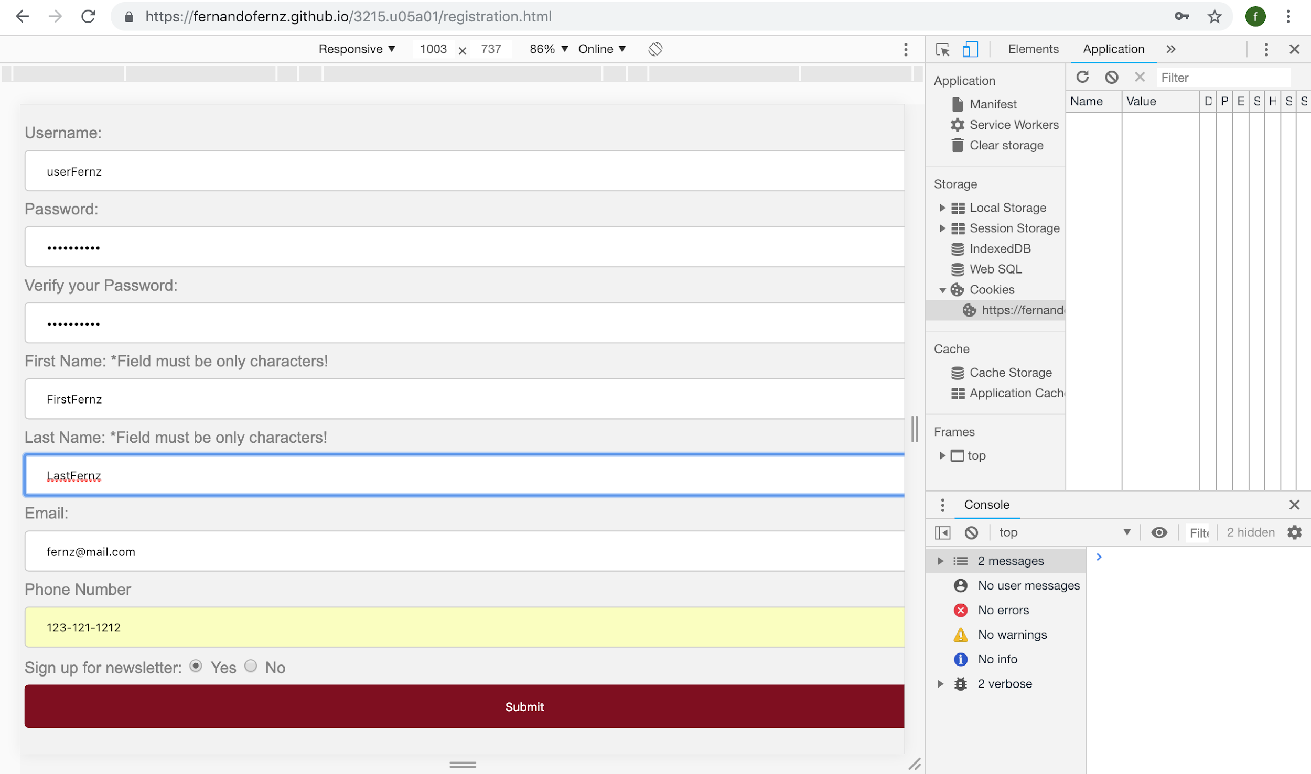

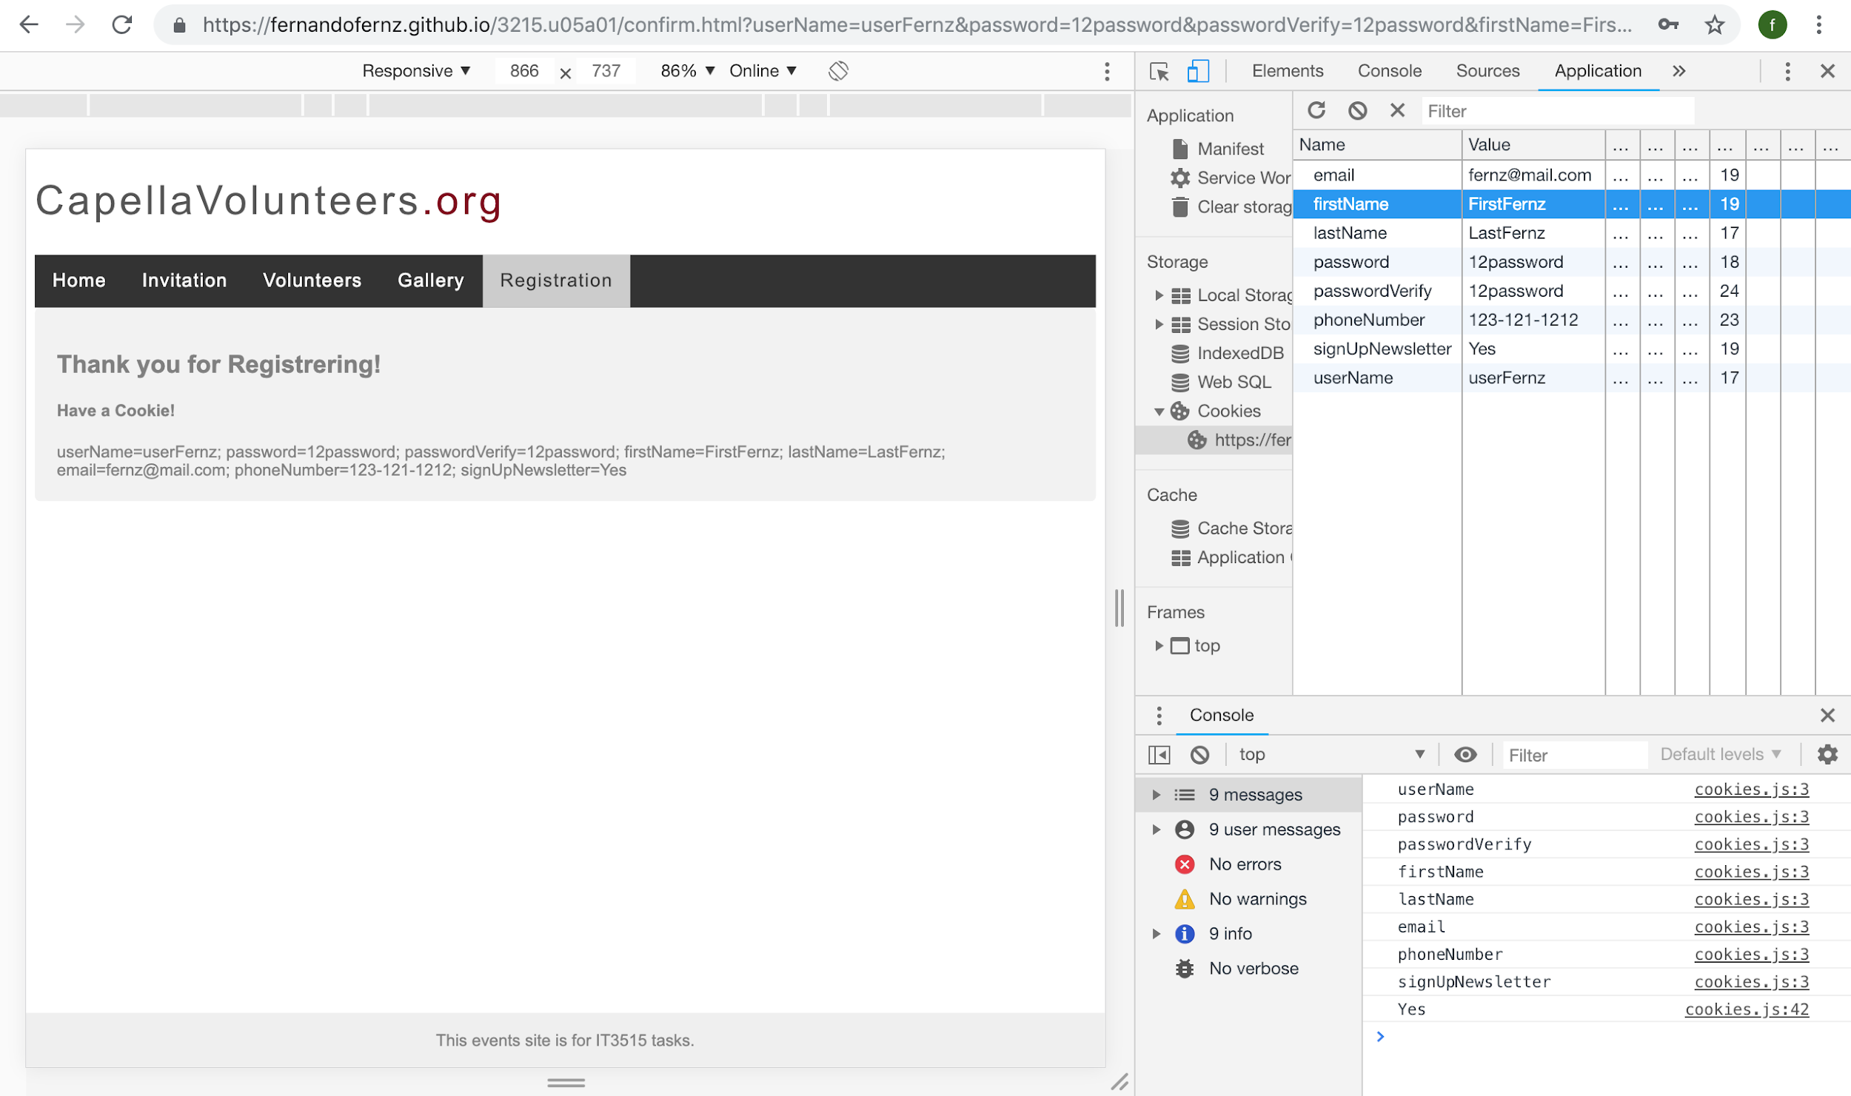

Safari Web Inspector:

