Fernando Becerra

Assignment #1

1/13/2019

Github was used to host the website.

Link:

<https://fernandofernz.github.io/FernandoB.3215/>

Google Chrome DevTools: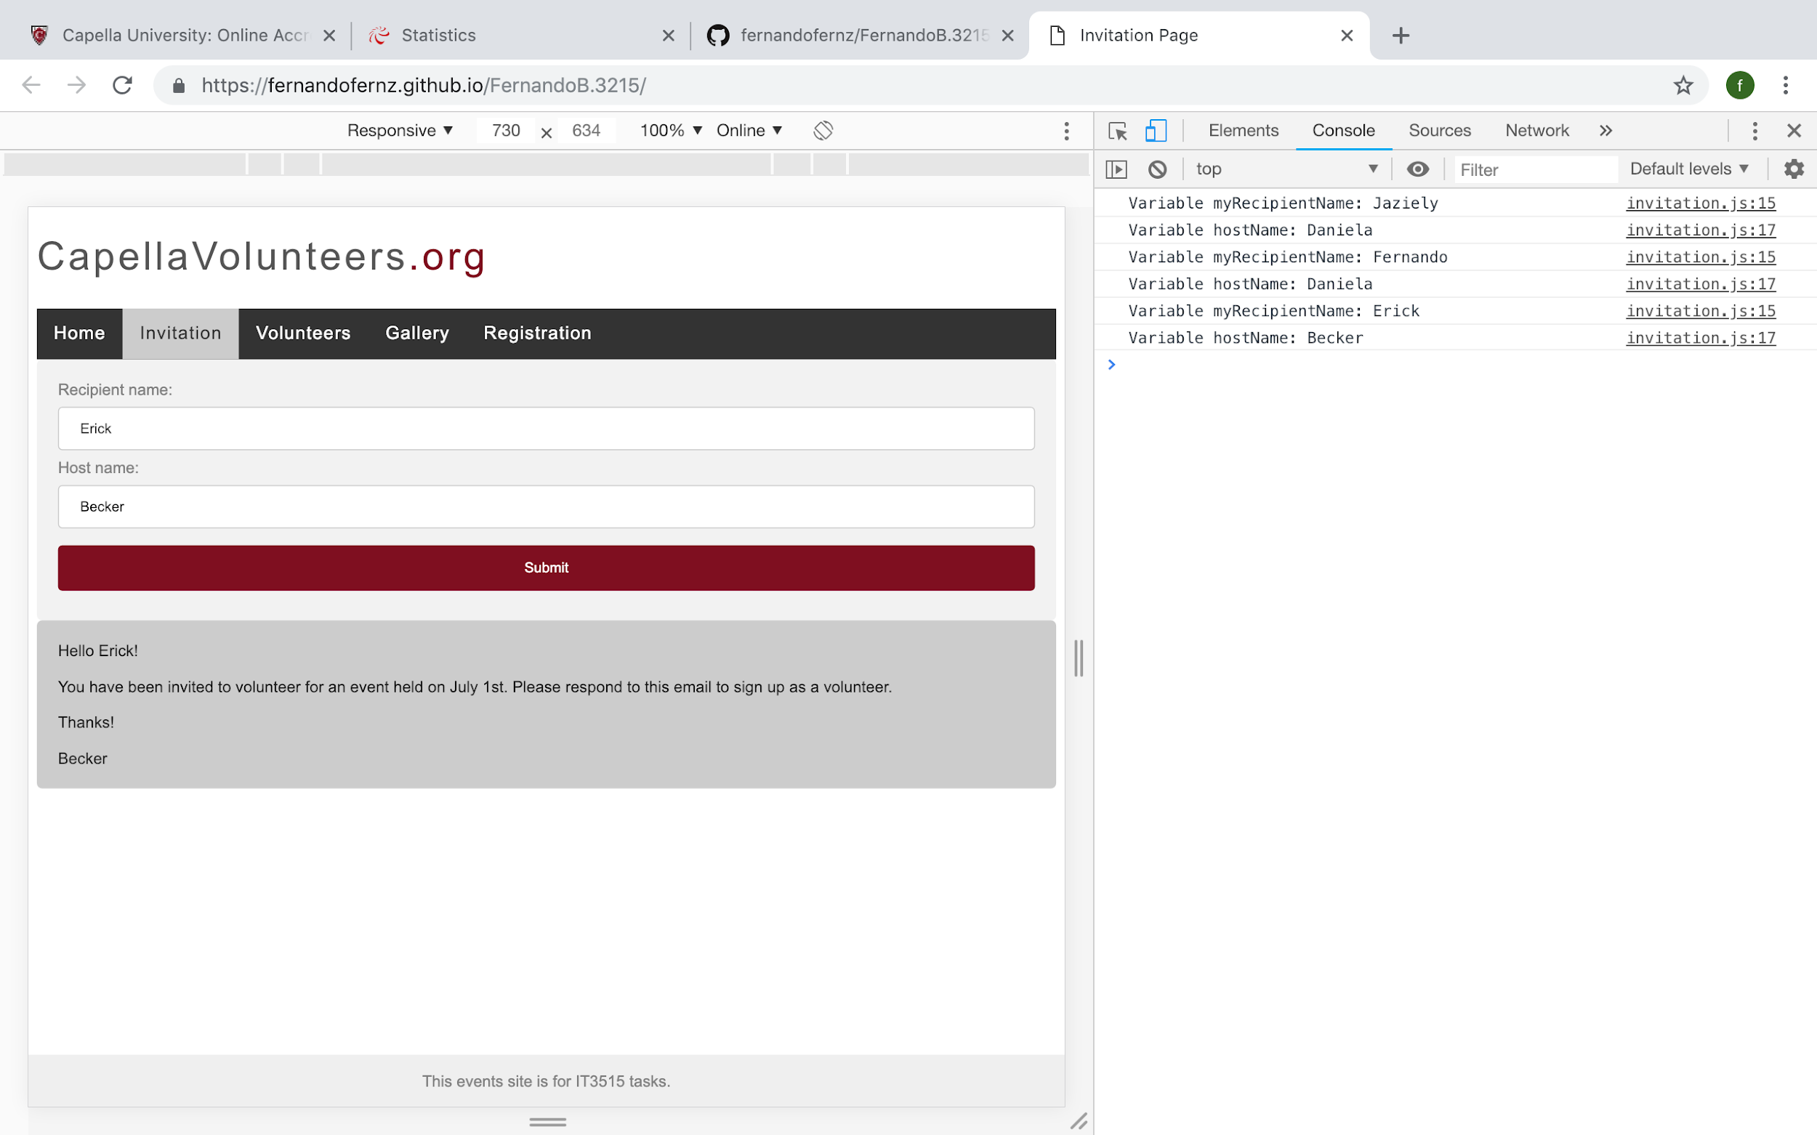

Safari Web Inspector:

