Fernando Becerra

Assignment # 1

1/13/2019

Github used to publish website

Link:

<https://fernandofernz.github.io/fb.3212.a01/>

Chrome DevTools:

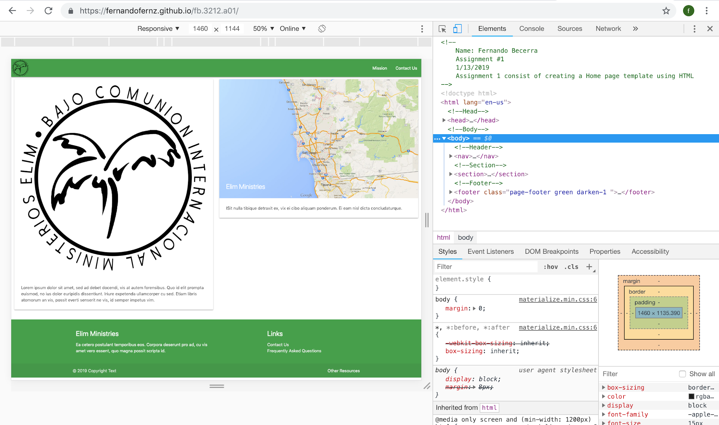

Safari Web Inspector:

