SOC ANALYST LAB REPORT
Tool: Cowrie v3.0.3 | Platform: Kali Linux VM | Date: June 2026 | Analyst: Fernando Gesa
github.com/fernandogesasoc-lgtm/soc-analyst-lab

HONEYPOT STATUS | Active — Cowrie SSH Honeypot listening on port 2222

ATTACK CAPTURED | 1 simulated SSH brute force session — 394.8 seconds duration

TTY SESSION | Full session recorded and replayed — all attacker commands logged

01 | Lab Overview

This lab documents the deployment of a Cowrie SSH honeypot on a Kali Linux virtual machine. The objective was to simulate a vulnerable SSH service, capture attacker behaviour in a sandboxed environment, analyse the resulting logs, and apply SOC detection methodology to the observed attack chain.

Cowrie is an open-source medium-interaction SSH and Telnet honeypot that logs brute force attacks, shell interaction, and command execution in a fake emulated environment. It is widely used in production SOC environments and threat intelligence operations.

02 | Lab Environment & Setup

Field | Details
Operating System | Kali Linux (Oracle VirtualBox VM)
Honeypot Tool | Cowrie v3.0.3.dev1+g5e930f918
Python Version | 3.13.9
Twisted Version | 26.4.0
Sensor UUID | 1941ba34-67a7-11f1-a917-0800271fb795
Listen Port | 2222 (emulating SSH port 22)
Output Engine | jsonlog
Fake Hostname | svr04 (Debian Linux decoy)
Fake OS | Linux svr04 6.1.0-21-amd64 Debian

03 | Installation Steps

- Install dependencies: git, python3-virtualenv, libssl-dev, libffi-dev, build-essential, python3-dev
- Clone Cowrie repository from GitHub: git clone http://github.com/cowrie/cowrie
- Create Python virtual environment: python3 -m venv cowrie-env
- Activate virtual environment: source cowrie-env/bin/activate
- Install Python dependencies: pip install -r requirements.txt
- Install Cowrie as editable package: pip install -e .
- Copy configuration file from source: cp src/cowrie/data/etc/cowrie.cfg.dist etc/cowrie.cfg
- Start honeypot: cowrie start
- Verify listening on port 2222: netstat -tlnp | grep 2222

04 | Captured Attack Session

SSH Connection Attempt
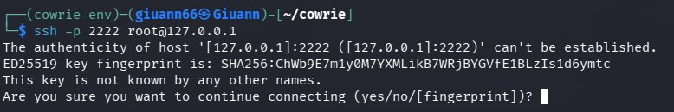
Figure 1: Attacker SSH connection attempt — fake fingerprint presented
The honeypot presented a fake SSH host key fingerprint (SHA256:ChWb9E7m1y0M7YXMLikB7WRjBYGVfE1BLzIs1d6ymtc) to the connecting client. This is a deliberate decoy designed to appear as a legitimate SSH server.

Authentication & Shell Access
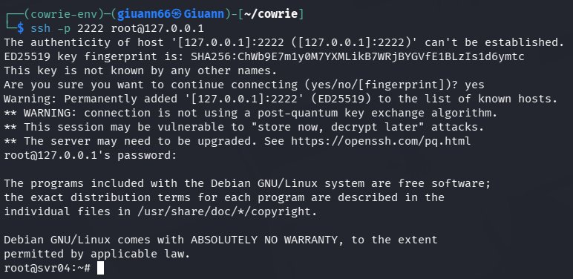
Figure 2: Attacker logged in as root using password123 — dropped into fake shell
The attacker successfully authenticated using the credentials root/password123. Cowrie accepted the login and presented a convincing fake Debian Linux shell environment, giving the attacker the impression of having full root access to a real server.

05 | Cowrie Log Analysis

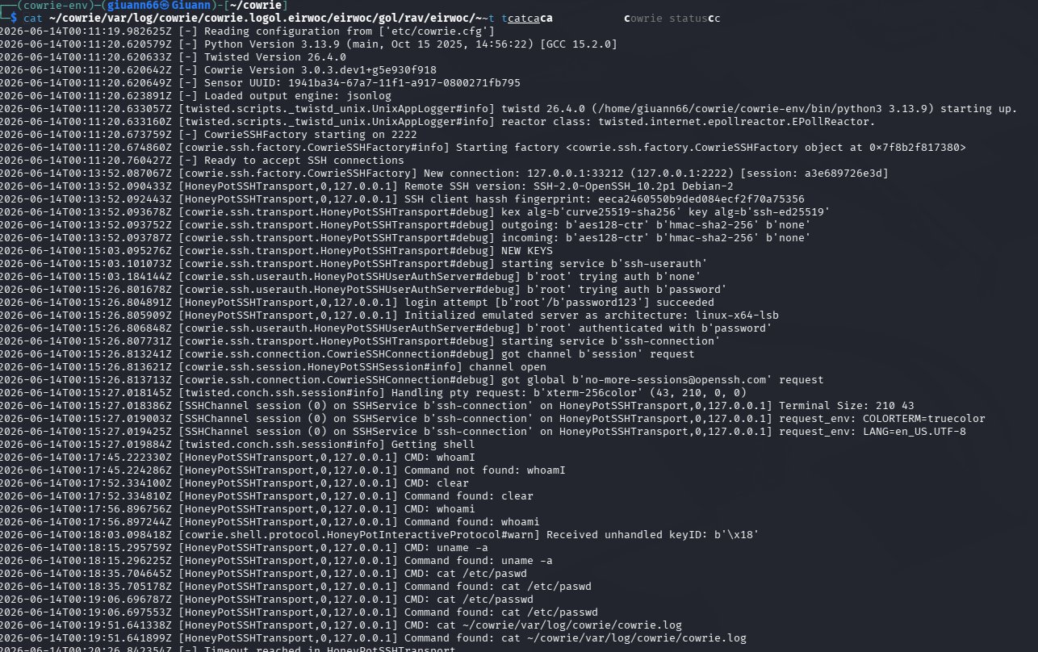
Figure 3: Cowrie log — full session from connection to authentication

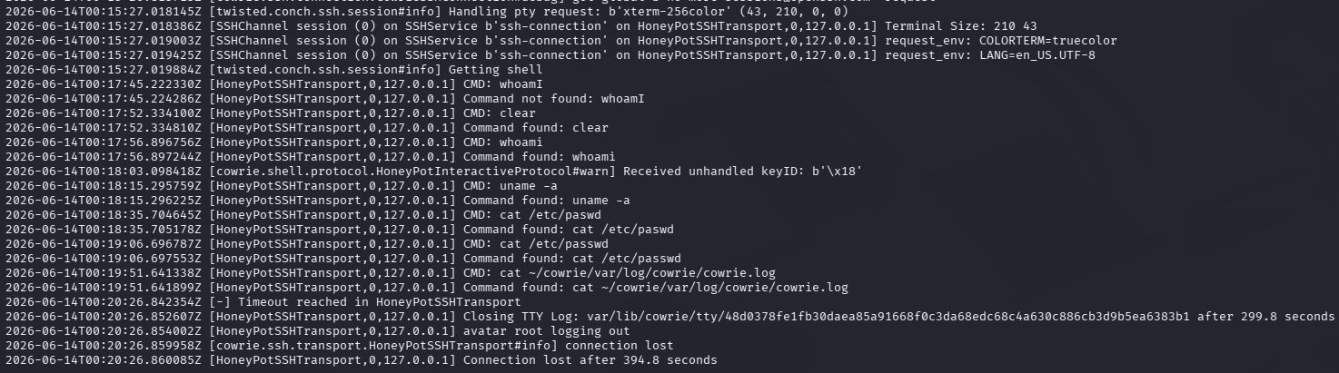
Figure 4: Cowrie log — command execution and session termination

Key Log Events
Timestamp (UTC) | Event
00:11:20 | Cowrie started — listening on port 2222
00:13:52 | New connection from 127.0.0.1:33212
00:13:52 | Remote SSH version: SSH-2.0-OpenSSH_10.2p1 Debian-2
00:13:52 | SSH client fingerprint: eeca2460550b9ded084ecf2f70a75356
00:15:26 | Login attempt: root / password123 — SUCCEEDED
00:15:26 | Emulated server architecture: linux-x86-64-lsb
00:17:45 | CMD: whoami — Command not found (first attempt)
00:17:52 | CMD: clear — Command found
00:17:56 | CMD: whoami — Command found
00:18:15 | CMD: uname -a — Command found
00:18:35 | CMD: cat /etc/paswd — Command not found (typo)
00:19:06 | CMD: cat /etc/passwd — Command found
00:19:51 | CMD: cat ~/cowrie/var/log/cowrie/cowrie.log — Not found (honeypot evasion attempt)
00:20:26 | Timeout reached — session ended after 394.8 seconds
00:20:26 | TTY log saved to var/lib/cowrie/tty/

06 | TTY Session Replay

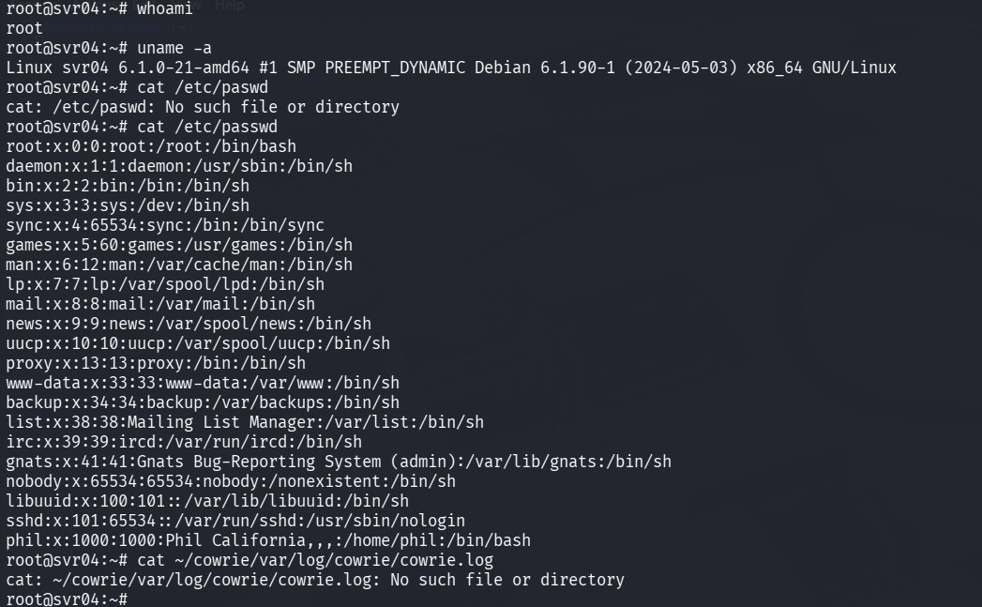
Figure 5: Full TTY session replay — attacker commands and honeypot responses

Attacker Behaviour Analysis
- whoami — System enumeration, confirming root privileges
- uname -a — OS fingerprinting: identified fake Debian Linux svr04
- cat /etc/paswd — Typo indicating manual typing, not automated script
- cat /etc/passwd — User enumeration: attacker reviewed fake user list including decoy user 'Phil California'
- cat ~/cowrie/var/log/cowrie/cowrie.log — Anti-forensics attempt: attacker tried to locate and read honeypot logs to determine if they were being monitored

Attacker Profile Assessment
Based on the observed commands, the attacker appears to be a manual operator rather than an automated bot. Key indicators include:
- Typo in /etc/paswd suggests manual typing
- Sequential enumeration commands consistent with manual reconnaissance
- Anti-forensics awareness — attempted to read honeypot logs
- No automated exploit or malware download attempted — suggests early-stage reconnaissance

07 | MITRE ATT&CK Mapping

Technique ID | Name / Observed Behaviour
T1110.001 | Brute Force: Password Guessing — root/password123 credential attempt
T1021.004 | Remote Services: SSH — attack delivered via SSH protocol on port 2222
T1082 | System Information Discovery — uname -a to fingerprint OS and architecture
T1033 | System Owner/User Discovery — whoami to confirm root privileges
T1087.001 | Account Discovery: Local — cat /etc/passwd to enumerate local users
T1070 | Indicator Removal — attempted to read/delete honeypot log files

08 | Indicators of Compromise

IOC Type | Value
Source IP | 127.0.0.1 (local simulation)
Source Port | 33212
Target Port | 2222 (SSH honeypot)
Username Used | root
Password Used | password123
SSH Client Version | SSH-2.0-OpenSSH_10.2p1 Debian-2
SSH Fingerprint | eeca2460550b9ded084ecf2f70a75356
Session Duration | 394.8 seconds
TTY Log Hash | 48d0378fe1fb30daea85a91668f0c3da68edc68c4a630c886cb3d9b5ea6383b1

09 | SOC Detection & Response

Detection Indicators
- Multiple rapid authentication attempts against SSH service — brute force pattern
- Root login attempt — high privilege account targeted
- Weak credential used (password123) — successful authentication to honeypot
- Sequential system enumeration commands post-login
- Anti-forensics behaviour — attempt to access log files
- SSH client fingerprint not matching known/trusted clients

Recommended Response Actions
- Block source IP at firewall immediately upon honeypot trigger
- Alert SOC team and escalate based on severity
- Cross-reference source IP against threat intelligence feeds
- Review production SSH server logs for same source IP
- Enforce SSH key-based authentication — disable password auth
- Implement fail2ban to auto-block repeated failed SSH attempts
- Deploy port knocking or move SSH to non-standard port
- Add credential pair (root/password123) to compromised credentials watchlist

10 | Lessons Learned

- Cowrie effectively emulates a realistic SSH environment — attackers cannot distinguish it from a real server
- TTY session recording provides invaluable forensic evidence of attacker behaviour and intent
- Even simple honeypots generate actionable threat intelligence for SOC teams
- Password-based SSH authentication is trivially exploited — key-based auth should always be enforced
- Attacker anti-forensics awareness (attempting to read logs) indicates a more sophisticated manual operator
- Honeypots should be monitored continuously and logs forwarded to a SIEM for correlation with other events
- Running honeypots on non-standard ports (2222 instead of 22) reduces noise from automated scanners

SOC Analyst Portfolio | Fernando Gesa | github.com/fernandogesasoc-lgtm/soc-analyst-lab | June 2026

